**Coordination control and analysis of tcsc devices to protect electrical power systems against disruptive disturbances**

**Diksha Patel 1 ,Parikshit Bajpai 2**

1 M.Tech, [diksh.patel07@gmail.com](mailto:diksh.patel07@gmail.com)

2 Assistant professor, [bajpai.parikshit@gmail.com](mailto:bajpai.parikshit@gmail.com)

**ABSTRACT**

This paper investigates the effect of series compensation on transmission voltages under different fault conditions in 400KV transmission systems with performance comparison with TCSC. Inserting a series capacitor into a transmission line reduces net line reactance and thus improves the line's power transfer capability. This paper also includes recommendations for series capacitor operation. The paper also includes a comparison to TCSC. A series compensator controlled by a thyristor is made up of a series capacitance with a parallel branch that includes a thyristor-controlled reactor. It is used in power systems to control the reactance of a line dynamically.In this study, a 400kV transmission line from Khandwa to Seoni is used as an example and monitored.The system is simulated using the MATLAB software, and the results are discussed. The information provided here is useful for grid operators who work with compensated lines and switch in and out series capacitors.

**INTRODUCTION**

The growing use of nonlinear loads in industries based on power electronic elements caused serious perturbation problems in the electric power system. The high cost of building new transmission corridors in recent years has prompted a search for ways to increase the transmission line capacity of existing lines. With series compensation, the viable distances of AC power transmission increase to the point where distance is no longer a limiting factor for AC transmission in most cases. As a result, series compensation is an effective way to address these issues. It should be connected to the transmission line in series. The method of improving system voltage by connecting a capacitor in series with the transmission line is known as series compensation. In other words, in series compensation, reactive power is connected in series with the transmission line to improve system impedance. It improves the line's power transfer capability. It is commonly found in extra and ultra high voltage lines.

**The advantages of series compensation are-**

• Improvement in System Stability

• Increase in power transfer capability

The power transfer (P1) over a uncompensated line is given by ;

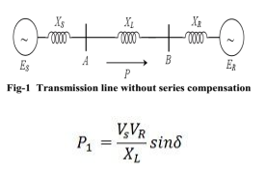

The power (P2) transmitted through series compensated transmission line is given by;

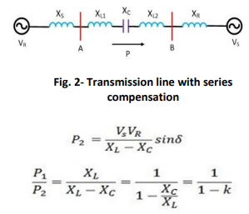

K is degree of compensation which may lie between 0.4 to 0.8. The amount of transmitted power is increased with series compensation.

• Load Distribution on Parallel Lines

• Voltage control

The series capacitor can be placed at either the sending or receiving end of the line, or in the middle.They are sometimes found at two or more points along the line.

**2. THYRISTOR CONTROLLED SERIES CAPACITOR:-**

FACT controller is TCSC. The use of thyristor control to provide variable series compensation makes using series capacitors in long lines appealing. A series capacitor bank shunted by a thyristor controlled reactor constitutes a thyristor controlled series capacitor. Figure 2 depicts a linear reactor 'L' connected to an alternating current source via two anti-parallel thyristors. By switching the capacitor and controlling the current in the reactor, a parallel combination of switched capacitors and controlled reactors provides a smooth current control range from capacitive to inductive values.

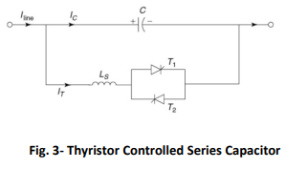

Thyristor-controlled series capacitors can be used to control current, improve stability, dampen oscillations, and limit fault current.

FACTS benefits include:

• increasing the loading capability of the lines in relation to their thermal capability; and

• overcoming their limitations through power sharing among lines.

• Provides greater flexibility in sitting new generation. • FACTS devices improve the overall system's speed of operation. • It improves the system's stability and thus makes the system secure.

**3.MATLAB SIMULATION AND RESULTS :-**

Simulink is used in MATLAB to simulate the 400 KV three phase gearbox systems. The model includes a 400 KV generation system and a step-up converter. 300-foot transmission line pi-section transformer km in length, series capacitors, or TCSC. The Three-phase gearbox systems are used. R-L Loading and connected through circuit breaker. When loaded A three-phase fault is simulated on one side. System of supply Voltage and current are measured. PGCIL Data in Use To obtain simulation results, has been used.

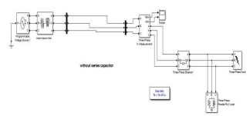

**Fig. 4- simulink model of system without series capacitor**

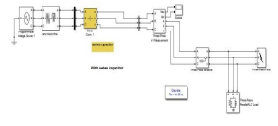

**Fig. 5- Simulink model of system with series capacitor**

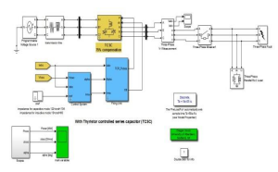

**Fig. 6- simulink model of TCSC controller**

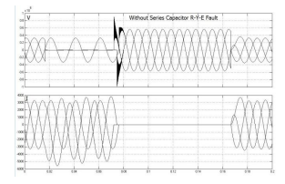

**Fig.7-Waveform of V &I without series capacitor**

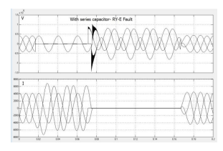

**Fig.8-Waveform of V & I with series capacitor**

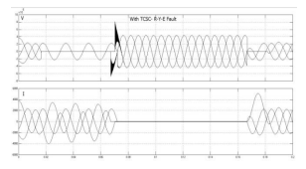

**Fig.9- Waveform of V & I with TCSC**

**4 MEASUREMENT RESULTS :**

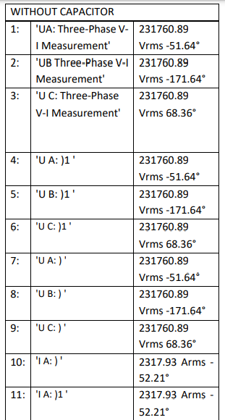

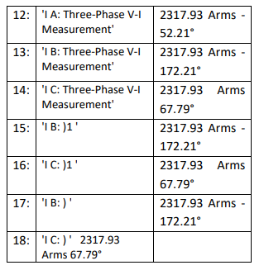

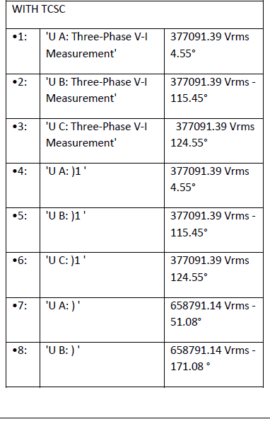

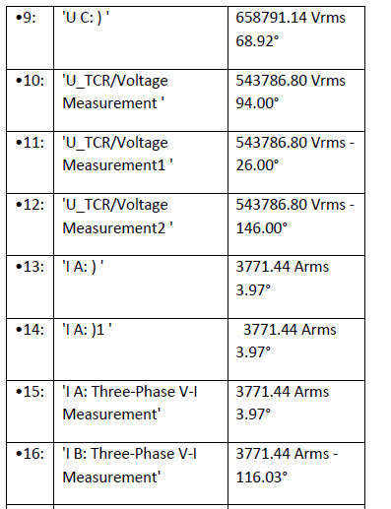

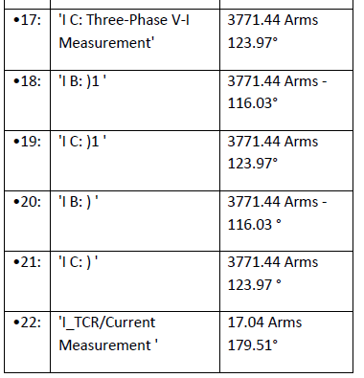

**5.CONCLUSION**

The comparison of the above waveforms demonstrates a significant increase in the transient stability margin in the system with TCSC. Power system oscillations can be effectively dampened using controlled series compensation. It is necessary to vary the applied compensation for power oscillation damping in order to counteract the acceleration and decelerating swings on the disturbed machines. To put it another way, as the rotationally oscillating generator accelerates and the angle increases, the electric power transmitted must increase to compensate for the increased mechanical input power. When the generator decelerates and the angle decreases, the electric power must be reduced to compensate for the insufficient mechanical input power.

Fixed series compensation is self-adaptive to load change and has a compensation effect on heavy load lines, but light load lines with high load fluctuation may cause abnormal voltage rise in front of the compensation point, necessitating the establishment of reasonable switching rules for series capacitors.

**6. R E F E R E N C E S**

[1] M. Begovic, D. Novosel, D. Karlsson, C. Henvill, and G. Michel: Wide-area protection and emergency control. Proc. T. IEEE 93 (2005), 876–891. DOI:10.1109/JPROC.2005.847258

[2] R. Bi, T. Lin, R. Chen, J. Ye, X. Zhou, and X. Xu: Alleviation of post-contingency overloads by SOCP based corrective control considering TCSC and MTDC. IET Gener. Transmiss. Distr. 12 (2018), 2155–2164. DOI:10.1049/iet-gtd.2017.1393

[3] Z. Bie, Y. Lin, G. Li, and F. Li: Battling the extreme: A study on the power system resilience. Proc. T. IEEE 105 (2017), 1253–1566. DOI:10.1109/JPROC.2017.2679040

[4] S. Biswas and K. P. Nayak: A new approach for protecting TCSC compensated transmission lines connected to DFIG-based wind farm. IEEE Trans. Industr. Inform. 17 (2021), 5282–5291. DOI:10.1109/TII.2020.3029201

[5] S. Bruno, G. De, and M. La: Transmission grid control through TCSC dynamic series compensation. IEEE Trans. Power Syst. 31 (2016), 3202–3211. DOI:10.1109/TPWRS.2015.2479089

[6] L. Chang, Y. Liu, Y. Jing, X. Chen, and J. Qiu: Semi-globally practical finite-time H∞ control of TCSC model of power systems based on dynamic surface control. IEEE Access. 8 (2020), 10061–10069. DOI:10.1109/ACCESS.2020.2964265

[7] Z. Chen and L. Shu: Distributed aggregative optimization with quantized communication. Kybernetika 58 (2022), 123–144. DOI:10.1155/2022/3436530

[8] Y. Chen, J. Wang, A. D. Dom´ınguez-Garc´ıa, and P.W. Sauer: Measurement-based estimation of the power flow Jacobian matrix. IEEE Trans. Smart Grid 7 (2015), 2507–2515. DOI:10.1109/TSG.2015.2502484

[9] T. Duong, J. Yao, and V. Truong: A new method for secured optimal power flow under normal and network contingencies via optimal location of TCSC. Int. J. Electr. Power Energy Syst. 52 (2013), 68–80. DOI:10.1016/j.ijepes.2013.03.025

[10] V. Durkovi´c and A. Savi´c: ATC enhancement using TCSC device regarding uncertainty of realization one of two simultaneous transactions. Int. J. Electr Power Energy Syst. 115 (2020), 105497. DOI:10.1016/j.ijepes.2019.105497

[11] A. Halder, N. Pal, and D. Mondal: Transient stability analysis of a multimachine power system with TCSC controller – A zero dynamic design approach. Int. J. Electr Power Energy Syst. 97 (2018), 51–71. DOI:10.1016/j.ijepes.2017.10.030

[12] S. Hameed, B. Das, and V. Pant: A self-tuning fuzzy PI controller for TCSC to improve power system stability. Electr. Pow. Syst. Res. 78 (2008), 1726–1735. DOI:10.1016/j.epsr.2008.03.005

[13] R. Hemmati, H. Faraji, and Y. N. Beigvand: Multi objective control scheme on DFIG wind turbine integrated with energy storage system and FACTS devices: Steady-state and transient operation improvement. Int. J. Electr. Power Energy Syst. 135 (2022), 107519. DOI:10.1016/j.ijepes.2021.107519

[14] J. Hu: On Robust Consensus of Multi-Agent Systems with Communication Delays Volume. Kybernetika 45 (2009), 768–784.

[15] J. Hu, G. Chen, and H. Li: Distributed event-triggered tracking control of leader-follower multi-agent systems with communication delays. Kybernetika 47 (2011), 630–643.

[16] Y. Liu, Q. Wu, and X. Zhou: Coordinated switching controllers for transient stability of multi-machine power systems. IEEE Trans. Power Syst. 31 (2016), 3937–3949. DOI:10.1109/TPWRS.2015.2495159

[17] Y. Luo, S. Zhao, D. Yang, and H. Zhang: A new robust adaptive neural network backstepping control for single machine infinite power system with TCSC. IEEE/CAA J. Automat. Sinica 7 (2020), 48–56. DOI:10.1109/JAS.2019.1911798

[18] H. Kumar and P. Singh: Coordinated control of TCSC and UPFC to aid damping oscillations in the power system. Int. J. Electron. 106 (2019), 1938–1963. DOI:10.1080/00207217.2019.1636296

[19] T. Nguyen and F. Mohammadi: Optimal placement of TCSC for congestion management and power loss reduction using multi-objective genetic algorithm. Sustainability 12 (2020), 2813. DOI:10.3390/su12072813

[20] M. Panteli and P. Mancarella: The grid: Stronger, bigger, smarter?: Presenting a conceptual framework of power system resilience. IEEE Pow. Energy Mag. 13 (2015), 58–66. DOI:10.1109/MPE.2015.2397334

[21] T. Prakash, P. V. Singh, and S. R. Mohanty: A synchrophasor measurement based wide-area power system stabilizer design for inter-area oscillation damping considering variable time-delays. Int. J. Electr Power Energy Syst. 105 (2019), 131–141. DOI:10.1016/j.ijepes.2018.08.014

[22] R. Rocchetta and E. Patelli: Assessment of power grid vulnerabilities accounting for stochastic loads and model imprecision. Int. J. Electr. Power Energy Syst. 98 (2018), 219–232. DOI:10.1016/j.ijepes.2017.11.047

[23] A. Rosso, C. A. Canizares and V. M. Dona: A study of TCSC controller design for power system stability improvement. IEEE Trans. Power Syst. 18 (2003), 1487–1496. DOI:10.1109/TPWRS.2003.818703

[24] B. Shafik, H. Chen, I. Rashed, and A. Sehiemy: Adaptive multi objective parallel seeker optimization algorithm for incorporating TCSC devices into optimal power flow framework. IEEE Access. 7 (2019), 36934–36947. DOI:10.1109/ACCESS.2019.2905266

[25] V. Terzija, G. Valverde, D, Cai. P, Regulski, V. Madani, J. Fitch, S. Skok, M. Begovic, and A. Phadke: Wide-area monitoring, protection, and control of future electric power networks. Proc. T. IEEE 99 (2011), 80–93. DOI:10.1109/JPROC.2010.2060450

[26] J. Xu, R. Yao and F. Qiu: Mitigating cascading outages in severe weather using simulation-based optimization. IEEE Trans. Power Syst. 39 (2021), 204–213. DOI:10.1109/tpwrs.2020.3008428

[27] C. Zhai, G. Xiao, M. Meng, H. Zhang, and B. Li: Identification of catastrophic cascading failures in protected power grids using optimal control. J. Energ. Engrg. 147 (2021), 6020001. DOI:10.1061/(ASCE)EY.1943-7897.0000731

[28] C. Zhai, G. Xiao, H. Zhang, P. Wang, and T. Pan: Identifying disruptive contingencies for catastrophic cascading failures in power systems. Int. J. Electr. Power Energy Syst. 123 (2020), 106214. DOI:10.1016/j.ijepes.2020.106214

[29] C. Zhai and Y. Hong: Decentralized sweep coverage algorithm for multiagent systems with workload uncertainties. Automatica 49 (2013), 2154–2159. DOI:10.1016/j.automatica.2013.03.017

[30] C. Zhai, G. Xiao, H. Zhang and T. Pan: Cooperative control of TCSC to relieve the stress of cyber-physical power system. In: International Conference on Control, Automation, Robotics and Vision 2018, pp. 4849–4854. DOI:10.1186/s13662-018-1910-6

[31] C. Zhai, H. Zhang, G. Xiao, and T. Pan: A model predictive approach to protect power systems against cascading blackouts. Int. J. Electr. Power Energy Syst. 113 (2019), 310– 321. DOI:10.1016/j.ijepes.2019.05.029

[32] C. Zhang, X. Wang, Z. Ming, Z. Cai, and H. Linh: Enhanced nonlinear robust control for TCSC in power system. Math. Probl. Eng. 2018 (2018), 1416059. DOI:10.1155/2018/3495096