**Coordination control and analysis of tcsc devices to protect electrical power systems against disruptive disturbances**

**Diksha Patel 1 ,Parikshit Bajpai 2**

1 M.Tech, [diksh.patel07@gmail.com](mailto:diksh.patel07@gmail.com)

2 Assistant professor, [bajpai.parikshit@gmail.com](mailto:bajpai.parikshit@gmail.com)

**ABSTRACT**

We investigate coordination control and the effective deployment of thyristor-controlled series compensation (TCSC) to protect power grids from disruptive disturbances in this paper. The power grid is made up of flexible alternative current transmission systems (FACTS) devices that regulate current flow.Power flow, phasor measuring units (PMUs) for detecting system states, and a control station are all examples of components. for generating the regulation signals. We present a unique TCSC device coordination control strategy for changing branch impedance and regulating power flow in the face of unexpected disruptions on buses or branches. More importantly, a numerical method for estimating a gradient vector for generating TCSC device regulatory signals and lowering computing costs is devised. A performance index based on the difference between the desired power flow and actual values is created to describe the degree of power system stress. Furthermore, technical analysis is presented to ensure the suggested coordination control algorithm's convergence. When compared to the standard PID control, numerical simulations show that the coordination control strategy may effectively alleviate the stress generated by contingencies on the IEEE 24 bus system.

**Keywords:** coordination control, thyristor-controlled series compensation(TCSC), power systems, disruptive disturbances

**LIST OF SYMBOLS AND ABBREVIATIONS**

**Constants c:** a small constant between 0 and 1

CP , CI , CD: the parameters of PID controller

k: the update times of Sk

m, n: the total buses and branches of a power grid

T: the number of time steps in the interval

XL: the reactance of transmission line between Bus i and Bus j

Zi , Zi : the lower and upper bound of Zi σi : the desired power flow of Branch i, (i ∈ 1, . . . , n)

e: a small constant

λ: a small perturbation

**1.INTRODUCTION**

Power system outages have become an intractable issue for both power sectors and governments all around the world in recent decades. To address this issue, some researchers seek a strategy for terminating cascading outages in the initial phase [26, 27], others study the impact of communication delay on fault propagation by viewing the power grid as a multi-agent system [14, 21], and still others attempt to identify disruptive disturbances (i.e., triggering events) [22, 28].Given that many blackouts are triggered by the overload precondition [31], it is critical to reduce the system pressures induced by overloads in order to avoid catastrophic effects and prevent cascading failures. FACTS devices are used to ensure power oscillation dampening and increase transient stability in order to alleviate system stressors [13]. TCSC devices facilitate the reliable operation of power grids by regulating power flow [9]. Many control strategies have been developed thus far, including intelligent algorithms [4, 5, 24], finitetime H control approach [6, adaptive neural network backstepping control [17], and so on. [2] investigates the function of TCSC in reducing system stress using second-order cone programming and model linearization. Furthermore, [11, 32] create robust and nonlinear controllers for TCSC devices.Existing work to increase transient stability [16, 18] focuses on how to construct standalone TCSC controllers or coordinate TCSC with other FACTS, which effectively ignores coordination control of TCSC devices against disruptive disturbances.In practise, because multi-agent coordination control has previously been widely utilised in many domains [15, 29], it is worthwhile to investigate the coordination between TCSC devices for jointly decreasing or eliminating the stress of the power grid produced by various events. Coordination control enables agents to coordinate individual control actions and achieve the control goal in a coordinated manner by sharing information with neighbouring agents. Coordination control of TCSC can be used to protect power grids in real time by treating each TCSC device as a smart agent [5]. By systematically removing stress from power grids, it helps to strengthen power grids' resilience to disruptive disturbances [30]. As a result, the current work develops a coordination control approach to alleviate system stress. The following are the main contributions of this work:

1. Develop a novel coordination control strategy for TCSC devices to regulate branch impedance in a coordinated manner.

2. Create a computationally efficient numerical algorithm for estimating the gradient vector.

3. Provide an effective TCSC device deployment strategy to reduce the number of TCSC without compromising control performance. The deployment of TCSC takes into account the ability to deal with contingencies, such as the stress caused by power flow congestion.The rest of this paper is organised as follows. Section 2 contains a problem formulation for the coordination control of TCSC devices. The innovative control scheme Section 3 presents the TCSC. Section 4 employs IEEE test systems to validate the proposed approach. Section 5 contains the conclusion.

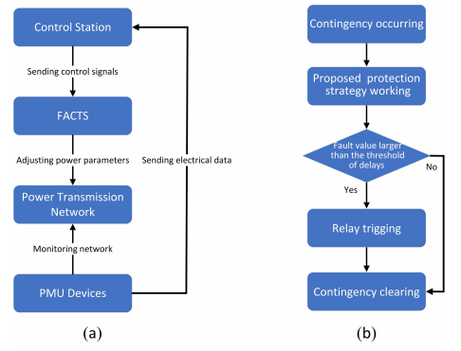

**Fig. 1. (a) Smart power grids with PMU and FACTS. (b) Action sequence between the proposed protection strategy and delays**.

1. **PROBLEM FORMULATION**

Transmission networks, phase measurement units, FACTS devices, and control stations comprise the smart power grid (see Figure 1 (a)). PMU, in particular, is used to detect the state of buses and transmit it to the control station in real time. Using the state information, the control station generates appropriate control signals to drive FACTS devices. Finally, TCSC devices adjust the impedance of branches to control power flow. The communication between TCSC, PMU and control station can be seen in Ref. [1, 25]. The common communication protocols for exchanging data are synchronous optical networks (Sonet/SDH) and asynchronous transfer mode (ATM), and electrical utilities have system management options for dealing with issues. Figure 1 (b) depicts the coordination relationship between the proposed protection strategy and delays. It has been observed that the proposed protection strategy takes effect before the relays protective systems and has a complementary effect to the existing protection systems.

min *H*(**Z**) (1)

using a tuning parameter of [0, 1], and an objective function H(Z) = PR R 2 + PI I 2. Z stands for the vector of branch impedance. Keep in mind that PR and PI correspond to Pe's real and imaginary halves, respectively. Other complicated variables are also affected by the superscripts R and I. The Lyapunov function candidate V (Z) is created below to address Problem 1.

*V*(**Z**) = *H*(**Z**) − *H*(**Z**∗)*,*

where *H*(**Z**∗) is the minimum value of Problem (1). Then the derivative of *V* (**Z**) with respect to the time *t* gives

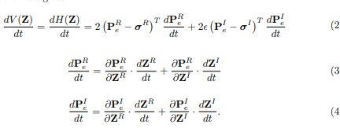

By substituting (3) and (4) into (2)

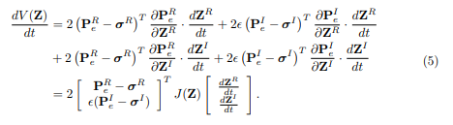

The Jacobian matrix J(Z) in (5)



The control input U is designed as



Because of the intricacy of the system model, obtaining an accurate value of J(Z) is difficult. As a result, a numerical method for estimating J(Z) is proposed. Furthermore, rather than converting the minimization Problem (1) into the KKT condition, this work designs a coordination control approach to minimize the value of H(Z). CCA, rather than the KKT condition, ensures the convergence of the objective function H(Z). Figure 2 depicts a simplified control flow chart for PMUs.

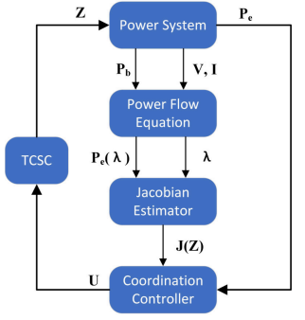

Pb, V, and I time series should be collected. The Jacobian matrix can then be computed using the power flow equation presented in the appendix by injecting a minor disturbance on the branch. Finally, the controller generates command signals for TCSC devices to regulate power flow in accordance with the defined control law, achieving the optimization goal. It is widely accepted that the TCSC device consists of two primary control blocks, the function of which is to improve the transmission capacity or stability of the power grid [23]. External control can be designed in a variety of ways depending on the control objectives. . The typical PI controller is a sluggish automatic control for power flow regulation [12], and the coordination control presented in this paper is a sort of external control. The internal control block's job is to create adequate gate drive signals for thyristors to generate compensating reactance. Appendix 6.1 shows the link between TCSC impedance and power flow.

**Remark 2.1**. The purpose of this work is to provide a novel coordination control method for regulating branch impedance via TCSC devices in order to reduce system stress. The proposed method is, in reality, ubiquitous. It is applicable not just to TCSC devices, but also to other FACTS devices.

**Remark 2.2.** As shown in Appendix 6.2, the generic TCSC model tries to alter branch power flow by varying reactance. The control signal UR merely needs to be set to zero for the control strategy and algorithm established in this study, and control algorithm convergence is still assured.

**3.COORDINATION CONTROLLER DESIGN**

This section addresses how to determine J(Z) and the creation of coordination control laws. Generation of feedback control signals

The coordination control law for TCSC devices is given by





with the constant *c >* 0 and the upper limit *Zi* and lower limit *Zi*. The Coordination Controller (8) is composed of three terms: ***κ***(**Z**), *J*(**Z**) and the error vector



(Z) allows you to alter the branch impedance in a specific interval with upper and lower bounds. J(Z) represents the incremental direction of the goal function in relation to branch impedance. Pe can be calculated by comparing the desired and actual numbers.

**Proposition 3.1.** The Control Input (8) for TCSC devices can ensure H(Z) convergence.

**P r o o f .** It is worth noting that both ZR and ZI are changed in accordance with (8). By swapping (7) for (5), we get



By substituting (8) into (9),

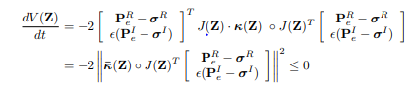

where κ¯(Z) = (p κ1(Z), p κ2(Z), . . . , p κ2n(Z))T . This indicates that the objective function decreases monotonously as t → +∞. Thus, H(Z) is convergent because of H(Z) ≥ 0.

# Construction of Jacobian estimator

The proposed CCA implementation necessitates the calculation of J(Z). J(Z) is calculated using the linear total least-squares method in [8]. Although there are approximations and relaxations in the modelling of pertinent problems, the procedure remains intricate and needs a considerable number of calculations. As a result, it is critical to devise a numerical method for estimating J(Z) that is computationally light. Four steps are involved in the Jacobian matrix approximation. Pe(Z) is calculated in the first step. The disturbed power flow Pe(ZR + ei) is then created by injecting a minor disturbance onto each branch, where ei indicates the unit vector with the ith entry being 1. Taylor's theorem allows PR (ZR + ei) and PI (ZR + ei) to be rewritten as

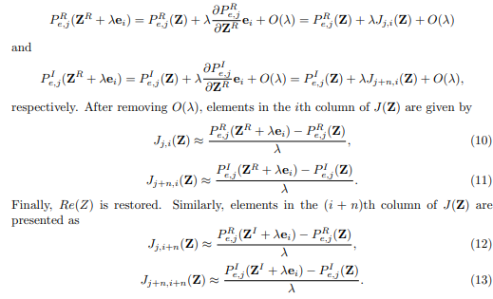

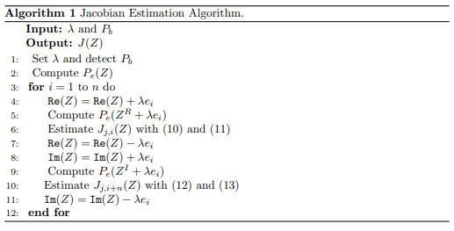

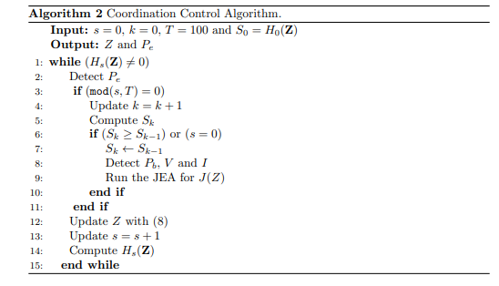

**Algorithm 2** describes the implementation of the suggested coordination controller, which allows for a reduction in the performance index Sk.

**Proposition 3.2:** CCA for TCSC devices in Algorithm 2 ensures monotonous convergence of Sk.

**P r o o f** . CCA allows you to generate a sequence with Skk=1. Sk+1 Sk and Sk 0, k Z+ imply that Sk converges to a constant value infk Z+ Sk monotonously as k approaches positive infinity.

**Remark 3.1:** The final value of Sk is an unknown constant related to power system disruptions. Sk converges to zero when the disturbances are minor. Sk will converge to a constant if the disturbances are substantial and the proposed management approach cannot eliminate them.

**4. NUMERICAL SIMULATIONS**

Extensive simulation results are presented to demonstrate the performance of the proposed control approach, and Figure 3 depicts the locations of TCSCs and PMUs. The following are some key parameters: c = 0.02, e = 0.2, λ = 10−6 and T = 100. The PID control parameters are given as CP = 2 105, CI = 102, and CD = 3 106. The Euler method is used to implement the control algorithm, with a step size of 0.01 and 104 total time steps. Furthermore, the branch impedance adjustment range is 0.8 to 1.7 times larger than the magnitude of the steady-state value. Per unit systems are used with a base value of 100 MVA. The performance of CCA is then evaluated using simulation cases.

**4.1. Disturbances on single or multiple branches**

This section will look at how to use the CCA to alleviate power system stress. caused by disruptive disturbances. Two types of emergencies are tested, each with a different outcome. Changes in branch impedance on a single transmission line and changes in branch impedance on multiple transmission lines. Table 1 displays branch data based on power system data and network topology. More information on these two contingencies can be found here. Table 2 summarises the findings. The first column contains the test ID, and the second column contains the results. The first column shows the branch ID where disruptive disturbances are added, the third column shows the value of branch impedance after contingencies, and the last column shows the value of branch impedance after contingencies. the disruption caused by bus faults on a large scale. In Test 1, it is assumed for simplicity that the injected bus power is subject to disturbances that satisfy the normal distribution with a mean value of = 0 and standard deviation of = 0.1. The disturbances in Test 1 are defined as the unit value, and the disturbances in subsequent tests are compounded by the unit value. The desired power flow is defined as power flow in the normal state prior to the initial contingency.

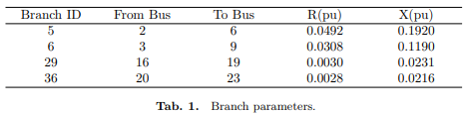

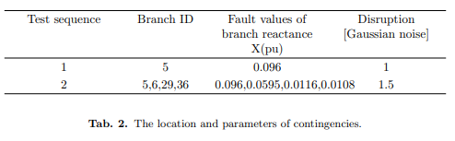

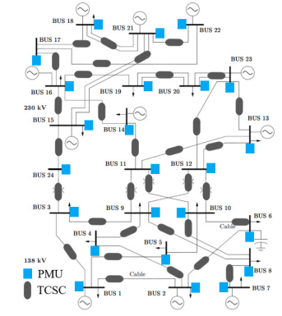

**Fig. 3. IEEE 24 bus system equipped with TCSC devices and PMUs.**

Figure 4 (a)-(b) show that the objective function H(Z) decreases monotonically from the initial to the final value in each test. In particular, H(Z) rapidly decreases from 0.0926 to 0.0075 in Test 1 and from 0.3577 to 0.0968 in Test 2. In those two tests, H(Z) gradually converges to small positive values, indicating the effectiveness of coordination control between TCSCs in relieving power system stress. Figure 4 (c)-(d) show the monotonous decrease of Sk from the initial value to the final value, which partially confirms Proposition 3.2's conclusion. The total number of k is 100 since Sk is computed for every T = 100

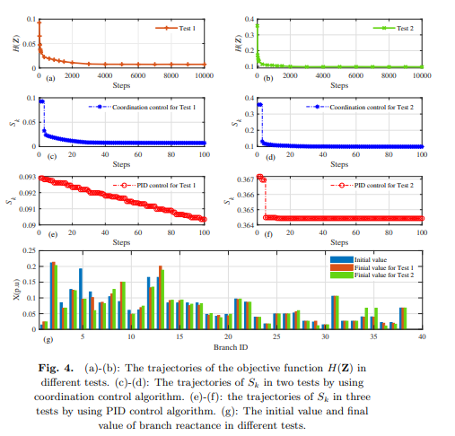

Figure 4 (a)-(b) show that the objective function H(Z) decreases monotonically from the initial to the final value in each test. In particular, H(Z) rapidly decreases from 0.0926 to 0.0075 in Test 1 and from 0.3577 to 0.0968 in Test 2. In those two tests, H(Z) gradually converges to small positive values, indicating the effectiveness of coordination control between TCSCs in relieving power system stress. Figure 4 (c)-(d) show the monotonous decrease of Sk from the initial value to the final value, which partially confirms Proposition 3.2's conclusion.

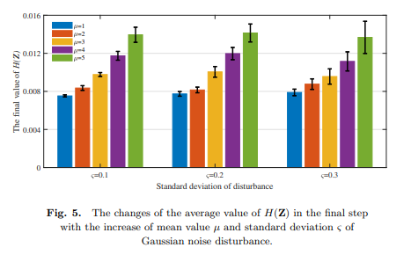

**4.2. Effects of TCSC deployment on system resilience**

Measures can be implemented in three stages to improve the resilience of the power system. [3] and [20]: identification and prediction prior to disaster, rapid response after disaster, and system recovery following disaster. This work focuses on a power system's ability to recover quickly after experiencing disruptive disturbances. The goal is to minimise the impact of disturbance as soon as possible using TCSC coordination control. In practise, due to the high cost of installing TCSC on all branches, it is necessary to investigate the strategy of reducing the number of TCSC and deployment of TCSC without impairing control performance and power system resilience. When studying the optimal deployment of TCSCs, the existing literature only considered power flow congestion. In [10], an evolutionary NSGA-II algorithm is used to determine the optimal deployment of TCSC, with the goal of maximising branch available transmission capacity. However, because the control strategy is based on DC power flow, it may differ from the actual operation of the power system. The multi-objective genetic algorithm is used in ref. [19] to determine the optimal locations of TCSCs, and the total power loss is reduced based on the optimal deployment of TCSCs. This paper examines the deployment of TCSCs from the standpoint of reducing power system stress, which includes the problem of power flow congestion. TCSC installation is considered at three different levels based on active power on branches, with TCSCs only installed on branches with active power greater than 1.2 pu (Test 1), branches with active power greater than 1.5 pu (Test 2), and branches with active power greater than 1.8 pu (Test 3). Table 3 depicts the location of TCSCs. In addition to the deployment in Test 3, another TCSC is installed on Branch 38, connecting Bus 21 and Bus 22. The initial contingency is applied to Branch 31, increasing the branch reactance to 1.5 times the normal value. The injected bus power is affected by disturbances that satisfy the unit value (as defined in 4.1). Table 4 displays the average value of H(Z) in the final step for each test's ten simulations. When the contingency occurs on Branch 31, H(Z) in Test 1 and Test 2 rapidly decreases from 0.2582 to 0.0029, where the number of TCSC is 15 in Test 1 and 13 in Test 2. This demonstrates that it is possible to reduce the number of TCSC based on active power. The number of TCSCs is reduced to 9 in Test 3, with TCSCs only installed on branches with higher power flow. As can be seen, H(Z) decreases from 0.2582 to 0.1341 and CAA is unable to effectively alleviate power grid stress. Figure 6 depicts the impedance changes on all branches from Test 1 to Test 3 in order to determine why the final value of H(Z) suddenly increases in Test 3. It should be noted that Branch 38's reactance is important in both Tests 1 and 2. Because the active power on Branch 38 is 1.56pu, which is less than 1.8pu, and TCSC is not installed on Branch 38 in Test 3 when the contingency occurs, adjusting the impedance value of the other branches is not feasible.

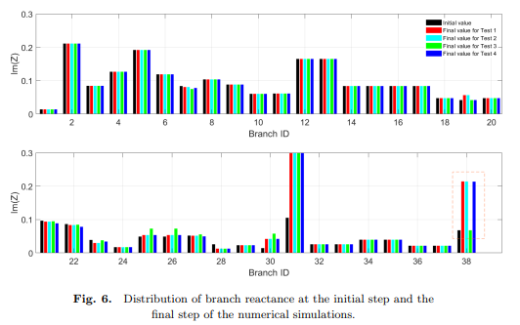

According to simulation results, the effective deployment of TCSCs is not solely dependent on branch capacity. In other words, only installing TCSC on transmission lines with relatively large transmission capacity may not be sufficient to effectively relieve power grid stress. It is discovered that the impedance of a branch with higher power flow is relatively smaller, whereas the power flow on a branch with low impedance is relatively larger. If TCSCs are installed on higher power flow branches, the adjustable range of the TCSC is relatively small, which may result in the failure of relieving stresses by adjusting the TCSC impedance. As a result, it is preferable to install TCSCs on branches with relatively high impedance.

**5.CONCLUSION AND FUTURE WORK**

A novel coordination control technique was developed to reduce system stress by managing power flow using TCSC devices. It also supplied the coordination controller design approach and demonstrated the convergence of the suggested control algorithm. The simulation results for various types of disturbances show that the suggested coordination control strategy has high stability when compared to the traditional control approaches. Finally, modelling findings showed that the successful deployment of TCSCs is closely related to the size of branch impedance, a novel technique to reducing the number of TCSCs. Future work could include optimising the deployment of restricted TCSC agents across the full power network using a distributed control mechanism [7], as well as estimating Jacobian elements from real PMU data without affecting the branch impedance.Furthermore, we intend to develop a multi-state control technique to improve system resilience while taking into account existing delay prevention technologies.

**R E F E R E N C E S**

[1] M. Begovic, D. Novosel, D. Karlsson, C. Henvill, and G. Michel: Wide-area protection and emergency control. Proc. T. IEEE 93 (2005), 876–891. DOI:10.1109/JPROC.2005.847258

[2] R. Bi, T. Lin, R. Chen, J. Ye, X. Zhou, and X. Xu: Alleviation of post-contingency overloads by SOCP based corrective control considering TCSC and MTDC. IET Gener. Transmiss. Distr. 12 (2018), 2155–2164. DOI:10.1049/iet-gtd.2017.1393

[3] Z. Bie, Y. Lin, G. Li, and F. Li: Battling the extreme: A study on the power system resilience. Proc. T. IEEE 105 (2017), 1253–1566. DOI:10.1109/JPROC.2017.2679040

[4] S. Biswas and K. P. Nayak: A new approach for protecting TCSC compensated transmission lines connected to DFIG-based wind farm. IEEE Trans. Industr. Inform. 17 (2021), 5282–5291. DOI:10.1109/TII.2020.3029201

[5] S. Bruno, G. De, and M. La: Transmission grid control through TCSC dynamic series compensation. IEEE Trans. Power Syst. 31 (2016), 3202–3211. DOI:10.1109/TPWRS.2015.2479089

[6] L. Chang, Y. Liu, Y. Jing, X. Chen, and J. Qiu: Semi-globally practical finite-time H∞ control of TCSC model of power systems based on dynamic surface control. IEEE Access. 8 (2020), 10061–10069. DOI:10.1109/ACCESS.2020.2964265

[7] Z. Chen and L. Shu: Distributed aggregative optimization with quantized communication. Kybernetika 58 (2022), 123–144. DOI:10.1155/2022/3436530

[8] Y. Chen, J. Wang, A. D. Dom´ınguez-Garc´ıa, and P.W. Sauer: Measurement-based estimation of the power flow Jacobian matrix. IEEE Trans. Smart Grid 7 (2015), 2507–2515. DOI:10.1109/TSG.2015.2502484

[9] T. Duong, J. Yao, and V. Truong: A new method for secured optimal power flow under normal and network contingencies via optimal location of TCSC. Int. J. Electr. Power Energy Syst. 52 (2013), 68–80. DOI:10.1016/j.ijepes.2013.03.025

[10] V. Durkovi´c and A. Savi´c: ATC enhancement using TCSC device regarding uncertainty of realization one of two simultaneous transactions. Int. J. Electr Power Energy Syst. 115 (2020), 105497. DOI:10.1016/j.ijepes.2019.105497

[11] A. Halder, N. Pal, and D. Mondal: Transient stability analysis of a multimachine power system with TCSC controller – A zero dynamic design approach. Int. J. Electr Power Energy Syst. 97 (2018), 51–71. DOI:10.1016/j.ijepes.2017.10.030

[12] S. Hameed, B. Das, and V. Pant: A self-tuning fuzzy PI controller for TCSC to improve power system stability. Electr. Pow. Syst. Res. 78 (2008), 1726–1735. DOI:10.1016/j.epsr.2008.03.005

[13] R. Hemmati, H. Faraji, and Y. N. Beigvand: Multi objective control scheme on DFIG wind turbine integrated with energy storage system and FACTS devices: Steady-state and transient operation improvement. Int. J. Electr. Power Energy Syst. 135 (2022), 107519. DOI:10.1016/j.ijepes.2021.107519

[14] J. Hu: On Robust Consensus of Multi-Agent Systems with Communication Delays Volume. Kybernetika 45 (2009), 768–784.

[15] J. Hu, G. Chen, and H. Li: Distributed event-triggered tracking control of leader-follower multi-agent systems with communication delays. Kybernetika 47 (2011), 630–643.

[16] Y. Liu, Q. Wu, and X. Zhou: Coordinated switching controllers for transient stability of multi-machine power systems. IEEE Trans. Power Syst. 31 (2016), 3937–3949. DOI:10.1109/TPWRS.2015.2495159

[17] Y. Luo, S. Zhao, D. Yang, and H. Zhang: A new robust adaptive neural network backstepping control for single machine infinite power system with TCSC. IEEE/CAA J. Automat. Sinica 7 (2020), 48–56. DOI:10.1109/JAS.2019.1911798

[18] H. Kumar and P. Singh: Coordinated control of TCSC and UPFC to aid damping oscillations in the power system. Int. J. Electron. 106 (2019), 1938–1963. DOI:10.1080/00207217.2019.1636296

[19] T. Nguyen and F. Mohammadi: Optimal placement of TCSC for congestion management and power loss reduction using multi-objective genetic algorithm. Sustainability 12 (2020), 2813. DOI:10.3390/su12072813

[20] M. Panteli and P. Mancarella: The grid: Stronger, bigger, smarter?: Presenting a conceptual framework of power system resilience. IEEE Pow. Energy Mag. 13 (2015), 58–66. DOI:10.1109/MPE.2015.2397334

[21] T. Prakash, P. V. Singh, and S. R. Mohanty: A synchrophasor measurement based wide-area power system stabilizer design for inter-area oscillation damping considering variable time-delays. Int. J. Electr Power Energy Syst. 105 (2019), 131–141. DOI:10.1016/j.ijepes.2018.08.014

[22] R. Rocchetta and E. Patelli: Assessment of power grid vulnerabilities accounting for stochastic loads and model imprecision. Int. J. Electr. Power Energy Syst. 98 (2018), 219–232. DOI:10.1016/j.ijepes.2017.11.047

[23] A. Rosso, C. A. Canizares and V. M. Dona: A study of TCSC controller design for power system stability improvement. IEEE Trans. Power Syst. 18 (2003), 1487–1496. DOI:10.1109/TPWRS.2003.818703

[24] B. Shafik, H. Chen, I. Rashed, and A. Sehiemy: Adaptive multi objective parallel seeker optimization algorithm for incorporating TCSC devices into optimal power flow framework. IEEE Access. 7 (2019), 36934–36947. DOI:10.1109/ACCESS.2019.2905266

[25] V. Terzija, G. Valverde, D, Cai. P, Regulski, V. Madani, J. Fitch, S. Skok, M. Begovic, and A. Phadke: Wide-area monitoring, protection, and control of future electric power networks. Proc. T. IEEE 99 (2011), 80–93. DOI:10.1109/JPROC.2010.2060450

[26] J. Xu, R. Yao and F. Qiu: Mitigating cascading outages in severe weather using simulation-based optimization. IEEE Trans. Power Syst. 39 (2021), 204–213. DOI:10.1109/tpwrs.2020.3008428

[27] C. Zhai, G. Xiao, M. Meng, H. Zhang, and B. Li: Identification of catastrophic cascading failures in protected power grids using optimal control. J. Energ. Engrg. 147 (2021), 6020001. DOI:10.1061/(ASCE)EY.1943-7897.0000731

[28] C. Zhai, G. Xiao, H. Zhang, P. Wang, and T. Pan: Identifying disruptive contingencies for catastrophic cascading failures in power systems. Int. J. Electr. Power Energy Syst. 123 (2020), 106214. DOI:10.1016/j.ijepes.2020.106214

[29] C. Zhai and Y. Hong: Decentralized sweep coverage algorithm for multiagent systems with workload uncertainties. Automatica 49 (2013), 2154–2159. DOI:10.1016/j.automatica.2013.03.017

[30] C. Zhai, G. Xiao, H. Zhang and T. Pan: Cooperative control of TCSC to relieve the stress of cyber-physical power system. In: International Conference on Control, Automation, Robotics and Vision 2018, pp. 4849–4854. DOI:10.1186/s13662-018-1910-6

[31] C. Zhai, H. Zhang, G. Xiao, and T. Pan: A model predictive approach to protect power systems against cascading blackouts. Int. J. Electr. Power Energy Syst. 113 (2019), 310– 321. DOI:10.1016/j.ijepes.2019.05.029

[32] C. Zhang, X. Wang, Z. Ming, Z. Cai, and H. Linh: Enhanced nonlinear robust control for TCSC in power system. Math. Probl. Eng. 2018 (2018), 1416059. DOI:10.1155/2018/3495096