**Improving Performance and Accuracy of Cloud Computing for Precision Agriculture in Smart Farming**

**Sangeeta Rani1, Mohd Soaib2,**

1Assistant Professor, Department of CSE, Chaudhary Devi Lal University Sirsa Haryana India

2M.Tech Scholar, Department of CSE, Chaudhary Devi Lal University Sirsa Haryana

**ABSTRACT**

Advanced Sensor data is sorted in precision agriculture according to many criteria, such as the presence of animals, the density depleted soils, and the level of soil moisture that was managed by NPK soil sensor. If adverse circumstances arise, a warning signal will be sent. However, if all preconditions are met, the operation will be postponed or skipped altogether. Cloud computing, the Internet of Things (IoT), and wearable robots have all been used in recently completed research projects aimed at finding intelligent solutions to difficulties in the healthcare and agriculture sectors. The research used these methods. The current study focuses mostly on improving the efficiency and precision use case of cloud computing for application precision in farming. The research done in this area has often focused on the problem-solving components of the field performed in respect to this matter. However, there is more work to be done before the full potential related to precision farming and the cloud can be realized. One difficulty is need for a preciseness method to protect the honesty of agribusiness calculations made in a Cloud Computing setting. One of these difficulties is the demand for an reliability technique, so this is crucial. In addition, there is a need to improve conventional research methods in order to increase precision.

**Keywords: Fog Computing, Smart Farming, Perfection, Efficiency**

1. **INTRODUCTION**

**1.1 Cloud Computing**

"Cloud computing" [1] is a way that makes it easier to share files, sensor data, and other forms of information. What we have here is the business of providing digital assistance to others. Server monitoring, data backup, database management, program design, and network administration are just few of the many options. management, and investigation based on networks. The market for such IT services is flooded with several providers. The phrase "cloud specialist co-ops" is used to designate businesses like this. Standard processing costs are often increased for companies. It is just like the utility bills we receive at home, in that respect.

**Vantages of Cloud Computing**

**Demand of Cloud Computing**

1. One, it is ready to assist you whenever you need it, seven days a week.
2. Cloud-based pay-as-you-go subscriptions.
3. Having a car may help you save money on gas and other transportation costs.
4. Four advantages of cloud computing are that it is dependable, versatile, and requires less upkeep.
5. Keeping our warehouses secure is a part of the price.
6. Releasing internal resources makes sense.
7. 7. All of them are examples of fully automated systems.
8. The Systems must be beneficial, which is why their development is vital.
9. Nine, it enables deployments to be carried out rapidly and easily.
10. You can access these buildings regardless of where you are or what technology you are using.

Below, we will discuss some of the benefits of cloud computing [3].

1. One possibility is giving web-based operators access to remote utilities.
2. Many useful online tools for developing may be accessed through the cloud.
3. Third, the developer is free to update it at any time while it is active.
4. Because to cloud computing, businesses now have instantaneous access to a wealth of web-based services that were previously inaccessible.
5. Visitors may acquire on-demand services using cloud computing without needing to link to a cloud-based specialized co-op.
6. Cloud computing has the potential to be very efficient if utilized correctly. Since it will not be utilized to its full potential, it's quite cost-effective.
7. Cloud computing is more reliable since the workload is spread among several servers.

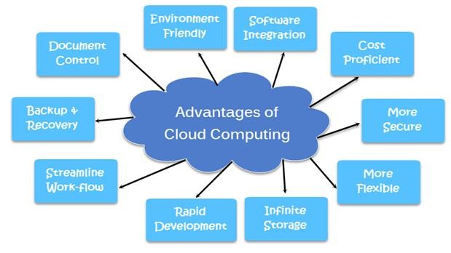Fig: 2 Vantages of Cloud Computing

1. 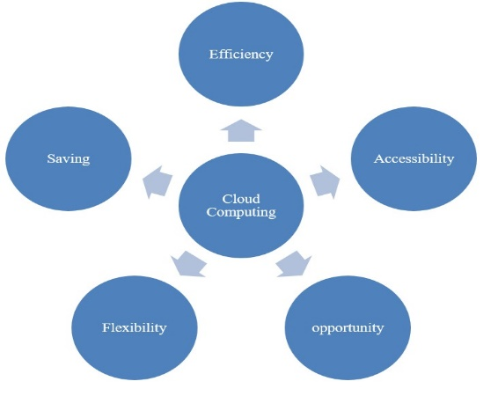Load balancing in cloud infrastructures is proof that they are stable, which is the eighth point.

Fig: 3 Cloud Computing Functions

* 1. **Farming Exactness**

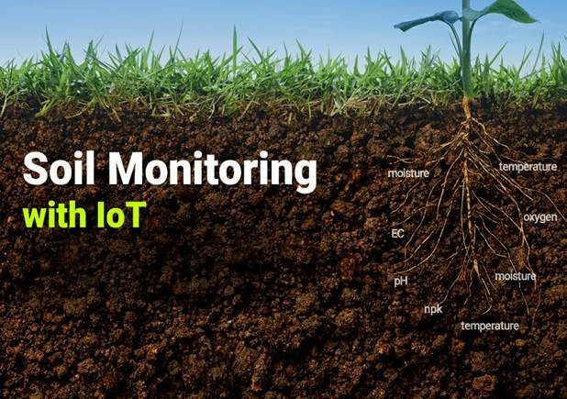Variations in agricultural output both across and within fields are considered by PA managers. All the theory and practice of PA advanced at the decade's conclusion in the 1980s. In order to maximize returns on inputs while decreasing waste, specialists in PA have embarked onto create a DSS for farm management. One such approach is called "phytogeomorphological," and it links landscape characteristics to long-term agricultural growth and stability. The phytogeomorphological approach is helpful since geomorphology often dictates the hydrology of agricultural land. Satellite navigation system (GNSS) advancements have made precision farming possible. Numerous factors, ionic strength, crop production, soil moisture, natural elements, levels of carbon dioxide and magnesium, and many other factors all be measured geographically with the use of maps by scientists and farmers. Harvesters with built-in global positioning systems collect data in a similar fashion using their advance sensor arrays. The arrays include real-time sensors and multispectral photography, enabling constant monitoring of water and chlorophyll levels in plants and crops. VRT makes effective use of the resources by using satellite images and data acquired from seeders, sprayers, etc. However, technological progress has made it possible to put wirelessly in the ground real-time sensors capable of communicating without human involvement.

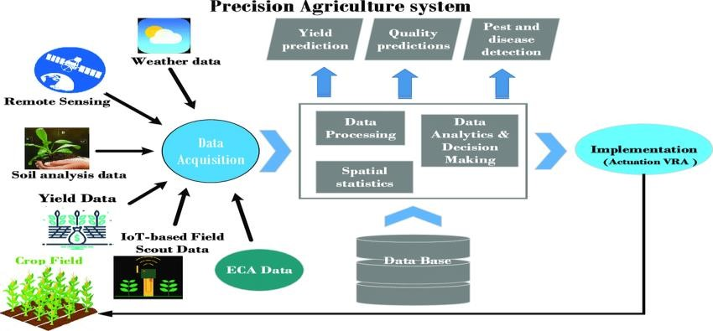

Fig: 4 Precision Agriculture System Fig: 5 Soil Monitoring with IOT System

Due to their low cost and ease of use, unmanned aerial vehicles (UAVs) have significantly altered the agricultural industry. Multiple big images captured by multispectral or RGB advance sensors mounted on agricultural drones may be combined using several photogrammetric methods to create an orthophoto. Multispectral images, which are required for analyzing and evaluating vegetative indices like NDVI maps, may include notably more information than simply the standard RGB values for each pixel. Some computer scientists utilize drones to do intricate algebraic map calculations by photographing the landscape and collecting detailed information about its topography, altitude, and other aspects. The nutrient management plans focus on the 4 R’s (Right amount, Right source, Right Soil placement, Right timing)

Therefore, accurate maps of the region may be created. Water, chemical fertilizers, pesticides, and other inputs like these may be delivered via a variety of applications after the relationship plant health and the surrounding environment.

**1.3** **Challenges**

Issues with connectivity are a key barrier to farmers using new technologies. We lack specific data discusses the ways in which farmers utilize the online or cell phones in agriculture, even though more than 90 million individuals utilize the Internet (as stated by internal surveys). Despite their widespread usage by large agribusinesses, many small farmers remain oblivious of their existence. Approximately 680 (or 68%) of the 1600 The majority of American farmers surveyed said they had no experience with IoT. Farmers on smaller plots of land cultivating a wider variety of crops may have a more difficult time adapting to and using this technology. But it would need a lot of money to develop and keep up such technology. Extreme weather conditions such as intense heat and humidity, torrential downpours, gusty winds and sand, and direct physical contact can cause significant damage to agricultural software and hardware, which drives up the price. Therefore, picking the best strategy for the company would be tough. Any objective in agriculture will need a solid Internet of Things business strategy. Second, we need to make sure that all our digital files are safe from prying eyes.

Another critical challenge is related to connectivity and network reliability. Smart farming heavily relies on real-time data transmission and communication between various devices, low cost sensors, and cloud platforms. However, many agricultural areas may suffer from poor network connectivity and unreliable internet access, leading to delays in data transmission and potentially inaccurate information for decision-making.

Data integration and interoperability also pose challenges in precision agriculture. Different devices and platforms may use diverse data formats and protocols, making it difficult to consolidate and analyze data effectively. Ensuring seamless data exchange and integration between various systems is essential to derive meaningful insights from the collected data. Due to the potential for Theft, improper usage, and changes in product cost and expenditures, it is crucial that all connected devices be constantly monitored and protected.

The last stumbling block is a lack of qualified workers. The data these devices collect and generate would be challenging to assess and interpret. Tools and strategies for data analysis using cloud computing have allowed manufacturers of agricultural equipment to increase output. Despite technological advancements, the agriculture business continues to depend heavily on antiquated systems that, at best, only offer little data backup and protection. For more accurate data gathering, for instance, A few different types of survey drone technology may be attached to farm machinery.

Even the most fundamental security measures, like the ability to monitor user activity or the requirement for a second authenticator for web connections, are commonly missing from these devices, which are frequently plugged into public networks and the internet..

1. **Literature Review**

To improve the security of cloud services, several research has been done to date. Some of these are addressed in this article. We narrowed down the scope of our inquiry after reading a wide range of academic literature. In [1], experts examined cloud computing and fog computing's role in extending cloud services to the network's periphery. As mentioned in [2], fog computing is widely considered to be distributed computing's natural next step after cloud computing. A new approach, called "fog computing," has been devised with the goal of addressing issues with cloud computing.

The authors Ara A. Sharma , et al. [3] and Attkan [4] examine the growth of cloud computing and draw similar conclusions about its significance for the IT sector. The proliferation of the cloud computing business has led to the development of several cloud-based solutions. Fog computing was created by Mohamed F. Mohamed et al. and first detailed in [5]. They pondered the potential benefits of this breakthrough for the development of cloud computing. While cloud computing has made it simpler to purchase scalable computing resources on demand through the Internet, proponents of fog computing say that it will improve simplicity and adaptability. In [6], the authors talk about how cloud computing has gone outside the IT industry. They said that by using the cloud, we could access extremely flexible computer resources at an affordable cost per usage. One other perk of cloud computing is its ability to re-establish communication channels between corporate IT and operational divisions.

Technology at this moment is a major enabler in the pursuit of high resource utilization in the context of equipment sharing, as shown by [7]. Actual usage typically stays low because it is challenging to correctly estimate the performance of many cloud applications simultaneously. We also give an experimental method for testing, as well as the most recent example of its ntiered use. Problems of this kind have already surfaced as a result of malleable universes. Gsangaya, K. R., Hajjaj [8] state that protecting sensitive data in wireless sensor networks was a primary area of study. This study suggests a method uses of the cluster-to-node authentication matrix in dynamic key management at the second level of authentication.

An asymmetric public-key infrastructure and a threshold-key scheme are included into the method. Diop et al. [9] proposed an EGKMST in addition to wireless sensor networks organized into clusters. It is recommended that important management and distribution strategies for sensor networks consider their hierarchical cluster structure employs pairwise & group-based threshold key cryptography. The revised method was summarized by Abhishek Khanna. [10].

Author was used for keys in a wireless sensor network, and ECC was included into the data link. By separating the distribution of keys from the transmission route, we increased security. Abdallah and his coworkers were worried that there may be several scenarios in which WSN security would be an issue. Since there are fewer communications and processing steps required to accomplish the operation, this Success and ease of implementation have been shown for the key exchange mechanism [11]. WSNs with a static complement of nodes and nodes were initially suggested by Patel and Gheewala.

Possible uses include keeping tabs on targets, keeping an eye on the battlefield, and even keeping tabs on the environment. This strategy of dynamically selecting CH maximum ESKM could be achieved if messages were routed via CH [12] after each cycle. while reducing power usage.

This might make the ESKM better and less harmful to the environment. Hemapriya and Gomathy suggested that they focus on using clustering methods. The author developed a node-level decision-making based clustering technique [13]. The focus of the research was on an all-encompassing method of reducing control messages for use in MANETs' cluster-based P2P file searches. Concern over India's fast-growing population was initially voiced by Raut et al. Within 25–30 years, the researcher had amassed 1.2 billion individuals, thanks to a monthly growth rate that was growing. Agriculture is becoming more vital due to the potential for a catastrophic food shortage [14]. Thakur, D., Kumar, et al. [15] offered apparatus for monitoring soil temperature, soil moisture, humidity, carbon dioxide levels, and sunshine intensity; and a probe for measuring soil moisture (MC).

The author thought about how the WSN was built. While conducting their experiments in the lab, Feng and his team investigated several potential applications in the agriculture sector. The purpose of this research was to provide workable, practical, and palatable wireless communication technology for precision agriculture [16]. Thakur et al. [17] examined the use of monitoring in many different industries, from agriculture and engineering to clinic and scientific knowledge. This study's main objective was to examine the effects of WSNs. on contemporary farming methods and conduct research into Technology based on WSNs used for precision farming. Yunguo Guan, Jun Shao [18] claim that WSNs may be used for more than only engineering and research, citing examples like as agricultural and military surveillance. An important cluster-based approach to managing organizations is presented in this research. The "digital gap" between farmers and IoT technology has been shown to be much less thanks to the work of Gómez-Chabla et al. Enhancements intake and treatment efficiency, and overall water use essential to enable future productivity gains in environmentally friendly food production

[19].Energy Efficient Stable Clustered Routing, inspired by Moth Flame Optimization, was considered by Keswani B. [20]. Bushra Zaheer Abbasi [21] shown the effect IoT has on precision farming. For large-scale wireless ad hoc networks, Nabil Abubaker et al. [22] developed a safe combination cluster hierarchies shared key contract. Decision making during IoT data collection was analyzed by Jiyuan Zhou [23] for its application to precision agriculture. As Raut, R., et al [24] performed studies on the use of sensors based on the internet of things to precision agriculture. The work of Abdallah, W., et al. [25] is particularly relevant here. The major focus of emphasis centered on utilizing a fog computing, middleware-in-context strategy for bridging the gap between IoT devices and precision farm machinery.

In-depth research of WSN key management, authentication, and trust management technologies was conducted by Patel, V., [26]. Mohamed Firdhous et al. [27] suggested using hybrid particle swarm optimization for smart sensor networks' cluster-based routing to save energy, but Zhao et al. [28] suggested that as part of the Internet of Things, cloud servers participate in coordinated high availability. The most notable benefit was the ability to run time-sensitive queries even while all available fog nodes were in use. There was a major benefit from this. To further improve efficiency, Diop, A., and his colleagues [29] created an encrypted routing approach that can encrypt both the image and the data associated with it. An evaluation method for several face recognition and identification algorithms was created by Bao, X et al. [30], which increased the trustworthiness and security of online transactions.

1. **PROPOSED OF RESEARCH METHODOLOGY**

The management of cloud computing for precision farming has been the focus of several research. However, the success of the idea depends on using cloud computing. Users should be able to access agricultural precision tools through a web-based, cloud-based interface. The given information must be kept secret. Filtering sensor data for things like animal presence, soil nutrition, and soil moisture helps farmers become more precise with their efforts. An alarm sound and notification provided if any undesirable conditions exist.

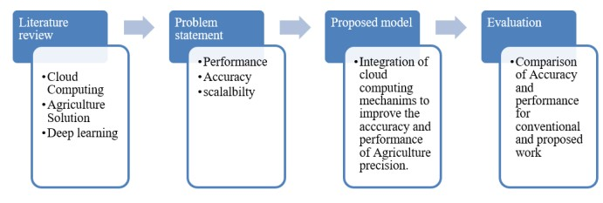If all preoperative conditions are met, surgery will be postponed. Advance sensor data is often sorted in precision agriculture according to animal life, healthy soil, and enough moisture all have a role. In the case of any undesirable occurrence, an alert will sound. However, when all the requirements are satisfied, nothing happens. Recent studies into the adoption of cloud computing technology have become widespread among Smart Agriculture Solutions. Previous research has often tried to address questions that have already been raised. Nevertheless, there are certain challenges that arise from considering cloud computing's implications for smart agriculture solutions. One of them is making sure the Smart Agriculture Solution does not get compromised when running on the cloud, which necessitates the development of an accuracy mechanism. Traditional techniques of research, however, may benefit from more precision.

Fig: 5 Process flow of Proposed work

1. **PROPOSED STATEMENT**

Sensor In precision agriculture, sensor data is meticulously categorized based on factors such as animal behavior, healthy soil indicators, and moisture levels. Any deviations from the desired conditions trigger alerts and notifications to address undesirable incidents promptly. Conversely, when all parameters align favorably, the system remains dormant, avoiding unnecessary interventions. The integration of cloud computing has gained significant traction in modern Smart Agriculture Solutions, offering scalable solutions for data management and analysis.

However, while earlier studies have explored recurring questions, novel challenges have emerged regarding the application of cloud computing in this context. The current research focus extends to critical factors including the optimal path selection for data transmission, overall system performance, encryption efficiency, and the temporal aspects of node interactions. A key challenge is securing Smart Agriculture in the cloud, met with precise mechanisms. Algorithms like Particle Swarm Optimization (PSO) and Dijkstra's address this. PSO optimizes data paths, reducing latency and boosting efficiency. Dijkstra's optimizes node travel time, enhancing system performance. Addressing these factors is pivotal to ensure seamless operation, data security, and efficient resource utilization within cloud-based agricultural systems.

A particularly critical challenge involves ensuring the robustness of Smart Agriculture Solutions when operated within a cloud environment. Safeguarding against potential compromises demands the implementation of precision-driven accuracy mechanisms. Traditional research methodologies, though valuable, could be enhanced to navigate these intricate concerns more effectively. This reflects the growing need for elevated accuracy and targeted investigation in addressing the complex interplay between cloud computing, agricultural innovation, and nuanced performance considerations.

1. **CONCLUSION**

Precision agriculture uses advance sensors to gather and organize data in three ways: by animal presence/absence, soil nutrient availability, and soil moisture. If there is an issue, you will be notified. When circumstances are favorable, however Nothing is done about it, unfortunately. Studies on "Smart Agriculture Solutions" Just Completed " has been using the Cloud for their studies. The problem-solving components of the discipline have been the focus of much research. However, there are challenges posed the need of providing an accurate the Implication of Cloud Computing for Smart Farm Strategies calls for a way to ensure the security of these solutions when they are hosted in the cloud, among other things.

1. **SCOPE OF RESEARCH**

The future scope of enhancing cloud computing for precision agriculture in smart farming is promising. The integration of edge computing, advanced analytics, and 5G connectivity could lead to real-time data processing, enabling faster decision-making on the field. Predictive modeling and advanced remote sensing, facilitated by cloud solutions, could offer accurate insights into crop health and environmental conditions. With improved precision application systems and collaborative platforms, farmers could optimize resource allocation while sharing best practices. Data security and privacy measures will be vital as more sensitive agricultural data moves to the cloud. Ultimately, these advancements could revolutionize agriculture, making it more efficient, sustainable, and responsive to evolving challenge.

**7.** **REFERENCES**

[1] P, Ajay., Sharma, A., V, D. G., Sharma, A., S, K., & Arun, M. R. (2022, May 1). Priority Queueing Model-Based IoT Middleware for Load Balancing. IEEE Xplore. [https://doi.org/10.1109/ICICCS53718.2022.9788 218](https://doi.org/10.1109/ICICCS53718.2022.9788%20218).

[2] Dankan Gowda, V., Sharma, A., Nagabushanam, M., Govardhana Reddy, H. G., & Raghavendra, K. (2022). Vector space modelling-based intelligent binary image encryption for secure communication. Journal of Discrete Mathematical Sciences and Cryptography, 1–15.

<https://doi.org/10.1080/09720529.2022.2075090>.

[3] Ara, A., Sharma, A., & Yadav, D. (2022). An efficient privacy-preserving user authentication scheme using image processing and blockchain technologies. Journal of Discrete Mathematical Sciences and Cryptography, 1–19.

<https://doi.org/10.1080/09720529.2022.2075089>.

[4] Attkan, A., & Ranga, V. (2022). Cyber-physical security for IoT networks: a comprehensive review on traditional, blockchain and artificial intelligence-based key-security. Complex & Intelligent Systems.

<https://doi.org/10.1007/s40747-022-00667-z>.

[5] Gautam, A.K., & Kumar, R. (2021). A comprehensive study on key management, authentication, and trust management techniques in wireless sensor networks. SN Applied Sciences, 3(1).

<https://doi.org/10.1007/s42452-020-04089-9>.

[6] Senthil, G. A., Raaza, A., & Kumar, N. (2021). Internet of Things Energy Efficient Cluster- Based Routing Using Hybrid Particle Swarm Optimization for Wireless Sensor Network. Wireless Personal Communications.

https://doi.org/10.1007/s11277-021-09015-9.

[7] Anand, S., & Sharma, A. (2021, December 1). Hybrid Security Mechanism to Enhance the Security and Performance of IoT System. IEEE Xplore. https://doi.org/10.1109/TRIBES52498.2021.9751455

[8] Gsangaya, K. R., Hajjaj, S. S. H., Sultan, M. T. H., & Hua, L. S. (2020). Portable, wireless, and effective internet of things-based sensors for precision agriculture. International Journal of Environmental Science and Technology. https://doi.org/10.1007/s13762-020-02737-6.

[9] Symeonaki, Arvanitis, & Piromalis. (2020). A Context-Aware Middleware Cloud Approach for Integrating Precision Farming Facilities into the IoT toward Agriculture 4.0. Applied Sciences,10(3),813.

<https://doi.org/10.3390/app10030813>.

[10] Abhishek Khanna, A., & Kaur, S. (2019). Evolution of Internet of Things (IoT) and its significant impact in the field of Precision Agriculture. Computers and Electronics in Agriculture, 157,218–231.

<https://doi.org/10.1016/j.compag.2018.12.039>.

[11] Naresh, V. S., Reddi, S., & Murthy, N. V. E. S. (2019). A provably secure cluster-based hybrid hierarchical group key agreement for large wireless ad hoc networks. Human-Centric Computing and Information Sciences, 9(1). <https://doi.org/10.1186/s13673-019-0186-5>.

[12] Dewi, C., & Chen, R.-C. (2019). Decision Making Based on IoT Data Collection for Precision Agriculture. Intelligent Information and Database Systems: Recent Developments,31–42.

https://doi.org/10.1007/978-3-030-14132-5_3.

[13] Jurcut, A. D., Ranaweera, P., & Xu, L. (2019). Introduction to IoT Security. Wiley 5G Ref, 1– 39.

<https://doi.org/10.1002/9781119471509.w5gref2>

[14] Feng, X., Yan, F., & Liu, X. (2019). Study of Wireless Communication Technologies on Internet of Things for Precision Agriculture. Wireless Personal Communications, 108(3), 1785–1802.

[https://doi.org/10.1007/s11277-019- 06496-7](https://doi.org/10.1007/s11277-019-%2006496-7)

[15] Thakur, D., Kumar, Y., Kumar, A., & Singh, P.K. (2019). Applicability of Wireless Sensor Networks in Precision Agriculture: A Review. Wireless Personal Communications, 107(1), 471–512.

https://doi.org/10.1007/s11277-019- 06285-2.

[16] Gómez-Chabla, R., Real-Avilés, K., Morán, C., Grijalva, P., & Recalde, T. (2019). IoT Applications in Agriculture: A Systematic Literature Review (R. Valencia-García, G. Alcaraz-Mármol, J. del Cioppo-Morstadt, N. Vera-Lucio, & M. Bucaram-Leverone, Eds.). Springer Link; Springer International Publishing.

<https://doi.org/10.1007/978-3-030-10728-4_8>.

[17] Mittal, N. (2018). Moth Flame Optimization Based Energy Efficient Stable Clustered Routing Approach for Wireless Sensor Networks. Wireless Personal Communications, 104(2), 677–694.

https://doi.org/10.1007/s11277-018- 6043-4.

[18] Yunguo Guan, Jun Shao, GuiyiWei, Data Security and Privacy in Fog Computing, 0890- 8044/18/$25.00 © 2018 IEEE

[19] Keswani, B., Mohapatra, A. G., Mohanty, A., Khanna, A., Rodrigues, J. J. P. C., Gupta, D., & de Albuquerque, V. H. C. (2018). Adapting weather conditions based IoT enabled smart irrigation technique in precision agriculture mechanisms. Neural Computing and Applications,31(S1),277–292.

https://doi.org/10.1007/s00521-018-3737-1

[20] Bushra Zaheer Abbasi, Munam Ali Shah 2017, Fog Computing: Security Issues, Solutions and Robust Practices, Proceedings of 23rd International Conference on Automation and Computing, University of Huddersfield, Hudders field, UK, 7-8September 2017

[21] Nabil Abubaker, Leonard Dervishi and ErmanAyday2017, Privacy-Preserving Fog Computing Paradigm, The 3rd IEEE Workshop on Security and Privacy in Cloud (SPC 2017)

[22] Jiyuan Zhou 2017, A Hierarchic Secure Cloud Storage Scheme based on Fog Computing, 2017 IEEE 15th Intl Conf on Dependable, Autonomic and Secure Computing, 15th Intl Conf on Pervasive Intelligence and Computing, 3rd Intl Conf on Big Data Intelligence and Computing and Cyber Science and Technology Congress

[23] Raut, R., Varma, H., Mulla, C., & Pawar, V. R. (2017). Soil Monitoring, Fertigation, and Irrigation System Using IoT for Agricultural Application. Intelligent Communication and Computational Technologies, 67–73.

<https://doi.org/10.1007/978-981-10-5523-2_7>.

[24] Abdallah, W., Boudriga, N., Kim, D., & An, S. (2015, July 1). An efficient and scalable key management mechanism for Wireless Sensor Networks. IEEE Xplore. <https://doi.org/10.1109/ICACT.2015.7224913>.

[25] Patel, V., & Gheewala, J. (2015, June 1). An Efficient Session Key Management Scheme for Cluster Based Wireless Sensor Networks. IEEE Xplore. <https://doi.org/10.1109/IADCC.2015.7154847>.

[26] Mohamed Firdhous, Osman Ghazali, Suhaidi Hassan 2014, Fog Computing: Will it be Future of Cloud Computing?ISBN: 978-1-941968-00-0 ©2014 SDIWC

[27] Zhao, Q., & Liu, X. (2014b, May 1). Cluster Key Management Scheme for Wireless Sensor Networks. Www.atlantis-Press.com; Atlantis Press.

<https://doi.org/10.2991/ictcs-14.2014.23>.

[28] Diop, A., Qi, Y., & Wang, Q. (2014). Efficient Group Key Management using Symmetric Key and Threshold Cryptography for Cluster based Wireless Sensor Networks. International Journal of Computer Network and Information Security,6(8),9–18.

<https://doi.org/10.5815/ijcnis.2014.08.02>.

[29] Bao, X., Liu, J., She, L., & Zhang, S. (2014, June 1). A key management scheme based on grouping within cluster. IEEE Xplore.

<https://doi.org/10.1109/WCICA.2014.7053290>.

[30] V. Namboodiri, V. Aravinthan, S. Mohapatra, B. Karimi and W. Jewell, "Toward a Secure Wireless-Based Home Area Network for Metering in Smart Grids", IEEE Systems Journal, vol. 8, no. 2, pp. 509-520, 2014.

[31] M.Georgescu and M.Matei 2013, The value of cloud computing in business environment, The USV Annals of Economics and Public Administration, vol.13, no.1, pp. 222--228, 2013.

[32] S.Malkowski, Y.Kanemasa, H.Chen, M.Yamamoto, Q.Wang, D.Jayasinghe, C.Pu, and M.Kawaba 2012, Challenges and opportunities in consolidation at high resource utilization: Non-monotonic response time variations in n- tier applications, in Fifth IEEE International Conference on Cloud Computing, Honolulu, HI, USA, 2012, pp. 162--169.

[33] Lalitha, T., & Umarani, R. (2011b). Energy Efficient Cluster Based Key Management Technique for Wireless Sensor Networks. Oriental Journal of Computer Science and Technology,4(2),293–304.<http://www.computerscijournal.org/vol4no2/en>ergy-efficient cluster-based-key-management- technique-for-wireless-sensor-networks/.

[34] Hemapriya, K., & Gomathy, K. (2007). IJARCCE A Survey Paper of Cluster based Key Management Techniques for Secured Data Transmission in Manet. International Journal of Advanced Research in Computer and Communication Engineering ISO, 3297. <https://doi.org/10.17148/IJARCCE.2016.510102>.