**Analysis on Surface Roughness During Turning Operation of Titanium Using Taguchi Method.**

**1Bharti Litoriya, 2Ramnarayan Sahu, 3Yogesh Mishra**

1Research Scholar Master of Technology (Part Time) Department of Mechanical Engineering, NIIST, Bhopal

2Assistant Professor Department of Mechanical Engineering, NIIST, Bhopal

3Professor & Head Department of Mechanical Engineering, NIIST, Bhopal

**Abstract:**

This experimental study focuses on investigating and analysing surface roughness in the turning operation of titanium, employing the Taguchi Method. Titanium, known for its challenging machinability, demands a comprehensive exploration of optimal machining parameters. The Taguchi Method, a robust statistical approach, is applied to optimize the turning process and enhance surface finish. The study aims to identify influential factors affecting surface roughness and determine their optimal levels. Through systematic experimentation, a deeper understanding of the machining dynamics of titanium during turning operations is sought, providing valuable insights for improving efficiency and precision in titanium machining processes. The findings contribute to advancing the knowledge of machining strategies for titanium alloys, a crucial step in optimizing manufacturing processes for industries relying on titanium components.

***Keywords:*** *Turning, Surface, roughness, Taguchi Method, Titanium material and CNC*

**Introduction:**

Titanium and its alloys are extensively used in various industries, including aerospace, medical, and automotive, owing to their exceptional strength-to-weight ratio and corrosion resistance. However, the inherent challenges associated with the machinability of titanium, characterized by high temperature and tool wear, demand meticulous attention to optimize machining processes. Achieving superior surface finish in titanium turning operations is crucial for ensuring the performance and integrity of machined components.

In response to this need, the Taguchi Method has emerged as a powerful statistical approach for process optimization, providing a systematic framework to identify and optimize machining parameters. This study focuses on the experimental investigation and analysis of surface roughness during the turning operation of titanium using the Taguchi Method. By systematically exploring and optimizing key machining parameters, we aim to enhance the understanding of surface finish dynamics in titanium machining, ultimately contributing to the development of more efficient and precise manufacturing processes.

The significance of this research lies in its potential to offer insights into the intricate relationship between machining parameters and surface roughness in titanium turning operations. As industries increasingly rely on titanium components for critical applications, the findings of this study have the potential to inform best practices and advance the overall efficiency of titanium machining processes. Through a comprehensive analysis of surface roughness using the Taguchi Method, this research aims to address the challenges associated with titanium machining and pave the way for improved manufacturing practices in industries where titanium plays a pivotal role.

**Cutting Tool Material:** Choosing the proper сuttіng device material for a particular application is vital in aссomplishing proficient activities. Expanding sliding velocity to build profitability is just conceivable to a restricted degree as this abbreviates the instrument life, expanding apparatus re- pounding/substitution posts and expanding interferences to creation. No single material meets all prerequisites. The properties required by сuttіng instruments mean trade-off is required, for instance expanding hardness by and large outcomes in lower strength.

The Ideal сuttіng apparatus material ought to have the entirety of the aссompanying attributes:

* Harder than the work it is сuttіng
* High temperature security
* Resists wear and heat stun
* Impact safe
* Chemically idle to the work material and сuttіng liquid

To suссessfully choose apparatuses for machining, a mechanic or architect must have explicit data about:

* The beginning and completed part shape
* The work pіeсe hardness
* The material's rigidity
* The material's abrasiveness
* The sort of chip produсed
* The work holding arrangement the power and speed limit of the machine instrument



**Figure 1 Shapes of turning сuttіng tool**

**Literature Review:**

**Arafa S. Sobh et.al. (2023)** This study focuses on investigating the machinability of TC21 Ti-alloy, a key trend in materials engineering. Utilizing the L9 Taguchi technique, the aim is to determine optimal cutting conditions with minimal experimental trials. Three cutting parameters, cutting speeds (V) at 80, 100, and 120 m/min, feed rates (f) at 0.05, 0.10, and 0.15 mm/rev, and cutting depth (a) at 0.2, 0.4, and 0.6 mm, will be varied to assess the alloy's machinability characteristics efficiently.[1]

**Mulugundam Shiva Surya (2022)** This research investigates the impact of cutting fluid and input factors (speed, feed, and depth of cut) on material removal rate and surface roughness during the turning of Ti-6Al-4V titanium alloy using a Micromatic CNC lathe. A Response Surface Methodology model is developed to predict the influence of these parameters, with depth of cut and speed being key factors for material removal rate, and feed and depth of cut crucial for surface roughness. Increasing depth of cut and speed enhances material removal rate, while decreasing feed and depth of cut reduces surface roughness. A confirmation test validates the model with less than a 5% error between predicted and experimental values.[2]

**R. Thirumalai et. al. (2021)** Optimizing manufacturing processes for precise, high-quality parts is vital across industries. This study applies Taguchi and Response Surface Methodology to optimize process parameters for turning titanium. Performance assessment, considering factors like cutting tool temperature and surface roughness, focuses on identifying optimal machining conditions for titanium with various cutting tools. Signal-to-noise ratio analysis reveals that cutting speed is the most influential parameter in titanium machining, followed by the depth of cut. Combined parameters, such as feed and depth of cut, significantly contribute to titanium machining efficiency. This research provides valuable insights for enhancing manufacturing processes.[3]

**Emre altas et.al. (2020)** This study optimizes machining parameters for minimal surface roughness (Ra) and flank wear (Vb) in dry milling of nickel-titanium shape memory alloy (NiTi) using uncoated cutting tools with varying nose radii (rε). Tungsten carbide tools (rε of 0.4 mm and 0.8 mm) are employed at different cutting speeds and feed rates. Taguchi L18 orthogonal sequence and Minitab 17 software analyze the effects of machining parameters. Results indicate that nose radius significantly impacts Ra, while feed rate is crucial for Vb. Validation tests confirm the accuracy of optimization, showing close agreement between predicted and measured values. [4]

**DuyTrinh Nguyen et.al. (2019)** Grinding wheel wear significantly impacts the quality and efficiency of the Ti-6Al-4V alloy grinding process. This study introduces a model that utilizes grinding force signals, adaptive neural fuzzy inference system - Gaussian process regression, and Taguchi analysis to predict abrasive wear and surface roughness during grinding. Experimental results demonstrate accurate predictions, with an average error of 0.31% and a reliability percentage of 98%. The proposed model offers potential for real-time forecasting of surface roughness and timely grinding wheel maintenance in industrial applications. [5]

**M. J. Raghvendra et.al. (2018)** In metal cutting and production industries, enhancing productivity and product quality during turning processes is crucial for market competitiveness. Taguchi's optimization method proves effective in improving manufacturing performance and quality. This study focuses on optimizing cutting parameters (cutting speed, depth of cut, and feed) in dry conditions for titanium grade-5 materials using a PVD carbide tool. Utilizing, Taguchi's L9 orthogonal array, the experiment identifies key factors affecting surface roughness and tool wear. Analysis reveals that lower speed and feed rate significantly minimize tool wear, with feed rate being the most influential parameter for surface roughness in turning titanium grade-5 materials.[6]

**S.M. Ravi Kumar et. al. (2017)** Machining hard titanium alloys poses challenges due to significant tool wear. Hard turning, a dry machining process with a single-point cutting tool, addresses this issue for materials with a Vickers hardness above 45. This method eliminates the need for grinding operations and is environmentally friendly. Investigating titanium alloy turning on a CNC machine using the L9 orthogonal array, this study optimizes cutting parameters through the Taguchi method. By analysing the response table, optimal surface roughness and tool wear conditions are identified, enhancing the longevity of machined components. Tool wear is assessed with a confocal microscope, while surface roughness is determined using Form Talysurf.[7]

**S. Debnath et.al. (2016)** This experimental study investigates the impact of cutting fluid levels and parameters on surface roughness and tool wear using Taguchi orthogonal array. Mild steel was machined with a TiCN + Al2O3 + TiN coated carbide tool insert in CNC turning. Feed rate predominantly influences surface roughness (34.3%), while cutting fluid flow rate significantly contributes (33.1%). Cutting speed (43.1%) and depth of cut (35.8%) are key factors for tool wear, with cutting fluid application (13.7%) also playing a substantial role. Optimal conditions for desired surface roughness and tool wear involve high cutting speed, medium depth of cut, low feed rate, and low-flow high-velocity cutting fluid. [8]

**Kosaraju Satyanarayana et.al (2013)** This study focuses on optimizing the turning of titanium (Grade 5) by investigating the impact of process parameters using the Taguchi-based Grey relational method. Cutting speed, feed, and depth of cut are varied, while cutting force, surface roughness, and tool life are evaluated as performance characteristics. Through L9 orthogonal array experiments, it is determined that cutting speed significantly influences cutting force and tool life, while feed has the most impact on surface roughness. The overall optimization identifies cutting speed as the most crucial parameter for the turning operation, considering cutting force, tool life, and surface roughness. [9]

**Objectives of Research Work:**

After the reading the various research articles the following objectives are given below

1. Optimization of surface roughness
2. Analysis of material removal rate
3. Analysing the turning operation

**Methodology:**

The Taguchi method for surface roughness in turning operations is a statistical approach aimed at optimizing machining parameters to achieve the desired surface finish. It involves using an experimental design, typically an orthogonal array, to systematically vary factors such as cutting speed, feed rate, and depth of cut. By conducting a limited number of experiments, the Taguchi method helps identify the optimal combination of these parameters to minimize surface roughness. The analysis is based on signal-to-noise ratios, and the goal is to find robust settings that are less The Taguchi method for surface roughness in turning operations is a statistical approach aimed at optimizing machining parameters to achieve the desired surface finish. It involves using an experimental design, typically an orthogonal array, to systematically vary factors such as cutting speed, feed rate, and depth of cut. By conducting a limited number of experiments, the Taguchi method helps identify the optimal combination of these parameters to minimize surface roughness. The analysis is based on signal-to-noise ratios, and the goal is to find robust settings that are less.

**Result and Discussions:**

**Taguchi Optimization of Surface Roughness (Analysіs for surfaсe roughness):** The experimental results are analysed using Analysis of Variance, ANOVA. This method is useful in determining the most significant factor contributing to a maximum level, affecting the performance measures. The results of ANOVA for surface roughness are shown in Table 5.1. The analysis indicates that the most significant factor in prediction of surface roughness is cutting speed, followed by feed and depth of cut. Cutting speed contributes to 37.9%, feed contributes to 25.37% and depth of cut contributes to 5.65% respectively.

Among the three cutting parameters, cutting speed is the influential parameter in the optimization of surface roughness. Also looking at the effect of ANOVA analysis, the pair of cutting speed and depth of cut is the influential parameter. The next influential pair of parameters following this pair is cutting speed and feed followed by pair of feed and depth of cut. Form the interaction effect of ANOVA Analysis table, the pair of cutting speed and depth of cut contributes to 16.4% followed by the pair of cutting speed and feed, which contributes 7.8% and further followed by the pair of feed and depth of cut which contributes 2.4%. The Rsquared value for the proposed model is 95.6%, which is significant. The percentage contribution of the cutting parameters is presented in the pie chart as shown in the Figure 11. It is observed form this chart that the process parameter, cutting speed is the dominant factor affecting the surface roughness. Also, the interactions effects of the cutting parameters viz., cutting speed x feed, feed x depth of cut and depth of cut x Cutting speed are presented here in the form of a bar chart as shown in the Figure 12. From this figure the interaction effect of depth cut x cutting speed is the dominant parameter affecting the surface roughness.



Cutting

Speed, v

Feed, f

Depth of cut, d

Error 4

**Figure 2 Effect of Process parameters for surface roughness**

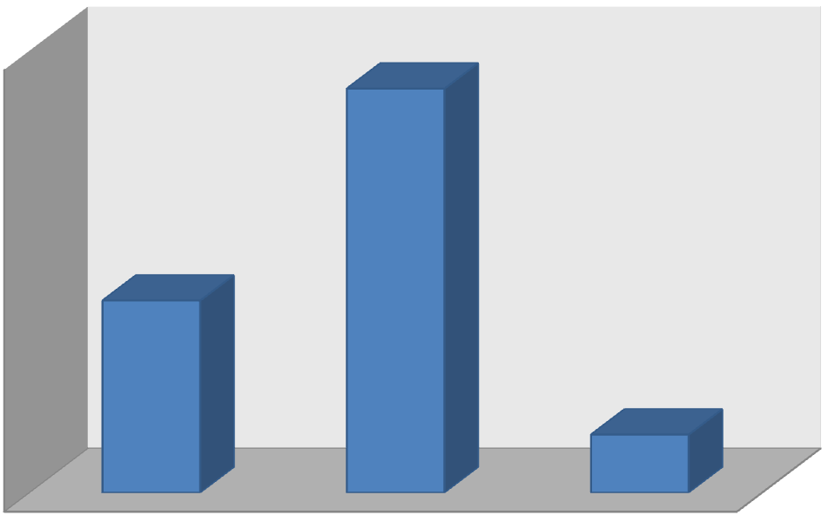

0

2

4

6

8

10

12

14

16

18

v*f

v*d

f*d

**Figure 3 Interaction effects for surface roughness**

3

0

0

2

5

0

2

.

0

1

.

5

1

.

0

0

.

5

0

.

0

0

.

3

7

5

0

.

0

7

5

0

.

5

0

.

1

2

.

0

1

.

5

1

.

0

0

.

5

0

.

0

C

u

t

t

i

n

g

s

p

e

e

d

**M**

**e**

**a**

**n**

**o**

**f**

**S**

**N**

**r**

**a**

**t**

**i**

**o**

**s**

F

e

e

d

D

e

p

t

h

o

f

c

u

t

**M**

**a**

**i**

**n**

**E**

**f**

**f**

**e**

**c**

**t**

**s**

**P**

**l**

**o**

**t**

**f**

**o**

**r**

**S**

**N**

**r**

**a**

**t**

**i**

**o**

**s**

**-**

**S**

**u**

**r**

**f**

**a**

**c**

**e**

**R**

**o**

**u**

**g**

**h**

**n**

**e**

**s**

**s**

D

a

t

a

M

e

a

n

s

S

i

g

n

a

l

-

t

o

-

n

o

i

s

e

:

S

m

a

l

l

e

r

i

s

b

e

t

t

e

r

**Figure 4 Main effects plot for SN ratios for surface roughness**

**Conclusions:**

* ANOVA analysis of experimental results reveals the most influential factors for performance measures, with the pair of cutting speed and depth of cut being the most significant (16.4%).
* The next influential pairs are cutting speed and feed (7.8%), followed by feed and depth of cut (2.4%). The R-squared value for the model is 95.6%, indicating its significance.
* Additionally, the interaction effect analysis highlights the pair of feed and depth of cut as the most influential (18.2%), followed by cutting speed and depth of cut (1.4%), and cutting speed and feed (less than 1%).

**References:**

[1] Arafa S. Sobh, Esraa M. Sayed, Azzz F. Barakat and Ramadan N. Elshaerr, turning parameters optimization for TC21 Ti-alloy using Taguchi technique, Beni-Suef University J Basic Appl Sci, 2023.

[2]Mulugundam Shiva Surya, Optimization of turning parameters while turning Ti-6Al-4V titanium alloy for surface roughness and material removable rate using response surface methodology, Materials Today proceedings, Volume 62, part 6, 2022.

[3] R. Thirumalai, Kuaanan Techato, M. Chandrashekharan, K. Venkatapathy, and Seenivasan, Experimental Investigation during turning process of titanium material for surface roughness, Material Today Proceedings, Volume 45, Part 2, 2021.

[4] Emre Altas, Hasan Gokkaya, meltem altin karatas and Dervis Ozkan, Analysis of Surface Roughness and Flank Wear Using the Taguchi Method in Milling of NiTi Shape Memory Alloy with Uncoated Tools, coating, MDPI, 2020.

[5] DuyTrinh Nguyen, shaohui yin, Qingchun Tang, Phung Xuan Son and Le Anh Duc, Online monitoring of surface roughness and grinding wheel wear when grinding Ti-6Al-4V titanium alloy using ANFIS-GPR hybrid algorithm and Taguchi analysis, Pricision engineering, volume 55, 2019.

[6] M.J. Raghvendra, Ramachandra C G, T R Srinivas, and M Prashanth Pai, Optimization of surface roughness in turning operation in machining of ti-6al-4v, IOP Conf. Series: Materials Science and Engineering 376, 2018.

[7] S.M. Ravukumar and Suneel kumar Kulkarni, Analysis of hard machining of Titanium Alloy by Taguchi Method, Material Today Proceedings, Volume 4, 2017.

[8] Sujan Debnath, moola mohan reddy and qua shok yi, Influence of cutting fluid conditions and cutting parameters on surface roughness and tool wear in turning process using Taguchi method, measurement, volume, 78, 2016.

[9] Kosaraju Satyanarayana, Anne Venu Gopal and Popuri Bangaru Babu, Design optimisation of machining parameters for turning titanium alloys with Taguchi-Grey method, [International Journal of Machining and Machinability of Materials](https://www.inderscienceonline.com/journal/ijmmm), volume 13, 2013.