**ORGANIZATIONAL BRANDING AND ITS IMPACT ON TALENT ACQUISITION**

**SINGRI KUSHAL SRIKANTH1**, **RAVI KUMAR J S 2**

1Student of MBA, Department of Management Studies, Ballari Institute of Technology and Management, Ballari, Karnataka

skushal3889@gmail.com

6361236454

2Asst Professor, Department of Management Studies, Ballari Institute of Technology and Management, Ballari, Karnataka

[mahijogin@gmail.com](mailto:mahijogin@gmail.com)

8310269929

**Abstract**

In today's competitive business environment, organizations recognize that attracting and retaining top talent is essential for their success and growth. As a result, companies have shifted their focus beyond traditional recruitment methods to embrace strategic talent acquisition practices. One key aspect of this approach is organizational branding, which refers to the image, reputation, and perception of an organization as an employer. The study titled "A Study on Organizational Branding and Its Impact on Talent Acquisition" aims to explore the relationship between organizational branding and talent acquisition. It seeks to understand how the perception of an organization as an employer influences the attraction, selection, and retention of talented individuals.

**INTRODUCTION**

Organizational branding plays a crucial role in talent acquisition by shaping the perceptions and expectations of potential candidates. A strong employer brand can differentiate an organization from its competitors, making it more appealing to top talent. Candidates often consider factors such as organizational culture, values, work environment, and opportunities for growth and development when evaluating potential employers. Thus, creating a positive and authentic organizational brand can significantly impact the talent acquisition process. The study will employ a mixed-methods approach, combining qualitative and quantitative research methods. Qualitative methods, such as interviews and focus groups, will be used to gather in-depth insights into candidates' perceptions of organizational branding and its influence on their decision-making process. On the other hand, quantitative methods, including surveys and statistical analysis, will provide a broader understanding of the relationship between organizational branding and talent acquisition.

The research will involve collecting data from a diverse range of participants, including job seekers, employees, and HR professionals, across various industries. By obtaining perspectives from multiple stakeholders, the study aims to provide a comprehensive analysis of the subject matter. The findings of this study can benefit organizations in several ways. First, it can help organizations identify the key elements that contribute to a strong employer brand and understand how these factors impact talent acquisition efforts. Second, it can provide insights into the expectations and preferences of prospective candidates, enabling organizations to align their branding strategies with the target talent pool. Lastly, the study can guide organizations in developing effective talent attraction and retention strategies based on a solid understanding of the relationship between branding and talent acquisition.

In conclusion, the study on organizational branding and its impact on talent acquisition explores the crucial role of employer branding in attracting and retaining top talent. By examining the perceptions and expectations of candidates, this research aims to shed light on the strategies and practices that organizations can adopt to build a compelling and authentic employer brand. Ultimately, the study aims to provide valuable insights to organizations seeking to optimize their talent acquisition processes and gain a competitive edge in the labour market.

**CONCEPTUAL BACKGROUND AND LITERATURE REVIEW**

**CONCEPTUAL BACKGROUND**

Organizational branding refers to the process of creating and managing the image, reputation, and perception of an organization as an employer. It involves establishing a distinct identity and communicating the organization's values, culture, and benefits to potential candidates. A strong employer brand can attract top talent, enhance employee engagement and retention, and positively influence the organization's overall reputation. Talent acquisition, on the other hand, encompasses the strategies and activities employed by organizations to identify, attract, select, and hire qualified individuals. It goes beyond traditional recruitment practices and emphasizes building relationships with candidates, evaluating their fit with the organization's culture and goals, and creating a positive candidate experience.

The relationship between organizational branding and talent acquisition is symbiotic. An organization's branding efforts directly impact its ability to attract and retain talented individuals. Candidates, especially those in high-demand fields, have multiple options when it comes to choosing employers. They consider not only job-specific factors but also broader aspects such as the organization's reputation, values, work environment, growth opportunities, and alignment with their personal and professional goals. A strong organizational brand can create a competitive advantage by positioning the organization as an employer of choice. It can enhance the organization's appeal, attracting a larger pool of qualified candidates who are more likely to fit well within the organizational culture and contribute to its success. Moreover, a positive employer brand can positively influence employee engagement and retention, leading to a more stable and productive workforce.

Understanding the impact of organizational branding on talent acquisition is crucial for organizations to effectively compete for top talent. By studying this relationship, organizations can gain insights into the factors that contribute to a strong employer brand and develop strategies to enhance their attractiveness as employers. This research can provide valuable guidance in designing branding initiatives, refining recruitment processes, and improving overall talent management strategies. Overall, the conceptual background of the study on organizational branding and its impact on talent acquisition highlights the importance of employer branding in today's competitive labour market. It emphasizes the need for organizations to strategically manage their employer brand to attract and retain top talent and gain a competitive advantage in talent acquisition.

**LITERATURE REVIEW**

Priya, G & Gopinath, Shanmuga & Raman, Dr. (2021). The study aims to investigate how employer branding affects the recruitment and retention of employees. Employer branding refers to how organizations attract talented employees, shape their work culture, and gain a competitive advantage in the market. Employers now recognize the importance of investing in branding because employees are like internal customers for the company.

G. Shanmuga Priya and Dr. UmaRaman.M. The purpose of this study is to examine how employer branding influences the recruitment and retention of employees. Employer branding is a modern term used in Human Resource Management and Marketing. It focuses on attracting skilled employees, shaping the organizational culture, and gaining a competitive advantage in the market.

Pandita, D., 2019. This research paper examines the significance of talent acquisition within HR, its evolution over time, and the changing recruitment strategies. The primary goal for organizations is to attract, recruit, and retain talented individuals. To gain clarity and explore trends in HR's talent acquisition area, this paper is based on a systematic review of literature, which analyses modern perspectives and evidence.

Krithika, J., This study aims to explore the impact of employer branding on the perception of employees during the talent acquisition process. A sample of 120 employees was selected, and a research survey was conducted to determine if employer branding influences talent acquisition. Primary data was collected through a questionnaire, and appropriate statistical tools were used to analyse the data.

Tripathi, A., 2018. This paper focuses on the importance of creating an employer brand to address the challenge organizations face in replacing experienced workers due to the retirement of the Baby Boomer generation. Simultaneously, there are significant shifts in employment and unemployment rates.

Tyagi, M.A., 2020The study examines both company-specific and independent social networking platforms and finds minimal differences, suggesting that the credibility of information is not a significant concern. Additionally, the results indicate that autonomy and knowledge gained through social networking do not directly impact the attractiveness and application rates for potential employers; rather, these factors are entirely mediated by the perception of a dominant corporate image.

Evans Sokro, (2012) The main aim of this study was to examine whether employers in the banking sector in Ghana utilize branding in their organizations, and how this employer branding impacts the attraction and retention of employees. The study employed a descriptive survey design and conveniently sampled a total of 87 employees, including both junior and senior staff members.

Puja Kumari, Mili Dutta and Manju Bhagat (2020)   
The main objective of this study is to examine the five-value proposition related to employee attractiveness. Data was collected using a questionnaire, and the analysis was conducted using SPSS. The analysis indicates that value propositions such as interest, social connections, job application, growth opportunities, and financial benefits are associated with the development of employer branding.

Srivastava, P., & Bhatnagar, J. (2010).   
This paper focuses on the challenges related to talent acquisition and how employer branding can address some of these challenges. By conducting a literature review and a pilot study on a group of potential employees in India, the paper presents a summary of findings and combines them with existing research.

Dr T. R. Kalai Lakshmi, Submitted: 2022 ,This study aims to examine how employer branding can help attract talented individuals to organizations. It will explore the effectiveness of employer branding and provide practical and managerial recommendations based on the findings.

Ms. Anney Chacko Prof Dr.Siby Zacharias (2020) Many organizations prioritize keeping talented employees as it sets them apart in managing their workforce effectively. This is particularly challenging for major IT companies competing in global markets. In today's competitive business environment, the retention of highly skilled employees is crucial for the success and survival of an organization.

Hasan Gilani and Lucy Cunningham, The main goal of this study is to investigate the impact of employer branding on employee retention. A thorough review of existing academic literature was conducted, identifying seven key themes within employer branding research: brand values, induction and training, internal brand communication, organizational culture, rewards and benefits, brand commitment, and employer brand management

Salifu D. Mohammed Study 2 focused on the role of social media as an information source for job seekers. I hypothesized that job seekers' use of four social media platforms (Facebook, Twitter, YouTube, and LinkedIn) in their job search would contribute to their attraction to organizations beyond the impact of traditional recruitment methods.

Shanmuga Priya, G.; M, UmaRaman The study aims to examine how employer branding influences the recruitment and retention of employees. Employer branding is a modern concept in Human Resource Management and Marketing. It focuses on attracting skilled employees, creating a positive organizational culture, and gaining a competitive advantage in the market. Organizations are investing in employer branding because employees are considered valuable assets.

Magdalena Kalinska-Kula , Iwona Staniec (2021) We aimed to find out which employer branding practices, whether external or internal, have the most significant impact on employees' perception of their employer's image. We collected data from 520 employees working in service companies. The findings suggest that both intensive external employer branding activities and intensive internal employer branding practices directly influence how attractive employees consider their employer, particularly in terms of expected benefits.

Witted Megacorp (2022) In simple terms, employer branding is about how current and potential employees perceive your company as an employer and how well your company promotes itself to prospective employees. It involves various aspects such as strategic decisions, talent acquisition, people operations, and communication efforts.

Ecaterina CHITU(2020) This paper aims to emphasize the significance of employer branding in recruiting young talent. The research methodology employed is qualitative, focusing on analyzing specialized literature, online magazines, press articles, and other relevant sources.

D.A.S. Udayanga, P.M.K.N. Jayarathna, (2021) This study focuses on understanding how employer branding affects employee retention in a selected multinational organization operating in Sri Lanka. The organization is a prominent brand in the global beverage industry.

Nayak, S., Bhatnagar, J. and Budhwar, P., 2018.   
This research examines how organizations in India strategically use social networking to enhance their employer branding and talent acquisition strategies. Through qualitative data from 78 interviews with HR professionals in the IT, ITeS, and talent acquisition sectors, it is evident that social networking sites (SNSs) are increasingly being incorporated into HR strategies for employer branding, talent sourcing, acquisition, retention, and fostering stronger employee relationships.

Mihalcea, A., 2017,This study aims to identify the key trends and strategies related to talent management programs and the development of digital skills for both employees and managers. The findings emphasize the significance of employer branding in attracting and retaining high-potential employees in an open talent economy.

**RESEARCH METHODOLOGY**

**STATEMENT OF THE PROBLEM**

In today's competitive business environment, organizations face challenges in attracting and acquiring top talent. The effectiveness of talent acquisition strategies is influenced by organizational branding. However, the extent of the impact and the specific mechanisms through which organizational branding affects talent acquisition remain unclear. Therefore, there is a need to investigate and understand the relationship between organizational branding and talent acquisition, and to identify the key factors that contribute to successful talent acquisition strategies in relation to branding. This study aims to address this gap in knowledge and provide insights into how organizations can enhance their talent acquisition efforts through effective organizational branding.

**NEED FOR THE STUDY**

1. Talent acquisition challenges: Organizations often face difficulties in attracting and acquiring skilled and qualified individuals who can contribute to their success. Understanding the impact of organizational branding on talent acquisition can provide valuable insights and strategies to overcome these challenges.
2. Employee retention: Acquiring talent is not enough; organizations also need to retain them. Effective organizational branding can contribute to employee satisfaction, engagement, and loyalty, thereby reducing turnover rates and improving retention.
3. Competitive advantage: In today's competitive market, organizations need to differentiate themselves to attract top talent. Developing a strong organizational brand can help create a positive image and reputation, making the organization more appealing to potential candidates.
4. Employer value proposition: Organizational branding plays a crucial role in shaping the employer value proposition (EVP). By studying the impact of branding on talent acquisition, organizations can identify and enhance their unique value proposition to attract and retain high-quality talent.

**OBJECTIVES**

The primary objective of this study is to identify key components of effective organizational branding, secondarily is to examine the influence of organizational branding on talent attraction and to explore the impact of digital platforms and social media on organizational branding in talent acquisition.

**RESEARCH METHODOLOGY  
  
Sampling Method**

**Cluster sampling:**It is probability sampling method in which you divide a population into clusters, such as districts or schools, and then randomly select some of these clusters as your sample. The clusters should ideally each be mini representations of the population.

**Data Collection Method**The data is collected through primary sources under which Survey tools like Questionnaire are used.  
Secondary data has also been used in the process of Literature Review.

**Target audience**

Job seekers and potential candidates are the primary audience for organizations looking to attract new talent. They would be interested in understanding how an organization's brand image impacts the recruitment process and how to evaluate an organization's branding efforts when considering a new job opportunity. Ultimately, the specific audience for an employer branding campaign will depend on the company's hiring needs, target markets, and overall business objectives.

**SCOPE OF THE STUDY**

The scope of the study titled "A Study on Organizational Branding and Its Impact on Talent Acquisition" includes the following aspects:

1. Organizational branding strategies: The study will explore various branding strategies adopted by organizations to create a positive image and reputation. This may include analyzing branding elements such as employer value proposition, brand messaging, visual identity, and employer branding initiatives.
2. Talent acquisition practices: The study will examine the talent acquisition practices employed by organizations, focusing on the recruitment and selection processes, employer branding activities, and candidate evaluation methods. It will explore how branding influences these practices and the extent to which it impacts the attraction and acquisition of talent.
3. Employee perception and decision-making: The study will investigate how organizational branding affects the perception and decision-making of prospective employees. It will examine factors such as brand reputation, employer attractiveness, organizational culture, and employee value proposition in influencing candidates' decisions to join an organization.
4. Retention and engagement: The study will assess the impact of organizational branding on employee retention and engagement. It will examine how a strong employer brand contributes to employee satisfaction, commitment, and long-term retention within the organization.The scope of the study is to provide a comprehensive understanding of the relationship between organizational branding and talent acquisition, offering insights that can be applied by organizations to attract, acquire, and retain top talent effectively.

**ANALYSIS AND INTERPRETATION**

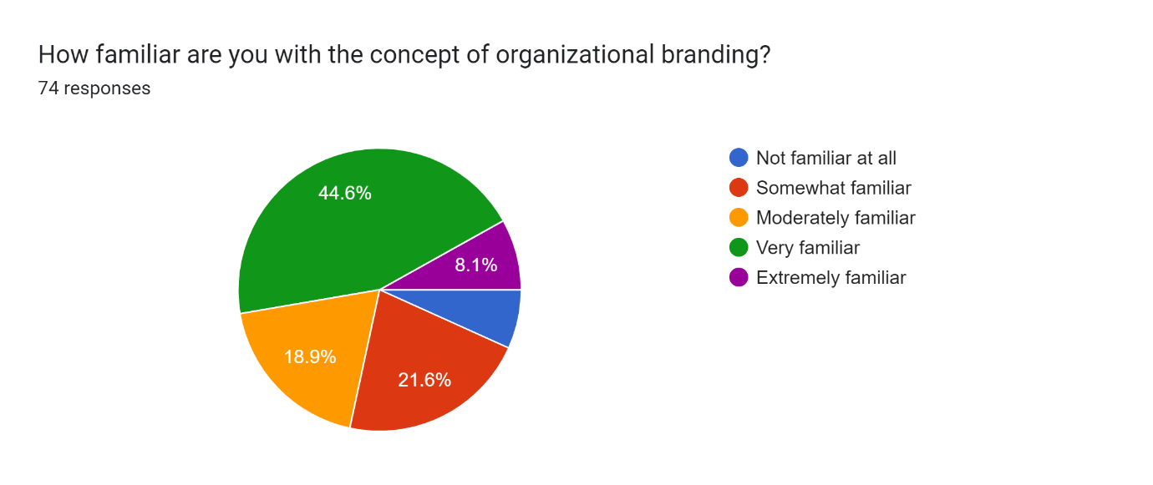

Very familiar: Thirty-three respondents indicated being very familiar with the concept of organizational branding. This indicates that approximately 45% (33 out of 74) of the respondents have a high level of familiarity with organizational branding. Moderately familiar: Fourteen respondents reported being moderately familiar with the concept of organizational branding. This represents approximately 19% (14 out of 74) of the total respondents. These individuals have a moderate level of understanding of organizational branding. Somewhat familiar: Sixteen respondents stated being somewhat familiar with the concept of organizational branding. This represents approximately 22% (16 out of 74) of the total respondents. These individuals have a limited or basic understanding of organizational branding. Extremely familiar: Six respondents indicated being extremely familiar with the concept of organizational branding. This represents approximately 8% (6 out of 74) of the total respondents.

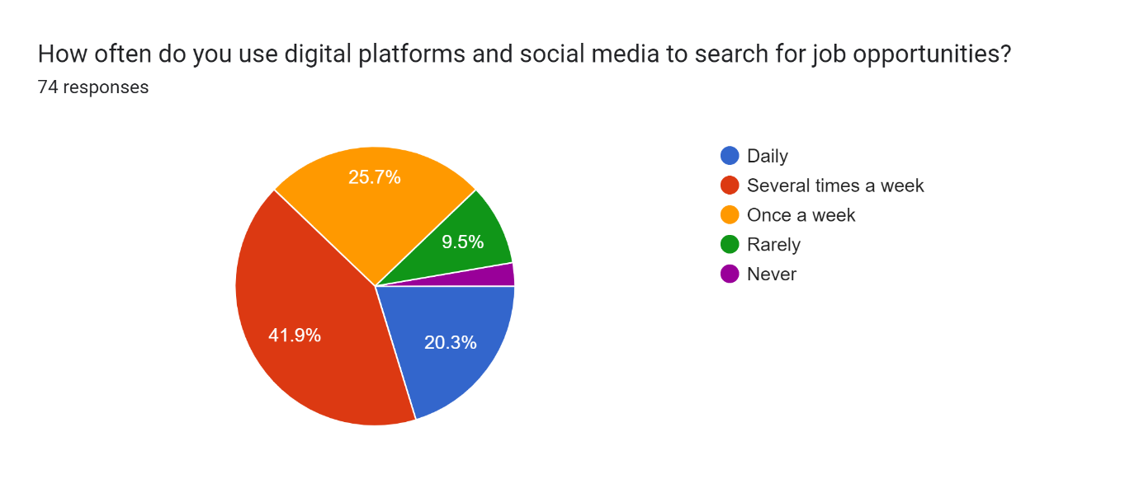

Once a week: Nineteen respondents reported using digital platforms and social media to search for job opportunities once a week. This represents approximately 26% (19 out of 74) of the total respondents. Several times a week: Thirty-one respondents reported using digital platforms and social media to search for job opportunities several times a week. This indicates that approximately 42% (31 out of 74) of the total respondents actively engage with digital platforms and social media on a frequent basis to search for job opportunities. Daily: Fifteen respondents reported using digital platforms and social media to search for job opportunities daily. This represents approximately 20% (15 out of 74) of the total respondents, indicating a consistent and regular usage of these platforms for job searches. Rarely: Seven respondents reported rarely using digital platforms and social media to search for job opportunities. This represents approximately 9% (7 out of 74) of the total respondents, indicating a minimal usage of these platforms for job searches. Never: Two respondents reported never using digital platforms and social media to search for job opportunities.

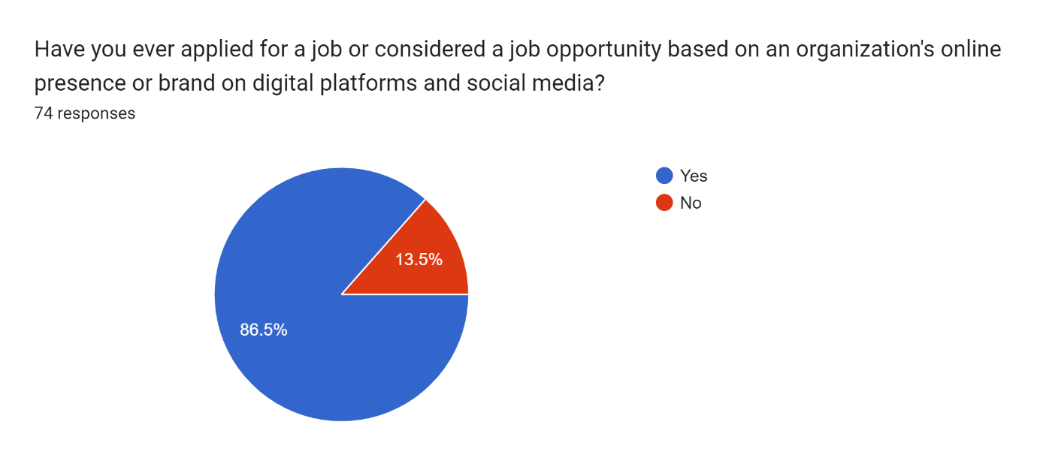64 respondents have considered a job opportunity based on an organization's online presence or brand on digital platforms and social media which indicates that online presence of an organization is important and attracts more job applications as it is convenient for the people to apply as per their commitments.

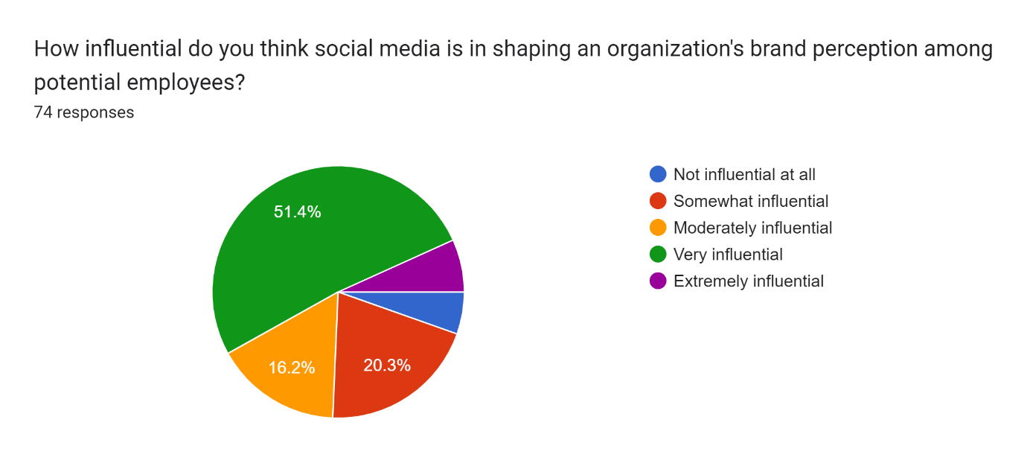

This indicates that 38 out of the 74 respondents believe social media has a significant impact on shaping an organization's brand perception among potential employees. They consider it to be a powerful tool in influencing how potential employees perceive a company's brand.12 moderately influential These 12 respondents believe that social media has a moderate level of influence on an organization's brand perception among potential employees. They acknowledge its impact but may not consider it as powerful as the "very influential" group15 somewhat influential: These 15 respondents perceive social media as having some level of influence on an organization's brand perception among potential employees. However, they likely consider other factors to be more significant in shaping the brand perception.5 extremely influential: This group of 5 respondents believes that social media has an exceptionally high level of influence on an organization's brand perception among potential employees.

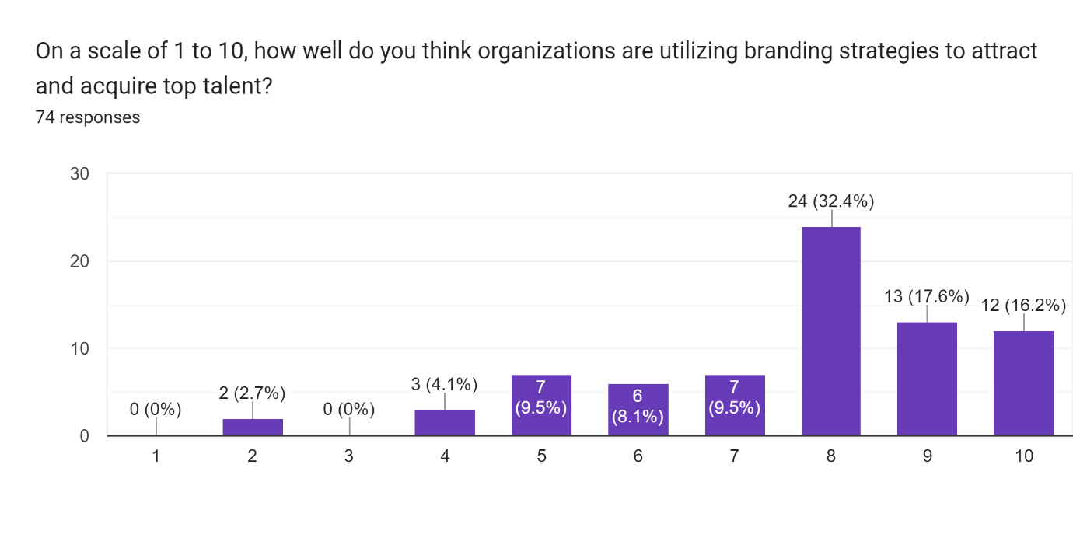

The provided data represents respondents' ratings on a scale of 1 to 10 regarding how well they think organizations are utilizing branding strategies to attract and acquire top talent. Here is the analysis and interpretation of the responses:

2 rating: Two respondents rated organizations very poorly, giving them a score of 2 out of 10, in terms of their utilization of branding strategies to attract and acquire top talent. These individuals believe that organizations are performing inadequately and need significant improvement in their branding strategies.

4 rating: Three respondents rated organizations low, giving them a score of 4 out of 10, in terms of their utilization of branding strategies. These respondents perceive limited effectiveness in the strategies employed by organizations to attract and acquire top talent and see room for substantial improvement.

5 rating: Seven respondents rated organizations at an average level, giving them a score of 5 out of 10, in terms of their utilization of branding strategies. They believe there is some effort being made by organizations, but also recognize that there is still room for improvement.

6 rating: Six respondents rated organizations slightly above average, giving them a score of 6 out of 10, in terms of their utilization of branding strategies. They acknowledge that organizations are making some effective efforts, but also believe there is potential for improvement and growth.

7 rating: Seven respondents rated organizations above average, giving them a score of 7 out of 10, in terms of their utilization of branding strategies. These respondents believe that organizations are making satisfactory efforts to attract and acquire top talent, but also see room for further enhancement.

8 rating: Twenty-four respondents rated organizations at a high level, giving them a score of 8 out of 10, in terms of their utilization of branding strategies. They perceive organizations as effectively using branding strategies to attract and acquire top talent, but also believe there is still potential for further improvement.

9 rating: Thirteen respondents rated organizations very well, giving them a score of 9 out of 10, in terms of their utilization of branding strategies. They believe organizations are highly effective in attracting and acquiring top talent, with minimal room for improvement.

10 rating: Twelve respondents rated organizations at the highest level, giving them a score of 10 out of 10, in terms of their utilization of branding strategies to attract and acquire top talent. These respondents believe organizations are extremely effective and successful in this aspect.

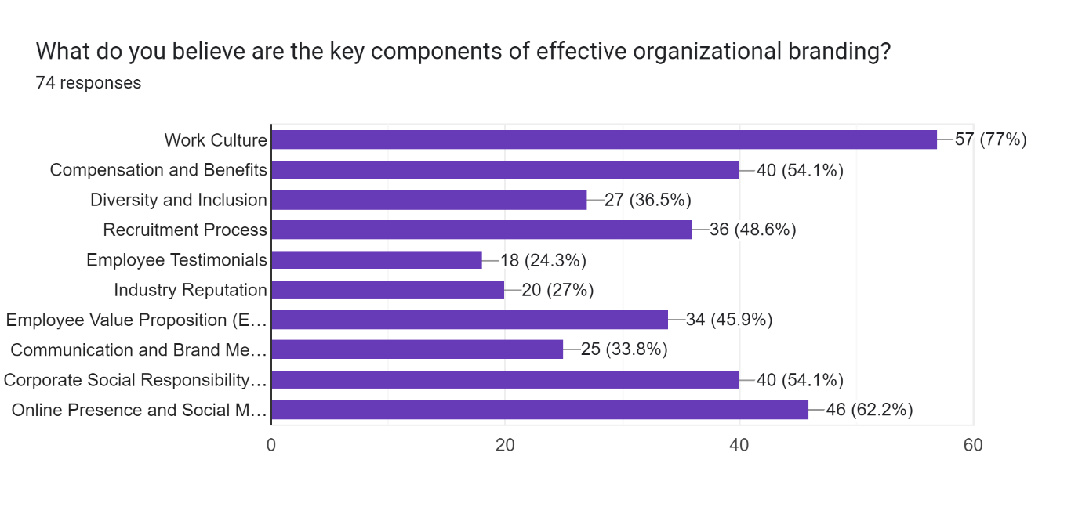

Work Culture: The majority of respondents, 57 out of the total 74, believe that work culture is a crucial component of effective organizational branding. They recognize that a positive and inclusive work culture can significantly contribute to the overall brand image and reputation of an organization. Compensation and Benefits: Forty respondents’ highlighted compensation and benefits as a key component of effective organizational branding. They believe that offering competitive and attractive compensation packages, along with appealing benefits, plays a significant role in shaping an organization's brand perception among potential employees.

Diversity and Inclusion: Twenty-seven respondents identified diversity and inclusion as a vital component of effective organizational branding. They consider organizations that prioritize and promote diversity and inclusion to have a more appealing brand image and reputation, particularly among diverse talent pools. Recruitment Process: Thirty-six respondents emphasized the importance of an effective and efficient recruitment process in organizational branding. They believe that a well-structured and positive recruitment process can enhance an organization's brand perception among potential candidates.

Forms response chart. Question title: Have you ever recommended a job opportunity to someone based on an organization's branding or reputation?
. Number of responses: 74 responses.

65 respondents answered "yes": This indicates that the majority of the respondents, 65 out of the 74, have recommended a job opportunity to someone based on an organization's branding or reputation. They consider the organization's positive image and reputation as influential factors in their recommendation. 9 respondents answered "no": Nine respondents stated that they have not recommended a job opportunity to someone based on an organization's branding or reputation. These respondents likely consider other factors, such as job requirements, personal experiences, or other sources of information, to be more important in their job recommendations.

Forms response chart. Question title: Do you believe organizational branding has an impact on employee retention and engagement in addition to talent attraction?
. Number of responses: 74 responses.

68 respondents answered "yes": This indicates that the majority of the respondents, 68 out of the 74, believe that organizational branding has an impact on employee retention and engagement, in addition to talent attraction. They recognize that a strong brand image and reputation can contribute to creating a positive work environment, fostering employee loyalty, and enhancing engagement. 6 respondents answered "no": Six respondents indicated that they do not believe organizational branding has an impact on employee retention and engagement, beyond talent attraction. These respondents may perceive other factors or aspects of the work environment to be more influential in employee retention and engagement.

Forms response chart. Question title: Are you familiar with the concept of organizational branding in the context of talent acquisition?
. Number of responses: 74 responses.

61 respondents answered "yes": This indicates that the majority of the respondents, 61 out of the 74, are familiar with the concept of organizational branding in the context of talent acquisition. They have knowledge and understanding of how organizations use branding strategies to attract and acquire talent.13 respondents answered "no": Thirteen respondents indicated that they are not familiar with the concept of organizational branding in the context of talent acquisition. They may not have much knowledge or understanding of how organizations utilize branding strategies in attracting and acquiring talent.

Forms response chart. Question title: How frequently do you engage with organizational branding content on digital platforms and social media when considering job opportunities?
. Number of responses: 74 responses.

18 respondents answered "always": This indicates that 18 out of the total respondents engage with organizational branding content on digital platforms and social media whenever they consider job opportunities. They actively seek out and engage with this content to inform their decision-making process.30 respondents answered "often": Thirty respondents stated that they frequently engage with organizational branding content on digital platforms and social media when considering job opportunities. They regularly interact with this content but may not do so for every job opportunity they consider.21 respondents answered "sometimes": These 21 respondents engage with organizational branding content on digital platforms and social media occasionally when considering job opportunities. They may do so selectively or when they come across particularly appealing or relevant content.5 respondents answered "rarely": Five respondents stated that they rarely engage with organizational branding content on digital platforms and social media when considering job opportunities. They may rely on other sources of information or factors in their decision-making process.

Forms response chart. Question title: Do you believe that the organizations that invest in digital platforms and social media for talent acquisition have a competitive advantage over those that do not?
. Number of responses: 74 responses.

72 respondents answered "yes": This indicates that the majority of the respondents, 72 out of the total respondents, believe that organizations that invest in digital platforms and social media for talent acquisition have a competitive advantage over those that do not. They recognize the importance of leveraging these platforms for attracting and acquiring talent and perceive it as a valuable strategy. 2 respondents answered "no": Two respondents indicated that they do not believe organizations that invest in digital platforms and social media for talent acquisition have a competitive advantage over those that do not. These respondents may have different perspectives or believe that other factors play a more significant role in gaining a competitive advantage.

**FINDINGS, CONCLUSION AND SUGGESTIONS**

**SUMMARY OF FINDINGS**

Social media has a significant influence on shaping an organization's brand perception among potential employees, with the majority of respondents considering it very influential (38 respondents) or moderately influential (12 respondents).

The utilization of branding strategies by organizations to attract and acquire top talent varies among respondents. While there is a significant number of respondents who rated organizations' utilization of branding strategies highly (8 rating: 24 respondents, 9 rating: 13 respondents, 10 rating: 12 respondents), there were also some who rated it lower (2 rating: 2 respondents, 4 rating: 3 respondents).

The majority of respondents (65 out of 74) have recommended a job opportunity to someone based on an organization's branding or reputation, indicating the impact of branding on attracting potential candidates.

Respondents strongly believe that organizational branding has an impact on employee retention and engagement, with 68 respondents stating yes and only 6 respondents stating no.

A majority of respondents (61 out of 74) are familiar with the concept of organizational branding in the context of talent acquisition, while a smaller proportion (13 out of 74) are not familiar with it.

When considering job opportunities, respondents engage with organizational branding content on digital platforms and social media frequently, with a significant number stating that they always (18 respondents) or often (30 respondents) engage with such content.

The majority of respondents (72 out of 74) believe that organizations investing in digital platforms and social media for talent acquisition have a competitive advantage over those that do not.

Key components of effective organizational branding, as identified by respondents, include work culture (57 respondents), compensation and benefits (40 respondents), online presence and social media (46 respondents), and corporate social responsibility (40 respondents).

**SUGGESTIONS**

Organizations should prioritize their branding strategies to create a positive perception among potential employees. This includes focusing on work culture, compensation and benefits, online presence, and corporate social responsibility.

Continuous monitoring and improvement of organizational branding efforts are necessary to stay competitive in attracting and retaining top talent. Regularly assessing and adjusting branding strategies based on feedback and market trends is recommended.

Organizations should leverage social media platforms and digital channels to effectively communicate their brand message and engage with potential candidates. This includes regular and meaningful content creation, active participation in relevant online communities, and prompt responses to inquiries and feedback.

Investing in employer branding training and development for HR and recruitment teams can enhance their understanding of branding strategies and enable them to effectively implement them in talent acquisition processes.

Regularly surveying employees and potential candidates to gather feedback on the organization's branding efforts can provide valuable insights for improvement and better alignment with candidate expectations.

Collaboration with marketing and communication teams can help organizations optimize their branding strategies and ensure consistent messaging across all channels.

Overall, an effective organizational branding strategy that considers the findings and suggestions mentioned above can significantly enhance an organization's ability to attract and acquire top talent.

**Conclusion:**

Based on the findings, interpretations, and suggestions, it can be concluded that organizational branding, particularly through social media and digital platforms, plays a significant role in shaping an organization's brand perception among potential employees and attracting top talent. The majority of respondents acknowledged the influential nature of social media in this regard.

Moreover, respondents believed that organizations utilizing branding strategies effectively have a competitive advantage in talent acquisition and that organizational branding also impacts employee retention and engagement. This highlights the importance of investing in branding efforts and leveraging digital platforms to engage with potential candidates.

The findings also revealed that the majority of respondents are familiar with the concept of organizational branding, indicating a general understanding of its significance in talent acquisition. Furthermore, respondents reported frequent engagement with organizational branding content on digital platforms and social media when considering job opportunities.

Key components of effective organizational branding identified by respondents include work culture, compensation and benefits, online presence and social media, and corporate social responsibility. These areas should be prioritized and regularly assessed to ensure a positive brand perception among potential employees.

1. Priya, G & Gopinath, Shanmuga & Raman, Dr. (2021). A Study on Strategy of Employer Branding and its impact on Talent management in IT industries 20. 3441-3451. 10.17051/ilkonline.2021.05.378.
2. G. Shanmuga Priya and Dr. UmaRaman.M.(2021) A Study on Strategy of Employer Branding and its impact on Talent management in IT industries.  
   xIlkogretim Online - Elementary Education Online,2021; Vol 20 (Issue 5): pp.3441-3451 http://ilkogretim-online.org doi: 10.17051/ilkonline.2021.05.378
3. Pandita, D., (2019) Talent acquisition: analysis of digital hiring in organizations. *SAMVAD*, *18*, pp.66-72.
4. Jeganathan, Krithika. (2020). An impact of employer branding on talent acquisition with special reference to private banks in Chennai. Xi'an Jianzhu Keji Daxue Xuebao/Journal of Xi'an University of Architecture & Technology. 12. 2935-2940.
5. Evans Sokro,(2012) European Journal of Business and Management www.iiste.org ISSN 2222-1905 (Paper) ISSN 2222-2839 (Online) Vol 4, No.18, 2012
6. Puja Kumari, Mili Dutta and Manju Bhagat (2020) DOI: 10.26573/2020.14.2.2 Volume 14, Number 2 May 2020, pp. 89-100
7. Srivastava, P., & Bhatnagar, J. (2010). Employer Brand for Talent Acquisition: An Exploration towards its Measurement. Vision, 14(1–2), 25–34. https://doi.org/10.1177/097226291001400103
8. Dr T. R. Kalai Lakshmi, An Impact of Employer Branding on Talent Acquisition in Banking Sector , International Journal of Advances in Engineering and Management (IJAEM) Volume 4, Issue 5 May 2022, pp: 495-501 www.ijaem.net ISSN: 2395-5252
9. Ms. Anney Chacko Prof Dr.Siby Zacharias(2020) IMPACT OF EMPLOYER BRANDING ON EMPLOYEE RETENTION © 2020 IJCRT | Volume 8, Issue 7 July 2020 | ISSN: 2320-2882
10. Gilani, Hasan & Cunningham, Lucy. (2017). Employer branding and its influence on employee retention: A literature review. The Marketing Review. 17. 239-256. 10.1362/146934717X14909733966209.
11. Tyagi, M.A., (2020) LEVERAGING SOCIAL MEDIA TO IMPROVE EMPLOYER BRANDING THEREBY ENHANCING EMPLOYEE RETENTION AND TALENT ACQUISITION. *PalArch's Journal of Archaeology of Egypt/Egyptology*, *17*(12), pp.1417-1437.
12. Allen, David & Mahto, Raj & Otondo, Robert. (2007). Web-Based Recruitment: Effects of Information, Organizational Brand, and Attitudes Toward a Web Site on Applicant Attraction. The Journal of applied psychology. 92. 1696-708. 10.1037/0021-9010.92.6.1696.
13. Magdalena Kalinska-Kula , Iwona Staniec(2021) Employer Branding and Organizational Attractiveness: Current Employees’ Perspective European Research Studies Journal Volume XXIV, Issue 1, 2021 pp. 583-603
14. Priya, G & Gopinath, Shanmuga & Raman, Dr. (2021). A Study on Strategy of Employer Branding and its impact on Talent management in IT industries A Study on Strategy of Employer Branding and its impact on Talent management in IT industries. 20. 3441-3451. 10.17051/ilkonline.2021.05.378.
15. Ecaterina CHITU(2020), The Importance of Employer Branding in Recruiting Young Talents 2020, Volume 11, Issue 3, pages: 220-230 | <https://doi.org/10.18662/po/11.3/209>
16. D.A.S. Udayanga, et al… (2021)Impact of Employer Branding on Employee Retention, SLIIT Business Review, 2021 Vol. 1, No.1, pp. 1-27 <https://doi.org/10.54389/OPSI7755>
17. Nayak, S., Bhatnagar, J. and Budhwar, P., (2018) Leveraging social networking for talent management: an exploratory study of Indian firms. *Thunderbird International Business Review*, *60*(1), pp.21-37.
18. Mihalcea, A., (2017) Employer branding and talent management in the digital age. *Management Dynamics in the Knowledge Economy*, *5*(2), pp.289-306.