**Design of Pipelined Noise Shaping DSMs ADC with LMS Algorithm technique for Flash ADCs.**

1Nikhil Yadav, 2 Deepak Sharma, 3Ranu Thakur

1M.tech Scholar, 2,3Assistant Professor

1, 2,3Dept. of ECE, LNCT (Bhopal) Indore Campus, Indore (M.P)

**Abstract: This paper presents the implementation and design of adaptive noise cancelling filters using the Delta Sigma Modulator (DSM) ADCs. It has been clearly shown how the process of recursive or pipelined noise shaping based conversion used in ADCs can achieve higher speeds even after employing Oversampling above Nyquist rate with recursive encoding. The various parameters affecting the design and performance of the DSM ADCs employed filter design have been analyzed. Stability considerations of higher order sigma delta modulators have also been analyzed to attain an optimized approach to decide upon the design of the DSM. Variation in the SNR has been shown with changes in Over Sampling Rate.**

***Keywords***: ***Adaptive Filter Design, DSM ADCs, Over Sampling Rate, Signal to Noise Ratio, Dynamic Range, Quantization Noise.***

**INTRODUCTION**

Adaptive filter design finds its applications in several fields of signal processing such as speech processing, analog to digital conversion, image processing etc. The very essence of adaptive filtering rests on the principle that the noise conditions faced by signals can vary. Adaptive filter adjust their coefficients to minimize an error signal and can be realized as finite impulse response (FIR), infinite impulse response (IIR), lattice and transform domain filter. Although real world signals are analog, it is often desirable to convert them into the digital domain using an analog to digital converter (ADC). Signal processing in the digital domain is useful in digital storage, biomedical applications, and industrial applications - from instrumentation to communication. Sigma Delta Modulators achieve a high degree of insensitivity to analog circuit imperfections, thus making them a good choice to realize embedded analog-to-digital interfaces. Application based and sophisticated design techniques demand Radio Frequency Identification Techniques which find its application in object tracking, etc. Sigma Delta ADC is high resolution ADC and acts as a major building block in RFID applications. [1] As per the sampling frequency, ADC is classified into two categories: Nyquist ADCs and Sigma- Delta ADCs. Nyquist ADCs have a lower effective number of bits due to process variation and mismatching [2]. One technique, Sigma Delta modulation, which is based on the combination of oversampling and quantization error shaping techniques, has become quite popular for achieving high resolution and high accuracy. [3] One significant advantage of the method is that analog signals are converted using only a 1-bit ADC and analog signal processing circuits having a precision that is usually much less than the resolution of the overall converter. Using sigma-delta A/D methods, high resolution can be obtained for only a low to medium signal bandwidths. The Oversampling behavior of the Sigma Delta Modulator restricts the bandwidth which can be overcome by using higher order architecture.

The Signal to Noise Ratio of Sigma Delta Modulator is dependent upon the number of bits of quantizer and is independent of amplitude of input signal. The N - bit quantizer has 2 levels and separated by V LSB. The amplitude of full scale sine wave input is 2 N-1 V LSB. Peak to peak value is given by 2 N V LSB Mean Square Value of the Signal is given by:

**S=(2N-1VLSB)2/2 (1)**

Mean squared Noise is given by the expression:

**N=V2LSB/12 (2)**

Therefore,

Signal to Noise Ratio (SNR) is given by:

**[(2N-1VLSB)2/2]/[V2LSB/12] (3)**

which reduces into

**SNR=*1*22N (4)**

Also,

**SNR=6.02N+1.76dB (5)**

**SYSTEM DESIGN**

The proposed system design is given by:

Firstly, initial parameters are defined like Over Sampling Ratio and Number of Quantization bits. In the next step, as per the order of Sigma Delta Modulator, loop filter parameters i.e. Signal Transfer Function and Noise Transfer Function are designed. Then input signal is defined for simulation of Sigma Delta Modulator through which performance parameters like Signal to Noise Ratio and Effective Number of bits are calculated. The stability of Sigma Delta Modulator depends upon loop filter parameter, and input signal amplitude. So, for designing a stable Sigma Delta Modulator, these parameters are considered.

The transfer function *Lo(z)* and Li(z) can also be realized by using feed forward signal paths to create the zeros of the NTF.

The transfer function of the feedback filter is

**L1(z) = -a1I(z) –a2I(z) 2- ….. –anI(z)n (6)**

Where I(z) is the delaying integrator's transfer function. The signal filter function is

**L0(z)=b1(a1I+.. anIn)+ b2(a2I+.. anIn-1) + bn+1(7)**

**Considering b2=b3=… bn=0 and b1=bN+1=1**

Therefore, L0(z)=1-L1(z) and STF=1,

We get and provides STF = 1.

The error computation based filter design using the LMSE approach is implemented using the relation:

$\min{E\left[z^{2}\right]=E\left[s^{2}\right]+\min{E[{\left(n_{0}-y\right)}^{2}]}}$**(8)**

The flowchart of the proposed system is shown below:

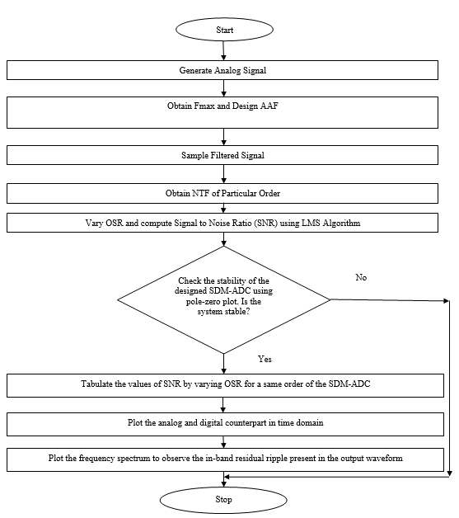

***Fig.1: Flow Chart for Proposed System***

**RESULTS**

The system has been designed on Matlab 2021a.

This section will deal with the comparative analysis of fourth order Sigma Delta Modulator with respect to different topologies for parameters like signal to noise ratio and effective number of bits. For realization initial parameters are taken for all topologies as OSR = 4, out of band gain (OBG) = 1.5, Quantization Level=7. A comparison of different parameters is done for different values of OSR. For the CIFB topology, Figure 5.12 gives the Realization of STF and NTF in voltage, Figure 5.13 shows the Realization of STF and NTF in dB, Figure 5.14 shows the time domain simulation of fourth order Sigma Delta Modulator , Figure 5.15 shows the integrator states of fourth order Sigma Delta Modulator where x1 is the output of first integrator, x2 is the output of second integrator, x3 is the output of third integrator, x4 is the output of fourth integrator and Figure 5.16 shows the frequency domain simulation of fourth order Sigma Delta Modulator.

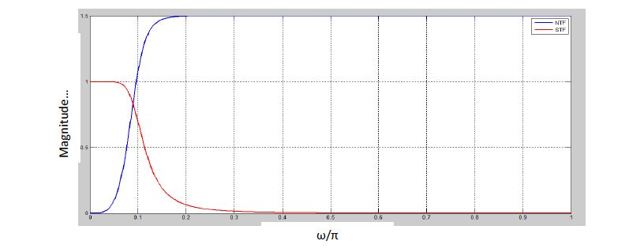

**Fig.2 Realization of STF and NTF in voltage**

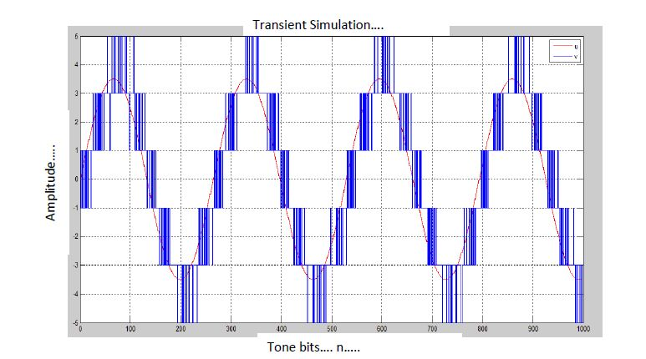

***Fig.3 Time Domain Simulation Of Fourth Order Sigma Delta Modulator With CIBF Architecture***

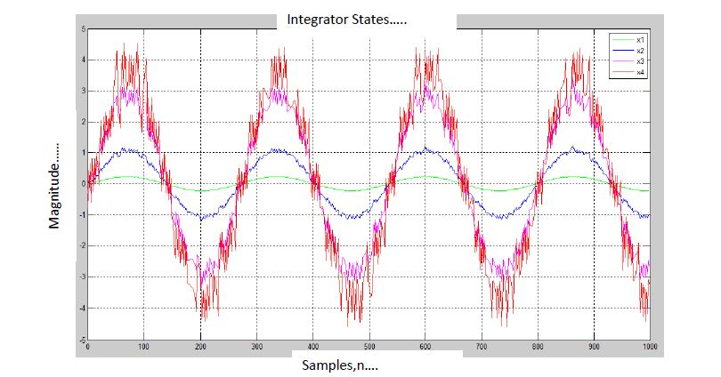

***Fig.4 Integrator States Of Fourth Order Sigma Delta Modulator With CIBF Architecture***

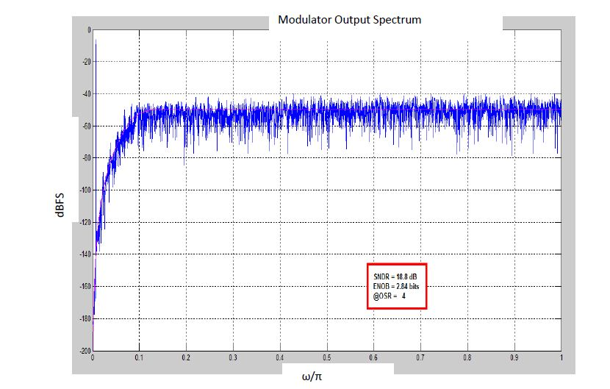

***Fig.5 Frequency Domain Simulation Of Fourth Order Sigma Delta Modulator With CIBF Architecture***

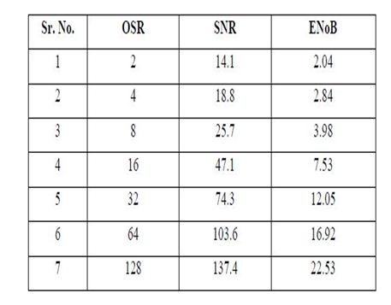

***Table.1 Analysis Of Fourth Order Sigma Delta Modulator For Signal To Noise Ratio And Effective Number Of Bits***.

Thus the aforesaid discussions along with the relevant waveforms and tables are self explanatory for the performance of higher order sigma delta modulators. The above comparative analysis concludes that parameters affecting the performance of Sigma Delta Modulator like Signal to Noise Ratio and Effective Number of Bits increases with increase in Over Sampling Ratio. Also, with the increase in order of modulator and quantization level, high SNR can be achieved at low OSR value. But with the increase of order, the modulator becomes unstable and also, maximum usable input signal amplitude decreases.

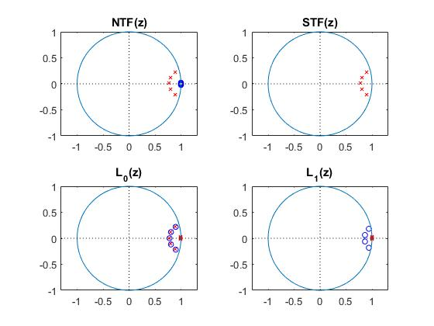

***Fig.6 Stability Analysis of 5th Order Filter***

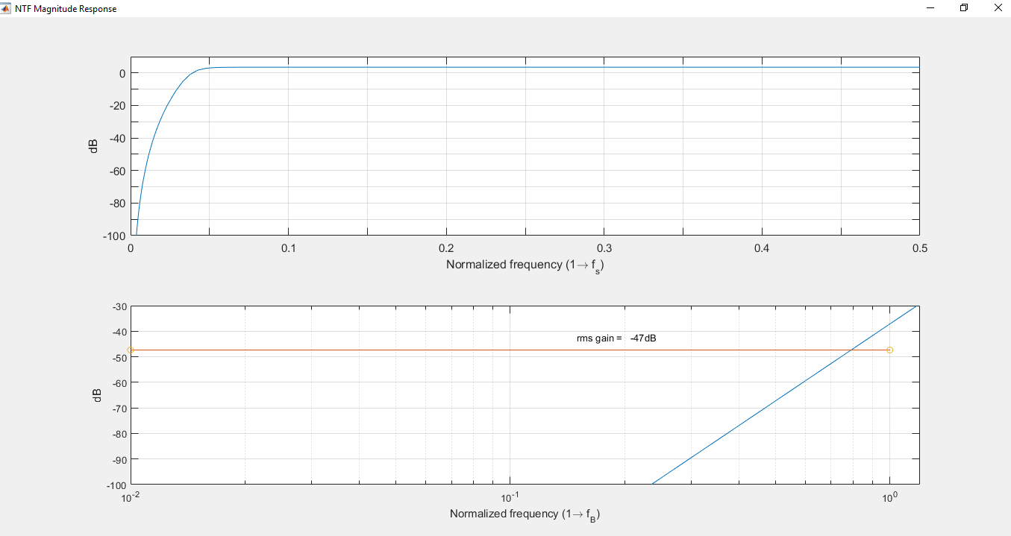

***Fig.7 Stability Analysis of 5th Order Filter***

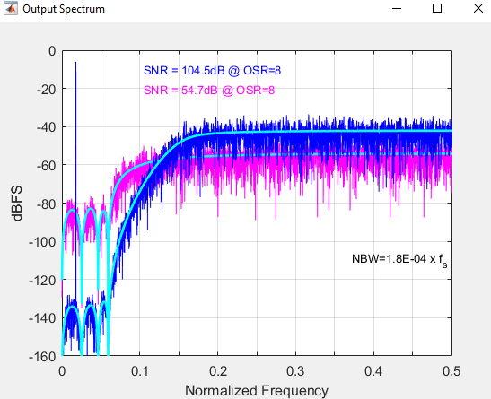

***Fig.8 Stability Analysis of 5th Order Filter***

The stability can be achieved for high order Sigma Delta Modulator by keeping the gain of Noise Transfer Function to be low. So, low order Sigma Delta Modulator with high OSR can be used for application.

By the use of uniform quantizer, the performance of Sigma Delta Modulator increases drastically. Stability issues can be resolved by using multibit quantizers. But the designing of multibit quantizer is complex. Also its implementation in chip is quite cumbersome, with respect to large scale integration technologies.

The stability of loop filter depends upon number of factors like maximum input signal range, position of poles of Noise Transfer Function in unit circle, gain value of the loop filter etc.So, by considering all the above parameters as per the application, the Sigma Delta Modulator of specific architecture with required order can be used. If the bandwidth requirement is modest, then conventional model of Sigma Delta Modulator of low order can be used. The Analog to Digital Converters required for audio signals which are having higher bandwidth can use Sigma Delta Modulator of higher order.

The take away of the results and discussions can be stated as follows:

The take away of the results and discussions can be stated as follows:

1) Conventional ADC design doesn’t have as much noise immunity as SDM based ADC design. Hence SDM based ADCs have higher accuracy.

2) Increasing the oversampling ratio (OSR) reduces the noise and hence increases the Signal to Noise Ratio

3) One stage of SDM may not suffice to render high SNR in the digitized form of the original signal. Hence it is necessary to implement a multi level SDM based ADC. Increasing the number of order of the SDM leads to reduced stability in the filter based implementation of the system.

5) The proposed system attains a higher SNR of 104.5 dB compared to previous work (96dB) [1].

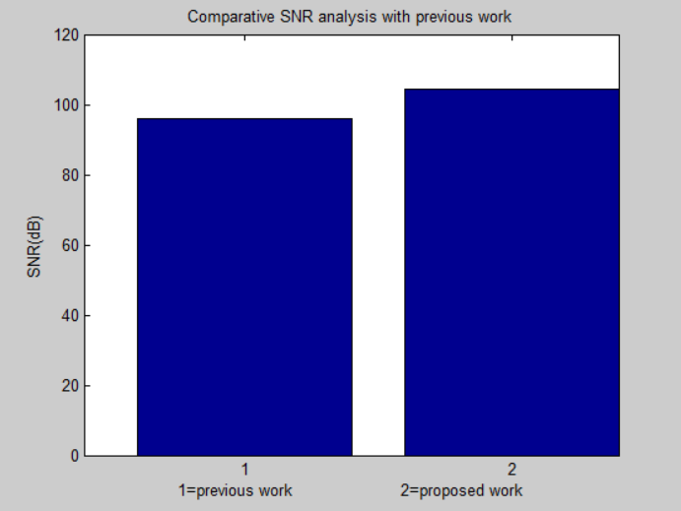

***Fig.9 Comparative SNR analysis with previous work***

**CONCLUSION**

**In this work, analysis of lower order and higher order DSM ADCin conjugation with the LMS algorithm has been done on the basis of Signal to Noise Ratio and Effective Number of Bits. The noise shaping property of Sigma Delta Modulator has made it popular in the application where high Signal to Noise Ratio is desired. The significant property of noise shaping, pushes the noise in the range out of band of interest which reduces the requirement of sharp cut off anti aliasing filter. As, the oversampling ratio increases the Signal to Noise Ratio also increases. Higher SNR values can be achieved at lower OSR also, if higher orders of modulators are used. But as the number of integrators in the modulator increases this affects in the position of poles of the Noise Transfer Function which can make the loop filter unstable. It can be concluded from the results and conclusions that the sigma delta scheme is a highly efficient technique that can be utilized for the design of Adaptive Filters which yield low Quantization Noise due to the noise shaping principle employed inherently in the proposed technique.**

**References**

1. E. Gutierrez, L. Hernandez, F. Cardes and P. Rombouts, "A Pulse Frequency Modulation Interpretation of VCOs Enabling VCO-ADC Architectures With Extended Noise Shaping," in IEEE Transactions on Circuits and Systems I: Regular Papers, 2021, vol. 65, no. 2, pp. 444-457.
2. S Oh, Y Oh, J Lee, K Kim, S Lee, J Kim, "A 80dB DR 6MHz Bandwidth Pipelined Noise-Shaping SAR ADC with 1–2 DSM structure," 2020 IEEE Custom Integrated Circuits Conference (CICC), 2020, pp. 1-4
3. M. Danesh and A. Sanyal, "Fully Digital 1-1 DSM VCO-Based ADC Architecture," 2019 IEEE 62nd International Midwest Symposium on Circuits and Systems (MWSCAS), 2019, pp. 501-504
4. P Payandehnia, H Mirzaie, H Maghami, J Muhlestein, “Fully passive third-order noise shaping SAR ADC”, Electronics Letters, IET Journal 2017
5. Rudolf Ritter, John G. Kauffman, Joachim Becker, Maurits Ortmanns, “A 10 MHz Bandwidth, 70 dB SNDR Continuous Time Delta-Sigma Modulator With Digitally Improved Reconfigurable Blocker Rejection”, IEEE 2016
6. S Tao, A Rusu, “A power-efficient continuous-time incremental sigma-delta adc for neural recording systems”, IEEE 2015
7. Angsuman Roy and Jacob Baker, “A Passive 2nd-Order Sigma-Delta Modulator for Low-Power Analog-to-Digital Conversion”, IEEE 2014
8. L Hernandez, E Gutierrez, “Analytical evaluation of VCO-ADC quantization noise spectrum using pulse frequency modulation”, IEEE 2014
9. M De Bock, X Xing, L Weyten, G Gielen, “Calibration of DAC Mismatch Errors in ADCs Based on a Sine-Wave Measurement”, IEEE 2013
10. HC Tsai, CL Lo, CY Ho, YH Lin, “A 64-fJ/Conv.-Step Continuous-Time Modulator in 40-nm CMOS Using Asynchronous SAR Quantizer and Digital Truncator”, IEEE 2013
11. V Srinivasan, V Wang, P Satarzadeh, “A 20mW 61dB SNDR (60MHz BW) 1b 3rd-order continuous-time delta-sigma modulator clocked at 6GHz in 45nm CMOS”, IEEE 2012
12. B Jacob, MR Baiju, “Vector-quantized space-vector-based spread spectrum modulation scheme for multilevel inverters using the principle of oversampling ADC”, IEEE 2012
13. Yingqi Qian Changchun Zhang a, Zhongchao Liu, Leilei Liu, YurongLuan,Yuming Fang and Yufeng Guo,“ A High-Performance Sigma-Delta Modulator in 0.18pm CMOS Technology” International Journal, Applied Mechanics and Materials Vols. 519-520 (2014) pp 1085-1088, February 2014
14. Fan Wenjie ,LvQiuye,HeChong,YinLiang,LiuXiaowei, “Architectural Design and Simulation of A Fourth-Order Sigma-Delta Modulator ” , International Journal, Key Engineering Materials Vols. 609-610 (2014) pp 723-727 , April 2014
15. Hetal Panchal, “Design and Simulation of Sigma Delta ADC Using VHDL AMS” , International Journal of Engineering Development and Research , Volume 2, Issue 1 ,pp no.548-551, 2014
16. Liu Liang, Chen Song , He Chong, Yin Liang, Liu Xiaowei“Design of Third-order Single loop Full Feed-forward Sigma Delta Modulator”, International Journal, Key Engineering Materials Vols. 609-610 (2014) pp 1176-1180, April 2014
17. RaminZanbaghi, Pavan Kumar Hanumolu “An 80-dB DR, 7.2-MHz Bandwidth Single OpampBiquad Based CT Modulator Dissipating 13.7-mW ”, IEEE Journal of Solid-State Circuits, Vol. 48, No. 2, pp 1 -15, February 2013
18. Jiandong Cheng, Guoyong Shi, and Ailin Zhang, “A Fast SNR Estimation Method for Sigma-Delta Modulator Design” , TENCON 2013, IEEE Conference, 22nd -25th October ,pp 1-4, 2013
19. Philip M. Chopp and Anas A. Hamoui, “A 1-V 13-mWSingle-Path Frequency-Translating AZ Modulator With 55-dB SNDR and 4-MHz Bandwidth at 225 MHz” , IEEE Journal of Solid-State Circuits, Vol. 48, No. 2, pp 1-14 February 2013
20. HisatoFujisaka , Takeshi Kamio, Chang-Jun Ahn, Masahiro Sakamoto, and Kazuhisa Haeiwa “Sorter-Based Arithmetic Circuits for Sigma-Delta Domain Signal Processing—Part I: Addition, Approximate Transcendental Functions, and Log-Domain Operations”, IEEE Transactions On Circuits and Systems—I: REGULAR PAPERS, Vol. 59, No. 9, ,pp no. 1952-1965, September 2012
21. Jose M. de la Rosa, “ Sigma Delta Modulators : Tutorial Overview, Design Guide, and State of the Art Survey ”, IEEE Transaction on Circuits and System - I , Vol 58 No. 1, pp 1­21, January 2011
22. Philippe Benabes, Catalin-Adrian TUGUI, “Effective Modeling Of CT Functions For Fast Simulations Using MATLAB-Simulink And VHDL AMS applied to Sigma-delta Architectures" Circuits and Systems (ISCAS), IEEE Conference, Page No. 2269 - 2272 , May 2011
23. Valeri Mladenov , “A Method for Validation the Limit Cycles of High Order Sigma-Delta Modulators” , IEEE Conference , Nonlinear Dynamics and Synchronization (INDS) & 16th Int'l Symposium on Theoretical Electrical Engineering (ISTET), 2011 Joint 3rd Int'l Workshop , pp 1-5, 25-27 July 2011
24. JozefMihalov, VieraStopjakova ,“Implementation of Sigma-delta Analog to Digital Converter in FPGA", IOP, Applied Electronics, IEEE Conference , Page No. 1-4, Sept. 2011
25. Ahmed Shahein, Mohamed Afifi, Markus Becker, NiklasLotze, YiannosManoli, “A Power- Efficient Tunable Narrow-Band Digital Front End for Bandpass Sigma—Delta ADCs in Digital FM Receivers’”, Circuits and Systems II: Express Briefs, IEEE Conference ,Vol. 57,Issue No. 11, pp 883 -887, November 2010