Deep Forest-Based Automatic Generation Control Strategy

Hussain Shaik hussainshaikresearch@gmail.com

***Abstract: The current automatic generation control (AGC) method needs to be enhanced and optimized as the power system's size continues to grow and the energy landscape drastically shifts. The grid AGC in use now primarily uses closed-loop PI control. This research provides a real-time AGC technique based on a deep forest network by learning an outstanding data set that combines the features of DFT control and PI control. The approach chooses the controller for the evaluation cycle for power deviation regulation studies based on which controller performed better in control during each assessment period. The simulation findings demonstrate that the technique outperforms all taught solutions and can accomplish real-time AGC regulation with fewer operations.***

***Index Terms****: Deep learning, deep forest, control techniques, automatic generation control.*

1. **INTRODUCTION**

Power systems balance power generation and load demand to function steadily and safely. Maintaining the relative balance between load and power generation is challenging due to variations in load demand, which has an impact on operational safety and system frequency. Countries all over the world are actively pushing the development of renewable energy, which is represented by wind power and photovoltaics, to address the shortage of fossil fuels and the environmental pollution crisis. Modern power systems emphasize wind and photovoltaic penetration on a large scale, which has an impact on conventional power plants' ability to provide system services [1]. Large-scale grid integration of intermittent new energy sources like solar and wind creates uncertainty in active power production, and the output volatility of these sources impacts the power system's frequency stability. For the purpose of adjusting to the demands of the grid, it is necessary to thoroughly examine, optimize, and enhance the current automatic power generation control schemes. Power systems employ automatic generation control (AGC) to adjust the system frequency to a predetermined value, to keep the contact line power exchange value to a planned value and to keep the overshoot and stabilization time within acceptable limits [2].  The main purpose of automatic generation control is to maintain frequency and power system stability through the use of the load frequency control (LFC) method [3]. Based on the control technique, research methodologies for AGC systems may be broadly classified into two groups: direct control of AGC and optimization modelling method. Numerous academics have undertaken pertinent study in this regard.

Improving the traditional proportional-integral (PI) control strategy or optimizing the PI control parameters is the main goal of the study of direct control strategies for AGC. A unique control design for an LFC of a hydro-hydro interconnected system based on joint actions of fuzzy logic and proportional-integral-derivative (PID) was proposed in the literature [4]. PSO was used to effectively optimize the system, yielding a Fuzzy-PSO-PID. To coordinate FLAGCs of all areas, the literature [5] presented a simultaneous coordination strategy based on particle swarm optimization (PSO) in conjunction with real coded genetic algorithms (RCGAs).. A fuzzy-assisted PID controller parameter tuning technique was presented in the literature [6]; it was based on a combination of an enhanced firefly optimization algorithm and hIFA-PS, a pattern search technique, is used to control a five-area power system's frequency. The purpose of the gravity search technique was to improve the response time in the event of a frequency divergence across multi-area power systems [7]. In the literature, a hybrid PID-fuzz controller for the best automatic generation control of a two-area linked power system was proposed [8]. The simulated annealing (SA) technique is used to create the controller parameters. The AGC with various renewable resources and an enhanced cascade controller was suggested in the literature [9]. To enable controller parameter optimization, a new hybrid technique based on the Improved Teaching Learning by Optimizing Differential Evolution (hITLBO-DE) algorithm is applied. A fuzzy predictive-proportional integral derivative (FP-PID) controller strategy for automatic generation controller was proposed in the literature [10]. Using the time multiplied by squared error (ITSE) as the objective function, the grasshopper optimization algorithm (GOA) was used to adjust the FP-PID controller's parameters.

In the modelling control strategy aspect, an AGC strategy model based on modern interior point theory for intercon- nected grids under control performance standard (CPS) was proposed in [11]. The model takes the optimal CPS1 index as the aim function, considers system constraints such as system power balance constraints and unit regulation capacity, and solves for an optimal set of AGC regulation commands, and shows the practicality of the proposed model with examples. The dynamic optimal scheduling model for AGC units was proposed in [12], and by adding the constraint relationship between the interconnection system frequency and the contact line power, the model of [11]'s constraints characterizing the unit regulation characteristics are enhanced. In order to minimize the power discrepancy between the scheduling orders and the actual power regulation output, an optimal mileage technique (OMD) based AGC scheduling was presented in [13]. This method optimizes the allocation of real-time overall AGC scheduling commands among various AGC units. In [14], a brand-new fast distributed auction-based algorithm (FDAA) with random forest assistance was created for coordinated regulation in sizable photovoltaic power plants in response to AGC signals. The paper in [15] presented a unique framework based on proximal. Due to the tight control constraints provided, the optimization modelling method's control strategy suffers from non-convergence of the model and poor timeliness, making it difficult to implement real-time AGC and real-time response to area control error. However, the direct control technique is a better option because the power system's actual load varies quickly and with huge amplitude variations, which is a typical non-stationary strongly stochastic process.

Research teams from both domestic and foreign universities are focusing on the study and use of machine learning in AGC at the same time. Six categories can be used to categorize machine learning: associative learning, empirical inductive learning,

Deep learning is associative learning, as are analogy learning, analytical learning, genetic learning, and reinforcement learning. To provide dependable and secure online monitoring for automated guided vehicles, the literature in [16] suggested an integrated IoT architecture based on developing deep neural networks (DNNs) and rectifying linear units for handling cyberattacks (AGVs). A weight initialization technique for neural networks with asymmetric activation functions was presented in the literature [17] and has the potential to enhance the network's performance. The literature [18] suggested a clever combination of a fresh IoT platform with profound. A deep reinforcement learning-based control strategy for AGC was proposed in the literature [19]. It primarily uses multiple neural networks to fit the system's behavioral policies for value assessment and enhances the effectiveness and caliber of AGC exploration as well as the system's control performance by introducing an enhanced behavior-criticism method with incentive heuristics. Deep learning has found rich applications in different domains in power systems. The transition from active deep learning predictors to data-driven deep learning predictors has been essentially accomplished with the advent of deep learning [20], [21]. This paper offers a fresh perspective on data-driven AGC strategy research, given the swift advancement of data-driven methodologies. Developing deep learning has produced better results than shallow models in recent years.. Zhou and Feng [26] introduced the deep forest algorithm, a novel approach for decision tree integration, in this context. A variation of random forest deep learning, deep forest (gcForest) offers improved parameter robustness and a quicker training rate.

The traditional PI control [27] and the discrete Fourier transform (DFT)-based AGC real-time control strategy [28] in the direct control approach are chosen as the two strategies for deep forest network learning in this research based on the aforementioned examination of the two AGC control methods. The controller with better performance is chosen for each assessment period as the controller for that period's power deviation regulation. When the controlled data set is generated by offline control, PI control is chosen in scenarios with sharp deviation fluctuations in area control error, and DFT control is chosen in scenarios with moderate deviation fluctuations. To enhance the AGC control method, this research suggests an automated power generation control technique based on deep forest algorithms. Combining the features of various AGC approaches to produce superior control datasets: In order to choose the control strategy with the best control performance and make adjustments, the deep learning approach requires the help of enough data. the area control error in various assessment cycles, to fully utilize the performance of various control methods in their respective favorable working environments, and to effectively combine the features of both DFT and PI control strategies to produce superior control datasets

1. A fresh take on deep learning: a deep forest algorithm-based approach for automatic generation control is put forth. This approach relies on deep learning techniques, which, through training with massive area control error (ACE) data, directly create mapping relationships between known inputs and total regulation commands. This solves the non-convergence issue with complex AGC modelling control methods and improves applicability in handling a range of grid operating conditions.
2. .

The control method of the deep forest approach is based on the traditional AGC strategy. The deep forest control technique splits the traditional AGC procedure into two simpler steps: figuring out whether the unit is acting and figuring out the precise overall regional regulation power. A triple classification network and two regression networks are used to build a deep learning model for the AGC strategy, and a deep forest-based AGC real-time control approach is suggested

.

1. The structure of the paper is as follows. The fundamentals of AGC are presented in Section II, along with the performance standards for AGC. The deep forest algorithm's guiding concepts are explained in Section III. In Section IV, the creation of the control dataset, the reasoning for choosing the network feature variables, and the deep forest-based AGC procedure are all explained. Lastly, Section V conducts simulations, and Section VI wraps up the paper.
2. **PRIMITIVE AGC CONTROL PRINCIPLES**
3. *AGC PRINCIPLE*

In order to minimize losses and balance the total power generated and the total load demand, automatic generation control is a control approach [29]. In traditional AGC control, the regional grid dispatch center uses the following formula to determine the current power imbalance, or area control error (ACE), in real time and then uses that information to regulate the frequency regulation units in order to minimize or eliminate the deviation:

*EACE* = *β∆f* + *∆PT* (1)

where FT is the contact line exchange power deviation, f is the frequency deviation, and β is the regional frequency deviation factor.

AGC control is a closed-loop feedback control process, the input variables are frequency deviation *∆f* and contact line exchange power deviation *∆PT* and other signals generated after ACE, according to a certain AGC control strategy to get the Frequency regulated generator sets new power *∆PG*, and then adjust the system frequency and contact line exchange power deviation, the control process is described in Fig. 1:

The load and power supply architecture of the AGC are two examples of the many variables that might affect its real-time control process.



**FIGURE 1.** Description of AGC control process.

The demand on system control is increased by the large-scale wind power and photovoltaic connections to the grid, which are volatile and intermittent, and by the periodic fluctuations in loads with different characteristics. As a result, the system requirements cannot be satisfied by the conventional AGC. In order to combine the benefits of various control strategies, deep forest model learning is used in the field of automatic power generation control strategies. This allows the system to make an intelligent decision about which controller will work best for unit regulation under various operating conditions.

1. *ASSESSMENT*

Since the 1960s, the AGC strategy's control goal has been to ensure that the ACE crosses zero. To this end, the North American Electric Reliability Council (NERC) has chosen the A1/A2 standard as the AGC performance evaluation index. However, inter-regional frequency support is not supported by this standard since it has an excessive number of needless modifications. The NERC-proposed control performance standard is more scientific and addresses the shortcomings of the A standard. The CPS standard gives additional leeway for the coordinated control of AGC by easing the requirement that "the ACE must pass zero within 10 minutes." The CPS1 and CPS2 standards are part of the CPS standard. The relationship between ACE variation and frequency deviation is counted using CPS1, and the ACE amplitude change is counted using CPS2, which is used to assess how well the control region can manage the tie line's power flow deviation. The CPS standard reduces the frequency of frequency regulation units, gives more weight to the long-term advantages of the AGC system, and uses a more reasonable and scientific combination of the control limit and the regional frequency deviation coefficient. It also does not require the area control error to cross zero frequently.

$K_{CPS1 }=2-\sum{\frac{\left[\frac{E_{AVE-min}∆F_{AVE-min}}{10B_{i}}\right]}{n/∈_{1}^{2}}}$ (2)

in which ∆FAVE−min is the average deviation of the one-minute frequency and EAVE−minis the average value of the one-minute ACE; ε1 is the root mean square value of the one-minute average of the deviation of the actual frequency from the standard frequency of the interconnected grid over a one-year period; Bi is the frequency response coefficient (MW/0.1Hz) for control zone I and n is the total number of minutes in the assessment period.

The 10-minute average of the ACE, or the tidal deviation of the contact line, needs to be controlled to a specific limit value. CPS2 is used to evaluate the control area's ability to achieve this goal. The following is how its indicator value is expressed:

$K_{CPS2}=1/N\sum_{t=1}^{N}{(10B∆f^{t}+∆P_{T}^{t})}L_{10}$*(3)*

$L_{10}=1.65∈_{10}\sqrt{(-10B_{i})(-10B_{i})}$ (4)

where N is the assessment period, ∆f t is the frequency deviation, ∆Pt is the tie-line power error, ε10 is the standard frequency deviation and mean square value of the average frequency based on 10 minutes per year, B is the control area's frequency coefficient, and Bs is the interconnected grid's frequency deviation coefficient. In light of the Guangxi grid's current state, the CPS assessment is qualified when 200% *K*cps1 or 100% *K*cps1 and *K*cps2 *L*10, where the average ACE limit *L*10 is taken as 100.

*T*

≤ ≤ | | ≤

1. **DEEP FOREST ALGORITHM**

The deep forest method, a supervised machine integration learning process based on the random forest (RF) algorithm, was made possible by the quick development of deep learning and deep neural networks. An integrated approach based on decision trees in both depth and width is called deep forest. The two stages that make up the entire method are cascade forest and multi-grained scanning. The key component of the deep forest algorithm is the cascade forest.

* *DECISION TREE*

The RF algorithm for regression and classification was proposed by Breiman [31]. Random forests use several decision trees that are based on Bag- ging's integrated learning technique [32]. The final classification is determined by voting on each decision tree's result once the samples to be classified have been input. In order to conduct the classification, the Random Forest algorithm learns the training classification rules on a given sample without requiring any prior knowledge.

* *RANDOM FOREST ALGORITHM*

The RF algorithm for regression and classification was proposed by Breiman [31]. Random forests use several decision trees that are based on Bag- ging's integrated learning technique [32]. The final classification is determined by voting on each decision tree's result once the samples to be classified have been input. In order to conduct the classification, the Random Forest algorithm learns the training classification rules on a given sample without requiring any prior knowledge.

* *CASCADE FOREST STRUCTURE*

The model used in this paper is the latest Deep Forest (DF21: A Practical Deep Forest for Tabular Datasets). DF21 is an implementation of Deep Forest 2021.2.1 with a cascade level with the original input feature vectors to form a set of vectors as the input of this level, so that the original features can be maintained and new feature vectors can be formed, which is a reinforcement of the original features and avoids the loss of feature information. The evaluation level is the highest level, where the generated category vectors are averaged and the sample classification result is taken from the category with the maximum value. Each stage of the training process uses k-fold cross validation, which involves training the training data k-1 times, generating and averaging k-1 category vectors, and using the averaged values as augmented feature vectors for the subsequent level in order to reduce the possibility of over-fitting the model. When the number of training layers increases, the Deep Forest algorithm automatically decides the number of levels in the cascade forest. It then utilizes a validation set to test performance and stops adding more cascade layers when the model accuracy performance no longer improves.

Different forests are used in each layer in deep forest models, a structure that improves the model's fault tolerance and generalization. With a random forest model and a fully random forest selected as the two forests for each layer by default, deep forest can have any number, kind, or combination of forests. Every tree in an entirely random forest selects a random characteristic to be a split node in the split tree, and the tree expands until every leaf node is split into only one category or ten samples. In a standard random forest, each tree randomly chooses sqrt (k) candidate features (k is the input feature dimension, or the total number of features) and filters the split nodes using the Gini coefficient.

1. **AGC STRATEGY BASED ON DEEP FOREST MODEL**
2. *CONTROLLED DATASET GENERATION*

The literature [27] designed an AGC controller based on the area control error in 1953 by using PI feedback regulation control. Although the design of a traditional PI controller is straightforward and simple to modify, it has poor dynamic performance, a lengthy change time, is prone to transient frequency oscillation, and is challenging to meet control needs with fixed coefficient PI control. Large change values may result from the influence of fixed parameters when the area control error swings smoothly. The discrete Fourier transform (DFT)-based AGC real-time control technique described in the literature [28] transforms discrete power fluctuations from the time domain to the frequency domain, categorizes ACE based on various reaction times, removes load variations that are within the primary frequency range.

The original data was obtained by using the present AGC technique after control on a provincial grid. In order to create the control data set, the ACE data that was already in existence had to be first restored using the PI control trategy principles. Since most of them are normal working conditions with small power deviation fluctuations, the DFT strategy can achieve fine control, order fewer times, regulate less, and have good economic benefits when enerating the control dataset. For this reason, the DFT strategy calculates and generates the total regional regulation power in the majority of assessment cycles (10min). When a portion of the difficult working conditions, or the CPS standard pass during this assessment time, is not guaranteed by the DFT approach A manual correction approach is used to determine the total regulation power to ensure the safe operation of the grid in the assessment cycle when the DFT and PI control methods are unable to achieve the control requirements in a relatively limited number of assessment cycles. Every evaluation cycle is an example of a distinct operational environment. A suitable controller is chosen for every assessment cycle in order to generate a total regulation command, which forms a control data set. Every 20 sample points during the data set production process, a total regional regulation power calculation is carried out.

1. *SELECTION OF FEATURE PARAMETERS*

Both PI control and DFT control use four variables—frequency deviation (∆f), area control error (ACE), CPS1 and CPS2—in the process of computing the total regulation power while creating the data set needed for network training. The first two variables provide the grid's actual operating status at the time of sampling, while the second pair of variables show the results of ACE-based computations both during the sample period and before. As an indicator of whether the unit is running, CPS does not require ACE to cross zero frequently, which lowers the frequency of unit modification. As a result, the three deep forest networks selected these four variable categories as their input feature quantities; however, due to the varying network tasks, the output variables differed. The output variables of the regression network are the positive and negative regional total regulation power values; the output variables of the classification network are the AGC unit state quantities, with 1, -1, and 0 denoting increased power regulation, decreased power regulation, and no action, respectively.

Tree models like decision trees, random forests, boosting, and bagging integrated learning models don't need data normalization. To design the tree model, the best dividing points to use are identified.

Several distinct forest algorithms serve as base learners in each layer of the cascading forest, and these algorithms are trained using the Stack approach [33]. After learning, each layer in the cascading forest creates new feature information for the following level based on the feature information it received from the level before. All layers except the first level stitch the feature vectors output from the previous

**TABLE 1.** Parameter setting of deep forest.

|  |  |  |
| --- | --- | --- |
|  | **Regression network** | **Classification network** |
| n-estimators | 6 | 4 |
| criteria | MSE | Gini |
| min-samples | 1 | 1 |
| n-trees | 800 | 400 |
| maximum layers | 20 | 10 |
| n-tolerant rounds | 2 | 5 |
| verbose | 1 | / |

The data is unchanged before and after the sample points are numerically scaled; this has no impact on the split nodes or the tree structure.

1. *MODEL CONSTRUCTION*

To train the network, the generated supervised learning dataset is split into a test set and a training set in a 7:3 ratio.

The deep forest algorithm's primary benefit is that it requires few hyper-parameters and is easy to modify, yielding good results for a wide range of jobs even with default parameter values. The number of forests in each cascade layer (n estimator), the number of trees in the forest (n tree), the criterion, the maximum number of cascade layers in the deep forest (max layers), the minimum number of samples needed at the leaf nodes (min samples leaf), and other factors are the main parameters that are involved in this paper.

To obtain more realistic values, the aforementioned hyperparameters have undergone repeated training.

*D. AGC FLOW BASED ON DEEP FOREST MODEL*

There are similarities in the control process between PI control and DFT control schemes, however they differ in terms of particular control techniques. The regulation dead-band value is computed after the regulation power demand value PR, which is determined using the area control error ACE, has been determined. Only during this control cycle is an order placed if the regulatory power demand value beyond the dead-band value's upper limit; otherwise, no order is placed. The entire regulation power of the region PG is determined in accordance with the calculation guidelines of each control strategy, in the event that an order is needed during this control cycle, and it is then sent out. Fig. 2 depicts the typical AGC control flow.

This paper's DF-based AGC control technique is inspired by the traditional AGC control procedure. AGC control must first determine whether the unit performs the commanded action in this control cycle and constructs a three-category network in the deep forest network to determine whether the unit is in action. In the control strategy, the non-action zone control threshold *ε* is set at 30 MW, because the unit does not need to respond to fast random load fluctuations, and if it responds to such load fluctuations, the AGC unit will action more often, with frequent back- and-forth adjustments will increase the mechanical loss of the unit. Therefore, while it is inside the regulation dead-band, no order is delivered during this control cycle. The order will be issued once more if it exceeds the legal dead-band.

If action is taken, two regression networks must be built

and used to compute the total regulation power values of

the ordered AGC units in the incremental and deceleration

states. This will help establish if a positive or negative unit

action is to be done. Three trained deep forest models—

the state classification model and the regression model of

the total regulation power in the acceleration and

deceleration regions—are included in the AGC control

process based on deep forest design presented in this

paper.

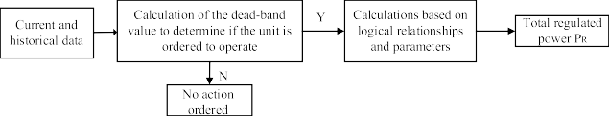 **FIGURE 2.** AGC control flow

1. **SIMULATION ANALYSIS**

Anaconda 4.7 PyCharm2021 is the experimental platform utilized in this work. The most recent version of deep forest (DF21), made public by Professor Zhou Zhihua, is utilized to train the deep forest model within the TensorFlow deep learning framework. To make the experimental implementation less challenging, the machine learning tool functions found in the scikit-learn package are called upon.

1. *EXPERIMENTAL DATA AND DATA ANALYSIS*

Using a sampling interval of two seconds per day and 43,200 sampling points per day, the experiment in this research picks data from a provincial power grid for five months, from June to August and October to November of 2018, following restoration, as the controlled data.. The controlled data combine with the DFT control strategy and PI control strategy, and the control strategy with the better effect is selected as the controller to calculate the total regulation command in each control cycle to generate the final control dataset, and the deep forest model is trained.

The control process is depicted in Fig. 3.

The specific steps are as follows:

Finding out if the unit follows the state classification model is the main goal of region I. The device can only accelerate and decelerate for 40 seconds at a time, and every 20 sample points, a control calculation is done. In order to assess the condition of the AGC unit, the four characteristic parameters at the time of judgment—∆f, area control error (ACE), CPS1 and CPS2—are made up of raw data that complies with the requirements of the deep forest network's input data and is fed into the state classification model. The unit's control state, either 1 (growing state), 1 (decreasing state), or 0, is the output of the state classification network (constant state). The AGC unit operates if the output is 0.

Determining the overall regulated power value is the main goal of area II. To obtain the regional total regulation power prediction data, the initial sample input to the state classification network is again input into the incremental regression model, with the output result of the state classification network set to 1 (incremental state). In this control cycle, no order is placed when PR < ε. When PR is greater than ε, the unit is operated at a faster rate based on the anticipated data.

FIGURE 3. AGC control flow based on deep forest

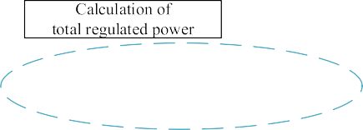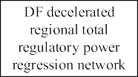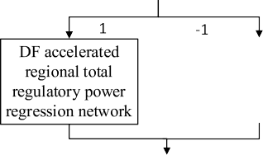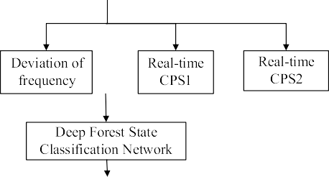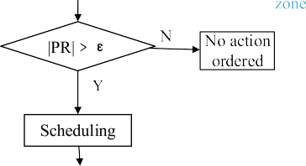

**TABLE 2.** Qualified points of each control method in December.

|  |  |  |  |  |  |
| --- | --- | --- | --- | --- | --- |
| **Status of assessment points** | | | **Control strategies** | **Min. Qualified points** | **No. of unit actions- Daily average** |
| **144** | **133-143** | **<135** |
| 3 | 15 | 12 | Without | 113 | / |
| 10 | 16 | 4 | With PI | 127 | 1167 |
| 10 | 16 | 4 | With DFT | 126 | 772 |
| 11 | 16 | 3 | With DF network | 128 | 462 |

1. *ANALYSIS OF EXPERIMENTAL RESULTS*

The findings of the simulation experiment, which was run on the restored data of a provincial grid for the first thirty days in December 2018, are displayed in the table below for the uncontrolled control, PI control, DFT control, and deep forest network control. The CPS criteria evaluate the impact of AGC control every ten minutes, with 144 assessment points allocated throughout the day for the CPS1 and CPS2 criteria. Below Table 2 and Figure 4 are the points that each control method received in December.

**FIGURE 4.** Each control method qualified points in December.

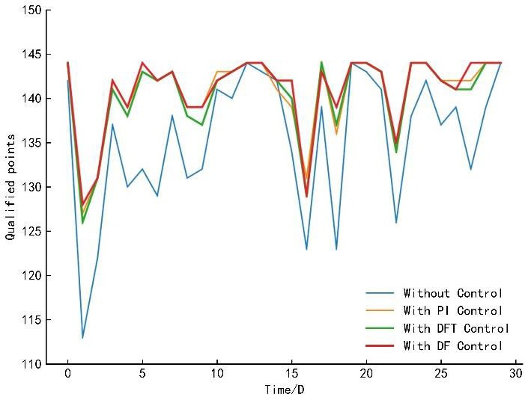

According to TABLE 2 and Fig. 4, the number of orders for DFT control is much smaller than that for PI control, and the deep forest network improves the average number of pass points per day by learning to fuse the advantages of these two control strategies. When compared to PI control and DFT control alone, the deep forest network control lowers the average daily number of orders by 60.41 percent and 40.16 percent, respectively, and the overall regulatory effect is superior. To further validate the efficacy of the approach presented in this research, use the real-time operating data from December 16, 2018, which has 43200 sample points spread over a 2 s sampling period, for simulation analysis. TABLE 3, Fig. 5 display the control impacts of the three control procedures during the course of the day on December 16.

**TABLE 3.** Simulation of each control method on December.

|  |  |  |  |  |  |
| --- | --- | --- | --- | --- | --- |
| **Qualified points** | **Control strategies** | **Qualified rate %** | **Unit actions number** | **Positive regulation (MWh)** | **Negative regulation (MWh)** |
| 139 | With PI | 96.53 | 1254 | 81.51 | -81.51 |
| 140 | With DFT | 97.22 | 817 | 18.04 | -18.09 |
| 142 | With DF network | 98.65 | 542 | 20.39 | -20.39 |

**FIGURE 5.** CPS1 comparison chart.

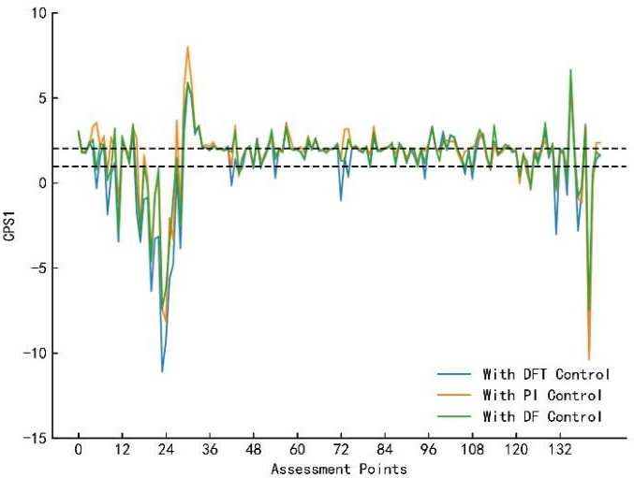

TABLE 3, Fig. 5 show that the deep forest network control strategy had 142 qualified points for the day, a qualified rate of 98.65 percent, 542 actions ordered by units, and 20.39 MWh and -20.39 MW of positive and negative unit miles throughout the day. Of these three control method effects, the Deep Forest Network control method had the most qualified points. During the 144 evaluation intervals of the day, the deep forest control strategy commands less frequently than the other two control techniques. The PI control method's enormous regulation volume and order volume verify the strategy's significant overshoot. The number of orders and the regulation volume of the DFT strategy are much lower than those of the PI control strategy because of the refinement of the total regulation power. Combining the benefits of both, the deep forest network control approach presented in this research can guarantee stable system operation while increasing the number of qualified spots with fewer commands and regulation amounts.

**TABLE 4.** Control situation of 22:10-22:20.

|  |  |  |  |
| --- | --- | --- | --- |
| **CPS1** | **CPS2** | **No. of actions** | **Control strategies** |
| 1.69 | 14.8 | 12 | With PI |
| 1.76 | 11.8 | 9 | With DFT |
| 1.93 | 3.37 | 7 | With DF network |

A standard ten-minute detail analysis is chosen on December 16 between 22:10 and 22:20. With 16 ordered points, the 10min is the 134th evaluation point of the day. Figs. 6, 7, and TABLE 4 display the outcomes of the ordered circumstances and the control impacts of the three control procedures.

**FIGURE 6.** 22:10-22:20 Change in ACE before and after control.

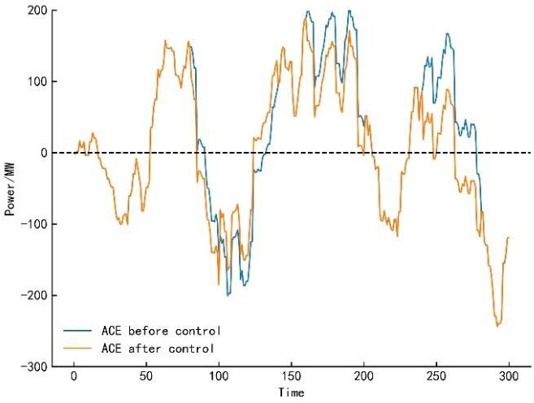

**FIGURE 7.** 22:10-22:20 CPS1 change before and after control.

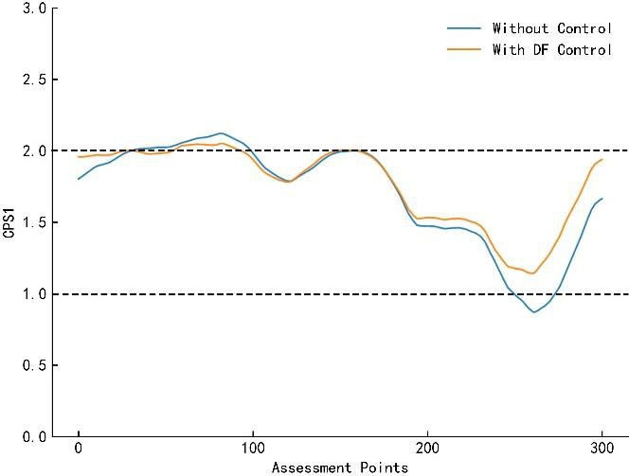

From TABLE 4, the number of orders of the deep forest network control method is smaller than that of the PI control strategy and the DFT control strategy, and its regulation power value is similar to that of the DFT control strategy and much lower than that of the PI control strategy, indicating that its control effect is better. Fig. 6 shows that the working conditions of this assessment cycle are smoother and milder, and the regional control deviation does not fluctuate much during the period. In the latter portion of the period when the area is not under control, as demonstrated by Fig. 7, the value of CPS1 is less than 1, indicating a failed assessment period. Within the parameters of the assessment pass, the deep forest network control continuously directs the deviation to be adjusted and manages the CPS indicator.

**CONCLUSION**

The power system must optimize and enhance the current

autonomous generation control method in light of the widespread grid integration of wind, solar, and other renewable energy sources as well as the rise in impact loads. This research proposes a network control strategy based on the Deep Forest algorithm, which is based on the classic PI control strategy and DFT control strategy. The following results are acquired by simulation. The strategy can complement the dominant operating conditions by learning from the excellent control data set that has been modulated by both control strategies.With fewer orders and better regulation precision, this network control technique may successfully regulate the ACE deviation within the evaluation range while avoiding frequent actions.

Deep forest networks for AGC can more successfully lower the unit's frequency regulation capacity and increase economic efficiency when compared to PI control techniques and DFT control strategies.

This paper's approach to AGC scheduling is based on a deep forest network algorithm. The grid operating modes and the quantity of the dataset used to train the deep forest model are constrained. In the future, the training of the network will become more sophisticated due to the expansion of the dataset, the use of additional control strategies to compensate for the dataset's unqualified cycles, and increased study of the control strategy of an autonomic generation control system incorporating new energy sources.

**REFERENCES**

1. K. Ullah, A. Basit, Z. Ullah, F. R. Albogamy, and G. Hafeez, ‘‘Automatic generation control in modern power systems with wind power and electric vehicles,’’ *Energies*, vol. 15, no. 5, p. 1771, Feb. 2022.
2. K. Ullah, A. Basit, Z. Ullah, S. Aslam, and H. Herodotou, ‘‘Automatic generation control strategies in conventional and modern power systems: A comprehensive overview,’’ *Energies*, vol. 14, no. 9, p. 2376, Apr. 2021.
3. A. Koehl, F. Michaud, S. Gubert, and J. Nicolas, ‘‘A generic method for the capability evaluation of hydraulic power-plant to participate to the load-frequency-control (LFC),’’ *La Houille Blanche*, no. 5, pp. 46–54, Nov. 2015.
4. M. Joshi, G. Sharma, P. N. Bokoro, and N. Krishnan, ‘‘A fuzzy-PSO- PID with UPFC-RFB solution for an LFC of an interlinked hydro power system,’’ *Energies*, vol. 15, no. 13, p. 4847, Jul. 2022.
5. A. D. Falehi, ‘‘Optimal design of fuzzy-AGC based on PSO & RCGA to improve dynamic stability of interconnected multi area power systems,’’ *Int. J. Automat. Comput.*, vol. 17, no. 4, pp. 599–609, Aug. 2020.
6. K. S. Rajesh, S. S. Dash, and R. Rajagopal, ‘‘Hybrid improved firefly- pattern search optimized fuzzy aided PID controller for automatic generation control of power systems with multi-type generations,’’ *Swarm Evol. Comput.*, vol. 44, pp. 200–211, Feb. 2019.
7. R. K. Sahu, S. Panda, and G. T. Chandra Sekhar, ‘‘A novel hybrid PSO- PS optimized fuzzy PI controller for AGC in multi area interconnected power systems,’’ *Int. J. Electr. Power Energy Syst.*, vol. 64, pp. 880–893, Jan. 2015.
8. M. Muntasir and A. Thamer, ‘‘Optimal design of automatic generation control based on simulated annealing in interconnected two-area power system using hybrid PID—Fuzzy control,’’ *Energies*, vol. 15, no. 4, p. 1540, Feb. 2022.
9. A. Behera, T. K. Panigrahi, P. K. Ray, and A. K. Sahoo, ‘‘A novel cascaded PID controller for automatic generation control analysis with renewable sources,’’ *IEEE/CAA J. Automatica Sinica*, vol. 6, no. 6, pp. 1438–1451, Nov. 2019.
10. R. Kumar and V. K. Sharma, ‘‘Automatic generation controller for multi area multisource regulated power system using grasshopper optimization algorithm with fuzzy predictive PID controller,’’ *Int. J. Numer. Model., Electron. Netw., Devices Fields*, vol. 34, no. 1, p. e2802, Jan. 2021.
11. B. Li, W. Hua, and N. Weitao, ‘‘AGC control strategy under control performance standard for interconnected power grid based on optimization theory,’’ *Proc. CSEE*, vol. 28, no. 25, pp. 56–61, Sep. 2008.
12. W. Yan, R. Zhao, X. Zhao, Y. Li, J. Yu, and Z. Li, ‘‘Dynamic optimization model of AGC strategy under CPS for interconnected power system,’’ *Int. Rev. Elect. Eng.*, vol. 7, no. 5, pp. 5733–5743, Oct. 2012.
13. X. Zhang, T. Tan, B. Zhou, T. Yu, B. Yang, and X. Huang, ‘‘Adaptive distributed auction-based algorithm for optimal mileage based AGC dispatch with high participation of renewable energy,’’ *Int. J. Electr. Power Energy Syst.*, vol. 124, Jan. 2021, Art. no. 106371.
14. X. Zhang, T. Yu, B. Yang, and L. Jiang, ‘‘A random forest-assisted fast distributed auction-based algorithm for hierarchical coordinated power control in a large-scale PV power plant,’’ *IEEE Trans. Sustain. Energy*, vol. 12, no. 4, pp. 2471–2481, Oct. 2021.
15. Z. Liu, J. Li, P. Zhang, Z. Ding, and Y. Zhao, ‘‘An AGC dynamic optimization method based on proximal policy optimization,’’ *Frontiers Energy Res.*, vol. 10, p. 969, Jul. 2022.
16. M. Elsisi and M.-Q. Tran, ‘‘Development of an IoT architecture based on a deep neural network against cyber attacks for automated guided vehicles,’’ *Sensors*, vol. 21, no. 24, p. 8467, Dec. 2021.
17. J. Liu, Y. Liu, and Q. Zhang, ‘‘A weight initialization method based on neural network with asymmetric activation function,’’ *Neurocomputing*, vol. 483, pp. 171–182, Apr. 2022.
18. M.-Q. Tran, M. Elsisi, M.-K. Liu, V. Q. Vu, K. Mahmoud,

M. M. F. Darwish, A. Y. Abdelaziz, and M. Lehtonen, ‘‘Reliable deep learning and IoT-based monitoring system for secure computer numerical control machines against cyber-attacks with experimental verification,’’ *IEEE Access*, vol. 10, pp. 23186–23197, 2022, doi: [10.1109/ACCESS.2022.3153471.](http://dx.doi.org/10.1109/ACCESS.2022.3153471)

1. L. Xi, J. Wu, Y. Xu, and H. Sun, ‘‘Automatic generation control based on multiple neural networks with actor-critic strategy,’’ *IEEE Trans. Neural Netw. Learn. Syst.*, vol. 32, no. 6, pp. 2483–2493, Jun. 2021.
2. Q. C. Zhang, J. H. Zhang, and H. Wang, ‘‘Data-driven minimum entropy control for stochastic nonlinear systems using the cumulant- generating function,’’ *IEEE Trans. Autom. Control*, Sep. 20, 2022, doi: [10.1109/TAC.2022.3208170.](http://dx.doi.org/10.1109/TAC.2022.3208170)
3. Q. C. Zhang and W. Hong, ‘‘A novel data-based stochastic distribution control for non-Gaussian stochastic systems,’’ *IEEE Trans. Autom.* *Control*, vol. 67, no. 3, pp. 1506–1513, Mar. 2022.
4. neural network with Chi-squared deep metric learning for facial expression recognition,’’ *Inf. Sci.*, vol. 608, pp. 472–488, Aug. 2022.
5. J. Jiménez-García, M. García, G. C. Gutiérrez-Tobal, L. Kheirandish- Gozal, F. Vaquerizo-Villar, D. Álvarez, F. del Campo, D. Gozal, and

R. Hornero, ‘‘A 2D convolutional neural network to detect sleep apnea in children using airflow and oximetry,’’ *Comput. Biol. Med.*, vol. 147, Aug. 2022, Art. no. 105784.

1. I. K. Gupta, A. Choubey, and S. Choubey, ‘‘Mayfly optimization with deep learning enabled retinal fundus image classification model,’’ *Comput.* *Electr. Eng.*, vol. 102, Sep. 2022, Art. no. 108176.
2. Z. H. Zhou and J. Feng, ‘‘Deep Forest,’’ *Nat. Sci. Rev.*, vol. 6, no. 1, pp. 74–86, Jan. 2019.
3. C. Concordia and L. K. Kirchmayer, ‘‘Tie-line power and frequency control of electric power systems [includes discussion],’’ *Trans. Amer. Inst. Elect.* *Eng. III: Power App. Syst.*, vol. 72, no. 3, pp. 562–572, Jun. 1953.
4. B. Li, Z. Li, and X. Bai, ‘‘AGC real-time control strategy based on DFT method,’’ in *Proc. IEEE 3rd Conf. Energy Internet Energy Syst. Integr.* *(EI2)*, Nov. 2019, pp. 1928–1932.
5. B. V. S. Acharyulu, P. K. Hota, and B. Mohanty, ‘‘CLSA-MRPID controller for automatic generation control of a three-area hybrid system,’’ *Energy* *Syst.*, vol. 11, no. 1, pp. 163–194, Feb. 2020.
6. C. Zhang, Y. He, S. Jiang, T. Wang, L. Yuan, and B. Li, ‘‘Transformer fault diagnosis method based on self-powered RFID sensor tag, DBN, and MKSVM,’’ *IEEE Sensors J.*, vol. 19, no. 18, pp. 8202–8214, Sep. 2019.
7. C. Li, Y. Tao, W. Ao, S. Yang, and Y. Bai, ‘‘Improving forecasting accuracy of daily enterprise electricity consumption using a random forest based on ensemble empirical mode decomposition,’’ *Energy*, vol. 165, pp. 1220–1227, Dec. 2018.
8. C. Wang, J. Du, and X. Fan, ‘‘High-dimensional correlation matrix estimation for general continuous data with bagging technique,’’ *Mach.* *Learn.*, vol. 111, no. 8, pp. 2905–2927, Mar. 2022.
9. D. H. Wolpert, ‘‘Stacked generalization,’’ *Neural Netw.*, vol. 5, no. 2, pp. 241–259, 1992.

 HUSSAIN SHAIK was born in Andhra Pradesh, India in 1984.He received the B.Tech degree in Electrical and Electronics engineering from Shadan College of Engineering & Technology, JNTU Hyderabad, India. He is currently pursuing the Ph.d degree with department of Electrical and Electronics engineering in Jawaharlal Nehru Technical University, Kakinada, India. His current research interests include the sustainable energy, controllers and optimization techniques.