Phytochemical analysis and antioxidant activity of vernonia anthelmintica whole plant
Dr.Sony Gurja,Assistant professor,Department of Biochemistry,St.Francis College for Women,Hyderabad

ABSTRACT

Vernonia anthelmentica is a popular medicinal plant used in local and traditional medicine to manage various disorders. Phytochemical studies have identified various constituents amongst which steroids form the most abundant class, followed by terpenes.
Crude extracts and isolated compounds exhibited various pharmacological activities such as anti-vitiligo, anti-diabetic, anti-inflammatory, antisoriatic, neuroprotective, hepatoprotective, analgesic,antipyretic, antioxidant, antiparasitic, antimicrobial, antiproliferative, immunomodulatory and helped in managing pulmonary fibrosis and promoting the synthesis of estrogen. Approximately 45 chemical constituents were found to be biologically active. All these studies were done using the seeds of the herb which are also used in culinary preparations .
The traditional and folk medicine claims that the whole plant is used in diabetes
. However, there were no reports about the efficacy of whole plant that are specific to diabetes.
So, this proposal is about evaluating the whole plant efficacy in diabetes along with phytochemical and pharmacological studies.. Aqueous, Methanol and Ethylacetate extracts are prepared from the plant sample. These extracts are used in performing the preliminary tests i.e qualitative analysis to test the presence of primary and secondary metabolites like carbohydrates,aminoacids,resins,tannins,phenols,steroids,flavonoids etc
.quantitative analysis is done by performing the total phenolic content ,total tannin content and total flavonoid content in the plant extracts using Folin–Ciocalteu reagent,potassium hexaferrocyanide and AlCl3,respectively. In addition, total antioxidant capacity of the extracts was estimated by different methods including: FRAP (ferric reducing ability in plasma ) assay, phosphomolybdate assay, total reducing power activity and DPPH (1,1-diphenyl-2 picrylhydrazyl radical).The results evidently show that the plant contains natural antioxidants in them and are very useful and sourceful for developing natural antioxidants from the plant and help the mankind.The aqueous extract of plant V.anthelmintica has abundant antioxidant properties than methanol and ethylacetate extracts comparatively.

INTRODUCTION

  - MEDICINAL PLANTS

A medicinal plant is any plant which, in one or more of its parts, contains substances that can be used for therapeutic purposes, or which are precursors for the synthesis of useful drugs. This description makes it possible to distinguish between medicinal plants whose therapeutic properties and constituents have been established scientifically, and plants that are regarded as medicinal, but which have not yet been subjected to a thorough scientific study. [1]
Medicinal plants, also called medicinal herbs, have been discovered and used in traditional medicine practices since prehistoric times. Plants synthesize hundreds of chemical compounds called phytochemicals ffunctions including defense against insects, fungi, diseases, and herbivorous mammals.
Numerous phytochemicals with potential or established biological activity have been identified.. Further, the phytochemical content and pharmacological actions, if any, of many plants having medicinal potential remain unassessed by rigorous scientific research to define efficacy and safety. [2]
According to the Botanical Survey of India, India is home to more than 8,000 species of medicinal plants. The country has a rich history of traditional healing systems, many of which list the use of these plants.
There are many medicinal plants available in India , some of them are Aloevera , Mint , Tulsi , Lime grass , coriander, carom are usually known as kitchen medicinal plants[4]. Amla (Emblica officinalis), Ashok (Saraca Asoca), Aswagandha (Withania Somnifera) , Bael / Bilva (Aegle marmelous) , Kantakari / Akranti Perennial (Solanum Xanthocarpum) etc. are some of the common medicinal plants.[5]

PHYTOCHEMICALS
Phytochemicals are chemicals of plant origin Phytochemicals (from Greek phyto, meaning "plant") are chemicals produced by plants through primary or secondary metabolism. They generally have biological activity in the plant host and play a role in plant growth or defense against competitors, pathogens, or predators.[6]
Phytochemicals are generally regarded as research compounds rather than essential nutrients because proof of their possible health effects has not been established yet. Phytochemicals under research can be classified into major categories, such as carotenoids and polyphenols, which include phenolic acids, flavonoids, stilbenes or lignans .Flavonoids can be further divided into groups based on their similar chemical structure, such as anthocyanins, flavones, flavanones, isoflavones, and flavanols. Flavanols are further classified as catechins, epicatechins, and proanthocyanidins .In total, over 25,000 phytochemicals have been discovered, and in most cases, these phytochemicals are concentrated in colourful parts of the plants like fruits, vegetables, nuts, legumes, and whole grains[7]

ANTIOXIDANT ACTIVITY

Antioxidant activity is an excellent example of a functional benefit that plant extracts can deliver. Plants are known to contain a variety of natural antioxidants that protect and preserve their physical and metabolic integrity as well as their heredity by way of their seeds.[9] Antioxidant assays are developed to evaluate the antioxidant activity of plants and food constituents vary. Therefore, to investigate the antioxidant activity of chemical(s), choosing an adequate assay based on the chemical(s) of interest is critical. [10]
Ferric reducing antioxidant power (FRAP), metal ions chelating activity, reducing power assay and scavenging activity of DPPH and ABTS radicals in aqueous and methanolic extracts obtained from plants. The antioxidant activity measured by the FRAP method of extracts from fresh samples were higher with respect to the dried samples generally. In general, the extracts of dried samples showed higher reducing power than the extracts of fresh samples and tend to show greater reducing power by aqueous than methanolic extracts. [11]
Antioxidant activity in traditional plant remedies may be one component of the traditional lifestyle that reduces the incidence of diabetes. Antioxidant activity in traditionally used plant species is a method of scientific validation of the medicinal plant use by Indigenous People. Plant species that are used traditionally for multiple symptoms could indicate a high level of antioxidant activity. A plant species that is used for heart disease, diarrhea, urinary issues, circulation, and blood disorders or blood reviver/tonic could be high in antioxidant activity. Rhus hirta, Solidago canadensis, Juniperus communis, and Picea glauca are four species of the boreal forest with high antioxidant activity and potential for further antidiabetic research. [12]
  - VERNONIA ANTHELMINTICA

Vernonia anthelmintica is a willd., an annual herb, is native to Africa, Asia temperate (China), and Asia tropical (Sri Lanka, Laos, Myanmar, Nepal, India, Pakistan) regions (Fig. 1) as indicated by Germplasm Resources Information (GRIN). It is commonly known as Purple Fleabane, has been used in local medicine to cure a wide spectrum of disorders including asthma, sores, inflammatory swellings, skin ailments, kidney troubles, itching of the eyes, and hiccough (Kirtikar and Basu, 1993; Manvar and Desai, 2012). V. anthelmintica , commonly known as Kalijiri, Somaraaji, Black cumin, or Purple Fleabane, is an annual, erect, robust pubescent herb. In India, the common name Somaraaji.[13]
.Phytochemical studies have revealed that V. anthelmintica contains fatty acids, steroids, flavonoids, sesquiterpene lactones, carbohydrates, and terpenes (Paydar et al., 2013; Srivastava et al., 2014). Phytochemical studies of V. anthelmintica have revealed the presence of 193 chemical constituents, including phenolic acids (11), chalcones (6), flavonoids (33), terpenes (42), fatty acids (33), steroids (48) and miscellaneous (20) compounds.
- anthelmintica possesses different pharmacological activities like anti-vitiligo, anti-diabetic, anti-inflammatory, antipsoriatic, anti-cholinesterase, hepatoprotective, antidepressant, analgesic, antipyretic, antiparasitic, antioxidant, antimicrobial, antiproliferative, immunomodulatory, and also helps in managing pulmonary fibrosis and promotes the synthesis of estrogen. The biological studies on parts corroborate the traditional medicinal use of the plant to treat various ailments. [14]. Vernonia anthelmintica has been widely used to treat diabetes, gastrointestinal problems, and skin ailments etc. Although, different parts of the medicinal plant like roots, leaves and seeds have been utilized but seeds seem to be the most frequently employed part of V. anthelmintica in local medicine but there is no work on whole plant which is why we are working to explore medicinal properties in whole plant .The phytochemical studies revealed 193 chemical compounds with dominancy of steroids and their derivatives. In most of the studies, seeds have been explored.[15].
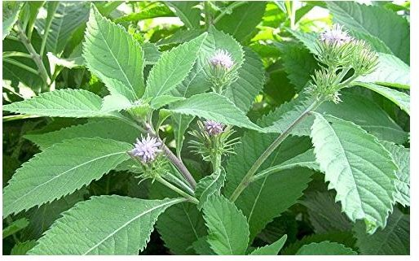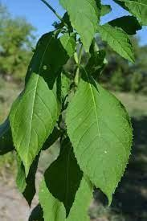

FIGURE NO- 1.1 Vernonia anthelmintica plant

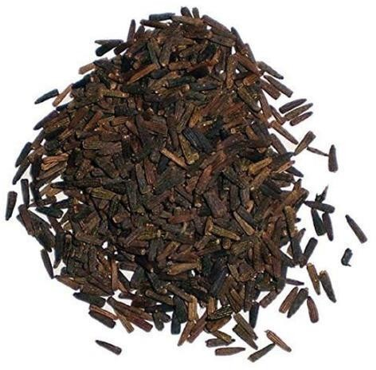
FIGURE NO- 1.2 Seeds of Vernonia anthelmintica plant

MATERIALS AND METHODS

Collection of plant sample:

The selected plant Vernonia anthelmintica are collected from PRAGATI RESORTS NURSERY,Hyderabad.

Sample preparation:

The collected plant saplings were planted and allowed to grow for some days with sufficient sunlight and water.The plants were then allowed to shadow dry after the required growth.Their leaves, roots, stems and branches where collected after shade drying.

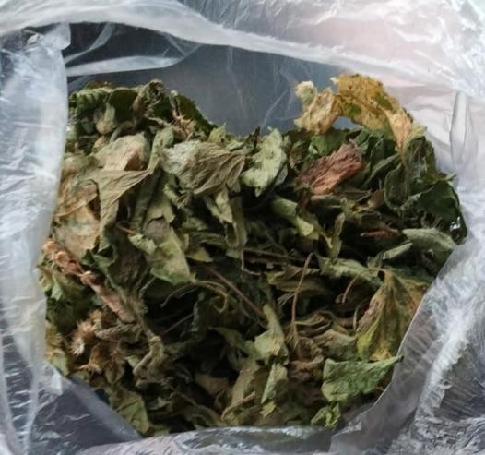
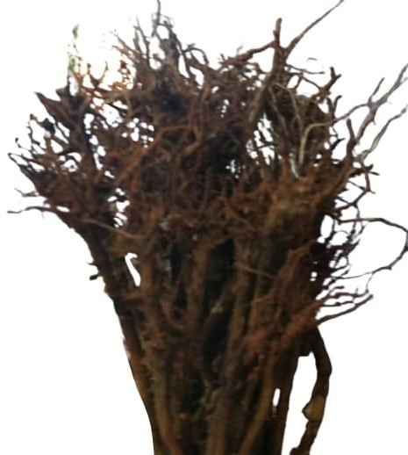
FIGURE NO-3.1 Dried leaves and flowers FIGURE NO-3.2 Dried roots and stems.

The collected plant parts where cut into pieces and grinded into fine powder.The powder was collected into to a container to avoid contamination.

Preparation of extracts:

    - 3.41 Aqueous sample extraction:
- 10g of plant extract is taken a conical flask and to this 100ml of distilled water is added.The conical flask was allowed to heat for half an hour and left for cooling.The plant extract was filtered using funnel and blotting paper.
The filtrate was used for further analysis.

3.42 Methanol and ethylacetate extract sample extraction:
- 15g of plant extract was taken in a round bottomed flask and 250ml of methanol solution is added to it.
The round bottomed flask is placed in the heat source and the whole apparatus is fixed properly for soxhlating the sample.The extracted was boiled at 60°C as the boiling point of methanol is 64.7°C.The extract was allowed to air dry and finally dried powder was collected.

PHYTOCHEMICAL QUALITATIVE ANALYSIS: [17]

  - QUALITATIVE ANALYSIS OF PRIMARY METABOLITES:

3.6 QUANTITATIVE ANALYSIS

  - TOTAL PHENOLIC CONTENT: [18]

- Take 200µl of aqueous extract in a test tube
(NOTE: Aqueous plant extract is prepared by taking 0.1g of powdered plant sample and dissolved in 4ml distilled water.)
- Add 1.5 ml of Folin- Ciocalteu reagent which is already diluted 10 fold with distilled water.
- Incubate the test sample for 5 minutes at room temperature.
- Now add 1ml of sodium bicarbonate and incubate it for 90 min at room temperature.
- Absorbance of the sample is measured at 440nm.

QUANTITATIVE TEST FOR TANNINS: [19]

PROCEDURE:

- Take two test tubes and label them as aqueous and methanol.
- Add 5 ml of aqueous extract and 1ml of methanol extract (make up to 5ml with distilled water).
(NOTE: Aqueous plant extract is prepared by taking 0.1g of powdered plant sample and dissolved in 4ml distilled water.
50mg of methanolic plant extract is obtained after soxhlating .to this 50mg sample 10ml of DMSO is added . This sample is used for quantitative analysis of tannins.)
- Add 0.5 ml of 0.1M ferric chloride and 0.5ml of 0.1M HCl to the plant extracts.
- Absorbance of the plant extracts are measured at 600nm.

QUANTITATIVE TEST FOR FLAVINOIDS: [20]

PROCEDURE:

    - Take 100µl of Aqueous extract in the test tube and make up to 1ml with distilled water.
    - Add 150µl of sodium nitrate (NaNO3) and then incubated for 5 minutes at room temperature.
    - Now add 150µl of Aluminium Chloride(AlCl3) and incubated for 6 minutes at room temperature.
    - Add 2ml of sodium hydroxide (NaOH) and make the complete sample into 4 ml by adding distilled water.

3.7 TESTS FOR ANTIOXIDANTS

3.71 FRAP (FERRIC ION REDUCING ANTIOXIDANT POWER) ASSAY: [21]

- Firstly, plant extracts should be prepared as following-
- Aqueous plant extract is prepared by taking 0.1g of powdered plant sample and dissolved in 4ml distilled water.
- Methanol plant extract is prepared by taking 0.1g of powdered plant sample and dissolved in 4 ml of methanol.
- Ethyl acetate extract is prepared by taking 0.1g of powdered plant sample and dissolve it in 4ml of Ethyl Acetate.
- Take three test tubes and label them as aqueous, methanol and ethyl acetate.
- The FRAP reagent is prepared in 10:1:1 ratio (Acetate buffer: TPTZ: ferric chloride).
- 300µlof plant extracts are added to the respective labelled test tubes and diluted with distilled water making upto 1 ml.
- To each labelled test tube 3 ml of FRAP reagent is added.
- Absorbance is taken at 570nm at two different time intervals.

PHOSPHOMOLYBDATE ASSAY: [22]

PROCEDURE:

- Take three test tubes and label them as aqueous, methanol and ethyl acetate.
- Add 0.1ml of plant extract to each test tube respectively and add 1ml of phosphomolybdate reagent to it.
- Now cap the test tubes and incubate in water bath at 95°C for 90 minutes.

- Cool the samples to the room temperature and then measure the absorbance of the mixture at 440nm.

TOTAL REDUCING POWER ACTIVITY: [23]

PROCEDURE:

- Take three test tubes and label them as aqueous, methanol and ethyl acetate.
- Add 1 ml of plant extract to the respective test tubes.
- Then to this add 0.5 ml of phosphate thiocyanate, later add 0.5ml of sodium phosphate buffer to it.
- Now incubate the test samples for 20 minutes at 50°C at room temperature then allow it to cool.
- Then add 0.25 ml of tricarboxylic acid (TCA)to it.
- Now collect 0.25ml of supernatant from the sample test tubes and add 2.5ml of distilled water, then add 0.25ml of ferric chloride to it.
- Absorbance of the samples are measured at 570nm.

DPPH – RADICAL SCAVENGING ACTIVITY: [24]

PROCEDURE:

- Take three sets of test tubes, each set containing five test tubes.
- Label all the sets of test tubes accordingly.
- Add the plant extracts in different concentrations in each test tube set.
- Now add 1ml of DPPH Reagent in each test tube set and make up with the distilled water accordingly.
- The sets of the samples are incubated for 30 minutes in dark.
- Absorbance is measured at 440nm for aqueous and methanol extracts, and at 420nm for ethyl acetate extracts.

RESULTS AND DISCUSSIONS
  - PHYTOCHEMICAL TESTS:

Our results with various phytochemical tests are shown below in table -4.1. the results showed that the plant extracts of vernonia anthelmintica are rich in carbohydrates, proteins, resins, tannins, phenols, flavonoids, quinones, phtosterols, steroids, terpinoids and coumarins in both primary metabolites and secondary metabolites. Other phytochemicals like gums and mucilage, fattyacids anthraquinones, alkaloids, glycosides, saponins, xanthoproteins, triterpinoids and anthocyanins are absent. Many phytochemicals are abundantly present in aqueous extract of Vernonia anhelmintica. The presence of phytochemicals in vernonia plant follows the order as -
AQUEOUS > METHANOL > ETHYLACETATE.

PRELIMINARY PHYTOCHEMICAL ANALYSIS IN AQUEOUS , METHANOL AND
ETHYLACETATE EXTRACTS OF VERNONIA ANTHELMINTICA PLANT
TEST | AQUEOUS | METHANOL | ETHYLACETATE
Test for  carbohydrates | + | + | +
Test for Starch | + | + | +
Test for proteins | + | + | +
Test for amino acids | + | + | +
Test for fatty acids | - | - | -
Test of resins | + | + | +
Gums and mucilage | - | - | -
Carboxylic acids | - | - | -
Test for  anthraquinones | - | - | -
Test for quinones | + | - | -
Test for alkaloids | - | - | -
Test for glycosides | - | - | -

Test for cardiac  glycosides | - | - | -
Test for phenol | + | - | -
Test for polyphenols | + | - | -
Test for tannins | + | + | -
Test for Flavonoids | + | - | -
Test for phytosterols | + | + | +
Test for saponins | - | - | -
Test for steroids | + | + | +
Test for  xanthoproteins | - | - | -
Test for Terpenoids | + | + | +
Test for triterpenoids | - | - | -
Test for anthocyanins | - | - | -
Test for Coumarins | + | + | +

Table – 4.1 preliminary qualitative tests
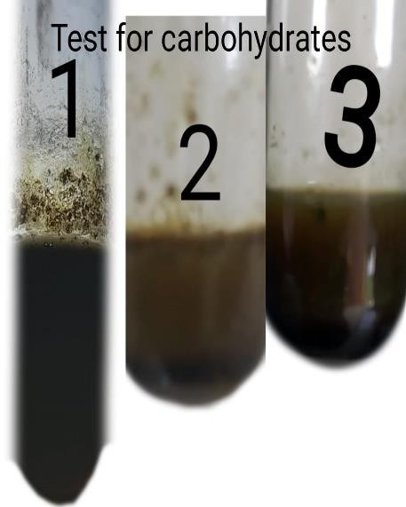 | 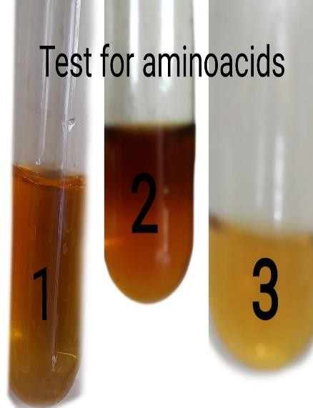 | 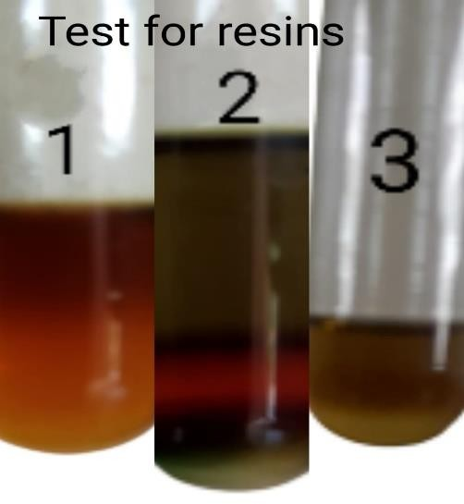

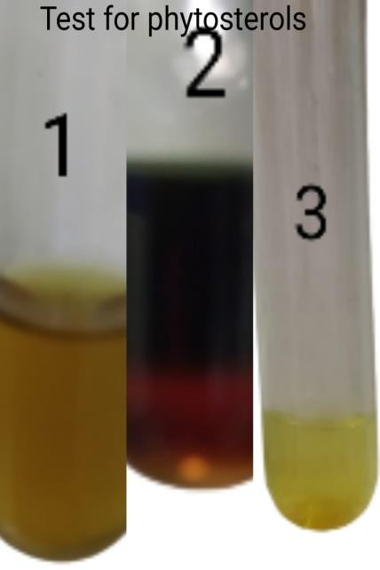 | 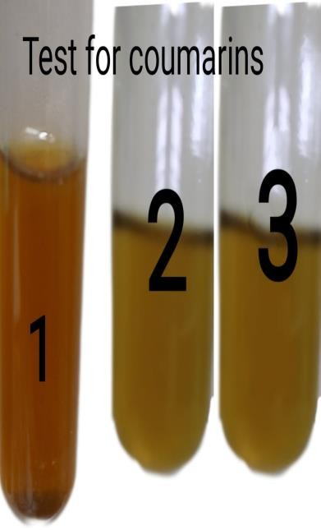 | 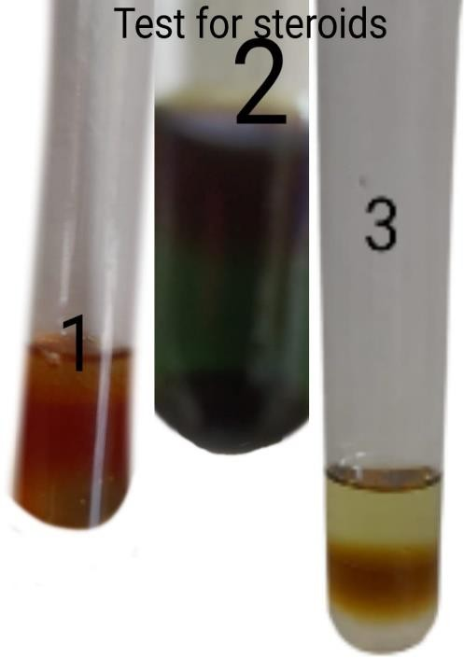

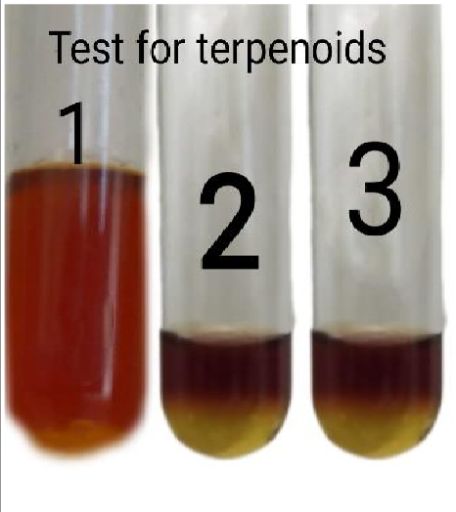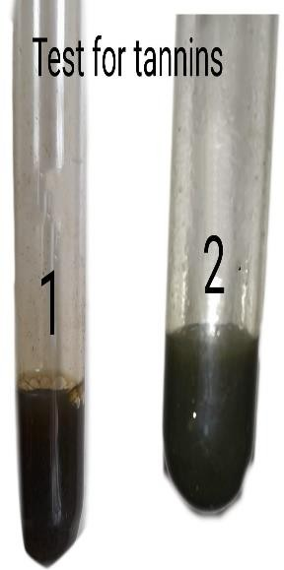
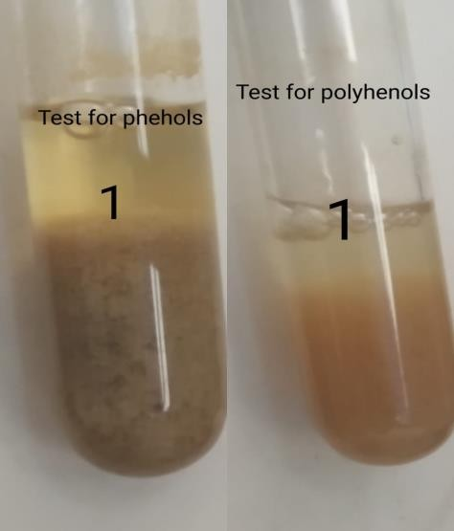
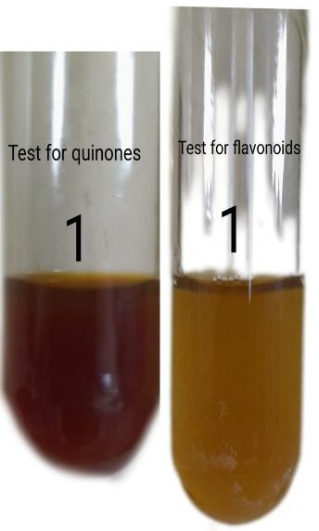
s

FIGURE NO-4.1 Preliminary tests for plant extracts. NOTE:
    - 1 indicates Aqueous extract.
    - 2 indictates Methanol extract.
    - 3 indicates Ethylacetate extract.

QUANTITATIVE ANALYSIS

  - TOTAL PHENOLIC CONTENT:
Total phenolic contents in different extracts of Vernonia anthelmintica were determined by Folin– Ciocalteu (F–C) method using gallic acid as the standard. The absorbance values obtained at different concentrations of gallic acid were used for the construction of calibration curve. the results show that the TPC values for standard gallic acid is more when compared with that of the aqueous sample.
ABSORBANCE

TOTAL PHENOLIC CONTENT
S.NO | CONC(µl) | ABSORBANCE
1 | 25 | 0.905
2 | 50 | 1.182
3 | 75 | 1.54
4 | 100 | 1.722
5 | 125 | 1.912

Table -4.2 Total phenolic content
TOTAL PHENOLIC CONTENT
2.5
y = 0.0177x
R² = 0.3379
2

1.5

1

0.5
STANDARD
AQUEOUS SAMPLE
0
0
50
100
150
Linear (STANDARD)
CONCENTRATION (µg)

TOTAL TANNIN CONTENT:
ABSORBANCE

The total tannin content was measured spectrophotometrically using potassium hexaferrocyanide colorimetric assay. It is estimated using tannic acid as a standard or positive control. Different concentrations of tannic acid was used to construct the calibrate curve. The results show that the tannin content increase as the concentration increases. Methanol extract has more tannin content when compared to that of aqueous extract.

TOTAL TANNIN CONTENT
S.NO | CONC(µg) | ABSORBANCE
1 | 1 | 0.302
2 | 2 | 0.611
3 | 3 | 0.912
4 | 4 | 1.227
5 | 5 | 1.534

Table -4.3 Total tannin content
QUANTITATIVE TEST FOR TANNINS
1.8
1.6
1.4
1.2
1
0.8
0.6
0.4
0.2
0
y = 0.3061x
R² = 0.9999
standard
AQUEOUS SAMPLE METHANOL SAMPLE
Linear (standard)
0123456
CONCENTRATION(µg)

TOTAL FLAVINOID CONTENT:
ABSORBANCE

The content of total flavonoid of the different plant extracts measured spectrophotometrically by using the aluminium chloride colorimetric assay. Rutin is used as standard at different concentrations to construct the calibration curve. The flavonoid content increases as the concentration of standard increases. The aqueous extract showed the maximum flavonoid content when compared to the standard.

TOTAL FLAVINOID CONTENT
S.NO | CONC(µg) | ABSORBANCE
1 | 1 | 0.015
2 | 2 | 0.017
3 | 3 | 0.019
4 | 4 | 0.021
5 | 5 | 0.023

Table -4.4 Total flavonoid content
QUANTITATIVE TEST FOR FLAVINOIDS
0.03

0.025
y = 0.0055x
R² = -2.841
0.02

0.015

0.01
O.D at 520nm
AQUEOUS SAMPLE
Linear (O.D at 520nm)
0.005

0
0
2
4
6
8
CONCENTRATION(µg)

4.3 ANTIOXIDANT ASSAYS:

  - FRAP (FERRIC REDUCING ABILITY IN PLASMA) ASSAY:

The reducing power of Fe²⁺ by selected plants was evaluated. Like the radical scavenging activity, all of the extracts from the selected plant Vernonia anthelmintica showed concentration-dependent reducing power. The greatest reducing antioxidant power was recorded aqueous extract followed by methanol and ethylacetate extracts as compared to standard ferric sulphate. The transformation ability of compounds from Fe3+/ferricyanide complex to Fe2+/ferrous form acts as a potential indicator for antioxidant activity [25]. In the FRAP assay, the yellow colour test solution changes to green and blue depending on the reduction capacity of extracts or compounds [26,27]. The presence of reductants in the test solution reduces Fe3+ to Fe2+, which can be monitored by measurement of Perl’s Prussian blue colour at 700 nm [28]. The FRAP assay of antioxidants is convenient, reproducible and linearly concentration-dependent [29].

FRAP ASSAY
S.NO | CONC(µg) | ABSORBANCE
1 | 13.16 | 0.158
2 | 19.74 | 0.267
3 | 2.32 | 0.372
4 | 32.9 | 0.495
5 | 39.48 | 0.597

Table -4.5 FRAP Assay
ABSORBANCE

TOTAL REDUCING POWER ACTIVITY:
FRAP
1.6
y = 0.015x
R² = 0.0513
1.4
1.2
1
0.8
0.6
0.4
0.2
O.D at 570nm
AQUEOUS SAMPLE METHANOL SAMPLE ETHYL ACETATE SAMPLE
Linear (O.D at 570nm)
0
0
20
40
60
80
100
CONCENTRATION (µg)

The reducing properties are generally associated with the presence of reductones which have been shown to exert antioxidant action by breaking the free radical chain by donating a hydrogen atom. Reducing power of Vernonia anthelmintica plant extracts was potent and the power of the extract was increased with quantity of sample. For the measurements of the reductive ability, the transformation of Fe³⁺ to Fe²⁺ was investigated in extract as described by Oyaizu et al [30]. The reducing power was increased with increasing the concentration of extract. The absorbance values of the increased concentration of the extracts were given in table 4.32. The absorbance of different extracts at 700 nm were increasing which were almost similar, indicating that compounds containing reducing properties were present in all these extracts.
TOTAL REDUCING POWER ACTIVITY
S.NO | CONC(µg) | ABSORBANCE
1 | 1 | 0.001
2 | 2 | 0.002
3 | 3 | 0.003
4 | 4 | 0.006
5 | 5 | 0.008
0.25

0.2
REDUCING POWER ACTIVITY
y = 0.0014x R² = 0.9005
O.D at 570nm
0.15
AQUEOUS SAMPLE
0.1

0.05
METHANOL SAMPLE
0
0
50
100
150
CONCENTRATION(µg)
ETHYL ACETATE
SAMPLE
Linear (O.D at 570nm)
ABSORBANCE

Table -4.6 Total Reducing Power Activity
REDUCING POWER ACTIVITY
0.01
0.008
y = 0.0014x
R² = 0.9005
0.006
0.004
0.002
O.D at 570nm
Linear (O.D at 570nm)
0
0
2
4
6
CONCENTRATION(µg)
ABSORBANCE

PHOSPHOMOLYBDATE ASSAY:
ABSORBANCE

This assay is based on the reduction of phosphomolybdate ion in the presence of an antioxidant resulting in the formation of a green phosphate which is measured spectrophotometrically [31].
Table 4.33 shows antioxidant capacity of Vernonia anthelmintica in the order of
methanol > aqueous > ethyl acetate extracts. The methanol exttract showed high antioxidant capacity followed by the aqueous and ethylacetate. However, the antioxidant activity of ascorbic acid, a known antioxidant used as the positive control.

PHOSPHOMOLYBDATE ASSAY
S.NO | CONC(µg) | ABSORBANCE
1 | 10 | 0.258
2 | 20 | 0.589
3 | 30 | 0.794
4 | 40 | 0.985
5 | 50 | 1.251

Table -4.7 Phosphomolybdate assay
PHOSPHOMOLYBDATE ASSAY
1.4
y = 0.0255x
R² = 0.9845
1.2
1
standard
0.8
0.6
AQUEOUS SAMPLE
0.4
METHANOL SAMPLE
0.2
0
ETHYL ACETATE SAMPLE
0102030405060
CONCENTRATION(µg)
Linear (standard)

DPPH-RADICAL SCAVENGING ACTIVITY:

DPPH radical is a stable organic free radical with an absorption band at 517 nm. It loses this absorption when accepting an electron or a free radical species, which results in a visually noticeable discoloration from purple to yellow. It can accommodate many samples in a short period and is sensitive enough to detect active ingredients at low concentrations [32]. Table
4.334 shows the DPPH scavenging activities of the extracts in a concentration-dependent manner. The extract obtained by ethylacetate yielded the highest DPPH radical scavenging activity at concentrations ranging from 0.305μg/mL to 0.397μg/mL. However, DPPH radical scavenging activity of aqueous and methanol are significantly similar and different from ethylacetate extract. All extracts obtained by using a methanol and ethylacetate gave stronger radical scavenging capacity than that of the water extract.

DPPH -RADICAL SCAVENGING ACTIVITY
s.no | conc(µg) | Aqueous | Methnol | Ethylacetate
1 | 0.4 | 0.239 | 0.253 | 0.305
2 | 0.8 | 0.243 | 0.282 | 0.348
3 | 1.2 | 0.253 | 0.287 | 0.388
4 | 1.6 | 0.269 | 0.301 | 0.393
5 | 2 | 0.272 | 0.309 | 0.397

Table -4.8 DPPH – radical scavenging activity
DPPH - RADICAL SCAVENGING
ACTIVITY
0.5

0.4

0.3

0.2

0.1
Aqueous
Methnol Ethylacetate
0
0.4
0.8
1.2
1.6
2
CONCENTRATION(µg)
ABSORBANCE

DISCUSSIONS:

The chemical constituents in the plants or crude extracts are known to be biologically active ingredients. Some chemical constituents are considered as secondary metabolites components. They are directly responsible for different activity such as antioxidant. [33]. All these secondary metabolites components showed antioxidant through different mechanism. Normally these secondary metabolites components were isolated from the different plant extracts [34]. The phytochemical screening of aqueous, ethylacetate and methanol extracts from dry powder leaves samples of V.anthelmintica used in this present study. The extracts revealed that the crude extracts contained flavonoids, tannins, phenols, phytosterols, terpinoids, coumarins, resins and
steroid compounds. The screening of the aqueous extracts studied were showed the presence of active constituent flavonoids. Alkaloids, anthraquinones, gums and mucilage, fattyacids,saponins,carboxylic acids and glycosides were not present in all extracts. Tannins were present in aqueous and methanol extracts of V.anthelmintica. The most important bioactive compounds phenols were found in aqueous extracts. Therefore, the detected different bioactive compounds in the different crude may be responsible for the antioxidant activity of the plant extracts. Several authors already reported on flavonoids groups exhibited a wide range of biological activities such as antioxidant, anti-inflammatory, antimicrobial, anti-angionic, anticancer and anti-allergic [35]. Tannins are phenolic compound and their derivatives are also considered as primary antioxidants or free radical scavengers [36].
Natural antioxidants present in plants are responsible for inhibiting or preventing the harmful consequences of oxidative stress. DPPH assay among many other assays is one of the convenient methods for determining the antioxidant potential of plants. The presence of antioxidant substances containing hydrogen-donating groups such as flavonoids and phenols causes the methanolic DPPH solution to get reduced due to the formation of non radical [37]. Apart from antioxidant properties, flavonoids and other phenolics also exhibit several biological activities such as antimicrobial, antiviral, and anticancer [38]. These biological and pharmacological activities are usually associated with their ability of binding proteins and free radical scavenging properties [39].
The antioxidant properties are found in many plants using same mechanisms or tests. Many plants have medicinal values present in them and researches are still going on search of identifying new medicinal plants to help the mankind. Our present work on the whole plant extract of Vernonia anthelmintica is once such trial to find the medicinal values in complete plant extract instead of individual extracts of plant parts. Our results after performing differents tests evidently show the presence of natural antioxidants present in different extracts. Among the 3 extracts from Vernonia anthelmintica , aqueous extract was containing highest amount of phenols,tannins and flavonoids. In previous several studies on flavonoids contents, their findings has been reported similar trend [40]. The difference of results obtained might possibly be due to the different method of extraction and solvents polarities. During the samples processing and drying, may be some volatiles active compounds destroyed or evaporated from the samples.

Medicinal plants are the best sources for chemical ingredients, antimicrobial and antioxidant agents for cure of different diseases. The aqueous and methanol crude extracts from Vernonia anthelmintica showed good amounts of total phenol ,tannins and flavonoids contents and these extracts could be used as antibiotics or different aliments.

CONCLUSIONS

The present investigation demonstrates total phenolic, flavonoid and tannin content of whole plant extracts of Vernonia anthelmintica . Preliminary phyto-chemical analysis of solvent extracts of V.anthelmintica revealed the presence of various phyto-chemicals such as phytosterols, terpenoids, flavinoids, quinones, anthraquinones, resins, tannin, reducing sugars, phenols and steroids. In this study, three kinds of solvents aqueous, methanol and ethyl acetate extracts from Vernonia anthelmintica were used to examine the effects of extraction solvent on total phenol, flavonoid content, tannin content and antioxidant activity of the extracts. Among three extracts, aqueous extract shows maximum total phenolic, flavonoid and tannin content. We found that the extraction yield increased with increasing the polarity of solvents. The TPC, TFC, TTC values, and antioxidant activity -studied by DPPH, FRAP assay, phosphomolybdate assay and total reducing power activity were high for intermediate-polarity-solvent extracts. Aqueous is considered a good solvent for extracting phenols, polyphenols and other metabolites in this plant besides commonly used solvents such as methanol and ethylacetate. This study, thus, indicates that the extracts obtained from whole plant of v.anthelmintica can be used for development of clinically important natural drug compounds .Further studies are needed to clarify the bioactive compounds individually and understand the mechanism of action for the substances fully drugs and antidiabetic activity presence in Vernonia anthelmintica.

REFERENCES
    - Sofowora, A. (2008). Medicinal Plants and Traditional Medicine in Africa'. 3rd edn. Ibadan: Spectrum Books.
    - Ahn, K. (2017). "The worldwide trend of using botanical drugs and strategies for developing global drugs". BMB Reports. 50 (3): 111–116. doi:10.5483/BMBRep.2017.50.3.221. PMC 5422022. PMID 27998396
    - Breslin, Andrew (2017). "The Chemical Composition of Green Plants". Sciencing, Leaf Group Ltd.
Molyneux, RJ; Lee, ST; Gardner, DR; Panter, KE; James, LF (2007). "Phytochemicals: the good, the bad and the ugly?". Phytochemistry. 68 (22–24): 2973–85. doi:10.1016/j.phytochem.2007.09.004. PMID 17950388.
Harborne, Jeffrey B.; Baxter, Herbert; Moss, Gerard P., eds. (1999). "General Introduction". Phytochemical dictionary a handbook of bioactive compounds from plants (2nd ed.). London: Taylor & Francis. p. vii. ISBN 9780203483756.

    - Corvallis, & Oregon. (2017) "Phytochemicals". Micronutrient Information Center, Linus Pauling Institute, Oregon State University.
Heneman, Karrie; & Zidenberg-Cherr, & Sheri (2008). "Publication 8313: Phytochemicals" (PDF). University of California Cooperative Extension.
Corvallis, & Oregon. (2017) "Carotenoids". Micronutrient Information Center, Linus Pauling Institute, Oregon State University.
Corvallis, & Oregon. (2017) "Flavonoids". Micronutrient Information Center, Linus Pauling Institute, Oregon State University.
    - Yancui Huang,& Indika Edirisinghe. (2016) " Phytochemicals". Reference Module in Food Science.
    - Cindy K. Angerhofer, &Paolo U. Giacomoni, (2009) in Skin Aging Handbook. [10] Agric, J. (2009) Food Chem. 57(5):1655-66. doi: 10.1021/jf803537k.
- Arbaayah, H. H., and Umi, K. Y. (2013). Antioxidant properties in the oyster mushrooms (Pleurotus spp.) and split gill mushroom (Schizophyllum commune) ethanolic extracts.
Mycosphere 4, 661–673. doi: 10.5943/mycosphere

- McCune, L.M. (2013) Bioactive Food as Dietary Interventions for Diabetes.

- Ethnopharmacol, J.& Ijaz, F. (2016) Investigation of traditional medicinal floral knowledge of Sarban hills, Abbottabad, KP, Pakistan.
- Ethnopharmacol, J. & Hussain, A. (2008). An account of the botanical anthelmintics used in traditional veterinary practices in Sahiwal district of Punjab, Pakistan.
- Skinner,W. &John L. Strother. National Plant Data Center., University Herbarium, University of California, 1001 Valley Life Sciences.
- https://www.rsc.org/publishing/journals/prospect/ontology.asp?id=CMO:0001609&MSID
=B21

- Harborne, J.B. ( 2005). Phytochemical Methods. Analysis. A Guide to Modern Techniques of Plant.
- Velioglu, Y.S., Mazza,G., Gao,L ,,Oomah, BD.(1998). Antioxidant activity and total phenollics in selected fruits,vegetables and grain products. Argic, J food chem., 46 (10):4113- 4117
- Macedonia, R., (2005). In vitro antioxidant activity of some Teucrium species (Lamiaceae). Acta pharm, 55:207-214
- Macedonia, R., (2005). In vitro antioxidant activity of some Teucrium species (Lamiaceae). Acta pharm, 55:207-214
- Benzie IF, Strain JJ. (1996) The ferric reducing ability of plasma (FRAP)as a measure of “antioxidant power”: the FRAP ssay. Anal Biochem.15;239(1):70-6
- Umamaheshwari M, Chatterji TK. (2008) In vitro antioxidant activities of the fractions of Coccinnia grandis L. leaf extract. Afr J Trad Compl Altern Med. 5-61-73.
- Yildirim, A. Mavi, A. (2001) & Determination of antioxidant and antimicrobial activities of Rumexcrispus L. extracts. J Agric Food Chem.
- M.A., Yonamine, M.& Aniya,y.(1999). Free –radical scavenging action of medicinal herbs from Ghana: Thonningiasanguinea on experimentally – induced liver injuries. General Pharmacology: The Vascular System,32(6):661-667
- Meir, S.; Kanner, J.; Akiri, B.; Philosoph-Hadas,S. (1995) Determination and involvement of aqueous reducing compounds in oxidative defense systems of various senescing leaves. J. Agric. Food Chem. 43, 1813–1819.
- Ferreira, I.C.; Baptista, P.; Vilas-Boas, M.; Barros, L. (2007) Free-radical scavenging capacity and reducing power of wild edible mushrooms from northeast Portugal: Individual cap and stipe activity. Food Chem. 100, 1511–1516.
- Zou, Y.; Lu, Y.; Wei, D. (2004) Antioxidant activity of a flavonoid-rich extract of Hypericum perforatum L. in Vitro. J. Agric. Food Chem. 52, 5032–5039.
- Amarowicz, R.; Pegg, R.; Rahimi-Moghaddam, P.; Barl, B.; Weil,J. (2004)Free-radical scavenging capacity and antioxidant activity of selected plant species from the Canadian prairies. Food Chem. 84, 551–562.
- Benzie, I.F.; Strain, J.J. (1996) The ferric reducing ability of plasma (FRAP) as a measure of “antioxidant power”: The FRAP assay. Anal. Biochem. 239, 70–76.
- Singleton VL, Orthofer R, Lamuela Raventos RM. (1999) Analysis of total phenols and other oxidation substrates and antioxidants by means of Folin Ciocalteu reagent. Methods Enzymol; 299:152 78.
- Prieto P., Pineda M., Aguilar M. (1999) Spectrophotometric quantification of antioxidant capacity through the formation of a phosphomolybdenum complex: specific application of vitamin E. Anal Biochem. 269(2):337–341.
- Hseu,Y.C., Chang,W.H., Chen,C.S., et al. (2008) Antioxidant activities of toona sinensis leaves extracts using different antioxidant models.Food Chem Toxicol. pp. 105-114.
- Hossain,M.A ., Nagooru M.R. (2011) Biochemical profiling and total flavonoids contents of leaves crude extract of endemic medicinal plant Corydyline terminalis L. Kunth. Pharmacogn
J. 2011;3(24):25–30

Harborne, J.B.(1998) Phytochemical methods: A guide to modern techniques of plant analysis. 2nd ed. London: Chapman and Hall; pp. 54–84.
Kokate, K.C., Vallabh Prakashan .(1997). Practical pharmacognosy; 4th ed. Delhi.

- Hossain MA, Muhammad MD, Charles G, Muhammad I. (2011) In vitro total phenolics, flavonoids contents and antioxidant activity of essential oil, various organic extracts from the leaves of tropical medicinal plant Tetrastigma from Sabah. Asian Pac J Trop Med. 4(9):717–721.
- Anyasor, G.N., Ogunwenmo,K.O., Oyelana ,O.A., Akpofunure, B.E. (2010) Phytochemical constituents and antioxidant activities of aqueous and methanol stem extracts of Costus afer Ker Gawl (Costaceae) Afr J Biotechnol. 9(31):4880–4884.
- Chao, P.D.L., Hsiu,S.L., Hou ,Y.C.(2002) Flavonoids in herbs: Biological fates and potential interactions with xenobiotics. J Food Drug Anal.10(4):219–228.
- Mensour, F.S., Menezes, G.G., Leitao, A.S., Reis, T.C., Dos Santos, and C. S. Coube. (2011) “Screening of Brazilian plant extracts for antioxidant activity by use of DPPH free radical method,” Phytotherapy Research, vol. 15, pp. 127–130.

- Havsteen,B.H. (2002) “The biochemistry and medical significance of flavonoids,” Pharmacology & Therapeutics, vol. 96, no. 2-3, pp. 67–202.
- Fotie, J. (2008) “The antiprotozoan potential of flavonoids: a review,” Pharmacognosy Reviews, vol. 2, no. 3, pp. 6–19.
- Rota, M.C., Herrera ,A., Martinez ,R.M., Sotomayor, J.A., Jordan, M.J.(2008) Antimicrobial activity and chemical composition of Thymus vulgaris, Thymus zygis and Thymus hyemalis essential oils. Food Control.
Ozguven ,M., Tansi ,S. (1998) Drug yield and essential oil of Thymus vulgaris L. as in influenced by ecological and ontogenetical variation. Turk J Agr Forest.

