***Review article:***

**An Overview Formulation and Evaluation of Herbal Suncreen Cream**

Ravindra Rohokale*, Ajay Sharma, Tushar Rode, Sabale Ankush

Final Year B. Pharmacy, Shri Swami Samarth Institute of Pharmacy, Malwadi (Bota), 422602, (MH), India.

**Akash shelke (M.pharm)**

Guide, Department of Pharmaceutical Quality Assurance, Shri Swami Samarth Institute of Pharmacy,

Malwadi (Bota), 422602, (MH), India.

**\*Corresponding author:**

Mr- Rohokale Ravindra Dattatray

Final Year B. Pharm

Shri Swami Samarth Institute of Pharmacy,

Malwadi (Bota), 422602, Maharashtra, India.

E-mail- ravirohokale2001@gmail.com

Tel: 7218523148

**“Formulation and Evaluation of Herbal Suncreen Cream”**

**Abstract:**

Sunscreen is a chemical substance that aids in UV radiation protection. UV B radiation is what causes sunburn, while UV A may do greater harm to the skin. The optimal sunscreen should obstruct both wavebands. The purpose of this study was to create a topical herbal sunscreen formulation using a combination of medicinal herbs and some fixed oils. Frequent use of sunscreen prevents melanoma, squamous cell carcinoma, and actinic keratosis from developing. Chemicals in sunscreen can be either organic or inorganic. Sunblock lotion is another name for sunscreen. Products that shield skin from UV rays by reflecting or absorbing them. Sunscreen use has increased due to the rising incidence of skin cancer and the photodamaging effects of UV radiation.

Which have demonstrated positive results in symptom reduction. Sunscreen ingredients should be completely safe, chemically inert, non-irritating, non-toxic, photo stable, and able to shield the skin from sun harm.

**Introduction:**

Herbal sunblock is another name for herbal sunscreen. Herbal sun protection lotion is a type of lotion, spray, or other topical treatment that helps shield the skin from UV radiation from the sun and

**1) Physical sunscreen**

Those that let in sunlight reflection.

**2) Chemical sunscreens**

Those are UV light-absorbing. Sunscreen agents should only be applied externally. the application of sunscreen as a UV protection photoprotectant. the topically applied sunscreen compositions that shield the treated region from sunburn Sunscreen's capacity to prevent UV-induced sunburns and their chemopreventive properties are dependent upon each other. Various skin damage, including sunburn, skin pigmentation, premature aging, and photocarcinogenesis, are caused by excessive sun UV radiation. Reactive oxygen species, or ROS, are the primary cause of UV radiation-induced skin damage. These molecules interact with proteins and lipids, changing them as a result .Skin damage is caused by UVB and, to a lesser extent, UVA rays.

For sunblock and antioxidant agents to effectively prevent photoaging and skin cancer, a sunscreen should also include both. Plants are regarded as an appealing choice to be utilized in sunscreen formulation for the prevention of skin damage caused by UV radiation because of their antioxidant potential. A topical substance called sunscreen shields the skin from the sun's damaging rays. [1]

**Classification of sunscreen and the mechanism of photoprotection:**

Based on the mode of administration, sunscreen is categorized as systemic or topical. Topical sunscreen is further classified into two classes according to their mode of action.

* organic sunscreen
* Inorganic sunscreen

**Organic Sunscreen:**

The way that organic sunscreen functions are by penetrating the skin and turning UV rays into heat. Because it is thin and perfect for daily use, skincare ingredients can be added with ease. Organic sunscreen active ingredients are carbon-based chemicals. It has an active ingredient that isn't mineral.

**In organic sunscreen:**

These particles serve as a physical barrier to indent ultraviolet and UV light because they scatter and reflect UV rays back to the surrounding environment. Since they encompass the whole ultraviolet spectrum, they are regarded as broad spectrum. Sunblock is another name for inorganic sunscreen. [2]

**The mechanism photoprotective**

It has been demonstrated that sunscreen increases the skin's tolerance to ultraviolet exposure by preventing and minimizing the damaging effects of ultraviolet sun rays. They utilize two mechanisms.

This mechanism is used by minerals based on inorganic sunscreen to scatter and reflect ultraviolet energy from the skin's surface, resulting in a coating that prevents sun rays from passing through the skin.

Organic sunscreen works on this mechanism by absorbing UV energy and converting it to heat energy, which lessens the harmful effects and decreases the depth at which it can penetrate the skin. [3]

**Main role of ingredient used in formulations:**

**Aloe vera:**

Aloe vera is a useful active component to include in your sunscreen blend. It has been demonstrated to treat and prevent skin burns. Aloe vera gel is made from the leaves of Aloe vera and A. barbadensis. Because of its moisturizing and revitalizing properties, aloe vera gel is used in cosmetic lotions. It preserves the natural moisture balance of the skin while blocking UVA and UVB rays. It inhibits sunburn and activates the immune system. Aloe vera gel can aid in the healing process of sunburns by lowering inflammation, which in turn helps to reduce pain and redness. Additionally, the gel promotes collagen synthesis, which aids in the healing process. [4]

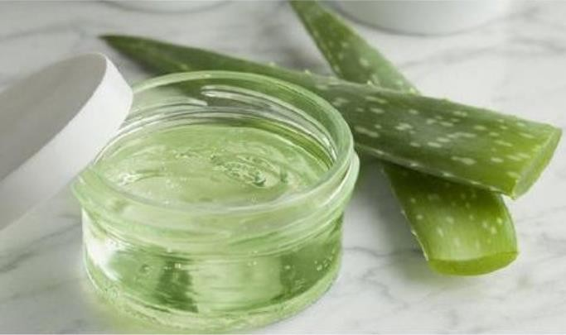

**Fig:1) Aloe vera**

**Butterfly pea flower:**

**Packed with antioxidant:**

The flowers of the butterfly pea plant are rich in antioxidants, including flavonoids, polyphenols, and authocyanins. Antioxidants are necessary for your skin's overall health and elasticity. antioxidants enhance the look and feel of your skin by reducing fine lines.

**Soothes minor skin irritation:**

The butterfly pea flower relieved general irritation and itching. The blossom of the butterfly pea is used to revitalize skin.

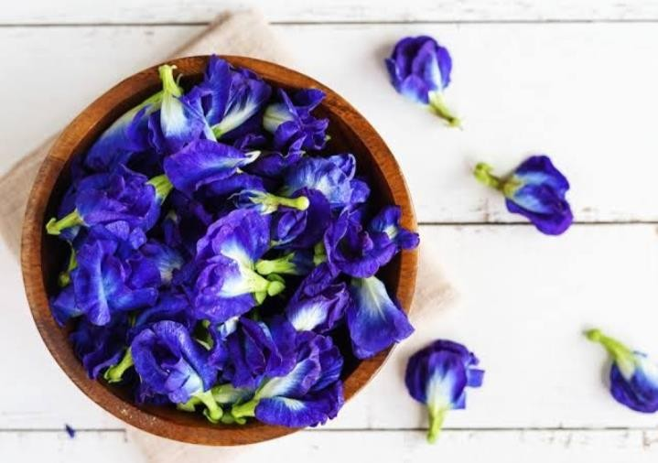

**Fig:2) Butterfly pea flower**

**Reduce redness:**

Butterfly pea flowers reduce redness from acne, dryness, and general irritation because of their capacity to calm irritated skin. When coupled with other nutrients that support the health of the skin, these nourishing qualities are further amplified.

**Improve moisture retention:**

This promotes skin turnover so that it can heal itself naturally. Retaining moisture prevents dryness and encourages lipid balance.

**Improve the skin barrier:**

The presence of plant-based antioxidants and antioxidant vitamins in butterfly pea flowers helps to improve the skin barrier.

**Suitable for all skin type:**

The butterfly pea flower is a secret skin-care hero. Regardless of the season, it is mild enough to use on any type of skin. [5]

**Coconut oil:**

Coconut oil prevents premature skin aging while maintaining the skin's softness and smoothness. Use coconut oil on your skin to hydrate and exfoliate dead skin cells. Coconut oil moisturizes dry skin, even in those who have eczema or other skin conditions. Its antimicrobial, antifungal, and antiviral qualities aid in wound healing by preventing skin damage from free radicals. Because of its anti-inflammatory qualities, coconut oil can help with skin conditions that cause redness on the skin, including oily and dry skin. [6]

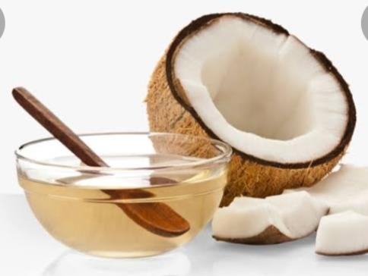  
**Fig:3) Coconut oil**

**Rose water:**

Rose water has vitamin B, which is frequently found in sun products and sunscreen. It enhances the efficacy of SPF protection. Rose water is a useful tool for reducing skin pigmentation. Rose water unclogs your pores, which helps remove dirt and oils from your skin. It aids in keeping your skin's pH level stable. The antioxidant levels in gulabjal combat free radicals and maintain healthy, radiant skin while also protecting the skin from damaging environmental aggressors. [7]

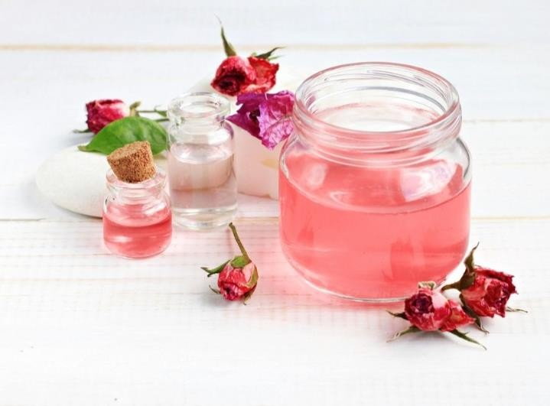

**Fig:4) Rose water**

**Vitamin E Capsule:**

Extra protection against acute UVB damage and against cell mutations brought on by exposure to the sun and pollution is provided by vitamin E. Vitamin E helps to improve skin elasticity and cleanse the skin by eliminating impurities. When vitamin E and lemon juice are combined, the skin becomes lighter. It is most well-known for improving the appearance and health of skin. It has anti-inflammatory and antioxidant qualities. [8]

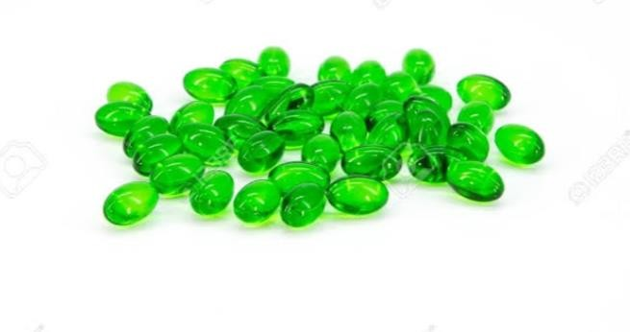

**Fig: 5) Vitamin E Capsule**

**Formulation of sunscreen cream:**

**Formulation of butterfly pea flower extract:**

Steep about twelve fresh or dried flower leaves in a cup of boiling water to extract butterfly pea flower for use as a herbal sunscreen. After a quarter of an hour, strain the liquid and throw away the leaves. Then, the rich blue water is prepared for use in sunscreen formulation. [9]

**Butterfly pea flower contain:**

|  |  |
| --- | --- |
| Soluble minerals | 8.94mg |
| Ash. | 0.9mg |
| Crude protein. | 41.27mg |
| Soluble carbohydrates. | 29.18mg |

**Formulation of sunscreen cream was prepared by following procedure:**

I have to take the extract from butterfly pea flowers. Then, since aloe vera gel has been shown to both treat and prevent skin burns, I've started taking it. After that, rose water was added to the mixture; this had a cooling effect. Then add vitamin E and coconut oil gradually. Using a spatula, all the ingredients were thoroughly combined for 20 to 30 minutes before being placed. [10]

**List of ingredients used in formulation:**

|  |  |
| --- | --- |
| Aloe vera. | 5 gm. |
| Rose water. | 2ml |
| Butterfly pea flower Extract. | 4gm |
| vitamin E. | 2gm |
| Coconut oil. | 2ml |

**Evaluation of sunscreen cream for sunscreening activity:**

**Effectiveness of sunscreen:**

Sunscreen protection factor (SPF), which is the ratio of UV energy needed to produce a minimal erythema dose in protected skin to unprotected skin, is typically used to express how effective a sunscreen is. A straightforward, quick, and accurate in vitro technique for determining the spf is to screen the product's absorbance between 290 and 320 nm at intervals of five nm. The Mansur equation, which is as follows, can be used to calculate SPF.

**SPF** spectrophotometric=CF×€EF (wavelength) ×I (wavelength) ×Abs (wavelength)

Where CF=correction factor (10), EE = erythmogenic effect of radiation with

Wavelength, Abs=spectrophotometric absorbance values at wavelength.

The value of EE × I constants. [11]

**PH of the cream:**

Standard buffer solution was used for the ph meter's calibration. The pH of the cream was measured after 0.5 of it was weighed, dissolved, and added to 50.0 milliliters of distilled water. [12]

**Homogeneity:**

The homogeneity of the formulations was assessed through both tactile and visual inspection.

Appearance: The color, pearlescence, and roughness of the cream were used to grade its appearance. [13]

**Removal:**

By using tap water to wash the area where the cream was applied, the cream's ease of removal was assessed.

**Irritancy test:**

After applying the cream to the designated area, the time was recorded. Any irritability, erythema, or edema was noted and monitored for up to 24 hours at regular intervals.

**After feel:**

Checks were made for emolliency, slipperiness, and amount of residue remaining after a set quantity of cream was applied. [14]

**Type of smear:**

Following cream application, the kind of film or smear that developed on the skin was examined.

|  |  |  |  |
| --- | --- | --- | --- |
| **Types** | **Description** | **SPF.** | **Character** |
| **1** | Always burn easily. And never  tans | More than 8. | Sensitive |
| **2** | Always burn and tan.  Minimally | 6-7. | Sensitive |
| **3** | Burn moderator and. Tan gradually | 4-5 | Normal |
| **4** | Burn minimal and. Always tan well | 2-3 | Normal |
| **5** | Barely burn and tan. Profusely | 2 | Insensitive |
| **6** | Never burn and. Become deeply Pigmented | None | Insensitive |

# Types of skin and SPF:

**Observations:**

|  |  |  |
| --- | --- | --- |
| **Sr. No.** | **Parameters** | **Observation** |
| 1 | Colour | Light Blue |
| 2 | Odour | Characteristics |
| 3 | Spreadability | Good and uniform |
| 4 | PH | 6.5 |
| 5 | Test for irritancy | No. irritation reaction |

**Benefits of sunscreen:**

• Lower chance of developing skin cancer

• Guard against sunburn

• Prevent redness and inflammation

• Steer clear of redness and hyperpigmentation.

• Prevent damage to DNA

• Stop fine lines and wrinkles from appearing too soon.

• Reduced risk of skin cancer

• Protection against damaging UV rays

• Preserve the appearance and feel of your skin.

• Postpones early indications of aging

• Absorbs UVA and UVB radiation.

• When applied topically, it takes effect right away. [15]

**Advantages:**

• Accessible

• Requires no specialized equipment for preparation

• They are reasonably priced.

• It's simple to find ingredients

• Resources that regenerate

• Have no irritant or toxic properties

• Be heat-stable

• Simple to produce [16]

**Disadvantages:**

The taste and smell are difficult to cover up.

The manufacturing process is labor-intensive and complex.

The effects of herbal drugs wear off more slowly than those of allopathic dosage forms and long-term therapy is necessary. [17]

**Result:**

A broad spectrum of absorbance is necessary for a sunscreen product to be effective in preventing sunburn and other skin damage. Spreadability and viscosity are the main factors that influence the acceptability of a cosmetic formulation when it comes to storage and handling. There was no redness, inflammation, or irritation with the formulated cream. No change in the cream's color was observed after the formulation was stored for an extended period of time. With a simple tap water wash, the cream came off with ease.

**Conclusion:**

The goal of the study was to create a herbal sunscreen cream by extracting the flower from the butterfly pea and testing its effectiveness in preventing sunburn.

**Reference:**

1) Boyd AS, Naylor M, Cameron GS, et al. The effects of chronic sunscreen use on the histologic changes of dermatoheliosis. J Am Acad Dermatol. Dec 1995; 33(6):941-6

2) DeBuys HV, Levy SB, Murray JC, et al. Modern approaches to photo protection. Dermatol Clin. Oct 2000; 18(4):577-90.

3) DiffeyBL and Grice J. The influence of sunscreen type on photo protection. Br J Dermatol. Jul 1997; 137(1):103-5.

4) Dromgoole SH and Maibach HI. Sunscreening agent intolerance: contact and photo contact sensitization and contact urticaria. J Am Acad Dermatol. Jun 1990; 22(6):1068-78.

5) Fotiades J, Soter NA and Lim HW. Results of evaluation of 203 patients for photosensitivity in a 7.3- year period. J Am Acad Dermatol. Oct 1995; 33(4):597-602.

6) Mithal BM and Saha RNA. Hand book of cosmetics, first edition, reprint-2007, Vallabh Prakashan, Delhi 122-124. 7) Gasparro FP, Mitchnick M and Nash JF. A review of sunscreen safety and efficacy. Photochem Photobiol. Sep 1998; 68(3):243-56.

8) Kaidbey KH. The photo protective potential of the new super potent sunscreens. J Am Acad Dermatol. Mar 1990; 22(3):449-52.

9) Kullavanijaya P and Lim HW. Photo protection. J Am Acad Dermatol. Jun 2005; 52(6):937-58; quiz 959-62.

10) Levy SB. How high the SPF? Arch Dermatol. Dec 1995; 131(12):1463-4.

11) Moloney FJ, Collins S and Murphy GM. Sunscreens: safety, efficacy and appropriate use. Am J Clin Dermatol. 2002; 3(3):185-91.

12) Naylor MF and Farmer KC. The case for sunscreens. A review of their use in preventing actinic damage and neoplasia. Arch Dermatol. Sep 1997; 133(9):1146-54.

13) Ahu RK, Roy A, Kushwah P, Sahu A. Formulation and development of face cream containing natural products. Research Journal of Topical and Cosmetic Science. 2012: 3(1): 16-19.

14). Roy A, Sahu RK, Mutlam M, Deshmukh VK, Dwivedi J, Jha AK. In vitro Techniques to Assess the Proficiency of Skin Care Cosmetic Formulations. Pharmacognosy Review. 2013:7(14): 97-106.

15) Sahu RK, Roy A, Kushwah P, Khare M, Mudotiya R. Formulation and development of whitening polyherbal face cream. Research Journal of Topical and Cosmetic Science. 2012:3(1): 23-27.

16) Sahu RK, Roy A, Jha AK, Dwivedi J. Promotion and computation of inhibitory effect on tyrosinase activity of herbal cream by incorporating indigenous medicinal plants. Pakistan Journal of Biological Sciences. 2014: 17(1): 146-150.

17). Shahriar M, Akhter S, Hossa MI, Haque MA, Bhuiyan MA. Evaluation of in vitro antioxidant activity of bark extracts of Terminalia Arjuna. Journal of Medicinal Plants Research. 2012; 6(39): 5286-5298