**GEROBIOTICS-HEALTHY AGEING**

**Jayashree H1, Vandana K V1, Ramachandra B2, Harshapriya N1, Devaraj R3**

1 M.Tech Scholar, Dept. of Dairy Microbiology, DSC, KVAFSU, Bengaluru, Karnataka, India

2 Associate Professor and HOD, Dept. of Dairy Microbiology, DSC, KVAFSU, Bengaluru, Karnataka, India

3 Assistant Professor and Head, Dept. of Dairy Engineering, DSCK, KVAFSU, Kalaburgi, Karnataka, India

**ABSTRACT**

Global ageing population is increasing rapidly. Age related chronic diseases are the prime cause of natural death. Prevention of age related diseases is the need of the hour. Various interventions have been developed for the same. One such novel approach is use of probiotics. Gerobiotics are defined as probiotic strains and their derived postbiotics and para-probiotics that are able to beneficially attenuate the fundamental mechanisms of ageing, reduce physiological ageing processes and thereby expand the health span of the host. Potential gerobiotics will be screened from functional probiotics and then studied on nematode, rodent and human models to determine its efficiency. Various biomarkers will be used to determine its efficiency and efficacy in preventing age related disorders.

**Keywords:** Gerobiotics, ageing, *C. elegans*, Rodents and human

1. **INTRODUCTION**

The global population is eight billion and India leads the world in population with a share of 17.85%. 10% of the population is comprised of elders aged above 65 years, making up a significant portion of the population [1].

Life expectancy is the number of years a newborn infant would live if prevailing patterns of mortality at the time of its birth were to stay the same throughout its life. Healthy life expectancy is the average number of years of life spent in good health that a person would be expected to live considering the age-specific mortality and morbidity for a given population in a calendar year. According to the report of WHO, life expectancy at birth is 73.4 years and healthy life expectancy is 63.7 years in 2019 [2].

According to National Council on Aging research, 95% of the senior adults have one chronic condition and 80% have at least two chronic diseases [3]. Disease and ageing are two natural causes of death. Scientists have discovered a cure for infectious diseases which is the primary cause of natural death [4]. In order to extend healthy life expectancy, attention is now being paid to the second cause of natural death and in response various anti-ageing interventions have been developed; one such novel approach is use of probiotics. Probiotics are live microorganisms which when administered in adequate amounts confer a health benefit on the host [5]. Lactobacillus, Bifidobacterium, Yeast and Bacillus are some of the genera of probiotics.

Probiotics provide various therapeutic benefits such as anti-allergic, anti-inflammatory, anti-carcinogenic, antimicrobial and preventing cardiovascular diseases [6]. Probiotics that have entered into anti-ageing concept are termed as GEROBIOTICS.

Geroscience is an interdisciplinary field that aims to understand the molecular and cellular mechanisms of ageing. The understanding of beginning aging management as early as possible is more crucial. People used to only become aware of age-related health difficulties when they started to lose their energy or developed high blood pressure, high blood sugar or high cholesterol in their 50s or 60s. Moreover, it was at that point that they began to take preventive medicine and pay attention to their diets and lifestyles. The idea of geroscience on the other hand seeks to highlight the significance of early intervention when people are in their 40s or even 30s prior to the onset of aging symptoms. In the field of preventative medicine, this is a new and innovative idea. Gerobiotics are defined as probiotic strains and their derived postbiotics and para-probiotics that are able to beneficially attenuate the fundamental mechanisms of ageing, reduce physiological ageing processes and thereby expand the health span of the host [7].

1. **LITERATURE REVIEW**

**Strategy for identification of potential gerobiotics**

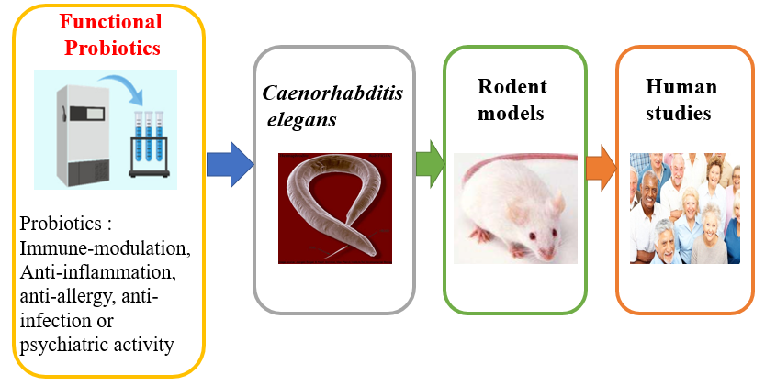

**Figure 1**: Strategy for identification of potential gerobiotics

First, prospective probiotics are screened from a functional probiotics bank. Next, high-throughput screening is performed using models of cells and invertebrates. An important part of the process is evaluating ageing indicators using a variety of rodent models, as this might help with experimental designs for human trials later on.

A three-phase methodical strategy has been developed for the creation of gerobiotics. First, it is necessary to assess whether probiotic candidates can increase longevity in animal models of invertebrates. The second piece of evidence is favorable effects on a number of ageing biomarkers in aged mouse models, which help identify the basic mechanisms underlying a potential gerobiotic strain's anti-aging properties. Finally, well-designed human clinical investigations should assess similar favorable trends in the same ageing process [7].

The detailed strategy for identifying potential gerobiotics are (Figure 1)

1. The functional probiotic strains that are currently on the market and have demonstrated immune-modulation, anti-inflammation, anti-allergy, anti-infection or psychiatric activity should be the first to be used in the screening process to make it easier.
2. Preliminary highthroughput screening from a wide variety of probiotic strains can be conducted using some of the cell models created for the screening of tiny molecular geroprotectors.
3. A functional probiotics bank might be utilized to screen potential gerobiotics, and in vitro cell and invertebrate models (*D. melanogaster* and *C. elegans*) could be employed for high-throughput screening.
4. To ensure that each candidate gets assessed in a variety of aging rat models, rodent models ought to be positioned at the center of a screening pipeline.
5. Human trials will ultimately reveal whether or not gerobiotics have anti-aging potential [7].

**Biomarkers for evaluating gerobiotic candidates**

Long and expensive studies are conducted to determine the impact of gerobiotic candidates on prolongevity. As a result, biomarkers may function as crucial indicators for assessing interventions and offering proof that ageing processes can be stopped [8].

Biomarkers should be easily tested with minimal invasiveness such as using blood, urine or saliva samples that might be obtained during different phases of the inquiry in order for them to be useful in human clinical investigations.

**Table 1**: Biomarkers for evaluating gerobiotic candidates

|  |  |  |
| --- | --- | --- |
| **Parameter** | **Biomarker** | **Reference** |
| Inflammation | IL6 (Interleukin 6), TNF (Tumour Necrosis Factor), CRP (C-Reactive Protein) | Justice *et al*., 2018 [9] |
| Nutrient sign | IGF-1 (Insulin like Growth Factor), Insulin, IGFBPs (Insulin like growth factor binding proteins) |
| Cardio vascular | NT-proBNP (N terminal pro Brain natriuretic peptide test), Fibrinogen |
| Blood based | IL-6 (Interleukin 6), TNF-α (Tumour Necrosis Factor –alpha), CRP (C-Reactive Protein), HbA1C (Heamoglobin A1C), TSH (Thyroid Stimulating Harmone), Vit D, NT-proBNP | Cardoso *et al*., 2018 [10] |
| DNA based | Telomere length, DNA repair, DNA/chromosomal damage |
| Epigenetic alterations | DNA methylation | Guerville *et al*., 2020 [11] |
| Telomere attrition | Telomere length |
| Nutrient sensing | Sirtuin 1 |

**Models used for studying ageing concept**

***Caenorhabditis elegans***

Their length is 1 mm. Their typical lifespan when cultured at 20°C is 18–20 days, and their reproductive cycle lasts 2.5–4 days at room temperature. Less active, uncordinated motions, the end of reproduction, and the buildup of autofluorescent deposits in cells are characteristics of aging.

It contains 143 important genes of which 108 are orthologs in humans; 97 of these genes are linked to 2,000 illnesses in total. A few benefits include low maintenance requirements, a translucent body that allows for anatomical inspection, high genetic similarity to humans, high rates of reproduction, a short lifespan and small size [12].

**Longevity pathway in *C.elegans***

**a. Insulin/IGF-1 signalling pathway**

Delay Accelerating Factor-2 (DAF-2) encodes the mammalian insulin/IGF-1 receptor homolog. The ortholog of mammalian phosphoinositide 3 kinase (PI3k) is encoded by AGE-1 (acetylated glycalation end product). A homolog of the human transcription factor forkhead box O (FOXO) is encoded by Daf-16 (Delay Accelerating Factor).

The IIS pathway is less active in worms with DAF-2 mutations, which phosphorylates DAF-16. Phosphorylated DAF-16 translocates into the nucleus to bind and start target gene expression, extending the worm's life span. Unfolded protein response and oxidative stress response are two examples of the stress-protective mechanisms that will be triggered. Through the ortholog SKN-1 (Skinhead), NF-E2 related factor (NRF-2) is reduced IIS increases lifespan. An essential regulator of the oxidative stress response and detoxification process is SKN-1 [12] (Figure 2).

**b. AMPK (AMP activated kinase pathway)**

During the starving, developmentally inactive diapause phase of the organism, it is necessary for metabolic adjustment. A longer lifespan is achieved by overexpressing this mechanism [12].

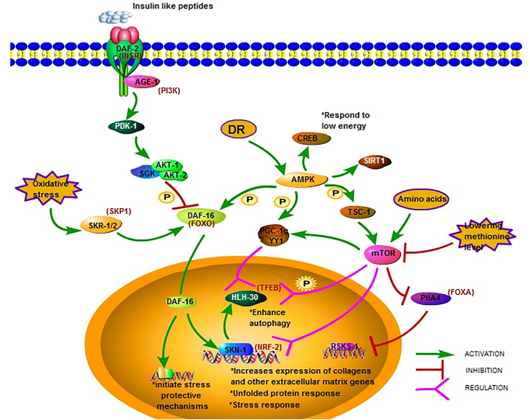

**Figure 2**: Longevity pathway of *C. elegans*

**c. mTOR (Mechanistic target of rapamycin signalling)**

An increase in intracellular amino acids triggers the activation of this mechanism, and inhibiting it lengthens life [12].

**Case studies in *C. elegans***

**Table 2**: Studies of potential gerobiotics in *C. elegans*

|  |  |  |  |
| --- | --- | --- | --- |
| **Strain** | **Mechanisms** | **Aging hallmark** | **Reference** |
| *L. gasseri* SBT2055 | p38 Mitogen activated protein kinase (p38 MAPK), Skinhead 1 (SKN-1) | Oxidative stress | Nakagawa *et al*., 2016 [13] |
| *B. longum* BB68 | Delay accelerating factor (DAF-16) | Deregulated nutrient sensing | Zhao *et al*., 2017 [14] |
| *L. fermentum* MBC2 | DAF-16 | Deregulated nutrient sensing | Schifano *et* *al*., 2019 [15] |
| *B. infantis* ATCC15697 | p38 MAPK, SKN-1, carbonyl | Deregulated nutrient sensing and oxidative stress | Sun *et al*., 2019 [16] |
| *B. subtilis* PXN21 | α-Synuclein, DAF-16 | Oxidative stress | Goya *et al*., 2020 [17] |

The anti-aging and lifespan benefits of *L. gasseri* SBT2055 (LG2055) are observed in *C. elegans*. The SKN-1 gene and its target genes, which encode antioxidant proteins and improve antioxidant defense responses, were both elevated in expression after feeding with LG2055. They discovered that feeding with LG2055 directly triggered the p38 MAPK (p 38 mitogen activated protein kinase) pathway, which in turn signaled SKN-1 activity. According to the findings, feeding *C.* eggplants with LG2055 can increase their resilience to oxidative stress and boost innate immune response signaling, which includes the p38MAPK signaling pathway among others, thereby extending their longevity [13].

When worms were given *B. longum* BB68, the longevity of nematodes rose by 28%; however in backgrounds with a defective DAF-16 gene, this lifespan extension was completely eliminated. The administration of BB68 led to the observation of elevated levels of DAF-16 (in the daf-16 (mu86); muIs61 strain) nuclear accumulation and high expression of the DAF-16-specific target gene SOD3 (Superoxide) [14].

In *L. fermentum* MBC2-fed worms, analysis of pumping rate, lipofuscin accumulation and body bending revealed anti-aging effects. Research on PEPT-1 mutations showed that while PEPT-1 was not necessary for the bacterial strain's ability to defend against oxidative stress, the pept-1 gene was involved in the anti-aging processes mediated by DAF-16 [15].

The proportion of worms in the *B. infantis* ATCC15697 (BI)-fed group that demonstrated coordinated sinusoidal movement was greater than that of the control worms. Enhanced antioxidant systems caused low levels of lipofuscin and protein carbonyl. Through the activation of SKN-1 and the stimulation of phase 2 detoxifying enzymes, the P38 MAPK pathway prolongs life [16].

Probiotic strain PXN21 of *Bacillus subtilis* reduces a-synuclein aggregation and removes pre-formed aggregates in a well-established synucleinopathy model in *Caenorhabditis elegans*. This defense which is observed in both young and elderly animals is partially mediated by DAF-16 [17].

**Rodent models**

Senescence accelerated mice (SAM) model, Aged mice model and D-galactose induced senescence accelerated mice models will be used.

**Case studies**

**Table 3**: Studies of potential gerobiotics in rodent models

|  |  |  |  |  |
| --- | --- | --- | --- | --- |
| **Strain** | **Model** | **Mechanisms** | **Aging hallmark** | **Reference** |
| *L. brevis* OW38 | Aged mice | LPS, p16, p53, Sterile alpha motif domain and HD domain containing protein 1(SAMHD1) | Cellular senescence | Jeong *et al*., 2016 [18] |
| *L. paracasei* K71 | SAMP8 mice | Monoamine oxygenase A (MA OA), Brain derived Neurotropic factor (BDNF), CREB | Neuropeptides | Corpus *et al*., 2018 [19] |
| *L.paracasei*PS23 | SAMP8 mice | Peroxisomeproliferator-activated receptor γ-coactivator α (PGC1-α),Nuclear respiratory factor (NRF1), SOD, GPx , IL-6,TNF-α, Monocyte chemoattractive protein 1 (MCP-1) | Deregulated mitochondrial function | Chen *et al*., 2019 [20] |
| *L. plantarum NDC 75017* | D-gal mice | ATP level | Mitochondrial dysfunction | Peng *et al*., 2014 [21] |
| *L. pentosus var plantarum C29* | D-gal mice | Double cortin (DCX), Brain derived Neurotrophic factor (BDNF), cAMP response element binding protein  (CREB), p16 | Oxidative stress | Woo *et al*., 2014 [22] |
| *L. plantarum AR501* | D-gal mice | Nuclear factor erythroid 2 related factor2 (Nrf2), glutathione reductase, glutathi -one S-transferase | Oxidative stress | Lin *et al*., 2018 [23] |

After eight weeks, the oral treatment of *Lactobacillus brevis* OW38 (1×109 cfu/mouse) to male elderly mice significantly decreased the level of lipopolysaccharide (LPS) in both colon fluid and blood. The ratio of Firmicutes or Proteobacteria to Bacteroidetes which was noticeably larger in elderly mice than in young animals was also decreased by OW38 therapy. In older animals, OW38 treatment reduced NF-κB activation and the production of inflammatory markers such myeloperoxidase, tumour necrosis factor (TNF), and interleukin (IL)-1β [18].

Fourteen-week-old female SAMP8 mice were given a regular diet for forty-three weeks, which included rice grains and sake lees as the source of 0.05% (w/w) *Lactobacillus casei* subsp. *casei* 327 (L. 327) or *Lactobacillus paracasei* K71 (L. K71). The cognitive performance of SAMP8 mice fed a diet supplemented with L. K71 was superior to that of the control and L. 327 groups. In the hippocampal region, prolonged administration of L. K71 raised BDNF protein expression and phosphorylation of CREB. These findings imply that by increasing BDNF expression in the hippocampus, a meal supplemented with a Lactobacillus strain obtained from sake lees may delay age-dependent cognitive decline [19].

Following the administration of *L. paracasei* PS23, proinflammatory cytokines such as IL-6, TNF-α and monocyte chemoattractive protein 1 (MCP-1) decreased and proliferator-activated receptor γ-coactivator α (PGC1-α), nuclear respiratory factor (NRF1), superoxide dismutase (SOD) and glutathione peroxidase (GPx) increased [20].

100 mg/kg D-gal was subcutaneously injected into the ageing model group of rats, while *L.* *plantarum* NDC 75017 was further given orally to the rats in the protective groups at doses of 1x108, 1x109, or 1x1010 CFU/100 mg body weight/day respectively. The findings demonstrated that the D gal-induced ageing model group's learning and memory capacities as well as their mitochondrial ATP levels were significantly lower than those of the control group [21].

Oral delivery of C29 activated cAMP response element binding protein (CREB) and restored D-galactose-suppressed production of Doublecortin (DCX), Brain Derived Neurotrophic Factor (BDNF) and DCX. Treatment with C29 prevented D-galactose-induced p16 expression and FOXO3a and nuclear factor kappa B activation [22].

When *L. plantarum* AR501 was taken orally, it enhanced the antioxidant status of D-galactose-induced oxidative stress. In the meantime, the Nrf2/Keap1 signaling pathway's expression rose. Nuclear factor erythroid 2 related factor 2 (Nrf2) gene expression was significantly increased by *Lactobacillus plantarum* AR501 which also enhanced the expressions of numerous antioxidant genes including glutathione reductase and glutathione S-transferase [23].

**Improvement of host health and longevity by *B. subtilis***

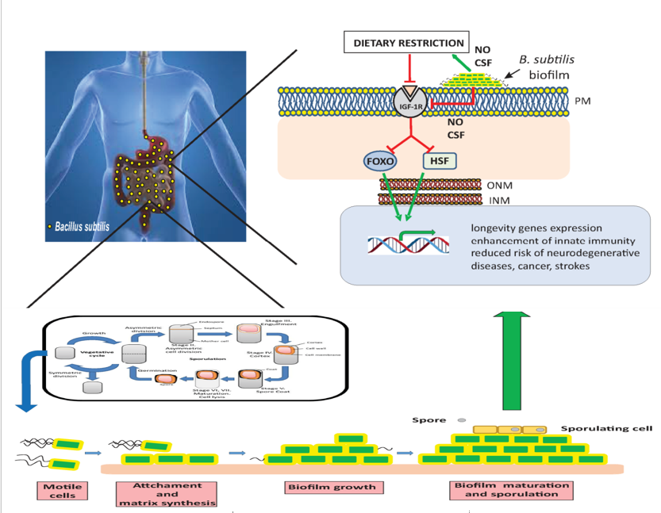

**Figure 3**: Improvement of health and longevity by *B. subtilis*

Spores of the probiotic bacterium *B. subtilis* can survive their passage through the stomach and enter the human intestine after being ingested through diet. Once these gut spores germinate, the probiotic's active form vegetative *B. subtilis* cells emerges, multiplies, and creates a helpful biofilm in the host intestine. The beneficial and anti-aging NO (nitrous oxide) and CSF (competence sporulation stimulating factor) chemicals that biofilm *B. subtilis* cells make are continuously and systematically supplied to the host tissues.

The activity of the gene-transcription factors FOXO and HSF (Heat shock factors) controls longevity at the genetic level. When insulin-like molecules attach to the insulin receptor, the receptor is activated. This leads to the activation of many protein kinase enzymes which phosphorylate FOXO and render it inactive inside the cytoplasm. Moreover an inhibitory protein complex that sequesters HSF in the cytoplasm is formed by an activated insulin receptor. Beneficial signals from the biofilm formed by *B. subtilis*, such as NO and CSF, cause the insulin receptor to be downregulated either directly or indirectly through the activation of the Dietary restriction. Upon downregulation of the insulin receptor, FOXO and HSF become active in the nucleus. There, both prolongevity transcription factors orchestrate the activation of host genes responsible for (i) resistance to age-related diseases and (ii) a prolonged and healthy longevity [4] (Figure 3).

**Human studies**

In human clinical trials, the majority of studies on aging have documented positive effects on immunological regulation, inflammation, infection, metabolic profiles, cognitive function, gut microbiome and quality of life [7].

**Case studies**

**Table 4**: Studies of potential gerobiotics in humans

|  |  |  |  |  |
| --- | --- | --- | --- | --- |
| **Strain** | **Model** | **Mechanisms**  **(Increases)** | **Aging hallmark** | **Reference** |
| *L. casei* shirota | Human | Innate NK cells activity, IL-12 | Altered intercellular communication | Dong *et al*., 2012 [24] |
| *B. lactis* HN019 | Mice  Human | Phagocytosis activity | Altered intercellular communication | Miller *et al*., 2017 [25] |
| *B. breve* B-3 | Mice Rats Human | Peroxisome proliferator-activated receptor γ-coactivator α (PGC 1α), Protein kinase B (Akt), AMP activated kinase (AMPK) | Deregulated nutrient sensing | Toda *et al*., 2019 [26] |

For four weeks, the participants were given a probiotic drink with 1.3*1010 CFU LcS (*L.casei* shirota) or skim milk every day as a supplement. Compared to placebo, probiotic consumption was linked to a significant drop in the mean fluorescence intensity of CD25 expression in resting T cells and a significant increase in natural killer (NK) cell activity relative to baseline. Furthermore, after consuming LcS, there was a tendency towards an elevated ratio of IL-10 to IL-12 in comparison to baseline [24].

Supplementing with *B. lactis* HN019 was very effective in boosting PMN phagocytic capability and only barely effective in NK cell tumoricidal activity. In healthy senior individuals, daily *B. lactis* HN019 ingestion improves NK cell and PMN function [25].

Rats given B-3 (*B. breve* B-3) had an increase in muscle mass and an impact on muscle metabolism. In the rat soleus, B-3HK markedly raised the expression of the genes for phosphorylated AMP-activated protein kinase (AMPK), peroxisome proliferator-activated receptor gamma coactivator (PGC)-1α and cytochrome c oxidase (CCO) indicating an impact on the AMPK-PGC1α-mitochondrial biogenesis pathway [26].

1. **Conclusion**

Probiotics is a million-dollar industry which have various health benefits and has emerged in providing therapeutic benefits. Various biomarkers are used to determine the ability of gerobiotics. Familiarization of gerobiotics is the need of the hour. It is one of the most promising intervention to have a healthy and prolonged life. The research is still in infancy stage. Hence more research about is efficiency and effectiveness is important at this stage. Marketing strategy is also important and helps in increasing the economy of the business. It has opportunities in food and dairy industry for developing functional food.

1. **References**
2. United Nations Department of Economic and Social Affairs (UN DESA), Population Division. 2022. World Population Prospects 2022: Summary of Results. UN DESA/POP/2022/TR/NO. 3.
3. World Health Organization 2023 data.who.int, India [Country overview]. (Accessed on 16 November 2023).
4. National Council on aging, “The Top 10 most chronic conditions in older adults,” Chronic conditions for older adults, Aug. 2023. Found on internet at https://www.ncoa.org/article/the-top-10-most-commonchronic-conditions-in-older-adults
5. F. R. Ayala, C. Bauman, S. Cogliati, C. Lenini, M. Bartolini and R. Grau, “Microbial flora, probiotics, *Bacillus subtilis* and the search for a long and healthy human longevity,” Microbial Cell, Vol. 4, issue 4, March 2017, pp. 133-136.
6. Food and Agricultural Organization of the United Nations and World Health Organization. Health and nutritional properties of probiotics in food including powder milk with live lactic acid bacteria. World Health Organization [online], (2001).
7. S. Raghuwanshi, S. Misra, R. Sharma and P. S. Bisen, “Probiotics: nutritional therapeutic tool,” Journal of Probiotics and Health, Vol. 6, issue 1, April 2018, p. 194.
8. Y. C. Tsai, L. H. Cheng, Y. W. Liu, O. J. Jeng and Y. K. Lee, “Gerobiotics: probiotics targeting fundamental aging processes,” Bioscience of microbiota, food and health, Vol. 40, issue 1, Oct. 2021, pp. 1-11.
9. K. Xu, Y. Guo, Z. Li and Z. Wang, “Aging biomarkers and novel targets for anti-aging interventions,” Reviews on Biomarker Studies in Aging and Anti-Aging Research, Vol. 1178, issue 9, Sept. 2019, pp. 39-56.
10. J. N. Justice, L. Ferrucci, A. B. Newman, V. R. Aroda, J. L. Bahnson, J. Divers, M. A. Espeland, S. Marcovina, M. N. Pollak, S. B. Kritchevsky and N. Barzilai, “A framework for selection of blood-based biomarkers for geroscience-guided clinical trials: report from the TAME Biomarkers Workgroup,” Geroscience, Vol. 40, Aug. 2018, pp. 419-436.
11. L. Cardoso, A. Fernandes, J. A. Aguilar-Pimentel, M. H. de Angelis, J. R. Guedes, M. A. Brito, S. Ortolano, G. Pani, S. Athanasopoulou, E. S. Gonos and M. Schosserer, “Towards frailty biomarkers: Candidates from genes and pathways regulated in aging and age-related diseases,” Ageing researchreviews, Vol. 47, July 2018, pp. 214-277.
12. F. Guerville, P. De Souto Barreto, I. Ader, S. Andrieu, L. Casteilla, C. Dray, N. Fazilleau, S. Guyonnet, D. Langin, R. Liblau and A. Parini, “Revisiting the hallmarks of aging to identify markers of biological age,” The Journal of prevention of Alzheimer's disease, Vol. 7, issue 1, Dec. 2019, pp. 56-64.
13. S. Zhang, F. Li, T. Zhou, G. Wang and Z. Li, “*Caenorhabditis elegans* as a useful model for studying aging mutations,” Frontiers in endocrinology, Vol. 11, Oct. 2020, pp. 1-9.
14. H. Nakagawa, T. Shiozaki, E. Kobatake, T. Hosoya, T. Moriya, F. Sakai, H. Taru and T. Miyazaki, “Effects and mechanisms of prolongevity induced by *Lactobacillus gasseri* SBT2055 in *Caenorhabditis elegans*,” Aging cell, Vol. 15, issue 2, Dec. 2015, pp. 227-236.
15. L. Zhao, Y. Zhao, R. Liu, X. Zheng, M. Zhang, H. Guo, H. Zhang and F. Ren, “The transcription factor DAF-16 is essential for increased longevity in *C. elegans* exposed to *Bifidobacterium longum* BB68,” Scientific Reports, Vol. 7, issue 1, Aug. 2017, pp. 1-7.
16. E. Schifano, P. Zinno, B. Guantario, M. Roselli, S. Marcoccia, C. Devirgiliis and D. Uccelletti, “The foodborne strain *Lactobacillus fermentum* MBC2 triggers pept-1-dependent pro-longevity effects in *Caenorhabditis elegans*,” Microorganisms, Vol. 7, issue 2, Feb. 2019, pp. 1-17.
17. S. Sun, Y. Mizuno, T. Komura, Y. Nishikawa and E. Kage-Nakadai, “Toll-like receptor homolog TOL-1 regulates *Bifidobacterium infantis*-elicited longevity and behavior in *Caenorhabditis elegans*,” Bioscience of Microbiota, Food and Health, Vol. 38, issue 3, May 2019, pp. 105-110.
18. M. E. Goya, F. Xue, C. Sampedro-Torres-Quevedo, S. Arnaouteli, L. Riquelme-Dominguez, A. Romanowski, J. Brydon, K. L. Ball, N. R. Stanley-Wall and M. Doitsidou, “Probiotic *Bacillus subtilis* protects against α-synuclein aggregation in *C. elegans*,” Cell reports, Vol. 30, issue 2, Jan. 2020, pp. 367-380.
19. J. J. Jeong, K. A. Kim, Y. J. Hwang, M. J. Han and D. H. Kim, “Anti-inflammaging effects of *Lactobacillus* *brevis* OW38 in aged mice,” Beneficial Microbes, Vol. 7, issue 5, Nov. 2016, pp. 707-718.
20. H. M. Corpuz, S. Ichikawa, M. Arimura, T. Mihara, T. Kumagai, T. Mitani, S. Nakamura and S. Katayama, “Long-term diet supplementation with *Lactobacillus paracasei* K71 prevents age-related cognitive decline in senescence-accelerated mouse prone 8,” Nutrients, Vol. 10, issue 6, June 2018, pp. 762-775.
21. L. H. Chen, S. Y. Huang, K. C. Huang, C. C. Hsu, K. C. Yang, L. A. Li, C. H. Chan and H. Y. Huang, “*Lactobacillus paracasei* PS23 decelerated age-related muscle loss by ensuring mitochondrial function in SAMP8 mice,” Aging (Albany NY), Vol. 11, issue 2, Jan. 2019, pp. 756-770.
22. X. Peng, J. Meng, T. Chi, P. Liu, C. Man, S. Liu, Y. Guo and Y. Jiang, “*Lactobacillus plantarum* NDC 75017 alleviates the learning and memory ability in aging rats by reducing mitochondrial dysfunction,” Experimental and therapeutic medicine, Vol. 8, issue 6, Oct. 2014, pp. 1841-1846.
23. J. Y. Woo, W. Gu, K. A. Kim, S. E. Jang, M. J. Han and D. H. Kim, “*Lactobacillus pentosus* var. *plantarum* C29 ameliorates memory impairment and inflammaging in a D-galactose-induced accelerated aging mouse model,” Anaerobe, Vol. 27, issue 6, June 2014, pp. 22-26.
24. X. Lin, Y. Xia, G. Wang, Z. Xiong, H. Zhang, F. Lai and L. Ai, “*Lactobacillus plantarum* AR501 alleviates the oxidative stress of D‐galactose‐induced aging mice liver by upregulation of Nrf2‐mediated antioxidant enzyme expression,” Journal of Food Science, Vol. 83, issue 7, July 2018, pp. 1990-1998.
25. H. Dong, I. Rowland, L. V. Thomas and P. Yaqoob, “Immunomodulatory effects of a probiotic drink containing *Lactobacillus casei* Shirota in healthy older volunteers,” European journal of nutrition, Vol. 52, issue 12, Jan. 2013, pp. 1853-1863.
26. L. E. Miller, L. Lehtoranta and M. J. Lehtinen, “The effect of *Bifidobacterium animalis* ssp. *lactis* HN019 on cellular immune function in healthy elderly subjects: systematic review and meta-analysis,” Nutrients, Vol. 9, issue 3, Feb. 2017, pp. 191-200.
27. K. Toda, Y. Yamauchi, A. Tanaka, T. Kuhara, T. Odamaki, S. Yoshimoto and J. Z. Xiao, “Heat-killed *Bifidobacterium breve* B-3 enhances muscle functions: possible involvement of increases in muscle mass and mitochondrial biogenesis,” Nutrients, Vol. 12, issue 1, Jan. 2020, pp. 219-232.