[1]

**TRI-BAND ANTENNA USING METAMATERIALS FOR 4G MOBILE COMMUNICATION**

**C K Navheen**

*Abstract*: ***An antenna is the interface between propagation of radio waves through electric currents and space moving in metal conductors. The reconfigurable antenna technique adaption is expected to have a significant impact in future wireless systems. Reconfigurable antenna is capable of modifying its frequency and radiation properties in a controlled and changeable manner. Tri-band antenna is an electronic device that can operate in three different frequency bands. The antenna is designed with the use of dielectric substrate of 1mm thickness with permittivity of 2.65. The design is simulated in ANSYS-HFSS based on the finite element method (FEM). In designed antenna, Antenna 1 operates in three frequency bands 1.78~1.84 GHz, 2.34~3.86 GHz and 5.75~5.87 GHz and Antenna 2 increases impedance matching of the third frequency band. Switching between the frequencies is achieved using metamaterials. The metamaterial antenna have advantages of minimizing the size and improves the compactness of antenna which is applicable to 4G wireless mobile communication system. Simulation result shows return loss for antenna 1 is -25 dB and return loss for antenna 2 is -27 dB. In future, by using metamaterials as substrate for Tri-band antenna we can achieve better antenna performance in terms of gain, efficiency and reduction of return loss.***

*Index Terms*: *Triband, Metamaterial, Reconfigurable antenna, wireless system.*

# **INTRODUCTION**

Mobile devices need to facilitate different communication services such as Wi-Fi, Bluetooth, GPS, LTE. Long term evolution (LTE) is the 4th generation wireless device which is widely used communication systems. The frequency bands used in each nation or wireless carrier is different, so a multi-band antenna is required. The multi-band antenna became more important in communication system ever since carrier collection technique of Long term evolution - advanced communication system was proposed. Nowadays researchers in wireless communication field is doing researches on multiband microstrip antenna, which is applicable for 4G wireless communication system, bluetooth systems, multiple input multiple output systems and wireless power transfer. Microstrip antennas have the advantage of light weight and low profile, allows easy integration with surface-mount devices and it is also flexible in dual-band and tri-band operations when compared to conventional antennas.

# **LITERATURE SURVEY**

**A. DUAL BAND PATCH ANTENNA**

The antenna proposed could cover E5a and E5b bands for Galileo systems. This antenna uses high permittivity materials to reduce the antenna size. The antenna design uses L-shaped proximity coupled feeding to increase bandwidth. The antenna is fabricated and the gain and axial ratio is measured. The smaller size of the antenna and longer distance coverage of the antenna makes it suitable for GPS applications.

**B. TRI-BAND MONOPOLE ANTENNA**

A Compact Triband monopole antenna is used for Wireless fedility and Wi-Max applications. It consists of an monopole antenna which is fed by coplanar waveguide is printed with the features of embedded metamaterial on single cell reactive and ground plane that is defected. It introduces another two resonances at lower frequency with monopole resonance. The performance of the antenna is verified by full wave simulation theoretically with data experimentation. It supports 90 MHz bandwidth from 2.42 GHz to 2.51 GHz and a broad band from 5.20 GHz to 7 GHz and also a bandwidth of 620 MHz from 3.35 GHz to 3.97 GHz for the bandwidth used for WiMax applications. The radiation patterns formed is between the upper and lower Wireless Fedility band and they are immaterial to each other. The WiMAX band radiation pattern exhibits two orthogonal E-field polarization linearly. The radiation effectiveness are in between the range of 70% to 90% obtained for three different bands. The antenna is fed by Co-Planar Waveguide transmission line can be easily merged with microwave circuits. The antenna is well suitable for future wireless applications from these attributes.

**C. TRI-BAND ANTENNA FOR RFID SYSTEMS**

The property of the fractal antenna is to maintain low profile, to obtain multi band, and to remain in smaller size. This system introduced RFID reader and tag antennas. A 10db bandwidth of 240MHz at 3.6GHz, 398MHz at 5.8GHz and 405MHz at 8.2GHz is exhibited by reader antenna. A 10db bandwidth of 238MHz at 3.9GHz, 180MHz at 5.9GHz and 310MHz at 8.2GHz is exhibited by tag antenna. The reader antenna obtains a maximum read range of 87.5cm and the tag antenna obtains a maximum read range of 85.6cm.

# **PROPOSED SYSTEM**

## **Figures and Tables**

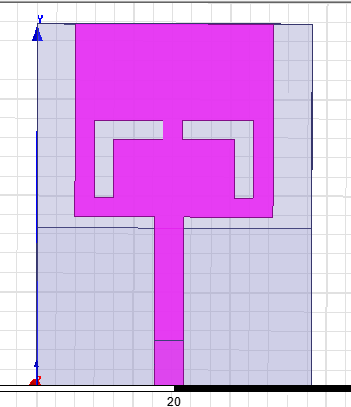

1. Design 1

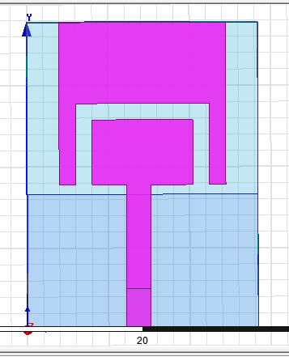

1. Design 2

When the switches are in ON condition, then the metallic strip-1 (a * b dimension) in rectangular shape is account for the lower frequency band. When the switches are in OFF condition then the metallic strip-2 (a1 * b1 dimension) in rectangular shape is account for the higher frequency band.

The antenna is designed with micro strip patch of length12.5mm and width 7.5mm. This increases the bandwidth of the antenna and it is easily reconfigured. The antenna design is simulated by using ANSYS-HFSS software and the directivity of the antenna is 1.

FR4 (Flame resistant) Substrate is the substrate considered with the relative permittivity value is 4.6 and the thickness of FR4 substrate is 1.6mm. The design considerations of the patch are well satisfied with the choice of FR4 substrate which suits for the required frequency of operation. The Landscape U shaped Patch dimensions are calculated as per the below mentioned formula and tabulated in table 1.

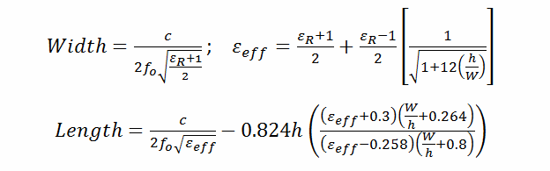

TABLE I

design specifications

|  |  |  |
| --- | --- | --- |
| Symbol | Quantity | Dimension |
| L | Proposed antenna length | 28.4 |
| W | Proposed antenna width | 16.6 |
| l | Patch length | 20.5 |
| εr | Permittivity relative to vacuum | 4.4 |

**B. RETURN LOSS**

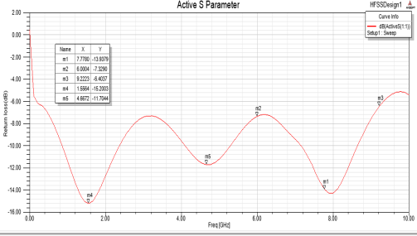

1. Return loss of design 1

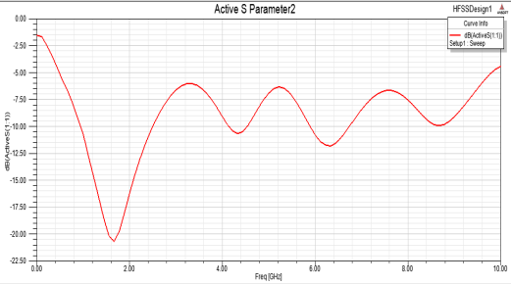

1. Return loss of design 2

The return loss for the antenna design 1 is -15.5dB which operates in the lower band of UWB that is 3-5GHz. The return loss of antenna design 2 is -20.5dB which operates in the higher band of UWB that is 6-9GHz.

**C. VSWR**

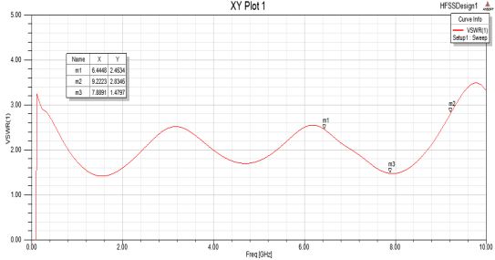

1. Vswr of antenna design 1

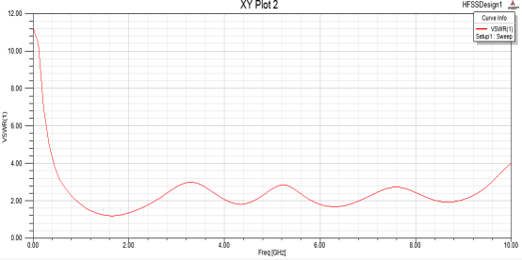

1. vswr of antenna design 2

The VSWR of the antenna design 1 and the antenna design 2 is plotted in graph in different frequency ranges.

**IV. RESULTS AND DISSCUSSION**

In design 1, all three switches are ON and the antenna operates between 3 to 5 GHz of UWB lower band. This antenna is used to examine the UWB lower band spectrum.

In design 2, all three switches are OFF and the antenna operates between 6 to 9 GHz of UWB higher band. The simulation results are in good agreement with the measured result. The simulated result shows better impedance matching for both designs and so it is better for using in cognitive radio applications. The cognitive radio system standardization is not done, so this design is to integrate the more number of frequency bands.

# **REFERENCES**

[1] Cheng Zhu, Jing-Jing Ma, Long Li, and Chang-Hong Liang, “Multi-Resonant Metamaterial Based On Asymmetric Triangular Electromagnetic Resonators, ” in IEEE Antennas Wireless Propag. Lett.,9, pp. 99-102, Feb 2017.

[2] A. Erentok and R. W. Ziolkowski, “Metamaterial-inspired efficient electrically small antennas,” IEEE Trans. Antennas Propag., vol. 56, no. 3, pp. 691–707, Mar 2008.

[3] Y. X. Guo, K. M. Luk, and K. F. Lee, “A Novel Miniaturized TribandPifa for Mimo Applications,” Microw. Opt. Technol. Lett., 40, 3, pp. 724–731, Jan 2007.

[4] F. J. Herraiz-Martinez, G. Zamora, F. Paredes, F. Martin, and J. Bonache, “Multiband printed monopole antennas loaded with open complementary split ring resonators for PANs and WLANs,” IEEE Antennas Wireless Propag. Lett.,10, pp. 1528–1531, Dec 2011.

[5] J. Kim, C.S. Cho and J.W. Lee, “5.2 GHz notched ultra-wideband antenna using slot-type SRR, ” Electron. Lett.,42, 6, Mar 2006.

# **AUTHORS PROFILE**



Navheen Chinnasamy Kannan

B.E ECE

1.