Redesigning IRCTC Booking Application

Parth Bansal

*Department of Computer Science Chandigarh University* Mohali, Punjab, India 21BCS1144@cuchd.in

Samay Kumar

*Department of Computer Science*

*Chandigarh University*

Mohali, Punjab, India

21BCS4656@cuchd.in

Kunal Kumar

*Department of Computer Science Chandigarh University* Mohali, Punjab, India [21BCS4739@cuchd.in](mailto:21BCS4739@cuchd.in)

**Abstract—** The project aims to revolutionize the user experience and functionality of the IRCTC (Indian Railway Catering and Tourism Corporation) mobile application, a vital platform for train ticket booking and travel-related services in India. In response to user feedback and evolving industry standards, this project endeavors to enhance the app's usability, accessibility, and visual appeal. Through comprehensive user research, competitor analysis, and rigorous testing, our team will redefine the information architecture, streamline user flows, and introduce an engaging visual design concept. The redesigned IRCTC app will not only address existing usability issues but also set new standards for intuitive navigation, seamless booking processes, and inclusivity for users of diverse needs

1. Introduction

The IRCTC app is a travel tool that requires significant enhancement. One of the major issues with the app is its complex and confusing navigation structure, which makes it challenging for users to locate the essential features and functions they need. Users have to go through multiple steps and screens to perform simple tasks, such as booking tickets, checking availability, or accessing other information. This creates a frustrating and time-consuming user experience, which can deter users from using the app.

Another issue with the app is its poor accessibility, which makes it unsuitable for a diverse range of users, especially those with disabilities. The app does not adhere to the accessibility guidelines or standards that ensure that the app is usable by everyone, regardless of their abilities or preferences. For example, the app does not have adequate contrast, font size, or voice-over options that would make it easier for users with visual impairments to use the app. The app also does not have any gestures or shortcuts that would make it more convenient for users with physical impairments to use the app. This shows a lack of inclusivity and equality in the app design, which can alienate some users and limit their access to the app.

The app also suffers from a low level of competitiveness, which makes it less attractive and appealing than other travel and booking apps in the market. The app does not offer any unique or innovative features that would differentiate it from other apps or provide added value to the users. The app also does not match the industry best practices or expectations in terms of design and functionality. For example, the app does not have a modern and sleek design that would make it more visually appealing and engaging. The app also does not have any features that would enhance the user interaction or personalization, such as reviews, ratings, recommendations, or preferences. This makes the app less competitive and relevant in a highly saturated and dynamic market.

The app also faces issues with its backend processes, which lead to inefficient and unreliable operations. The app does not optimize the transaction processing, which results in slow and inconsistent performance. The app also causes high system load and frequent errors or crashes, which affect the stability and reliability of the app. This creates a negative user experience, which can cause users to lose trust and confidence in the app. It also affects the operational efficiency and effectiveness of the IRCTC organization, which can impact its revenue and profitability.

The app also has a negative impact on the brand image of the IRCTC organization, which can damage its reputation and credibility. The design of the app directly reflects on the perception of the IRCTC brand by the users and other stakeholders. A poorly designed app conveys a message of low quality and user-unfriendliness, which can undermine the organization's commitment to quality and user-centricity. This can affect the loyalty and satisfaction of the users, as well as their willingness to recommend or promote the IRCTC brand to others.

These problems need to be addressed urgently to improve the IRCTC app and make it a better tool for travelers. The redesign of the IRCTC app is a strategic initiative that aims to achieve multiple goals, such as enhancing user satisfaction, ensuring accessibility, promoting competitiveness, achieving operational efficiency, fostering a positive brand image.

Addressing these multifaceted UX issues and inefficiencies is imperative to enhance the IRCTC app's overall usability and effectiveness, ultimately resulting in a more satisfactory and user-centric platform for travelers seeking to engage with Indian Railways' ticketing, travel, and catering services

1. 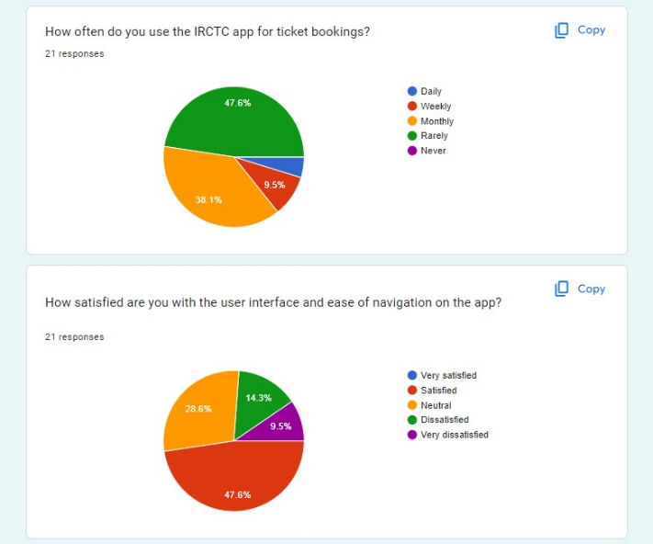Literature Review

Moving from introduction to literature review, we conducted a survey of the existing application IRCTC, where the questions were asked such as are they satisfied with the app, are they able to complete the task The survey data showed a unanimous agreement among the participants, who consisted mostly of college students and adults.

They expressed a strong desire for the IRCTC app to deliver swift and efficient performance, enabling them to accomplish their tasks in a timely and seamless manner. The IRCTC app is the official app of Indian Railways, and it is used by millions of people every day to book train tickets and access other railway-related information. However, the app is known for its complex and confusing interface, which can make it difficult for users to find the information and features they need. In addition, the app has been criticized for its slow performance and frequent crashes. This can lead to a frustrating and time-consuming experience for users, especially during peak times when the app is heavily used. A redesign of the IRCTC app could address these problems and improve the overall user experience. The new design should be focused on simplicity and ease of use, with a clear and concise interface that is easy to navigate. The app should also be fast and reliable, with the ability to handle large volumes of traffic without crashing.[1]

The target users, such as college students and adults, voiced an urgent need for fast functionality within the app. Their busy lifestyles and changing routines demanded an app that streamlined processes and significantly shortened the time taken to complete essential tasks. In essence, the overarching expectation was for the IRCTC app to operate with outstanding speed and efficiency, aligning with the fast-moving lives of the surveyed user base. This vital requirement for quick functionality underscored the significance of optimizing the app's performance to meet the expectations of the discerning college student and adult audience. It streamlines decision-making, enhances navigation efficiency, directs attention to crucial elements, boosts engagement, and influences user preferences. By leveraging these theories, designers create interfaces that not only captivate users but also drive desired behaviors, resulting in a more enjoyable and effective user journey. This, in turn, contributes to increased user satisfaction and ultimately serves the business objectives by improving conversions and user retention.

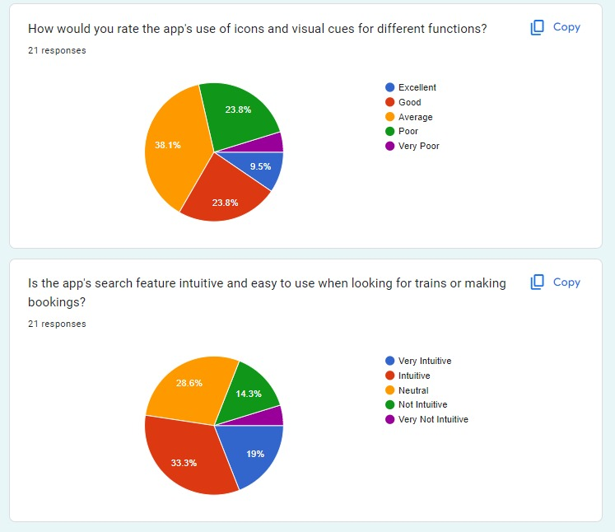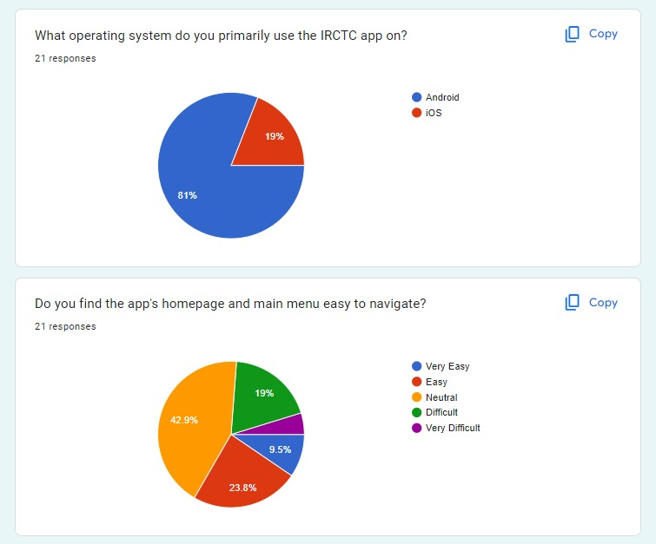

Fig.1: Survey Results

By acknowledging and addressing this need for speed and efficiency, the redesign of the IRCTC app could profoundly enhance user satisfaction and considerably elevate the overall user experience for this crucial demographic. Efficient task completion was pivotal in ensuring that the app became an indispensable tool for managing travel plans, aligning seamlessly with the lifestyle needs of college students and adults alike.

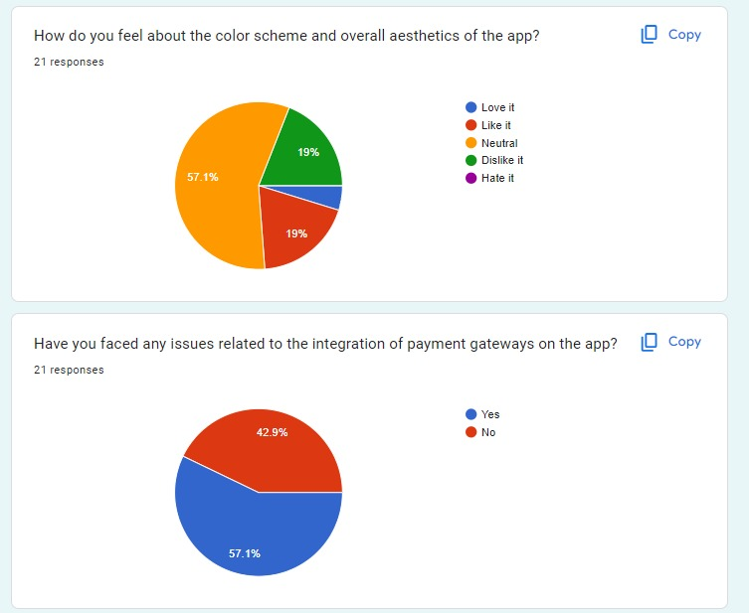

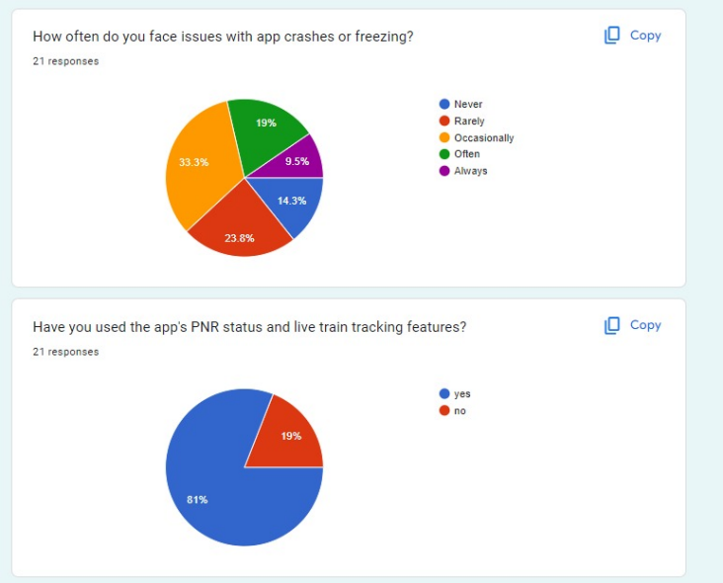

Fig. 2: Survey Results

The theories aid in reducing decision fatigue, improving efficiency and accuracy, guiding attention, enhancing engagement, and influencing user choices. By understanding and utilizing these theories effectively, designers can create interfaces that lead to a more satisfying and effective user experience, ultimately driving desired actions and conversions. It streamlines decision-making, enhances navigation efficiency, directs attention to crucial elements, boosts engagement, and influences user preferences. By leveraging these theories, designers create interfaces that not only captivate users but also drive desired behaviours, resulting in a more enjoyable and effective user journey. This, in turn, contributes to increased user satisfaction and ultimately serves the business objectives by improving conversions and user retention.

1. Methodology

* Low-Fi-Wireframes

Creating low-fi wireframes of the main IRCTC pages, such as the search page, booking page, and account page.

Ask users to navigate through the wireframes and complete specific tasks.

Observing how users interact with the wireframes and identify any areas where they have difficulty.

Making changes to the layout of the pages based on user feedback.

**Navigation bar:** Creating a low-fi wireframe of the navigation bar and asking users to find specific pages and features. Observe how users interact with the navigation bar and identify any areas where they have difficulty.

**Search bar:** Creating a low-fi wireframe of the search bar and asking users to search for specific information. Observe how users interact with the search bar and identify any areas where they have difficulty.

**Call to action buttons:** Creating a low-fi wireframe of the call-to-action buttons and asking users to complete specific tasks, such as booking a ticket or cancelling a reservation. Observing how users interact with the call-to-action buttons and identify any areas where they have difficulty.

**User flow:** The wireframes should accurately represent the steps that users will take to complete their tasks.

**Layout:** The wireframes should show the placement of key UI elements such as the navigation bar, search bar, and call to action buttons.

**Labelling:** All UI elements should be clearly labelled.

**Functionality:** The wireframes should be interactive enough to allow users to test the basic functionality of the new design.

Below we have some Low-Field Wireframes of some screens.

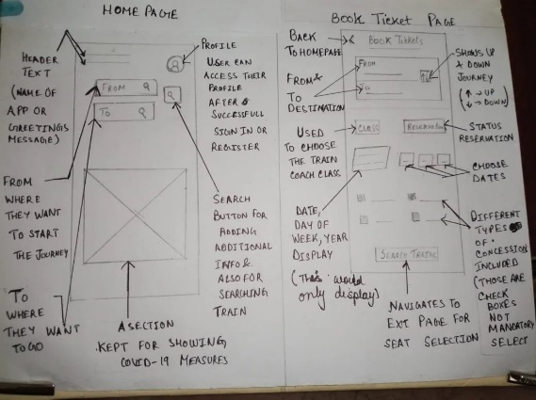

Fig.3.1: Home Page low-field wireframe

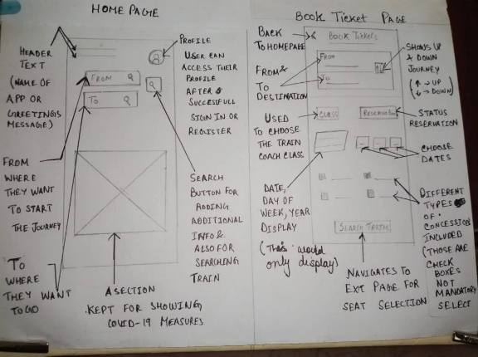

Fig. 3.2: Book Ticket Page low-field wireframe

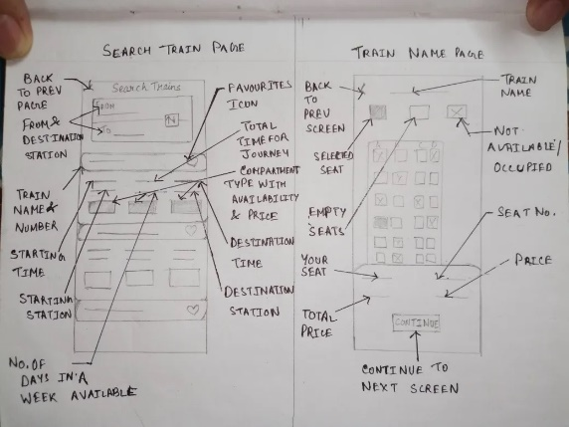

Fig. 3.3: Search Train Page low-field wireframe

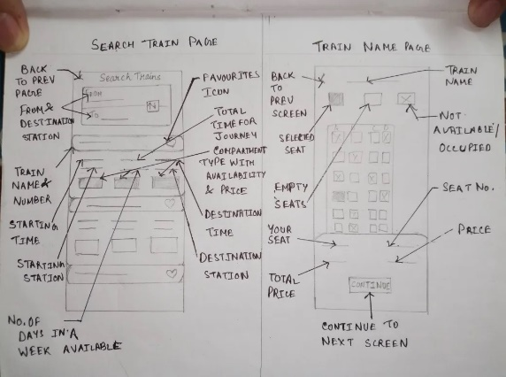

Fig. 3.4: Train Name Page low-field wireframe

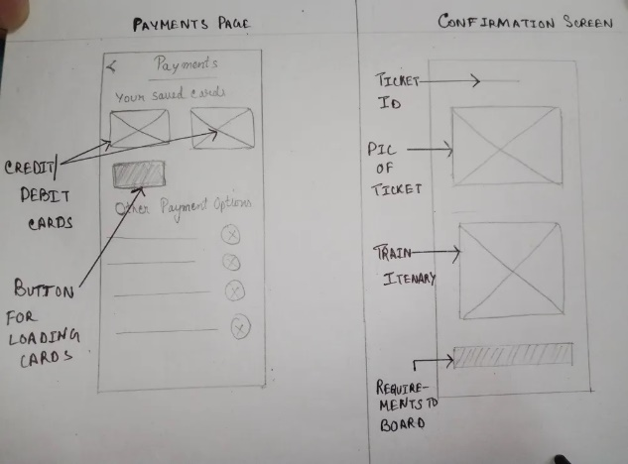

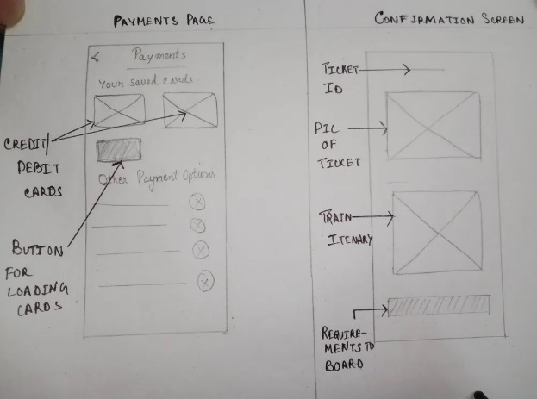Fig. 3.5: Payment Page low-field wireframe

Fig. 3.6: Confirmation Screen low-field wireframe

**Mid-Field Wireframe:**

Mid-fidelity wireframes are more refined than low-fidelity wireframes, but less refined than high-fidelity wireframes. When creating mid-fidelity wireframes for IRCTC, it is important to focus on the following:

**Visual design:** The wireframes should have a basic visual design that is consistent with the IRCTC brand identity. This includes using the correct colours, fonts, and logos.

**Animation:** The wireframes can use basic animation and micro interactions to create a more engaging user experience. For example, you could use animation to show how a menu unfolds or how a button is clicked.

Functionality: The wireframes should be fully interactive, allowing users to test all of the features of the new design.

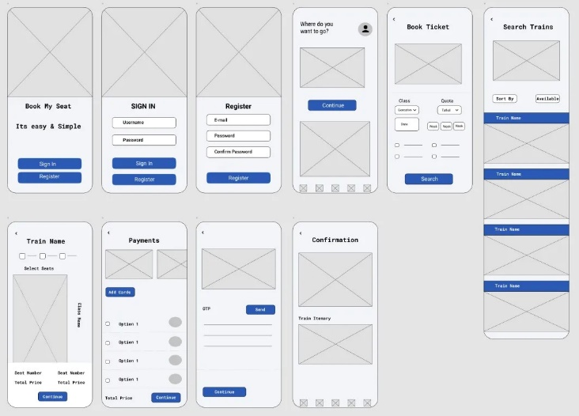Fig.3.7: Mid-field wireframe

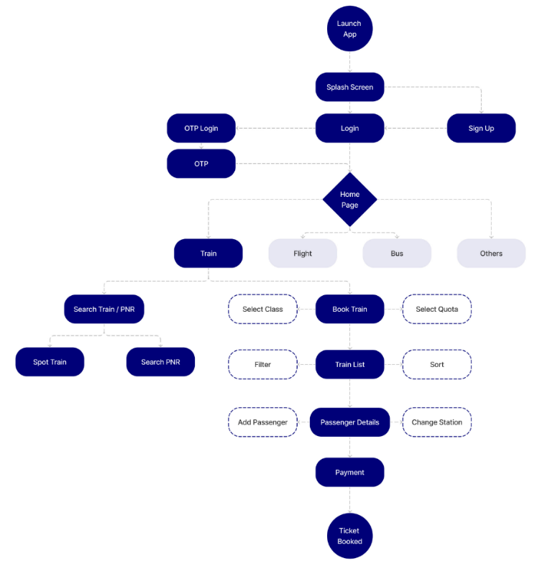

Fig.4: User Flow Diagram

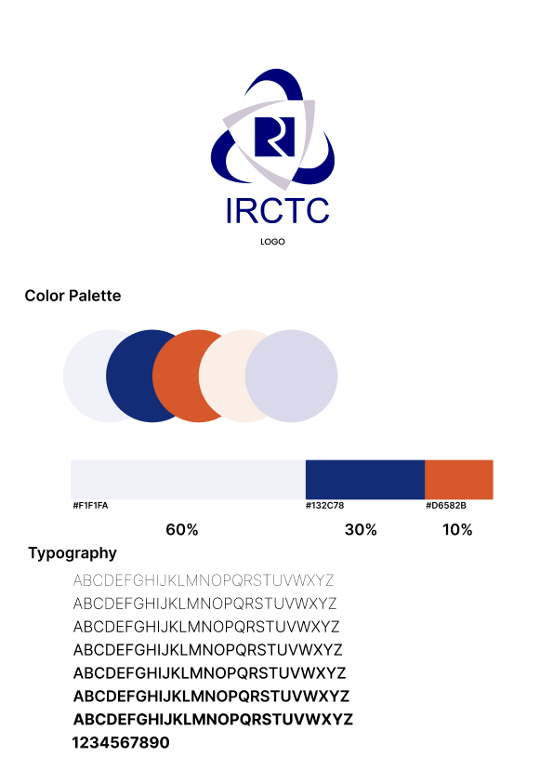

Fig.5: Mood board

1. Results

A possible description for the implementation of a solution for IRCTC redesign is:

The main objective of the IRCTC redesign is to improve the user experience and satisfaction of the online railway ticket booking system in India. The redesign will involve the following steps:

Conducting user research to understand the needs, preferences, pain points and expectations of the target users, such as frequent travellers, senior citizens, students, etc.

Creating user personas, scenarios and journey maps to represent the different types of users and their goals, motivations and frustrations when using the current system.

Performing a heuristic evaluation and usability testing of the current system to identify the strengths and weaknesses, as well as the opportunities and threats for improvement.

Developing a new information architecture, navigation, layout and visual design for the system, based on the user research findings and best practices of web design and usability.

Implementing the new design using HTML, CSS and JavaScript, as well as integrating it with the existing backend functionalities and databases.

Evaluating the new design using usability testing, user feedback and analytics to measure its effectiveness, efficiency and satisfaction.

Iterating the design based on the evaluation results and user feedback until it meets the desired quality standards and user expectations.

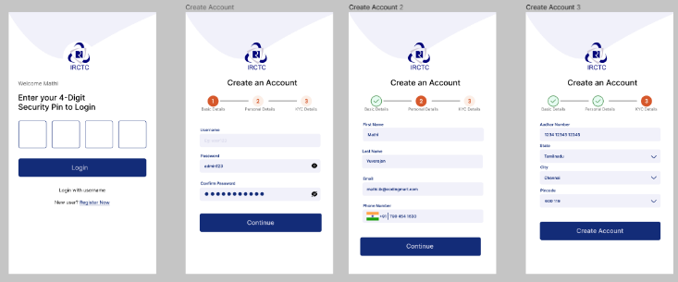

Fig. 6.1: Login Page

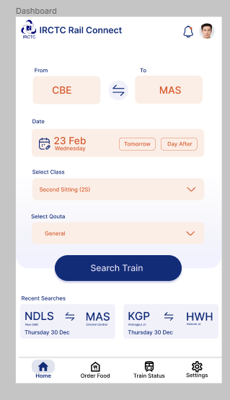

Fig. 6.2: Dashboard

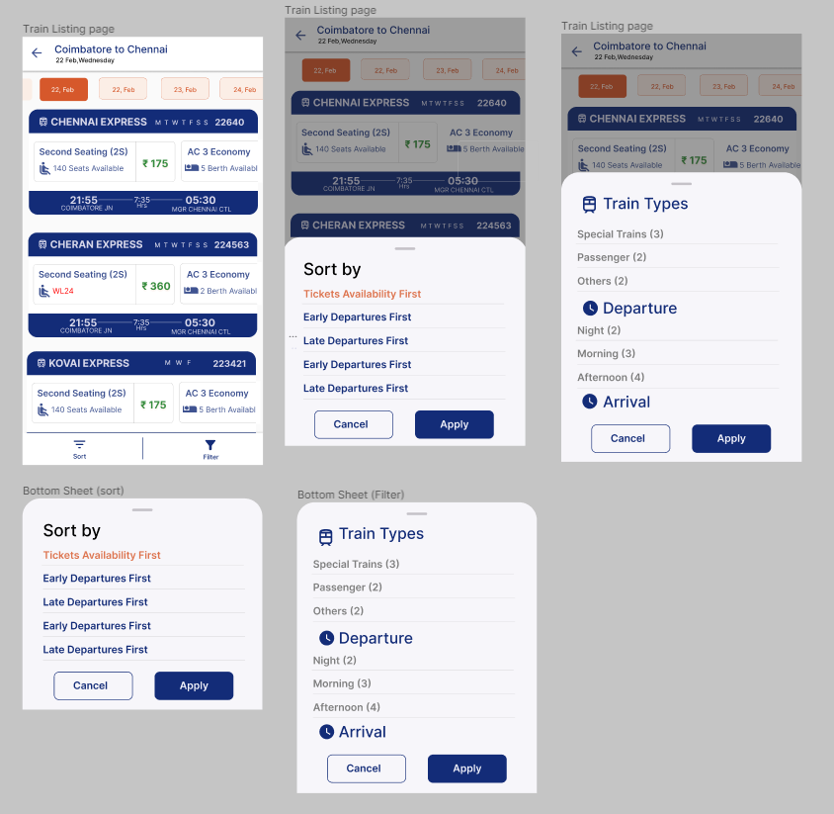

Fig. 6.3: Train Listing

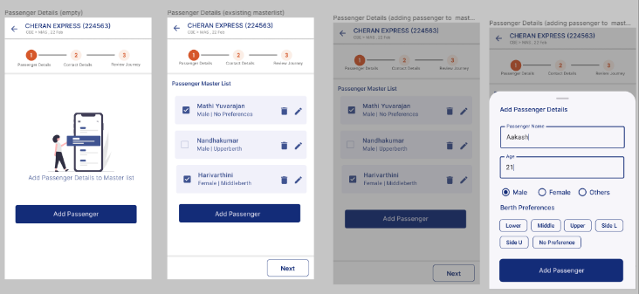

Fig. 6.4: Passenger Details

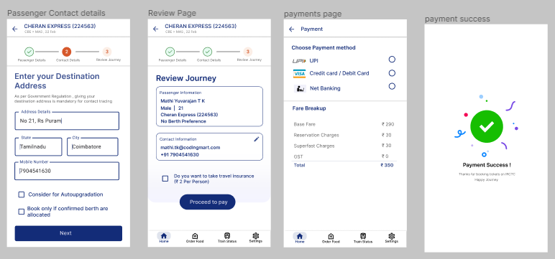

Fig.6.5: Review Page



Fig.6.6: Payment Page

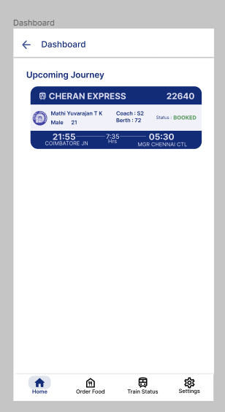

Fig. 6.7: Dashboard

1. Conclusion

The redesign of the IRCTC app represents a significant stride towards providing users with a seamless, efficient, and user-friendly mobile experience. By incorporating principles of user-centric design, prioritizing mobile responsiveness, and ensuring intuitive navigation, the redesigned app aims to cater to the diverse needs of users, whether they are regular commuters or tourists.

The emphasis on security, accessibility, and performance optimization underscores a commitment to user trust and inclusivity. The integration of additional features, such as real-time updates, multi-language support, and streamlined booking processes, contributes to an enhanced travel experience for app users.

Continuous user feedback and data analytics will be pivotal in refining the app over time. Regularly analysing user behaviour and preferences will enable iterative improvements, ensuring the app remains responsive to evolving user needs.

1. References

|  |  |
| --- | --- |
| [1] | H. Agarwal, "Medium," 8 8 2021. [Online]. Available: https://medium.com/@harsh_youx/irctc-app-redesign-60f4d3a7c0b0. |
| [2] | R. Macías, "Case study: Creating a travel booking app applying design thinking methodology," 5 2 2021. [Online]. Available: https://bootcamp.uxdesign.cc/case-study-creating-a-travel-booking-app-applying-the-design-thinking-methodology-b6b61ba46ca. |
| [3] | Karthick, "Case Study : Making a micro change in MakeMyTrip app to improve the user experience," 23 1 2023. [Online]. Available: https://bootcamp.uxdesign.cc/making-a-micro-change-in-makemytrip-app-to-improve-the-user-experience-ux-case-study-63e2ed8c98b2. |
| [4] | M. Jain, "UX Case Study for a Train Ticket Booking Application," 16 8 2019. [Online]. Available: https://www.behance.net/gallery/86877573/UX-Case-Study-for-a-Train-Ticket-Booking-Application. |
| [5] | D. B. a. L.-X. Lavallee, "Growth Design," [Online]. Available: https://growth.design/case-studies. |