**A review on Drive shaft and loading analysis on drive shaft of automobile**

**Mr. Shaikh Aafan Zakir1, Prof. N.K. Kharate.**

1P.G. Scholar, 2Professor,

Department of Mechanical Engineering, M.V.P. Samaj’s, K.B.T College of Engineering and Research, Nashik, Maharashtra, India.

**ABSTRACT**

Drive shafts are mechanical components that are widely used in vehicle powertrain systems to transmit torque and rotation between different components which are not in line or cannot be connected directly. It must transmit the torque from transmission of Differential Gear Box. The Drive shaft is made of heavy duty steel due to its tremendous amount of strength and applicability. Almost all automobiles (at least those which correspond to design with rear wheel drive and front engine installation) have transmission shafts. The weight reduction of the drive shaft can have a certain role in the general weight reduction of the vehicle and is a highly desirable goal, if it can be achieved without increase in cost and decrease in quality and reliability. The current case study explains the review on different loading constraints on vehicle drive shaft of an automobile.

**Keywords:** Drive shaft, loading constraints, automobile transmission

1. **INTRODUCTION**

Drive shafts are mechanical components that are widely used in vehicle powertrain systems to transmit torque and rotation between different components which are not in line or cannot be connected directly. During operation, drive shafts are usually subject to torsion and shear stress depending on the input torque and the external load. As key components carrying torque, they must be strong enough to bear the stress for short term loading, the stress state is quasi static and the drive shaft should be designed to prevent plastic deformation; for long term loading, the stress state is dynamic therefore the shaft must be designed for millions of stress cycles. [2] The common drive shafts used in industry are,

1. ***Single Piece Drive Shafts :***

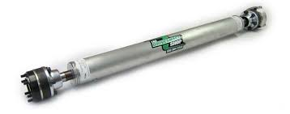

**Figure 1** Single Piece Drive Shafts [3]

It is a driveshaft that is designed for applications that call for increased horsepower, so you can hit the road with confidence. Reduced overall weight and rotating mass, Delivers improved driving performance and Provides quicker acceleration. It is lighter in weight which is the main benefit, due to which it takes slightly less power to turn it and has a higher speed handling capability. The focus of attraction for selecting this shaft is it takes less power. It is one less joint in the shaft than the stock one and it has no centre carrier bearing. [3]

1. ***Slip Tube Drive Shafts :***

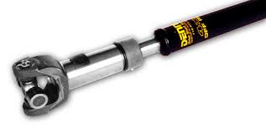

**Figure 2** Slip Tube Drive Shafts

A tube shaft is a drive shaft component that is used with a slip yoke, which in turn allows for axial movement. The slip in tube is basically a collapsible driveshaft. So a tube within a tube (kind of like a telescope). Suitable materials for driveshaft depends on the torque transmission, it'll have to have a torsional rigidity large enough not to twist itself apart or collapse.

1. ***Multi-Piece Drive Shafts :***

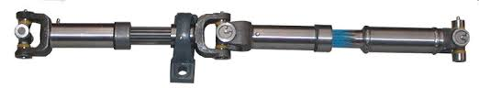

**Figure 3** Two Piece Drive Shafts

All multi piece driveshaft are system balanced at road speed RPMs to ensure smooth, vibration-free performance.  System balancing means that all shafts are balanced as a unit so that the drive shafts all work together to deliver the power.  Like our one piece drive shafts, the Action Machine tolerances for balancing multi piece driveshaft’s are half that of OEM standards.  This fact is even more important when working with multi piece shafts because poorly straightened and balanced shafts can cause vibrations to be amplified as they travel down the long distances.

1. **LITERTURE SURVEY :**

The shaft made of steel and fabric reinforcement added to the shaft made the shaft advantageous in weight reduction. [1] The forged steel shafts have its own advantages and disadvantages in implementation and use. The paper describes the chemical composition and material properties of forged steel. [2] The shaft meet with the fracture due to bumping nature of road condition. The material discuss in the paper is 42CrMo4 grade of steel. [3] The parameters of impact are discussed along with the experimental test of Izod Test. [4] [5]. The shaft is designed using carbon fibre and various failure criteria’s which help in designing of shaft. [6] Shaft of Maruti Suzuki Omni and various Design Considerations of Shaft subjected to different moments. [7] Conducts the buckling analysis of composite drive shaft for automotive applications. The single piece composite drive shaft is better suitable for driveline applications. [8] The work carried out on the composite drive shafts which are used in the automotive applications; fabrication techniques and materials used in the fabrication of composite shafts, finite element analysis on composite shaft and steel shaft. [9]. An attempt is made to evaluate the suitability of composite material such as E-Glass/Epoxy and Carbon/Epoxy for the purpose of automotive transmission applications. [10]. The research work is to replace conventional steel material two piece three universal joints drive shaft with composite material single-piece drive shaft. Single-piece drive shaft was designed using the Solid Edge and Pro-E software. [11] The static, free vibration and Tensional buckling analysis was made which are very much required for rotating elements like drive shafts. The modelling of composite drive shafts is made in analysis software ANSYS. [12] In the process of damage accumulation, the damage first appears at the stress concentration of fibre matrix. [13] In the present work, Composite propeller shaft of E Glass/Epoxy is made identical as steel propeller shaft of same torque carrying capacity. The propeller shaft is designed for 2 Ton truck with torque capability of 1500 Nm. [14] The tensile and torsion experiments were carried out on 3D braiding composite shafts with diﬀerent braiding angles, and AE was used to monitor the damage evolution during the experiments. [15].

1. **COMPONENT SPECIFICATIONS:**

In this case study, the design and analysis of propeller shaft is considered. The shaft considered for case study is selected from Maruti Omni. Maruti Suzuki Omni is 5 seating Capacity vehicle depending on the seating arranged. The Shaft used in this case Study is of Maruti Van. The shaft is made of ANSI Steel. The diameter of Shaft is 43mm which is linked with universal Joint on its either sides. The Universal Joint is of same material. The Centralised Length of Assemble is 850 mm and actual length of is 730mm.

**Table 1** Specifications of Maruti Omni

|  |  |
| --- | --- |
| **Parameter** | **Value** |
| Max Power | 8.04 bhp @ 3400 rpm |
| Max Torque | 6.1 kgm @ 3000 rpm |
| Overall Length (mm) | 3310 |
| Overall Width (mm) | 1410 |
| Overall Height (mm) | 1640 |
| Kerb Weight (Kgs) | 785 Kg |
| Gross Vehicle Weight (GVW) | 1385 Kg |
| Body Option | Multi-Purpose Vehicle |
| Mileage (Diesel Fuel) | 19 kmpl |

1. ***Torsional Moment :***

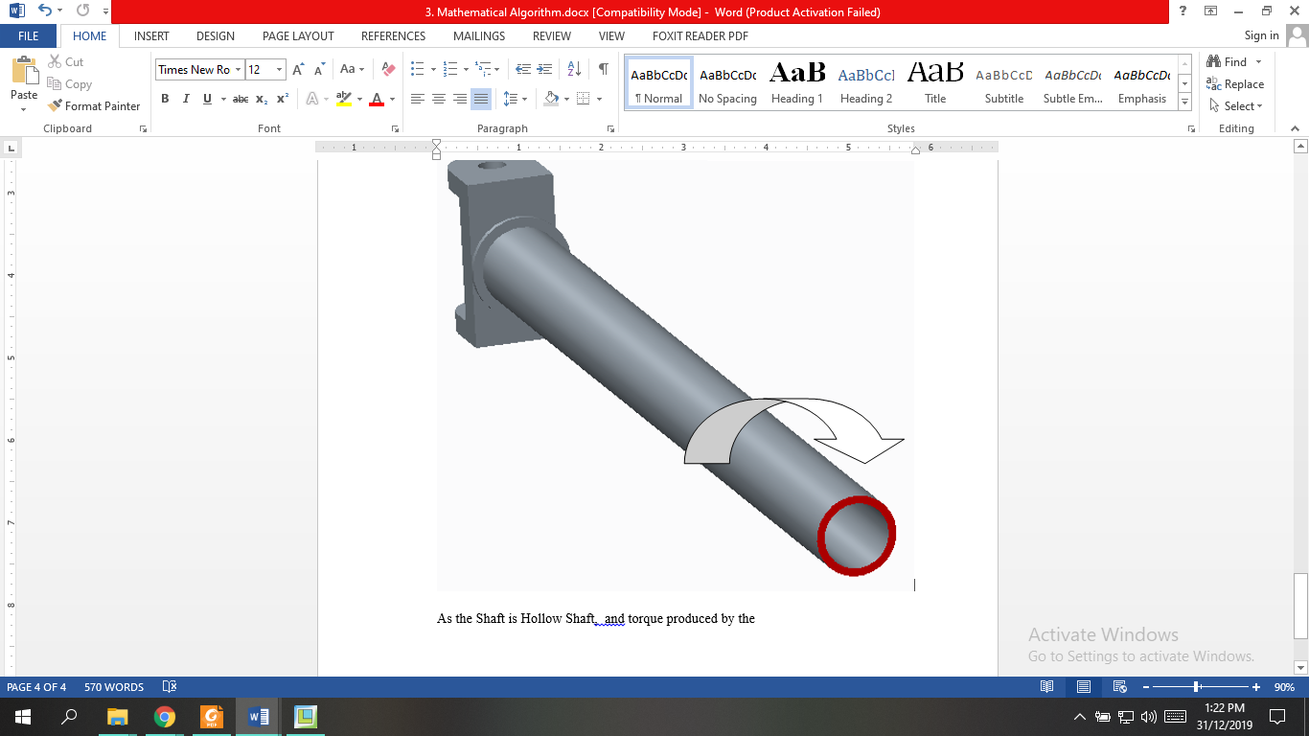

**Figure 4.** Application of Torque.

As the maximum engine speed is 3400 rpm, hence, the maximum power transmitted by the engine is 6KW, the torque transmitting capacity of the engine is 59.82N.m, hence the same is considering as applied torque.

1. ***Torsional Force:***

The torsional force is the force which is required to produce the estimated torque. Hence Torsional Force (F1) generated by engine during running is 2790N to a margin considered as 3000N (Safety).

1. ***Rotational Velocity:***

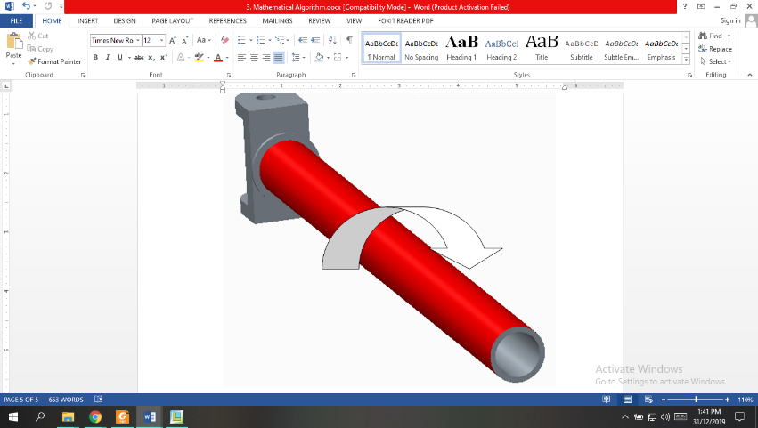

**Figure 9** Rotational Velocity

It is the speed of the shaft which is running to transmit the speed. As the engine speed is 3400 rpm, the rotational velocity is considered the same. The Angular Velocity (ω) subjected to the shaft is 356.04 Rad/Sec.

1. ***Shaft Subjected to Bending Moment :***

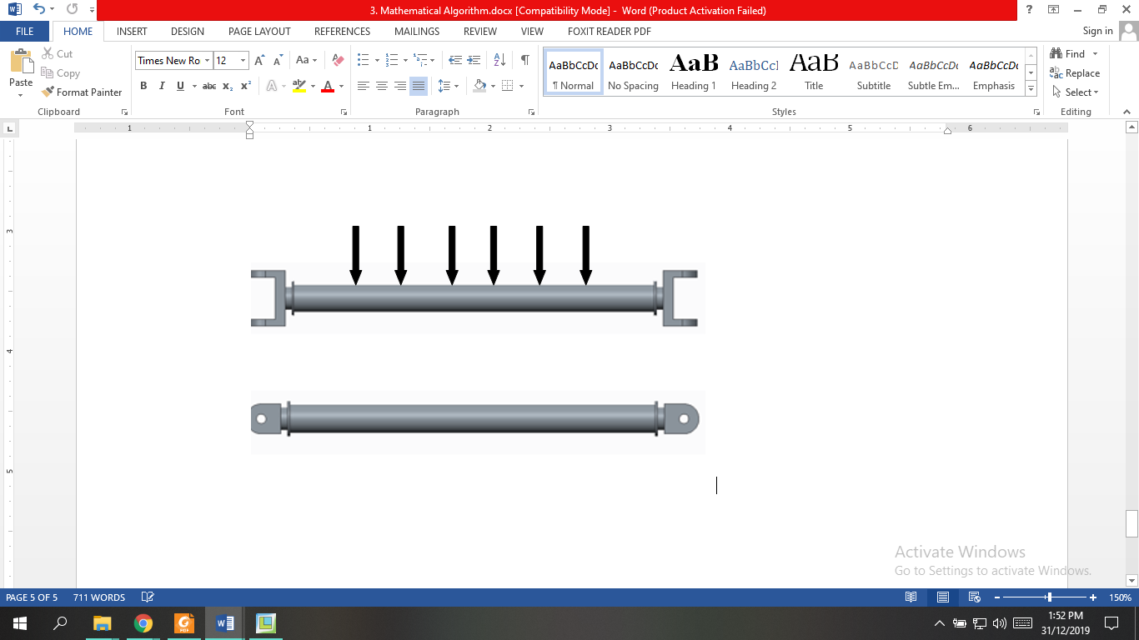

**Figure 10** Torsional Shaft Subjected to Bending

Considering the shaft subjected to its self-weight of 4 Kg which is equivalent to 40 N. Hence Bending Moment, (M) is considered as 5 x 105 N.mm.

1. ***Torsional Buckling :***

Torsional buckling (Ǿ) capacity of shaft Torsional buckling (Ǿ) capacity of shaft as 433 N.mm

1. **CONCLUSIONS :**

* In this paper, the material optimization of shaft made SMC45 Steel is done with the replacement of aluminum and polymer matrix components.
* All the loading constraints have been studied and applied to determine the loading conditions that can be used for FEA.
* The aesthetics of shaft have been studied and discovered thoroughly
* The Mechanical Properties and Chemical composition of the shaft have been studied.
* The dimensions of shaft have been taken and a Prototype model is been prepared in Creo 2.0 Software.
* The Load and Stress analysis have been studied and mathematical algorithm has been prepared to define the area and section of torsional and bending loading.

1. **REFERENCES**

|  |  |
| --- | --- |
|  | C Elanchezian et.al. “Design and Comparison of Strength and Efficiency of Drive Shaft made of Steel and Composite Material”, Journal of Materials Today, Else Vier Publication, 2018. |
|  | M. Godec and Dj. Mandrino, M. Jenko, “Investigation of the fracture of a car’s drive shaft”, Journal of Engineering Failure Analysis, Else Vier Publication, Volume 16, 2019. |
|  | Madhu K.S., Darshan B.H., Manjunath K., “Buckling Analysis Of Composite Drive Shaft For Automotive Applications”, Journal of Innovative Research and Solutions, A Research Gate Publication, Volume No.1A, Issue No.2, Page No: 63 ‐70, Jan – Jun 2013. |
|  | Belawagi Gireesh, Sollapur Shrishail B, V. N. Satwik, “Finite Element & Experimental Investigation of Composite Torsion Shaft”, International Journal of Engineering Research and Applications (IJERA), A Research Gate Publication, Volume 3, Issue 2, March -April 2013. |
|  | Souvik Das, Goutam Mukhopadhyay, Sandip Bhattacharyya, “Failure analysis of axle shaft of a fork lift”, Journal of Case Studies in Engineering Failure Analysis, Else Vier Publication, Volume 03, 2015. |
|  | Ashwani Kumar, Rajat Jain, Pravin P. Patil, “Dynamic Analysis of Heavy Vehicle Medium Duty Drive Shaft Using Conventional and Composite Material”, IOP Conf. Series: Materials Science and Engineering, IOP Publishing, Volume 149, 2016. |
|  | P. Satheesh Kumar Reddy and Ch. Nagaraju, “Weight optimization and Finite Element Analysis of Composite automotive drive shaft for Maximum Stiffness”, 5th International Conference of Materials Processing and Characterization (ICMPC 2016), Materials Today: Proceedings, Else Vier, Volume 04, 2016. |
|  | Linhui Gong et.al., “Design on the driveshaft of 3D 4-Directional carbon fiber braided composites” Journal of Composite Structures, Else Vier Publication, Volume 203, 2018. |
|  | Shoaib Nadeem SK, G Giridhara, H K Rangavittal, “A Review on the design and analysis of composite drive shaft”, Materials Today: Proceedings, Else Vier Publication, Volume 05, 2018. |
|  | Ammineni Syam Prasad, “Experimental Investigations on Static and Dynamic Parameters of Steel and Composite Propeller Shafts with an Integrated Metallic Joints”, Materials Today: Proceedings, Else Vier Publication, Volume 05, 2018. |
|  | Guoqi Zhao, Lu Zhang, Ben Wang, Wenfeng Hao*, Ying Luo, “HHT-based AE characteristics of 3D braiding composite shafts”, Journal of Polymer Testing, Else Vier Publication, Volume 79, 2019. |
|  | Li-Hui Zhao et.al. “Failure and root cause analysis of vehicle drive shaft”, ”, Journal of Engineering Failure Analysis, , Else Vier Publication, Volume 99, 2019. |
|  | Yang Liu et.al., “Fracture failure analysis and research on drive shaft of positive displacement motor”, Journal of Engineering Failure Analysis, , Else Vier Publication, Volume 106, 2019. |
|  | Wenfeng Hao et.al. “Study on the torsion behavior of 3-D braided composite shafts”, Journal of Composite Structures, Else Vier Publication, Volume 229, 2019. |
|  | Mahmood M. Shokrieh, “Shear buckling of a composite drive shaft under torsion”, Journal of Composite Structure, Else-Vier Publication, 2018. |