**SUBMARINE ROCK VS MINE PREDICTION**

**Mrs. Chithra M1 , Dr. Ananth S2 , Mr. Deepan T3 , Mr. Kathir VR4 , Mr. Kavin S5 , Mr. Jeevananthan S6**

1Assiatant Professor, Mahendra Engineering College, Mahendrapuri, Namkkal, Tamil Nadu, India.

2Head of the department, Mahendra Engineering College, Mahendrapuri, Namkkal, Tamil Nadu, India.

3,4,5,6 UG Scholars (B.Tech), Mahendra Engineering College, Mahendrapuri, Namkkal, Tamil Nadu, India.

1,2,3,4,5,6Artificial Intelligence and Data Science, Mahendra Engineering College, Mahendrapuri, Namkkal, Tamil Nadu, India.

**ABSTRACT**

The detection and classification of underwater objects, such as submarines and mines, is of paramount importance for maritime security and defense. Traditional methods of detection and classification in this challenging environment have limitations in terms of accuracy and efficiency. This study introduces a novel approach for Submarine Rock vs. Mine Prediction using Machine Learning, leveraging advanced techniques to enhance the accuracy of target identification. This research project encompasses the development and implementation of a machine learning model designed to discriminate between natural submarine rock formations and man-made naval mines. The model is trained on a diverse dataset of acoustic and sonar data collected from underwater environments, incorporating various types of vessels and underwater geological features.The machine learning model utilizes state-of-the-art algorithms, including deep neural networks and feature engineering, to effectively differentiate between the acoustic signatures of rocks and mines. It demonstrates robust performance in terms of classification accuracy, precision, and recall, contributing to the reduction of false alarms and improved maritime security.

**Keywords:**Machine Learning,Prediction,Feature Selection,Data Analytics,Rocks and mines,SONAR

**1. INTRODUCTION**

Machine learning is a subfield of artificial intelligence (AI) that uses algorithms trained on data sets to create self-learning models that are capable of predicting outcomes and classifying information without human intervention. Machine learning is used today for a wide range of commercial purposes, including suggesting products to consumers based on their past purchases. Predicting stock market fluctuations, and translating text from one language to another. In common usage, the terms “machine learning” and “artificial intelligence” are often used interchangeably with one another due to the prevalence of machine learning for AI purposes in the world today.

**1.METHODOLOGY**

Initially, data collection involves deploying hydrophones at strategic locations to capture ambient noise and target signatures. Signal preprocessing includes noise reduction and feature extraction, where relevant acoustic parameters such as frequency, amplitude, and time-domain characteristics are meticulously identified. Machine learning algorithms, particularly deep neural networks, play a pivotal role in model development. Training the model involves feeding it with labeled datasets containing examples of both submarine rocks and mines, ensuring robust classification capabilities. Rigorous testing and validation are conducted using distinct datasets to assess the model's generalization and predictive accuracy. Additionally, real-time monitoring and adaptive learning mechanisms are implemented to enhance the model's performance in dynamic underwater environments.

**2. 1 Supervised Learning**

Supervised learning (SL) is a paradigm in machine learning where input objects (for example, a vector of predictor variables) and a desired output value (also known as human-labeled supervisory signal) train a model. The training data is processed, building a function that maps new data on expected output values.

**3. 2 Unsupervised Learning**

Unsupervised learning in artificial intelligence is a type of machine learning that learns from data without human supervision. Unlike supervised learning, unsupervised machine learning models are given unlabeled data and allowed to discover patterns and insights without any explicit guidance or instruction.

**4. 3 Reinforcement Learning**

Reinforcement Learning is a part of machine learning. Here, agents are self-trained on reward and punishment mechanisms. It's about taking the best possible action or path to gain maximum rewards and minimum punishment through observations in a specific situation.

**5. MODELING AND ANALYSIS**

This involves constructing a predictive model, often utilizing advanced machine learning techniques such as deep neural networks, to discern patterns that distinguish between submarine rocks and mines. The model is meticulously trained on a labeled dataset, optimizing its parameters to accurately capture the complex relationships within the data. Rigorous testing is conducted to evaluate the model's performance, assessing its ability to generalize to unseen instances. Additionally, sensitivity analysis is employed to understand the impact of different features on prediction outcomes, ensuring robustness and reliability. Iterative refinement of the model is carried out, incorporating feedback from real-world scenarios to enhance its predictive capabilities.

**6.1 Collecting Data:** Data collection is the process of gathering and measuring information on targeted variables in an established system, which then enables one to answer relevant questions and evaluate outcomes. Data collection is a research component in all study fields, including physical and social sciences, humanities, and business.

**7.2 View:** The viewpoint encompasses a comprehensive understanding of the underwater environment through a multi-modal approach. We employ acoustic, sonar, and other relevant sensor data to construct a holistic view of the submarine landscape. This involves integrating data from various perspectives and depths to enhance the model's ability to discern subtle distinctions between rocks and mines. The diverse viewpoints contribute to a more nuanced representation of underwater features, enabling the prediction model to operate effectively in different conditions.

**3.3 Preprocessing:** Data Pre-processing is a technique that is used to convert the raw data into a clean data set cleaning the data refers to removing the null values, filling the null values with meaningful value, removing duplicate values, removing outliers, removing unwanted attributes.

**3.4 Identifying Features:** To identify distinctive features that can aid in accurate classification. These features serve as the foundation for machine learning algorithms to distinguish between underwater geological formations (submarine rock) and man-made objects (mines). Some of the key features that are typically considered include acoustic backscatter patterns, target size and shape, shadowing effects, spectral characteristics, and temporal changes in the environment.

**3.5 Prediction:** It involves the utilization of advanced machine learning and pattern recognition techniques to classify underwater objects based on their unique features. By training predictive models on a dataset containing labeled instances of submarine rock and mines, these models can learn the underlying patterns and relationships within the data.

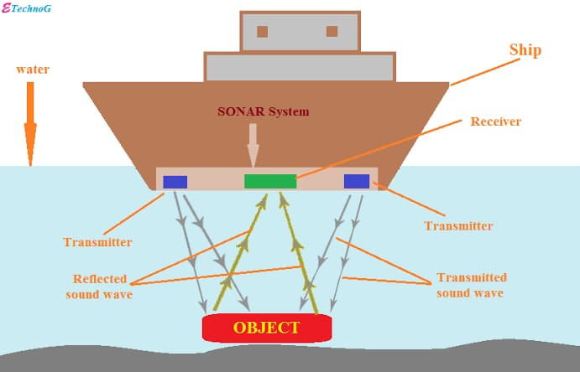

**Figure 1:** Working Process

**4. RESULTS AND DISCUSSION**

In the Result and Discussion phase of the Submarine Rock vs. Mine Prediction project, the performance of the developed model is rigorously evaluated based on its predictions. Quantitative metrics, such as accuracy, precision, recall, and F1 score, provide insights into the model's effectiveness in distinguishing between submarine rocks and mines.

The results are presented alongside qualitative assessments of the model's behavior in various scenarios, shedding light on its strengths and potential limitations.The discussion delves into the implications of the findings, exploring the model's sensitivity to different environmental conditions, noise levels, and variations in target characteristics. Any discrepancies between predicted and actual outcomes are analyzed to identify areas for improvement or optimization. Moreover, the discussion may touch upon the practical feasibility of deploying the model in real-world applications, considering factors such as computational efficiency and scalability.

Overall, the Result and Discussion phase serves as a critical step in refining the Submarine Rock vs. Mine Prediction system, providing valuable insights for further iterations and optimizations to enhance its predictive accuracy and real-world applicability.

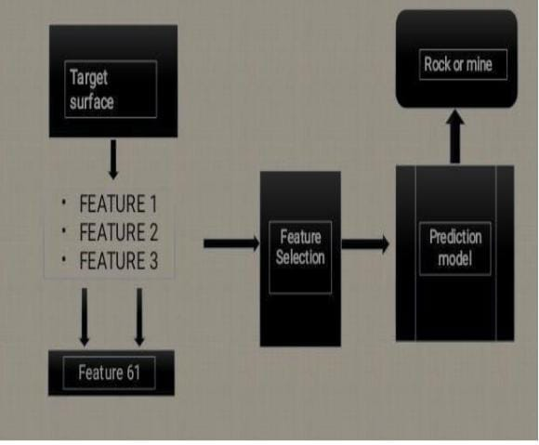

**Figure 2:** Result of the Sonar Data

**5. CONCLUSION**

In conclusion, the application of machine learning in Submarine Rock vs Mine Prediction represents a pivotal advancement in the field of maritime security and underwater defence. The ability to accurately distinguish between natural submarine rock formations and potentially hazardous naval mines is of paramount importance, and machine learning offers an innovative and effective solution to this complex challenge.

**6. REFERENCES**

1) Dura Esther, et al. "Active learning for detection of mine-like objects inside scan sonar imagery," IEEE Journal of Oceanic Engineering 302: 360-371 (2005)

2) Erkmen, Burcu,and Tülay Yildirim. "Improving classification performance of sonr targets by applying general regression neural network with PCA Expert Systems with Applications 35.1-2:473-475. (2008)

3) Bacardit, Jaume, and Martin V. Butz. Data mining in learning classifier system: comparing XCS with GAssist." Learning Classifier Systems, Springer, Berlin, Heidelberg, 283-290. (2007)

4) N. Hoods et al. "B2 PSE framework for high dimensional imbalanced data: A case study for drug toxicity prediction, Neurocomputing, (2018)

5) N.Hooda, Nishtha et al. "Fraudulent Firm Classification: A Case Study of External Audit." Applied Artificial Intelligence 32.1: 48-64 (2018)

6) Ho, Tin Kam. Random Decision Forest (PDF). Proceedings of the 3rd International Conference on Document Analysis and Recognition, Montreal, QC, 14-16 August 1995. pp. 278-282, (1995).Corinna, Cortes; Vladimir N. Vapnik “Support-vector networks. Machine Learning 20(3): 273-297, dui: 10.1007/B00994018. (1995)

7) Kg, Balazes. "The turn of AdaBoost MH: multiclass Hamming trees. arXiv:1312.6086. (20 December 2013)

8) Pearl Judea City: Models, Reasoning, and Inference. Cargo University Press, ISBN 0-521-77362-8. OCLC 4229125, (2000)

9) Huang Jin Performance measures of machine learning. University of Western Ontario, (2006)

10) Bradley, Andrew P. The use of the area under the ROC curve in the evaluation of machine learning algorithms. Pattern recognition 30.7: 1145-1159. (1997)