# A STUDY ON CUSTOMER SATISFACTION WITH SPECIAL REFERENCES TO

# D-MART AT TUMKUR CITY

1 , LAVANYA N 2, MOHAMMED SHOAIB.

1 MBA Student, Department of MBA, Shridevi Institute of Engineering and Technology, Tumkur, Karnataka, India.

2 MBA Student, Department of MBA, Shridevi Institute of Engineering and Technology, Tumkur, Karnataka, India.

# ABSTRACT

The study is aims to probe at customer satisfaction in D- Mart at tumkur city. If any firm want to sustain in the market, it as to satisfy and fulfilling the needs and wants of the customer. D-Mart is a network of supermarket chains where products will be available at bargain basements, and. This study is used to determine the level of customer satisfaction with respect to the service provided by D-Mart, to analyse the display pattern of D Mart products, and to analyse the Compare between pricing strategy followed by D-mart with other of retail strategies. The primary objective of this survey is to mainly know that the customer is becoming more aware of the prices of the product just because there has been a rapid increase in the inflation rate in India, the customer is becoming more aware of their expenditure on their daily life’s product and the comparison of price at retail store and D-Mart. D-Mart not only buys the product bulk and sells it at bargain basements but it’s also some of its producing its own manufactured some of the product and producing at a low price with standard quality.

Keywords: bargain basement, customers, satisfaction. D-mart

# INTRODUCTION:

The D-Mart is best to know for its discounting of the products at reasonable price and also making the customer to buy of more. The D-Mart is started at May 2002 by “Mr. Radhakrishna Damani “ owned and operated by Avenue Supermarket Ltd (ASL) . The D-Mart full form Damani the surname of founder. The products available like grocery and staples, daily essentials, dairy and frozen , home furniture and appliances , clothing , footwear , toys, luggage , health and beauty , sporting goods and fitness. The D-Mart have best strategy of arranging the product in the rack and displaying of the products price and there discounting rates on the product , the important thing we should notice is that India is a diversified country with many local languages to make a customer feel comfort the product name is displayed in their local languages. The D-Mart is almost having it own land and building then renting it branches and having it’s having around of 336 stores all over India. Their mission and vision will give us how much there fascinate towards customer normative and there firm is booming in the market

**LITREATURE REVIEW:**

* **Nanded District**: It is compared of D-Mart and Reliance Smart its concluded of their profile, preferences of brand, discounting percentage, customer convinces, purchase behaviour pattern and important customer satisfaction.
* **Swapna Dubhe:** Its reviewed that, their main customer are of middle income level group people, brand loyalty, quality offered with discount its attracting more customer. It’s suggested that it as to provide online service. the demerit is staff should have to give of training and handle of customer during crowd at twin cities in Telangana.
* **Akshay Kumar G Bhat and Rajendra Prasad:** The retail store are booming just like IT industry, this study determines that it as best know for its pricing strategy, staff behaviour, need to concentrate more on advertising of there store , crowding managing is good .
* **Saloni Chechani:** It’s is used to compare the D-Mart and retail store and how its as been effeceted the local store due to establish of the D-Mart . Its as informed that it is still following both traditional and modern form of selling branded products.
* **M. Guruprasad:** According to this study the customer are satisfied with services and product provided by the D-Mart .Its as concluded there are spending of the major amount at the store . Improvement in the infrastructure, layout . The customer are delight with the return policy.
* **Debendra Prasad Kundu**:By this study the customer are aware of both organised and non-organised stores , the pricing strategy , availability of product, services , quality and quantity , offers . Its as conclude that major of the shopping at the organised store.

**OBJECTIVE OF THE STUDY:**

* To know the level of customer satisfaction with respect to service provided by D-Mart.
* To analyse the Display pattern at D Mart product
* To analyse the Comparison between pricing strategy followed by D-mart with other of retail.

**RESEARCH METHODOLOGY:**

In this study both primary and secondary data are used to collect the information and conducted a survey . By creating a google from and framing a questionnaire according to the study objective framed .

**RESEARCH INSTRUMENT:**

Chart and table are using to analysis the respondent importance.

**Limitation of the study:**

* As ta study is applied to collection of the respondent of customer Tumkur only.
* The maximum figure of respondent of 120 only.
* In the survey conducted given a open option to share their value.

**DATA INVESTIGATION AND ANALYSIS:**

(Note: Demographics Factors are considered and graph is plot in Percentage)

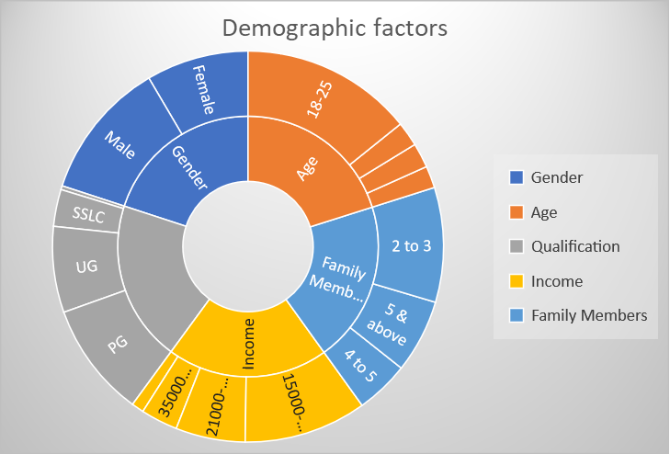

Graph 1: Showing the Demographics Factors of respondents

**INTERPRETATION –**

The graph illustrate that majority male respondents, with the age of 18-25, family members of 2 to 3 and 5 & above, qualification of Post graduate are more, and income is of 15000 to 20000 .

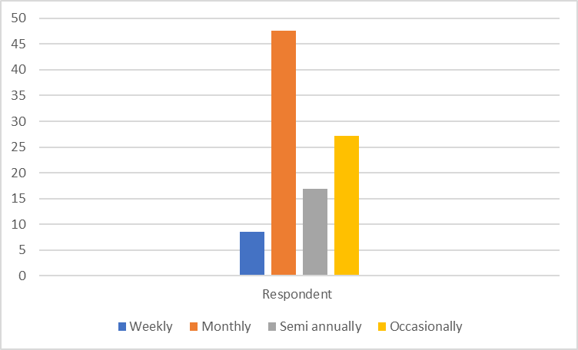

**Graph 2: A graph showing the based on how often do you visit the D-Mart**

**INTERPRETATION**: The graph provide that visit at different frequencies of customer to the D-Mart, the most of respondent like to visit monthly why because of the income level factor we can analysis it is the important factor as income is the main sources for the life style that as to be balanced it will determine visiting capacity.

|  |  |
| --- | --- |
| Different Frequencies | Respondent (%) |
| Weekly | 8.5 |
| Monthly | 47.8 |
| Semi annually | 16.9 |
| Occasionally | 27.1 |

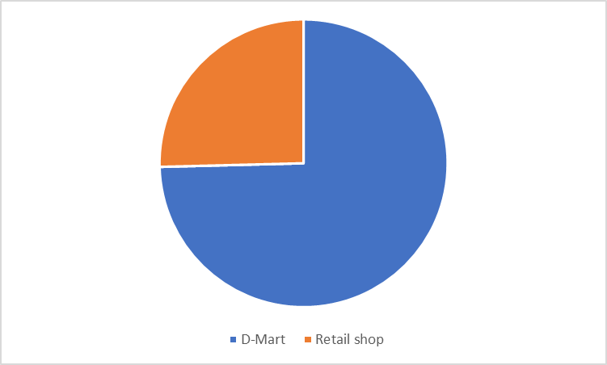

**Graph 3: Showing Where to you like to buy a product more at D-Mart or Retail shop**

|  |  |
| --- | --- |
| Like | Respondent (%) |
| D-Mart | 74.6 |
| Retail shop | 25.4 |

.

**INTERPRETATION:** The greater part of the customer is like to buy at D-Mart because of the majority opinion that the quality, discount rate provided

**Graph 4: Showing satisfaction with services provided by the D-Mart**

**INTERPRETATIO**N: From the analysis we can look of they are satisfied it means neither very sad nor very happy. Over all services provided it so good, but small fault is it as to increases the bill counter. Its best to see is no one are despondent with D-Mart service experiences

**Table showing the satisfaction level of D-mart**

|  |  |
| --- | --- |
| Level of satisfaction | Respondent (%) |
| Highly satisfied | 23.7 |
| Satisfied | 62.7 |
| Neutral | 13.6 |
| Dissatisfied | 0 |
| Highly dissatisfied | 0 |

**Graph 5 : Showing of how often you are satisfied with return policy services of D-Mart**

**INTERPRETATION:** The analysis is showing of they are neutrally satisfied, even some customer are dissatisfied according to the policy on return service of some products like clothing, home appliances and some more , they are not dissatisfied it due their opinion like some time they are good at the time of buy the product not later when we use it off , by mistakenly took a damaged goods , some products are not show of working condition.

|  |  |
| --- | --- |
| Level of satisfaction | Respondent (%) |
| Highly satisfied | 25.4 |
| Satisfied | 8.5 |
| Neutral | 52.5 |
| Dissatisfied | 13.6 |
| Highly dissatisfied | 0 |

**Graph 6: Showing the how would you rate the arrangement and display of products**

**INTERPRETATION:** This analysis that almost satisfied and highly satisfied with 40.7 and 37.3 respectively. The best thing is to the customer can select of there own by knowing their budget level and like to buy the products.

|  |  |
| --- | --- |
| Level of arrangement | Respondent (%) |
| Highly satisfied | 37.3 |
| Satisfied | 40.7 |
| Neutral | 20.3 |
| Dissatisfied | 1.7 |
| Highly dissatisfied | 0 |

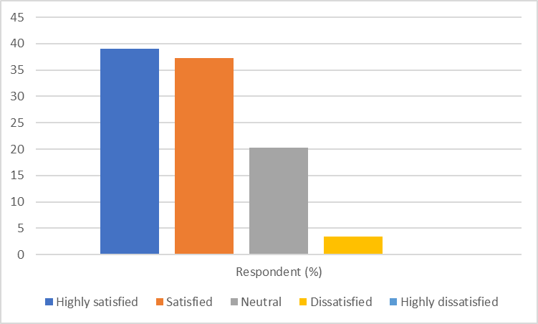

**Graph 7: Showing the how would you rate the pricing strategy**

**INTERPRETATION**: The analysis that the customers are satisfied with the price of the products with a offered ability rate to customer.

|  |  |
| --- | --- |
| Pricing level | Respondent (%) |
| Highly satisfied | 39 |
| Satisfied | 37.3 |
| Neutral | 20.3 |
| Dissatisfied | 3.4 |
| Highly dissatisfied | 0 |

**FINDING:**

* Demograhic factors are also to consider of purchasing pattern just because our spending dependent of age if qualification is good means automatically our spending on the accessories will be it dependent on earning level, family members its also important that if more number of people are living means we have to buy the products in a bulky amount for that it require of huge amount , if a customers get same quality of goods at discount means it will good .
* The customers are satisfied with pricing level, arrangement of the products in a attracting manner, services.
* The return policy as to be improved.

**SUGGESTION \ RECOMMENDATION:**

* At the billing counter they as to increased (special during weekend time)
* Return policy as to be checked properly and get a best for the customer
* Services the product quality sometime it will be it as to be improved (suggest answer by majority respondents)

**CONCLUSION:**

A study on customer satisfaction with special references to D-mart at Tumkur city some improvements as to be made at the store , need to create more promotion activity of D-Mart .

**REFRENCES:**

1. A study on consumer behaviour toward D-Mart's , Swapna Dubha. (JETIR.ORG).
2. A Study on Customer Satisfaction towards D Mart Retail Outlet in Karwar city, Akshay Kumar G Bhat and Rajendra Prasad (International E Conference on Adapting to the New Business Normal – The way ahead December 3-4, 2020 Mysuru, India ).
3. A comparative study of consumer satisfaction between d-mart and reliance smart with special reference to nanded district” (Submitted by Mr. Waghmare Balaji Tukaram ,

Dr. V. P.Kawade.

1. Study on “Impact of D-Mart on small grocery retailers- consumer perspective in Bhilwara” Saloni Chechani (Marketing, 2019-21, Sri Balaji University, Pune).
2. Study on the Consumer Preference and Perception of Supermarket Chain - Case of D-Mart M. Guruprasad Director Research Universal Business School.
3. CONSUMER BEHAVIOR AND PREFERENCE (ORGANIZED VS UNORGANIZED RETAIL) Debendra Prasad Kundu National Institute of Technology Assam, Department of Management Studie (International Journal of Engineering Applied Sciences and Technology, 2022 Vol. 6, Issue 11, ISSN No. 2455-2143, Pages 106-115) .