**SIGN LANGUAGE DETECTION USING CNN**

**Mrs. Mekala R1, Dr. Ananth S2, Mr. Praveen kumar B3 , Mr. Ganeshkumar P4 ,**

**Mr. Murali kumar P5 , Mr. Kavinkumar K6**

1Assiatant Professor, 2 Head of the department , 3,4,5,6 UG Scholars(B.Tech)

1,2,3,4,5,6 Artificial Intelligence and Data Science

1,2,3,4,5,6 Mahendra Engineering College, Mahendrapuri, Namkkal, Tamil Nadu, India.

**ABSTRACT**

Sign language is a system of communication using Visual gestures and signs. Hearing impaired people and the deaf and dumb community use sign language as their only means of communication. Understanding sign language is so much difficult for a normal person. Therefore, the minority group has always faced many difficulties in communicating with the General population. In this research paper, we proposed a new deep learning-based approach to detect sign language, which can remove the barrier of communication between normal and deaf People. To detect real-time sign language first we prepared a Dataset that contains 11 sign words and 26 Alphabets. We used these sign words to Train our customized CNN model. We did some preprocessing in the dataset before the training of the CNN model.

**Keywords:** CNN, Sign Language, Deep learning, Communication.

1. **INTRODUCTION**

Communication is a vital tool in human existence. it's a basic and effective manner of sharing thoughts, feelings and opinions. A considerable fraction of the world's population lacks this many of us are tormented by hearing disorder, speaking impairment or each. Sign languages are used as a primary suggests that of communication by deaf and onerous of hearing folks worldwide. it's the foremost potent and effective thanks to bridge the communication gap and social interaction between them.

1. **METHODOLOGY**

The foundation of these methodologies lies in extensive data collection and annotation. Building datasets of sign language gestures and manually labeling them helps in training machine learning models. Natural Language Processing (NLP) also plays a significant role, integrating sign language detection with processes like text-to-speech (TTS) or speech-to-text (STT) conversion.

**2.1Convolutional Neural Networks (CNNs):**

Analyzing images or video frames to recognize patterns in sign language gestures.

* 1. **Recurrent Neural Networks (RNNs)** :

Analyzing temporal sequences of sign gestures to understand context and meaning.

* 1. **Hybrid Models:**

Combining CNNs with RNNs for better understanding both spatial and temporal features.

1. **MODELING AND ANALYSIS**

The system architecture for our Sign Language detection project is designed with a primary goal in mind: to bridge the communication gap between users and those who may not be familiar with sign language. This architecture seamlessly blends both hardware and software components to achieve real-time recognition and interpretation of Sign Language gestures.

**3.1 Collecting Data:** The data collection phase for the Sign Language detection project is a crucial step in developing a robust system. It involves gathering a diverse dataset of Sign Language signs and gestures from various sources, including Sign Language dictionaries, native signers, public Sign Language corpora, and custom recordings.

**3.2 View:** The "View" aspect of this project refers to the graphical user interface (GUI) that enables users to interact with the Sign Language Detection system. The GUI provides a user-friendly platform for individuals to input sign language gestures via a camera feed and receive real-time recognition feedback. It includes a video display of the user's sign language gestures and a display area for the recognized sign or corresponding text.

**3.3 Preprocessing:** The "Preprocessing" phase in the Sign Language recognition system is a crucial step aimed at optimizing the input data, typically captured through a camera feed. This phase involves several key tasks to enhance the quality and suitability of the visual data for subsequent recognition processes.

**3.4 Identifying Features:** The "Identifying Features" stage Sign Language Detection is a pivotal component of the system's functionality. At this phase, the system focuses on extracting essential characteristics from the preprocessed image data, primarily related to the signer's hand gestures and movements. This process begins with the extraction of key points, including the fingertips and the center of the palm, which are instrumental in determining hand shape and movement.

**3.5 Prediction:** The "Prediction" stage is where the heart of the Sign Language Detection system lies. In this phase, the system takes the features extracted from the preprocessed image data and employs machine learning algorithms. These algorithms are primarily deep learning-based models, which have demonstrated remarkable performance in image and sequence recognition tasks.

**3.6 User Interface:** The User Interface (UI) of the Sign Language Detection system is a critical element designed to facilitate an intuitive and user-friendly experience for its users. Its primary role is to bridge the gap between technology and the users, making Sign Language Detection communication more accessible and inclusive. The UI includes various essential features, such as real-time video feed, displaying users' signing gestures, and providing instant feedback by showing recognized Sign Language Detection in text form.

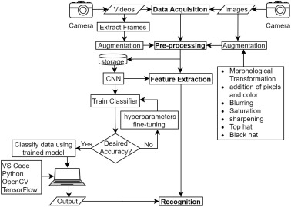

**Figure 1:** Sign language Architecture.

1. **RESULTS AND DISCUSSION**

Results are shown in an GUI that comprises of a pink color rectangular area in which the sign will be shown.

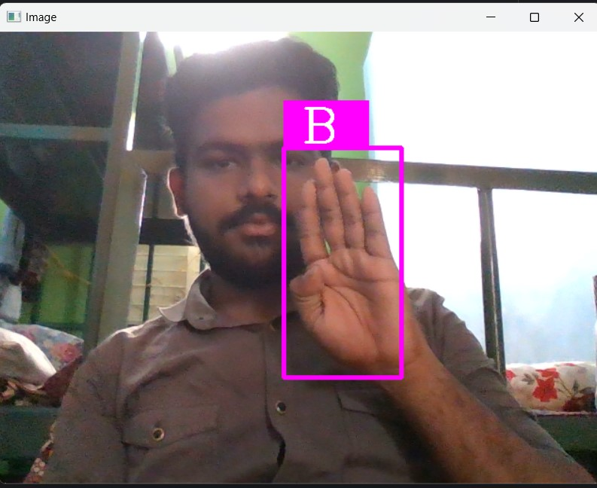

**Figure 2:** Result of the Sign

1. **CONCLUSION**

In conclusion, this project has delved into the realm of Sign Language detection using deep learning techniques. By addressing the limitations of the existing systems, the proposed recognition system aims to enhance communication between the deaf and hearing communities. The project's objectives revolved around the development of a cost-effective, efficient, and accessible system, which was successfully achieved. The implementation of CNNs, when combined with a well-structured user interface, enhances the accessibility and usability of the system.

1. **REFERENCES**
2. S.C. Agrawal, A.S. Jalal, R.K. Tripathi, (2016) “A survey on manual and non-manual sign language recognition for isolated and continuous sign” International Journal of Applied Pattern Recognition, Vol. 3 (2), pp. 99.
3. Pu, Junfu, Wengang Zhou, and Houqiang Li. (2019) “Iterative alignment network for continuous sign language recognition”, Proceedings of the IEEE/CVF conference on computer vision and pattern recognition.
4. C. Szegedy et al., "Going Deeper with Convolutions," arXiv:1409.4842, 2014.
5. TensorFlow. (2021). TensorFlow. [Online]. Available: <https://www.tensorflow.org/>.
6. Sincan, OzgeMercanoglu, et al. (2021) “Chalearn LAP large scale signer independent isolated sign language recognition challenge: Design, results and future research”, Proceedings of the IEEE/CVF Conference on Computer Vision and Pattern Recognition.