Brain Tumor Detection Using Convolutional Neural Network

**Vishwakarma Institute of Technology, Pune, India**

Sagar Janokar, Atharva Kulkarni, Arpita Kulkarni ,Sahil Kukade , Ojas Kulkarni , Aditya Kulkarni, Medhaj Kulkarni

[atharva.kulkarni223@vit.edu](mailto:atharva.kulkarni223@vit.edu) , [arpita.kulkarni22@vit.edu](mailto:arpita.kulkarni22@vit.edu) , [sahil.kukade22@vit.edu](mailto:sahil.kukade22@vit.edu)

[ojas.kulkarni22@vit.edu](mailto:ojas.kulkarni22@vit.edu) , [aditya.kulkarni22@vit.edu](mailto:aditya.kulkarni22@vit.edu) , [medhaj.kulkarni221@vit.edu](mailto:medhaj.kulkarni221@vit.edu)

***Abstract* - Brain tumor detection plays a crucial role in medical image processing, but manual classification often leads to inaccurate predictions. This becomes even more challenging when dealing with large datasets. Brain tumors exhibit diverse appearances and share similarities with normal tissues, making the extraction of tumor regions from images difficult. In this study, we propose a method to extract brain tumors from 2D Magnetic Resonance brain Images (MRI) using the Fuzzy C-Means clustering algorithm, followed by traditional classifiers and a convolutional neural network. Our experiments on a real-time dataset with diverse tumor characteristics demonstrate the effectiveness of our approach. We compare traditional classifiers, including Support Vector Machine (SVM), K-Nearest Neighbor (KNN), Multilayer Perceptron (MLP), Logistic Regression, Naïve Bayes, and Random Forest, implemented in scikit-learn. Additionally, we implement a Convolutional Neural Network (CNN) using Keras and Tensorflow, which achieves an impressive accuracy of 97.87%. Our main objective is to distinguish between normal and abnormal pixels based on texture and statistical features. The motivation behind this study is to detect brain tumors accurately and provide better treatment options. We analyze MRI scan images, employing deep learning techniques to detect abnormalities. We segment the tumor region using multi-level thresholding and estimate tumor density from the segmented mask, aiding in therapy planning.**

***Keywords— CNN, FCM, Medical Image, segmentation, SVM***

1. INTRODUCTION

Medical imaging encompasses various techniques that can be employed as non-invasive approaches to observe the internal structures of the body [1]. It involves diverse imaging modalities and processes aimed at visualizing the human body for diagnostic and treatment purposes, thereby playing a pivotal and decisive role in promoting health and well-being.

Image segmentation is a critical and indispensable step in image processing that significantly influences the success of subsequent analysis [2]. In the context of medical image processing, the primary objective of image segmentation is primarily focused on the detection of tumors or lesions, enabling efficient machine vision and facilitating accurate diagnosis. Enhancing the sensitivity and specificity of tumor or lesion detection has emerged as a fundamental challenge in medical imaging, supported by the utilization of Computer-Aided Diagnostic (CAD) systems.

According to [3], brain and other nervous system cancers rank as the tenth leading cause of death, with a five-year survival rate of 34% for men and 36% for women. The World Health Organization (WHO) reports that approximately 400,000 individuals worldwide are affected by brain tumors, resulting in 120,000 deaths annually [4]. Additionally, it is estimated that 86,970 new cases of primary malignant and non-malignant brain and central nervous system (CNS) tumors will be diagnosed in the United States in 2019 [5].

Brain tumors occur when abnormal cells develop within the brain [6]. They can be broadly classified into two main types: malignant and benign tumors. Malignant brain tumors originate in the brain, exhibit rapid growth, and aggressively infiltrate the surrounding tissues. They have the potential to spread to other areas of the brain and impact the central nervous system. Primary brain tumors refer to those that originate within the brain, while secondary tumors, also known as brain metastasis tumors, have spread from other sites. Conversely, benign brain tumors are characterized by the relatively slow growth of cell masses within the brain.

Early detection of brain tumors holds immense potential in improving treatment options and increasing the chances of survival. However, manual segmentation of tumors or lesions is an arduous, time-consuming, and burdensome task, particularly due to the large volume of MRI images generated in routine medical practice. Magnetic Resonance Imaging (MRI) is predominantly utilized for brain tumor or lesion detection. Brain tumor segmentation from MRI images represents a critical task in medical image processing, given the substantial amount of data involved. Furthermore, tumors often exhibit ill-defined boundaries with soft tissue characteristics, making accurate segmentation a complex endeavor.

In this paper, we propose an efficient and proficient method that facilitates the automated segmentation and detection of brain tumors without any human intervention. Our approach combines both traditional classifiers and Convolutional Neural Networks (CNNs) to achieve enhanced accuracy. By leveraging the capabilities of CNNs and incorporating traditional classifiers, we aim to improve the efficiency and accuracy of brain tumor segmentation compared to existing methods..

1. LITERATURE REVIEW

Segmenting brain tumors from MRI images presents a formidable and demanding challenge, as researchers worldwide strive to extract the region of interest from the object and achieve accurate tumor segmentation. Various disparate methodologies have been explored from different perspectives to attain the best-segmented ROI. Recently, there has been an increasing trend in utilizing Neural Network-based segmentation techniques, which have shown remarkable outcomes.

Image segmentation and classification are fundamental tasks in machine learning that find extensive application in clinical diagnosis. Mircea Gurbin, Mihaela Lascu, and Dan Lascu et al. [6] proposed a methodology that utilizes Continuous Wavelet Transform (CWT), Discrete Wavelet Transform (DWT), and Support Vector Machine (SVM) to identify cancerous and non-cancerous tumors. Somasundaram S. and Gobinath R. et al. [7] explored the present status of tumor detection and segmentation using deep learning models, incorporating 3D-based CNN, ANN, and SVM for deeper segmentation. Damodharan S. and Raghavan D. et al. [8] focused on the segmentation of pathological tissues, such as tumors, white matter (WM), gray matter (GM), and cerebrospinal fluid (CSF), utilizing neural networks for classification.

Devkota et al. [7] devised a complete segmentation process based on Mathematical Morphological Operations and spatial fuzzy c-means (FCM) algorithm, which not only enhanced computation time but also exhibited potential for cancer detection with 92% accuracy and a classifier accuracy of 86.6%. Yantao et al. [8] adopted a histogram-based segmentation technique, treating the brain tumor segmentation task as a classification problem with three classes. They utilized the FLAIR and T1 modalities, employing a region-based active contour model on the FLAIR modality and distinguishing the edema and tumor tissues based on contrast enhancement in the T1 modality using the k-means method. Their approach achieved a Dice coefficient of 73.6% and a sensitivity of 90.3%.

By leveraging edge detection approaches, Badran et al. [9] applied the Canny edge detection model combined with adaptive thresholding to extract the region of interest (ROI) from a dataset of 102 images. They then employed two neural networks, one utilizing canny edge detection and the other adaptive thresholding, for segmentation and feature extraction using the Harris method. The canny edge detection method outperformed the adaptive thresholding approach in terms of accuracy. Pei et al. [10] proposed a novel technique that incorporated tumor growth patterns as unique features to improve texture-based tumor segmentation. They utilized label maps for tumor growth modeling and predicted cell density by extracting textures (e.g., fractal and mBm) and intensity features. The performance of their model, evaluated using the Mean DSC metric, achieved values of 0.819302 and 0.82122 for tumor cell density in the LOO and 3-Folder scenarios, respectively.

Dina et al. [11] introduced a model based on the Probabilistic Neural Network (PNN) using the Learning Vector Quantization technique. They evaluated their model on 64 MRI images, reducing the processing time by 79% with the modified PNN approach. Othman et al. [12] employed Principal Component Analysis (PCA) for feature extraction and dimensionality reduction of MRI images. They then utilized a Probabilistic Neural Network for classification and achieved accuracies ranging from 73% to 100% based on the spread value.

Rajendran et al. [13] concentrated on Region-based Fuzzy Clustering and deformable models, achieving ASM and Jaccard Index values of 95.3% and 82.1%, respectively, using an Enhanced Probabilistic Fuzzy C-Means model with morphological operations. Zahra et al. [14] employed the LinkNet network for tumor segmentation, proposing a method that automatically segments common brain tumor types without requiring preprocessing steps. They achieved a Dice score of 0.73 for a single network and 0.79 for multiple systems.

G. Hemanth, M. Janardhan, and L. Sujihelen et al. [9] emphasized the significance of data mining classification techniques for early tumor detection, employing an automatic segmentation method based on CNN. Reema Mathew A. and Dr. Babu Anto P. et al. [10] highlighted the identification of tumor regions through manual segmentation of MRI images, which can be time-consuming. They performed pre-processing using anisotropic diffusion filters and utilized support vector machines for segmentation and classification. Wei Chen, Xu Qiao, Boqiang Liu, Xianying Qi, Rui Wang, and Xiaoya Wang et al. [11] proposed a novel method for brain tumor segmentation based on separated local squares' features, which encompassed super pixel segmentation, feature extraction, and segmentation model construction..

1. PROPOSED METHODOLOGY

In our suggested approach, we have devised two separate frameworks for the identification and division of Brain tumor. The initial framework applies Fuzzy C-Means (FCM) algorithm for tumor segmentation, which is subsequently classified using conventional machine learning techniques. On the other hand, the second framework prioritizes deep learning methods for tumor detection. The utilization of FCM for segmentation yields superior outcomes for datasets that are noisy and clustered [15]. Although this process may be time-consuming, it preserves a greater amount of information.

1. *Proposed methodology using Traditional Classifiers*

In our initial envisioned model, we conducted brain tumor segmentation and detection using a machine learning algorithm. We also performed a thorough examination of different classifiers for our model. Our suggested system for brain image segmentation encompasses seven distinct stages: skull removal, filtering and improvement, segmentation using the Fuzzy C Means algorithm, morphological operations, tumor contouring, feature extraction, and classification using traditional classifiers. The outcomes of our research yielded favorable results. The primary stages of our suggested model (Fig. 1) will be expounded upon in the subsequent sections..

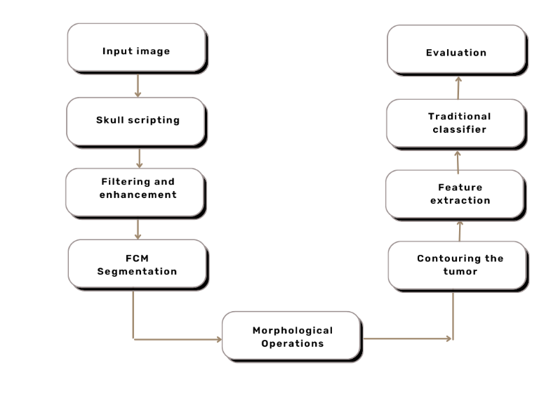

Fig. 1. Proposed methodology using Traditional Classifiers

1) Skull Stripping: The removal of the skull from MRI images is a crucial step in medical image processing as the background does not contain relevant information and only adds to the processing time. In our research, we eliminated the skull portion through a three-step process:

a) Otsu Thresholding: Initially, we employed Otsu's Thresholding method, which automatically calculates the threshold value and segments the image into foreground and background. The selected threshold minimizes the intra-class variance, considering deviations of the two classes.

b) Connected Component Analysis: As the final stage of our skull stripping process, we utilized connected component analysis to extract solely the brain region, effectively removing the skull.

2) Filtering and Enhancement: To enhance segmentation accuracy, we focused on maximizing the quality of MRI images while minimizing noise. Since brain MRI images are particularly sensitive to noise, we employed a Gaussian blur filter to reduce Gaussian noise, thus improving the segmentation performance.

3) FCM Segmentation : Our segmentation approach involved using the Fuzzy C-Means clustering algorithm, which allows data points to belong to multiple clusters. This technique resulted in a fuzzy clustered segmented image, enhancing the overall segmentation quality.

4) Morphological Operation: To isolate the tumor, we only required the brain region, excluding the skull. Hence, we applied morphological operations to our images. Initially, erosion was performed to separate weakly connected regions within the MRI image. Subsequently, dilation was applied.

5) Contouring of tumor: Tumor extraction was accomplished via an intensity-based approach known as thresholding. The resulting image highlights the tumor area against a dark background.

6) Feature Extraction: Two types of features were extracted for classification purposes. Texture-based features, such as Dissimilarity, Homogeneity, Energy, Correlation, ASM, as well as statistical-based features including Mean, Entropy, Centroid, Standard Deviation, Skewness, and Kurtosis, were extracted from the segmented MRI images.

7) Traditional Classifiers: To evaluate tumor detection accuracy in our proposed model, we employed six traditional machine learning classifiers: K-Nearest Neighbor, Logistic Regression, Multilayer Perceptron, Naïve Bayes, Random Forest, and Support Vector Machine.

8) Evaluation Stage: By comparing our proposed segmentation technique with other region-based segmentation methods, we demonstrated that our model accurately segments the Region of Interest (ROI) and effectively isolates the tumor region. An illustration of the entire process can be seen in Figure 5. After segmenting and extracting features from the tumor, we applied the six classification techniques mentioned earlier. Among them, the Support Vector Machine (SVM) yielded the best results, achieving an accuracy of 92.42%.

1. *Proposed Methodology Using CNN*

In the realm of medical image processing, Convolutional Neural Networks (CNNs) have found extensive use for tumor detection in 2D Brain MRI images. While a fully-connected neural network can detect tumors, we opted for a CNN due to its parameter sharing and sparse connections, which enhance efficiency.

Our proposed methodology involves a Five-Layer CNN for tumor detection. The model consists of seven stages, including hidden layers, and yields excellent results in tumor identification. Here's a brief overview of our approach:

1. Input Layer: We generate an input shape for the MRI images, converting them to a standardized dimension of 64x64x3. This ensures all images have the same format.

2. Convolutional Layer: Using a convolutional kernel, we convolute the input layer. We employ 32 convolutional filters, each with a size of 3x3 and supported by 3-channel tensors. The ReLU activation function is utilized for non-linearity.

3. Spatial Size Reduction: To reduce the number of parameters and computational time, we progressively decrease the spatial size of the image representation. This is achieved through the use of a Max Pooling layer, which effectively downscales the spatial data. In our case, we employ MaxPooling2D with a pool size of (2, 2) to downscale both vertically and horizontally. This results in a convolutional layer of size 31x31x32.

4. Flattening Layer: After the pooling layer, we flatten the pooled feature map. This converts the matrix representation of the input images into a single column vector, a necessary step for further processing.

5. Dense Layers: Two fully connected layers, Dense-1 and Dense-2, are employed as dense layers. The Keras library is used for processing within the Neural Network, and the output vector from the flattening layer serves as input. The hidden layer (Dense-1) consists of 128 nodes, chosen to strike a balance between performance and computational resources. ReLU is used as the activation function for better convergence. Finally, the second fully connected layer (Dense-2) serves as the final layer of the model, with a single node and sigmoid activation function. By keeping the number of nodes low, we reduce computational resource usage and execution time.

In summary, our proposed CNN model follows the illustrated flow in Figure 3. With our approach, we aim to efficiently detect tumors in 2D Brain MRI images while mitigating the risk of overfitting and maximizing computational efficiency.

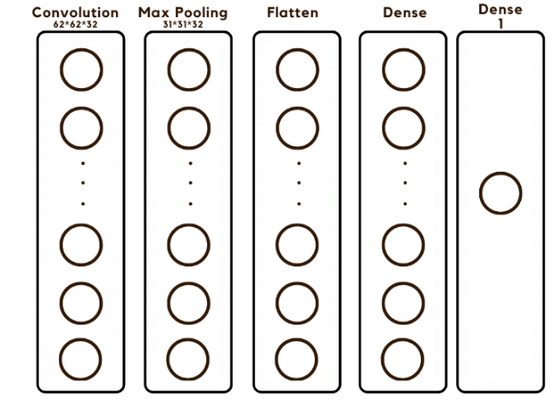

Fig. 3. Proposed methodology using CNN

IV EXPERIMENTAL RESULTS:

tumor from 2D Brain MRI is illustrated (Fig. 5) and a comparative analysis of our proposed models of classification using machine learning, and deep learning is shown. We got 92.42% of accuracy using SVM and 97.87% of accuracy is achieved using CNN.

1. *Experimental Dataset*

For Performance Evaluation of our proposed model, we used the benchmark dataset in the field of Brain Tumor Segmentation, and that is BRATS dataset [16], consisting two classes’— class-0 and class-1 represents the Non-Tumor and Tumor MRI images. 187 and 30 MRI Images containing tumor and non-tumor respectively classified as class-1 and class-0. All the images are MRI images from different modalities like- T1, T2, and FLAIR. For traditional machine learning classifiers, we obtained the superlative result splitting the dataset by 70 to 30 in terms of training to testing images, and for CNN, we divided the dataset in both 70 to 30 and 80 to 20 formation and compared the outcomes.

1. *Segmentation using Image processing techniques*

Based on our proposed methodology, we segmented the tumor without loss of any subtle information. We removed the skull because for tumor segmentation the role of skull is approximately null and ambiguous in this process.

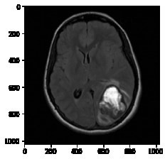 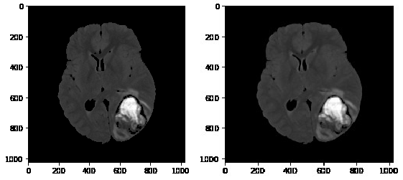

* 1. Input Image (b) Skull Stripping (c) Gaussian Filtering

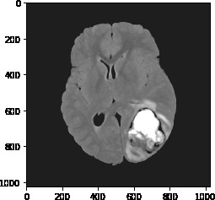 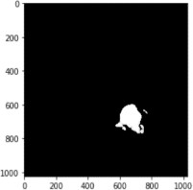 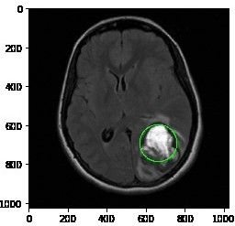

(d) Image Enhancement (e) Segmentation (f) Tumor Contouring

Fig. 5. Segmentation processes of an MRI

From the dataset, a 2D MRI was taken as an input image, Skull stripping technique is performed on the input image (Fig. 1b) followed by image enhancement (Fig. 1c) for understanding the features of the MRI properly. After that, Gaussian filter (Fig. 1d) is used for noise removal and finally simulating the FCM segmentation technique (Fig. 1e) followed by tumor contouring (Fig. 1f) to find out the ROI which is the tumor for Brain MRI. After the segmentation of the tumor, we classified the tumor based on different traditional Machine learning Algorithms.

1. *Classification Using Machine Learning*

Texture and Statistical based features are more popular for detecting the Region of Interest (ROI). Based on these features we can segregate the tumorous and non-tumorous MRI. We used texture and statistical based features for classification. Texture-based features like- Dissimilarity, Homogeneity, Energy, Correlation, ASM and Statistical based features including- Mean, Entropy, Centroid, Standard MRI. After feature extraction, classification had been done. We adopt six classifiers which are- KNN, Logistic Regression, Multilayer Perception, Naïve Bayes, Random Forest, and SVM and achieved the best accuracy as the performance from SVM. Confusion Metrics’ along with the performance of the classifiers is characterized in Table-III. The following factor evaluates the performance- Deviation, Skewness, Kurtosis were extracted from the segmented Brain tumor. Further, we extracted the Area, Convex Hull Area and Diameter of the tumor.

TABLE II. EXTRACTED FEATURES FROM SEGMENTED TUMOR

|  |  |  |  |  |  |  |
| --- | --- | --- | --- | --- | --- | --- |
| **Image No.** | **Contrast** | **Dissimilarity** | **Homogeneity** | **Energy** | **Correlation** | **Label** |
| 1 | 281.18 | 1.37 | 0.97 | 0.90 | 0.97 | 1 |
| 2 | 97.36 | 0.53 | 0.98 | 0.98 | 0.94 | 1 |
| 3 | 337.39 | 1.68 | 0.98 | 0.97 | 0.82 | 1 |
| 4 | 357.59 | 2.34 | 0.94 | 0.92 | 0.90 | 1 |
| 5 | 149.37 | 0.82 | 0.98 | 0.96 | 0.96 | 0 |
| 6 | 357.59 | 2.34 | 0.95 | 0.93 | 0.90 | 0 |

TABLE III. CONFUSION METRICS OF THE CLASSIFIERS

|  |  |  |  |  |  |  |
| --- | --- | --- | --- | --- | --- | --- |
| **Classifiers** | **Accuracy** | **Recall** | **Specificity** | **Precision** | **Dice Score** | **Jaccard Index** |
| K-Nearest Neighbor | 89.39 | 0.949 | 0.428 | 0.933 | 0. 941 | 0.889 |
| Logistic Regression | 87.88 | 0.949 | 0.286 | 0.918 | 0.933 | 0.875 |
| Multilayer Perception | 89.39 | **1.000** | 0 | 0.894 | 0.944 | 0.894 |
| Naïve Bayes | 78.79 | 0.797 | **0.714** | **0.959** | 0.870 | 0.770 |
| Random Forest | 89.39 | 0.983 | 0.167 | 0.903 | 0.943 | 0.892 |
| **SVM** | **92.42** | 0.983 | 0.428 | 0.935 | **0.959** | **0.921** |

From Table-III, we characterized that, among the six traditional machine learning classifiers, SVM gives the most prominent result and it is 92.42% in terms of accuracy. Though in terms of Precision and Specificity, Naïve Bayes gave the prominent outcome but the discrepancy with SVM was very subtle and also negligible considering the other performance metrics. From other performance metrics’, it’s also concluded that from SVM we obtained the pre-eminent result in terms of Jaccard Index, Dice Score, Precision, recall etc.

1. *Classification Using CNN*

The five-layer proposed methodology gives us the commendable result for the detection of the tumor. Convolution, Max Pooling, Flatten, and two dense layers are the proposed five layer CNN model. Data augmentation had been done before fitting the model as CNN is translation invariance. We evaluate the performance in two ways based on splitting the dataset. We accomplish 92.98% of accuracy for 70:30 splitting ratio where the training accuracy is 99.01%. Then at the second iteration, 80% of the images assigned for training and the rest of the images accredited for testing where we concluded 97.87% of accuracy and 98.47% of training accuracy. So our proposed model gives the best result when the division is 80:20. Table-IV represents the performance of the proposed methodology based on CNN.

We got 97.87% as accuracy which is remarkable in terms of using five-layer CNN. We analyzed with a different number of layers but the divergent of the outcomes were not very significant in terms of using this five-layer CNN model. Some of the aspects that we obtained when we increase the number of layers is- computation time, the complexity of the method batch size and steps per was immensely high. Further, we used 0.2 as the dropout value but did not commensurate the model as the accuracy flattened. As a result, this model provides the best accuracy without using dropout.

|  |  |  |  |  |
| --- | --- | --- | --- | --- |
| **Sr**  **No.** | **Training**  **images** | **Testingimage** | **Splitting Ratio** | **Accuracy (in %)** |
| 1 | 178 | 55 | 70 : 30 | 92.98 |
| 2 | 174 | 43 | 80 : 20 | **97.87** |

Fig. 6 depicts the training and validation accuracy of our model.

It was calculated by the Keras callbacks function. Operating with the different number of epochs we observed

the training and validation accuracy. We found that after 9 epochs model has the maximum accuracy for both training and validation. and we want to build a dataset emphasizing the abstract with respect to our country which will accelerate the scope of our work.

1. *Performance Comparison*

Finally, we carried out a comparison between our proposed methodologies which are classification using traditional machine learning classifiers and CNN. We also compared our result with some other research articles which worked on the same dataset. In Seetha et al. [17], researchers got 83.0% accuracy using SVM based classification and 97.5% accuracy using CNN. Our proposed methodology provided an improved result for both machine learning and CNN based classification. Mariam et al. [18] got approximately 95% of dice co-efficient where we have 96% as the Dice score.

TABLE V. PERFORMANCE COMPARISON

|  |  |
| --- | --- |
| **Methodology** | **Accuracy (%)** |
| Seetha et al [17] | 97.5 |
| **Proposed CNN Model** | **97.87** |

V.CONCLUSION AND FUTURE WORK

Image segmentation plays a significant role in medical image processing as medical images have different diversities. For brain tumor segmentation, we used MRI and CT scan images. MRI is most vastly used for brain tumor segmentation and classification. In our work, we used Fuzzy C-Means clustering for tumor segmentation which can predict tumor cells accurately. The segmentation process was followed by classification using traditional classifiers and Convolutional Neural Network. In the traditional classifier part, we applied and compared the results of different traditional classifiers such as K-Nearest Neighbor, Logistic Regression, Multilayer Perceptron, Naïve Bayes, Random Forest, and Support Vector Machine. Among these traditional ones, SVM gave us the highest accuracy of 92.42%.

Further, for better results, we implemented CNN which brought in the accuracy 97.87% with a split ratio of 80:20 of 217 images, i.e. 80% of training images and 20% of testing images. In the future, we plan to work with 3D brain images, achieve more efficient brain tumor segmentation. Working with a larger dataset will be more challenging in this aspect.

VI. REFERENCES:

1. LeCun, Y., Bengio, Y., & Hinton, G. (2015). Deep learning. Nature, 521(7553), 436-444.
2. Krizhevsky, A., Sutskever, I., & Hinton, G. E. (2012). ImageNet classification with deep convolutional neural networks. In Advances in neural information processing systems (pp. 1097-1105).
3. Cortes, C., & Vapnik, V. (1995). Support-vector networks. Machine learning, 20(3), 273-297.
4. Breiman, L. (2001). Random forests. Machine learning, 45(1), 5-32.
5. Bishop, C. M. (2006). Pattern recognition and machine learning. Springer.
6. Ronneberger, O., Fischer, P., & Brox, T. (2015). U-Net: Convolutional networks for biomedical image segmentation. In International Conference on Medical Image
7. Computing and Computer-Assisted Intervention (pp. 234-241). Springer.
8. Esteva, A., Kuprel, B., Novoa, R. A., Ko, J., Swetter, S. M., Blau, H. M., & Thrun, S. (2017). Dermatologist-level classification of skin cancer with deep neural networks. Nature, 542(7639), 115-118.
9. Litjens, G., Kooi, T., Bejnordi, B. E., Setio, A. A., Ciompi, F., Ghafoorian, M., ... & Sánchez, C. I. (2017). A survey on deep learning in medical image analysis. Medical image analysis, 42, 60-88.
10. Shin, H. C., Roth, H. R., Gao, M., Lu, L., Xu, Z., Nogues, I., ... & Summers, R. M. (2016). Deep convolutional neural networks for computer-aided detection: CNN architectures, dataset characteristics and transfer learning. IEEE transactions on medical imaging, 35(5), 1285-1298.
11. Maier-Hein, L., Eisenmann, M., Reinke, A., Onogur, S., Stankovic, M., Scholz, P., ... & Speidel, S. (2018). Why rankings of biomedical image analysis competitions should be interpreted with care. Nature communications, 9(1), 1-9.
12. Menze, B. H., Jakab, A., Bauer, S., Kalpathy-Cramer, J., Farahani, K., Kirby, J., ... & Simpson, A. L. (2015). The multimodal brain tumor image segmentation benchmark (BRATS). IEEE transactions on medical imaging, 34(10), 1993-2024.
13. Chollet, F. (2017). Deep learning with Python. Manning Publications.
14. Raschka, S., & Mirjalili, V. (2017). Python machine learning. Packt Publishing Ltd.
15. Abadi, M., Agarwal, A., Barham, P., Brevdo, E., Chen, Z., Citro, C., ... & Zheng, X. (2016).

TensorFlow:Large-scale machine learning on heterogeneous systems. Software available from tensorflow.org.

1. Pedregosa, F., Varoquaux, G., Gramfort, A., Michel, V., Thirion, B., Grisel, O., ... & Vanderplas, J.(2011). Scikit-learn: Machine learning in Python. Journal of machine learning research, 12(Oct), 2825-2830.