**Artificial intelligence In drug design**

__________________________________________________________

**>Abstract** :

This research paper explores the significant role of Artificial Intelligence (AI) in revolutionizing drug design processes. AI’s applications in pharmaceutical research have led to increased efficiency, cost-effectiveness, and improved drug discovery. This paper highlights the legal considerations and challenges associated with implementing AI in drug design. Artificial intelligence is thought to be human-like abilities displayed by machines. Deep neural networks and recurrent networks in particular, as well as other artificial neural networks, are the driving forces in this field. De novo design using artificial intelligence directs the creation of functional new biologically active molecules toward desired qualities. The effectiveness of artificial intelligence in this subject is demonstrated by a number of cases,It is possible to combine drug discovery with synthesis planning and simplicity of synthesis, and in the near future, more and more automated drug discovery by computers is anticipated. Additionally way for incorporating different computational tools into the discovery and design of novel drugs.

# **>Keywords :**

Artificial intelligence, database , drug design, de novo drug design,

***_____________________________________________________________________________________***

**______________________________________________________________________________**

# **>Introduction.**

In the relentless pursuit of novel therapeutics to combat a myriad of diseases afflicting humanity, the pharmaceutical industry stands at the forefront of scientific innovation. However, this quest is marked by formidable challenges – the escalating costs and time required for drug development, the pressing need for precision medicine, and the daunting complexity of biological systems. In this landscape of immense opportunity and complexity, artificial intelligence (AI) has emerged as a transformative force, promising to redefine how we discover, design, and develop drugs.

Over the past decade, AI has transcended the boundaries of science fiction to become an indispensable tool in the pharmaceutical industry. This multifaceted technology encompasses a range of machine learning algorithms, deep learning models, natural language processing techniques, and computational simulations. Harnessing the computational power of AI, researchers are now able to mine vast datasets, predict biological phenomena with unprecedented accuracy, and simulate complex molecular interactions. As a result, the intersection of AI and drug design has led to ground breaking advances in target identification, compound screening, lead optimization, pharmacokinetics prediction, toxicity assessment, and clinical trial optimization.

___________________________________________________________________________________

* **The Need for AI in Drug Design :**

Traditional drug discovery and development are marred by a high attrition rate, sky-high costs, and excruciatingly long timelines. The journey from a promising compound to a marketable drug typically spans over a decade and involves billions of dollars in investment. Furthermore, the discovery process is often characterized by a high failure rate at various stages, particularly during clinical trials, leading to significant financial losses and delayed patient access to life-saving medications.

The critical challenge of identifying suitable drug targets underscores the necessity of AI in modern drug design. Identifying and validating drug targets with therapeutic relevance is the foundational step in the drug discovery process. Historically, target identification relied heavily on time-consuming and resource-intensive experimental approaches. However, AI now enables researchers to sift through enormous datasets encompassing genomics, proteomics, and clinical information to pinpoint potential drug targets. This not only expedites the process but also enhances the probability of identifying targets with a high likelihood of clinical success.

Beyond target identification, AI holds the key to expediting compound screening, lead optimization, and early-stage drug development. The adoption of high-throughput screening techniques combined with AI-driven data analysis has revolutionized the pace at which lead compounds are identified. Researchers can now harness the predictive power of AI to discern the structural attributes of compounds that render them efficacious against specific targets while mitigating potential toxicological concerns. This optimization, driven by AI, not only shortens the drug development timeline but also reduces the chances of late-stage clinical failures.

**______________________________________________________________________________**

* **AI in Target Identification :**

Target identification serves as the foundational pillar of drug design. It involves the identification and validation of molecular targets associated with diseases. Historically, target identification relied heavily on time-consuming and resource-intensive experimental approaches, often limiting the scope of target discovery. AI has revolutionized this process by leveraging computational power to analyze vast and diverse biological datasets.

AI algorithms can sift through genomic data, transcriptomics, proteomics, and other biological information to identify potential targets that play pivotal roles in disease pathways. The ability to integrate and analyze these multi-omics data sources has significantly expanded our understanding of disease mechanisms and potential intervention points. Machine learning models, particularly deep learning, excel at uncovering hidden patterns, biomarkers, and signaling pathways, aiding in the prioritization of targets with therapeutic relevance.

To illustrate the power of AI in target identification, consider the case of cancer research. AI-driven analyses have unveiled specific genetic mutations and signaling pathways driving various types of cancer. This information has led to the identification of novel therapeutic targets, resulting in the development of targeted therapies that are more effective and less toxic than traditional chemotherapy.

In addition to target identification, AI can predict the druggability of identified targets, aiding in the selection of targets with a higher likelihood of successful drug development. Machine learning models can analyze the structural and biochemical properties of proteins to assess their amenability to small molecule intervention. This prediction of druggability is instrumental in avoiding the pursuit of targets that may prove challenging to modulate pharmacologically.

This introduction provides an overview of the importance of AI in drug design, touching on key aspects such as target identification and validation, the need for AI in drug discovery, and the transformative potential of AI-driven drug design. Further sections of your paper can delve into each of these aspects in more detail and explore specific applications, methodologies, challenges, and future directions.

# **Structure-Based Drug Design: A Pathway to Targeted Therapeutics**

# **>Introduction:**

The development of new drugs has historically been a lengthy and challenging process, characterized by a high failure rate and significant resource expenditure. Traditional methods often relied on serendipity and empirical observations. However, the advent of computational tools and structural biology has paved the way for a more rational and precise approach known as structure-based drug design (SBDD). In this essay, we explore the principles, methodologies, and applications of SBDD, emphasizing its significance in the quest for targeted therapeutics.

* **The Foundation of SBDD :**

At its core, SBDD is founded on the concept of understanding the three-dimensional structures of biological macromolecules, primarily proteins, and their interactions with small molecules, i.e., potential drug candidates. This understanding is achieved through techniques such as X-ray crystallography, nuclear magnetic resonance (NMR) spectroscopy, and cryo-electron microscopy (cryo-EM), which provide detailed insights into the atomic-level architecture of biomolecules.

* **Key Components of SBDD :**

1. **Target Identification and Validation:**SBDD begins with the selection and validation of a specific molecular target associated with a disease. This target is often a protein involved in a disease pathway or an essential component of a pathogenic organism.
2. **Structure Determination:** The next step involves the determination of the three-dimensional structure of the target protein, typically through X-ray crystallography, NMR, or cryo-EM. This process reveals the spatial arrangement of atoms within the protein.
3. **Ligand Binding Site Identification:** Computational methods are employed to identify potential binding sites on the protein surface where drug molecules can interact. These binding sites are often referred to as active sites.

* **Applications of SBDD :**

1. **Lead Compound Identification:** SBDD facilitates the identification of lead compounds or small molecules that can interact with the target protein at the active site. Virtual screening, molecular docking, and molecular dynamics simulations are computational techniques often employed for this purpose.
2. **Lead Optimization:** Once lead compounds are identified, SBDD allows for the rational modification and optimization of these compounds to improve their binding affinity, selectivity, and pharmacokinetic properties.

* **Challenges and Future Directions :**

1. **Data Availability: A**ccess to high-quality structural and biochemical data is critical for SBDD. forts are ongoing to enhance data sharing and standardization.
2. **Computational Challenges :** Accurate modeling of protein-ligand interactions and the consideration of solvent effects remain computationally demanding areas of SBDD.

* **Polypharmacology :**

As our understanding of complex diseases evolves, there is a growing need for drugs that target multiple proteins. SBDD is adapting to address the challenges of polypharmacology

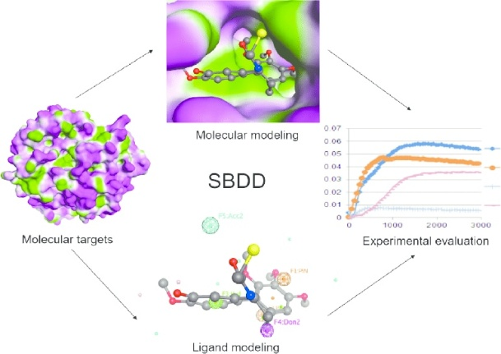

# **Databases in Artificial Intelligence-Based Drug Design: An Essential Resource**

# **>Introduction :**

The intersection of artificial intelligence (AI) and drug design has ushered in a new era of pharmaceutical research and development. AI-driven approaches are transforming the drug discovery process by streamlining the identification of potential drug candidates, optimizing compound properties, and predicting drug-target interactions. At the core of these advancements are databases specifically curated to support AI-driven drug design. In this review, we delve into the critical role of databases in AI-based drug design, exploring their types, significance, and applications in accelerating drug discovery

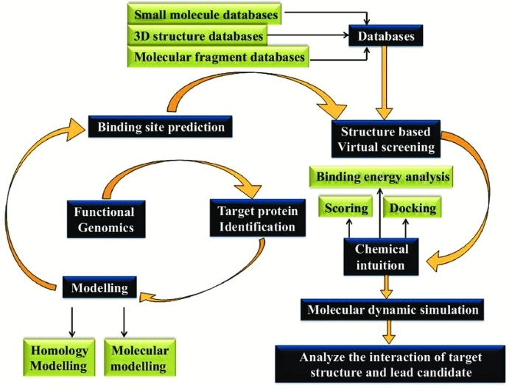

* **Types of Databases for AI-Driven Drug Design :**

1. **Chemical Databases :** These databases store information about chemical compounds, including their structures, properties, and activities. Prominent examples include the Chemical Abstracts Service (CAS) Registry and the PubChem database.
2. **Biological Databases :** These databases contain biological data, such as genomic and proteomic information, essential for target identification and validation. Examples include the GenBank, UniProt, and Protein Data Bank (PDB) databases.

.3 **Chemogenomic Databases :** These databases link compounds with their target proteins and facilitate the discovery of potential drug-target interactions. The ChEMBL and DrugBank databases are prominent examples.

* **Significance of Databases in AI-Driven Drug Design**

1. **Data Accessibility :** Databases provide researchers with easy access to a wealth of chemical and biological data, enabling AI models to learn from a diverse and extensive dataset.
2. **Training AI Models :** High-quality databases serve as training datasets for machine learning algorithms, allowing them to predict properties, interactions, and toxicity of compounds accurately.
3. **Virtual Screening :** AI-driven virtual screening relies on databases to identify potential drug candidates by predicting their interactions with target proteins, saving time and resources in experimental screening.

* **Applications and Case Studies :**

1. **Drug Repurposing :** AI models leverage databases to identify existing drugs with the potential to treat new diseases, accelerating the development of therapeutic solutions.
2. **Predicting Drug-Drug Interactions :** Databases play a crucial role in predicting potential iteractions between drugs, helping to avoid adverse effects and ensuring drug safety.

* **Challenges and Future Directions**

1. **Data Quality:** Ensuring the quality and reliability of data in databases remains a challenge, necessitating continuous curation efforts.
2. **Integration and Standardization:** The integration of diverse databases and standardization of data formats are crucial for enhancing AI-driven drug discovery pipelines.

# **Deep Learning Techniques in Molecule Generation for Drug Design**

**>Introduction :**

The process of drug discovery has traditionally been a lengthy and resource-intensive endeavor, characterized by the synthesis and testing of vast chemical libraries to identify potential drug candidates. However, recent advancements in deep learning techniques have revolutionized this field, offering innovative approaches to molecule generation for drug design. Deep learning models, particularly generative models, have emerged as powerful tools for designing novel compounds with desired properties, accelerating drug discovery, and reducing costs. In this review, we explore the application of deep learning in molecule generation, delving into methodologies, challenges, and the potential future of this transformative technology.

* **The Rise of Deep Learning in Drug Design :**

Deep learning, a subfield of machine learning, has garnered immense attention for its ability to extract complex patterns and representations from large datasets. In drug design, this technology has found applications across various stages of the drug discovery pipeline, from target identification to lead optimization. However, one of the most promising applications of deep learning is in molecule generation, where generative models are employed to create entirely new chemical compounds with specific properties.

* **Generative Models and Molecule Generation :**

Generative models are a class of deep learning models that excel at creating new data samples that resemble a given dataset. In the context of drug design, these models can generate molecular structures that are chemically plausible and possess desired pharmacological properties. Two prominent types of generative models utilized in molecule generation are recurrent neural networks (RNNs) and generative adversarial networks (GANs).

* **Recurrent Neural Networks (RNNs) :**

RNNs are a class of neural networks well-suited for sequential data, making them particularly useful for modeling molecular structures, which are inherently sequential. In the context of molecule generation, RNNs can generate molecules one atom or bond at a time, making them capable of producing valid chemical structures.

* **SMILES Notation and RNNs :**

Simplified Molecular Input Line Entry System (SMILES) notation is a widely used text-based representation of molecular structures. RNNs trained on SMILES data can generate molecular structures by iteratively predicting the next character in the SMILES string, ensuring that the generated molecules adhere to chemical rules. This approach has demonstrated remarkable success in generating diverse and synthetically feasible molecular structures.

* **Generative Adversarial Networks (GANs) :**

GANs are another class of generative models that consist of two neural networks: a generator and a discriminator. The generator attempts to create data samples that resemble the training dataset, while the discriminator distinguishes between real and generated samples. The two networks engage in a adversarial training process, continually improving the quality of generated data.

* **Conditional GANs for Molecule Generation :**

Conditional GANs are GAN variants where the generator is conditioned on specific input data. In molecule generation, these models can be conditioned on molecular properties or desired chemical characteristics. This conditioning allows for the generation of molecules with predefined properties, such as high binding affinity to a target protein or improved pharmacokinetic profiles.

* **Applications of Deep Learning in Molecule Generation :**

**Lead Compound Discovery:**

Deep learning models can be used to generate novel lead compounds with desired target binding affinities. By training on existing compound datasets and target interaction data, these models can propose potential drug candidates for experimental validation

# **The de novo drug design:**

# **>Introduction :**

The process of discovering new drugs, also known as de novo drug design, is an intricate and resource-intensive endeavor. Historically, it has been marked by a high attrition rate, exorbitant costs, and prolonged development timelines. Traditional drug discovery relies heavily on trial-and-error approaches, involving the synthesis and testing of vast libraries of chemical compounds, often yielding suboptimal results. However, the advent of artificial intelligence (AI) has disrupted this paradigm, offering a transformative approach to designing novel therapeutic agents with unprecedented efficiency and precision. In this review, we delve into the profound impact of AI on de novo drug design, exploring the methodologies, applications, and future prospects of this rapidly evolving field.

* **The Evolution of de novo Drug Design :**

De novo drug design refers to the process of creating entirely new drug candidates from scratch, as opposed to modifying existing compounds. Historically, this approach was a formidable challenge, as it required a deep understanding of the complex interactions between biological targets and small molecules, along with a vast chemical knowledge base. Researchers often relied on intuition and empirical knowledge to design new compounds, a process prone to failure.

AI-driven de novo drug design represents a paradigm shift. It leverages machine learning algorithms, deep learning models, and computational simulations to design molecules with desired properties. The process begins with the generation of molecular structures, followed by property prediction, optimization, and ultimately, experimental validation. This approach not only accelerates drug discovery but also enhances the probability of identifying compounds with the desired therapeutic characteristics.

* **Molecular Representation and Generative Models :**

At the heart of AI-driven de novo drug design lies molecular representation, a critical step in generating novel compounds. Molecular structures can be encoded in various ways, including SMILES notation, graph-based representations, or three-dimensional coordinates. Generative models, such as recurrent neural networks (RNNs) and generative adversarial networks (GANs), are then employed to create new molecular structures based on these representations.

SMILES notation, which encodes molecules as text strings, has gained popularity due to its simplicity and compatibility with neural networks. RNNs and GANs trained on SMILES data can generate novel molecules by learning patterns and relationships within chemical structures. This approach has demonstrated remarkable success in generating diverse and synthetically feasible molecular structures.

* **Property Prediction and Optimization :**

Once molecular structures are generated, AI models are employed to predict their properties, such as binding affinity to a target protein, solubility, and toxicity. These predictions are essential for identifying promising drug candidates.

Quantum mechanics simulations and molecular docking are often integrated with AI to predict the binding affinity between generated molecules and target proteins. This enables the prioritization of compounds with high binding affinity, streamlining the lead optimization process.

AI-driven optimization algorithms can iteratively refine molecular structures to enhance desired properties while minimizing undesired ones. Reinforcement learning and genetic algorithms are frequently employed to optimize molecular properties systematically. This iterative process significantly accelerates lead optimization.

* **Applications in Target-Based and Phenotypic Drug Discovery :**

AI-powered de novo drug design finds applications in both target-based and phenotypic drug discovery. In target-based drug discovery, researchers focus on a specific moleculartarget, such as a protein associated with a disease. AI models can design molecules with high affinity and selectivity for the target, potentially yielding potent therapeutics.

Phenotypic drug discovery, on the other hand, is characterized by screening molecules for their effects on cellular or organismal phenotypes. AI-driven de novo drug design can generate molecules with desired phenotypic effects, even in cases where the precise molecular target is unknown. This approach is particularly valuable in complex diseases with poorly understood underlying mechanisms.

* **Challenges and Future Directions :**

While AI-driven de novo drug design offers immense promise, it is not without challenges. Data quality, model interpretability, and ethical considerations are important factors to address. Furthermore, the integration of AI into the regulatory framework poses questions about validation and safety assessment.

In the future, the field is expected to witness advancements in reinforcement learning, graph neural networks, and generative models for molecular design. Additionally, collaborative efforts between computational chemists, biologists, and AI experts will be crucial in harnessing the full potential of AI in drug discovery.

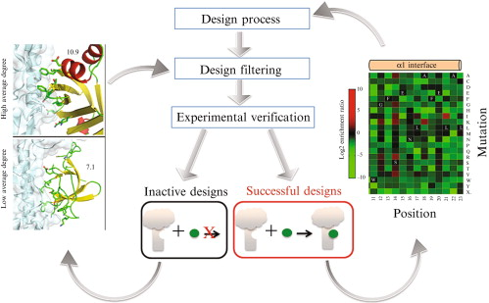

# **>Conclusion**:

Databases are the backbone of AI-driven drug design, providing the essential data required for training, prediction, and discovery. Their significance in accelerating drug discovery, predicting drug interactions, and facilitating drug repurposing cannot be overstated. As AI and computational approaches continue to evolve, databases will remain integral to advancing pharmaceutical research and development.

Deep learning techniques in molecule generation are at the forefront of drug discovery and materials science. As AI continues to advance, researchers are likely to see further improvements in the accuracy and efficiency of molecule generation. Combining deep learning with other computational techniques, such as quantum chemistry simulations, holds the potential to revolutionize the field of molecular design.

In conclusion, deep learning techniques represent a paradigm shift in molecule generation. They enable the rapid exploration of chemical space, expediting drug discovery and materials design. While challenges exist, ongoing research and innovation promise to overcome these limitations and further harness the potential of deep learning in molecule generation, paving the way for novel therapeutics and materials that could change the world.

Deep learning techniques, particularly generative models like RNNs and GANs, are reshaping the landscape of molecule generation for drug design. These models offer innovative solutions to the challenges of drug discovery, including lead compound discovery, de novo drug design, and chemical property optimization. While challenges remain, the potential of deep learning in revolutionizing drug design is undeniable. As research in this field continues to progress, it holds the promise of expediting the development of life-saving medications and improving the efficiency of pharmaceutical research.

AI-driven de novo drug design has ushered in a new era of drug discovery, characterized by efficiency, precision, and innovation. This transformative approach holds the promise of accelerating the development of life-saving therapeutics, improving drug safety, and addressing some of the most pressing healthcare challenges of our time. As AI continues to evolve and integrate with traditional drug discovery pipelines, it has the potential to reshape the pharmaceutical industry and benefit patients worldwide.

**References**:

* + Arrowsmith, J., & Miller, P. (2013). Trial watch: Phase II and phase III attrition rates 2011–2012. Nature Reviews Drug Discovery, 12(8), 569.
  + Joosten, R. P., te Beek, T. A., Krieger, E., Hekkelman, M. L., Hooft, R. W., Schneider, R., … & Vriend, G. (2011). A series of PDB related databases for everyday needs. Nucleic Acids Research, 39(suppl_1), D411-D419.
  + Halgren, T. A. (2009). Identifying and characterizing binding sites and assessing druggability. Journal of Chemical Information and Modeling, 49(2), 377-389.
  + Segler, M. H., Kogej, T., Tyrchan, C., & Waller, M. P. (2018). Generating focused molecule libraries for drug discovery with recurrent neural networks. ACS Central Science, 4(1), 120-131.

- Benson, D. A., Cavanaugh, M., Clark, K., Karsch-Mizrachi, I., Lipman, D. J., Ostell, J., & Sayers, E. W. (2013). GenBank. Nucleic Acids Research, 41(D1), DD36-D42.

- Berman, H. M., Westbrook, J., Feng, Z., Gilliland, G., Bhat, T. N., Weissig, H., … & Bourne, P. E. (2000). The Protein Data Bank. Nucleic Acids Research, 28(1), 235-242.

* + Gaulton, A., Hersey, A., Nowotka, M., Bento, A. P., Chambers, J., Mendez, D., … & Overington, J. P. (2017). The ChEMBL database in 2017. Nucleic Acids Research, 45(D1), D945-D954.
  + Wishart, D. S., Knox, C., Guo, A. C., Shrivastava, S., Hassanali, M., Stothard, P., … & Woolsey, J. (2006). DrugBank: a comprehensive resource for in silico drug discovery and exploration. Nucleic Acids Research, 34(suppl_1), D668-D672.
  + [**https://www.researchgate.net/figure/Structure-based-drug-design-SBDD-process_fig2_311755738/download?_tp=eyJjb250ZXh0Ijp7ImZpcnN0UGFnZSI6Il9kaXJlY3QiLCJwYWdlIjoiX2RpcmVjdCJ9fQ**](https://www.researchgate.net/figure/Structure-based-drug-design-SBDD-process_fig2_311755738/download?_tp=eyJjb250ZXh0Ijp7ImZpcnN0UGFnZSI6Il9kaXJlY3QiLCJwYWdlIjoiX2RpcmVjdCJ9fQ)
  + [**https://www.researchgate.net/figure/Fig-8-Flow-chart-of-Structure-Based-Drug-Designing_fig5_312167419**](https://www.researchgate.net/figure/Fig-8-Flow-chart-of-Structure-Based-Drug-Designing_fig5_312167419)

Stärk, H.; Ganea, O.; Pattanaik, L.; Barzilay, R.; Jaakkola, T. Equibind: Geometric deep learning for drug binding structure prediction. In Proceedings of the International Conference on Machine Learning, Baltimore, MD, USA, 17–23 July 2022; pp. 20503–20521.

Corso, G.; Stärk, H.; Jing, B.; Barzilay, R.; Jaakkola, T. DiffDock: Diffusion Steps, Twists, and Turns for Molecular Docking. arXiv2022, arXiv:2210.01776.

Jin, W.; Barzilay, R.; Jaakkola, T. Multi-objective molecule generation using interpretable substructures. In Proceedings of the 37th

International Conference on MachineLearning, Online, 13–18 July 2020; pp. 4849–4859.