AN ASSESSMENT OF WOMEN ENTREPRENEURSHIP IN INDIA
¹Dr.C.P.JAYASEELAN,² Mr.D.GOKUL NATH
¹ Assistant Professor,² Ph.D Research Scholar,
^{1, 2,} Department of Cooperation,
¹ TBML College Porayar, Mayiladuthurai-609307
² Sri Ramakrishnana Mission Vidyalaya
College of Arts and Science, Coimbatore-641020

Abstract
In today's modern era, women are carrying the same obligations as their male counterparts in all aspects of life, whether it is the private or public sector. Females are expanding in practically all industries. In this setting, the growing number of women's participation According to the organization, women need to be recognized as active participants in the nation. The development procedure From agricultural society to modern information society and global society, women's roles have shifted dramatically. There is still plenty to be done for striving women. sustainable Entrepreneurship. Empowerment essentially implies having equal status, opportunities, and independence. In a nutshell, women's empowerment means giving women the freedom to make their own decisions and creating an improved place for them in society. Education and entrepreneurship are two important components required for the self-sufficiency of Indian women. This research will shed light on the issues, challenges, and obstacles that women entrepreneurs face in India. This also serves as an attempt to examine the available financial help and government financing initiatives for women entrepreneurs. This research relies on secondary sources.The study's goal is to identify the primary drivers or push factors for increasing the number of female entrepreneurs and to make some appropriate recommendations.
Keyword: Entrepreneur, Empowerment, Women, Development.
Introduction
Indian Women are entering the sphere of entrepreneurship and developing themselves efficiently in the field of business. They are breaking down social barriers and using their intelligence to achieve great results as entrepreneurs. According to a Fortune India report, women like Zia Mody, Kiran Mrs. Mazumdar Shaw, Mallika Srinivasan, and Renuka Ramnath set the standard in society. great load for the overall family. However, the situation has entirely altered as women in India are reaching new heights of achievement in every field, including defense, politics, sports, medicine, and the corporate world. Women are not only making their families proud but also raising the flag of their country on a global scale by challenging society's long-held beliefs. In several areas, Indian women now outperform men. Women are making big contributions in the business realm as well. Women have been regarded as critical contributors to long-term development. According to a comprehensive approach to women's equality, they can play a significant part in the process of nation-building planning through entrepreneurship.
Examine the Literature
1. Indevar Pandey, Et Contributors, (2023), Article entailed on G20 reaches consensus on more power to women. The G20 New Delhi Leaders' Charter for 2023, promising equal rights for women and women's empowerment, is an important turning point in the fields of international politics and diplomacy. Recognizing the vital role of gender equality, G20 leaders constituted a technical group aimed at promoting the G20 Women's Conference during India's chairmanship. This decision reflects the unwavering efforts of the world's leaders, authorities, and citizens.
2. Women Empowerment NGOs with Udyogini!, (2023), A attempted probe on The Impact of Women Empowerment NGO: Making a Difference. NGOs, such as the All India Women's Conference (AIWC), are crucial in promoting women's empowerment. They offer quality education and opportunities for women's entrepreneurship, fostering a more inclusive future. Four active NGOs in India are Udyogini, Goonj, Azad Foundation, and Breakthrough India. They combat injustice, inequality, poverty, and violence by providing skill training, income-generating ventures, and vocational training. They also offer legal assistance to abused women, raise awareness about women's rights, and empower women in decision-making processes. NGOs also improve access to health and well-being, eradicating stigmas and encouraging women to take control of their bodies.

3. Women Empowerment NGOs with Udyogini!, (2023), Examine Article on Women’s Economic Empowerment: 5 Stories of Women’s Success. Kiran Mazumdar-Shaw, founder of Biocon Limited, is a symbol of gender equality. Chanda Kochhar, ICICI Bank's first female managing director, joined in 2009. Indra Nooyi, PepsiCo's CEO, expanded the company's product portfolio. Nita Ambani launched Reliance Foundation, focusing on education, healthcare, and disaster relief. Aditi Gupta started Menstrupedia to eradicate menstruation stigma. Economic empowerment for women is crucial for India's growth.

Aims of the Probe
- To find out the problems and obstacles that women entrepreneurs face.
- To evaluate the fiscal aid and government programs accessible to women entrepreneurs.
Methods and Materials
This writing is analytical in nature since it will examine the significance of government financial aid to the expansion of women entrepreneurs. This the material might also reflect light on the Women's restrictions and roadblocks Indian business owners. This report bases its findings on secondary data gathered from numerous government news accounts, media, subject-related knowledge about and articles from newspapers and magazines.
Problems and obstacles that women entrepreneurs face
Women entrepreneurs confront distinct hurdles in the business sector due to sociological, economic, and cultural issues. Access to funding, restricted networking opportunities, work-life balance, gender bias, lack of role models, market biases, limited access to knowledge and resources, legal and regulatory impediments, lack of confidence, and market access are all common challenges. These barriers can undermine women's credibility, decision-making authority, and access to markets and distribution channels. To overcome these issues, efforts should be focused on developing more equitable funding methods, providing mentorship and support networks, and addressing corporate preconceptions and biases. Promoting gender equality in entrepreneurship can contribute to economic growth and innovation by utilizing the untapped potential of women in companies.
Problems face the women entrepreneurs
Women entrepreneurs in India face distinct hurdles and obstacles as a result of the country's social, economic, and cultural characteristics. Here are some of the issues and challenges that women entrepreneurs in India face:

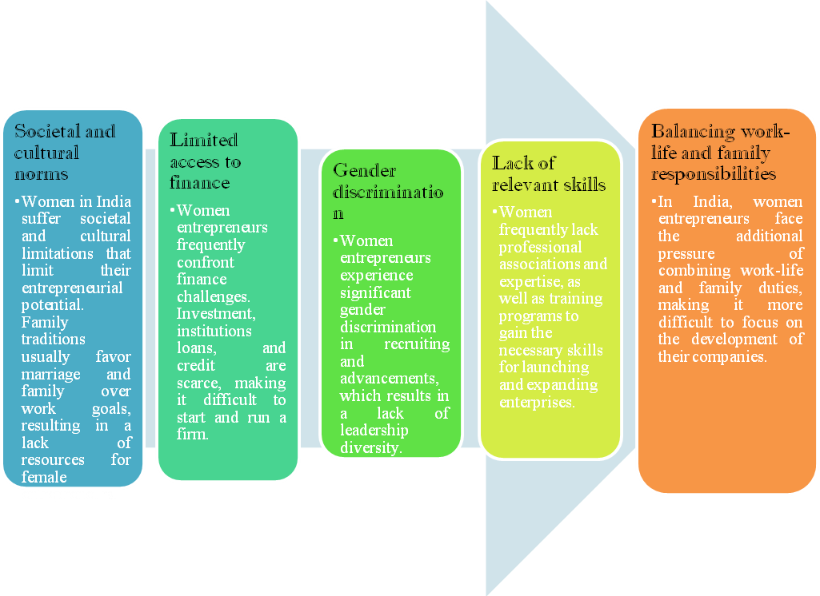
Outline of Info Diagram

The Indian government has introduced a number of schemes and schemes to assist women entrepreneurs, but more work is needed to solve these issues and create equal opportunities for men and women in entrepreneurship.

Obstacles face the women entrepreneurs

Women entrepreneurs in India encounter a number of challenges that can make it difficult for them to develop and grow their businesses. Cultural, societal, and economic variables frequently affect these impediments. Here are some of the major challenges that women entrepreneurs in India face:

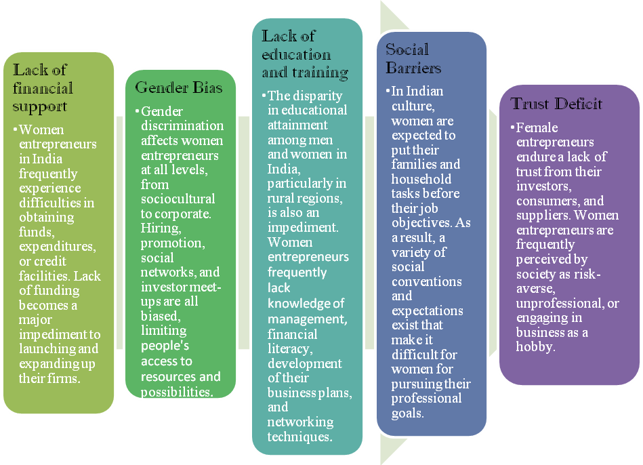

Outline of Info Diagram

To motivate women entrepreneurs in India, governments and the private sector in general must overcome these hurdles and provide a favorable environment for them to grow. Knowledge and training, equitable access to funding, mentorship programs, and laws and regulations that address biases, hurdles, and stereotypes should all be part of the ecosystem.

Evaluate the fiscal aid and government programs accessible to women entrepreneurs

Government efforts in India, such as the "Women Entrepreneur Scheme," aim to assist female entrepreneurs by providing financial and non-financial assistance at the national, state, and municipal levels. These programs address the special obstacles that women experience in business, while also encouraging economic development and empowerment.

S. No | Scheme Name | Beneficiaries | Eligibility
1 | Beti Bachao, Beti Padhao Scheme:  The Beti Bachao Beti Padhao Scheme, launched by India's Prime Minister in Haryana, aims to empower women by addressing declining sex ratios, enhancing welfare services, and ensuring girl child survival. | Primary, secondary, and tertiary groups in India include young couples, pregnant mothers, parents, adolescents, doctors, and general people, while tertiary groups include religious leaders, frontline workers, officials, media, and women's SHGs. | Eligible families with a girl child under 10 years old in India must have a Sukanya Samriddhi Account (SSA) opened in a nationalised bank.
2 | Working Women Hostel Scheme :  The Indian government has introduced the 'Working Women Hostel Scheme' to provide safe accommodation and daycare facilities for working women and their children. | Working Women (single, widowed, married, divorced, separated). | Working women with non-metropolitan families and those undergoing job training must maintain a monthly gross income of ₹50,000 in metropolitan cities and ₹35,000 in other cities.
3 | One-Stop Centre Scheme:  The One Stop Centre Scheme, funded by the Nirbhaya fund, is a centrally sponsored initiative in India aimed at women's empowerment. It offers emergency medical, legal aid, counseling, and non-emergency services to state governments, ensuring protection against gender-based violence. Complaints are registered through SMS or internet, and case details are entered into a system. | The One Stop Centre Scheme provides benefits to all women affected by violence, regardless of their class, caste, region, religion, marital status, or sexual orientation. | All women, including girls aged below 18.
4 | Women Helpline Scheme:  The Women Helpline Scheme is a government initiative offering 24x7 emergency services to women affected by violence, tracking their address and addressing any disruptions. | Any women or girls facing violence or willing to know about various women related schemes or programs. | -
5 | Mahila Police Volunteers Scheme:  Mahila E-Haat is an online platform by the Ministry of Women and Child Development, enabling women entrepreneurs to sell their products through mobile and internet connections. | Women entrepreneurs, women self-help groups (SHG), NGOs | Women entrepreneurs must be Indian citizens and their products must be legally sold.
6 | Mahila Police Volunteers Scheme:  The Mahila Police Volunteers scheme, launched by the Ministry of Women and Child Development and Home Affairs, aims to establish a centrally sponsored connection between police authorities and local communities. | Woman in India | Women 21+ with 12th-grade certificate, local language knowledge, no criminal record, and no political party membership are eligible for the scheme.
7 | STEP (Support to Training and Employment Program for Women):  The Support to Training and Employment Program for Women (STEP) in India is a government-sponsored initiative that provides women with skill development training and employment opportunities. | The focus is on marginalized groups, including SC/ST households, women-headed households, families below the poverty line, asset-less rural women, and urban poor. | Non-government organizations, voluntary societies, co-operative societies, women of 16+, and institutions registered under various statutes are eligible for registration.
8 | SWADHAR Greh:  The SWADHAR Greh scheme is a government initiative in India that provides women with shelter, food, clothing, social security, legal assistance, and societal re-adjustment. | Women in prison, suffering from AIDS, HIV, homeless, trafficked, or deserted situations lack economic and social support. | Women aged 18 years or above
9 | Mahila Shakti Kendras (MSK):  The Mahila Shakti Kendra is a renowned Indian women empowerment scheme, providing comprehensive support services to women at national, state, and district levels, aiming to establish 920 in underdeveloped districts.
10 | Rajiv Gandhi National Creche Scheme  The National Creche Scheme is a government initiative empowering working mothers by providing daycare facilities, promoting children's health, nutrition, physical, social, and holistic development, and educating parents on childcare methods.

Outline of Info Table

It's crucial to remember that the particular details and characteristics of women entrepreneur programs may differ by state and location, and new efforts may be launched over time. These initiatives seek to foster a more inclusive and supportive environment for women entrepreneurs in India, thereby contributing to economic growth and women's empowerment. Women who want to establish or build a business should look into the various programs and resources available at the local, state, and national levels to take advantage of the assistance and opportunities they provide.

Discussions
Women entrepreneurs in India have a lot of opportunities in large-scale and technology-based businesses. The majority of the businesses run by female entrepreneurs are either self-funded or small businesses. Their engagement in small-scale industry is significant. Also, very little The Third All-India Conference Report According to the Small-Industry Census, only 11% of micro and small industries were managed by women. There is still more work to be done before women is empowered through business. To include ongoing efforts to increase this population segment, action should be taken in order to deliver the advantages of government-sponsored financial schemes. Several investigations have demonstrated that government programs are extremely beneficial to women entrepreneurs in terms of self-employment, self-development, and financial success. Stability.
References
1.Dr. Anjali Kulkarni:(2019) “Entrepreneurship Promotion: Are We Making Enough Efforts in This New Era of Business?” Tata Institute of Social Sciences ISSN: 2230-9667 Chronicle of The Neville Wadia Institute of Management Studied And Research page no (26-31)
2. Surbhi Jain(2016) “Growth of startup ecosystems in India” IJAR ; 2(12): 152-154 www.allresearchjournal.com
3. Bhawna Mittal and Others(2018): “A Conceptual Study of Startup India – A Rejuvenation” Journal of Commerce and Trade, Ap2018;13:1;Pp.1–14
4. A. K. Thakur, and Others. 2009. Women Entrepreneurship. Deep and Deep Publications. New Delhi. 41–43.
5. PurvaKhera, (2018) : Closing Gender Gaps in India: Does Increasing Womens‟ Access to Finance Help?”, IMF Working Paper No. 18/212.
6. McKinsey Global Institute,(2015): “The Power of Parity: Advancing Women‟s Equality in India”,
7.https://economictimes.indiatimes.com/news/india/g20-reaches-consensus-on-more-power-to- women/articleshow/103699696.cms The author is Secretary, Ministry of Women and Child Development
8. https://udyogini.org/impact-of-women-empowerment-ngo-making-a-difference/
9. https://udyogini.org/womens-economic-empowerment-5-stories-of-womens-success/

