**A RELIABLE IoT-DRIVEN FRAMEWORK FOR ANALYZING STUDENT PERFORMANCE IN SMART CLASSROOM**

D. Hema Priya 1, S.S. Rajasekar 2  
1PG Scholar, Department of Computer Science and Engineering, Bannari Amman Institute of Technology, Sathyamangalam - 638401

2Associate Professor, Department of Computer Science and Engineering, Bannari Amman Institute of Technology, Sathyamangalam – 638401

***Abstract*** - A new era of smart classrooms has begun with the incorporation of Internet of Things (IoT) technologies, completely changing how teachers and students teach and learn. This research presents a stable and efficient Internet of Things-driven architecture for analyzing how students perform in smart classrooms. The framework provides current knowledge about student interactions, engagement, and academic success by utilizing an interconnected network of devices, sensors, and data analytics. IoT sensors that are thoughtfully positioned throughout the classroom to collect a variety of data points, including student attendance, engagement, and biometric data, are among the framework's essential elements. A central data hub receives this data for processing and analysis in real-time. To identify both group and individual achievement indicators, machine learning algorithms are utilized to extract significant variations and patterns from the data. Teachers can use the resultant insights to modify their lesson plans, provide challenging students with timely interventions, and enhance the atmosphere of learning for better results. Security and privacy were given top priority when designing this framework. The suggested IoT-driven framework offers teachers and educational institutions data-driven tools to improve teaching strategies and student outcomes, which has the potential to greatly improve the educational experience. Through the development of a more dynamic and flexible learning environment, this framework hopes to support the continued advancement of smart classrooms in the age of digital technology.

***Keywords****: IoT, Smart Classrooms, RFID, Student Performance Analysis, Data Analytics, Machine Learning, Privacy, Security.*

1. **INTRODUCTION**

In the digital world of today, technology has permeated every aspect of our lives and revolutionized a wide range of sectors and companies. The education sector is one such area that has seen tremendous change.

The way we teach and learn has been completely transformed by the use of Internet of Things technologies in the classroom. Smart classrooms, where cutting-edge tools and technologies are employed to improve the learning experience for students, are made possible by the usage of IoT in education [1]. Through the provision of services such effective online learning, teaching-learning optimization, classroom occupancy monitoring, content recommendation, and learner behavior monitoring, IoT and data analytics enhance the proficiency of educational systems [2]. In addition, the integration of IoT with educational systems aids in student motivation, identifies weak and struggling pupils, evaluates learners' progress, and makes the learning process easier.

**1.1 Information on IoT-Driven Framework in Education**

This essay aims to explore the implications, benefits, challenges, and considerations associated with implementing IoT-driven frameworks in education. While there are numerous advantages associated with using IoT-driven frameworks in education, there are also challenges that need careful consideration before implementation. Privacy concerns arise from the collection of sensitive student data which must be handled securely while ensuring compliance with relevant regulations such as GDPR or FERPA. Additionally, issues related to security vulnerabilities must be addressed adequately to safeguard against potential cyber threats. Data management and storage, as well as ethical considerations surrounding data usage, must also be considered.

**1.2 Importance of Analyzing Students' Performance in Smart Classrooms**

Smart classrooms, equipped with advanced technologies, have revolutionized the traditional education system by providing interactive and engaging learning environments. These modern classrooms leverage technology to enhance teaching methods and improve student outcomes. One crucial aspect of smart classrooms is the ability to analyze student performance effectively. This essay aims to explore the importance of analyzing student performance in smart classrooms and how it can benefit both educators and learners.

**1.2.1 Benefits of Analyzing Student Performance in Smart Classroom**

Analyzing student performance in smart classrooms provides valuable insights for teachers and educators. By collecting data on student progress, educators can identify areas where students may be struggling or excelling. This information allows them to tailor their instruction based on individual needs, providing personalized learning experiences for each student.

**1.3 Role of IoT in Analyzing Student Performance**

One of the key benefits of IoT in education is its ability to analyze student performance. Establishing a Reliable IoT-driven Framework for analyzing student performance in smart classrooms is crucial for educators and administrators. The integration of IoT technology in smart classrooms allows for the collection of real-time data on student behavior, engagement, and performance. This data can be analyzed and utilized to gain insights into individual student progress, identify areas of improvement, and tailor instructional strategies accordingly.

The integration of IoT in education systems also facilitates the identification of weak or struggling students [3]. Through real-time monitoring of student performance, IoT can help educators identify students who may be lagging or having trouble in certain subjects or skills. This early detection allows for timely interventions and tailored support to help these students catch up and succeed academically. Another valuable aspect of IoT-driven student performance analysis is the ability to assess learners' progress accurately.

**1.4 Scope of Study**

The Scope of the study is to explore and analyze the various technologies and components that make up a smart classroom, such as IoT devices, sensors, data collection systems, and communication infrastructure.

Develop methods and techniques to collect real-time data on students' performance, such as academic progress, attendance, engagement, behavior, and other relevant metrics. This may involve integrating sensors, wearable devices, and IoT technologies to capture and transmit data.

Address ethical considerations and privacy concerns related to the collection and analysis of students' data. Ensure compliance with relevant data protection regulations and guidelines. Assess the potential impact and benefits of implementing the IoT-driven framework for analyzing students' performance in smart classrooms. This may include improved teaching strategies, personalized learning experiences, and enhanced educational outcomes.

**1.5 Overview of Project Topic and Its Significance**

The overview of the project focuses on leveraging IoT technologies to develop a framework that can collect, analyze, and interpret real-time data on students' performance in smart classroom environments. This framework aims to provide educators and stakeholders with valuable insights into students' academic progress, engagement levels, behavior, and other relevant metrics. Overall, the project holds significant potential to transform the way student performance is assessed and monitored in smart classrooms. By leveraging IoT technologies and data analytics, educators can gain valuable insights, make data-driven decisions, and ultimately enhance the learning experience for students.

1. **LITERATURE REVIEW**

IoT applications have become increasingly popular over the past few years in a variety of industries, with education being one of them. Many research investigations have been done to examine the use of IoT and IoT enabled devices to present a clever and effective method of learning. Multiple educational applications, such as attendance tracking and finding nearby teachers in an emergency, might be created using current technology like NFC and RFID. Additionally, smart eyewear technology can aid students in having the greatest possible learning experience. This section will cover research studies that were done in many areas of education. Smart Classrooms would involve examining existing research and scholarly articles related to IoT applications in education and student performance analysis.

**2.2 Internet of Things (IoT) in Education**

In the current digital age, technology has permeated every aspect of our lives and revolutionized a wide range of sectors and companies. The education sector is one such area that has seen tremendous change. In the current digital age, technology has permeated every aspect of our lives and revolutionized a wide range of sectors and companies. The education sector is one such area that has seen tremendous change. The way we teach and learn has been completely transformed by the use of Internet of Things technologies in the classroom. Smart classrooms, where cutting-edge tools and technologies are employed to improve the learning experience for students, are made possible by the usage of IoT in education [1].

Through the provision of services such as effective online learning, teaching-learning optimization, classroom occupancy monitoring, content recommendation, and learner behavior monitoring IoT and data analytics enhance the proficiency of educational systems [2]. Additionally, incorporating IoT into educational systems aids in student motivation, identifying weak and struggling learners, tracking learners' progress, and streamlining the learning process.

1. **SOFTWARE ARCHITECTURE**

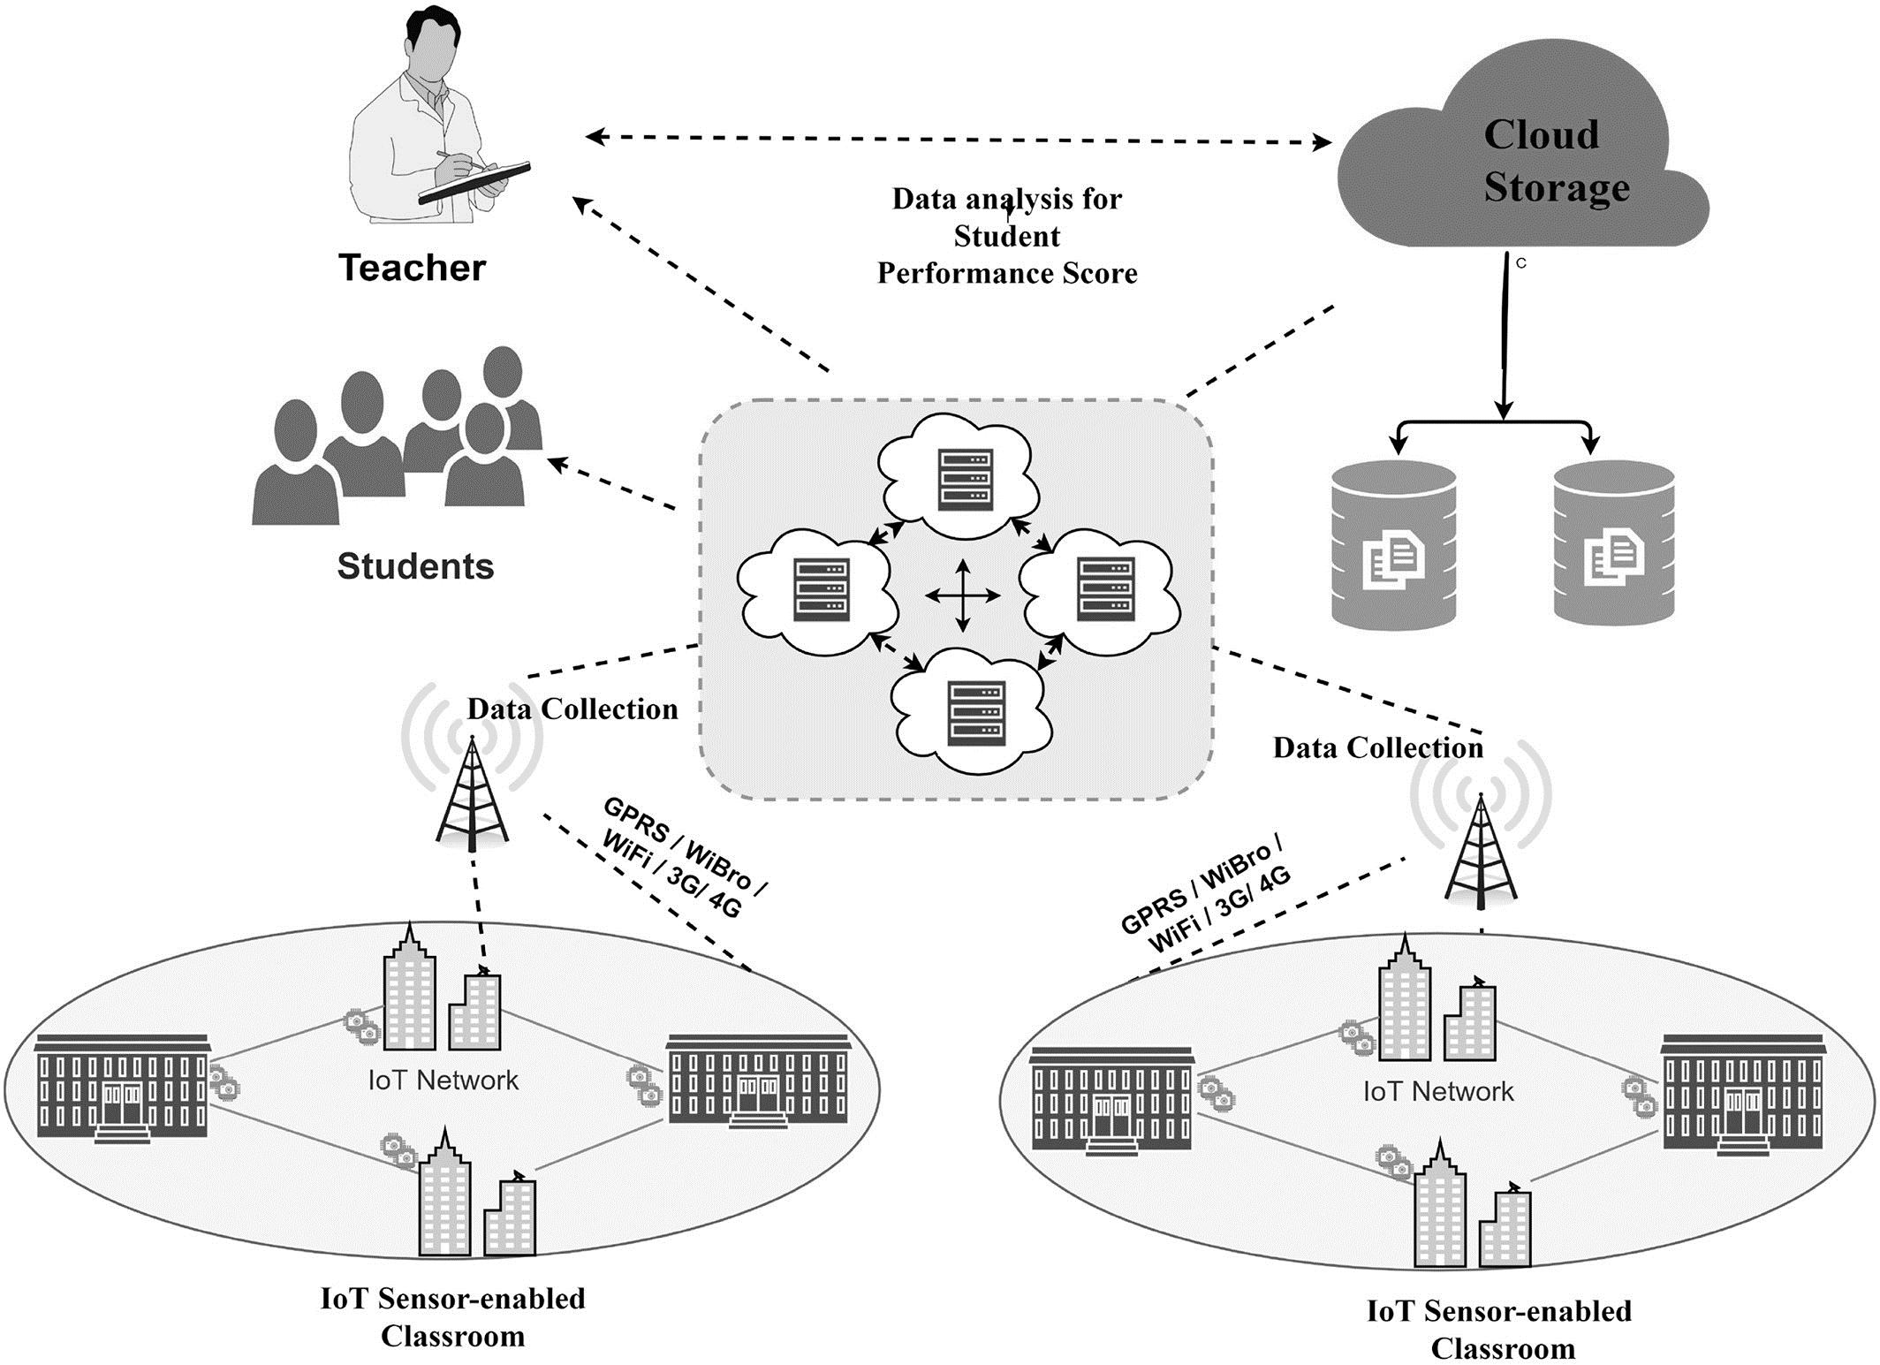

**Figure: 1 Software Architecture**

**3.1 Data Collection Mechanisms**

IoT sensors and devices (mentioned in table 1) are strategically deployed within the Smart Classroom environment. Smart Boards are interactive whiteboards that can capture data on teacher presentations, notes, and student interactions with the board. Wearable Devices that may include students may wear devices like smartwatches or fitness trackers that collect biometric data, including heart rate, movement, and engagement. Students might use personal devices like tablets, laptops, or smartphones for educational purposes. These devices can capture data related to students' interactions with digital content, online quizzes, or educational apps.

Automated attendance systems, such as RFID scanners or facial recognition technology, track student attendance and entry/exit times that mentioned in the figure 1. Security cameras or specialized classroom cameras may record student interactions, expressions, and movements, helping assess engagement and attentiveness. Data from the LMS, such as students' logins, course progress, and performance on online assessments, can be integrated into the analysis referred as the figure 1.

**Table: 1 Components / Modules/ Methods/ Techniques used for the project Development**

|  |  |  |
| --- | --- | --- |
| ID cards with RFID chips | Attendance | It describes the regularity of the students in the class |
| Real-Time communication  tools and time-stamp  technology | Assignments | Number of assignments  submitted to the teacher for evaluation |
| Biometric system | Finger print | Fingerprint reader |
| Software tools encompassed data analytics frameworks like | Python and machine learning libraries | Ensuring accurate analysis of the collected data. User interfaces, including interactive dashboards and mobile applications, facilitated data access and feedback provision |

**3.2 Data Security and Privacy Considerations**

All data, whether in transit or at rest, is encrypted using strong encryption algorithms to prevent unauthorized access. Access to the framework is strictly controlled and restricted to authorized personnel only. Role-based access control ensures that users can only access data and features relevant to their roles. Users are required to authenticate themselves using strong, unique credentials (e.g., usernames and passwords) to access the framework. Two-factor authentication may be implemented for enhanced security.

The framework collects and retains only the data necessary for its intended educational purposes. Unnecessary data is not collected to minimize privacy risks. Personally identifiable information (PII) is anonymized or pseudonymized whenever possible to protect student identities. This ensures that data analysis is conducted without directly identifying individuals.

**4. METHODOLOGY**

**4.1 Proposed Methodology:**

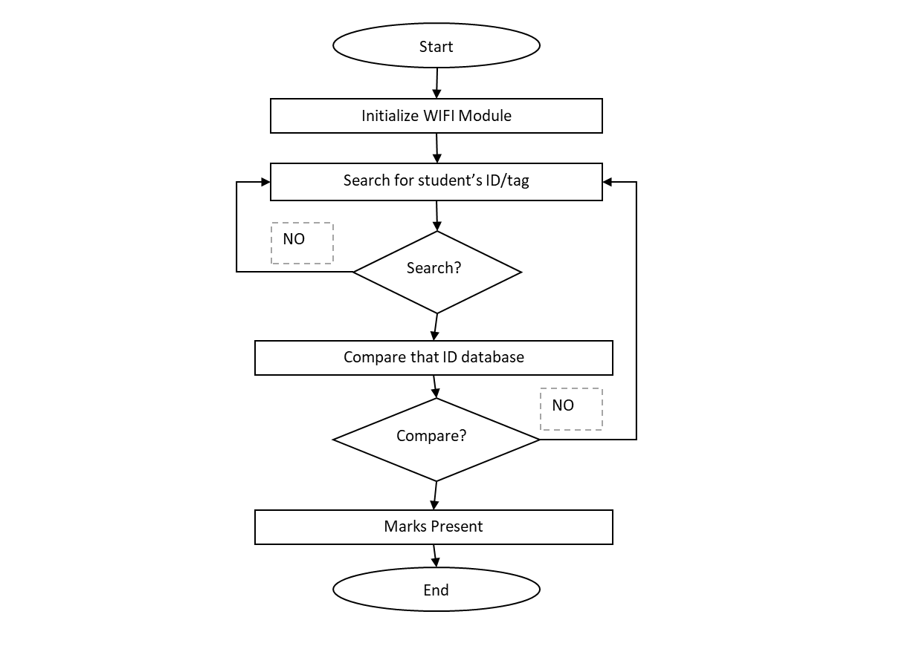

**Figure: 2 Proposed Methodology**

**4.2 Data Collection and Sensors:**

Data is collected from a variety of sensors and devices within the Smart Classroom, such as smart boards, wearable devices, environmental sensors, and attendance systems. Data collection is a crucial component facilitated by various sensors and devices deployed in the Smart Classroom. These sensors and devices play a key role in gathering real-time information on student activities and classroom dynamics.

Data from diverse sensors and devices are collected in real-time or near real-time and form the foundation for the subsequent data analysis and insights generation within the framework. This multifaceted data collection approach provides a holistic view of student activities and classroom dynamics in the Smart Classroom that represented in the figure 2

**4.3 Data Preprocessing Pipeline:**

Raw data is collected from various sources within the Smart Classroom, such as smart boards, wearable devices, environmental sensors, and attendance systems. The collected data undergoes preprocessing to clean, organize, and enhance its quality for analysis.

The data preprocessing pipeline ensures that the data is cleaned, structured, and ready for analysis, improving the accuracy and reliability of insights derived from machine learning algorithms and analytics. Properly pre-processed data is essential for making informed decisions in Smart Classrooms while safeguarding student privacy and data integrity.

**5. DATASET COLLECTION AND ANALYSIS**

**5.1 Student Performance Dataset**

In this analysis of high school student performance using the Kaggle dataset, we have embarked on a comprehensive journey to understand the factors influencing student success. While the dataset comprises various attributes, including gender, race/ethnicity, parental education level, lunch, test preparation course, math, reading, and writing scores, our focus has been on data manipulation, visualization, and statistical insights.

**Table: 2 Sample Dataset collection of Student performance in Exams**

|  |  |  |  |  |  |  |
| --- | --- | --- | --- | --- | --- | --- |
| STUDENT RFID | GENDER | RACE/ETHNICITY | TEST PREPARATION COURSE | MATH SCORE | READING SCORE | WRITING SCORE |
| RF-1221 | Female | Group B | None | 72 | 72 | 74 |
| RF-1222 | Female | Group C | Completed | 69 | 90 | 88 |
| RF-1223 | Female | Group B | None | 90 | 95 | 93 |
| RF-1224 | Male | Group A | None | 47 | 57 | 44 |
| RF-1225 | Male | Group C | Completed | 76 | 78 | 75 |
| RF-1226 | Female | Group B | None | 71 | 83 | 78 |
| RF-1227 | Female | Group B | Completed | 88 | 95 | 92 |
| RF-1228 | Male | Group B | None | 40 | 43 | 39 |
| RF-1229 | Male | Group D | Completed | 64 | 64 | 67 |
| RF-1230 | Female | Group B | None | 38 | 60 | 50 |
| RF-1231 | Male | Group C | Completed | 58 | 54 | 52 |
| RF-1232 | Male | Group D | Completed | 40 | 52 | 43 |
| RF-1233 | Female | Group B | Completed | 65 | 81 | 73 |
| RF-1234 | Male | Group A | Completed | 78 | 72 | 70 |
| RF-1235 | Female | Group A | None | 50 | 53 | 58 |
| RF-1236 | Female | Group C | None | 69 | 75 | 78 |
| RF-1237 | Male | Group C | Completed | 88 | 89 | 86 |
| RF-1238 | Female | Group B | Completed | 18 | 32 | 28 |
| RF-1239 | Male | Group C | Completed | 46 | 42 | 46 |
| RF-1240 | Female | Group C | None | 54 | 58 | 61 |

**5.2 Data Cleaning and Overview**

We initiated the analysis by importing essential Python libraries such as NumPy, Pandas, Matplotlib, and Seaborn, ensuring we have the necessary tools for the task. We then read the dataset using Pandas' `read_csv` function and examined its structure using the `head` method. This step ensured that the dataset was correctly loaded and that we understood its structure. The dataset consists of 1000 records and 7 columns, with a combination of categorical and numerical features.

**5.2.1 Statistical Insights**

To gain a quick overview of the dataset's statistical characteristics, we used the `describe ()` method, providing us with important metrics like count, mean, standard deviation, and quartiles for the numerical variables. This statistical summary allowed us to grasp the central tendencies and spread of student performance in math, reading, and writing. It was noted that there were no missing values in the dataset, eliminating potential issues associated with imbalanced observations and biased estimates. We improved data readability by renaming columns, making them more concise and replacing spaces with underscores for consistency.

**6. DATA VISUALIZATION**

When creating data visualizations for student performance analysis, it's important to ensure that the visualizations are clear, accurate, and aligned with the specific goals of the analysis. It's also crucial to consider privacy and data protection regulations when handling student data. Effective data visualization can help educators and administrators make informed decisions, identify areas for improvement, and support students in their learning journey. Interactive dashboards provide a dynamic way to explore and analyze student performance data. Tools like Tableau, Power BI, and Python libraries like Plotly and Bokeh can be used to create interactive data visualizations. Data Visualization in this project was analyzed in two ways. Uni-variate and Multivariate Visualization.

**6.1 Univariate Visualization**

For quantitative features (math, reading, and writing scores), we employed histogram plots to visualize the distribution of student performance. Box plots were used to visualize key statistics, including medians, quartiles, interquartile ranges, and potential outliers. We explored gender-based performance, uncovering differences in the number of students scoring above 80% in math, reading, and writing, emphasizing the role of gender in academic performance. For categorical features (gender, race/ethnicity, parental education, lunch, and test preparation), we created frequency tables to provide insights into class distribution and parental education levels.

**6.2 Multivariate Visualization**

Multivariate plots allow us to see relationships between two and more different variables. We examined the correlation matrix of numerical variables to understand relationships among them, discovering a strong positive correlation between reading and writing scores. Gender statistics were further explored, indicating that the student population predominantly consisted of females. The impact of test preparation on student performance, particularly in math, was assessed. Those who completed the test preparation course demonstrated higher math scores.

**7. DATASET ANALYSIS**

**Table: 3 Analysis of Datasets**

|  |  |  |  |
| --- | --- | --- | --- |
| Dataset | Math Score | Reading Score | Writing Score |
| Count | 1000.00000 | 1000.00000 | 1000.00000 |
| Mean | 66.08900 | 69.1690000 | 68.054000 |
| Std | 15.16308 | 14.600192 | 15.195657 |
| Min | 0.00000 | 17.000000 | 10.000000 |
| 25% | 57.00000 | 59.000000 | 57.750000 |
| 50% | 66.00000 | 70.000000 | 69.000000 |
| 75% | 77.00000 | 79.000000 | 79.000000 |
| Max | 100.00000 | 100.000000 | 100.000000 |

**Abbreviation of Table:**

Count: Shows the total number.

Mean: Shows the average.

Std: Standard deviation value

Min: Minimum value

%25: First Quantile

%50: Median or Second Quantile

%75: Third Quantile

Max: Maximum value

Student performances in Exams are analysed in Univariate Visualization and Multivariate Visualization.

**8. SAMPLE OUTPUT**

Its output is mostly self-explanatory. 25%, 50%, and 75% are the corresponding percentiles.

**Quantitative features**

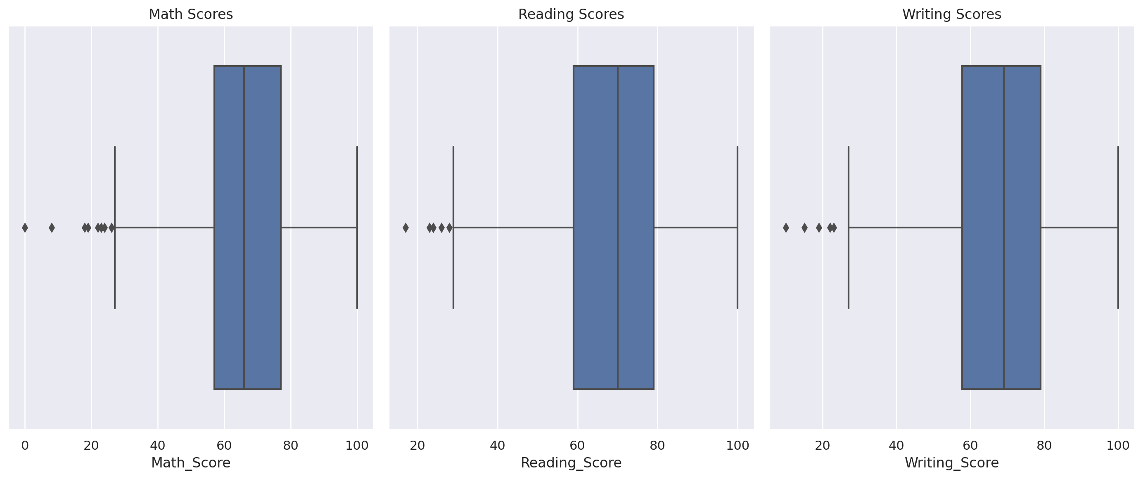

**Figure: 3 Box Plot graph**

The box plot of figure 3 comprises of above-mentioned graph:

1. A box: this shows the distribution's interquartile spread; the 25𝑡ℎ(Q1) and 75𝑡℗(Q3) percentiles define the box's length. The median (50%) of the distribution is indicated by the vertical line inside the box.

2. Whiskers: These are the lines that protrude from the box. The data points that lie inside the interval (Q1−1.5⋅IQR,Q3+1.5⋅IQR) are represented by it, and the `interquartile range} is denoted by {IQR=Q3−Q1}.

3. Outliers - An outlier is a single data point that dramatically deviates from the majority of the data in a population or sample.

The plot below Figure 4 shows that in all courses, Females get high scores compared to the males.

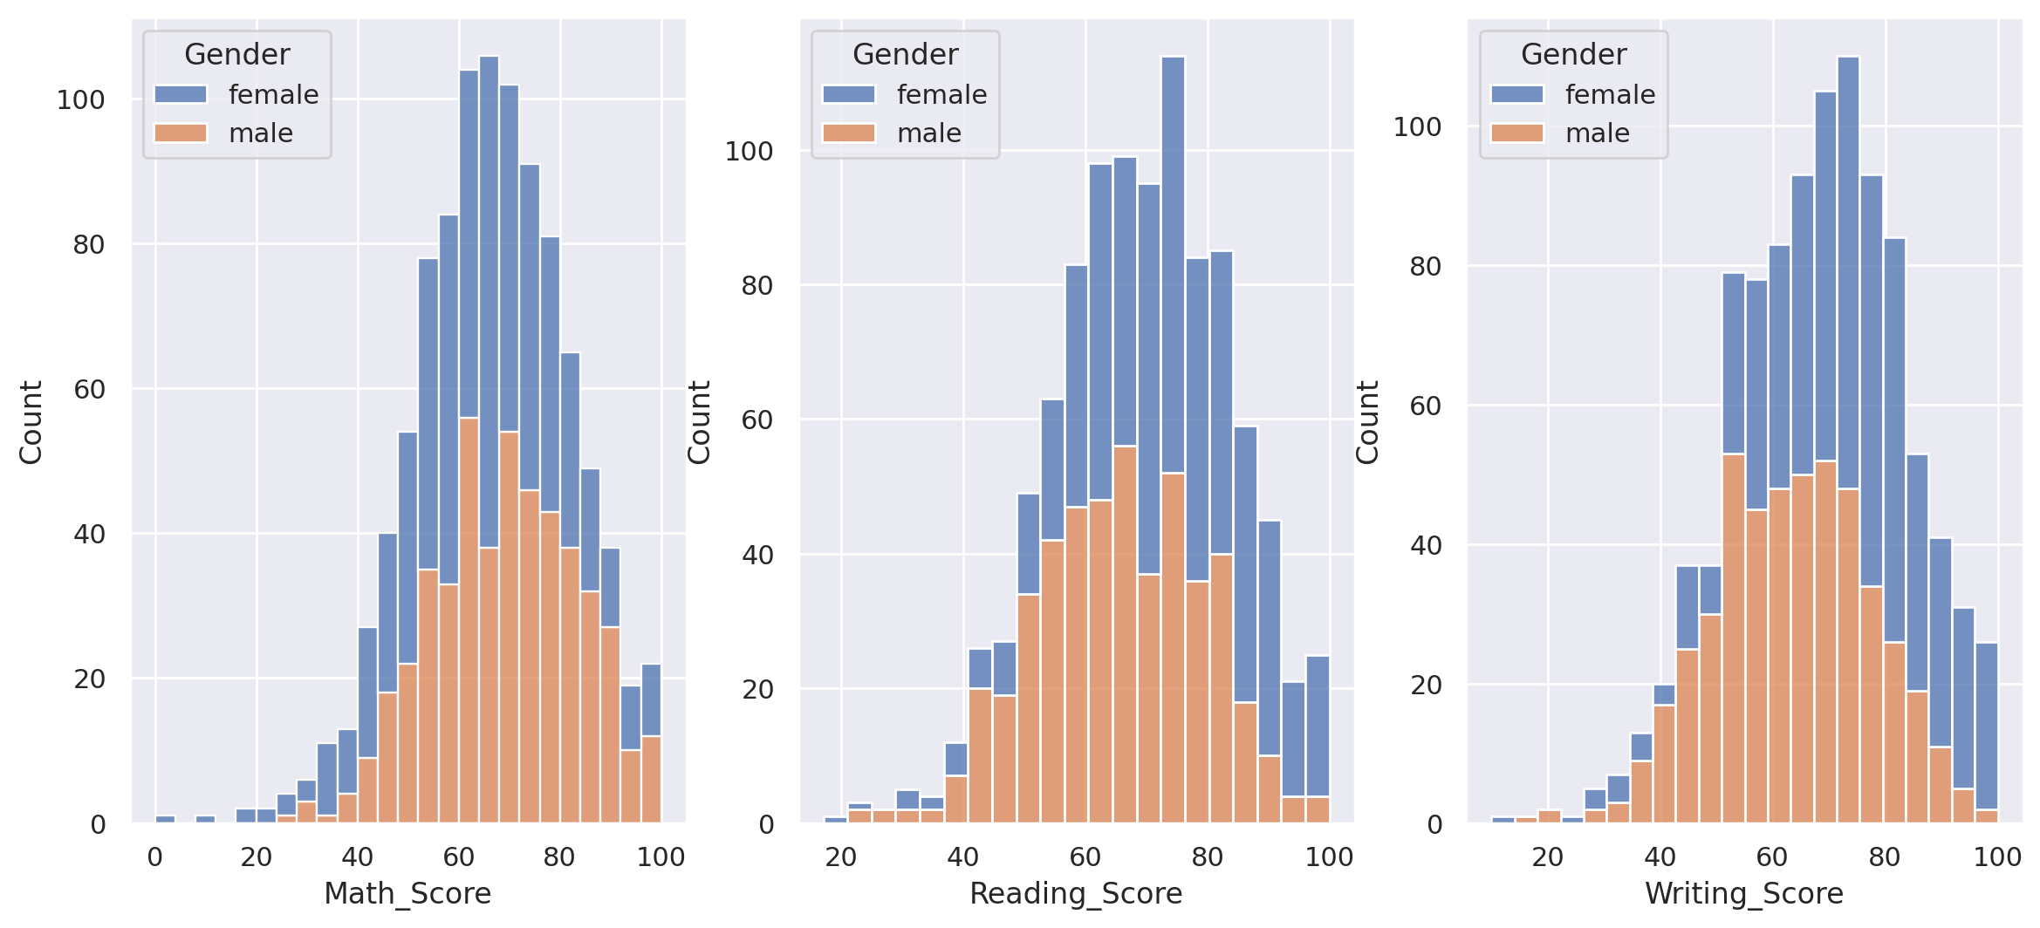

**Figure: 4 Gender-wise Scores in the Graph**

From the analysis, we can say that a larger number of males scored more than 80% in mathematics compared to the females while a larger number of females scored more than 80% in Reading and Writing represented in Pie chart figure 5.

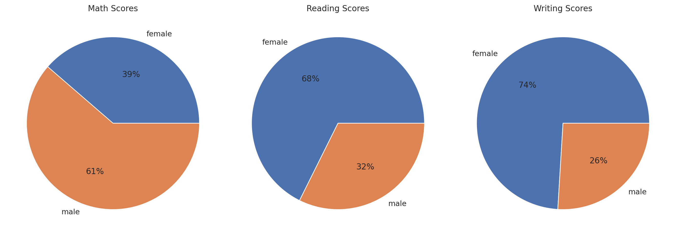

**Figure: 5 Pie chart of Maths, Reading and Writing Scores**

**Qualitative features**

From the qualitative analysis figure 6, 31.9% of students in the class belong to ethnic group C, 26.2% of students in the class belong to ethnic group D, 19.0% to the group B, 14.0% to the group E, 8.9% to the group A which are represented below pie chart figure 6. Average scores of the subjects are represented in figure 7.

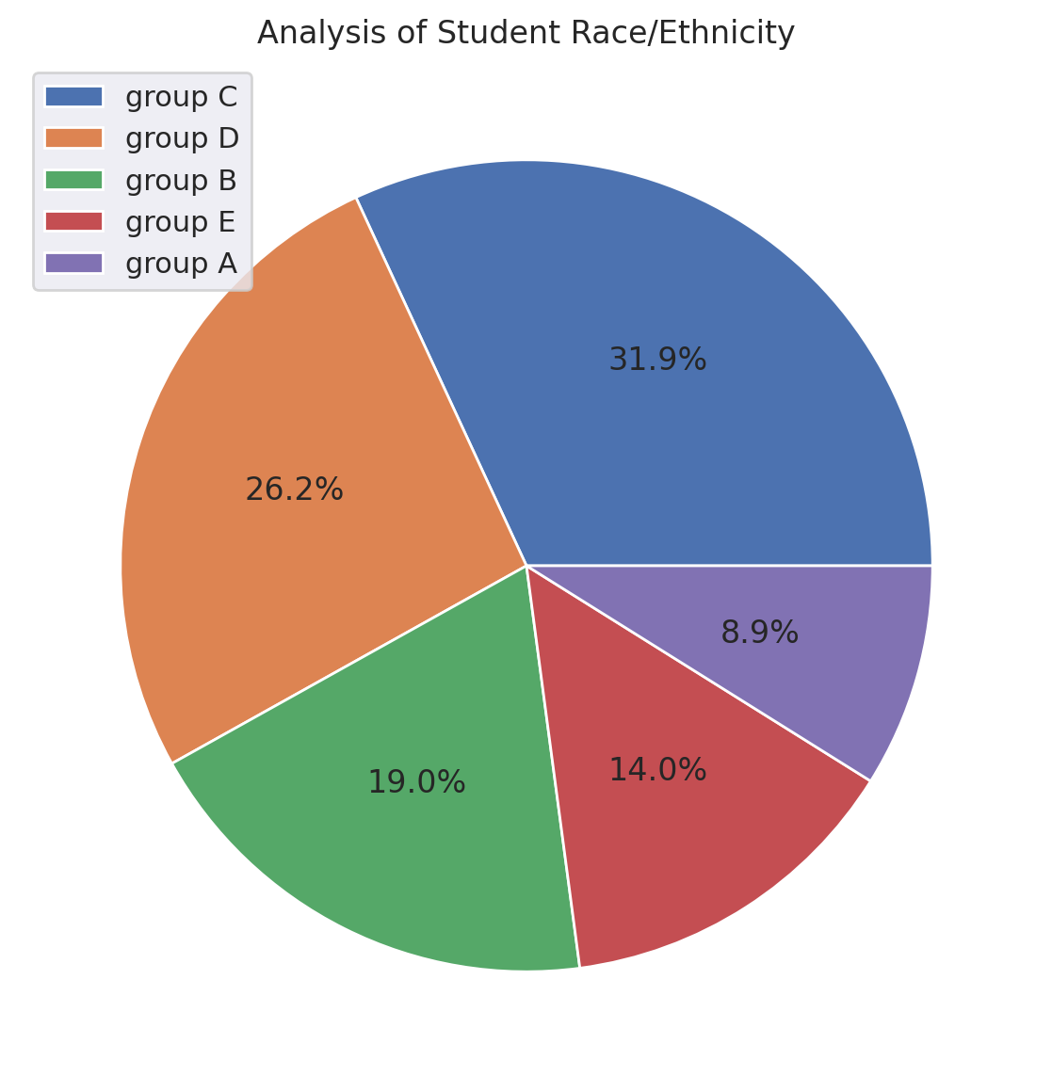

**Figure: 6 Analysis of Students Race/Ethnicity**

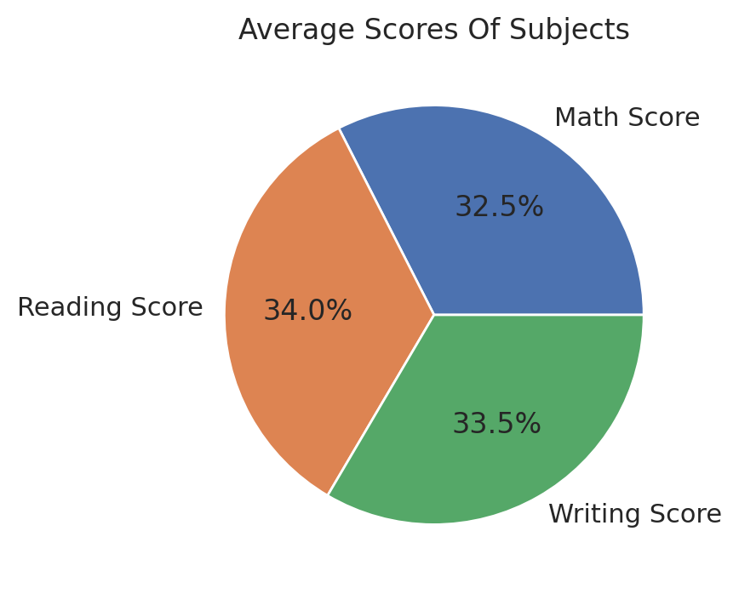

**Figure: 7 Average Score of Subjects**

The majority of the students (64.2%) did not attend the test preparation course in figure 10 and figure 11. From the chart below, we can say that the test preparation course was helpful since the student with the highest score in mathematics completed the course.

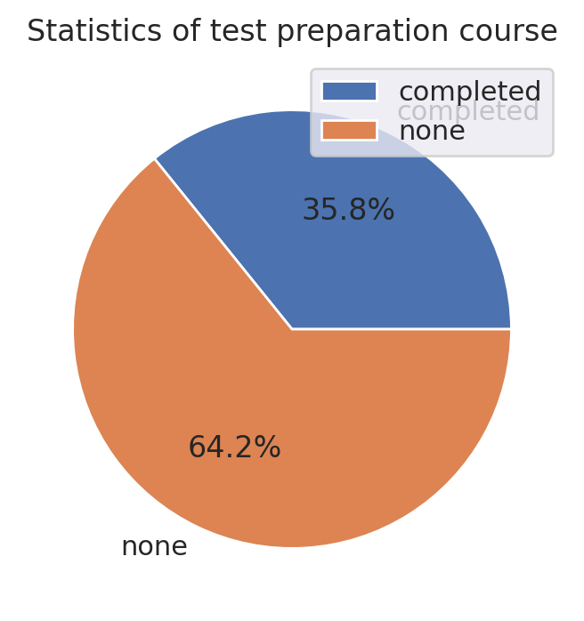

**Figure: 10 Statistics of Test-Preparation Course**

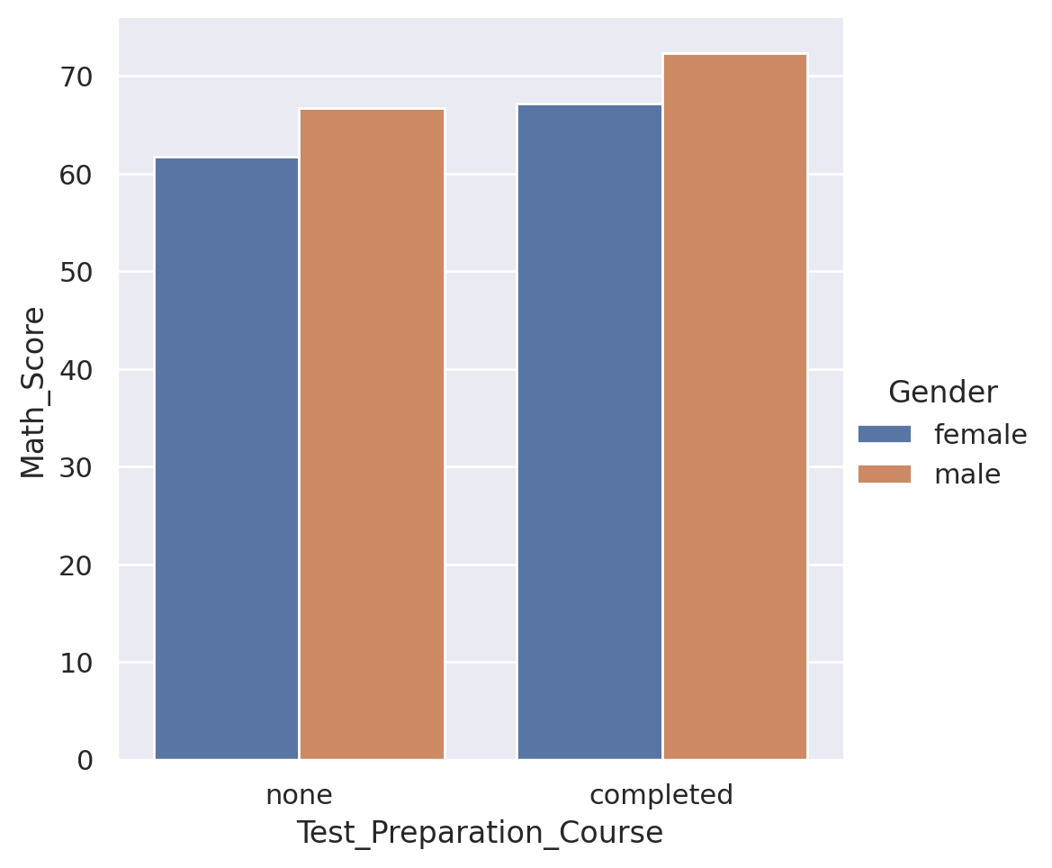**Figure: 11 Test-Preparation Course**

From the chart below figure 12, we can say that about 75% of the students passed the three exams.

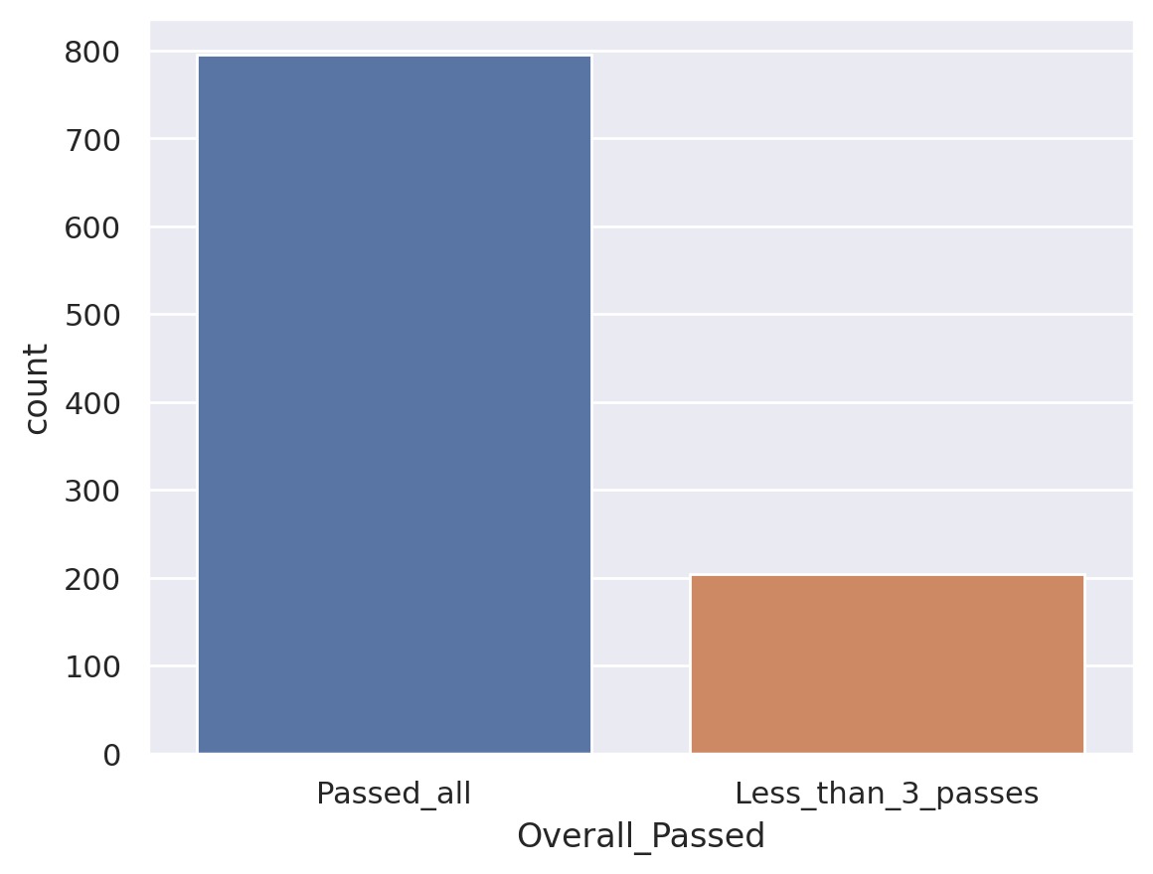

**Figure: 12 Overall Passed Graph**

**Table 5: Assigning GPA to Each Student**

|  |  |  |  |
| --- | --- | --- | --- |
| GPA | MARKS | GPA | MARKS |
| GRADE B | 261 | GRADE A | >80 |
| GRADE C | 256 | GRADE B | >70 |
| GRADE A | 198 | GRADE C | >60 |
| GRADE D | 182 | GRADE D | >50 |
| GRADE F | 103 | GRADE F | <50 |

Table 5 represents the grade system and analysis of student's marks according to the scores obtained by the students in exams.

VALUES

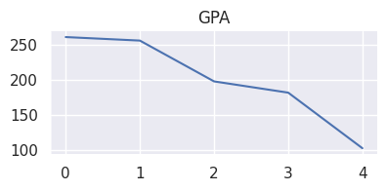

**Figure: 13 GPA Values**

DISTRIBUTION

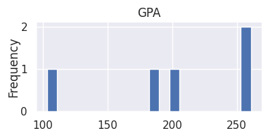

**Figure: 14 GPA Distribution**

From the chart figure 13 and 14, we see that most of the class had an average GPA of B and C. Hence represented as GPA values and Distribution in the graph

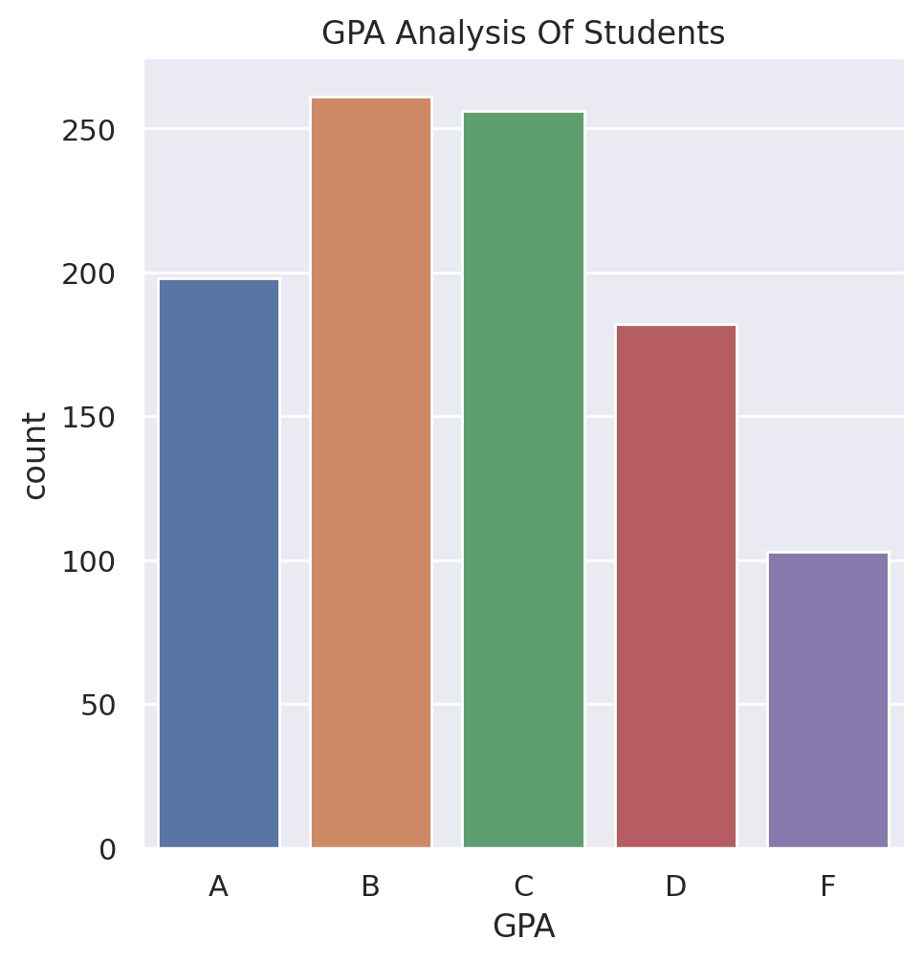

**Figure:15 GPA Analysis of Students**

Figure 15 mentioned above represents the GPA Analysis of the students who performed in the exams and are classified according to the grading system. A, B, C, D, and F represent the Grades obtained by the Students in Exams. These results underscore the potential of IoT-driven solutions to revolutionize educational practices and foster more effective, individualized learning environments in smart classrooms.

**9. RESULTS AND DISCUSSION**

The integration of IoT in education systems also facilitates the identification of weak or struggling students. Through real-time monitoring of student performance, IoT can help educators identify students who may be lagging or having trouble in certain subjects or skills. This early detection allows for timely interventions and tailored support to help these students catch up and succeed academically. Another valuable aspect of IoT-driven student performance analysis is the ability to assess learners’ progress accurately. Data processing and analysis revealed patterns and trends in student performance, enabling proactive interventions for personalized learning experiences.

**9.1 Future work**

Future trends for IoT-based analysis of student performance in smart classrooms are expected to further enhance the capabilities and benefits of this technology in education. One future trend is the integration of artificial intelligence algorithms into IoT systems to provide a more sophisticated and personalized analysis of student performance. By leveraging AI, IoT systems can gather and analyze a vast amount of data on students' learning patterns, behaviors, and preferences. This advanced analysis can provide valuable insights into individual student strengths, weaknesses, and areas for improvement, allowing educators to tailor their instructional approaches and interventions accordingly. Another future trend is the use of predictive analytics in IoT-based student performance analysis.

**10. CONCLUSION**

In conclusion, the future of IoT-based analysis of student performance in smart classrooms holds immense potential for improving education systems. Through the integration of IoT technologies, such as data analytics, predictive analytics, and wearable devices, educators can gain valuable insights into student performance and implement targeted interventions to support students' academic success. (Saleem & Chishti, 2019)[2].

This can lead to improved student outcomes, increased engagement, and enhanced learning experiences. Additionally, IoT-based student performance analysis in smart classrooms can also have implications for curriculum development and instructional strategies. The integration of IoT technologies in smart classrooms allows for the collection and analysis of data that can provide valuable insights into student performance. By understanding how students interact with instructional materials and identifying areas where they may be struggling, educators can tailor their teaching methods to better meet the needs of individual This data can inform educators about the effectiveness of their teaching methods and curriculum, allowing for adjustments and improvements to be made. Overall, the future of IoT-based analyzing student performance in smart classrooms holds promise for revolutionizing education systems by creating a more personalized and efficient learning experience.

**10.1 Summary of Findings**

This analysis provides a comprehensive exploration of the Kaggle dataset, encompassing data cleaning, statistical insights, and extensive visualizations. The detailed univariate and multivariate visualizations allow us to understand not only the individual factors affecting student performance but also the interactions between these factors. The emphasis on gender-based performance and the influence of test preparation on math scores adds novel insights to our understanding of student achievement. In summary, this analysis equips us with a rich understanding of the dataset and its various attributes, shedding light on factors influencing student performance in high school. It provides valuable insights for educators, policymakers, and researchers interested in enhancing educational outcomes and equity.

**REFERENCES**

1. M. Al-Abdullatif, A. Al-Dokhny and A. E. E. Drwish, "Critical Factors Influencing Pre-Service Teachers’ Use of the Internet of Things (IoT) in Classrooms".
2. Saleem, T J., & Chishti, M A. (2019, December 4). Data Analytics in the Internet of Things: A Survey. https://scite.ai/reports/10.12694/scpe.v20i4.1562
3. Zairul, M., Ismail, I A., Jamil, M A M., Azlan, A., Ismail, I S., Jalil, H A., & Sharef, N M. (2022, December 2). Smart Classroom Adoption in Higher Education: A Thematic Review. https://scite.ai/reports/10.6007/ijarbss/v12-i14/15825
4. Investigating the impact of IoT-Based smart laboratories on students’ academic performance in higher education. (n.d.) Retrieved September 11, 2023, from link.springer.com/article/10.1007/s10209-022-00944-1
5. A critical evaluation, challenges, and future perspectives of using artificial intelligence and emerging technologies in smart classrooms. (n.d.) Retrieved September 11, 2023, from slejournal.springeropen.com
6. Education Sciences | Free Full-Text | A Survey of Smart Classroom Literature. (n.d.) Retrieved September 11, 2023, from www.mdpi.com/2227-7102/12/2/86
7. Prabal Verma & Sandeep K. Sood (2017): Internet of Things-based student performance evaluation framework, Behaviour & Information Technology, DOI: 10.1080/0144929X.2017.1407824
8. Gao, Z., Huang, Y., Zheng, L., Li, X., Lu, H., Zhang, J., … Fang, J. (2021). A Student Attendance Management Method Based on Crowdsensing in Classroom Environment. IEEE Access, 9, 31481–31492. doi:10.1109/access.2021.3060256
9. Munish Bhatia, Avneet, "Quantum computing inspired framework of student performance assessment in the smart classroom”, DOI: 10.1002/ett. June 2020
10. Irene Cittaning Laksmi, Puspanda Hatta, and Endar Suprih Wihidayat, A Systematic Review of IoT Platforms in Educational Processes. Proceedings of the International Conference on Industrial Engineering and Operations Management Istanbul, Turkey, March 7-10, 2022
11. Moridani, M. K. (2021). The role of the Internet of Things in the Educational System during the Corona Pandemic. 2021 5th International Conference on Internet of Things and Applications (IoT). doi:10.1109/iot52625.2021.9469606 – 2021
12. Eleni Dimitriadou and Andreas Lanitis, “A critical evaluation, challenges, and future perspectives of using artificial intelligence and emerging technologies in smart classrooms”, Smart Learning Environments <https://doi.org/10.1186/s40561-023-00231-3>