**Evaluation of Fly Ash Composite Polymer**

Mayur Solanki, Nitesh Rane

PG Scholar, MED, Dr. APJ Abdul Kalam University Indore, M.P., India E mail –smayur0111@gmail.com

Assistant Professor, MED, Dr. APJ Abdul Kalam University Indore, M.P., India E mail – nitesh.rane@aku.edu.in

**ABSTRACT**

Because it is inexpensive and readily available, industrial waste like fly ash, which is causing environmental issues, is largely employed as a building material. However, the primary drawback of these bricks is their lack of strength. Thus, there is a great deal of research being done to make these bricks stronger. The goal of the current research project is to create a novel, methodical process for making fly ash composite bricks with increased compressive strength. To discover a solution for the brick industry, fly ash is combined with cold setting resin in various ratios and water treated at various temperatures. Under ideal test conditions, the fly ash-resin powder bricks had compressive strength, hardness, water absorption, density, and thermal conductivity of 11.24.MPa, 47.37HV, 19.09% 1.68 g/cm3, and 0.055 W/mK respectively. The sliding wear behavior is also investigated. The structure-property correlations of these composites are studied using X-ray diffraction, FTIR analysis and scanning electron microscopy.

**Key Words:** Fly-Ash, Building Material, Compressive Strength, Resin Powder, Bricks

**INTRODUCTION**

The production value of electricity and, by extension, its consumption as energy, determine a nation's whole development. In order to meet the expectations of its citizens and achieve its goal of being a developed nation by 2020, our country, India, need enormous power resources. In order to meet the need for power generation, fossil fuels are crucial.One of the wealthiest and most abundant fossil fuels in the planet is coal. India ranks third globally in terms of coal output and possesses the fourth-largest coal reserves, with an approximate total of 197 billion tons. According to estimates, 75% of India's installed power is thermal, with coal accounting for over 90% of this total. Approximately 600 million tons of coal is produced worldwide every year, with Fly ash generation is about 500 MT at (60-78 %) of whole ash produced [1, 2].In India, the current generation of FA is nearly about 180 MT/year and is probable to increase about 320 MT/year by 2017 and 1000MT/year by 2032 [3] . Indian coal undoubtedly has a poor heat value and a high ash content. An rising number of coal-based thermal power plants have been built to fulfill the demanding demands. This led to the production of a massive amount of burned residue in the form of fly ash (80%) and bottom ash (20%). The burned coal's finely divided particles are released into the flue gases, which are mechanically separated from one another by separators and electrostatic precipitators before being gathered in hopper fields. The production rate of FA is significant and continues to rise annually. Indian coal undoubtedly has a poor heat value and a high ash content. An rising number of coal-based thermal power plants have been built to fulfill the demanding demands. This led to the production of a massive amount of burned residue in the form of fly ash (80%) and bottom ash (20%). The flue gases from the burned coal release the finely divided particles, which are mechanically separated by electrostatic precipitators. The United States, China, and India together produce over 275 million metric tons of FA annually. However, only about half of this is consumed nationwide. The largest issue facing the manufacturing and processing sectors is how to properly dispose of leftover garbage. The detrimental effect. Waste products that are generally toxic, ignitable, corrosive or reactive have detrimental environment consequences. This major issue requires an effective, economic and eco- friendly method to tackle with the disposal of the residual industrial waste products. The problem with safe disposal of ash without affecting the environment, disturbing ecological balance and the large storage area required are major issues and challenges for safe and sustainable development of the country. Hence needful efforts are being made continuously by making stringent regulations by the government to fully utilize the ash. Currently only 50% of the fly ash is being profitably utilized in India [4]. The most common and feasible ways to utilize these industrial wastes products is to go for construction of roads, highways and embankments. The Problem with environmental

If these waste products are efficiently used in the building of roads, highways, and embankments, pollution can be significantly decreased. However, it is difficult to get enough soil of the right quality in significant quantities. Therefore, these industrial wastes not only serve as a substitute for natural soils in building, but they also provide a solution to the disposal and environmental pollution issues. This will save natural resources, reduce the amount of trash going to landfills, cut the cost of building materials, and save waste disposal expenses, all of which will have a major positive impact on the construction sector and the nation as a whole. With the help of some suitable stabilizer like lime, thermosetting resins or cement, the properties of fly ash can be increased and it can be further used as a construction material. FA shows self -hardening behavior that is why it is used in construction broadly.

### **FLY ASH: AN OVERVIEW**

FA is an industrial waste that is produced when coal is burned to provide energy and is recognized as a pollutant to the environment. Carbon and volatile elements entirely burn off when coal is heated inside a boiler's grate. Nevertheless, some inorganic impurities of earthly materials, such as feldspar and sand, are bound together and released through flue gases. Fly ash, which are tiny, spherical particles, are created when these fused materials are allowed to solidify. These FA particles are microscopic spheres encased in plerospheres, which are large spheres. Cenospheres are another name for hollow spheres. Because of the bonding that occurs during the suspension of discharged flue gases from the boiler or chimney, FA particles have a spherical morphology. These tiny particles are mostly made up of iron, aluminum, and silicon oxides. There are also trace amounts of Cu, Zn, Mn, Fe, B, and Mo in addition to a few elements including P, Mg, K, and Ca. The characteristics of FA varies between sources, within the same source over time, and depending on the methods employed for processing, storing, and varying load creation.

# OBJECTIVE OF THE WORK

The aim of the present work is to fabricate Fly ash polymer composite at different proportions of polymer and to study physico mechanical, thermal conductivity and wear behavior. In present project an attempt was made to increase the density and hardness of the water cured cylindrical samples. SEM, XRD and FTIR analysis were also done to investigate the microstructural changes.

**Result-**

**Composition of Fly ash**

FA mainly consists Silica (Sio2), Alumina (Al2o3), Calcium Oxide (CaO), and Iron Oxide (Fe2O3).The chemical composition of Fly ash is tabulated in table 4.1.

|  |  |  |  |  |  |  |  |  |  |
| --- | --- | --- | --- | --- | --- | --- | --- | --- | --- |
|  | SiO2 | Al2O3 | CaO | Mgo | P2O5 | Fe2o3 | SO3 | K2O | LOI |
| Composition (%) | 54.5 | 26.5 | 2.1 | 0.57 | 0.6 | - | - | - | 14.18 |

Table 1 Compositional analysis of Fly ash

### Water Absorption Test

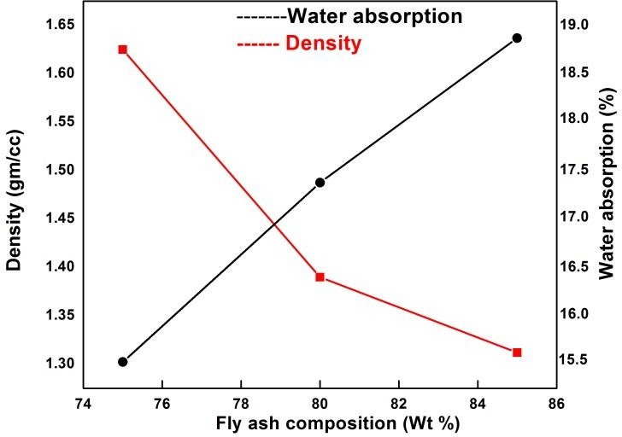

Figure.4.1 Water absorption and density as a function of FA Composition

### Density Measurement

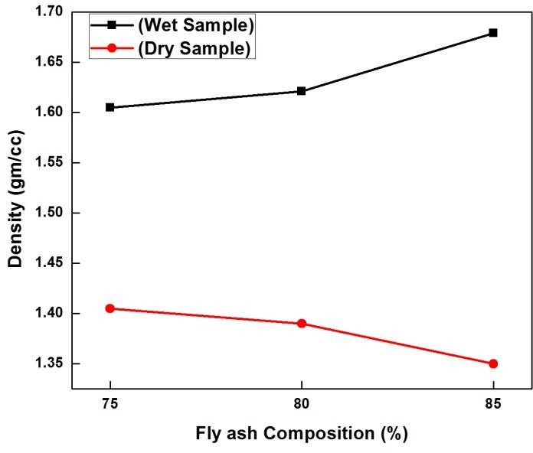

Fig.2 Variation in dry and wet density w.r.t FA composition

|  |  |  |
| --- | --- | --- |
| Mix Composition (Wt. %) | Density (g/cm3) | |
| Dry | Wet |
| (FA)75%+ (RP)25% | 1.40 | 1.60 |
| (FA)80%+ (RP)20% | 1.38 | 1.62 |
| (FA)85%+ (RP)15% | 1.35 | 1.67 |

Table 3 Density value of dry and wet FA polymer compacts

### Hardness Measurement

|  |  |  |  |
| --- | --- | --- | --- |
| S.NO | Mix Composition (Wt. %) | Micro hardness value (HV) | |
| Dry | Wet |
| 1 | (FA)75%+ (RP)25% | 32.93 | 39.78 |
| 2 | (FA)80%+ (RP)20% | 38.26 | 43.04 |
| 3 | (FA)85%+ (RP)15% | 44.08 | 47.37 |

Table 4 Hardness values of various FA resin mix compacts

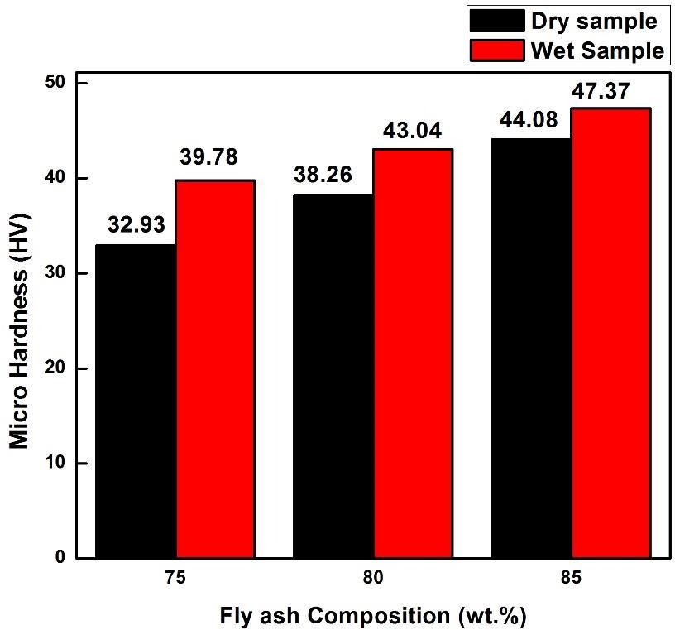

Fig. 3 Variation in hardness values with wt. % of FA

### XRD Analysis

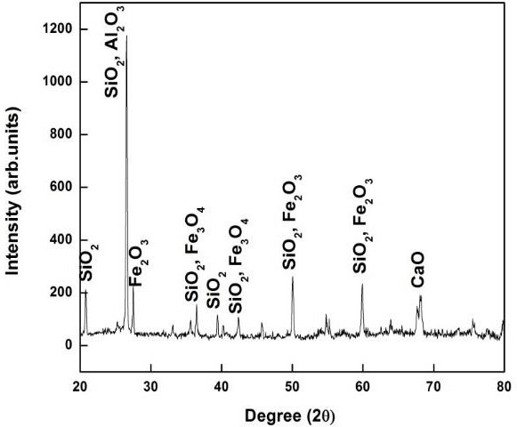

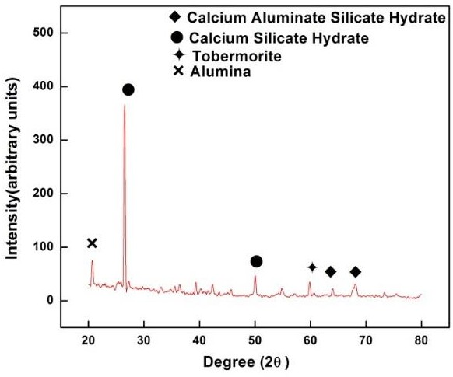

Fig.4 (a) XRD analysis of Fly ash and Fig.4.4 (b) XRD analysis of water cured compact

### FTIR Analysis

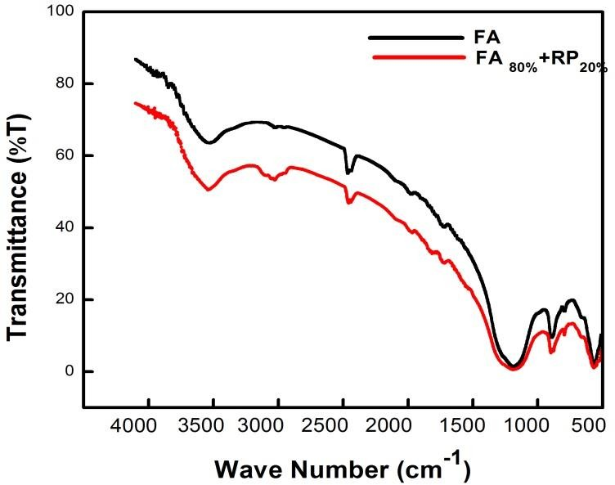

Fig.5 IR spectra of the FA and FA resin Powder mix

### Determination of Compressive Strength

|  |  |  |  |
| --- | --- | --- | --- |
| S.NO | Mix Composition (Wt. %) | Compressive Strength (MPa) | |
| Dry | Wet |
| 1 | (FA)75%+ (RP)25% | 6.5 | 5.52 |
| 2 | (FA)80%+ (RP)20% | 8.73 | 7.98 |
| 3 | (FA)85%+ (RP)15% | 11.28 | 9.43 |

Table 5 Compressive strength values of different FA resin mix compacts

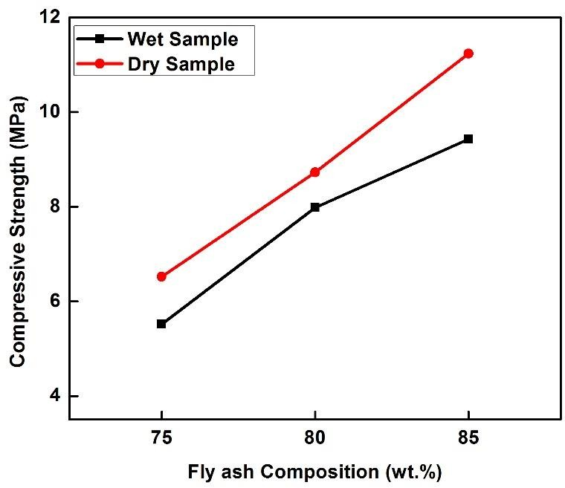

Fig.6 Compressive Strength of Compacts at different FA compositions

### Thermal Conductivity measurement

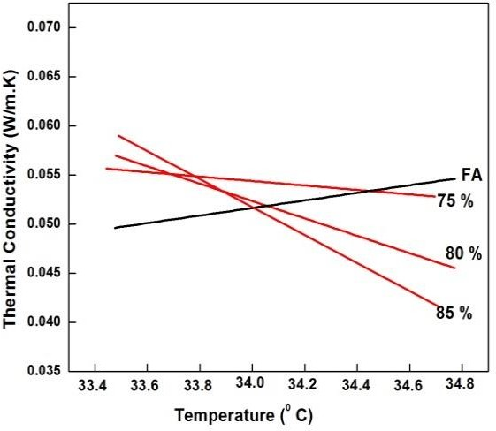

Fig.4.7 Thermal conductivity of FA –Resin powder Mix at different compositions

**Wear Study**

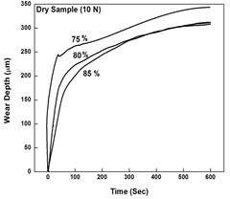

(a)

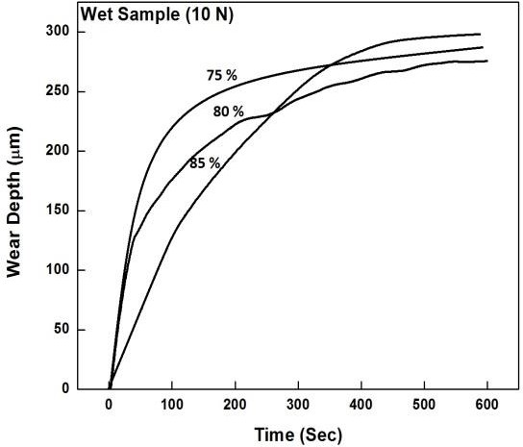

(b)

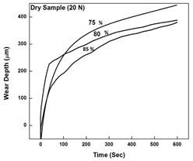

(c)

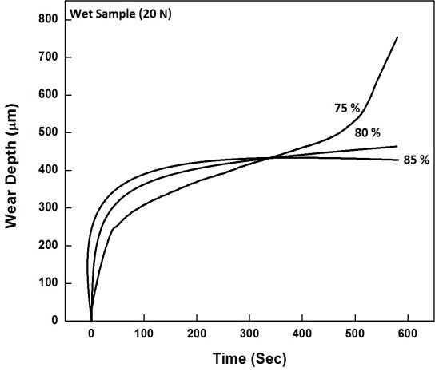

(d)

Figure 8 Wear behavior of FA compacts at different loads

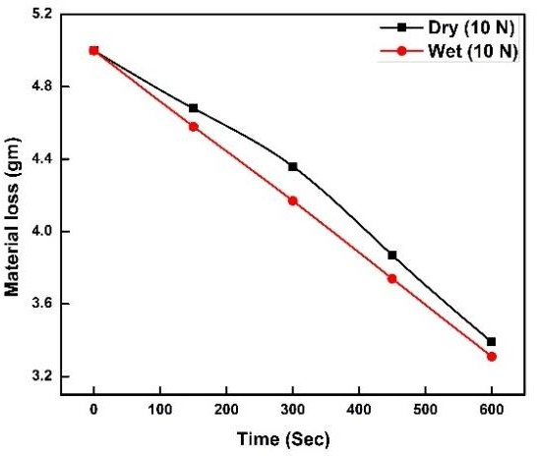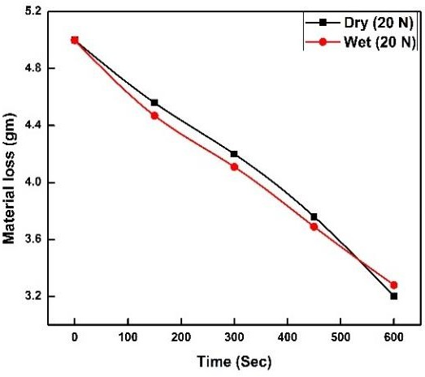

Fig.9 (a & b) shows the variation in weight loss (gm) with respect to time (sec).

### Friction Study

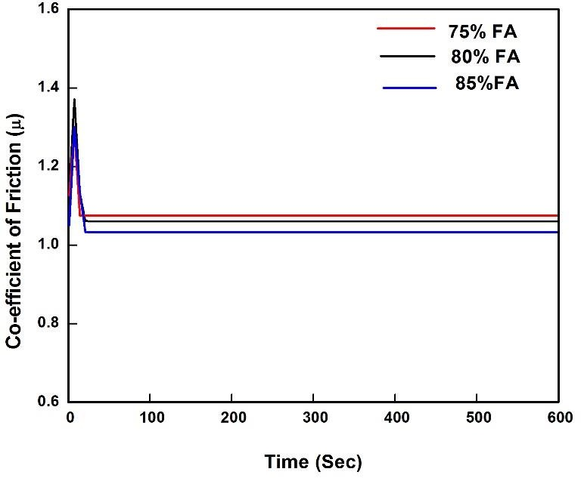

**(a)**

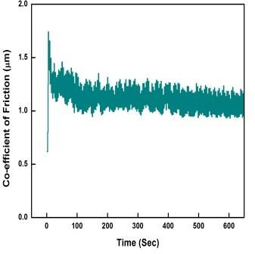

**(b)**

Fig.10 (a, b) Variation in co-efficient of friction w.r.t FA composition

**SEM Analysis**

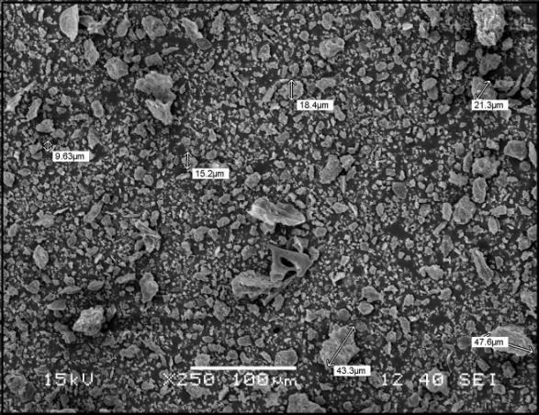

**(a)**

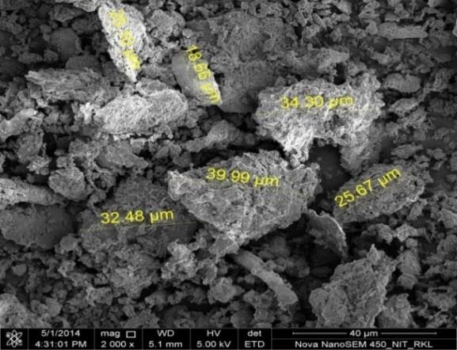

**(b)**

Figure.4.11 (a, b) Particle size distribution of FA powder at different Magnification

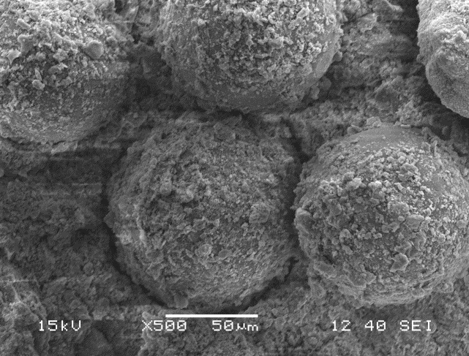

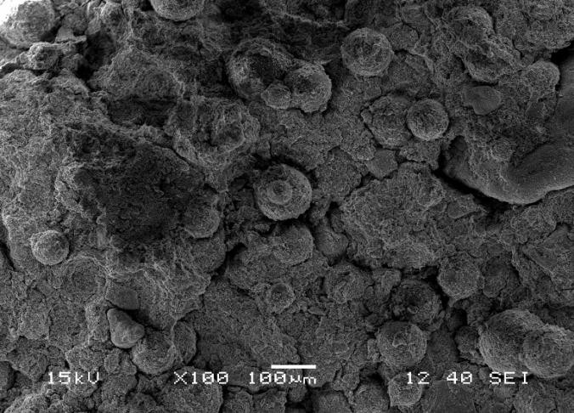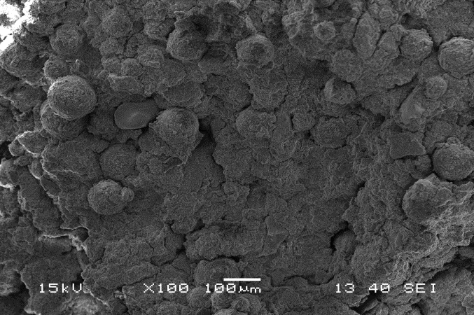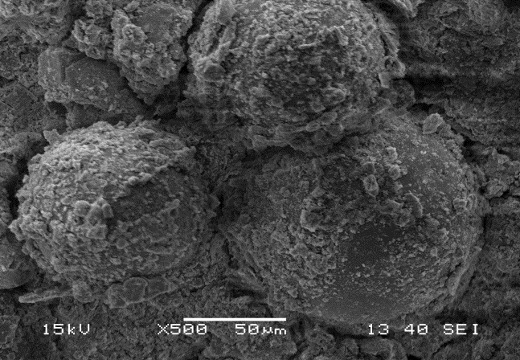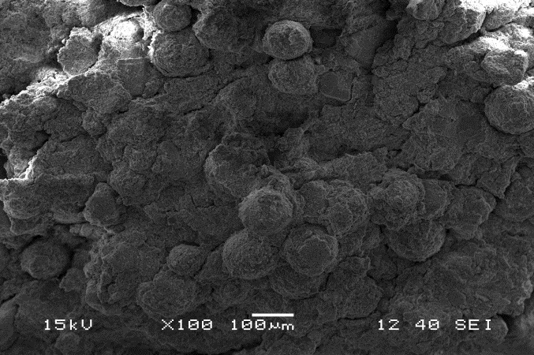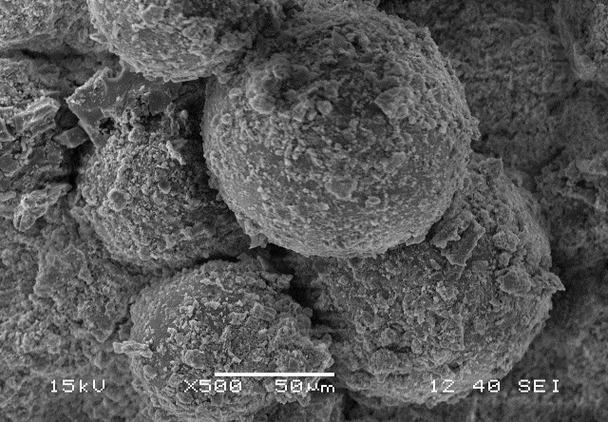

|  |  |
| --- | --- |
| **(a)** |  |
|  | |

|  |  |
| --- | --- |
| **(b)** |  |
|  | |

|  |  |
| --- | --- |
| **(c)** |  |
|  | |

|  |  |
| --- | --- |
| **(e)** |  |
|  | |

|  |  |
| --- | --- |
| **(d)** |  |
|  | |

|  |  |
| --- | --- |
| **(f)** |  |
|  | |

Fig.12 Morphology of Fly ash compacts with different composition and at different magnifications

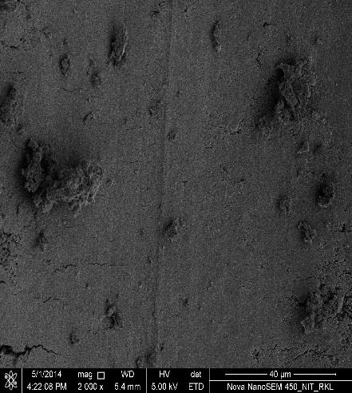

(a)

Micro Cracks

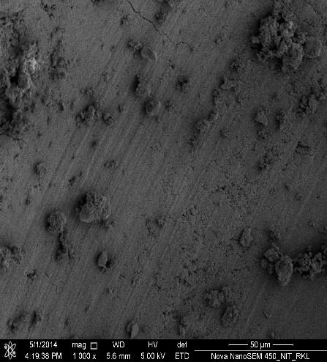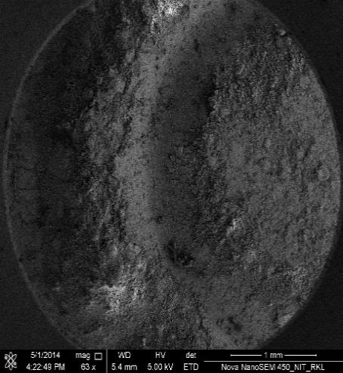

(b)

(c)

Sliding Distance

Fig. 4.13 FESEM image of wear track at different magnification

**RESULT:-**

It appears that the fly ash-resin powder composite made in this study is suitable for usage as a building material. The utilization of fly ash for value-added products will undoubtedly increase with the production of this kind of composite. Conversely, the environment will be better protected if less clay is used to make traditional clay bricks.

**CONCLUSIONS :-**

On the basis of present study following conclusion can be drawn:

* + 1. 1) The hardness levels of compacts treated with water indicate favorable benefits. FA with 85 weight percent has the highest hardness value of 44.08 HV among all dry compacts. When the composites are treated in water at 1110–1800C, a significant improvement in the hardness value is obtained; this value increased to 47.37 HV. According to XRD research, the presence of CSH and CASH in the presence of moisture is what caused the hardness value to increase..
    2. 2) The compressive strength of dry compacts drops to 6.5 MPa as the amount of polymer (resin powder) is increased. A composition of 75% FA demonstrates a lower value. Wet compact results in no appreciable decrease in compressive strength.
    3. 3) The hardness value and wear studies of various composites are easily connected. FA with an 85% weight percentage exhibits superior wear resistance compared to the other two compositions in both dry and wet conditions. As the FA content rises, wear resistance rises as well. Throughout the testing period, the co-efficient of friction exhibits a linear pattern and declines as the FA percentage rises.
    4. 4) Thermoconductive properties of FA increase as temperature rises, but the conductivity of composites made from resin powder FA mixes diminishes as temperature rises. It yields a substantially lower conductivity value, making it suitable for use as a clay alternative..
    5. Water absorption increases with increase in FA content. Maximum of 19% water is absorbed in case of 85 wt. % FA.
    6. Density of dry compacts decreases with increase in FA content. While in case of wet compacts, it increases with increase in FA content.
    7. The morphology of the mostly spherical FA particles was revealed by SEM analysis. The interface bonding improves and fewer cracks were discovered at the interfaces with a decrease in polymer addition, or an increase in FA content.

# REFERENCES

Joshi RC, Lothia RP. Fly ash in concrete: production, properties and uses. In: Advances in concrete technology, vol. 2. Gordon and Breach Science Publishers; 1999

2. Ahmaruzzaman M. A review on the utilization of fly ash. Prog Energy Combust 2010; 36:327–63.

3. Rai A.K., Paul B. and Singh G., A study on physico chemical properties of overburden dump materials from selected coal mining areas of Jharia coalfields, Jharkhand, India, Int. Journal of Environmental Sc., 1 (2011): pp. 1350-1360.

4. Sahay A.N., R&D initiatives in utilization of fly ash in coal sector, in: Proc. of Fly ash an opportunity for Mining Sector, New Delhi, India, 2010, pp. 26-35.

5. Das S.K. and Yudhbir, Geotechnical properties of low calcium and high calcium fly ash, Journal of Geotechnical and Geological Engineering, 24 (2006): pp. 249-263

6. Sinsiri T, Chindaprasirt P, Jaturapitakkul Ch. Influence of fly ash fineness and shape on the porosity and permeability of blended cement pastes. Int J Miner Metal Mat 2010; 17:683-690.

7. P.S.M. Tripathy, S.N. Mukherjee, Perspectives on Bulk Use of Fly Ash, CFRI Golden Jubilee Monograph, Allied Publishers Limited, 1997, p. 123.

8. Sidhu, Buta Singh, Singh, Harpreet, Puri D., Prakash, S., “Wear and Oxidation Behavior of Shrouded Plasma Sprayed Fly ash Coatings”, Tribology International, Volume 40, (2007), pp.800-808.

9. China Economic Trade Committee, Tenth ﬁve-year program of building materials industry, China Building Materials 7, 2001, pp. 7–10

10. P. Wouter, Energy Performance of Building: Assessment of Innovative Technologies, ENPER-TEBUC, Final Report, 2004

11. M. Anderson, G. Jackson, The history of pulverized fuel ash in brick making in Britain, J. Inst. Ceram. 86 (4) (1987) 99–135.

12. M. Anderson, G. Jackson, The beneficiation of power station coal ash and its use in heavy clay ceramics, Trans. J. Br. Ceram. Soc. 82 (2) (1983) 50–55.

13. Pofale and Deo, 2010; Kumar, 2000; Reddy and Gourav, 2011; Dry et el., 2004; Mitraet al., 2010).

14. Shenbaga, R. Kaniraj and V. Gayathri (2004), “Permeability and Consolidation Characteristics of Compacted Fly Ash”, Journal of Energy Engineering. ASCE, Vol. 130,117-211

15. ASTM C 618-08a (2008) Standard specification for coal fly ash and raw or calcined natural pozzolan for use in concrete, American Society for Testing and Materials

16. ASTM C 618-08a (2008) Standard specification for coal fly ash and raw or calcined natural pozzolan for use in concrete, American Society for Testing and Materials.

17. Jala S, Goyal D. Fly ash as a soil ameliorant for improving crop production – a review. Bioresour Technol 2006; 97(9):1136–47.

18. Sikka R, Kansal BD. Characterization of thermal power-plant fly ash for agronomic purposes and identify pollution hazards. Bioresour Technol 1994; 50:269–73

19. Matsi T, Keramidas VZ. Fly ash application on two acid soils and its effect on soil salinity, pH, B, P and on ryegrass growth and composition. Environ Pollut 1999; 104(1):107–12

20. http://flyashindia.com/properties.htm.

21. Roy WR, Thierry RG, Schuller RM, Suloway JJ. Coal fly ash: a review of the literature and proposed classification system with emphasis on environmental impacts. Environmental geology notes 96. Champaign, IL: Illinois tate Geological Survey; 1981.

22. Tolle DA, Arthur MF, Pomeroy SE. Fly ash use for agriculture and land reclamation: a critical literature review and identification of additional research needs. RP-1224-5. Columbus. Ohio: Battelle Columbus Laboratories; 1982.

23. Mattigod SV, Dhanpat R, Eary LE, Ainsworth CC. Geochemical factors controlling the mobilization of inorganic constituents from fossil fuel combustion residues: I. Review of the major elements. Journal of Environmental Quality 1990;19:188–201

24. Da Costa JCD, Prasad P, Pagan RJ. Modern environmental improvement pathways for the coal power generation industry in Australia. Process Safe Environ Protect 2004; 82(3B):191–9.

25. Matsi T, Keramidas VZ. Fly ash application on two acid soils and its effect on soil salinity, pH, B, P and on ryegrass growth and composition. Environ Pollut 1999; 104(1):107–12.

26. Pandey VC, Singh N. Impact of fly ash incorporation in soil systems. Agric, Ecosys Environ 2010; 136(1 2):16 27.

27. Pujari GK, Dash PM. Fly ash – problem and management aspect. Envis Newsl Centre Environ Stud 2006; 3(1):1–8.

28. ASTM Standard D5334-08 – Standard Test Method for Determination of Thermal Conductivity of Soil and Soft Rock by Thermal Needle Probe Procedure, doi:10.1520/D5334-08

29. Chapman TR, Niesz DE, Foxrt, Fawcett T. Wear 1999;236:81

30. Swanepoel J.C., Strydom C.A.: Utilization of fly ash in a geopolymeric material, Applied Geochemistry, vol. 17, pp. 1143-1148, (2002).

31. Fernandez-Jimenez A., Palomo A, Composition and microstructure of alkali activated fly ash binder: Effect of the activator. Cement and Concrete Research, vol. 35, pp. 1984-1992, (2005).

32. Khatri C, Rani A. Synthesis of a nano-crystalline solid acid catalyst from fly ash and its catalytic performance. Fuel. 2008; 87(13):2886–92. doi:10.1016/j.fuel.2008.04.011.

33. Saikia BJ, Parthasarthy G, Sarmah NC, Baruah GD. Fourier-transform infrared spectroscopic characterization of naturally occurring glassy fulgurites. Bull Mater Sci. 2008; 31(2):155–58