**THE TRENDS OF HERBAL NUTRACEUTICALS**

**USED IN CHRONIC DISEASE**

**Authors -** Mr. Divyesh Prashant Gahivad1, Ms. Rutuja Prashant Gahivad2,

**Guidance by -** Dr. Swapnil Dilip Deo3, Dr. Gajanan Tulshiram Daphal4,

Mr. Harshal Dipak Borse5, Mr. Nazeer Ahmed6 , Ms. Bhavna Mahajan7

**Abstract**

Nutraceuticals are a combination of the words "nutrition" and "medicine".  
In general terms, nutraceuticals are foods or parts of food that play an important role in modifying and controlling the effects of the body to protect human health. In recent years, there has been interest in nutraceuticals that have health benefits and can replace traditional medicine. Nutritious vegetables and fruits are an important part of a healthy diet. The main reasons for the growth of the global nutraceutical industry are current population and health trends. Foods used as nutraceuticals can be divided into dietary fiber, prebiotics, probiotics, polyunsaturated fatty acids, antioxidants and other plant/natural foods. The emergence of nutrients as medicines is very important in the pharmaceutical world and has attracted the attention of scientists and researchers due to their important benefits. Therefore, now this collaboration is used to craft and create different types of medicines that will make these herbs effective in their applications. Extensive research has shown that this drug plays a role in the treatment of various diseases such as cancer, arthritis, metabolic abnormality, diabetes, asthma and others. This review aims to describe all types of nutraceuticals and highlight their uses in the treatment of various diseases. The importance and challenges of using design and quantitative design data to deliver better trucks are also noted. Ultimately, they make life better and help develop new research in the field of new nutraceuticals.

**Keywords:** Nutraceuticals, Nutrition, Health Benefits, Dietary Supplements, Therapeutic Effects.

**1.Introduction**

Nutraceuticals are characterized as ‘specially designed arrangements’, formulated withthe aim of enjoyable precise nutritional necessities and/or provide preventive health care. Nutraceuticals are the system of nutrient/vitamins which enables in prevention and remedy of a few illnesses, similarly to a complement weight loss program. Nutraceutical is a term given with the aid of Dr. Stephen De Felice in 1989 and came from two words “nutrients” and “pharmaceutical”. these are meals or part of ingredients that are useful in imparting numerous health blessings which include the treatment and/or prevention of the disease. science of vitamins has an increasing number of accomplished new horizons, beginning from the anticipation of deficiencies in vitamins to prominence on human health and prevention and remedy of persistent illnesses. phrases ‘nutraceuticals’, ‘food supplements’, ‘dietary dietary supplements’ have evolved after the idea became originated by using Dr. De Felice. there is no sharp demarcation between meals supplements and nutraceuticals given by using regulatory government. Literature of latest years emphasizes on redefining the idea of nutraceuticals, thinking of the efficacy, protection and toxicity of these merchandise. food products are nourishing materials which might be eaten, under the influence of alcohol or in any other case taken to sustain existence, offer strength and sell increase. currently, isolation of vitamins from these food merchandise are nicely diagnosed and used. The place to begin to distinguish food/nutritional dietary supplements and nutraceuticals is the identity of an epidemiological goal, accompanied via safety and efficacy studies that apprehend the mechanism of movement. One technique to distinguish these two styles of formulations is describing ‘meals dietary supplements’ as marketers to compensate deficiencies in micro- or macronutrients; further, the usage of a “nutraceutical” inside the treatment of a pathological disease have to be supported by using sturdy clinical proof [1]. With good enough clinical proof, nutritional dietary supplements must have a sturdy safety profile with few undesirable aspect consequences and better bioavailability. there may be a totally fine line of demarcation among sort of formulations: the same ingredients may fit as a nutraceutical or meals supplement, but may be demarcated on the basis of claims. Nutraceuticals encompass single or mixtures of seasoned- and pre-biotic nutrients and food for unique scientific uses; and food dietary supplements includes single or combos of mineral, nutrients, protein dietary supplements, useful ingredients and herbal merchandise. with the aid of prolonging or eliminating the need for pharmaceuticals in subjects to match for an alternative nonpharmacological remedy to a pathological condition, the incorporation of nutraceuticals into every day food regimen might also resource inside the prevention of pathological problems[2]. There are claims that meals such as spices and herbs own the tendency to lower the danger of many sicknesses and can be enormously beneficial in improving the best of lifestylesthere may be a plethora of advantages that nutraceuticals have provided, which includes their promising outcomes within the prevention and remedy of complex sicknesses. however, there may be a want of administration and prescription of nutraceuticals and they need to be strictly regulated which will save you their uncontrollable use and side results [3]. numerous researchers have studied drug compound-based totally nutraceuticals to improve the efficacy in addition to bioavailability. The protection and efficacy of diverse statins were used inside the prevention of cardiovascular illnesses even in pregnant ladies. Nutraceuticals with an powerful protection profile and nicely-hooked up impact onpregnancy might be a suitable therapeutic choice for preventing diabetes mellitus and hypertensive problems, or as an adjuvant to therapy with trendy medicines. Calcium, omega-three polyunsaturated fatty acids, vitamin D, folic acid, resveratrol, alpha-lipoic acid, zinc, inositol, and probiotic dietary supplements are probably validated applicants as novel nutraceuticals [4]. Researchers have evaluated the nutraceutical related to the drug compound ezetimibe for patients atrisk of elevations of statin degree, which similarly ends in cardiovascular illnesses [5]. the usage of a unique nutraceutical in blend with non-steroidal anti inflammatory drugs (NSAIDs) has been verified a potential candidate for osteoarthritis, accordingly improving its efficacy and safety for industrial use [6].  
The market remains robust and ever-growing for nutraceuticals together with antioxidants; omega-three fatty acids; flowers such asalgae, aloe vera, seaweed, and wheatgrass; teas and herbs such asginseng and Echinacea. an in depth findings which include medical information on nutraceuticals are shown in desk 1 [7,8]. A recent survey cautioned that the nutraceutical market is increasing globally and the probability states that it may reach up to $340 billion with the aid of the yr 2024. The compound annual increase rate (CAGR) of nutraceuticals is expected to be 7.2% inside the yr 2016 to 2024. This increment in the increase of the nutraceuticals-primarily based industry is associated with different factors which include a upward push in call for for nutraceuticals, an focus among human beings for the advantages of nutrition and an incremental charge found inside the healthcare graph [9,10]. currently, Europe, u.s. and Japan account for ˃ninety% of the overall international nutraceutical market and the worldwide marketplace is supposed to attain $336 billion with the aid of 2023 from $247 billion in 2019 at a CAGR of eight%. With this attainment of maturity of worldwide markets, now the point of interest of nutraceutical players has been shifted closer to growing economies, particularly the ones throughout Asia Pacific, such as India. TheIndian market had simplest 2% market proportion of general international nutraceutical marketplace in 2017. it's miles predicted to attain $eleven billion by 2023, growing at a CAGR of 21%. through 2023, India is likewise anticipated to preserve at least three.five% marketplace proportion of the worldwide market[11,12].

**2.Concept Of Nutracueticals**

During drug development, clinical trials must be conducted for tests and research on animals and their therapeutic effects must be confirmed. But when it comes to food, there is no proven way for food to prevent disease. However, in recent years, it has been scientifically proven that food ingredients cause lifestylerelated diseases and has become a problem in society. These foods are known to have health benefits such as reducing the risk of cancer and heart disease, and may also prevent or treat high blood pressure, high cholesterol, excess weight, osteoporosis, diabetes, arthritis, macular degeneration (which causes blindness). , cataracts, menopausal symptoms, insomnia, memory and concentration problems, work, indigestion and constipation, not to mention headaches; Other products are touted as a treatment against hair loss due to lack of self-confidence. The concept of nutraceuticals for weak skin, varicose veins, alcoholism, depression and lethargy began to be seen as one of the measures for the prevention of these diseases[13-15].

PHARMACEUTICAL REMEDY FOR SICKNESS/INJURY

NUTRION REQUIRED FOR HEALTH

NUTRACEUTICALS PREVENTATIVE MEDICAL APPROACH

**Fig:1 Concept of Nutraceuticals**

**3.Nutraceuticals Growth**

Nutraceuticals and functional foods have become a multibillion dollar business in the global economy. Globally, the growth of this activity is limited by the need to accurately label and measure the healthfulness of foods and processed foods. The United States (US) currently has the largest and fastest growing food and beverage market in the world. India is home to many types of herbs, spices and herbs and has a large market[16]. However, India's main export destinations are the United States and Japan.The growth of the global food industry is shown in Figure 2. Different research groups and various government agencies have advanced the benefits of food and food services in the public sector. Being aware of changes in food and nutraceutical ingredients will provide the business with customers a variety of new products that can be created for specific markets[17].

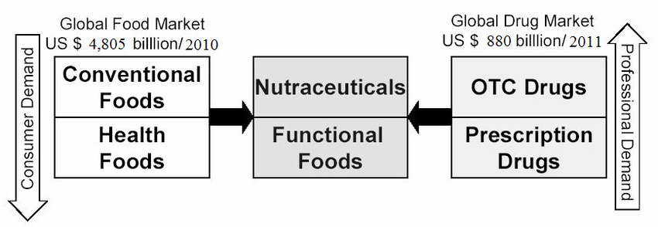

**4.Nutraceuticals in Various Diseases**

Nutraceuticals help improve health, wellbeing and modify the immune system, thus preventing and treating many diseases and health problems[18] There are many diseases that

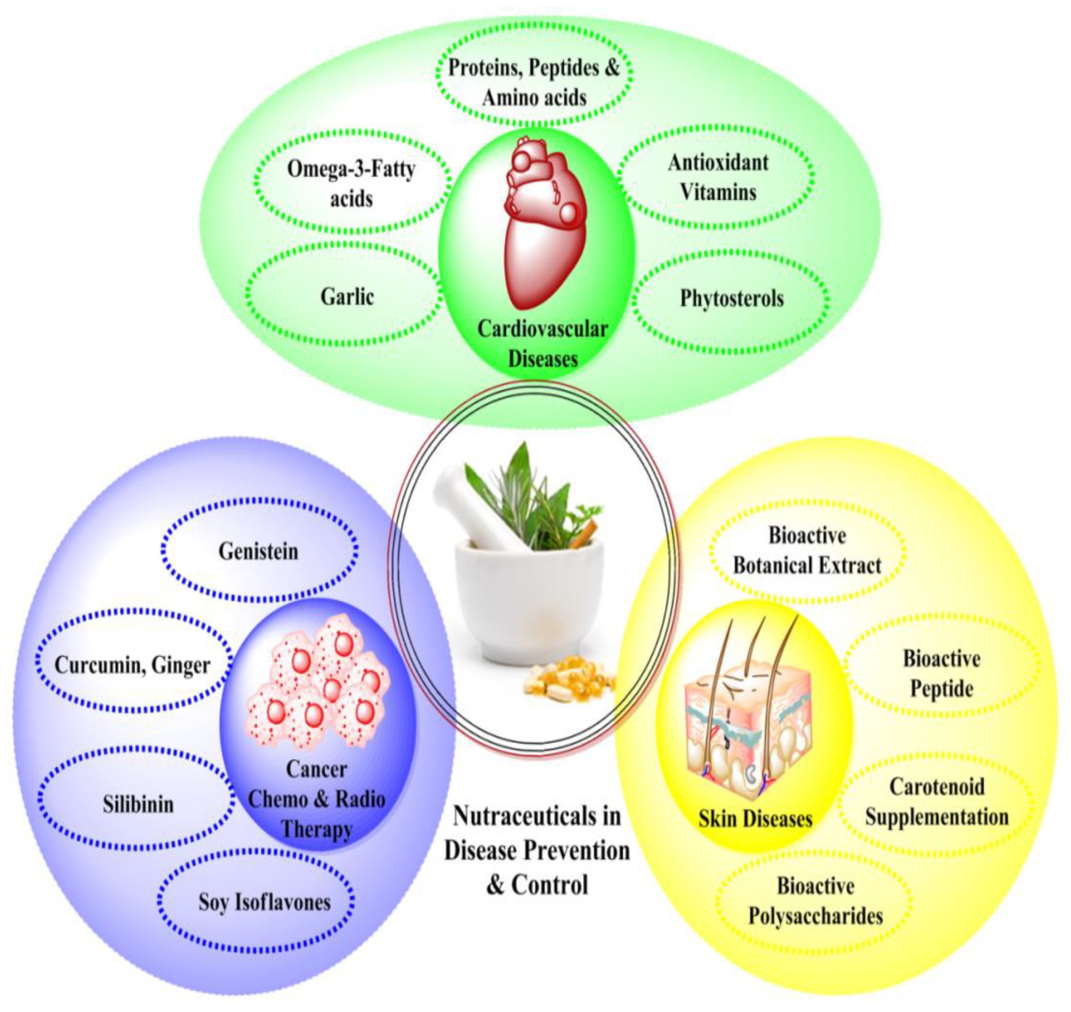

**Fig:2 Nutraceuticals and Dietary Supplements in various diseases.**

**4.1 Nutraceuticals in Cardiovascular Diseases**

Among all other diseases, cardiovascular diseases have a significant impact on the effect of a particular diet. There is significant evidence for the use of nutraceuticals in the treatment of cardiovascular disease[19-20].  
Cardiovascular disease (CVD) mainly affects blood vessels and heart function. CVD is one of the leading causes of death, accounting for approximately 30% of deaths worldwide each year[21]. Food products have been shown to be effective in risk management and prevention of cardiovascular diseases and can be classified as drugs used to treat cardiac arrhythmias , congestive heart failure , angina [22] and hypertension , and hyperlipidemia[23]. Some nutraceuticals and nutritional supplements used to treat and prevent heart disease are discussed below.

**4.1.1. Allicin and Alliin**

Ischemic heart disease and atherosclerosis are associated with increased levels of plasma triglycerides and cholesterol in the blood. Garlic has a hypolipidemic effect mainly by removing excess cholesterol and its end products from the feces and reducing endogenous cholesterol synthesis[24]. This helps create a better HDL/LDL ratio. Allicin and alliin may affect cholesterol levels if inhibited by stomach acid. The effect of garlic supplementation on blood cholesterol was evaluated using 13 placebocontrolled studies involving 781 patients. In addition to lowering blood lipids, garlic also has some blood pressure-lowering properties[25-26].

**4.1.2. Omega-3Fatty Acids**

Omega3 fatty acids are obtained from the oceans and are called polyunsaturated fatty acids (PUFA). Docosahexaenoic acid (DHA) and marine omega-3 eicosapentaenoic acid (EPA) play an important role in treating and preventing heart disease. One study reported that fish oil consumption reduced mortality rates by 29% over 2 years in the Diet and Research Study (DART), which included 2,033 patients after myocardial infarction. Randomized study in men. Fish oil consumption reduced deaths by 45%, cardiovascular disease by 30%, and allcause mortality by 20%. According to a recent clinical study, omega3 fatty acids may reduce the risk of heart arrhythmias and also improve the health of patients with atherosclerotic plaques. Omega-3 fatty acids improve the electrical stability of heart cells, thus prolonging their relative unresponsiveness and helping to treat cardiac arrhythmias[27-28].

**4.1.3. Soy Isoflavones**

Soy protein and liquid isoflavones are important nutrients supporting the biology of collaborative rationality analysis, with therapeutic potential such as hypolipidemic, hypotensive, hypoglycemic, antioxidant, anticancer, anti-inflammatory, anti-obesity and neuroprotective activities. Clinical trial data shows that consuming liquid protein can reduce cholesterol in humans [29]. Additionally, the U.S. Food and Drug Administration has proven that eating 25 grams of soy protein or isoflavones per day can lower blood pressure in postmenopausal women. Additionally, soy protein has a positive effect on blood lipid concentration, especially in patients with hypercholesterolemia. One study found that people who ate a diet low in saturated fat had a reduced risk of heart disease. Soy isoflavones do not affect blood lipids [30]. Additionally, one study reported a reduction in the ratio of LDL to HDL after consuming fresh soy sauce, which contains high levels of isoflavones, cotyledonary soy fiber, and soy phospholipids[31].

**4.1.4. Proteins, Peptides and Amino Acids**

High blood pressure is associated with heart disease. ACE (angiotensin converting enzyme) inhibitors have been the mainstay in the treatment of this disease, but these drugs can cause side effects such as hypotension, increased potassium levels and renal failure, work, cough and rash [32]. Natural ACE inhibitors are found in casein and whey proteins found in milk. Animal studies have also proven that the proteins obtained from this milk have an antihypertensive effect. Clinical studies have reported the same; Statistically significant blood pressure lowering effects were observed[33].

**4.1.5. Antioxidant Vitamins**

Antioxidants are used as supplements for chronic diseases such as heart disease and cancer. They reduce the oxidation of LDL cholesterol by preventing the damage of free radicals. Vegetables, fruits, fish and fixed oils contain many antioxidant vitamins that work to prevent the production of free radicals or capture free radicals. Various epidemiological studies in patients with heart disease have shown that a diet rich in antioxidants reduces morbidity and mortality. Supplements containing vitamins C and E may help prevent heart disease. However, beta-carotene supplementation may have side effects and is not recommended. The National Health and Nutrition Examination SurveyI Cohort Study found that consuming vitamin C may reduce the risk of heart disease; This is a survey of men and women aged 25.74 in the US country, including over 10 years and more. 50 things. Different combinations of 10 nutritional supplements were randomly used over the years[34].

**4.1.6. Phytosterols**

Phytosterols are similar to cholesterol. They tend to compete for absorption from the small intestine. It is found in vegetable oils, seeds, nuts, grains, wood pulp, etc[35]. They are found. Consumption of plant sterols increases the absorption of LDL by the liver, lowers LDL levels in the blood and reduces cholesterol absorption. Studies have shown that the use of plant sterols[36]. can reduce LDL by up to 15% Phytosterols are obtained from natural grains such as apples, sunflowers and corn. Many studies have shown that consuming 2,3 grams of plant sterols/stanols per day can reduce LDL cholesterol by up to 20%; Although there are many individual differences[37].

**4.2. Nutraceuticals in Cancer Chemo- and Radiotherapy**

Radiotherapy and chemotherapy are cancer treatments but are associated with serious side effects and many complications (such as pain, fatigue, diarrhea, vomiting, nausea, and hair loss)[38-39] Some tumors are very resistant to chemotherapy and radiation therapy, and therefore cytotoxic chemotherapy and radiotherapy are less effective in ensuring patient survival[40,41] . In this case, combining various treatments to create a good way to treat cancer. Likewise, there are many herbs and natural remedies that reduce the side effects of radiation and chemotherapy. Therefore, these drugs must be used together with radiotherapy or chemotherapy to reduce side effects and improve treatment. The growth of cancercausing cells creates the need for treatment, and the nutraceutical industry is constantly evolving to meet consumer needs. It can be said that the development of the nutraceutical industry started with health promotion and has now reached disease prevention. Many plants and phytochemicals currently in use have been shown to be pharmacologically safe and to be effective nutraceuticals in inhibiting tumor growth, reducing the side effects of radiation and chemotherapy, and increasing sensitivity to these treatments. Caponio and his team evaluated the effects of phenolic compounds found in Aglianico fruit pulp (GP) on colon cancer cells at different stages of development after application to in vitro digestion models. Aglianico GP extract has been shown to have a positive effect on cell proliferation and apoptosis, as well as other cellular processes. A significant increase in Bax, as well as Bax/Bcl-2 ratio and caspase-3, was observed in HT29 and SW480 cells. UHPLCDAD analysis showed that anthocyanins, phenolic acids and flavonoids were mainly responsible for the increase of TPC (total phenolic content) and antioxidant activity in Aglianico GP digestive extract In 2021, Zhang and colleagues studied the combination of chrysin and apigenin in colon cancer by inhibiting the activity of the P38MAPK/AKT pathway. Apigenin and chrysin, both at 25 μM, inhibited clone number, migration, and invasion while increasing apoptosis in two human breast cancer (CRC) cell lines. Additionally, chrysin and apigenin inhibited p-P38 and p-AKT. Anisomycin is a P38 agonist that can reduce the production of the tumor suppressors apigenin and chrysin. Apigenin (25 µM) and chrysin (25 µM) work synergistically to suppress CRC cell proliferation and metastasis by inhibiting the P38-MAPK/AKT pathway.

**4.2.1. Curcumin (Diferuloyl-Methane) from Turmeric (Curcuma Longa)**

Curcumin has been classified as an important nutrient for cancer treatment. Preclinical studies of curcumin have shown that it can inhibit the carcinogenesis of various types of cancer, such as pancreatic, gastric, prostate, gastric, and liver cancer; it can also affect all steps such as angiogenesis, metastasis and proliferation. Cancer treatment is more effective when combined with chemotherapy and radiation therapy[42].

**4.2.2. Ginger**

Ginger is an antibacterial, antifungal and antiinflammatory nutraceutical that can reduce the side effects of radiation and antibiotics. It is the properties of ginger that are beneficial to the immune system. It has been reported that the morphine dose in cancer patients is reduced with the help of ginsenoside Rf and ginseng, whose polysaccharides help reduce the side effects of cancer treatment and have been shown to reduce the risk of cancer by 50% less risk in the recurrence of cancer[43].

**4.2.3. Genistein**

Genistein is a powerful isoflavone with good anti-cancer properties. In vitro studies have shown that some components can exert anti-inflammatory effects only at higher concentrations, and this cannot be achieved with a healthy diet. Therefore, it is difficult to obtain the desired results at the tumor site, which suggests to us that it is very important to consider the delivery method in in vivo research and clinical trials. The nontoxicity of natural ingredients is very important for proper treatment. However, some medications have been shown to be more effective when taken early in life, and cytisine is one of them[44].

**4.3. Nutraceuticals in the Treatment of Prostate Cancer (PCa)**

Prostate cancer is the most common type of cancer and is listed as the second leading cause of cancer among men in the United States. Men from the United States and Africa have been noted to have the highest cancer death rate compared to men of European descent. Although current treatment strategies are effective, there is always resistance to the disease and progression to metastasis, and more may occur over time. Therefore, a better and nontoxic treatment is needed to overcome these major problems and ensure proper control and treatment of this disease. Therefore, in this context, many potential safe nutraceuticals may be helpful as drugs against prostate cancer. Frankly speaking, the use of nutraceuticals may have the potential to improve the accuracy of drug production, reduce the risk of toxicity, reduce the resistance of bacteria, and treat local diseases and high levels[45].

**4.3.1. Silibinin**

Silybin, a flavanolignan derived from the seeds of milk thistle Silybummarianum, has antiinflammatory properties that protect against various cancers, including PCa. Preclinical animal models have demonstrated that silibinin has important functions in the treatment of prostate cancer, and bioavailability studies have also been evaluated in phase II clinical trials. Larger clinical studies are still needed to confirm the biological activity and efficacy of silibinin as a nutritional supplement for the clinical management of advanced or localized PC.

**4.3.2.Soy Isoflavones**

Soy isoflavones are members of the polyphenolic flavonoid family commonly found in soybeans, red clover, kudzu, etc. and are widely used in Asian and African cuisines. Clinical studies have proven that liquid isoflavones show some effect on prostate cancer due to having a significant effect on inflammation issues and insulin. In addition, isoflavones have also been reported to release antiinflammatory properties in the blood of asymptomatic patients with biochemically relapsed PCa. High plasma genistein levels were found to be associated with a 69% lower risk of future PCa in Chinese patients. Isoflavones exert inhibitory effects on prostate tumor cell cycles when administered for as short a period as six weeks and have also been shown to be associated with apoptosis; but their effects on testosterone, PSA, free testosterone in prostate cancer patients, and others. Cholesterol levels are useless. A 6month clinical study showed that liquid protein intervention did not affect the ratio of EGFR, Bax:Bcl-2, and Bax:PCNA, molecular markers that determine growth and apoptosis in patients with low-risk PCa. In contrast, ingestion of soy proteins (alcohol-washed) reduced tissue levels of Bax and PCNA compared to patients treated with cow's milk protein

**4.4 Nutraceuticals For Skin Treatment**

As we all know, skin is the largest organ of the human body and provides protection against many diseases, UV rays and chemicals that can cause sensitivity. Since the skin plays an important role in the body's defense, it will face changes in immunity, photovoltaic, inflammation, etc., and therefore the same will pose a danger to human health. Potential strategies may be found to delay or reduce premature skin aging and reduce skin diseases with the help of nutraceuticals. Nutraceuticals include bioactive peptides, bioactive polysaccharides, plant extracts, carotenoids, etc. it could be. Additionally, these products have been shown in many human trials to reduce signs of aging and also protect against UV rays[46].

**4.4.1 Bio- Active Polyssacharides**

These are glycopolymers that store energy and have a functional structure. They are found in life forms such as plants, fungi, animals and prokaryotes and have different monosaccharide combinations, physicochemical properties and structures. For nutraceuticals, the most important ones are glycosaminoglycans derived from the sea. Its basic units are non-disaccharide (repeating) amino sugar units (called N-acetylglucosamine or Nacetylgalactosamine) and uronic acid (called glucuronic acid or idose aldehydes). The process, which involves these ingredients, which include glycosaminoglycans as well as some proteins, has been tested in humans using Imedeen® DermOne® as a nutritional product for skin care. Apart from protein, the supplement also contains zinc gluconate and vitamin C, which affect skin care. In the experiment, 10 women were treated with 500 mg of Imedeen® for 90 days. Tests are dryness, brittleness, wrinkles and blemishes in hair and nails. After 90 days, all these symptoms resolved and skin thickening and elasticity were observed.

**4.4.2 Bio-Active Botanical Extracts**

These are natural pigments found in algae, photosynthetic organisms and many plants. They have a linear tetraterpene structure. They are found in places like fruits and vegetables. α-carotene, β-carotene, β-cryptoxanthin, lutein, zeaxanthin and lycopene are the most commonly used carotenoids. These carotenoids are used in skin health applications such as antiaging and skin protection. Probiotics and carotenoids have been reported to reduce skin damage from UV exposure and modulate early skin biomarkers of UV effects. The carotenoid compounds alpha-carotene, beta-carotene, and lutein have been shown to have photoprotective effects. Similarly, a combination of the carotenoids betacarotene, lutein, and lycopene has been reported to prevent erythema. The photoprotective effects of vitamins C and E have been investigated and found to be beneficial in skin care. Vitamin C is a hydrophilic vitamin that is often consumed in large amounts from various foods to prevent the formation of carcinogenic nitrous metabolites. It acts as a cofactor for the synthesis of collagen fibers and inhibits the biosynthesis of elastin in fibroblasts thereby preventing its accumulation.

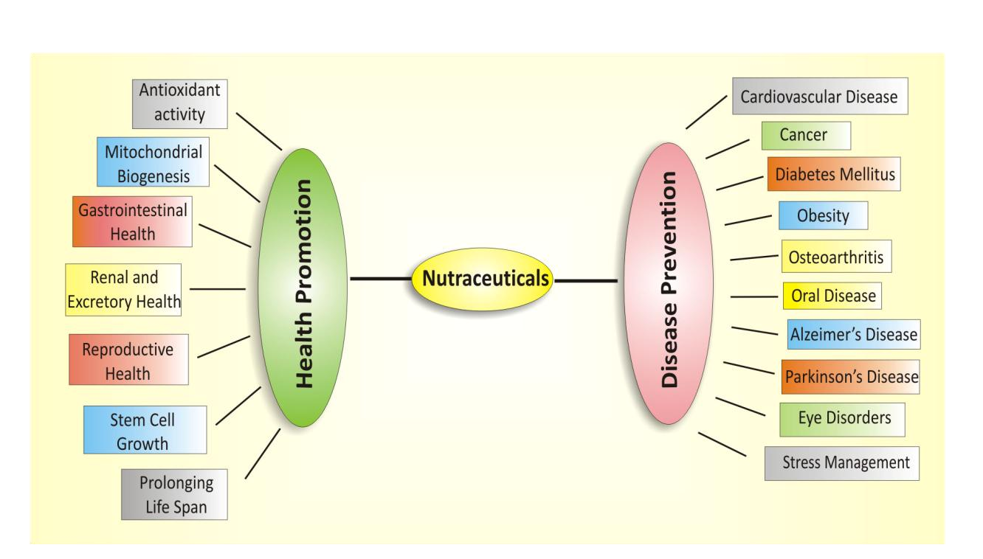

**Fig:3 Role of nutraceuticals in disease prevention and health promotion.**

**5.CLASSIFICATION**

1.Traditional

* Chemicals constituents Nutrients, Herbals, Phytochemicals.
* Probiotic Organisms.
* Nutraceutical enzyme.

2. Non Traditional

* Fortified nutaceuticals.
* Recombinant Nutraceuticals

3. Substance with established nutrional functions

* Vitamins, Minerals, Amino acid, Fatty acids.

4. Herbs (or)Botanical products

5.Reagents derived from other sources

* Pyruvate, Chondroitin sulphate, Steroid hormone precursors

6. Functional foods

7. Probiotics and prebiotics

8. polyunsaturated fatty acids

9. Antioxidant Vitamin

10. Polyphenols

11. Spices

**TRADITIONAL NUTRACEUTICALS**

This category includes foods that have not been modified by hand.  
These ingredients are natural and may be beneficial for health. Lycopene is obtained from tomatoes, red fruits, guava, papaya, orange, and its benefits and antioxidant activity prevent the formation of tumors (especially prostate, bladder, cervix, leukemia).

**NON TRADITIONAL NUTRACEUTICALS**

These types of foods improve nutrition by adding nutrients to foods to improve nutritional quality[47]. For example: Carrots are the benefits of βcarotene obtained from various fruits and vegetables, carrots, oranges, tangerines, it has antioxidant activity, can be effective against free radicals and protect the cornea from damage caused by ultraviolet rays,  
Antioxidants are anti-carcinogenic and anti-cancer.

**Fortified Nutraceuticals**

Fortification of food ingredients is the process of adding micronutrients (essential elements and vitamins) to foods to improve performance and nutrition. Examples include milk fortified with cholecalciferol for the treatment of vitamin D deficiency.

**Recombinant Nutrceticals**

It involves the use of biotechnology and genetic engineering in the production of fortified foods such as yogurt and cheese, or the extraction of bioactive ingredients by enzyme or fermentation technology. Golden kiwi has been genetically modified to be rich in ascorbic acid, carotenoids, lutein and zeaxanthin. For example: Lutein is derived from corn, avocado, egg yolk and spinach and has anti-cancer properties[48].

**SUBSTANCE WITH ESTABLISHED NUTRITIONAL FUNCTIONS**

**Vitamin**

Many vitamins are important for maintaining metabolism and health.  
Any type of vitamin deficiency can cause significant symptoms. Therefore, most nutraceutical or health food products contain some vitamins such as vitamin A, vitamin B, vitamin C, vitamin D and vitamin E.  
Most vitamins are from food plants that humans depend on for survival. and plant biotechnology, used to increase the vitamin content in plants.

**Minerals**

Mineral elements such as Ca, I, Zn, Fe, Mn, Mg are important elements for human health. Deficiency of these nutrients can cause serious health problems. Calcium, zinc, iron and other minerals in your diet come from meat and plant foods. For various reasons, nutritional deficiencies, especially calcium, zinc and iron deficiencies, are a major health problem in developing countries, especially for infants and children. However  
consuming more calcium, iron and zinc in plant foods is an important strategy to improve nutrition[49].

**HERBS (OR) BOTANICAL PRODUCTS**

Herbs (or) botanical products are available as concentrates and extracts. Medicinal plants are as old as human civilization and provide a complete set of treatments for acute and chronic diseases. India has the oldest written form of medicine called Ayurveda, which has many methods to achieve healing. Many nutraceuticals are found in the main components of plants.

**REAGENTS DERIVED FROM OTHER SOURCES**

**Glucosamine and Chondroitin**

Glucosamine is the precursor to molecules called glycosaminoglycans, which are used in cartilage formation and repair. SourceBovine or calf cartilage Glucosamine sulfate  
is used as a first-line treatment for arthritis in many European countries. Glucosamine sulfate stimulates the production of hyaluronic acid in joint fluid. Hyaluronic acid reduces inflammation and increases cartilage mobility. In vitro experiments with glucosamine showed that the proteoglycan dose increased after administration. It is usually sold as the hydrochloride or sulfate salt. Both compounds have anti-inflammatory properties.  
Combination of Glucosamine and Chondroitin is available. Chondroitin is the most abundant glycosaminoglycan in cartilage and is responsible for its flexibility.

**Flavonoids**

The major dynamic Nutraceutical fixings in plants are flavonoids. As is ordinary for phenoliccompounds, they have antioxidant, antimicrobial, antibacterial, antiviral and antifungal, antiulcer, hepatoprotective, anti-inflammatory, anti-diabetic, vasorelaxant, anti-atherosclerotic,antithrombogenic, cardio defensive and anti-neoplastic exercises in expansion to their significant  
effects on the central anxious framework[50].

**Dietary Supplements and Dietary Fibers**

A dietary supplement may be a item which comprises a supplementary dietary fixing includedas a cure to lacks or maladies. The slant toward dietary supplements has raisedmany folds to progress wellbeing, wellness, tonic to delay maturing, make strides execution, and bodybuilding. A dietary fixing is one which upgrades the nourishment and its wholesome evaluation.Vitamins and minerals as dietary supplements exist in multiple fixings or singleingredient items within the market[51]. Dietary supplements other than vitamins and minerals  
also include herb, botanicals, amino acids, immaculate extricates, concentrate or combination ofnumber of fixings organ extricates, and organ tissues. It isn't assumed to be utilized astraditional or ordinary nourishment component or as the customary thing within the suppers or diet[52]. Dietary fibers and tall fiber items are of extraordinary intrigued since of critical wellbeing benefits.

**Phytochemicals**

Phytochemicals are too nutraceuticals and within the display communication they give  
medical and wellbeing benefits. Glucose and affront controls are critical highlights of  
phytochemicals and there are interesting reappraisals of conventional treatment of diabetes.Actually, more than 1000 plants have been claimed to other extraordinary benefits within the treatment  
of diabetes, few have gotten logical examinations. In expansion, the dietary, tonic, and  
medicinal properties of mushrooms have been recognized for a long time restorative valueslike antitumor, antiviral and hypolipidemic impacts have been emphasized. Lentinan upgradeshost resistance against diseases with microscopic organisms as well as parasites, parasites, and infections,including the specialist of Helps.

**FUNCTIONAL OF FOODS**

Useful nourishments are the source of completely vital supplements giving more than thequantities required for support, development, and development. The course of usefulfood incorporates numerous assist subclasses such as cereals, vegetables, and matured nourishment. Thepotentiality of the utilitarian nourishment counting cereals such as rice, corn, wheat, millets,  
sorghum, and buckwheat has been found in numerous ways to dispense with the chance of coronary heartdisease, tumor frequency, and bringing down of blood pressure. Kidney beans, part beans,chickpeas, lentils, and soybeans have been investigated to have significant antioxidant andprotective impact against cardiovascular infections and diabetes. In expansion, chocolate has  
also been found to be a subclass of useful nourishment which could be a wealthiest source of proteins,calcium, press, magnesium, and riboflavin. Citrus natural products are another sort of utilitarianfood which has as of now been detailed to deliver helpful impacts as anticancer, antiviral,  
antioxidant specialists, and encourage have potential to invigorate safe system. The maturedmilk and related items are too the illustration of a useful nourishment which offers gooddigestive impacts. For occurrence, Yoghurt could be a exceedingly nutritive aged nourishment related with  
the anticancer action; it has moreover been detailed to avoid gastrointestinal diseases and atherosclerosis. It is suggested for lactose narrow minded patients[53].

**PROBIOTICS AND PREBIOTICS**

Probiotic category incorporates the live microbial nourishment fixings which are beneficial to health. Their activity incorporates grip to gastrointestinal tract at particular destinations and their survival lead to disposal of pathogens. Prebiotic category incorporates specifically fermented fixings or a fiber that advance changes in gastrointestinal micro flora and its activity giving great impacts to the wellbeing of have. They are the fertilizing specialists for the  
probiotic microbes in colon. These are not influenced by gastric pH and stomach related acids. The example incorporates affront which on encourage hydrolysis gives oligo fructose and galacto oligosaccharide[54]

**POLY UNSATURATED FATTY ACIDS**

The gather of poly-unsaturated greasy acids (PUFAs) is isolated into two bunches: omega-3 (n-3)and omega-6 (n-6) polyunsaturated greasy acids (PUFA), varying within the position where the first twofold C-bound is found. Two PUFAs are called basic greasy acids since they can not be synthesized within the human body and are imperative for physiological judgment. In this manner, they  
must be gotten from the eat less.

**ANTI-OXIDANT**

Harm to cells caused by free radicals is accepted to play a central part within the maturing prepareand in infection movement. Cancer prevention agents are our to begin with line of defense against free radicaldamage, and are basic for keeping up ideal health and wellbeing. Oxygen could be a exceedingly  
reactive molecule that's competent of getting to be portion of possibly harming atoms commonlycalled free radicals. Free radicals are able of assaulting the solid cells of the body ,causing them to lose their structure and work. Cancer prevention agents are able of stabilizing, order activating, free radicals some time recently they assault cells. Cancer prevention agents are completely basic formaintaining ideal cellular and systemic wellbeing and well-being. People have advanced a highly advanced and complex antioxidant assurance framework. It includes a assortment of components, both endogenous and exogenous in beginning, that work intelligence and  
synergistically to neutralize free radicals.

**POLYPHENOLS**

Polyphenols are phytochemical compounds found in foods such as fruits, vegetables, whole grains, cereals, legumes, tea, coffee, wine and cocoa; More than 8,000 polyphenolic compounds have been identified in all food plants, such as phenolic acids and flavonoids. . These compounds are secondary metabolites of plants that provide protection against UV rays, oxidants and bacteria. Polyphenols can be divided into various groups according to the number of phenolic rings and the structure connecting these rings. Phenolic acids constitute approximately one third of the polyphenolic compounds in the diet and include two main groups: a) hydroxybenzoic acid derivatives (protocatechuic acid, gallic acid, phydroxybenzoic acid) and b) hydroxycinnamic acid derivatives (Caffeic acid), chlorogenic acid, coumaric acid, ferulic acid, sinapic acid); Fruits, kiwi, cherries, apples, pears, chicory and coffee are foods that contain phenolic acid.

**SPICES**

Spices are aromatic substances that can be found whole, broken or ground; Its main function in foods is to provide flavor rather than nutrition. The content of these spices gives foods their own taste, aroma and spiciness. Aromatic oils are responsible for aroma and flavor, and oleoresins are responsible for spiciness. Apart from food and spices, spices are widely used in domestic medicine, medicine, nutraceuticals, aromatherapy, preservatives, beverages, natural colorants, perfumes, dental preparations, cosmetics and botanicals, and therefore play an important role in pesticides. Economy. as a country. This product is attributed to many chemicals synthesized in the spice.  
Certain herbs such as turmeric, red pepper, black pepper, clove, ginger, garlic, coriander, rosemary, saffron and cinnamon have been shown to increase their activity against neurodegenerative diseases.

**6.RATIONALE FOR USE OF NUTRACEUTICALS**

Nutrition plays an important role in the early onset of chronic diseases, disease progression, morbidity and mortality. Conventional medicine is not part of nutraceuticals.  
Specialty food products are specially designed or engineered to meet special nutritional requirements arising from physical or physiological conditions or certain diseases. These are presented as follows; The nutritional content of these foods should be different from the Indian Standard (IS) composition of similar food products**.**

**7.APPLICATIONS OF NUTRACEUTICALS IN DISEASE MANAGEMENT**

Extensive research has shown that nutraceuticals can be used to treat many conditions such as insomnia, digestive problems, abnormal blood pressure, cold and cough, depression, slow digestion, and many more. Nutraceuticals are now considered beneficial for heart disease, obesity, diabetes, cancer, osteoporosis, and other chronic and degenerative diseases such as Parkinson's disease and Alzheimer's disease. There is evidence for the effects of natural products on many biological processes, including activation of antioxidant protection, signal transduction, gene expression associated with cell survival, cell proliferation and differentiation, and cell protection.Mitochondrial integrity.  This product seems to play an important role in preventing many agerelated diseases or pathologies of chronic diseases.

**8.FDA MODERNIZATION ACT**

The Food and Drug Administration Modernization Act of 1997 (FDAMA) provides nutraceutical manufacturers with a variety of options to balance the balance of FDA regulatory approval of medical products, allowing them to obtain benefits. protect public health.

**9.FUTURE ISSUE AND PROPOSALS**

Change in the lifestyle can prevent the diseases like metabolic syndromes. One of the solutions in the lifestyle change is changes in their diet. The key issues for Nutraceuticals are;

• Establishment of scientific assessment standard for prevention of diseases

• Establishment of assessment system for disease prevention by human trials.

• Establishment of seamless system to transfer stage from basic research to industrialization.

Nutraceuticals don't have to be just one ingredient; Therefore, the need for protection may arise from the action of various ingredients present in the product, making it necessary to compare the protection of different types of food.Therefore, biomarker research is necessary to prevent diseases.  
Therefore, it is still necessary to clarify the measurement of biomarkers and model the measurement.

**10.Conclusions**

Nutraceuticals are derived from plants and are known to provide health benefits, including the prevention or treatment of diseases. The market for herbal nutraceuticals has grown all over the world in the last few years, including India, due to its obvious medicinal properties and public interest in exercise, muscle and body shaping. This review provides information on the herbal properties of nutraceuticals obtained from various medicinal herbs/plants and various methods for their extraction and purification. The main elements of these compounds are discussed and aloe vera, fennel, bay, coriander, dill, holy basil, thyme, saffron, sage, etc., which have a significant portion of the bioactive substances that make them work. There are medicinal plants. capacity. The biological activity of the material of this activity is that many different extraction methods are used to get good results, allowing these compounds to get good results. Extraction methods range from Soxhlet extraction to cuttingedge technologies such as supercritical fluid extraction, microwaveassisted extraction, and others. The principles can be preserved by selecting the appropriate extraction process and subsequent purification of the bioactive material of interest. These concepts are discussed in detail. The global nutraceutical industry continues to grow and is expected to reach $561 billion or more in the coming years. Since the Indian economy accounts for only 2% of the world market, it is necessary to increase production to meet the growing demand. Herbal nutraceuticals prevent cancer, diabetes, obesity, high blood pressure, etc. It helps improve and maintain the quality of life by solving problems related to various human diseases such as. There are many types of herbal supplements on the market, so it is important to understand their advantages and disadvantages. In this context, future studies should focus on determining the therapeutic effects of different bioactive compounds in plants, as well as investigating strategies to identify and minimize these effects associated with herbal nutraceuticals.

**Reference**

1. Santini A., Novellino E. Nutraceuticals—Shedding Light on the Grey Area between Pharmaceuticals and Food. *Expert Rev. Clin. Pharmacol.*2018;11:545–547. doi: 10.1080/17512433.2018.1464911.
2. Keservani R.K., Kesharwani R.K., Sharma A.K., Gautam S.P., Verma S.K. *Developing New Functional Food and Nutraceutical Products.* Academic Press; New York, NY, USA: 2017. Nutraceutical formulations and challenges; pp. 161–177.
3. Fernandes S.D., Narayana R.C., Narayanan A.V. The Emergence of India as a Blossoming Market for Nutraceutical Supplements: An Overview. *Trends Food Sci. Technol.*2019;86:579–585. doi: 10.1016/j.tifs.2019.02.017.
4. Fogacci F., Fogacci S. *Nutraceuticals and Cardiovascular Disease.* Humana; Cham, Switzerland: 2021. Cardiovascular Risk Factors Management in Pregnancy: A Role for Nutraceuticals? pp. 245–253.
5. Mazza A., Nicoletti M., Lenti S., Torin G., Rigatelli G., Pellizzato M., Fratter A. Effectiveness and Safety of Novel Nutraceutical Formulation Added to Ezetimibe in Statin-Intolerant Hypercholesterolemic Subjects with Moderate-to-High Cardiovascular Risk. *J. Med. Food.*2021;24:59–66. doi: 10.1089/jmf.2020.0019
6. Colletti A., Cicero A.F. Nutraceutical Approach to Chronic Osteoarthritis: From Molecular Research to Clinical Evidence. *Int. J. Mol. Sci.*2021;22:12920. doi: 10.3390/ijms222312920.
7. Pandey M.M., Rastogi S., Rawat A.K.S. Indian traditional ayurvedic system of medicine and nutritional supplementation. *Evid.-Based Complement. Alternat. Med.*2013;2013:376327. doi: 10.1155/2013/376327.
8. Ozdal T., Tomas M., Toydemir G., Kamiloglu S., Capanoglu E. *Aromatic Herbs in Food.* Academic Press; New York, NY, USA: 2021. Introduction to nutraceuticals, medicinal foods, and herbs; pp. 1–34
9. Da Costa J.P. A Current Look at Nutraceuticals—Key Concepts and Future Prospects. *Trends Food Sci. Technol.*2017;62:68–78. doi: 10.1016/j.tifs.2017.02.010.
10. Elkhalifa A.E.O., Alshammari E., Adnan M., Alcantara J.C., Awadelkareem A.M., Eltoum N.E., Ashraf S.A. Okra (Abelmoschus Esculentus) as a Potential Dietary Medicine with Nutraceutical Importance for Sustainable Health Applications. *Molecules.*2021;26:696. doi: 10.3390/molecules26030696.
11. hopra A.S., Lordan R., Horbańczuk O.K., Atanasov A.G., Chopra I., Horbańczuk J.O., Jóźwik A., Huang L., Pirgozliev V., Banach M., et al. The current use and evolving landscape of nutraceuticals. *Pharmacol. Res.*2022;175:106001. doi: 10.1016/j.phrs.2021.106001.
12. Chauhan B., Kumar G., Kalam N., Ansari S.H. Current Concepts and Prospects of Herbal Nutraceutical: A Review. *J. Adv. Pharm. Technol. Res.*2013;4:4–8.
13. Whitman M, Understanding the perceived need for complementary and alternative nutraceuticals: lifestyle, Clin J Oncol Nur, 2001; 5: 190-94
14. Heyland DK, In search of the magic nutraceuticals: problems with current approaches, J Nut, 2001; 131: 2591-95.
15. Elizabeth A C, over the counter products: Nonprescription medications, nutraceuticals and herbal agents, Clin Obstet Gynecol, 2001; 45: 89-98.
16. World Nutraceuticals, Industry Study with Forecasts to 2010 & 2015. The Freedonia Group, 2006; Cleveland, OH USA
17. Patwardhan, B D Warude, P Pushpangadan and N Bhatt, Ayurveda and Traditional Chinese Medicine: a comparative overview. Evid Based Complement Alternat Med, 2005; 2: 465-73.
18. Zayed A., Serag A., Farag M.A. Cynara cardunculus L.: Outgoing and potential trends of phytochemical, industrial, nutritive and medicinal merits. *J. Funct. Foods.*2020;69:103937. doi: 10.1016/j.jff.2020.103937
19. Reklou A., Katsiki N., Karagiannis A., Athyros V. Effects of lipid lowering drugs on arterial stiffness: One more way to reduce cardiovascular risk? *Curr. Vasc. Pharmacol.*2020;18:38–42. doi: 10.2174/1570161117666190121102323.
20. . Caliceti C., Urao N., Rizzo P., Giuliano M. New Trends in Antioxidant Compounds: A Precise Nutraceutical in Cardiometabolic Disorders. *Oxid. Med. Cell. Longev.*2019;2019:4794563. doi: 10.1155/2019/4794563.
21. Mannarino M.R., Bianconi V., Pirro M. Commentary to the possible role of nutraceuticals in the prevention of cardiovascular disease. *High Blood Press. Cardiovasc. Prev.*2019;26:259–261. doi: 10.1007/s40292-019-00317-5.
22. Myung S.K., Kim H.B., Lee Y.J., Choi Y.J., Oh S.W. Calcium supplements and risk of cardiovascular disease: A meta-analysis of clinical trials. *Nutrients.*2021;13:368. doi: 10.3390/nu13020368.
23. Russell C., Keshavamurthy S., Saha S. Nutraceuticals in the Management of Cardiovascular Risk Factors: Where Is the Evidence? *Cardiovasc. Hematol. Disord. Drug Targets.*2021;21:150–161. doi: 10.2174/1871529X21666211201104124
24. Chakraborty R., Roy S. Angiotensin-converting enzyme inhibitors from plants: A review of their diversity, modes of action, prospects, and concerns in the management of diabetes-centric complications. *J. Integr. Med.*2021;19:478–492. doi: 10.1016/j.joim.2021.09.006
25. Chan W.J.J., McLachlan A.J., Luca E.J., Harnett J.E. Garlic (Allium sativum L.) in the management of hypertension and dyslipidemia—A systematic review. *J. Herb. Med.*2020;19:100292. doi: 10.1016/j.hermed.2019.100292.
26. Sobenin I.A., Myasoedova V.A., Iltchuk M.I., Zhang D.W., Orekhov A.N. Therapeutic effects of garlic in cardiovascular atherosclerotic disease. *Chin. J. Nat. Med.*2019;17:721–728. doi: 10.1016/S1875-5364(19)30088-3
27. Manson J.E., Cook N.R., Lee I.M., Christen W., Bassuk S.S., Mora S., D’Agostino D. Marine n − 3 fatty acids and prevention of cardiovascular disease and cancer. *N. Engl. J. Med.*2019;380:23–32. doi: 10.1056/NEJMoa1811403.
28. Barry A.R., Dixon D.L. Omega-3 fatty acids for the prevention of atherosclerotic cardiovascular disease. *Pharmacotherapy.*2012;41:1056–1065. doi: 10.1002/phar.2615.
29. El-Beltagi H.S., Mohamed A.A., Mohamed H.I., Ramadan K., Barqawi A.A., Mansour A.T. Phytochemical and Potential Properties of Seaweeds and Their Recent Applications: A Review. *Mar. Drugs.*2022;20:342. doi: 10.3390/md20060342.
30. Padhi E.M., Hawke A., Liu R., Zhu H., Duncan A.M., Tsao R., Ramdath D.D. Tracking isoflavones in whole soy flour, soy muffins and the plasma of hypercholesterolaemic adults. *J. Funct. Foods.*2016;24:420–428. doi: 10.1016/j.jff.2016.04.027
31. Ohta S., Asanoma M., Irie N., Tachibana N., Kohno M. Soy Phospholipids Exert a Renoprotective Effect by Inhibiting the Nuclear Factor Kappa B Pathway in Macrophages. *Metabolites.*2022;12:330. doi: 10.3390/metabo12040330.
32. Möller N.P., Scholz-Ahrens K.E., Roos N., Schrezenmeir J. Bioactive peptides and proteins from foods: Indication for health effects. *Eur. J. Nutr.*2008;47:171–182. doi: 10.1007/s00394-008-0710-2.
33. Liao W., Sun G., Xu D., Wang Y., Lu Y., Sun J., Xia H., Wang S. The blood-pressure-lowering effect of food-protein-derived peptides: A meta-analysis of recent clinical trials. *Foods.*2021;10:2316. doi: 10.3390/foods10102316.
34. Mannucci C., Casciaro M., Sorbara E.E., Calapai F., Di Salvo E., Pioggia G., Navarra M., Calapai G., Gangemi S. Nutraceuticals against oxidative stress in autoimmune disorders. *Antioxidants.*2021;10:261. doi: 10.3390/antiox10020261.
35. Majeed M., Ahmad F., Mundkur L., Appian S. Pharmacology of α-spinasterol, a phytosterol with nutraceutical values: A review. *Phytother. Res.*2022;36:3681–3690. doi: 10.1002/ptr.7560.
36. Poli A., Marangoni F., Corsini A., Manzato E., Marrocco W., Martini D., Medea G., Visioli F. Phytosterols, cholesterol control, and cardiovascular disease. *Nutrients.*2021;13:2810. doi: 10.3390/nu13082810.
37. Schoeneck M., Iggman D. The effects of foods on LDL cholesterol levels: A systematic review of the accumulated evidence from systematic reviews and meta-analyses of randomized controlled trials. *Nutr. Metab. Cardiovasc. Dis.*2021;31:1325–1338. doi: 10.1016/j.numecd.2020.12.032.
38. Saldanha S.N., Tollefsbol T.O. The role of nutraceuticals in chemoprevention and chemotherapy and their clinical outcomes. *J. Oncol.*2012;2012:192464. doi: 10.1155/2012/192464.
39. Tripathi Y.B., Tripathi P., Arjmandi B.H. Nutraceuticals and cancer management. *Front. Biosci.*2005;10:1607–1618. doi: 10.2741/1644.
40. Ranzato E., Martinotti S., Calabrese C.M., Calabrese G. Role of nutraceuticals in cancer therapy. *J. Food Res.*2014;3:18. doi: 10.5539/jfr.v3n4p18
41. Arora D., Jaglan S. Nanocarriers based delivery of nutraceuticals for cancer prevention and treatment: A review of recent research developments. *Trends Food Sci. Technol.*2016;54:114–126. doi: 10.1016/j.tifs.2016.06.003.
42. Yoshida T., Maruyama T., Miura M., Inoue M., Fukuda K., Shimazu K., Shibata H. Dietary intake of pyrolyzed deketene curcumin inhibits gastric carcinogenesis. *J. Funct. Foods.*2018;50:192–200. doi: 10.1016/j.jff.2018.09.033.
43. . Wong A.S., Che C.M., Leung K.W. Recent advances in ginseng as cancer therapeutics: A functional and mechanistic overview. *Nat. Prod. Rep.*2015;32:256–272. doi: 10.1039/C4NP00080C.
44. Hsiao Y.C., Peng S.F., Lai K.C., Liao C.L., Huang Y.P., Lin C.C., Chung J.G. Genistein induces apoptosis in vitro and has antitumor activity against human leukemia HL-60 cancer cell xenograft growth in vivo. *Environ. Toxicol.*2019;34:443–456. doi: 10.1002/tox.22698
45. Li Y., Ahmad A., Kong D., Bao B., Sarkar F.H. Recent progress on nutraceutical research in prostate cancer. *Cancer Metastasis Rev.*2014;33:629–640. doi: 10.1007/s10555-013-9478-9.
46. Pérez-Sánchez A., Barrajón-Catalán E., Herranz-López M., Micol V. Nutraceuticals for skin care: A comprehensive review of human clinical studies. *Nutrients.*2018;10:403. doi: 10.3390/nu10040403.
47. Chintale A. G, Kadam V. S, Shakhare R. S, Birajdar G. O, Nalwad D. N, Role of nutraceuticals in various diseases: A comprehensive review, Int J Res Pharm Chem, 2003; 3: 290-9
48. . Singh J, Sinha S, Classification, regulatory acts and applications of nutraceuticals for health, Int J Pharm Biol Sci, 2012; 2: 177-87.
49. Dureaj H, Kaushik D and Kumar V, Development of nutraceuticals, Indian Journal of Pharmacology, 2003; 35: 363-72.
50. Tapas AR, Sakarkar DM, Kakde RB. Flavonoids as nutraceuticals: A review. Trop J Pharm Res, 2008; 7: 1089-99
51. . Pandey M, Kumar V. Nutraceutical supplementation for diabetes: A review. Int J Pharm Pharm Sci., 2011; 3: 33-40.
52. Pandey N, Prasad M R, Rai S K, Rai S P. Medicinal plants derived nutraceuticals: A reemerging health aid. Int J Pharm Bio Sci., 2011; 2: 420-41
53. Shiby V K, Mishra H N, Fermented milks and milk products as functional foods-a review, Crit Rev Food Sci Nutr, 2003; 53: 482-96
54. Shukla G, Kumari S, Maguddayao A V, Prashar S, Kumar C J, Nutraceuticals: The future therapeutics, Int J Pharm Technol, 2014; 4: 146-50.