**Stages Of Drug Discovery And Development**

**Authors Name: Tejasvinee Sahebrav Chaudhari 1 Gayatri Anil Patil2**

**Rutuja Gajanan Chaudhari3**

**Guide Name: Habiburrehman Shaikh4 Saeed Ahmad5**

**Abstract**

Drug design is often referred to as conformal pharmaceutical design or simply standard design. It is defined as the creative process of finding new drugs based on knowledge of biological targets. A drug is generally a small organic molecule that activates or inhibits the activity of biomolecules such as proteins, thereby providing therapeutic benefits to patients. It is based on a molecular model or model and is an alternative to blindly testing hundreds of molecules to see if one or more will bind to a cell or molecular target. Drug discovery is a way of identifying compounds that can be used to treat and cure diseases. Methods include identification, synthesis, characterization, validation, optimization, screening and clinical decision making of drug users. The journey of medicine from its first discovery to its commercialization is a long and difficult process. From discovery to approval of a drug, it takes 12 to 15 years and requires an investment of approximately $1 billion. On average, a million molecules are analyzed, but only one is studied in late clinical trials and eventually delivered to patients.

**Keywords:** Drug Development, Drug Discovery, Clinical Trials, Preclinical research

**Introduction**

The development of new drugs is very complex, costly and risky. Its success is highly dependent on an intense collaboration and interaction between many departments within the drug development organization, external investigators and service providers, in constant dialogue with regulatory authorities, payers, academic experts, clinicians and patient organizations. Within the different phases of the drug life cycle, drug development is by far the most crucial part for the initial and continued success of a drug on the market.{1,2} Developing a new drug from an original idea to the launch of a finished product is a complex process which can take 12–15 years and cost in excess of $1 billion. The idea for a target can come from a variety of sources including academic and clinical research and from the commercial sector. It may take many years to build up a body of supporting evidence before selecting a target for a costly drug discovery program. Drug discovery has a long history and dates back to the early days of human civilization. In those ancient times, treatments were often discovered by chance or resulted from observation of nature, typically but not exclusively, using ingredients extracted from plants/animals, and not just used for physical remedy but also for spiritual healing. Modern drug discovery research started to being performed around the early 1900s. This article will look at key preclinical stages of the drug discovery process, beginning with initial target identification and validation. The primary focus of this review is on general approaches and considerations toward development of analytical methods for separation, identification, and quantification of active pharmaceutical compounds (APIs), which may be applied within various functions in the drug development continuum. The review also discusses the issues and parameters that must be considered in the validation of analytical methods, clinical and pre-clinical study which helps to determine safety and efficacy of drug molecule on human body.{3}

* The Discovery and Development
* Preclinical Research. Preclinical Research. Drugs undergo laboratory and animal testing to answer basic questions about safety.
* Clinical Research.
* FDA Review.
* FDA Post-Market. Safety Monitoring.

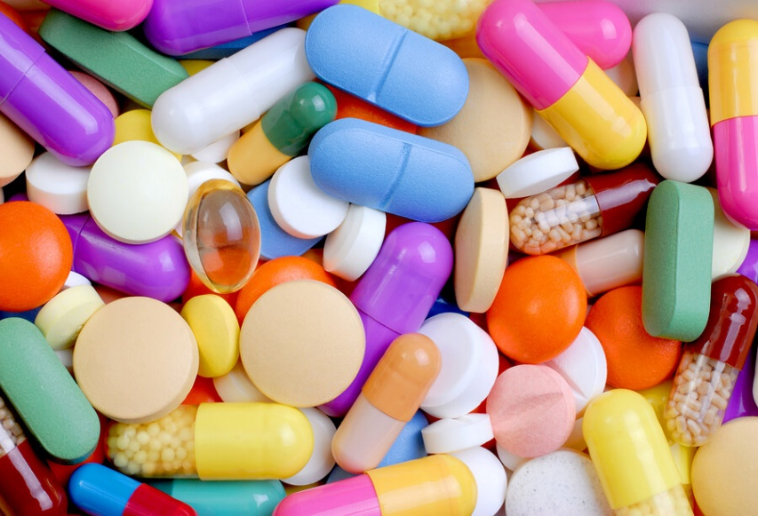

**Fig No:1**

**Objective Of Drug Discovery And Development**

* Recognize the investigational drug success rates by stages.
* Define Pre-clinical studies
* Define Investigational New Drug Application – Phase I, Phase II, Phase III studies
* Define New Drug Application
* Define Phase IV studies{4,5}

**Stages Of Drug Discovery And Development**

• Target identification

• Target validation

• Lead identification

• Lead optimization

• Product characterization

• Formulation and development

• Preclinical research

• Investigational New Drug Application (INDA)

• Clinical trials

• New Drug Application

• FDA Review

• Approval

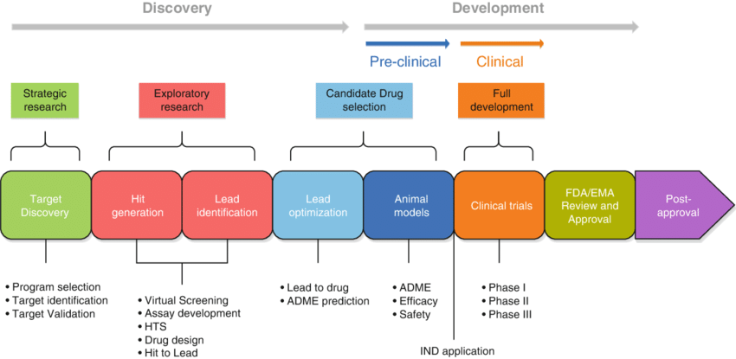

**Fig No 2: Stages Of Drug Discovery And Development**

**Target Identification**

The first step in the discovery of a drug is identification of the biological origin of a disease, and the potential targets for intervention. Target identification starts with isolating the function of a possible therapeutic target (gene/nucleic acid/protein) and its role in the disease.{8}

Drugs fail in the clinic for two main reasons; the first is that they do not work and the second is that they are not safe. As such, one of the most important steps in developing a new drug is target identification and validation. A target is a broad term which can be applied to a range of biological entities which may include for example proteins, genes and RNA. A good target needs to be efficacious,safe, meet clinical and commercial needs and, above all, be ‘druggable’.{8}

**Approaches:**

• Data mining using bioinformatics — identifying, selecting and prioritizing potential disease targets

• Genetic association — genetic polymorphism and connection with the disease

• Expression profile — changes in mRNA/protein levels

**Target Validation**

New target validation is the basis of completely new drug exploration and the initial step of drug discovery {9}The drug target has to be validated experimentally according to the proposed mode of action. Here data link directly to the probability of clinical efficacy (i.e. experiments in human cells/tissues of eminent importance). Functional studies can apply genetic knockdown, knockout or, using target specific tools, if SMOL compounds or tool antibodies are available.{10}

The target validation process might include six steps:

1. Discovering a biomolecule of interest.
2. Evaluating its potential as a target.
3. Designing a bioassay to measure biological activity.
4. Constructing a high-throughput screen.
5. Performing screening to find hits.
6. Evaluating the hits.

**Identification Of Lead**

A chemical lead is defined as a synthetically stable, feasible, and drug like molecule active in primary and secondary assays with acceptable specificity, affinity and selectivity for the target receptor.

Characteristics of a chemical lead are:

• SAR defined

• Drug ability (preliminary toxicity, hERG)

• Synthetic feasibility

• Select mechanistic assays

• In vitro assessment of drug resistance and efflux potential

• Evidence of in vivo efficacy of chemical class

• PK/Toxicity of chemical class known based on preliminary toxicity or in silico studies

In order to decrease the number of compounds that fail in the drug development process, a drug ability assessment is often conducted. This assessment is important in transforming a compound from a lead molecule into a drug.

**Lead Optimization**

In the lead optimization (LO) process, the lead compounds discovered in the H2L process are synthesized and modified to improve potency and reduce side effects. Lead optimization conducts experimental testing using animal efficacy models and ADMET tools, designing the drug candidate. It is the process by which a drug candidate is designed after an initial lead compound is identified. The process involves iterative series of synthesis and characterization of a potential drug to build up a representation of in what way chemical structure and activity are related in terms of interactions with its targets and its metabolism.{10}

**Product Characterization**

When any new drug molecule shows a promising therapeutic activity, then the molecule is characterized by its size, shape, strength, weakness, use, toxicity, and biological activity. Early stages of pharmacological studies are helpful to characterize the mechanism of action of the compound.

**Formulation And Development**

Formulations can be categorized according to the route of administration and include oral, rectal, vaginal, inhalation, topical, transdermal, intraocular, intranasal, and parenteral drug products. Pharmaceutical development information provides the scientific rationale for the formulation development approach through to the final development and justification of a suitable dosage form. Regulatory guidance describes only limited detail of the requirements for the data sets associated with pharmaceutical development.{11}

**Preclinical research**

Preclinical studies are in vivo studies that usually occur in animals. Initially, they are conducted in animals without the disease of interest in order to test toxicology, then later in animal models of the disease that allow for assessment of disease-modifying effects. The purpose of this research is to obtain FDA approval for an IND that will in turn allow for subsequent research in human subjects.{12}

Experiment are generally performed on a rodent (mouse, rat, guinea pig, hamster, rabbit) and then on a larger animal (cat, dog, monkey). As the evaluation progresses unfavourable compounds get rejected at each step, so that only a few out of thousands reach the stage when administration to man is considered. The following types of tests are performed;

1. Screening tests.

2. Tests on isolated organs, bacterial cultures, etc.

3. Tests on animal models of human disease.

4. Confirmatory tests and analogous activities.

5. Systemic pharmacology.

6. Quantitative tests.

7. Pharmacokinetics.

8. Toxicity tests.{13}

**The Investigational New Drug Application (INDA)**

INDA is applied after the Preclinical studies show success and if the INDA submission is accepted the product is further forwarded to the clinical research studies (Phase I - Phase IV studies).

**Clinical Trials**

A clinical trial is a research study that tests a new medical treatment or a new way of using an existing treatment to see if it will be a better way to prevent and screen for diagnose or treat a disease. Clinical trial phases are steps in the research to determine if an intervention would be beneficial or detrimental to humans and include Phases 0, I, II, III, IV, and V clinical studies

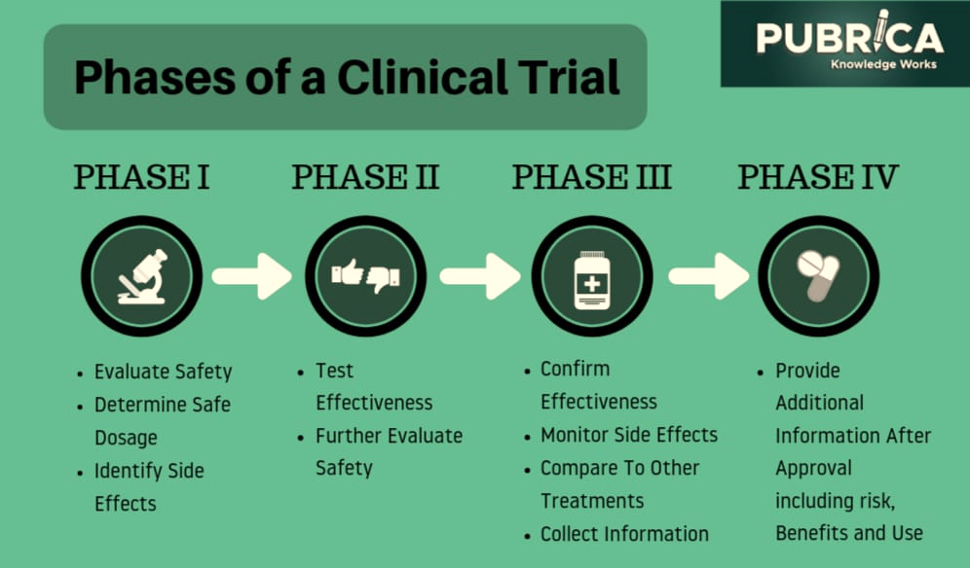

**Fig No: 3 Phases Of Clinical Trial**

**Phase 0:Clinical Trials**

Phase 0 trials can help drug sponsors improve their preclinical selection process. If a company is choosing between several preclinical candidates, a Phase 0 trial could gather early human data for all candidates in a relatively cheap way, Burt explains. According to the FDA a phase ‘0’ is designed to carry out before in phase 1, it has very limited human exposure receiving only sub therapeutic dose and this means the volunteer produces a response (Pharmacological Action) than the toxic effect with less risk compared to conventional clinical trials in phase 1 in which administration continues if clinical benefit which means even phase ‘0’ trials don’t have any therapeutic intention.

**Phase 1: Safety and doses**

Phase I trials are the first tests of a drug with a lesser number of healthy human volunteers. In most cases, 20 to 80 healthy volunteers with the disease/condition participate in Phase 1. Patients are generally only used if the mechanism of action of a drug indicates that it will not be tolerated in healthy people. However, if a new drug is proposed for use in diabetes patients, researchers conduct Phase 1 trials in patients with that type of diabetes.{15,16}

**Phase 2:** **Efficacy and side effect**

This is conducted by physicians who are trained as clinical investigators, and involve 100–500 patients selected according to specific inclusion and exclusion criteria. The primary aim is establishment of therapeutic efficacy, dose range and ceiling effect in a controlled setting. Tolerability and pharmacokinetics are studied as extension of phase I. The study is mostly controlled and randomized, and may be blinded or open label. It is generally carried out at 2–4 centres. The purpose of a phase II trial is to investigate the short-term safety and therapeutic efficacy of the drug in patients with the disease or condition that the drug is intended to treat.

**Phase 3: Efficacy and adverse drug reactions monitoring**

Phase III trials are the most expensive, time-consuming and difficult trials to design and run, especially in therapies for chronic medical conditions. Most drugs undergoing Phase III clinical trials can be marketed under FDA norms with proper recommendations and guidelines, but in case of any adverse effects being reported anywhere, the drugs need to be recalled immediately from the market. While most pharmaceutical companies refrain from this practice, it is not abnormal to see many drugs undergoing Phase III clinical trials in the market.

**Phase 4: Post-Market Drug Safety Monitoring**

Pharmacovigilance is the term used in Europe describing the ongoing evaluation of the safety of the drug in the post marketing period; it is a requirement that all pharmaceutical companies with a post marketed product must comply. The drug company will also provide periodic safety update reports on the new drug after its approval. Post-marketing or safety surveillance trials are sometimes referred to as phase IV clinical trials. Harmful effects discovered during phase IV trials can lead to the withdrawal of the drug from the market as seen in the example of rofecoxib (Vioxx) and cerivastatin (Lipobay, also known as Baycol in the United States).

**New Drug Application**

A New Drug Application (NDA) expresses the full story of a drug molecule. Its purpose is to verify that a drug is safe and effective for its proposed use in the people studied. A drug developer must include all about a drug starting from preclinical data to Phase 3 trial data in the NDA.{14}

Beside with clinical trial outcomes, developers must include:

• Proposed labeling

• Safety updates

• Drug abuse information

• Patent information

• Institutional review board compliance information

• Directions for use.

**FDA Review**

Once FDA receives an NDA, the review team decides if it is complete. If it is not complete, the review team can refuse to file the NDA. If it is complete, the review team has 6 to 10 months to make a decision on whether to approve the drug.

**FDA Approval**

In cases where FDA determines that a drug has been shown to be safe and effective for its intended use, it is then necessary to work with the applicant to develop and refine prescribing information. This is referred to as “labeling.” Labeling accurately and objectively describes the basis for approval and how best to use the drug.

**Conclusion**

The drug discovery and development process is a long and complicated process. Before any newly drug is placed on the market, it must undergo extensive testing. The discovery and development of new medicines is a long, expensive and complicated process. New drugs are an important part of modern medicine with the emergence of diseases. A few decades ago, a disease such as peptic ulcers was an indication for major surgery. A new drug development is a long way proceeds through various phases over many years. It is including testing in vitro, in vivo, pre-clinical and finally clinical trial phases to get into final approval. All of the phases provide detailed explanation and also give us clear views on efficacy, safety and side effects of drugs on human body.

Reference

1. Hughes JP, Rees S, Kalindjian SB, Philpott KL. 2011,Principles of early drug discovery. Br J Pharmacol,162: 1239-1249.
2. Pharmaceutical Research and Manufacturers Association (PREMA) Introduction to drug development process. 30th PREMA Anniversary.
3. SK Manirul Haque and Elaref S. Ratemi. Drug Development and analysis review. Journal of Pharmaceutical Chemistry Journal. 2017; 50: 837-850.
4. Shu-Feng Zhouand Wei-Zhu Zhong. Drug Design and Discovery: Principles and Applications. Journal of Molecules. 2017; 22: 279-285.
5. Hughes JP, Rees S, Kalindjian SB, Philpott KL. Principles of early drug discovery. Br J Pharmacol 2011; 162: 1239-1249.
6. Pharmaceutical Research and Manufacturers Association (PREMA) Introduction to drug development process. 30th PREMA Anniversary.
7. Lindsay MA. 2003,Target discovery. Nature Reviews Drug Discovery, 2:831–838.
8. JP Hughes, S Rees, SB Kalindjian, KL Philpot. Principles of early drug discovery. British Journal of Pharmacology. 2011; 162: 1239-1249.
9. Peet NP. 2003,What constitutes target validation? Targets. 2:125–127
10. Drug discovery hit to lead. [cited 2012 march 26]. Available from: en.wikipedia.org/wiki/Drug_discovery_hit_to_lead.
11. Thomas J. DiFeo, Ph.D. Drug Product Development: A technical review of chemistry, manufacturing, and controls information for the support of pharmaceutical compound licensing activities. Journal of Drug Development and Industrial Pharmacy. 2003; 29: 939-958.
12. Nalaka Gooneratne. Overview of drug development. Academic Entrepreneurship for Medical and Health Scientists. 2019; 1: 1-9.
13. Tripathi,K.D (2018).Essentials of medical pharmacology (8th Edition).Jaypee Brothers medical,78-79
14. Huber W. A new strategy for improved secondary screening and lead optimization using high-resolution SPR characterization
15. Shayne CG. Introduction: drug Discovery in the 21stCentury. Drug Discovery Handbook, Wiley Press, 2005; 1-10.
16. Smith GC, OíDonnel JT. The Process of New Drug Discovery and Development, Eds., 2nd edition, Informa Healthcare, New York 2006.
17. FDA, 2002,The FDA and the Drug Development Process: How the FDA insures that drugs are safe and effective, FDA Fact Sheet .
18. The Lancet 2009,“Phase 0 trials: A platform for drug development ?”. The Lancet.374(9685): 176-118
19. Yang, Z.J., et al. 2010,“Motivation for Health Information Seeking and Processing about Clinical Trial Enroollment.” Health Communication 25(5): 423-436. 43.Life Science Stratedy Group, May 2009, “Clinical Trial Technology Utilization”.
20. .DeMets, D., Friedman, L. and Furberg, C. 2010, Fundamentals of Clinical Trials. 4th Edition, Springer, Berlin.
21. Rogers, M.A. 2009, What Are the Phases of Intervention Research? American Speech-Language-Hearing Association, Rockville.
22. Philip Sedgwick. What are the four phases of clinical research trials? BMJ, 2014; 348: 1-2.
23. Marc Buyse, Phase III design: principles, © Chinese Clinical Oncology. 2016; 5: 1-13.
24. Nihad A.M. Tamimi Peter Ellis, Drug Development: From Concept to Marketing. Journal of Nephron Clinical Practice. 2009; 113: 125-131.
25. Christopher P. Adams and Van V. Brantner. Estimating the cost of new drug development: Is It Really $802 million?, Health affairs. 2006; 25: 420-428.
26. DiMasi J. Risks in New Drug Development: Approval success Rates for Investigational Drugs. Clinical Pharmacology & Therapeutics, 2001; 297-307.
27. Friedhoff L. New Drugs: An Insider‘s Guide to the FDA‘s New Drug Approval Process for Scientists, Investors and Patients. New York, NY: PSPG Publishing; 2009.
28. Lu DY and Che JY. Rethink Of Diabetes Treatment and Drug Development. Cell Dev Biol. 2014;3:e125.
29. Papanastasopoulos P. Functional Imaging in Cancer Drug Development: A Mini-Review. J Med Diagn Meth; 2014;3:157.
30. Melchior ACB, et al. Bromodomain as New Targets in Drug Discovery. Biochem Pharmacol (Los Angel). 2015;4:e176.
31. ICH Harmonized Tripartite Guideline for Good Clinical Practice ‘Academy For Clinical Excellence’.
32. Storer, B.E. 1989, Design and Analysis of Phase I Clinical Trials. Biometrics, 45, 795- 798.
33. Ankur Rohilla, Ravi Kumar Singh, Deepti Sharma, Phases of Clinical Trials. International Journal of Pharmaceutical, Chemical and biological sciences. 2013; 3: 700-703.