Compact Wideband Single Layer Microstrip patch Antenna by Using T shape and Rectangular slot for C band Application and stable radiation patterns

1Pankaj Kumar, 2Lalit Jain

1Research Scholar, 2Assistant Professor

[1pankajcool29@gmail.com,](mailto:1pankajcool29@gmail.com) [2lalitjain@oriental.ac.in](mailto:2lalitjain@oriental.ac.in)

Department of Electronics and Communication Engineering Oriental College of Technology, Bhopal, India

**Abstract:** A wide band antenna using T slot plane for single band wireless communication is proposed. The antenna used with rectangular slot in a ground plane work as electronics band gap so that we can tune the frequency for a different wireless communication application. In proposed design it works as a single band from 4.9 to 8.5 GHz. The exciting patch or a radiator patch consist of T slot and separated ground and exciting patch through FR4 dielectric substrate. The structure of a design is compact and simple. The dimension of a proposed antenna is 18 x 14 x1.5 mm3 with respect to wavelength 0.3λ0 where λ0 is a free space wavelength. The proposed design is suitable for multiple wireless communication likewise WLAN, WiMAX and for X band application. The bandwidth of a proposed antenna is 53.4% with VSWR<2, minimum return loss -22.5 dBi and directivity is

4.3 dBi.

# Introduction

There has been tremendous improvement or interest in the field of free space communication

[1-2] the different slot cutting as well as stub matching technique is used to tune and adjust the propagation characteristic for different propagation spectrum. And also improve the qualitive of service (QoS) [3-4]. In today’s scenario requirement for wireless with frequency band for 3G/4G/5G/6G wireless communication systems became more powerful with wide band and multi bank frequency spectrum [5-6]. As we already know that microstrip antenna is advantageous over conventional microwave antennas and therefore used in various fields such as global positioning system applications, mobile and satellite communication, radar application and telemedicine application [1-6]. As compared to conventional microwave antenna microstrip patch antenna has many advantages such as light weight, thin profile, dual frequency and dual polarization, easy fabrication etc. In previous research we have seen that the pattern near and far field fluctuates significantly nearly the operating band because of this the gain at higher frequency became smaller as compared to lower band [7].

The T shape cross dipole antenna is used to achieve the dual band and is circularly polarized [8]. In our design we use to calculate the accurate impedance in terms of position and size of slot and thus match the impedance with 50 Ω microstrip line for maximum power transformation. Ideally, the range of voltage standing wave ratio is from zero to infinity. Practically for good performance voltage standing wave ratio must be less than two. The variations in VSWR with respect to the frequency are shown in figure (5). The VSWR is effectively less than 2 in between 4.9 to 8.5 GHz. The Return Loss for notch is effective between these band. From such result the design is applicable for X band application.

# Design Consideration

The dimensions, length (Lg) and width (Wg) of ground plane are calculated by using dimensions of patch antenna as equation below:

𝑳𝒈 = 𝑳 + 𝟔. 𝒉 **………………………(1)**

𝑾𝒈 = 𝑾 + 𝟔. 𝒉**….………………….(2)**

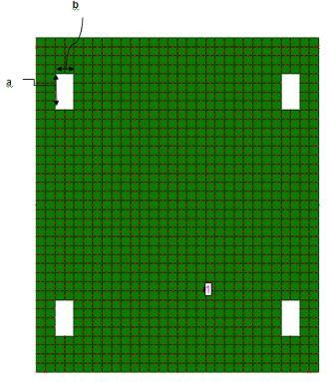

***Fig (b)***

***Fig.1: (a) and (b) Geometry of exciting patch with T shape and four rectangular slot with shorting pin.***

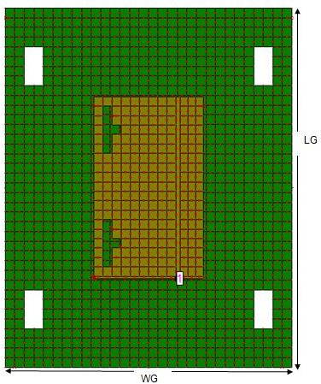

***Fig.2: Top View Proposed geometry***

In above formulae “h” is height of substrate. The dimension of patch antenna is represented as, “L” represents as length (in mm)

“W” represents as width (in mm)

Microstrip patch antenna’s width is formulated as,

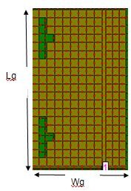𝑾 = 𝟏

𝟐.𝒇𝒓√𝝁𝟎𝗌𝟎

**…………………………….………. (3)**

Microstrip patch antenna’s length is formulated as,

𝑳 = 𝑳𝒆𝒇𝒇 − 𝟐. ∆𝑳 **…………………………….…. (4)**

Where,

𝑳𝒆𝒇𝒇

= 𝒄

𝟐𝒇𝒐√𝗌𝒆𝒇𝒇

**………………….…………. (5)**

***Fig (a)***

(𝗌𝒆𝒇𝒇 +𝟎.𝟑)(𝒘+𝟎.𝟐𝟔𝟔𝟒)

∆𝑳 = 𝟎. 𝟒𝟏𝟐𝒉 𝒉 𝒘 **……………. (6)**

(𝗌𝒆𝒇𝒇−𝟎.𝟐𝟓𝟖)(𝒉 +𝟎.𝟖)

𝗌 = 𝗌𝒓+𝟏 + 𝗌𝒓−𝟏 𝟏

**…………………. (7)**

matching. The dimension of the rectangular slot

𝒆𝒇𝒇 𝟐

Where,

𝟐 √𝟏+𝟏𝟐𝒉

𝒘

shape and T shaped slotted is given in above table.

"𝜀𝑒𝑓𝑓 "represents the effective value of dielectric constant of the substrate

“c” represents the speed of light in free space.

The proposed structure is simulated and analyzed on IE3D (Integrated Electromagnetic 3 Dimension) tool. The study of planned antenna depends on effective values of FR4 substrate. Substrate height 1.5 mm is considered. The ideal value of dielectric constant of substrate is 4.3. The ideal value of loss tangent of FR4 substrate is

0.019. Ground plane of dimension 18 x 14 x1.5 mm3 is used to fabricate the prototype. The design specifications of design antenna are shown in below table.

***Table No.1: Mathematical calculation of the proposed antenna***

|  |  |  |
| --- | --- | --- |
| **S.**  **N.** | **Parameters** | **Values for proposed antenna** |
| **1** | Design frequency (f ) | 10GHz |
| **2** | Dielectric constant(εr) | 4.3 |
| **3** | Height of substrate(h) | 1.5 mm |
| **4** | Loss tangent for FR4 | 0.019 |
| **5** | Width of rectangular patch(W) | 9.21442mm |
| **6** | Length of rectangular patch(L) | 5.5745 mm |
| **7** | Width of ground plan (Wg) | 18.2144 mm |
| **8** | Length of ground plan (Lg) | 14.5774mm |
| **9** | Feed location:  Xf (along length), Yf (along width) | -1.50662 mm 4.6072mm |
| **10** | a | 4 mm |
| **11** | b | 2mm |

In this design a cutting slot is used to integrate on microstrip patch. The exciting patch are rectangular Slot shape slotted for impedance

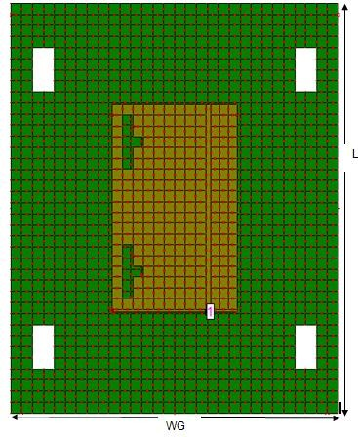***Fig. 3: Geometry of Planned Antenna***

The geometry of ground plane and exciting patch antenna is as shown in figure 3. The proposed antenna consists of a loaded four rectangular shape slot in the ground plan and the shorting pin is connected in between excited patch and ground is as shown in figure 3. From this work the rectangular slot and T shape slotted is used which provides a better bandwidth enhancement as compared to other work.

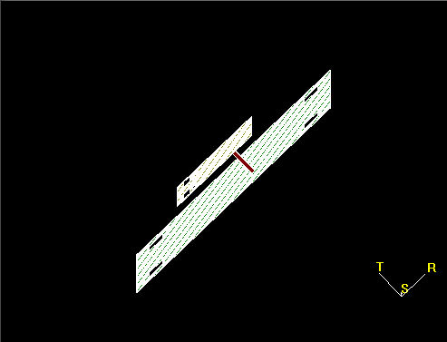

***Fig. 4: 3D view of proposed structure***

The 3 D view of proposed antenna with a probe feeding and proposed antenna.

# Return Loss and Bandwidth

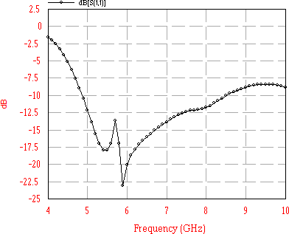

4.9 to 8.5 GHz

***Fig.5: Simulated values of S11 vs. Frequency.***

For proposed design the antenna have bands from

4.9 to 8.5 GHz. The Return Loss for notch is effective between these two band. From such result the design is applicable for X band. The improved impedance bandwidth of antenna is calculated as,

(𝒇𝑯 − 𝒇𝑳)

ratio of highest voltage of forward wave and the lowest voltage of reflected wave is termed as voltage standing wave ratio.

Ideally its range is from zero to infinity. Practically for excellent performance, VSWR should be less than 2.

In our design we use to calculate the accurate impedance in terms of position and size of slot and thus match the impedance with 50 Ω microstrip line for maximum power transfer. Ideally, the range of voltage standing wave ratio is from zero to infinity. Practically for good performance voltage standing wave ratio must be less than two. The variations in VSWR with respect to the frequency are shown in figure (5). The VSWR is effectively less than 2 in between 4.9 to 8.5 GHz.

𝑩𝑾 = 𝟐 × (𝒇

𝑯

+ 𝒇𝑳

) × 𝟏𝟎𝟎

The Return Loss for notch is effective between

this band. From such result the design is

As we previously discussed about three resonances that we obtain in the graph, gives return loss of -22.5 dBi at 5.9 GHz.

# Voltage Standing Wave Ratio

VSWR (voltage standing wave ratio) is a reflection from an antenna to transmission line because of impedance mismatching. As we previously discussed that to transfer maximum power from transmission line to antenna, impedance of antenna and transmission line must be matched. When the impedance mismatching occurs some power reflected reverse to transmission line from antenna and mixed with forward wave hence form a standing wave. The

applicable for X band application.

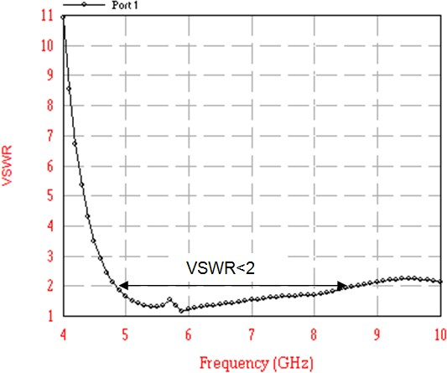

***Fig. 6: VSWR vs. Frequency graph***

# Directivity

Directivity is a measure of maximum directional gain of antenna. The directivity of an antenna is

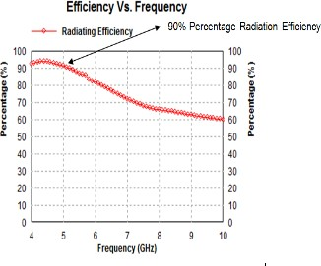define as a maximum power transmitted in a particular direction. The directivity vs frequency plot is shown in figure 7.

The maximum directivity is achieved be 4.3 dBi in operating frequency range from 7 to 8 GHz.

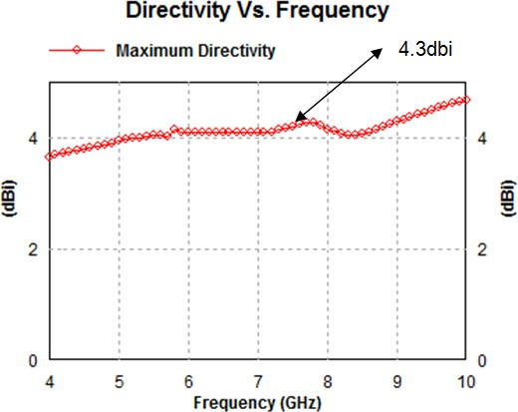

***Fig. 7: Simulated values of Directivity vs. Frequency***

# Efficiency

Efficiency defines how fine an antenna converts its received power to radiated power. The radiating efficiency consider losses related to antenna only that is conductor losses and dielectric losses while an antenna efficiency consider losses related to return loss and VSWR. The radiating efficiency is always more than antenna efficiency. Figure 8 shows that in our design maximum antenna efficiency for proposed structure is 90%.

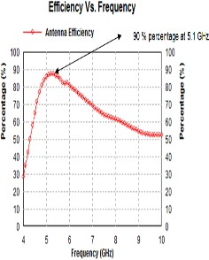

***Fig.8: Simulated values of Efficiency vs. Frequency***

# Axial Ratio

Axial Ratio (AR) is defined as ratio between minor and major axis of polarization ellipse. Figure 9 shows AR vs. frequency of designed antenna.

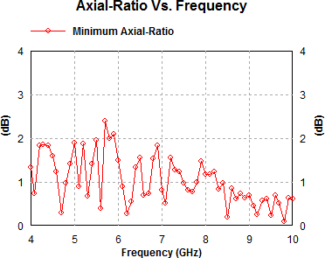

***Fig. 9: Axial-ratio Vs. Frequency graph***

# Radiation Pattern

Figure 10, represent the 2D radiation pattern of design antenna at resonance frequency 4.5, 8 and

11.2 GHz.

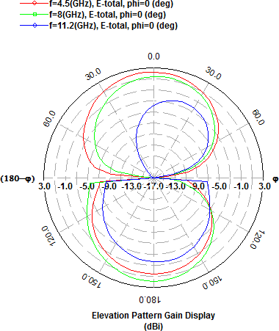

***Azimuth and Elevation Pattern of a proposed antenna***

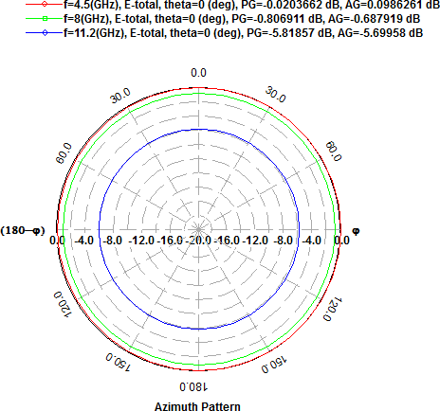

***Fig. 10: 2D Radiation pattern of proposed antenna at 4.5, 8 and 11.2 GHz***

The radiation pattern of elevation and azimuth angle of E field is shown in figure 11.

# 3D View of Proposed Antenna

***Table No.2: Result Comparison***

|  |  |  |
| --- | --- | --- |
| **Title** | **Base Paper Work [1]** | **Proposed work** |
| VSWR<=2 | 1.67 GHz to  2.72 GHz | 4.9 GHz to 8.5 GHz |
| Axial ratio | - | Less than 3dBi |
| Directivity | - | 4.3dBi |
| Efficiency | - | 50% – 90 % Antenna Efficiency  50% -90% Radiation Efficiency |
| Percentage  Bandwidth | 47.8% | 53.4% |
| Return Loss | - | -22.5 dBi at 5.9GHz |
| Substrate | FR4 | FR4 |
| Feeding  Method | Coaxial Feed | Coaxial Feed |

**Conclusion:** The microstrip patch antenna with Slotted line at ground plane and two inverted T

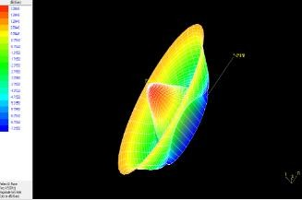 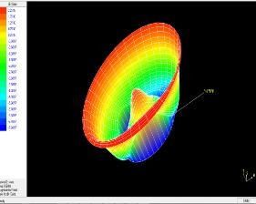

***Fig 11 (a) Fig11 (b)***

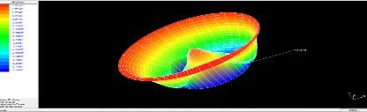

***Fig 11 (c)***

***Fig.11: 3D View Radiation Pattern of Designed Antenna.*** The 3D radiation pattern for 4.9, 5.1 and 8.5 GHz is as shown in fig.11 the radiation pattern along with gain and polarization is as clearly presented by using this 3D radiation pattern. From fig it is clear that the radiation pattern is stable through out the entire band.

Shape is presented in this paper. It has been observed that by introducing the Shape with four rectangular slot the bandwidth and return loss results are enhanced. The antenna simulation is done on IE3D software. The VSWR and radiation efficiency is also achieved within suitable limit. All the parameters of proposed antenna are calculated for 10 GHz frequency band. The proposed antenna obtained a band of approximately 53.4%, with a acceptable radiation pattern within the frequency range. The antenna is designed on FR4 substrate because of its low profile, low cost and thickness. The probe feeding technique is used.

# References

1. Liang Hua Ye, Yuan Jun Li and Duo Long Wu, ***“Dual-Wideband Dual-Polarized Antenna with T-Shaped Slots and Stable Radiation Pattern”***, IEEE Antenna and Wireless Propagation

Letter Vol.2 March 2022 pp 610-614.

1. Sai Radavaram, Maria Pour, ***“Wideband Radiation Reconfigurable Microstrip Patch Antenna Loaded With Two Inverted U Slot”***, IEEE Transactions on Antenna and Propogation, Volume 67 Issue 3, pp 1501 - 1508 March 2018.
2. Joysmita Chatterjee, Akhilesh Mohan and Vivek Dixit, ***“Broadband Circular Polarized H- Shaped Patch Antenna Using Reactive Impedance Surface”***, IEEE Antenna and wireless propagation letters, Volume: 17, [Issue: 4](https://ieeexplore.ieee.org/xpl/tocresult.jsp?isnumber=8332009) pp. 625 – 628 April 2018
3. Adel Y.I. Ashyap, Z.Z Abidin, S.H Dahlan,

H.A. Majid. ***“Inverted E-Shaped Wearable Textile Antenna For Medical Application”***, IEEE Access, Volume 6 Inspec Access No.17905778 pp.35214-35222. June 2017.

1. Bhartia P, Bahl I, Ittipiboon A., ***“Microstrip antenna design”***, handbook Artech House Inc.Norwood: 2001, ISBN 0-89006-513-6.
2. A. Balanis, ***“Antenna theory: analysis and design***

***/Constantine*** third edition, Hoboken, NJ: Wiley, 2005, ISBN 047166782X.

1. T. W. Chiou and K. L. Wong, ***“Designs of compact microstrip antennas with a slotted ground plane,”*** in 2001 IEEE Antennas Propagation. Soc. Int. Symp. Dig. pp. 732– 735.
2. Mukesh Ku Khandelwal, Santanu Dwari, Kanaujia BK, Sachin Kumar, ***“Design and Analysis of Microstrip Patch Antenna with***

***Enhanced for Ku Band Applications”,*** Elsevier, AEUE-51203.

1. Guha D, ***“Microstrip Patch Antenna with Defected Ground Structure for Cross Polarization Suppression”***. IEEE Antennas & Wireless propagation letters, vol. 4, 2005.