TUBERCULOSIS

( TB )

𝗔𝘂𝘁𝗵𝗼𝗿𝘀 - Ketan Sunil Patil 1st , Divyesh Prashant Gahiwad 2nd , Lokesh Devidas Chaudhari 3rd , Prashant Bhausaheb Patil 4th , Gaurav Umesh Patil 5th .

𝗚𝘂𝗶𝗱𝗮𝗻𝗰𝗲 𝗯𝘆 - Mr Nazeer Ahmed 6th , Ms Bhavna Mahajan 7th , Mr Harshal Dipak Borse 8th .

____________________________________________________________________________

## ABSTRACT

Tuberculosis (TB) is a persistent global health issue caused by Mycobacterium tuberculosis, impacting millions of lives annually. This comprehensive overview delves into TB's history, types, causes, risk factors, symptoms, pathogenesis, diagnosis, management, complications, market significance, and treatment. TB presents in latent and active forms, with the latter being highly contagious. Key complications include drug-resistant TB, extra-pulmonary TB, and severe conditions like tuberculous meningitis. The TB treatment market is growing, driven by innovation and increased awareness. Effective treatment involves a combination of antibiotics, and adherence is paramount. The text underscores the importance of early diagnosis, timely treatment, and measures for infection control to tackle the TB challenge and reduce its global impact. Despite the challenges, there is optimism that continued efforts in prevention and healthcare infrastructure improvement can eventually lead to the elimination of this ancient disease.

##### Keywords: Tuberculosis, Mycobacterium tuberculosis, latent TB, active TB, drug-resistant TB, extra-pulmonary TB, treatment market, diagnosis, complications, causes, risk factors, symptoms, pathogenesis, management, prevention, BCG vaccine, antibiotics, healthcare infrastructure, marketing significance, prevention, infection control, multidrug-resistant TB, treatment, conclusion.

____________________________________________________________________________

## l INTRODUCTION

Tuberculosis, often abbreviated as TB, is a highly infectious disease caused by the Mycobacterium tuberculosis bacteria. This ancient pathogen has plagued humanity for centuries, with evidence of its existence dating back to ancient Greece and Rome. TB primarily targets the respiratory system, particularly the lungs, but it's not confined to this region; it can also affect other vital organs such as the brain, kidneys, or spine. The disease presents in two main forms, latent and active, each with distinct characteristics and implications.

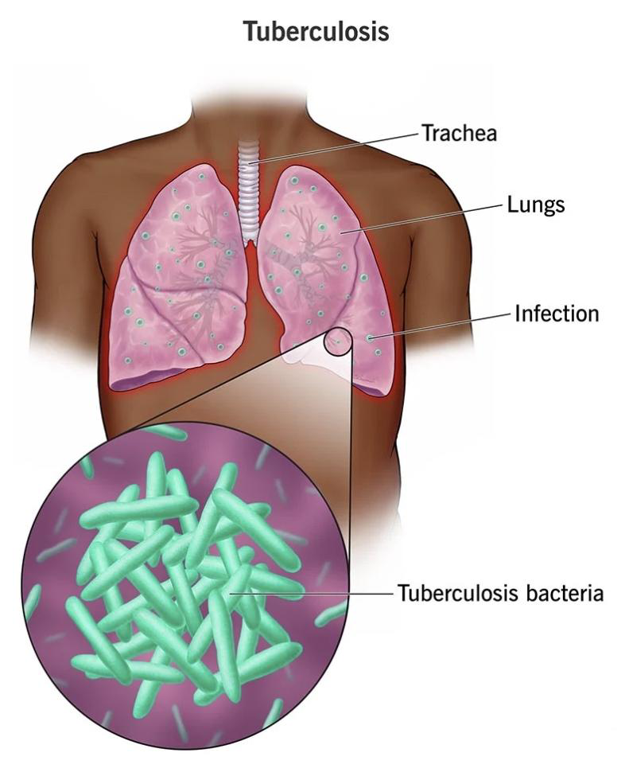

Latent TB infection, also known as inactive TB, is a state in which the individual is infected with the TB bacterium but remains asymptomatic. In essence, the bacteria are in a dormant state, coexisting peacefully with the host's immune system. This state often goes unnoticed, and the infected person may not even be aware of their condition. Latent TB is not transmissible, meaning it cannot be spread to others, and it might remain dormant for years or even a lifetime.

However, latent TB is not without its risks. Approx 10% of latent infections may progress to active Tuberculosis disease if left untreated. When the bacterium get active, it transitions into a formidable adversary. Active TB disease is characterized by a range of distressing symptoms, including a persistent and often bloody cough, fever, night sweats, unexplained weight loss, and an overall feeling of weakness and illness. These symptoms are why TB was historically referred to as "consumption" due to the severe weight loss associated with the disease.

The most concerning aspect of active TB is its contagiousness. People with active TB can transmit the bacterium to others when they cough, sneeze, speak, or even sing. These tiny TB germs can linger in the air for hours, depending on environmental factors, and anyone who inhales them may become infected. This is the basis for the alarming spread of TB, especially in crowded or poorly ventilated settings.

Several factors can increase the risk of developing active TB. Individuals with weakened immune systems, such as those with HIV/AIDS, are particularly vulnerable. Additionally, tobacco smokers are more susceptible to TB infection, as smoking compromises the respiratory system's ability to fight off the bacterium.

To diagnose TB, various tests are employed. Chest X-rays are commonly used for the detection of active TB, while microscopic examination and culture of body fluids can confirm the presence of the bacterium. Diagnosing latent TB relies on the tuberculin skin test (TST) or blood tests to detect the immune response to the infection.

Preventing the spread of TB is crucial. This involves screening individuals at high risk, early detection, and prompt treatment of active cases. Vaccination with the bacillus Calmette-Guérin (BCG) vaccine has been employed in many parts of the world to protect against TB, especially in high-risk areas. People at elevated risk include those who have had close contact with active TB cases in their households, workplaces, or social circles.

The treatment of TB is a lengthy and complex process, typically requiring the use of multiple antibiotics for several months. However, a growing concern is the emergence of antibiotic-resistant strains of TB, known as multiple drug-resistant tuberculosis (MDR-TB). This poses a significant challenge to TB control efforts.

As of recent data, TB remains a global health issue. In 2020, an estimated 10 million people developed active TB, resulting in 1.5 million deaths, making it the second leading cause of death from an infectious disease after COVID-19. Most TB cases are concentrated in specific regions, including South-East Asia, Africa, and the Western Pacific. Efforts to combat TB are ongoing, with a focus on early detection, treatment, and vaccination to reduce the burden of this ancient and persistent infectious disease .

### 

## ll. TYPES OF TUBERCULOSIS

1 ) Pulmonary tuberculosis

Pulmonary tuberculosis, caused by Mycobacterium tuberculosis (MTB), is a severe infection affecting the lungs and possibly spreading to other organs. Although TB, once referred to as consumption, is now rare in the United States, it still poses a threat, especially in communities like the homeless. Multidrug-resistant TB epidemics exist in certain countries. Additionally, immune-compromised individuals, including those with HIV/AIDS, can be vulnerable to atypical mycobacteria.

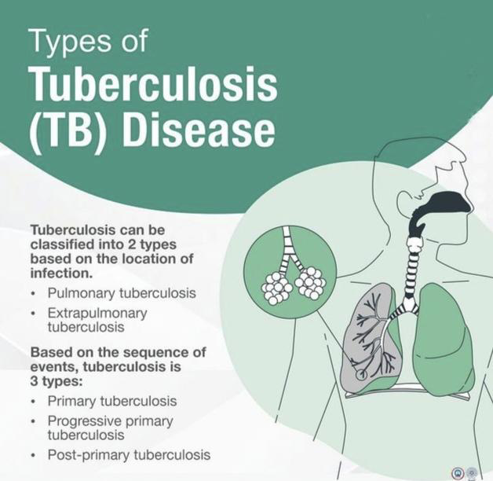

M. tuberculosis is the culprit behind TB, a contagious airborne disease that damages body tissues. Pulmonary TB is its primary target, though it can spread to other organs. Timely diagnosis and antibiotic treatment can cure pulmonary TB.

Historically, pulmonary TB, known as consumption, caused widespread epidemics in North America and Europe during the 18th and 19th centuries. The discovery of antibiotics like streptomycin and isoniazid, combined with improved living conditions, enabled better control of TB's spread.

While TB has declined in most developed nations, it remains a major global health issue. According to the World Health Organization , it ranks among the top 10-15 causes of death worldwide. Developing countries bear the brunt, accounting for 95% of TB diagnoses and related deaths.

To protect yourself from TB, it's essential to be vigilant. The American Lung Association says that over 9.6 million people have active TB. Left untreated, TB can lead to severe complications, including permanent lung damage.

• Primary tuberculosis is typically transmitted through the inhalation of air droplets containing Mycobacterium tuberculosis (MTB) from an infected person's cough or sneeze. It can affect anyone who comes into contact with these infectious droplets. However, in most cases, the primary TB infection remains clinically limited, causing mild or no symptoms, especially in individuals with robust immune systems. It is worth noting that infants and the elderly are more susceptible to developing active TB disease from primary infection.

• Secondary tuberculosis, on the other hand, is the reactivation of a dormant MTB infection that has been present in the body for years. This reactivation occurs primarily in individuals with weakened immune systems, but it is not limited to them. Secondary TB can affect anyone who has a latent (dormant) TB infection. When the immune system becomes compromised, the dormant bacteria can become active, leading to the development of active tuberculosis disease. This form of TB is characterized by more severe and symptomatic infections.

2 ) Extra Pulmonary tuberculosis

Extrapulmonary tuberculosis, or EPTB, refers to tuberculosis affecting organs outside the lungs, such as the pleura, lymph nodes, abdomen, genitourinary tract, skin, joints, bones, or meninges. When a patient has both pulmonary TB (PTB) in the lungs and EPTB, it's categorized as PTB. For instance, miliary TB is considered PTB because it involves lung lesions. On the other hand, conditions like tuberculous intrathoracic lymphadenitis or tuberculous pleural effusion, without lung abnormalities on X-rays, are classified as EPTB.

EPTB is an infectious disease caused by Mycobacterium tuberculosis, occurring in organs other than the lungs. Risk factors include being born in high TB-prevalent countries, exposure in institutional settings, and homelessness.

Diagnosis can be delayed due to non-specific symptoms that progress slowly and the limited sensitivity of acid-fast bacilli (AFB) smear on extrapulmonary samples.

Microbiological confirmation is crucial for diagnosis, often requiring tissue biopsy. Other supporting evidence includes the presence of granulomas and a positive AFB stain in pathology, as well as X-ray findings.

Treatment typically involves a 4-drug regimen of isoniazid, rifampicin, pyrazinamide, and ethambutol, lasting at least 6 months.

•Lymph Node TB

Lymph node TB typically leads to painful swelling of one or more lymph nodes, with a high occurrence in the neck's anterior or posterior cervical chains or supraclavicular region, often affecting both sides. This condition is more common among children and females of Asian and Pacific ethnicities, known as scrofula or cervical tuberculous lymphadenitis. Key symptoms include lymph node swelling or pain, initially small painless nodules in the neck that can grow larger, possibly draining pus or fluid. Additional signs encompass fever, general discomfort, weight loss, night sweats, fatigue, and cough.

•Pleural TB

Tuberculous pleural effusion, often called tuberculous pleurisy, is a common form of tuberculosis outside the lungs, particularly in regions with high TB prevalence. It can result from primary TB or latent TB reactivation and presents with fever, chest pain, and cough. Diagnosis can be challenging, but it's crucial to treat with standard TB medications. Biomarkers like adenosine deaminase and interferon-γ, in combination with pleural fluid analysis, can aid in diagnosis. Recurrence risk is high if left untreated.

•Upper Airways TB

tuberculosis (TB) in the upper respiratory tract, primarily focusing on laryngeal TB. It mentions that TB in the upper respiratory tract can be found in individuals with various risk factors, such as HIV infection, diabetes, and substance abuse. Diagnosis is often based on epidemiological factors or a lack of response to standard treatment, and treatment involves anti-TB drugs for an extended period. In some condition , surgery may be required. The text highlights that TB is no longer limited to developing countries and has also become a concern in developed nations due to factors like HIV and drug resistance. The study emphasizes the importance of considering TB as a possible diagnosis in patients with upper airway masses, as it can mimic malignancies.

•Skeletal TB

Skeletal tuberculosis, including spinal tuberculosis or Pott's disease, affects the bones and joints, typically occurring when Mycobacterium tuberculosis spreads outside the lungs. It's more common in underdeveloped countries and can spread through blood vessels from the lungs or lymph nodes. Symptoms are often hard to detect in the early stages and can include severe back pain, swelling, and stiffness. Advanced stages may lead to neurological complications, paralysis, limb-shortening in children, and bone deformities. It's relatively rare but has seen an increase in developing nations, partly due to the spread of AIDS.

•Miliary TB

Miliary tuberculosis is a life-threatening form of tuberculosis where tiny tuberculous lesions, resembling millet seeds, spread through the bloodstream to various organs. The term "miliary" comes from the Latin word for millet seed. It's considered disseminated tuberculosis when at least two different body organs or the blood, bone marrow, or liver are affected. A chest X-ray often shows characteristic miliary mottling, aiding in diagnosis. Symptoms of miliary tuberculosis can be nonspecific and include weight loss, fever, chills, weakness, and breathing difficulties. Infection of the bone marrow may lead to severe anemia and blood abnormalities, mimicking leukemia. When bacteria sporadically enter the bloodstream, it can cause recurrent fevers and progressive weight loss.

•Pericardial TB

Tuberculous pericarditis is a significant complication of tuberculosis, particularly prevalent in regions with a high burden of TB. Diagnosis and management of this condition can be challenging, leading to delayed detection and increased mortality. Its occurrence is more common in areas with a high prevalence of TB and is increasingly associated with HIV infection. In developed countries, tuberculous pericarditis is relatively rare.

•Gastrointestinal TB.

Gastrointestinal tuberculosis is a common type of tuberculosis that occurs outside the lungs , but its acute frequency is challenging to ascertain because many cases do not display symptoms , making it difficult to estimate. Diagnosis is often delayed because symptoms can be nonspecific, and TB can affect any part of the GI tract. TB remains a significant global health concern, and this article discusses its impact, epidemiology, clinical presentation, and the need for timely recognition and treatment.

•Tuberculous Meningitis

Tuberculosis (TB) is a contagious lung infection caused by Mycobacterium tuberculosis. If left untreated, it can spread through the bloodstream to infect the brain and spinal cord's protective membranes, leading to a life-threatening condition known as tuberculous meningitis (TBM). TBM can cause severe headaches, neurological problems, and, if not treated, may result in a coma or death. This article discusses the causes, risk factors, symptoms, diagnosis, and treatment of TBM, as well as the prognosis for those with this condition.

## lll. CAUSES AND RISK FACTORS OF TUBERCULOSIS

Tuberculosis (TB) is caused by the bacterium Mycobacterium tuberculosis. It spreads through the air when an infected person coughs or sneezes, releasing the bacteria into the environment. Factors contributing to TB transmission include:

1. Close contact with an infected person.

2. Weakened immune system, such as from HIV infection.

3. Poor living conditions with inadequate ventilation.

4. Malnutrition and overcrowding.

5. Substance abuse.

6. Travel to or residence in areas with high TB prevalence.

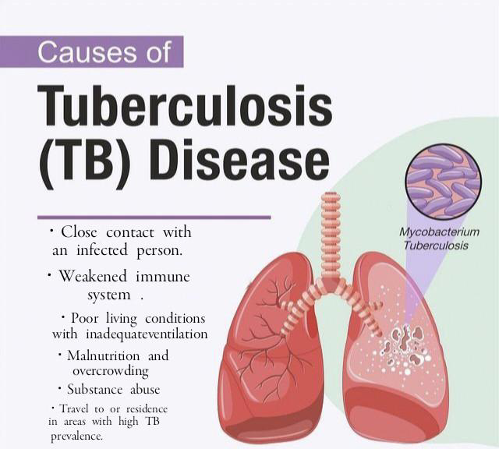

Preventive measures, such as vaccination (BCG), early diagnosis, and treatment, are essential in controlling TB's spread.

## risk factors of tuberculosis

1. TB can develop in individuals soon after infection or years later when the immune system weakens. The risk is higher for those with weakened immune systems.

2. Two main categories of people at high risk for TB are those recently infected and those with weakened immune systems.

3. Factors increasing the risk of recent infection include close contact with TB patients, immigration from high TB areas, young age with a positive TB test, and specific high-risk groups.

4. Factors weakening the immune system and increasing the risk of TB include conditions like HIV, substance abuse, diabetes, silicosis, organ transplants, and certain medical treatments.

5. TB can exist as latent TB infection, where the bacteria are in the body but not causing symptoms, or as active TB disease with symptoms such as a persistent cough, chest pain, and more.

6. Active TB disease can be treated with medicine, but it's crucial to complete the treatment to prevent drug resistance.

7. Certain groups, like those in close contact with TB patients or from high TB prevalence countries, are at higher risk and should be tested for TB.

8. TB control strategies aim to reduce transmission from infectious cases and understand the risk factors related to infection and progression to disease, including host-related factors (e.g., HIV, diabetes) and environmental factors (e.g., smoking, alcohol, and indoor air pollution). The risk of progression to TB disease is higher in immunocompromised individuals.

## lv. SIGNS AND SYMPTOMS OF TUBERCULOSIS

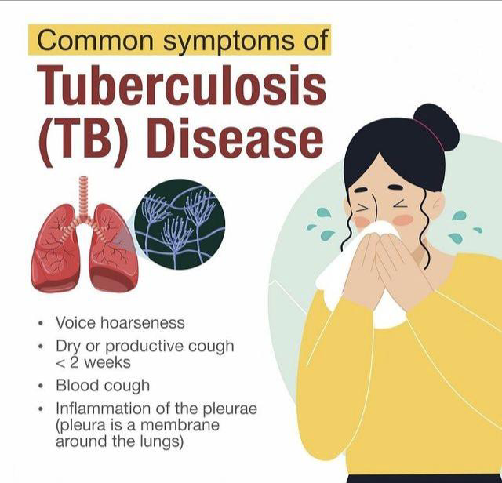

Tuberculosis (TB) symptoms can vary depending on the part of the body affected.

•General TB Symptoms

1. Fever

2. Chills

3. Night sweats

4. Unintentional weight loss

5. Loss of appetite

6. Fatigue

7. Feeling unwell in general

Specific Symptoms for Pulmonary TB (Lung TB)

1. Persistent cough lasting more than three weeks

2. Chest pain

3. Coughing up blood or sputum (phlegm from deep inside the lungs)

Specific Symptoms for Extra-Pulmonary TB (Outside the Lungs)

1. Kidneys: Symptoms related to kidney dysfunction

2. Liver: Symptoms related to liver involvement

3. Brain and Spinal Cord: Symptoms related to fluid surrounding these areas

4. Heart Muscles: Symptoms related to heart muscle involvement

5. Genitals: Symptoms related to the genital area

6. Lymph Nodes: Swelling or symptoms related to affected lymph nodes

7. Bones and Joints: Bone pain and joint symptoms

8. Skin: Skin-related symptoms

9. Blood Vessels: Symptoms related to blood vessel walls

10. Voice Box (Larynx): Symptoms resembling lung disease in this area

Symptoms in Children:

• Teenagers: Similar to adult symptoms

• 1- to 12-year-olds: Fever and weight loss

• Infants: Poor growth, fussiness, vomiting, feeding difficulties, and other specific symptoms depending on the affected area.

Latent TB Infection (No Symptoms):

• People with latent TB infection do not feel sick, have no symptoms, and cannot spread TB to others. This means they have a TB infection, but the bacteria are not causing harm.

It's important to note that while these symptoms can indicate TB, they can also occur with other diseases. If you suspect exposure to TB or experience these symptoms, it's crucial to seek medical evaluation and get a TB test to confirm the diagnosis.

## V. PATHOGENESIS OF TUBERCULOSIS

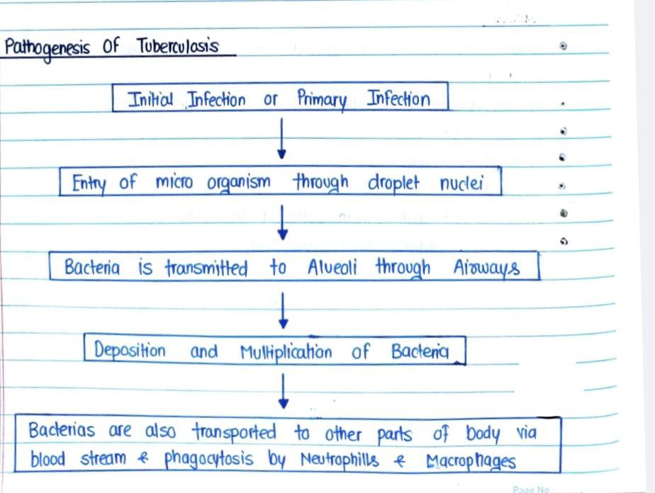

The pathogenesis of tuberculosis (TB) involves a complex series of events as the bacterium Mycobacterium tuberculosis infects the human body.

1. Entry of Microorganism through Droplet Nuclei:

•TB primarily spreads through the inhalation of tiny respiratory droplets containing Mycobacterium tuberculosis, which are released when an infected person with active TB coughs, sneezes, or talks.

• These droplets can remain suspended in the air and are inhaled by individuals in close proximity to the infected person.

2. Transmission to Alveoli through Airways:

• Once inhaled, the TB bacteria can reach the alveoli, which are tiny air sacs in the lungs.

• The bacteria are carried by the inhaled air through the airways and eventually reach the alveoli, where they establish an initial infection.

3. Deposition and Multiplication of Bacteria:

• In the alveoli, the TB bacteria encounter the lung's natural defense mechanisms, primarily alveolar macrophages.

• Some bacteria are engulfed by these macrophages but can evade destruction. They multiply within the macrophages, forming structures called granulomas, which are clusters of immune cells and bacteria.

• The immune system attempts to contain the infection within the granulomas, leading to latent TB in many cases.

4. Transportation to Other Parts of the Body:

• TB bacteria can spread beyond the lungs through the following routes:

• Bloodstream: Some bacteria can enter the bloodstream, allowing them to be transported to other parts of the body. This is called hematogenous dissemination.

• Phagocytosis by Neutrophils & Macrophages: As the immune system recognizes the presence of TB bacteria, neutrophils and other macrophages are recruited to the site of infection to help control the infection.

• Lymphatic System: TB can also spread via the lymphatic system to nearby lymph nodes.

The progression of TB infection can take different courses in individuals. Some people develop active TB disease, where the bacteria continue to multiply and cause symptoms, while others may have latent TB infection, where the bacteria remain dormant and do not cause symptoms. Reactivation of latent TB can occur if the immune system becomes compromised, leading to active disease.

It's important to note that effective treatment with antibiotics like isoniazid and rifampin is available for both latent and active TB to prevent its spread and manage the infection. TB remains a global health concern, and understanding its pathogenesis is crucial for its prevention and control.

## VI . DIAGNOSIS

1. Clinical Evaluation: The process typically begins with a patient history to determine if there has been exposure to TB. During a physical examination, healthcare providers may listen to the lungs and check for swollen lymph nodes in the neck.

2. TB Screening Tests:

a. Mantoux Tuberculin Skin Test (TST): Involves injecting a small amount of purified protein derivative (PPD) under the skin of the forearm. A healthcare provider will examine the injection site after two to three days.

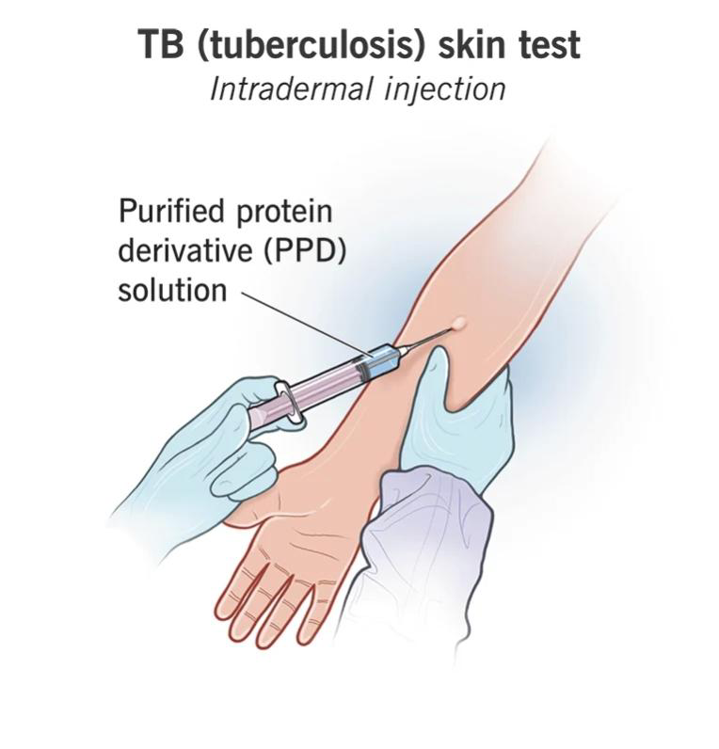

b. Interferon Gamma Release Assay A blood test that measures how the immune system response to TB bacteria. This test can help confirm or rule out latent or active TB.

3. Further Tests to Determine Active Infection:

a. Sputum and Lung Fluid Tests: Laboratory tests on sputum and lung fluid samples to identify the presence of TB bacteria.

b. Chest X-ray: An X-ray of the chest to check for visible signs of TB in the lungs.

c. Computed Tomography (CT) Scans: Sometimes, CT scans are used to provide more detailed images of the lungs to detect TB.

d. Other Sample Tests: Depending on the suspected site of infection, other samples like cerebrospinal fluid, urine, or procedures like removing sputum from the lungs may be used for testing.

4. Microscopy for Acid-Fast Bacilli (AFB): The most common method for identifying TB is the smear microscopy for acid-fast bacilli. It involves staining clinical samples with carbol-fuchsin, gentle heat, and decolorizing acid. However, this method is relatively insensitive, especially in children and patients with HIV.

5. Mycobacterial Culture: This is a more sensitive technique that involves growing M. tuberculosis in a culture medium. It can confirm the presence of TB and is used for drug susceptibility testing. It takes several weeks for results to become available.

6. Nucleic Acid Amplification Tests (NAAT): These tests detect TB DNA in clinical samples and can also identify resistance to certain drugs. The GeneXpert MTB/RIF test is a notable example that is endorsed by WHO for its high sensitivity and specificity.

7. Diagnosing Drug-Resistant TB: Molecular methods like the GeneXpert MTB/RIF and line probe assays are used to detect resistance to specific drugs, particularly rifampicin. These tests provide rapid results for rifampicin resistance.

It's important to note that the choice of diagnostic tests may depend on factors such as the patient's clinical presentation, the resources available, and local guidelines. The aim is to accurately diagnose TB, determine the presence of drug resistance, and initiate appropriate treatment. The GeneXpert MTB/RIF test has been a significant advancement in improving the speed and accuracy of TB diagnosis, especially for rifampicin resistance, and has been widely adopted in many countries.

## VII. MANAGEMENT AND LIFE STYLE

1. Isolation and Medication:

• Individuals with active TB disease should stay home until the doctor approves their return.

• Complete the full course of prescribed medications to prevent drug-resistant TB.

2. Preventing Transmission:

• Use masks, cover your mouth when coughing or sneezing, and ensure good room ventilation.

• Inform close contacts (family, friends, coworkers) to get tested for infection.

3. Healthy Lifestyle:

• Manage stress through meditation or yoga.

• Consume a balanced diet rich in fruits, vegetables, and vitamins.

• Avoid smoking and alcohol during treatment.

• Prioritize rest and adequate sleep.

• Stay positive and control emotions.

• Attend routine check-ups for treatment evaluation.

4. Medication Side Effects:

• Monitor for medication side effects like upset stomach, numbness, skin issues, and eye problems.

• Report any unusual symptoms promptly to your healthcare provider.

5. Lowering TB Risk:

• Maintain good hygiene and handwashing practices.

• Consume a nutritious diet.

• Get enough sleep and establish healthy sleep habits.

• Manage stress through relaxation techniques.

• Engage in regular physical activity.

• Quit smoking to reduce lung damage.

• Consider the BCG vaccine for protection.

• Seek medical attention if you have TB symptoms or have been in contact with an infected person.

These steps aim to effectively manage TB and reduce the risk of transmission and reinfection.

## VIII. COMPLICATIONS

Tuberculosis (TB) can lead to various complications if left untreated or not properly managed. Some of the common complications include:

1. Multidrug-Resistant Tuberculosis (MDR-TB): TB that is resistant to the most common antibiotics used for treatment can be harder to treat.

2. Extensively Drug-Resistant Tuberculosis (XDR-TB): This is a more severe form of drug-resistant TB, which is resistant to a wider range of drugs, making treatment even more challenging.

3. Disseminated or Extrapulmonary Tuberculosis: TB can affect other organs besides the lungs, leading to complications such as meningitis, bone and joint infections, or abdominal TB.

4. Tuberculous Meningitis: When TB affects the membranes surrounding the brain and spinal cord, it can lead to severe neurological complications.

5. Pleural Effusion: TB can cause a buildup of fluid in the pleural cavity, leading to pleurisy or difficulty breathing.

6. Tuberculous Empyema: This occurs when pus accumulates in the pleural space due to TB infection.

7. Hemoptysis: Coughing up blood can be a complication of TB.

8. Lung Cavities: TB can create cavities in the lungs, increasing the risk of bacterial superinfections.

9. Scarring of Lung Tissue: Long-term TB infection can result in lung damage and fibrosis.

10. Tuberculosis of the Spine (Pott's Disease): This can lead to spinal deformities and neurological problems.

11. Tuberculosis in Children: In children, TB can result in growth and developmental problems.

12. HIV Coinfection: TB and HIV often occur together, complicating treatment and increasing the risk of severe illness.

13. Social and Economic Consequences: TB can lead to social stigmatization, loss of employment, and economic challenges for affected individuals.

Prompt diagnosis and appropriate treatment are essential in preventing these complications. TB is a treatable and curable disease when managed correctly. If you suspect TB or are at risk, it's crucial to seek medical attention.

## IX.MARKETING SIGNIFICANCE

The global market for tuberculosis treatment drugs was worth $1.9 billion in 2021, and it's projected to reach $3.2 billion by 2031, growing at a 5.3% annual rate from 2022 to 2031. Tuberculosis (TB) is a bacterial infection primarily affecting the lungs but can also impact other parts of the body, requiring a prolonged treatment period of six to nine months with a combination of antibiotics.

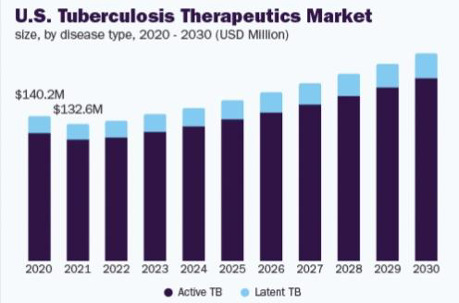

Primary drugs for TB treatment include isoniazid, rifampicin, ethambutol, and pyrazinamide, while second-line drugs include fluoroquinolones, aminoglycosides, and capreomycin. Completing the full treatment course is crucial, even if symptoms improve earlier. In cases of drug-resistant TB, newer medications like bedaquiline and delamanid may be used. Patients must closely follow their healthcare provider's guidance to ensure proper medication usage and monitor for potential side effects. In addition, they should adhere to additional recommendations like minimizing close contact with others until they are no longer contagious.

The market's growth is driven by innovations in the pharmaceutical industry, increased prevalence of tuberculosis, product approvals, clinical trials, and rising demand for effective anti-TB drugs. Emerging markets, with improved healthcare infrastructure and rising drug-resistant cases, are significant drivers. E-commerce has contributed to market growth, alongside health apps educating people about TB. The demand for anti-TB drugs extends beyond developed countries to emerging economies like China, Brazil, and India. Despite some side effects and limited reimbursement policies, increasing awareness, research and development, and governmental guidelines offer opportunities for market growth.

Understanding the TB market is crucial for the development and introduction of new products. The COVID-19 pandemic has impacted TB care, causing delays in treatment and increasing latent TB and active TB in children due to household transmission. Testing for TB has risen, with new testing kits entering the market. For instance, a genetic test for TB diagnosis was launched in December 2022.

The market faces challenges due to the high cost of treating multidrug-resistant TB (MDR TB), with half a million MDR TB cases estimated globally each year. High treatment costs, long durations, and potentially life-threatening side effects limit the market's growth.

The global tuberculosis ( tb ) therapeutics market was estimated at USD 2.01 billion in 2022, with an expected 5.09% annual growth rate from 2023 to 2030. Factors driving this growth include the rising prevalence of tuberculosis, increased healthcare infrastructure investments, and an aging population. Tuberculosis remains a significant global health concern, being the 13th leading cause of death worldwide with an estimated 10.6 million cases in 2021.

## X . TREATMENT

The treatment of tuberculosis involves taking a combination of antibiotics for a specified duration. If you have latent TB infection, it typically lasts for three to four months. For active TB disease, the treatment duration can range from four to nine months. Common medications include Isoniazid, Rifampin, Rifabutin, Rifapentine, Pyrazinamide, and Ethambutol. It's crucial to complete the full course of treatment to ensure all bacteria are killed and prevent drug resistance. Some people may need directly observed therapy (DOT), and if you experience side effects, you should inform your healthcare provider. TB is caused by Mycobacterium tuberculosis and can affect various parts of the body. Inactive TB is called latent TB, and active TB is known as TB disease. TB is spread through the air when an infected person with active TB coughs or sneezes. Diagnosis involves skin tests or blood tests, and further tests like sputum analysis, chest X-rays, and CT scans can determine the extent of infection. Testing for TB is recommended for individuals at risk or with symptoms. The incidence of TB varies, and some strains of TB have become resistant to medications, requiring a multi-drug approach for treatment. Completing the entire prescription is crucial.

And according to the cause of tuberculosis following treatment are helpful

The primary treatment for TB is a combination of antibiotics over a specific duration (usually 6 to 9 months). The most common medications include isoniazid, rifampin, pyrazinamide, and ethambutol. Here's a basic outline of TB treatment:

1. Initial phase: Patients are typically prescribed a combination of four drugs for the first two months. This intensive phase aims to rapidly reduce the number of bacteria.

2. Continuation phase: After the initial phase, the treatment may continue with two drugs for an additional 4 to 7 months to eliminate any remaining bacteria.

3. Adherence: It's crucial to take the medications as prescribed, for the full duration, even if the symptoms improve before the treatment ends.

4. Monitoring: Patients are monitored throughout the treatment to ensure the infection is under control and to detect any side effects.

5. Preventive therapy: For individuals at high risk, preventive therapy with isoniazid may be recommended to prevent TB infection from progressing to active disease.

6. Infection control: Preventing the spread of TB involves proper ventilation, isolation of infectious patients, and the use of masks.

## XI . CONCLUSION

In conclusion, tuberculosis (TB) remains a significant global health concern, with millions of people affected by this infectious disease. TB can manifest in various forms, affecting different organs of the body. Early diagnosis and appropriate treatment are essential to prevent complications and the development of drug-resistant strains. The TB treatment market is growing, with a focus on innovation and improved healthcare infrastructure. It's crucial for individuals to complete their prescribed treatment to ensure a successful recovery and reduce the risk of transmission. TB continues to be a challenge, but with continued efforts in prevention, diagnosis, and treatment, there is hope for controlling and ultimately eliminating this ancient disease.

## XII. REFERENCE

[1]

https://www.cdc.gov/tb/publications/factsheets/general/tb.htm#:~:text=Tuberculosis%20(TB)%20is%20a%20disease,they%20do%20not%20get%20treatmen

[ 2 ]

https://en.m.wikipedia.org/wiki/Tuberculosis

[ 3 ]

https://my.clevelandclinic.org/health/diseases/11301-tuberculosis

[ 4 ]

https://www.webmd.com/lung/understanding-tuberculosis-basics

[ 5 ]

https://www.nature.com/articles/nrdp201676#:~:text=tuberculosis%20can%20evolve%20from%20containment,active%20pulmonary%20TB%20is%20contagious.

[ 6 ]

https://www.ncbi.nlm.nih.gov/pmc/articles/PMC10049048/

[ 7 ]

https://www.houstonmethodist.org/pulmonology/tuberculosis/

[ 8 ]

https://www.healthline.com/health/pulmonary-tuberculosis

[ 9 ]

https://www.ncbi.nlm.nih.gov/pmc/articles/PMC4388900/#:~:text=EPTB%20refers%20to%20TB%20involving,are%20lesions%20in%20the%20lungs.

[ 10 ]

https://bestpractice.bmj.com/topics/en-gb/166

[ 11 ]

https://www.ncbi.nlm.nih.gov/pmc/articles/PMC4450036/#:~:text=The%20lymph%20node%20TB%20usually,can%20be%20involved%20%5B3%5D.

[ 12 ]

https://m.netmeds.com/health-library/post/lymph-node-tuberculosis-is-treatable-diagnosis-key

[ 13 ]

https://www.uptodate.com/contents/tuberculous-pleural-effusion#topicContent

[ 14 ]

https://link.springer.com/chapter/10.1007/978-3-030-04744-3_2

[ 15 ]

https://www.ncbi.nlm.nih.gov/pmc/articles/PMC4016357/

[ 16 ]

https://journals.asm.org/doi/10.1128/microbiolspec.tnmi7-0009-2016

[ 17 ]

https://www.webmd.com/lung/what-is-skeletal-tuberculosis

[ 18 ]

https://www.healthline.com/health/bone-tuberculosis#symptoms

[ 19 ]

https://www.ncbi.nlm.nih.gov/books/NBK562300/#:~:text=Miliary%20tuberculosis%20is%20a%20potentially,to%202%20mm)%20tuberculous%20foci.

[ 20 ]

https://www.msdmanuals.com/en-in/home/infections/tuberculosis-and-related-infections/miliary-tuberculosis-tb

[ 21 ]

https://www.uptodate.com/contents/tuberculous-pericarditis#H1

[ 22 ]

https://www.sciencedirect.com/topics/medicine-and-dentistry/tuberculous-pericarditis

[ 23 ]

https://journals.asm.org/doi/10.1128/microbiolspec.tnmi7-0014-2016

[ 24 ]

https://www.ncbi.nlm.nih.gov/pmc/articles/PMC8555774/

[ 25 ]

https://www.medicalnewstoday.com/articles/tuberculosis-meningitis#cause-of-tbm

[ 26 ]

https://www.healthline.com/health/meningitis-tuberculosis

[ 27 ]

https://www.cdc.gov/tb/topic/basics/risk.htm

[ 28 ]

https://www.cdc.gov/tb/features/riskfactors/RF_Feature.html

[ 29 ]

https://www.ncbi.nlm.nih.gov/pmc/articles/PMC3583136/

[ 30 ]

https://www.cdc.gov/tb/topic/basics/default.htm#:~:text=Tuberculosis%20(TB)%20is%20caused%20by,with%20TB%20bacteria%20becomes%20sick.

[ 31 ]

https://www.mayoclinic.org/diseases-conditions/tuberculosis/symptoms-causes/syc-20351250

[ 32 ]

https://my.clevelandclinic.org/health/diseases/11301-tuberculosis

[ 33 ]

https://www.webmd.com/lung/understanding-tuberculosis-basics

[ 34 ]

https://www.mayoclinic.org/diseases-conditions/tuberculosis/symptoms-causes/syc-20351250

[ 35 ]

https://www.cdc.gov/tb/topic/basics/signsandsymptoms.htm

[ 36 ]

https://www.lung.org/lung-health-diseases/lung-disease-lookup/tuberculosis/symptoms-diagnosis

[ 37 ]

https://www.mayoclinic.org/diseases-conditions/tuberculosis/diagnosis-treatment/drc-20351256

[ 38 ]

https://my.clevelandclinic.org/health/diseases/11301-tuberculosis

[ 39 ]

https://www.lung.org/lung-health-diseases/lung-disease-lookup/tuberculosis/symptoms-diagnosis

[ 40 ]

https://www.nationaljewish.org/conditions/tuberculosis-tb/lifestyle-management#:~:text=The%20bacteria%20that%20cause%20TB,bag%20to%20throw%20it%20away.

[ 41 ]

https://healthlibrary.askapollo.com/lifestyle-changes-to-treat-tuberculosis-at-home/

[ 42 ]

https://www.lung.org/lung-health-diseases/lung-disease-lookup/tuberculosis/treating-and-managing

[ 43 ]

https://www.ndtv.com/health/tuberculosis-these-lifestyle-changes-could-lower-your-risk-of-tuberculosis-3886165

[44] https://www.ncbi.nlm.nih.gov/pmc/articles/PMC4561400/

[ 45 ]

https://www.alliedmarketresearch.com/tuberculosis-treatment-drugs-market

[ 46 ]

https://www.tballiance.org/access/understanding-tb-market

[ 47 ]

https://www.grandviewresearch.com/industry-analysis/tuberculosis-tb-drugs-therapeutics-market

[ 48 ]

https://www.mayoclinic.org/diseases-conditions/tuberculosis/diagnosis-treatment/drc-20351256

[ 49 ]

https://my.clevelandclinic.org/health/diseases/11301-tuberculosis

[ 50 ]

https://www.pacehospital.com/tuberculosis-symptoms-types-causes-prevention