**Impact of anthropogenic activities on bird population in Himalayan foot hills in Jammu and Kashmir**

Khired Tanveer, Dr Poornima Shrivastava, Dr Ashit Dutta

(Department of Environmental Science, Bhagwant University, Ajmer)

*corresponding author,* [*Khired@gmail.com*](mailto:Khired@gmail.com)

**Abstract:** The paper studies the impact of human activities on birds’ population, nest making, effect of artificial illuminations and use of hazardous chemicals on bird populations. The paper studies a variety of issues concerning bird populations, such as habitat loss, use of pesticides, population increase. The paper mentions a number of measures for reducing the impact of anthropogenic activities on avian population.

***Keywords: bird diversity, migratory birds, Himalayan birds, harmful impacts of humans on birds, declining bird population.***

1. **INTRODUCTION**

Human activities have had significant impacts on bird populations in the UK. Some of the key factors contributing to these impacts include habitat loss, pollution, climate change, and direct human interference. However, there are several measures that can be taken to mitigate these effects and promote bird conservation. Here are some of the impacts and mitigation strategies:

1. Habitat Loss: Urbanization, intensive agriculture, and deforestation have resulted in the loss and fragmentation of bird habitats. This has affected breeding, nesting, and foraging opportunities for many bird species. To mitigate habitat loss, efforts should focus on preserving and restoring natural habitats, creating wildlife corridors, and implementing sustainable land management practices.
2. Pollution: Pollution from various sources, including pesticides, industrial emissions, and plastic waste, poses a threat to bird populations. It can contaminate food sources, disrupt reproductive cycles, and harm overall bird health. Reducing pollution requires implementing stricter regulations on chemical usage, promoting sustainable agricultural practices, and raising awareness about the impact of waste on bird habitats.
3. Climate Change: Climate change affects bird populations by altering their breeding patterns, shifting their distribution ranges, and impacting food availability. To mitigate the effects of climate change, it is crucial to reduce greenhouse gas emissions through the adoption of renewable energy sources, energy efficiency measures, and sustainable transportation systems. Creating climate-resilient habitats and implementing adaptive management strategies can also help bird populations cope with changing conditions.
4. Direct Human Interference: Human activities such as hunting, trapping, and disturbance at nesting sites can directly impact bird populations. Implementing and enforcing legislation to protect birds, such as bird conservation acts and wildlife protection laws, is essential. Public education campaigns can raise awareness about the importance of bird conservation and promote responsible behavior around bird habitats.
5. Invasive Species: Invasive species can outcompete native birds for resources and disrupt ecosystems. Controlling and managing invasive species through measures such as habitat restoration, targeted removal efforts, and early detection and response programs can help mitigate their impact on bird populations.
6. Conservation Initiatives: Supporting and actively participating in bird conservation initiatives, such as citizen science projects, bird banding, and habitat restoration programs, can contribute to the preservation of bird populations. Encouraging community involvement and collaboration among scientists, policymakers, conservation organizations, and the general public is crucial for successful bird conservation efforts.
7. STUDY AREA

2.1. GEOGRAPHICAL FEATURES OF JAMMU AND KASHMIR

The Union Territory of Jammu & Kashmir and Union Territory of Ladakh are situated within the Himalayan Mountain system forming the northern most part of India. Twin Union Territories are bestowed with lofty snow-clad peaks of Himalayas, deep gorges, glaciers, lush green meadows and beautiful valleys full of Chinar trees, fresh water lakes, plenty of flora and fauna.

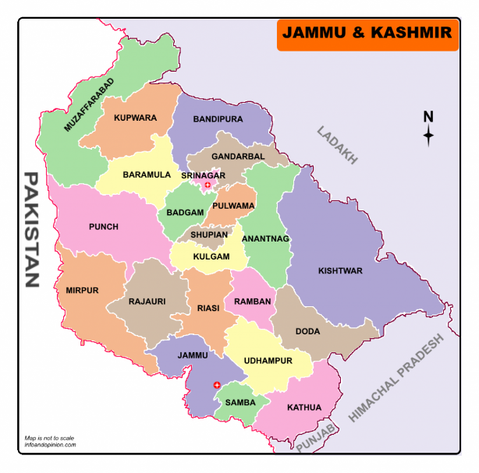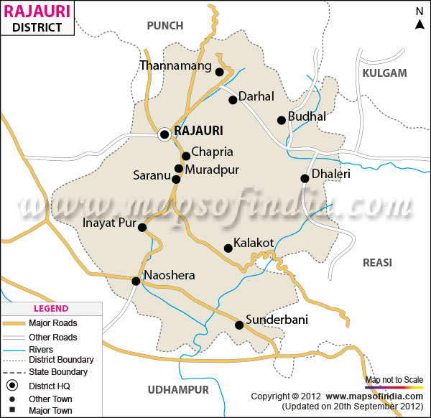

  Fig1: Map of J&K(MapsofIndia.com). Fig 2: Map of Dist. Rajouri

**2.2 VEGETATION AND WILD LIFE (FLORA AND FAUNA)**

The Union Territory of Jammu and Kashmir is well endowed with the natural vegetation. Its natural vegetation has great diversity in flora, ranging from the lush green margs (Alpine Pastures) to evergreen conifers on gentle slopes of high altitudes. Scrub forest cover southern slopes of Siwalik foot hills and deciduous forest are found on the southern slopes of Siwalik and Pir-Panjal range.

The common types of trees found in Jammu region are Kikar (Acacia), Ber, Shisham, Pipal, Banyan, Mango and Palm. Chir, Deodar, Spruce, Maple Oak, Walnut and Poplar are found in Kashmir. The willow, mulberry and walnut trees provide raw materials required for the development of sports goods, furniture and wood artefacts. Many people earn their livelihood from these forest-based industries. Forests also provide turpentine and a variety of resins, used in several chemical industries. Resin is collected from the pine trees.

* 1. **STUDY DESIGN**

Avifauna of Darhal was explored based upon both extensive and intensive avian studies in various bio-geographical zones of the valley. Extensive studies mainly involved the detailed survey of avifauna in different study sites, whereas, intensive studies were based on Line Transect Method which is based on the theory of walking along a predetermined route to record the objects on or near the line. This is one of the most commonly used methods for estimating the abundance of bird populations and is practical, efficient and relatively inexpensive (Burnham et al., 1980). It is also applicable for monitoring of birdlife of an area throughout the year. Keeping in view the hilly and more rugged terrain of the state, Piecewise Linear Line Transects were marked and monitored fortnightly in various experimental 30 sites. Further, these transects were monitored as open width transects, where birds were recorded irrespective of their distance from the transect.

1. **OBSERVATIONS**

Four bird species—Small Pratincole, Little Ringed Plover, Great Thick-knee and Little Tern—have shown a distressing decline of 50-80 per cent in their populations, according to the State of India’s Birds (SoIB) report 2023. Mid-river sandbars serve as vital nesting grounds for certain bird species, with the Indian Skimmer and Black-bellied Tern being notable examples. Unfortunately, these species are facing a concerning decline in their populations, leading to their Endangered status on the IUCN Red List. Sharing these nesting sites are other avian species including the River Lapwing, River Tern, Little Tern, Great Thick-knee (Near Threatened), and Small Pratincole.

Once widely distributed across Southeast Asia, the Indian Skimmer and Black-bellied Tern have experienced a significant reduction in their distribution range and decline in the population, and are now largely limited to India, Pakistan, Bangladesh, Nepal, and Myanmar. This decline can be attributed to the widespread degradation of river habitats due to factors like irrigation projects, sand mining, transportation activities, heightened human disturbances, domestic utilization, and pollution from agricultural and industrial sources.

**Species that have suffered the highest declines**

* White-rumped Vulture
* Richard's Pipit
* Indian Vulture
* Large-billed Leaf Warbler
* Pacific Golden Plover
* Curlew Sandpiper

**Species whose numbers have increased**

* Rosy Starling
* Feral Pigeon
* Glossy Ibis
* Plain Prinia
* Ashy Prinia
* Indian Peafowl

1. **SUMMARY AND CONCLUSION**

The study cautions that its research is also a chronicle of "individual species", and not a report on the "overall health of India's birds, including those considered common and hence of little conservation concern".

It says that "abundance trends" are available only for "a handful of bird species" - and mostly for those that tend to be "larger, more obviously threatened and relatively charismatic".

"For the vast majority of Indian birds, lack of data has hindered a clear understanding of how they are faring. Such an understanding is vital for conservation science, management and policy."

**1. Mark Windows**

Birds tend to hit windows because they cannot see them. The level of impact is sometimes so heavy that some end up dead.

Birds may sometimes encounter life-ending injuries such as broken wings and necks. Marking windows is a simple yet effective solution. This is best served using decals and frosted glass, allowing the birds to avoid the glass.

**2. Keep the Pets Indoors**

Cats and other house pets like hunting smaller animals, especially birds. This harms their numbers, which can be devastating in the case of [endangered species](https://www.conserve-energy-future.com/20-extraordinary-things-you-can-do-to-save-endangered-species.php). The problem can be contained by ensuring that the pets remain indoors most of the time when possible.

**3. Use Natural Pest Control**

Many bird species predate on smaller rodents and animals that feed on grain and cereals found in the open, with some birds also eating these grains themselves. Unfortunately, these food sources can be disrupted when chemicals are used for pest control.

Chemical pesticides such as [Dichlorodiphenyltrichloroethane](https://en.wikipedia.org/wiki/DDT)(DDT), while very effective as pesticides, do not organically decompose quickly and can be passed from pest to bird.

This means that any birds that feed off of pests or seeds that have come into contact with this chemical slowly accumulate fatal amounts of the chemical within their bloodstream. However, using natural pest control measures ensures that this does not happen.

**4. Vote Against the Use of Chemical Pesticides**

Given the concerns mentioned earlier, it becomes crucial for people to advocate for legislation that prohibits farmers from using such chemicals.

This would prevent the import of harmful substances into countries and discourage their use altogether. By doing so, we can safeguard birds from harm and protect their food sources.

**5. Do Not Purchase Birds Illegally**

The endangered bird species are numerous, and they all attract high prices on the black market due to their rarity. By purchasing these birds as pets, one bolsters the market and incentivizes poachers to continue to decimate the already fragile populations. Hence, by not participating in the market, the poachers are starved of profits, and the incentive to poach the birds is lost.

**6. Reduce Your Carbon Footprint (Global Warming Increases Pest Numbers that Kill Birds)**

Parasites are part of the reason birds suffer and their dwindling numbers. Attacks by ticks and mites can lead to weakened bird populations. This is mostly due to a rise in the number of parasites in the wild.

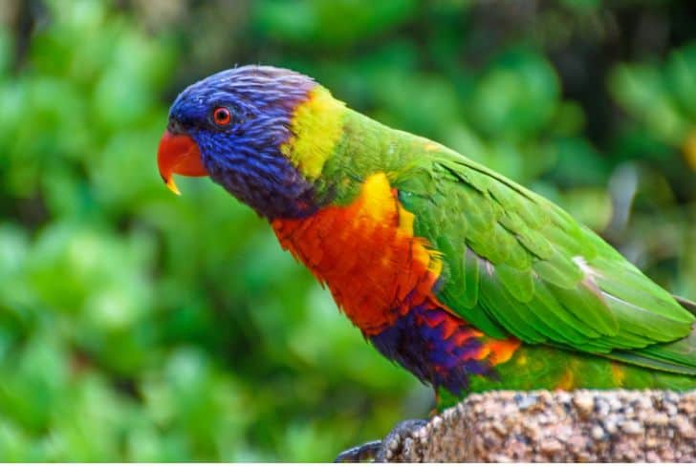Their increase can be traced to the rising global temperatures that make for shorter winters with higher average temperatures. This means that more insects survive the winter cycle each season. To combat this, we should reduce [greenhouse gas emissions](https://www.conserve-energy-future.com/greenhouse-gases.php).

**7. Join Conservation Groups**

Conservation groups actively participate in conservation attempts to [protect endangered species](https://www.conserve-energy-future.com/15-extraordinary-extinct-species.php). These groups are especially beneficial as they can pull in larger funds from donors.  They also practice better coordination tactics that have more of an impact on bird conservation efforts.

**8. Place Trash in Appropriate Bins**

Birds tend to be curious about the [garbage](https://www.conserve-energy-future.com/51-unique-innovative-ways-reuse-garbage.php) that people produce. [Dumping things in the open](https://www.conserve-energy-future.com/what-is-sanitary-landfill.php) usually leads to birds attempting to eat whatever has been dumped, sometimes including materials such as paper and shiny plastic beads. This could end up harming the birds or [causing diseases and infections](https://www.conserve-energy-future.com/critical-and-grievous-diseases-caused-by-water-pollution.php). It also places the birds at risk of being attacked by other animals as they try to pick out food. Putting trash in inappropriate places lessens the chances of these problems.

**9. Learn and Obey the Hunting Laws of Your Region**

Hunting laws work towards maintaining a balance between hunting and the protection of animal species. Hunting without knowledge of what species the government is keen on protecting could mean that you are damaging a program that’s put in place to replenish bird populations.  Hence, one should understand what they can hunt for when acquiring their permit to avoid such scenarios.

**10. Slow Down on the Road**

Several bird deaths occur when they run into vehicles while flying low over the tarmac. While it is hard to avoid, there is a chance that more birds could be saved if more individuals slowed down around country regions, especially if flocks of birds had been sighted close by.

1. **BIBLIOGRAPHY**

**Abdar Mohan Ramchandra. (2013).** Diversity and richness of bird species in newly

formed habitats of Chandoli National Park in Western Ghats, Maharashtra State, India.

Biodivers. J. Agric. Res. New Delhi.4(1): 235-242.

**Abdar Mohan Ramchandra. (2007).** Hydrobiology and monitoring avifauna of

Morna, Dist. Sangli (M. S.) India, Thesis submitted to Dr. Babasaheb Ambedkar

Marathwada University, Aurangabad: 1-5.

**Abdar M. R. (2009).** Hydrobiological monitoring avifauna and ichthyofauna of Sina

Dam Dist. Ahmednagar (M.S.) India, A thesis submitted to Dr. Babasaheb Ambedkar

Marathwada University, Aurangabad: 1-5.

Asefa A., Y. Mamo G. Mengesha and A. Shimelis (2015). Woody plant diversity

along disturbance gradients in thenorthern Afro-montane forests of the Bale Mountains,

Ethiopia. Int. J. Dev. Res. 5: 3745–3754.

**Bassouvalingam K., Inbanathan Jagannathan, Jayaraman Nadarajan (2012).** The

Status of avifauna of Ousudu lake, Puducherry, India. Int. J. Res. BioSci. 1(2): 38-46.

Bennett A.F., Brown G., and Silins J. (1998). Fragments for the Future. Wildlife in

the Victorian Riverina (The Northen Plains). Department of Natural Resources and

Environment, Melbourne: 1-7.

**Bhatti R. (2002).** On bio diversity and ecology of aquatic avifauna at Bhavnagar Coast

line, A thesis submitted to Bhavnagar University, Bhavnagar: 1-5.

**Chandra, K., Sheela, S. and Das, D. 2016. Animal Discoveries 2016** – New Species

and New Records. Published by the Director, Zoological Survey of India, Kolkata:

1-108.

**Chavan S., Dudhmal D., Hambarde S. and Kulkarni A. (2015).** Birds from Godavari

river basin in Nanded district of Maharashtra state,India. Annoted status and new

reports. Int. J. Curr. Res. Acad. Rev.3: 328-351.

**Chilke A. M. (2012).** Avian diversity in and around Bamanwada lake of Rajura, district

Chandrapur (Maharashtra). Scholars Research Library. Ann. Biol. Res. 3(4): 2014-

2018.

**Desai M. and Shanbhag, A. (2007).** Birds breeding in unmanaged monoculture

plantations in Goa, India. Ind. For. (133): 1367-1372. 100

**Dev B. (2003).** Carried Ecological studies on the avifauna of Barak Valley, Assam with

special reference to family – Ardeidae, A thesis submitted to Assam University, Silchar:

1-5.

**Hutto R.L. (1985).** Habitat selection in birds. Academic Press. Inc., Montana: 450-

455. 102

**Ibarra J. T., Christopher B. Anderson, Tomás A. Altamirano, Ricardo Rozzi, and**

**Cristián Bonacic (2010).** Diversity and singularity of the avifauna in the austral peat

bogs of the Cape Horn Biosphere Reserve, Chile Cien. Inv. Agr. 37(1):29-43.

Johnsingh AJT, Paramarandham K, S Murali (1981) Foraging behaviour and

interactions of Whiteheaded Babbles Turdoides affinis with other species. J BHNS 79:

503-514

**Jog P. and Pardeshi K. S. (2012).** Avian diversity on fort Panhala, Kolhapur,

Maharashtra, recent trends in Zoology, a compilation of research articles, ISBN: 978-

93-8491664-8.

**Mattu VK, Thakur ML (2006)** Birds of summer hill, Simala (Himachal Pradesh).

Ind Forester 132(10): 1271-1281