**Bird diversity of Darhal: A study of migratory birds of Darhal Valley, Rajouri, J&K**

Khired Tanveer, Dr Poornima Shrivastava, Dr Ashit Dutta

(Department of Environmental Science, Bhagwant University, Ajmer)

*corresponding author,* [*Khired@gmail.com*](mailto:Khired@gmail.com)

**Abstract:** The valley of Darhal situated in district Rajouri in the Himalayan UT of Jammu and Kashmir is bestowed with the rich biodiversity of fauna and flora. The valley, which is very narrow in breadth, is home to numerous migratory species of birds. This includes swifts, reptiles, the raptors, thrusts, buzzards, barbets et cetera. These birds migrate from Siberia, Russia, China, Mongolia, Mediterranean belt and Europe. A total of 99 species of birds were recorded in the study area, majority of which are migratory.

***Keywords: bird diversity, migratory birds, Himalayan birds, birds of temperate regions*.**

1. **INTRODUCTION**

Structure of avian diversity: Diversity of avifauna is main biological indicator of habitat quality, change in climatic conditions, effect of environmental factors and health of ecosystem. Rapid destruction of forest, natural habitats, nesting trees directly affects the breeding sites of birds. The grassland, wetland and agricultural ecosystems are the sites of breeding of birds. During their breeding season they construct their nests. The wetlands are productive ecosystems for fishing, irrigation but due to the overexploitation of these natural resources like water harvesting and fishing declining the wetland bird population. In agricultural land due to burning activities and ecological succession the nesting sites of birds and eggs gets destructed. The mining, illegal digging, burning of grassland destructs the ground nesting of birds in agriculture, terrestrial and wetlands. This study contributes to the knowledge of bird diversity in Forest ecology and rural landscapes and supplies the most recent status of bird diversity in wetland and alpine ecosystem. Our findings detect that bird diversity in wetlands can be great in surrounding nature reserves. Specially, the endemic and migratory birds which have not been previously recorded. The effect of the landscape types on bird species richness and relative abundance will be illustrated. Results show the influence of agriculture practice, residential neighbourhoods and informal settlements on species diversity indices and rank/ abundance relative to the rest of the micro-landscapes in this study. This study gives a current and useful reference for decision makers and verifies the existence of a great diversity of wildlife within forests, open green spaces, agricultural fields and wetland. We suggest that the development and implementation wetland use plans should consider this biodiversity, especially when villages and cities are in close proximity of protected areas or nature reserves. Ultimately, botanical gardens and public parks are included in the master 4 plan of the smart city is very important, as our study shows that the design needs an understanding in particular of avian populations.

Nesting behaviour: A bird nest is the spot in which a bird lays and incubates its eggs and raises its young. Although the term popularly refers to a specific structure made by the bird itself (Salim Ali, 2012). Not all bird species build nests. Some species lay their eggs directly on the ground or rocky ledges, while brood parasites lay theirs in the nests of other birds, letting unwitting &quot;foster parents&quot; do the work of rearing the young. Although nests are primarily used for breeding, they may also be reused in the nonbreeding season for roosting and some species build special dormitory nests or roost nests (or winter-nest) that are used only for roosting (Alexander and Skutch, 2005). Usually, birds build a new nest every year, though some renew their old nests ([www.smithsonianscience.org](http://www.smithsonianscience.org) 92015). The birds built their nests in different kinds. Following are few types of nests which are used to lay and incubate the young ones.

**Migratory pattern:**

The migration of birds is unsolved mystery to the ornithologist. Birds in India generally migrates for breeding, in search of food during every year in monsoon, winter and summer. During our study we observed monsoon migratory birds like Rain quail (Coturnix coromandelicia), common Hawk cuckoo (Hierococcyx varius), Jakobin cuckoo (Clamator jacobinous), where as winter migratory Ruddy shelduck (Tadorna ferruginea), Purple heron (Adrea purpurea), Eurasian teal (Anas crecca) etc. and summer migratory Grey heron (Ardea cinerea) etc.

The birds travel across the continents during the period of migration in sky to reach their destination. So, the questions arise what promotes to migration of birds? Why they take the risk of migration? How they know the transcontinental path of migration? Birds before migration gains lots of weight to fulfil their requirement during flight and to breed the young once. The migratory birds during their migration temporarily lands in a locality where abundant availability of food and safe place are available, such migratory birds in that locality considered as passage migrants. Few birds they found throughout the year in a locality considered as residents. Where-as the birds which are found at one site in India but not at another site during particular season are considered as local migrants.

The migratory birds fly in groups considered as flocks which are in thousands are attractive and fascinating to our society. The autumn migration of birds from the breeding grounds, north to south and from higher altitude to the lower altitude in northern hemisphere. In southern hemisphere the path of migration gets reversed along with north to south during winter. It is understandable that most of the birds prefer milder climate and avoids harsh winter.

The birds start their return journey when the climatic conditions get favourable such as ample availability of food and place of dwelling. Again during end of summer season the young one’s are well grown and ready to start their journey in sky from north to south. Migratory status of birds studied as resident, within subcontinent migrants and long distance migrants (State of India’s birds 2020).

1. **MATERIALS AND METHODS**

**2.1. STUDY AREA**

Comprehensive avian studies were conducted on various biological aspects of birds in different bio-geographical zones of Darhal valley, district Rajouri. These investigations were mainly aimed at knowing the current status of birds in different pockets of this valley. An attempt has been made to know the avian diversity, distribution and their relative abundance in different habitats of the valley.

Moreover, changes in avifauna along the altitudinal gradient was also analysed. Keeping in view the threats to certain bird species, effort has been made to evolve some remedial measures for the conservation of avifauna of this hilly state.

**2.2. GEOGRAPHICAL FEATURES OF JAMMU AND KASHMIR**

The Union Territory of Jammu & Kashmir and Union Territory of Ladakh are situated within the Himalayan Mountain system forming the northern most part of India. Twin Union Territories are bestowed with lofty snow-clad peaks of Himalayas, deep gorges, glaciers, lush green meadows and beautiful valleys full of Chinar trees, fresh water lakes, plenty of flora and fauna.

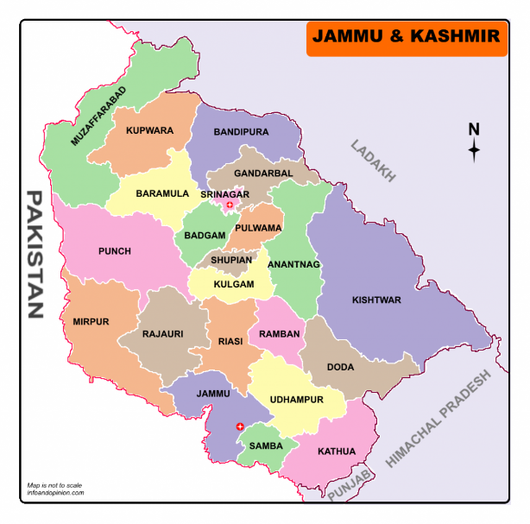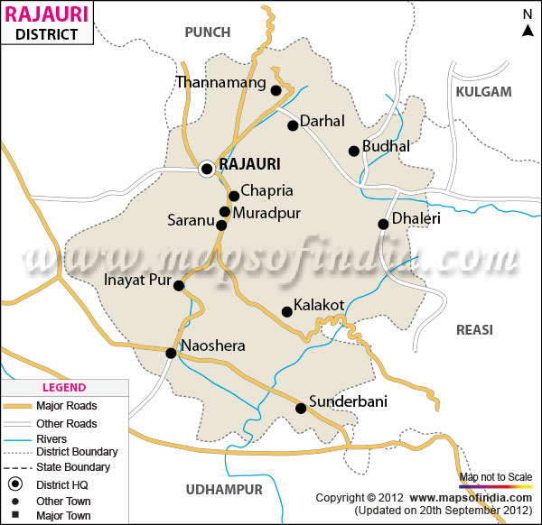

  Fig1: Map of J&K(MapsofIndia.com). Fig 2: Map of Dist. Rajouri

* 1. **VEGETATION AND WILD LIFE (FLORA AND FAUNA)**

The Union Territory of Jammu and Kashmir is well endowed with the natural vegetation. Its natural vegetation has great diversity in flora, ranging from the lush green margs (Alpine Pastures) to evergreen conifers on gentle slopes of high altitudes. Scrub forest cover southern slopes of Siwalik foot hills and deciduous forest are found on the southern slopes of Siwalik and Pir-Panjal range.

The common types of trees found in Jammu region are Kikar (Acacia), Ber, Shisham, Pipal, Banyan, Mango and Palm. Chir, Deodar, Spruce, Maple Oak, Walnut and Poplar are found in Kashmir. The willow, mulberry and walnut trees provide raw materials required for the development of sports goods, furniture and wood artefacts. Many people earn their livelihood from these forest-based industries. Forests also provide turpentine and a variety of resins, used in several chemical industries. Resin is collected from the pine trees.

* 1. **STUDY DESIGN**

Avifauna of Darhal was explored based upon both extensive and intensive avian studies in various bio-geographical zones of the valley. Extensive studies mainly involved the detailed survey of avifauna in different study sites, whereas, intensive studies were based on Line Transect Method which is based on the theory of walking along a predetermined route to record the objects on or near the line. This is one of the most commonly used methods for estimating the abundance of bird populations and is practical, efficient and relatively inexpensive (Burnham et al., 1980). It is also applicable for monitoring of birdlife of an area throughout the year. Keeping in view the hilly and more rugged terrain of the state, Piecewise Linear Line Transects were marked and monitored fortnightly in various experimental 30 sites. Further, these transects were monitored as open width transects, where birds were recorded irrespective of their distance from the transect.

1. **OBSERVATIONS**

|  |  |  |  |  |  |
| --- | --- | --- | --- | --- | --- |
| **S.No.** | **COMMON NAME** | **SCIENTIFIC NAME** | **FAMILY** | **HABITAT** | **IUCN STATUS** |
|  | MALLARD | *Anasplatyrhynchos* | ANATIDAE | MARSHES, WOODY SWAMPS | LC |
|  | EURASIAN JAY | *Garrulusglandarius* | CORVIDAE | CONIFEROUS FORESTS | LC |
|  | HIMALAYAN BLACK LORED TIT | *Parusxanthogenys* | PARIDAE | FOREST EDGES | NGT |
|  | SPOTTED FORK TAIL | *Enicurusmaculatus* | MUSCICAPIDAE | TROPICAL AND SUBTROPICAL MOIST MONTAIN FORESTS | LC |
|  | ULTRAMARINE FLYCATCHER | *Ficedulasuperciliaris* | FICEDULA FAMILY | FOOTHILLS OF THE HIMALAYAS AND WINTERS IN SOUTHERN INDIA | LC |
|  | GRAY HERON | *Ardea cinerea* | ARDEIDAE | FOUND IN AND AROUND SHALLOW WATER | LC |
|  | YELLOW BRESTED GREEN-FINCH | *Chlorisspinoides* | FINCHES | TEMPERATE FORESTS AND TEMPERATE SHRUBLAND | LC |
|  | ROCK BUNTING | *Emberiza cia* | EMBERIZIDAE | NEW AFRICA, SOUTHERN EUROPE, EAST TO CENTRAL ASIA | LC |
|  | EGYPTIAN VULCHURE | *Neophronpercnopterus* | ACCIPITRIDAE | OPEN HILLS, LOW MOUNTAIN RANGES | EN |
|  | SHIKRA | *Accipiter badius* | ACCIPITRIDAE | OPEN JUNGLE, EVEN URBAN GARDENS | LC |
|  | BLACK THROATED THRUST | *Turdusatrogularis* | THRUST FAMILY | EDGES OF CLEARINGS IN CONIFEROUS OR MIXED DECIDUOUS FORESTS | NGT |
|  | GRAY WAGTAIL | *Motacillacinerea* | MOTACILLIDAE | OPEN HILLS, LOW MOUNTAIN RANGES | LC |
|  | SLATY HEADED PARAKEET | *Psittaculahimalayana* | PSITTACULIDAE | CONIFEROUS FORESTS | LC |
|  | LEMON RUMPED WARBLER | Phylloscopusproregulus | PHYLLOSCOPIDAE | OPEN HILLS, LOW MOUNTAIN | LC |
|  | ROCK PIGEON | *Columba livia* | COLUMBIDAE | AROUND BARN YARDS, PARKS AND HOUSES | LC |
|  | ASIAN KOEL | *Eudynamysscolopaceus* | CUCKOOS FAMILY | LIGHT WOODLAND AND CULTIVATION | LC |
|  | COMMON HAWK CUCKOO | *Hierococcyxvarius* | CUCULIDAE | GARDENS, GROOVES | LC |
|  | EURASIAN HOOPOE | *Upupa epops* | UPUPIDAE | EUROPE, ASIA AND NORTH AFRICS | LC |
|  | HIMALAYAN WOODPECKER | *Dendrocoposhimalayensis* | PICIDAE | BOREAL FORESTS AND TEMPERATE FORESTS. | LC |
|  | HOUSE CROW | *Corvussplendens* | CORVIDAE | SOUTH ASIA, INDIA, PAKISTAN | LC |
|  | LARGE BILLED CROW | *Corvusmacrorhynchos* | CORVIDAE | WOODLANDS, URBAN LAND SCAPES | NT |
|  | HIMALAYAN BULBUL | *Pycnonotusleucogenys* | BULBUL FAMILY | HOME GARDENS, HILLY SLOPES | LC |
|  | COMMON MYNA | *Acridotherestristis* | STARLING | OPEN COUNTRY AND CULTIVATED LAND | LC |
|  | BANK MYNA | *Acridotheresginginianus* | STURNIDAE | ALMOST RESTRICTED TO INDIAN SUBCONTINENT | LC |
|  | ORIENTAL MAGPIE ROBIN | *Copsychussavlaris* | THRUS FAMILY- TURDIDAE | OPENWOODLAND AND CULTIVATED AREAS | LC |
|  | HOUSE SPARROW | *Passer domesticus* | PASSERIDAE | CLOSE TO HUMAN HABITATION | LC |
|  | BLACK KITE | *Milvusmigranus* | ACCIPITRIDAE | TIMBERED WATER CORSES TO OPEN LAND | LC |
|  | SPOTTED DOVE | *Spilopeliachinensis* | COLUMBIDAE | WOODLAND AND SCRUB | LC |
|  | PIED CUCKOO | *Clamatorjacobinus* | CUCULIDAE | LOW LAND AND FOOT HILLS | LC |
|  | HAIR CRUSTED DRONGO | *Dicrurushotteentottus* | DICRURIDAE | WOODED HABITATS, DENSE FORESTS TO SAVANNA | LC |
|  | GRAY BREASTED PRINIA | *Priniahodgsonii* | CISTICOLIDAE | SCRUB FORESTS AND UNDER GROWTH ALONG FOREST EDGES | LC |
|  | BLUE THROATED FLYCATCHER | *Cyusnisrubeculoides* | MUSCICAPIDAE | HIMALAYAS FROM NORTH EAST TO NORTH WEST. | LC |
|  | KHALIJ PEASANT | *Lophuraleucomelanos* | PHASIANIDAE | FOREST AND THICKETS, HIMALAYAN FOOTHILLS | LC |
|  | CATLLE EGRET | *Bubulcus ibis* | ARDEIDAE | PASTURES AND FARM LANDS | LC |
|  | PLUM HEADED PARAKEET | *Psittaculacyanocephala* | SPITTACIDAE | FOREST AND OPEN WOODLAND | LC |
|  | ASHY DRONGO | *Dicrurusleucophaeus* | DICRURIDAE | ANY WOODED HABITAT, ACROSS THE HIMALAYAN FOOR HILLS | LC |
|  | INDIAN PARADISE FLYCATCHER | *Terpsiphoneparadisi* | MONARCHIDAE | TEMPERATE FORESTS AND TROPICAL RAIN FORESTS | LC |
|  | BARN SWALLOW | *Hirundorustica* | HIRUNDINIDAE | EAVES, RAFTERS AND CROSS BEAMS OF BARNS | LC |
|  | BLACK BULBUL | *Hypsipetesleucocephalus* | PASSERINE BIRDS | BROAD LEAVED FORESTS AND GARDENS | LC |
|  | BLACK THROATED TIT | *Aegithalosconcinnus* | AEGITHALIDAE | BROAD LEAF AND FIXED FORESTS IN FOOTHILLS | LC |
|  | JUNGLE MYNA | *Acridotheresfuscus* | STARLING FAMILY | TERRESTRIAL MANAGED FORETS, PLANTATIONS AND ORCHARDS | LC |
|  | VERDITER FLYCATCHER | *Eumyiasthalassi nus* | MUSCICAPIDAE | OPEN LOW LAND AND LOWER MOUNTAIN FORESTS | LC |
|  | RUSSET SPARROW | *Passer rutilans* | PASSERIDAE | LIGHT WOODLAND, TRACE CULTIVATION ACROSS EDGES OF VILLAGES | LC |

IUCN; LC: LEAST CONCERT, NT: NOT THREATNED, NGT: NOT GLOBALLY THREATNED, VU: VULNERABLE, EN: ENDANGEREED.

1. **SUMMARY AND CONCLUSION**

The valley of Darhal situated in district Rajouri in the Himalayan UT of Jammu and Kashmir is bestowed with the rich biodiversity of fauna and flora. The valley, which is very narrow in breadth, is home to numerous migratory species of birds. This includes swifts, reptiles, the raptors, thrusts, buzzards, barbets et cetera. These birds migrate from Siberia, Russia, China, Mongolia, Mediterranean belt and Europe. A total of 99 species of birds were recorded in the study area, majority of which are migratory. The birds travel across the continents during the period of migration in sky to reach their destination. So, the questions arise what promotes to migration of birds? Why they take the risk of migration? How they know the transcontinental path of migration? Birds before migration gains lots of weight to fulfil their requirement during flight and to breed the young once. The migratory birds during their migration temporarily lands in a locality where abundant availability of food and safe place are available, such migratory birds in that locality considered as passage migrants. Few birds they found throughout the year in a locality considered as residents. Where-as the birds which are found at one site in India but not at another site during particular season are considered as local migrants.

1. **BIBLIOGRAPHY**

**Abdar Mohan Ramchandra. (2013).** Diversity and richness of bird species in newly

formed habitats of Chandoli National Park in Western Ghats, Maharashtra State, India.

Biodivers. J. Agric. Res. New Delhi.4(1): 235-242.

**Abdar Mohan Ramchandra. (2007).** Hydrobiology and monitoring avifauna of

Morna, Dist. Sangli (M. S.) India, Thesis submitted to Dr. Babasaheb Ambedkar

Marathwada University, Aurangabad: 1-5.

**Abdar M. R. (2009).** Hydrobiological monitoring avifauna and ichthyofauna of Sina

Dam Dist. Ahmednagar (M.S.) India, A thesis submitted to Dr. Babasaheb Ambedkar

Marathwada University, Aurangabad: 1-5.

Asefa A., Y. Mamo G. Mengesha and A. Shimelis (2015). Woody plant diversity

along disturbance gradients in thenorthern Afro-montane forests of the Bale Mountains,

Ethiopia. Int. J. Dev. Res. 5: 3745–3754.

**Bassouvalingam K., Inbanathan Jagannathan, Jayaraman Nadarajan (2012).** The

Status of avifauna of Ousudu lake, Puducherry, India. Int. J. Res. BioSci. 1(2): 38-46.

Bennett A.F., Brown G., and Silins J. (1998). Fragments for the Future. Wildlife in

the Victorian Riverina (The Northen Plains). Department of Natural Resources and

Environment, Melbourne: 1-7.

**Bhatti R. (2002).** On bio diversity and ecology of aquatic avifauna at Bhavnagar Coast

line, A thesis submitted to Bhavnagar University, Bhavnagar: 1-5.

**Chandra, K., Sheela, S. and Das, D. 2016. Animal Discoveries 2016** – New Species

and New Records. Published by the Director, Zoological Survey of India, Kolkata:

1-108.

**Chavan S., Dudhmal D., Hambarde S. and Kulkarni A. (2015).** Birds from Godavari

river basin in Nanded district of Maharashtra state,India. Annoted status and new

reports. Int. J. Curr. Res. Acad. Rev.3: 328-351.

**Chilke A. M. (2012).** Avian diversity in and around Bamanwada lake of Rajura, district

Chandrapur (Maharashtra). Scholars Research Library. Ann. Biol. Res. 3(4): 2014-

2018.

**Desai M. and Shanbhag, A. (2007).** Birds breeding in unmanaged monoculture

plantations in Goa, India. Ind. For. (133): 1367-1372. 100

**Dev B. (2003).** Carried Ecological studies on the avifauna of Barak Valley, Assam with

special reference to family – Ardeidae, A thesis submitted to Assam University, Silchar:

1-5.

**Hutto R.L. (1985).** Habitat selection in birds. Academic Press. Inc., Montana: 450-

455. 102

**Ibarra J. T., Christopher B. Anderson, Tomás A. Altamirano, Ricardo Rozzi, and**

**Cristián Bonacic (2010).** Diversity and singularity of the avifauna in the austral peat

bogs of the Cape Horn Biosphere Reserve, Chile Cien. Inv. Agr. 37(1):29-43.

Johnsingh AJT, Paramarandham K, S Murali (1981) Foraging behaviour and

interactions of Whiteheaded Babbles Turdoides affinis with other species. J BHNS 79:

503-514

**Jog P. and Pardeshi K. S. (2012).** Avian diversity on fort Panhala, Kolhapur,

Maharashtra, recent trends in Zoology, a compilation of research articles, ISBN: 978-

93-8491664-8.

**Mattu VK, Thakur ML (2006)** Birds of summer hill, Simala (Himachal Pradesh).

Ind Forester 132(10): 1271-1281