Moringa olifera and their nutritional properties,Meathod of Preparation.

By,

Mr.Digvijay Shivaji Deshmukh.

Mr.Kunal Vijay Wankhede

Mr.Saurabh Prakash Chaudhari

**Abstract**

Moringa is native to India and grows in tropical and subtropical regions of the world. It is often called the "drumstick tree" or "horseradish tree".

Moringa is grown all over the world because it is resistant to harsh and cold weather conditions. Because of its high nutritional value, all parts of the tree are suitable for food or commercial use.  
Leaves are rich in minerals, vitamins and other important phytochemicals. Leaf extract is used to treat malnutrition and increase milk production in breastfeeding mothers. It is used as antibiotic, antibiotic, antibiotic, antibiotic and antibiotic. Olea europaea seed is a natural coagulant and is widely used in water purification. The results of this study provide insights into the use of moringa to treat diabetes and cancer, as well as the preservation of moringa in commercial products.  
This review explores the use of moringa across disciplines for its medicinal value and deals with cultivation, nutrition, commercial and prominent pharmacological properties of this “Miracle Tree’’.[1]

**Introduction**

Moringa belongs to the **Moringaceae**family and is an excellent remedy  against malnutrition. Moringa leaves, peels and seeds contain many important phytochemicals, making them beneficial. In fact, moringa is said to provide 7 times more vitamin C than oranges, 10 times more vitamin A than carrots, 17 times more calcium than milk, 9 times more protein than yogurt, 15 times more potassium and more iron than bananas. than banana. 0.25 times. Spinach [1]. Moringa is easy to grow, making it a cure for malnutrition. Countries such as Senegal and Benin use Moringa to treat children [2]. Children who are not breastfed often have signs of malnutrition. Galactagogues are often given to breastfeeding mothers to increase milk production. Galactagogues are produced from plant sterols, which are precursors of hormones essential for children's development. Moringa is rich in phytosterols such as stigmasterol, sitosterol and campesterol, which are hormone precursors. These compounds increase estrogen, which stimulates the growth of the mammary ducts to produce milk. It is used to treat malnutrition in children under 3 years of age.

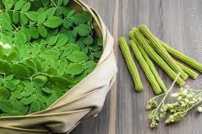

**Nutritive properties**

Every part of Moringa is a storehouse of essential nutrients and antioxidants. Moringa leaves are rich in minerals such as calcium, potassium, zinc, magnesium, iron and copper. [2] Olive oil also contains vitamins C, D, and E, such as vitamin A, vitamin B, beta-carotene, folic acid, pyridoxine, and niacin. [8] Phytochemicals such as tannins, sterols, terpenoids, flavonoids, saponins, anthraquinones, alkaloids, and reducing sugars and antioxidants such as glucosinolates, isothiocyanates, glycoside compounds, and Glyceryl-1-9- octadecanote[9] Moringa leaves are also low in calories and can be used in the diet of obese people. Broad beans are rich in fiber and are beneficial in treating digestive problems and preventing cancer. [10,62] A study found that ripe fruit has approximately 46.78% fiber and approximately 20.66% protein content. The amino acid content of pods is 30%, leaves are 44%, and flowers are 31%. Fruits and immature flowers contain similar amounts of palmitic, linolenic, linolenic and oleic acids. [11]  
Moringa contains many nutrients necessary for growth and development; Calcium is considered one of the most important nutrients for human development. 8 ounces of milk provides 300-400 mg, moringa leaves provide 1000 mg, and moringa powder provides over 4000 mg. Moringa powder can be used as a substitute for iron tablets in the treatment of diabetes. While beef contains only 2 mg of iron, moringa leaf powder contains 28 mg of iron. Moringa reportedly contains more iron than spinach. [12] Adequate dietary zinc is essential for the development of sperm cells and is required for DNA and RNA synthesis. Moringa leaves contain approximately 25.5-31.03 mg/kg of zinc, which is the daily zinc requirement. [13]

PUFA are linoleic acid, linoleic acid and oleic acid; These polyunsaturated fatty acids can control cholesterol. Research shows that moringa seed oil contains approximately 76% PUFA, making it ideal for use as an alternative to olive oil. [14] It is important to note that food supply varies by location. Fuglie showed that season can affect food supply. Research shows that vitamin A is abundant in hot and humid seasons, while vitamin C and iron are abundant in cold and dry seasons. [15] The difference in results can be attributed to location, weather, and environmental factors that affect the content of the trees. [16]

**Processing of moringa**

Most plants lose their nutritional value when processed. When the nutritional content of raw, germinated and fermented Moringa oleifera seed powder was compared, it was found that raw Moringa oleifera seed powder had more phytochemicals, while fermented and sprouted Moringa oleifera seed powder contained the most amino acids. [17,59] The result of biochemical activity during germination and microbial activity during fermentation. However, one study examined the effects of boiling, simmering, and boiling to monitor the nutrients in Moringa leaves. Interestingly, boiling was the most effective of all the methods studied, as it reduced cyanide, oxalate, and phytate levels more than the other two methods. The presence of phytates and other chemicals can reduce the bioavailability of some nutrients so that they can be processed to use the nutrients needed in the seeds and leaves. [18,63] reported that anger increased iron and antioxidant content. Therefore, Moringa seed powder treatment can be used to treat adverse problems. However, some studies show that children are reluctant to eat moringa because it tastes a bit bitter. [70] used three methods to cook noodles: stir-frying, steaming, and boiling when producing moringa noodles. The noodles were tested on mice and their effects on mammary tumors were investigated. Interestingly, stir-fried noodles have a positive effect on the mammary glands of mice and increase milk production. The benefits of fried noodles are that it increases lactose because the oil used is rich in sterols. Olea europaea is also added to chocolate. A recent report tested different concentrations of moringa in chocolate supplements and found that 20% moringa in cocoa powder was good. Likewise, adding moringa to halava tahini increases the nutritional value of this delicious dish. These studies reveal the potential of producing chocolate and halva tahini with high protein and mineral content. [20] Various moringa supplements can ensure that children get adequate nutrients.

**Preservation methods**

Moringa can also be stored for a long time without losing its nutritional value. Leaves can be stored dry or frozen. [15] found that oven heat used to dry leaves retained more nutrients other than vitamin C than dried leaves. Therefore, for the health of the leaves, the drying process can be done using household appliances such as ovens. The shelf life of Moringa can be increased by drying it without changing its nutritional value.  
Consuming too much moringa can cause serious iron deficiency. Too much iron can cause intestinal problems and hemochromatosis. Therefore, it is recommended to consume 70 grams of moringa per day to prevent overeating.[21]

**Morphology**

The tree grows very quickly in fertile and well-drained sandy soil and prefers upright growth heights, but sometimes its branches are often uneven and of poor quality with an umbrella-shaped crown; The brown seeds have a halved shape. -transparent shell. ,< br>Each canopy is umbrella-shaped; The brown seeds have an outer shell that can hold approximately 15,000-25,000 seeds per plant per year.

**Botanical and Geographical Distribution**

Moringa oleifera is widely distributed worldwide, but has its origin in India. It is seen in Asia, Africa, the Caribbean, Latin America, Arabia and the East Indies. It is found in Asia, Africa, Caribbean, Latin America, Pacific Islands, Florida, Madagascar, Central America, Cuba, Philippines, Ethiopia, Pacific Islands, Florida, Madagascar, Central America, Cuba, Philippines, Ethiopia. and Nigeria. The history of the plant told M. Camellia oleifera was introduced from Nigeria. Plant history describes the origin of Olea oleifera from India to Africa, Southeast Africa and the Philippines. In ancient times, it ranged from India to Africa, Southeast Africa and the Philippines. It needs tropical and subtropical regions where the temperature is up to 25-35°C, and tropical and subtropical regions where the temperature is up to 25-35°C. Olea europaea is a deciduous tree that usually grows in tropical and subtropical regions. Olea europaea is a deciduous tree that grows mostly in tropical and subtropical regions around the world. It grows best in indirect sunlight in the world and does not become waterlogged. It grows best in direct sunlight without stagnation of water, and the soil should be slightly acidic or alkaline. The tree begins bearing fruit between 6 and 8 pm and the soil should be slightly acidic to alkaline. The tree begins to bear fruit when it is 6-8 months old. It has been grown commercially in many countries such as Africa and Mexico. It is grown commercially in many countries such as Africa, Mexico, Hawaii, Iko, Hawaii and South America. However, food quality is different in South America due to different soils. However, because the soil is different, the main points are also different from South America, there are differences.

**Cultivation and Collection**

Moringa is a small to medium-sized deciduous or evergreen tree, widespread in tropical, mountainous and some central regions of Nepal. [It grows up to 25-30 meters tall and grows in middle table, siwalik and teraiarea regions. It is most suitable for its cultivation. It grows best in direct sunlight, at an altitude of 0 to 1000 meters. Moranga tolerates a wide range of soils but prefers neutral to slightly acidic (pH 6.3-7.0). This indicates that it likes well-drained sand or loam soil. The minimum annual precipitation should be approximately 250 mm and the maximum should be more than 3,000 mm. However, roots rot in waterlogged soil. In areas with heavy rainfall, trees can be planted on slopes to encourage water flow. The presence of a long taproot allows the plant to withstand drought. The ideal temperature is 12-40 degrees Celsius, but the tree can withstand temperatures up to 48 degrees in the shade and survive light frosts. It easily colonizes coastal and savanna areas where the soil is well-drained and the water table remains fairly high throughout the year. Although the plant is drought tolerant, leaf production is greatly reduced when exposed to constant water stress. It is not damaged by frost, but it freezes back to the ground and dies.

**Benefits of Moringa oleifera**

Nutritional properties:-

Moringa is known as the "miracle tree" due to its high nutritional value and ability to treat many ailments. Every part of the plant contains nutrients. Moringa leaves are rich in minerals such as calcium, potassium, zinc, magnesium, iron and copper. Its leaves do not contain calories and can be used in the diet of obese people. The leaves also contain all the essential amino acids and are rich in protein and minerals. Broad beans contain approximately 46.78% fiber, 20.66% protein and are effective in the treatment of stomach disorders and cancer. Moringa also contains vitamins such as vitamin A, vitamin B, beta-carotene, pyridoxine, niacin, vitamin C, vitamin D and E.

**The use of different parts of Moringa oleifera is described as below:-**

1.Leaves: MO leaves are thought to be a rich source of vitamins and minerals and strong antioxidant activity, mainly coming from plant vitamins and phenolic compounds such as quercetin and kaempferol. The leaves can also be used as a vegetable and used in tea, powder and other medicinal purposes. Additionally, juice from fresh leaves has growth benefits and can increase yields by 25-35%. According to a 2009 study conducted in Japan, leaves are good sinks for absorbing and using carbon dioxide. Moringa trees absorb carbon dioxide 20 times faster than normal plants. Moringa is said to provide 7 times more vitamin C than oranges, 10 times more vitamin A than carrots, 17 times more calcium than milk, 9 times more protein than yogurt, 15 times more potassium than bananas and 25 times more iron. spinach. .

2.Root: Moringa root bark can treat stomach ulcers and gastric mucosal lesions. It also reduces acidity and increases the pH of the juice. Therefore, MO has anti-inflammatory and anti-inflammatory properties and can therefore be used as an anti-inflammatory drug in the future.

3.PODhusks: MO bark contains alkaloids, flavonoids, tannins, triterpenes, diterpenes and cardiac glycosides. MO broad bean shell extract has antibacterial properties against some Gram-positive Staphylococcus epidermidis, Enterococcus faecalis and Gram-negative bacteria Klebsiella pneumoniae.

4.Seed: Moringa seeds contain many phytochemicals, including antioxidants, flavonoids and anthocyanins, as well as some rare substances such as vitamin C, beta-carotene, alpha- and gamma-tocopherols, beta-sitosterol, vitamin A, the phenolic compounds quercetin and kaempferol. . The class includes alkaloids, glucosinolates, and isothiocyanates. Mature seeds of MO are rich in oil, containing 22% to 40% crude oil. Analysis of the composition of the oil showed that the oil contains a high content of monounsaturated fatty acids, especially oleic acid. A higher dietary intake of monounsaturated fatty acids (mainly oleic acid) has been shown to be associated with a reduced risk of heart disease. The seed extract can be used to prevent malaria vectors such as Anopheles malaria mosquitoes. Phytochemicals extracted from MO seed extract are mosquito vector control agents, and plant extracts can be used in additional pest control.

**Medicinal Properties**

Moringa has many medicinal properties and can treat many ailments. It is used to treat diabetes, heart disease, anemia, arthritis, respiratory problems, skin problems, liver problems, stroke, infertility, rheumatism, digestive disorders and other ailments. It was selected as the tree of the year 2008 by the National Institute of Health and Home Care in India. It is also used to treat acid, pneumonia and insect bites in many countries, including Africa. According to various studies, the leaves are said to have antiseptic, antibacterial, anti-abortion properties and act as a flocculant and stimulant. Moringa powder can be used as a substitute for iron tablets and thus treat diabetes. The health benefits of this wonderful herb are seemingly endless.

**IT FIGHT AGAINST FREE RADICALS**

Antioxidants are popular because they kill free radicals that cause oxidative stress, cell damage, and inflammation. In addition, the leaves, flowers and seeds of Moringa contain antioxidants called flavonoids, polyphenols and ascorbic acid, which are beneficial in many ways. One study found that leaf extracts had greater antioxidant activity, free radical scavenging ability, and greater inhibition of lipid, protein, and DNA oxidation than flowers and seeds. This means that it prevents damage and damage caused by free radicals to cells in different organs of the body, keeping them healthy and functioning well. [19]

**HEPATO PROTECTIVE**

Moringa leaves and flowers contain large amounts of polyphenols, which play an important role in protecting the liver from damage, oxidation and toxicity. Moringa oil also restores liver enzymes to normal levels, reduces oxidative stress and increases protein content in the liver. The liver is responsible for detoxification of blood, bile, fructose metabolism, fat metabolism and nutrition. For example, low levels of liver enzymes can impair the liver's ability to filter blood.

**ANTI INFLAMMATORY**

The best use of Moringa extract is in the treatment of various ailments and inflammations. The disease can lead to chronic diseases such as diabetes, respiratory disease, heart disease, arthritis and obesity. Moringa reduces inflammation by inhibiting inflammatory enzymes and proteins in the body, and leaf concentrate may reduce inflammation in the brain. [20]

**IT PROTECTS CARDIOVASCULAR SYSTEM**

Moringa leaf powder is especially beneficial for heart health by regulating blood lipids, preventing plaques in the arteries, and lowering cholesterol. The excellent combination of diuretics with lipid-lowering and blood pressure-lowering properties makes this herb useful against heart diseases. Moringa leaf juice has significant benefits in controlling blood pressure. Glucosinolates and thiocarbamate glycosides have been isolated from moringa leaves and have been shown to have anti-inflammatory effects. [20]

**ANTI DIABETIC**

Moringa has good antidiabetic properties. Leaf powder is effective in lowering blood lipid and sugar levels and controlling oxidative stress in diabetics; This means it lowers blood sugar and cholesterol levels and improves protective repair of the hand. Moringa has been shown to treat patients with type 1 and type 2 diabetes (called type 1 diabetes) who are unable to produce insulin. Insulin is a medication that controls blood sugar levels in the body. Type 2 diabetes is a type of diabetes associated with insulin resistance. Type 2 diabetes occurs due to beta cell dysfunction. In such diseases, beta cells cannot detect glucose, therefore reducing insulin signals, causing blood sugar to rise. Many studies have demonstrated the potential of Moringa as an anti-diabetic agent. [20]

**Conclusion:-**

1.Moringa leaves contain antibacterial, antifungal and anti-inflammatory properties. Moringa leaves can lower blood sugar and cholesterol. The leaves of this plant are effective in the treatment of many diseases, especially cancer, heart diseases and diabetes.

2.Moringa seeds are a good alternative to alum.  
3.Increasing the dose of moringa results in a decrease in the apparent dose, followed by an increase in residual turbidity due to re-stabilization of the initial turbidity due to flocculation, followed by a good increase.

**NUTRIENT CHART:**

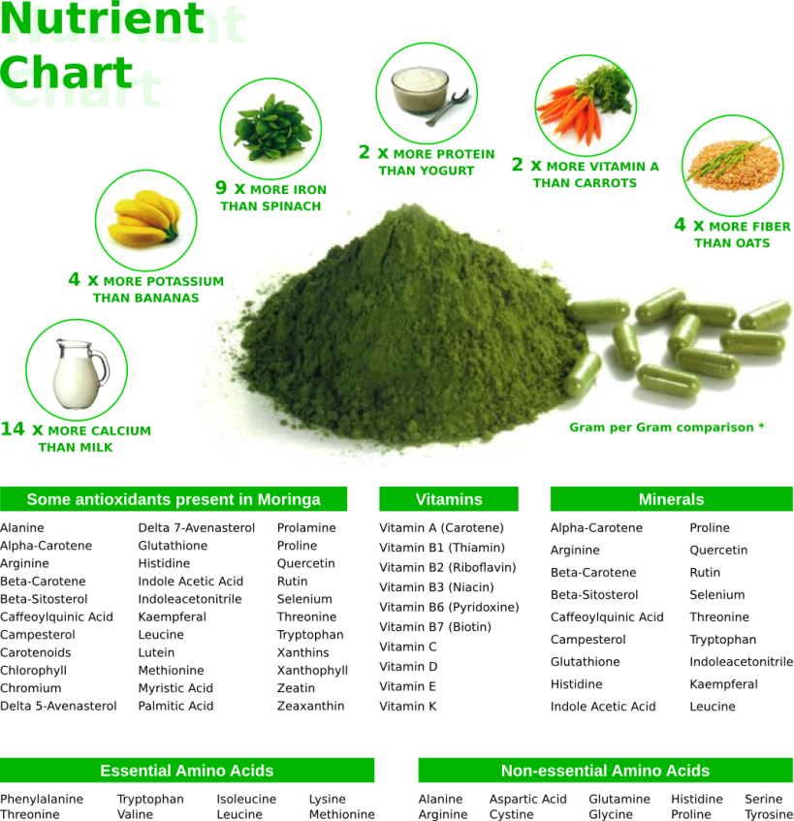

**How To Make Moringa Powder**

Although fresh moringa leaves are easily available in the market, it is better to grind moringa leaves into powder and use it whenever needed. It is quite easy to make powder from moringa leaves. Take the fresh leaves, remove the leaves and discard the stalks and stems, then wash them wel 2-3 times with enough water, then spread them on a kitchen towel to absorb excess water. Now spread this on a colander/strainer or paper towel and place the mixture in a covered area (do not expose it to direct sunlight as it will affect the bright green color of the leaves). If you cannot dry it in the sun, you can dry it under a fan.

The leaves will dry after 12 days. Once the leaves are crispy, gently crush them, discarding the stems and stems (if any), then grind the leaves in a blender and store in an airtight container. Keep fresh for 6 months at room temperature. After 6 months it will lose some of its strength, but it is still edible. If there is a lot, it can be put in the refrigerator. The taste may be slightly bitter, so use a small amount.

**How to Use Moringa Powder-**

1. Add 1 tsp powder in your regular daal to make it healthier..
2. Add in your chapati dough or bread dough.
3. Sprinkle it on any stir fry like you add coriander powder.
4. Add some Moringa powder, lemon juice and honey in a cup of boiling water to make healthy Moringa tea.
5. Add some moringa powder in your yogurt, raita, soup and stew.
6. Can be added in your dosa or cheela batter.
7. **My favourite way**– Mix some moringa powder in your coriander powder jar so it can be added regularly in your daily daal and sabzi, I always add some dried Moringa leaves and dried curry leaves in my Home made Coriander powder to make it more flavourful and healthier.
8. Add in your favorite breakfast smoothies.
9. When ever you make green chutney add 1/2 tsp of moringa powder.
10. Add a little in your salad dressing.
11. It does not dissolve in cold water so add in hot water or liquids.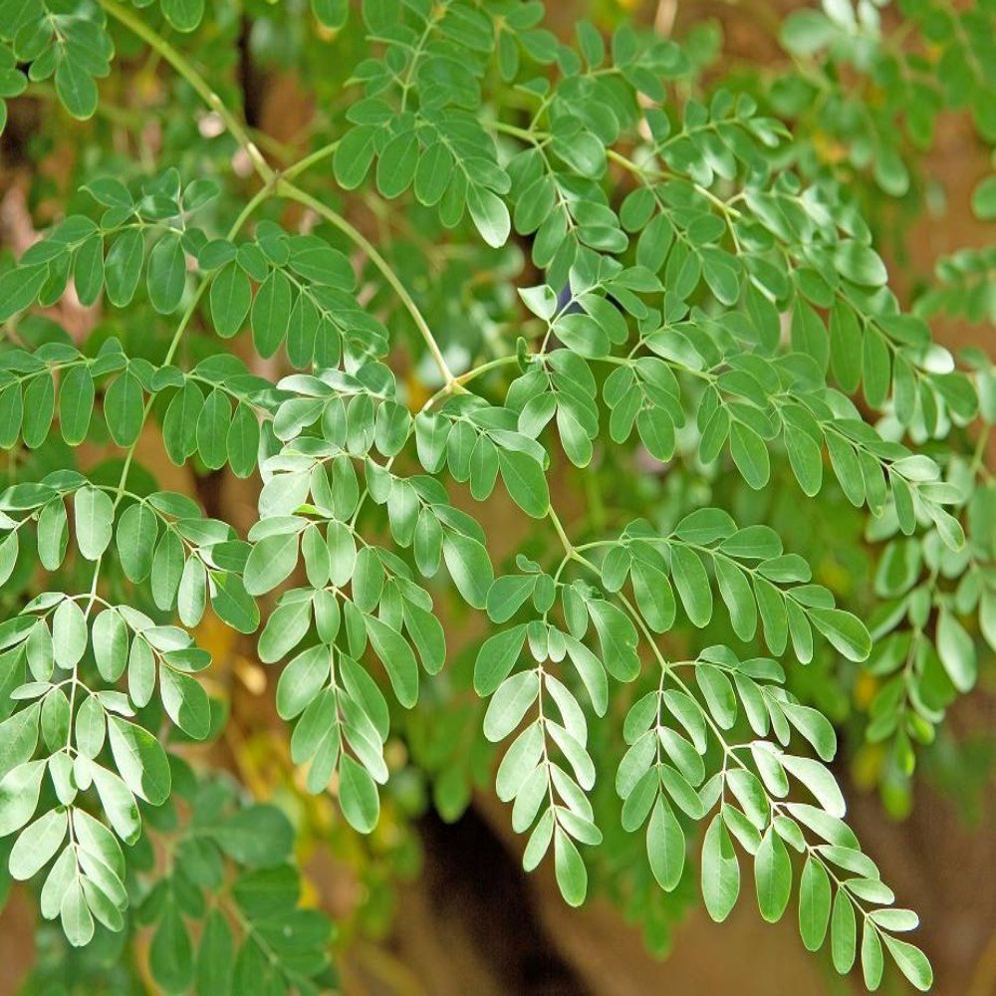

References

in fructose fed insulin resistant and STZ induced diabetic wistar rats: a

comparative study, Asian J. Pharm. Clin. Res. 5 (2012) 67–72.

[1] J.L. Rockwood, B.G. Anderson, D.A. Casamatta, Potential uses of Moringa oleifera and an examination of antibiotic efficacy conferred by M. oleifera seed and leaf extracts using crude extraction techniques available to under- served indigenous populations, Int. J. Phytothearpy Res. 3 (2013) 61–71.

[2] J.N. Kasolo, G.S. Bimenya, L. Ojok, J. Ochieng, J.W. Ogwal-okeng, Phytochemicals and uses of Moringa oleifera leaves in Ugandan rural communities, J. Med. Plants Res. 4 (2010) 753–757.

[3] T. Mutiara Titi, E.S.W. Estiasih, Effect lactagogue moringa leaves (Moringa oleifera Lam) powder in rats, J. Basic Appl. Sci. Res. 3 (2013) 430–434.

[4] M.D. Thurber, J.W. Fahey, Adoption of Moringa oleifera to combat under- nutrition viewed through the lens of the diffusion of innovations theory, Ecol. Food Sci. Nutr. 48 (2010) 1–13.

[5] M.F. Aslam, R. Anwar, U. Nadeem, T.G. Rashid, A. Kazi, M. Nadeem, Mineral composition of Moringa oleifera leaves and pods from different regions of Punjab, Pakistan, Asian J. Plant Sci. 4 (2005) 417–421.

[6] W.J. Asante, I.L. Nasare, D. Tom-Dery, K. Ochire-Boadu, K.B. Kentil, Nutrient composition of Moringa oleifera leaves from two agro ecological zones in Ghana, African J. Plant 8 (2014) 65–71.

[7] S.O. Dania, P. Akpansubi, O.O. Eghagara, Comparative Effects of different fertilizer sources on the growth and nutrient content of moringa (Moringa oleifera) seedling in a greenhouse trial, Pharma. Clin. Res. 5 (2014) 67–72.

[8] M. Mbikay, Therapeutic potential of Moringa oleifera leaves in chronic hyperglycemia and dyslipidemia: a review, Front. Pharmacol. 3 (2012) 1–12.

[9] L. Berkovich, G. Earon, I. Ron, A. Rimmon, A. Vexler, S. Lev-Ari, Moringa oleifera aqueous leaf extract down-regulates nuclear factor-kappaB and increases cytotoxic effect of chemotherapy in pancreatic cancer cells, BMC Complement. Altern. Med. 13 (2013) 212–219.

[10] I. Oduro, W.O. Ellis, D. Owusu, Nutritional potential of two leafy veg- etables: Moringa oleifera and Ipomoea batatas leaves, Sci. Res. Essays 3 (2008) 57–60.

[11] D.I. Sánchez-Machado, J.A. Nún ̃ez-Gastélum, C. Reyes-Moreno, B. Ramírez-Wong, J. López-Cervantes, Nutritional quality of edible parts of Moringa oleifera, Food Anal. Methods 3 (2010) 175–180.

[12] L.J. Fuglie, The Moringa Tree: A local solution to malnutrition Church World Service in Senegal, 2005.

[13] J.T. Barminas, M. Charles, D. Emmanuel, Mineral composition of non- conventional leafy vegetables, Plant Foods Hum. Nutr. 53 (1998) 29–36.

[14] S. Lalas, J. Tsaknis, Characterization of Moringa oleifera seed oil variety Periyakulam-1, J. Food Compos. Anal. 15 (2002) 65–77.

[15] R. Yang, L. Chang, J. Hsu, B.B.C. Weng, C. Palada, M.L. Chadha, V. Levasseur, Nutritional and functional properties of moringa leaves from germplasm, to plant, to food, to health, Am. Chem. Soc. (2006) 1–17.

[16] B. Moyo, P. Masika, A. Hugo, V. Muchenje, Nutritional characterization of Moringa (Moringa oleifera Lam.) leaves, African J. Biotechnol. 10 (2011) 12925–12933.

[17] O.S. Ijarotimi, O. Adeoti, O. Ariyo, Comparative study on nutrient compo- sition, phytochemical, and functional characteristics of raw, germinated, and fermented Moringa oleifera seed flour, Food Sci. Nutr. 1 (2013) 452–463.

[18] B. Sallau, S.B. Mada, S. Ibrahim, U. Ibrahim, Effect of boiling, simmering and blanching on the antinutritional content of Moringa oleifera leaves, Int. J. Food Nutr. Saf. 2 (2012) 1–[19]Dixit S., *et al*. “Medicinal properties of Moringa oleifera: A Re- view”. *International Journal of Education and Science Research*

[20] Chaudhary K and Chaurasia, S. “Neutraceutical Properties of Moringa oleifera : A Review”. European journal of Pharmaceutical and medical research. 2017.

[21] I.J. Asiedu-Gyekye, S. Frimpong-Manso, C. Awortwe, D.A. Antwi, A.K. Nyarko, Micro- and macroelemental composition and safety evaluation of the nutraceutical Moringa oleifera leaves, J. Toxicol. 2014 (2014) 1–13.

[22] M.E. Cerf, Beta cell dysfunction and insulin resistance, Front. Endocrinol. 4 (2013) 1–12.

[23] S.M. Divi, R. Bellamkonda, S.K. Dasireddy, Evaluation of antidiabetic and antihyperlipedemic potential of aqueous extract of Moringa oleifera

L. Gopalakrishnan et al. / Food Science and Human Wellness 5 (2016) 49–56 55

[24] E. Wright, J.L. Scism-Bacon, L.C. Glass, Oxidative stress in type 2 dia- betes: the role of fasting and postprandial glycaemia, Int. J. Clin. Pract. 60

(2006) 308–314.

[25] H. Kaneto, Y. Kajimoto, J. Miyagawa, T. Matsuoka, Y. Fujitani, Y. Umaya-

hara, T. Hanafusa, Y. Matsuzawa, Y. Yamasaki, M. Hori, Beneficial effects of antioxidants in diabetes: possible protection of pancreatic -cells against glucose toxicity, Diabetes 48 (1999) 2398–2406.

[26] M. Prentki, C.J. Nolan, Islet cell failure in type 2 diabetes, J. Clin. Invest. 116 (2006) 1802–1812.

[27] N. Kamalakkannan, P.S.M. Prince, Antihyperglycaemic and antioxidant effect of rutin, a polyphenolic flavonoid, in streptozotocin-induced diabetic wistar rats, Basic Clin. Pharmacol. Toxicol. 98 (2006) 97–103.

[28] D. Aronson, E.J. Rayfield, How hyperglycemia promotes atherosclerosis: molecular mechanisms, Cardiovasc. Diabetol. 1 (2002) 1.

[29] P. Chumark, P. Khunawat, Y. Sanvarinda, S. Phornchirasilp, N.P. Morales, L. Phivthongngam, P. Ratanchamnong, S. Srisawat, K.U. Pongrapeeporn, The in vitro and ex vivo antioxidant properties, hypolipidaemic and antiatherosclerotic activities of water extract of Moringa oleifera Lam. leaves, J. Ethnopharmacol. 116 (2008) 439–446.

[30] C. Tiloke, A. Phulukdaree, A.A. Chuturgoon, The antiproliferative effect of Moringa oleifera crude aqueous leaf extract on cancerous human alveolar epithelial cells, BMC Complement. Altern. Med. 13 (2013) 226–233.

[31] I.L. Jung, Soluble extract from Moringa oleifera leaves with a new anti- cancer activity, PLOS ONE 9 (2014) 1–10.

[32] G.Y. Liou, P. Storz, Reactive oxygen species in cancer, Free Radic. Res. 44 (2010) 479–496.

[33] A. Hermawan, K.A. Nur, Sarmoko, D. Dewi, P. Putri, E. Meiyanto, Etha- nolic extract of Moringa oleifera increased cytotoxic effect of doxorubicin on HeLa cancer cells, J. Nat. Remedies 12 (2012) 108–114.

[34] Y. Nakamura, M. Kawakami, A. Yoshihiro, N. Miyoshi, H. Ohigashi, K. Kawai, et al., Involvement of the mitochondrial death pathway in chemo preventive benzyl isothiocyanate-induced apoptosis, J. Biol. Chem. 277 (2002) 8492–8499.

[35] N. Miyoshi, K. Uchida, T. Osawa, Y. Nakamura, A link between ben- zyl isothiocyanate-induced cell cycle arrest and apoptosis: involvement of mitogen-activated protein kinases in the Bcl-2 phosphorylation, Cancer Res. 64 (2004) 2134–2142.

[36] K. Baker, C.B. Marcus, K. Huffman, H. Kruk, B. Malfroy, S.R. Doctrow, Synthetic combined superoxide dismutase/catalase mimetics are protective as a delayed treatment in a rat stroke model: a key role for reactive oxy- gen species in ischemic brain injury, J. Pharmacol. Exp. Ther. 284 (1998) 215–221.

[37] W. Kirisattayakul, J. Wattanathorn, T. Tong-Un, S. Muchimapura, P. Wan- nanon, J. Jittiwat, Cerebroprotective effect of Moringa oleifera against focal ischemic stroke induced by middle cerebral artery occlusion, Oxid. Med. Cell. Longev. 2013 (2013) 10–13.

[38] C. Sutalangka, J. Wattanathorn, S. Muchimapura, W. Thukham-mee, Moringa oleifera mitigates memory impairment and neurodegeneration in animal model of age-related dementia, Oxid. Med. Cell. Longev. 2013 (2013) 1–9.

[39] O.S. Adeyemi, T.C. Elebiyo, Moringa oleifera supplemented diets pre- vented nickel-induced nephrotoxicity in Wistar rats, J. Nutr. Metab. 2014 (2014) 1–8.

[40] M.K. Choudhary, S.H. Bodakhe, S.K. Gupta, Assessment of the antiulcer potential of Moringa oleifera root-bark extract in rats, JAMS J. Acupunct. Meridian Stud. 6 (2013) 214–220.

[41] T.G. Monera, C.C. Maponga, Prevalence and patterns of Moringa oleifera use among HIV positive patients in Zimbabwe: a cross-sectional survey, J. Public Health Africa 3 (2012) 6–8.

[42] G.S. Mahajan, A.A. Mehta, Anti-arthritic activity of hydroalcoholic extract of flowers of Moringa oleifera lam. in Wistar rats, J. Herbs Spices Med. Plants 15 (2009) 149–163.

[43] G.H.F. Viera, J.A. Mourão, Â.M. Ângelo, R.A. Costa, R.H.S.D.F. Vieira, Antibacterial effect (in vitro) of Moringa oleifera and Annona muricata against Gram positive and Gram negative bacteria, Rev. Inst. Med. Trop. Sao Paulo 52 (2010) 129–132.

56 L. Gopalakrishnan et al. / Food Science and Human Wellness 5 (2016) 49–56

[44] J. Fahey, Moringa oleifera: a review of the medical evidence for its nutri- tional, therapeutic, and prophylactic properties, Trees Life J. 1 (2005) 1–33.

[45] S. Suhartini, N. Hidayat, E. Rosaliana, Influence of powdered Moringa oleifera seeds and natural filter media on the characteristics of tapioca starch wastewater, Int. J. Recycl. Org. Waste Agric. 2 (2013) 1–11.

[46] K. Ravikumar, A.K. Sheeja, Heavy metal removal from water using Moringa oleifera seed coagulant and double filtration, Int. J. Sci. Eng. Res. 4 (2013) 10–13.

[47] O. Aluko, M.R. Brai, A.O. Adelore, Materials evaluation of sensory attributes of snack from maize-moringa seed flour blends, Int. J. Innov. Res. Sci. Eng. Technol. 7 (2013) 597–599.

[48] I.O. Steve, O.I. Babatunde, Chemical compositions and nutritional proper- ties of popcorn-based complementary foods supplemented with Moringa oleifera, Leaves Flour 2 (2013) 117–132.

[49] D. Owusu, I. Oduro, Development of crackers from cassava and sweet- potato flours using Moringa oleifera and Ipomoea batatas leaves as fortificant, Am. J. Food Nutr. 1 (2011) 114–122.

[50] A.L. Al-Malki, H.A. El Rabey, The antidiabetic effect of low doses of Moringa oleifera Lam. seeds on streptozotocin induced diabetes and dia- betic nephropathy in male rats, Biomed. Res. Int. 2015 (2015) 1–13.

[51] O.E. Adejumo, A.L. Kolapo, A.O. Folarin, Moringa oleifera Lam. (Moringaceae) grown in Nigeria: in vitro antisickling activity on deoxy- genated erythrocyte cells, J. Pharm. Bioall. Sci. 4 (2012) 118–122.

[52] P.T. Olagbemide, P.C. Alikwe, Proximate analysis and chemical composi- tion of raw and defatted Moringa oleifera kernel, Adv. Life Sci. Technol. 24 (2014) 92–99.

[53] M. Lurling, W. Beekman, Anticyanobacterial activity of Moringa oleifera seeds, J. Appl. Phycol. 23 (2010) 503–510.

[54] L.P. Shank, T. Riyathong, V.S. Lee, S. Dheeranupattana, Peroxidase activity in native and callus culture of Moringa oleifera Lam, J. Med. Bioeng. 2 (2013) 163–167.

[55] T.R. Santos, M.F. Silva, L. Nishi, A.M. Vieira, M.R. Klein, M.B. Andrade, M.F. Vieira, R. Bergamasco, Development of a magnetic coagulant based on Moringa oleifera seed extract for water treatment, Env. Sci. Pollut. Res. (2016) 1–9.

[56] K.J. Raphaël, Effects of substituting soybean with Moringa oleifera meal in diets on laying and eggs quality characteristics of KABIR chickens, J. Anim. Nutr. 1 (2015) 1–6.

[57] T.S. Olugbemi, S.K. Mutayoba, F.P. Lekule, Effect of Moringa (M. oleifera) inclusion in cassava based diets fed to broiler chickens, Int. J. Poult. Sci. 9 (2010) 363–367.

[58] M.E. Sengupta, B. Keraita, A. Olsen, O.K. Boateng, S.M. Thamsborg, G.R. Pálsdóttir, A. Dalsgaard, Use of Moringa oleifera seed extracts to reduce helminth egg numbers and turbidity in irrigation water, Water Res. 46 (2012) 3646–3656.

[59] S.P. Mishra, P. Singh, S. Singh, Processing of Moringa oleifera leaves for human consumption, Bull. Environ. Pharmacol. Life Sci. 2 (2012) 28–31. [60] Moringa Leaf Powder: A nutritional analysis of leaf powder. http://www.

moringaleafpowder.co.za/analysis.html.

[61] S. Nair, K.N. Varalakshmi, Anticancer, cytotoxic potential of Moringa

oleifera extracts on HeLa cell line, J. Nat. Pharm. 2 (2011) 138–142.

[62] I. Oduro, W.O. Ellis, D. Owusu, Nutriional potential of two leafy veg- etables: Moringa oleifera and Ipomoea batatas leaves, Sci. Res. Essays 3

(2008) 57–60.

[63] F. Kachik, B.G. Mudlagiri, R.B. Gary, H. Joanne, W.R. Lusby, D.T. Maria,

M.R. Barrera, Effects of food preparation on qualitative and quantitative distribution of major carotenoids constituents of tomatoes and several green vegetables, J. Agric. Food Chem. 40 (1992) 390–398.

[64] S. Leelawat, K. Leelawat, Moringa olefiera extracts induce cholangiocar- cinoma cell apoptosis by induction of reactive oxygen species production, Int. J. Pharmacogn. Phytochem. Res. 6 (2014) 183–189.

[65] Y.J. Lee, E. Shacter, Oxidative stress inhibits apoptosis in human lymphoma cells, J. Biol. Chem. 274 (1999) 19792–19798.

[66] M. Chen, R.P. Verdes, Elucidation of bactericidal effects incurred by Moringa oleifera and Chitosan, J US SJWP 4 (2009) 65–79.

[67] S.A. Jahn, H.A. Musnad, H. Burgstaller, The tree that purifies water: cultivating multipurpose Moringaceae in the Sudan, Unasylva 38 (1986) 23–28.

[68] A.K. Arise, R.O. Arise, M.O. Sanusi, O.T. Esan, S.A. Oyeyinka, Effect of Moringa oleifera flower fortification on the nutritional quality and sensory properties of weaning food, Croat. J. Food Sci. Technol. 6 (2014) 65–71.

[69] M.K. Nair, C. Varghese, R. Swaminathan, Cancer current scenario, inter- vention strategies and projections for 2015, Burd. Dis. India (2005) 219–225.

[70] V.S. Nambiar, S. Parnami, Standardization and organoleptic evaluation of drumstick (Moringa oleifera) leaves incorporated into traditional Indian recipes, Trees 3 (2008) 1–7.