# A REVIEW ON 3D PRINTING TECHNOLOGY IN PHARMACEUTIC

AUTHER: 1) WANI NITIN RAMA 2) PATIL KULDIP RAVINDRA

GUIDE : DR .GAJANAND DAPHAL , DR. SWAPNIL DEO

***1 . ABSTRACT :-***

3D printing has become one of the most flexible and powerful tools as a personal fabrication tool for many materials, tissue engineering and line patterns. Current successes include the use of a variety of immediate-release drug products, therapeutic materials and personalized medicine. Three-dimensional printing technology used to several kinds of drug delivery systems, such as controlled-release oral systems, micropills, microchips, implants, microneedles , fast-dissolving tablets, and multiphase release dosage forms. Compared to conventional manufacturing methods for pharmaceutical products, 3D printing has many advantages, including high production speeds due to flexible operating systems and high drug loading with the required precision and accuracy for effective drugs administered in small doses. Manufacturing costs through 3D printing can inexpensive by reducing material waste, and the process can adjusted to many classes of API , including those with poor solubility. Although several studies have looked at the benefits of 3D printing technology, hospitals and pharmacies have only implemented the process for a small number of practical applications. This article discusses recent applications of 3D printing in hospitals and pharmacies for medicinal products. The article also discusses the potential authentication of 3D printing in pharmaceuticals. ***KEYWORDS: 2.INTRODUCTION:*** 3D printing is an "additive manufacturing" technology unlike "subtractive manufacturing" technology, creates models using computer-aided design software, cuts them, transfers them to the printer, and then produces 3D objects one by one process[1]. Three-dimensional printing (3DP) is a method of creating 3D objects from digital models by mixing or placing materials in a complete process, allowing objects with various geometries to retreated layer by layer. Most 3D printing programs use CAD (computer-aided design) software to create the design, which introduced into the appropriate 3D printing (or slicing) program using Standard Tessellation Language files. Use slicing software to slice your 3D design into appropriate layers for your specific 3D printer. After cutting the design into pieces, the 3D printer creates the design in the desired size and shape. These machines reproduced more than 50 years ago [1]. Today, 3D printing is one of the greatest branches of technology, art and science, and its applications are still expanding. The International Organization for Standardization (ISO) defines the term "3D printing " as: the production of materials by placing materials using a head, head, or other printer^. This machine is one of the additive manufacturing (AM) methods in which parts reappeared from 3D model data by combining the data layer by layer, unlike the most used extraction and design methods. ***3. RECORD:***  Idea of 3DP began in the 1970s, when Pierre A. L. Ciraud described the use of powder materials and then worked with great force to perform the process. In this case, it is theoretically possible to use fusible materials such as plastic or metal to prepare the product. In the early 1980s, under the patent title "BA Process for Forming Three-Dimensional building , Ross Housholder described the concept of combining sand from different materials, and Carl Deckard developed a method for curing the powder bed with a laser be also known selective laser sintering (SLS). The first commercial technology developed by Chuck Hull was stereolithography (SLA). This method predicate photopolymerization of liquid resin under UV light. In the early 1980s, Scott Crump patented fused deposition modeling (FDM), a technique for preparing thermoplastic materials. In the 1990s, MIT researcher Emanuel Sachs and his colleagues patented three-dimensional printing technology utilize combining selected powder with binder materials[3]. ***4.TYPES AND PRINTING TECHNIQUE OF 3D PRINTERS USED IN PHARMACEUTICAL APPLICATIONS:*** The pharmaceutical industry is already using a variety of 3D printing technologies, with the technology chosen depending on the specific application and product type. Only some of the many 3D printing technologies abused in the pharmaceutical industry. Applicable equipment may vary depending on the specific requirements of the manufacturer and the equipment. The following 3D printer examples used.

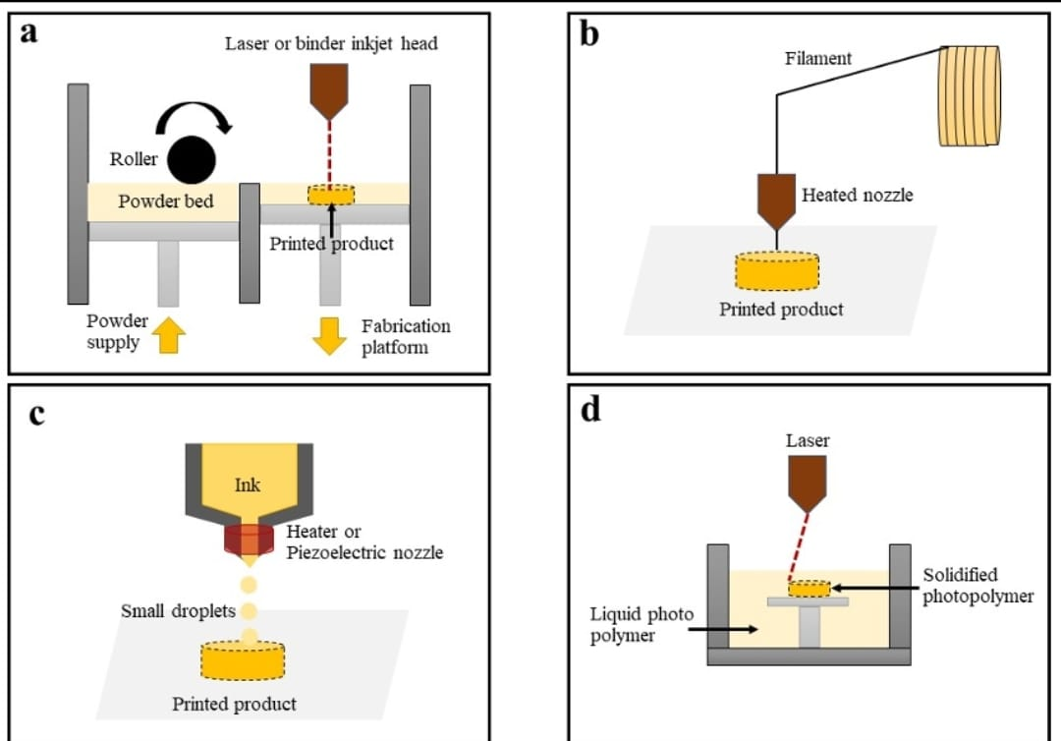

Figure 1. Schematic working process of 3D printing techniques, including (a) powder-based 3D printing, (b) extrusion-based 3D printer, (c) inkjet-based 3D printing, and (d) laser-based 3D printing

***4.1 POWEDER BASED 3D PRINTING :***

A powder-based 3D printing technology in which a binder or laser is sprayed/irradiated onto a bed of powder to bind the powder together and create a 3D printed model[4,5]. In general, the system includes an adhesive tank for storing glue/ink, a powder pool, and a design platform for the printing process[6].

***4.2. EXTRUSION- BASED 3D PRINTING :***

Extrusion-based 3D printing uses a heated nozzle to extrude a continuous line of molten polymer; this is then layered and cooled to form a 3D object (Figure 1b)[7]. These systems are divided into two methods: semisolid extrusion and fused deposition models[8].

The equipment is not complicated and printing management is not easy. Therefore, extrusion-based 3D printing is widely used in pharmaceutical research. Various pharmaceutical products such as immediate-release tablets, floating tablets, colonic tablets and extended-release tablets are prepared using this technology. However, there are concerns about the use of these systems. Since a heating nozzle is used for printing, the active ingredients must be temperature stable and the materials must be prepared before printing[9,10,11].

***4.3. INKJET-BASED 3D PRINTING OR DIGITAL INKJET PRINTING:***

Continuous inkjet printing and optional memory inkjet printing are two technologies available in inkjet 3D printers. Continuous inkjet printing technology uses a high-pressure pump to create a continuous flow of ink from 50 to 80 microns in diameter, while on-demand memory inkjet printing technology produces inkjet printers with sizes and volumes of 10 to 50 microns. 1 to 70 picoltres[12].

The technology involves using an inkjet printer to deposit a layer of photopolymer resin that is cured using UV light to create a 3D object as shown in Figure 1c. These printers are designed for unstable chemicals or heat sensitive materials[13]. Many dosage forms, including tablets, implants, and orodispersible films, are prepared using this technology. Many dosage forms, including tablets, implants, and orodispersible films, are prepared using this technology[13,14,15].

***4.4. LASER-BASED 3D PRINTING:***

This technology is also called selective laser sintering (SLS), laser beam melting, or stereolithography (SLA). The basis of SLA production of 3D products is to control the solidification of liquid resin through photopolymerization[16]. This method provides accurate and clear printing patterns. For this reason, it has been used in the production of drugs that require high precision, such as microneedles[17].

***5. ADVANTAGES OF 3D PRINTING TECHNOLOGY IN PHARMACEUTICS:***

***5.1. PERSONALIZED MEDICINE FOR SPECIAL POPULATIONS :*** The health and safety of medicines for special groups such as the elderly and children have long been a concern [12,13]. Children are in a period of growth and development and have a special response and sensitivity to medications; Absorption and metabolism are reduced in the elderly, which is common for many joint diseases and drug treatments [14]. Now drug quantities have become standardized and there are some special drugs for special groups. Artificial products are often used in children's medicines, which is not wrong, but it can also lead to certain preparation patterns, which can cause negative effects[18,19,20,21].

3D printers are flexible and can print drugs by adjusting parameters such as size, shape or filler [16]. For pediatric patients, 3D printing technology can be used to create child-friendly personalized medicine. It can also be used to improve the appearance and taste of the medicine and increase its compliance with the patient's stomach; For adults with swallowing problems, 3D printers can be used to create loose and porous preparations to help them take medications; For patients taking many medications at the same time, different medications can be combined into one tablet to avoid errors or missing medication, thus ensuring safety and good operation. Medicine ; Additionally, for the convenience of blind patients, special writing can be written or special characters can be printed on the surface of the preparation. The advantages of 3D printing technology in delivering personalized medicine provide support for people to achieve personalized medicine, and some pharmaceutical companies have moved 3D printing into the goal of personalized medicine, such as Fab Rx, which makes a personalized preparation for children with maple syrup in the UK. . In Spain, medicines and SSE printers were installed in hospital pharmacies and clinical studies on these issues were completed[22,23,24,25].

***5.2. PRECISE CONTROL OF DRUG RELEASE :***

Tablets, the most widely used oral vehicle, account for 70% of all drug production. Tablets can be produced at low cost with traditional production methods, but there is less creativity in design, longer development times and the inability to create designs specific to personal needs. Compared with traditional tablets, anti-release medication can control the release of the drug, prevent side effects and improve performance. However, traditional production methods pose more challenges in the development and production of controlled release systems due to their limitations. 3D printing technology is flexible and suitable for the design and production of complex preparations by mixing different substances, creating complex patterns and making changes to the printed form[26,27].

For example, Triastek's 3D printed product T19 received FDA IND approval in January 2021. It is a controlled-release model designed to target the circadian rhythm of rheumatoid arthritis. Eliminate the most severe pain, joint stiffness, dysfunction and other symptoms and provide patients with a better medication option by controlling blood throughout the day for best results[28].

***5.3. RAPID INTEGRATION/ABSORPTION OF PRODUCTION :***

In addition, in the pharmaceutical research and development stage, 3D printing is suitable for the production of small drugs that need to be changed and produced frequently due to its low cost, size and production process. Pharmaceutical research and development status. Important role. Time and resources are limited. Merck uses 3D printing technology to create a new drug. The amount of the drug will be reduced in order to increase the lovel.50 %[30].

In large-scale pharmaceutical production, ordinary pharmaceutical companies usually have more production capacity to meet the global demand for traditional medicine. However, the production equipment is generally large and the equipment type is single, and there is no need for necessary equipment. He has talent. Flexibly and quickly complete cleaning products and replace various chemicals. On the other hand, 3D printing technology can integrate fast production, compact equipment, fewer production steps, automated and digitalized production process, and it is easy to change the type of drug produced. For example, SSE technology can switch syringes containing different chemicals to meet the needs of production equipment[29].

***6. PRINCIPLE OF BJ-3D PRINTING TECHNOLOGY AND APPLICATION IN THE PHARMACEUTICAL INDUSTRY :***

***6.1. PRINCIPLE OF BJ -3D PRINTING TECHNOLOGY :***

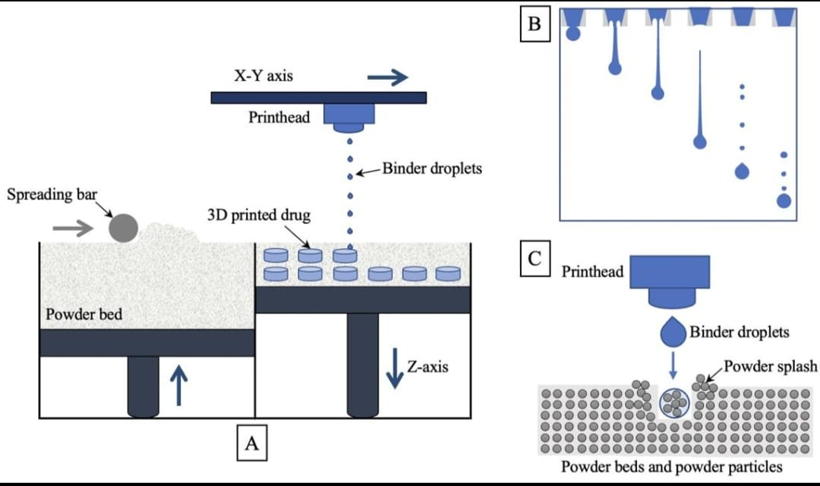

Figure 1. schematic diagram of the principle and mechanism of tablet preparation by BJ -3D Printing technology: (A) schematic diagram of the printing principle of BJ-3DP technology; (B) schematic diagram of the flight state of a droplet after ejection through the nozzle; and (C) schematic diagram of droplet impact on the powder bed.

BJ-3DP is the primary 3D printing technology used for drug production . The printing principle is shown in Figure 1A. First, the roller spreads a thin powder layer on the platform, the droplets are sprayed through the removable printhead, and they selectively bind the powder together; then the platform is lowered, the roller spreads a new powder layer, the print head continues to add droplets, using the principle of layer-by-layer printing, and so on until complete; finally, the preparations are removed, the adhering powder is removed, and post processing is carried out [30]. Printing inks can contain only the binder, while the powder bed contains the API and other excipients. API can also be sprayed into the powder bed as a solution or as a suspension of nanoparticles . The raw materials that can be used in BJ-3DP technology not only provide good solubility in water, for poorly soluble materials, the solubility of raw materials can also be improved by pretreatment, but there is also some science. For example, Kozakiewicz-Latała et al. The hydrophobic raw material clotrimazole was used as the drug model, and the suspension was prepared proportionally with the hydrophilic excipients PVP and lactose and spray-dried to improve the wettability and printability of clotrimazole[29,30,31].

In recent years, SLA technology has been widely used in the microneedle field due to its performance and high efficiency. Microneedles are tiny needles that penetrate biological issues (such as skin) causing minimal disruption, avoiding contact with blood vessels and nerves and therefore not causing pain or bleeding. Microneedles are now considered a powerful drug delivery system with excellent distribution. Figure 10 and Table 3 list the basic information and properties of microneedles prepared with SLA technology in recent years.

The process of BJ-3DP technology is complex, the printing process of this technology can be divided into three stages: (1) the formation of droplets, (2) the use of selection process of suspended powder into powder, (3) drying or processing of finished products[32].

***6.2. BJ -3D PRINTING TECHNOLOGY IN PHARMACEUTICAIS:***

The first paper on the application of BJ-3DP in medicine was published in 1996 , and this paper demonstrated the possibility of using 3D printers to create drugs. Since then, BJ-3DP technology has been used to prepare a variety of drugs for research. Such as immediate release, sustained and controlled release, combination preparation and implantable preparation . Table 2 describes the various schemes made using BJ-3DP technology in recent years. In the published research, BJ-3DP technology was used in two projects[33,34].

As a new tool for preparing data on oral nutrition, initial research focused on determining the feasibility of the complex process. When water droplets are selected in the powder bed, a multilayer process can be prepared by changing the entire powder bed due to the composition of the powder bed. Although the print head can be filled with inks of different products, there is no such thing as volume or speed, complex formulations can be prepared by adjusting the number of chemicals and the position of the water. Spritam®, the first 3D printed model released in 2015, was prepared using BJ-3DP technology. This plan shows the features of the BJ-3DP. Unlike the mechanical strength of modern technology, tablets are prepared only by the contact of powder and ink, which makes the structure quickly porous. With the understanding of the science of BJ-3DP technology, the type of plan created with BJ-3DP technology is now generally readily available. understanding of the science of BJ-3DP technology, the type of plan created with BJ-3DP technology is now generally readily available[35].

Moreover, the scaffold prepared by BJ-3DP can serve as natural bone and shows great potential in the preparation of bone scaffolds. It also has a loose and porous structure and a high level of roughness, which is very good for cell attachment and growth. ; Table 2 lists the studies conducted on the subject in recent years. Compared with traditional manufacturing methods, 3D printing can better control factors such as the shape, size and internal structure of the stent, so that the implant can largely fit into the delivery area.[36]

***7. PRINCIPLE OF FDM TECHNOLOGY AND APPLICATION IN THE PHARMACEUTICALS:***

***7.1. PRINCIPLE OF FDM TECHNOLOGY:***

FDM technology is widely used in the pharmaceutical industry due to its advantages of simple materials, low cost and high efficiency. Computer design software is used to create 3D printed products by pouring molten material through layers of the printer. The principle is shown in Figure 2. Polymer filaments with FDM technology are widely used in the pharmaceutical industry due to their simple material advantages, low cost and commercial properties. Computer design software is used to create 3D printed products by pouring molten material through layers of the printer. The principle is shown in Figure 2. The polymer filament containing the solution is extruded by two rollers through a high-temperature nozzle, the print head moves along the X-Y axis under the control of computer software publishing products; complete one after another. After printing, the printer is lowered or the Z axis is raised by the thickness of one layer and the printing of the next layer is started and the process is repeated until it is finished. The solution is extruded by two rollers through a high-temperature nozzle, the print head moves along the X-Y axis under the control of computer software to print the product. equals the thickness of the layer. remove the distance, start printing the next layer and reat the process to finish[37,38].

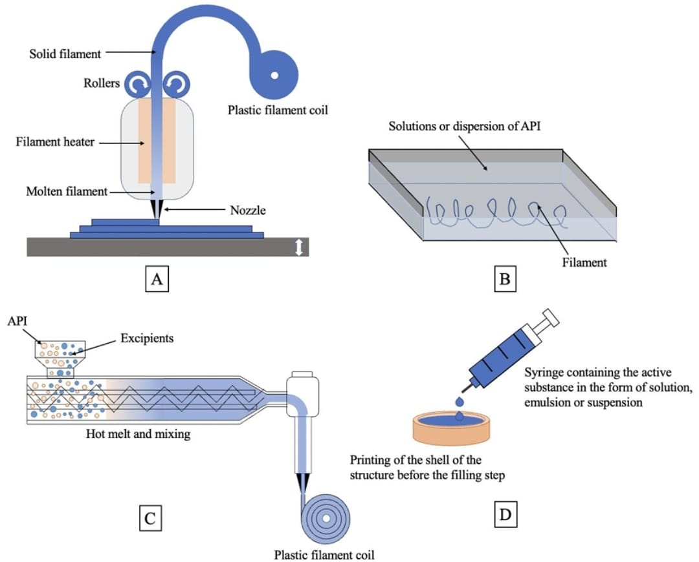

Figure 2. Schematic diagram of the principle of FDM technology and three methods of tablet prepara­tion: (A) schematic diagram of the printing principle of FDM technology; (B) schematic diagram of the preparation of drug-containing filaments by the dipping-melting method; (C) schematic diagram of the preparation of drug-containing filaments by the HME-FDM method; and (D) schematic diagram of the preparation of tablets by the filling and forming method.

Currently, there are three main methods to prepare 3D tablets using FDM technology, as shown in Figure 2B-D: (1) Immersion method: Immersing the filament in the solution is a dispersion containing an API to obtain a filament containing an API for printing. . (2) HME-FDM: Add API and auxiliaries to the conveyor and take the API-containing filaments from the extrusion unit to prepare the 3D printing drug. This is the most common method now. (3) Collection and processing: first print an empty shell, fill in the API, and then continue printing the shell; Printing and writing operations can be done simultaneously or sequentially[39].

For example, in the HME-FDM method, the drug is first mixed with excipients such as molten polymers, and filaments of the target diameter are extruded at certain speeds, high speeds, etc. The filament is then passed into the heating zone without being spun or extruded, heated to a temperature slightly above its melting point, and extruded through the nozzle to prepare the 3D printing tablet. This method requires all the strength and flexibility of the chemical wire to prevent the metal from cracking or breaking during printing; This affects printing accuracy and product quality; Therefore, this tool has a good limit for the use of the product. API and print version are optional[37].

Physicochemical properties of the filament, such as mechanical, thermal and rheological properties, determine its printability. Polymers used in FDM technology must be thermoplastic and contain materials, the most common materials are acrylonitrile butadiene styrene , polylactic acid, polyamide and polycarbonate. Additionally, polyvinyl alcohol, a biodegradable material often used as a support material, has been shown to have the potential to be developed into an important material for self-healing drugs as it comes volatile dissolved in colloidal solution. PCM is generally characterized by parameters such as glass transition temperature (Tg) and melting temperature (Tm). In particular, the Tg of the polymer should be as far as possible from the decomposition temperature. McKay et al. Tg + 78 °C was estimated to be the lowest FDM printing temperature for the amorphous polymer and was derived from the average of the lowest FDM printing temperature for the three polymers. Second, the rheological properties of the filament material are also important. Viscosity, as an important representative of rheological properties, not only affects the ability of the filament to pass through the nozzle of the hot press, but also the ability of the filament to return to its structure after deposition [81]. The shear viscosity of a filament passing through the nozzle depends not only on product internal factors such as the filament's formulation, molecular weight, and product of the drug, but also on other factors such as extrusion temperature and shear ratio. Nozzle diameter (usually narrow to small) and its effect on printing speed. In addition, properties such as the consistency of the filament and the absence of clumps or bubbles are also very important for the completion of the printing process[40,41,39].

***7.2. FDM TECHNOLOGY IN PHARMACEUTICALS :***

FDM technology is widely used in preparing various types of designs according to their properties. For example, the first study to evaluate patient acceptance of 3D-printed models of different shapes and sizes was conducted using this technology, and researchers also used this technology to prepare and measure samples of different colors, as shown in Figure 3A. As seen in B, this shows that mostly small round tablets are obtained [84]. Additionally, Jamróz et al. Aripiprazole orodispersible films were prepared using FDM technology, and in vitro studies showed that 3D printed films had higher dispersibility. FDM technology can also be used in the preparation of controlled-release drugs such as Lim et al. FDM technology is used to print a hollow stent for continuous drug delivery; The stent has a hollow base covered by a cap and has many small holes. The results showed that the stent with holes on its side exhibited zero-level kinetics with a beneficial product release. FDM printers can be equipped with multiple nozzles to print mixed patterns containing different materials. In 2015, Goyanes et al. Using this technology, multilayer capsules and double-layer capsules were prepared using paracetamol and caffeine as model drugs, as shown in Figure 3C; where one layer consists of one drug, the next layer consists of other drugs, and the next layer consists of other drugs. A two-layer capsule is made by encapsulating a drug within a shell made of other drugs. FDM technology was developed by Goyaneset et al. It has also been used in the field of transdermal drug delivery. In 2016 , Muwaffatal. Use FDM technology to create a nasal mask so patients can more effectively treat their acne through cosmetic management. Using FDM technology to print wound dressing to resemble nose and ear[37,42,43].

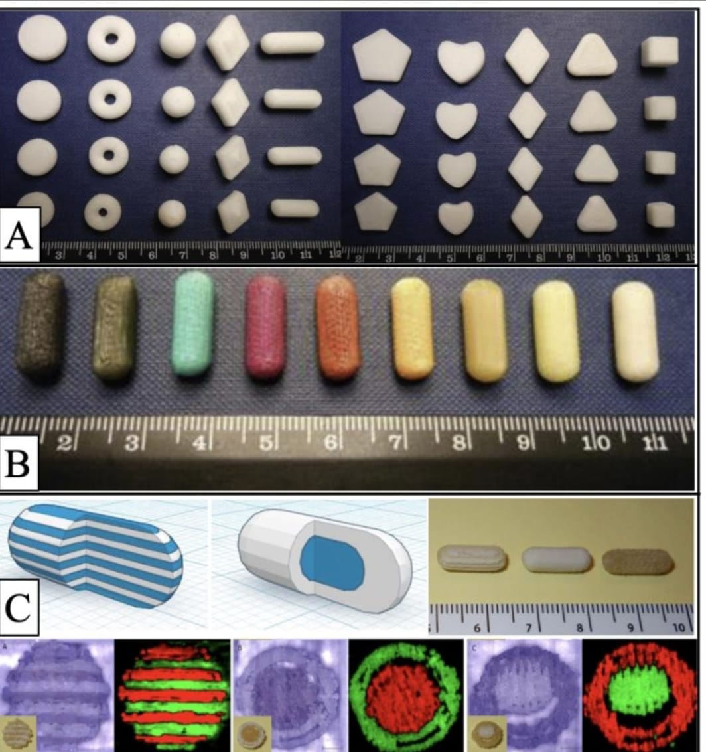

Figure 3. Images of various types of tablets prepared by FDM technology: (A) Images of 3D-printed tablets with different shapes and sizes [42]; (B) images of 3D-printed tablets in capsule form with different colors [42]; (C) sectioned multilayer device and sectioned DuoCaplet (caplet in caplet) model images, 3D-printed preparations, and white light and 2-dimensional Raman mapping images [85]. Figures were reproduced and modified with permission from [43].

***8. PRINCIPLE OF SSE TECHNOLOGY AND APPLICATION IN PHARMACEUTICAL INDUSTRY :***

***8.1 . PRINCIPLE OF SSE TECHNOLOGY :***

Principle of SSE technology SSE is additive manufacturing equipment that places the semi-materials into the process in layers, driven by the extrusion head and extrudes the semi-materials according to the process, layer by layer until the product is printed. 88 . This technology is based on FDM, but the difference is that the printing material used in this technology is half room temperature, so the temperature will need to be controlled during heating to prevent the product from softening too much due to the temperature and cannot be published. Maintain his image during deposition. During printing, the printed material is held in a special electromagnetic system as shown in Figure 4. SSE is an additive manufacturing process that releases semi-rigid materials from layer to layer, where the extrusion head moves according to the setting and extrudes semi-rigid materials. Solid materials are layered together until a printing material is obtained. This technology is based on FDM, but the difference is that the printing material used in this technology is half room temperature, so the temperature will need to be controlled during heating to prevent the product from softening too much due to the temperature and cannot be published. Maintain his image during deposition Print items while printing[29,44].

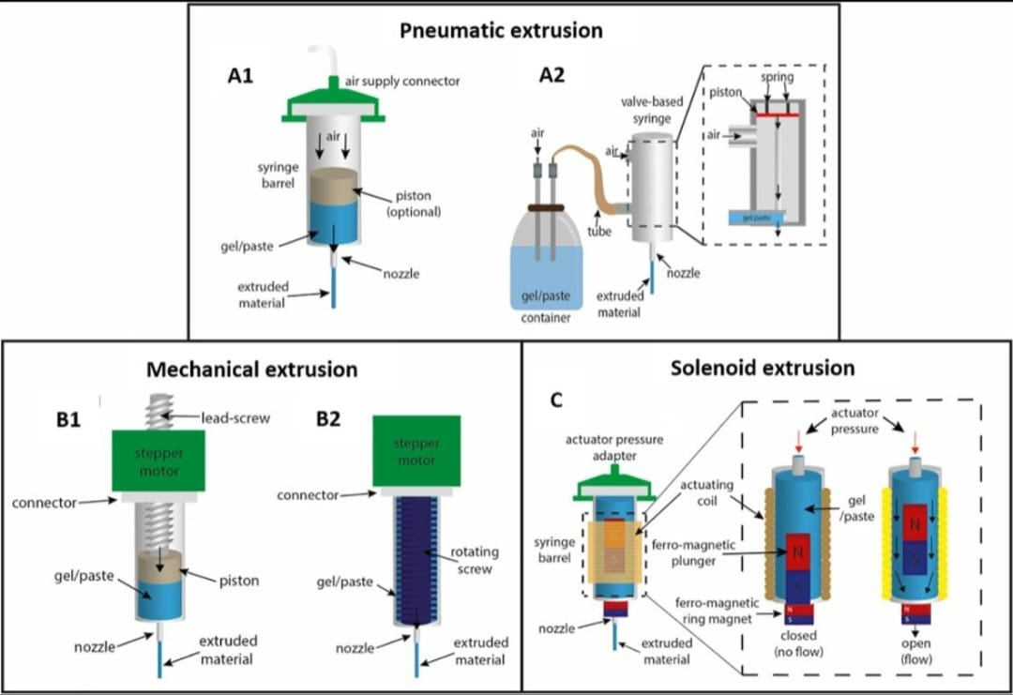

Figure 4. SSE 3DP extrusion mechanisms: (A) pneumatic extrusion, including (A1) valve-free and (A2) valve-based, (B) mechanical extrusion, including (B1) piston-or (B2) screw-driven, and (C) solenoid extrusion [27]. Figures were reproduced and modified with permission from [27].

Pneumatic-based extruders use compressed air to remove semi-solids and are suitable for both low and high viscosity materials. Mechanically based extrusion systems apply any force directly to the syringe and are classified as reciprocating or screw type. Compared with pneumatic machines, this extrusion machine does not need an air compressor, is simpler, cheaper and easier to transport . In addition, the printing process becomes faster as the syringe can be changed more easily during printing. The electromagnetic drive uses electrical pulses to open the valve at the bottom of the syringe. The electromagnetic drive uses electrical pulses to open the valve at the bottom of the syringe. This is designed for ionic low viscosity bioinks[27].

***8.2. SSE TECHNOLOGY IN PHARMACEUTICS :***

The use of SSE 3DP in pharmaceuticals can produce large amounts of data while avoiding the harsh conditions sometimes associated with other technologies such as FDM. The condition of the feed material for the extrusion process should be carried out at high temperature without affecting the accuracy, and the use of pre-filled waste material facilitates the whole process standard. The equipment was first used to produce compound drugs and tablets[45,46].

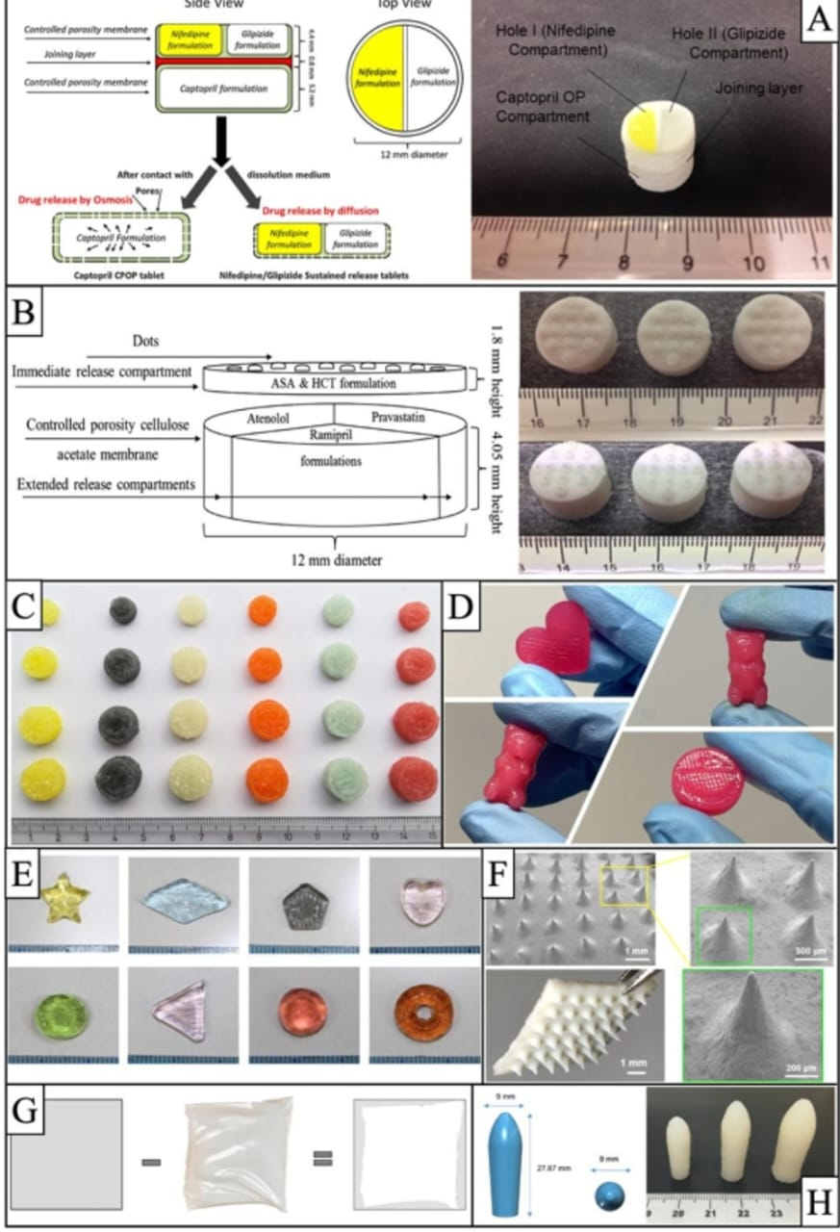

Figure 6. Images of various types of preparations prepared by SSE technology:

Like other 3DP technologies, SSE has continued to evolve since the first SSE printer. SSE 3D printers have evolved from the simplest printers with one needle in an electric robotic gantry to printers featuring multiple printheads. Print multiple files simultaneously with specially designed software and higher resolution. An example of the evolution of this type of 3D printing is the multi-material 3D printer (MM3D).

3D printing technologies such as FDM and DPE, SSE is best suited to personalized medicine production as it can be produced and produced in various forms (ODF, chewable tablets, polypills, etc.). in many shapes and forms. taste. The main advantage of this device is its simplicity, as the drug can be directly mixed with additional materials and filled into syringes or cartridges for printing [38]. Use it instead.

There is also research on other forms of verbal communication. The first is immediate release, which has the advantage of being therapeutic. For example, the dose of levetiracetam in children with epilepsy can vary with different treatments, and SSE technology can easily obtain a specific levetiracetam dose needed from the child by changing the size and structure of the structure Representatives 100. Second, sustained-release tablets can be prepared by adding a releasing agent to the semi-active material. In 2020 prepared theophylline tablets using HPMC K4M and E4 release materials, investigated the quality of the HPMC ratio, and provided in vitro dissolution results of tablets that released the drug within 12 hours. Finally, another type of drug is dispersible films (ODF). Sjöholm et al used SSE technology to prepare ODF using warfarin, which has a narrow therapeutic window and is a medical model, solving the problems of self-administration and dysphagia. There are also some studies on medical devices, but these are still within the scope of the research paper, which found that SSE technology can be used in the preparation of medical devices. In 2020, used SSE technology to print a cylindrical substrate and patch array, and then stretched the array with a glass plate stretching device to form a needle-like head. As shown in Figure 6F, insulin-containing microneedles can penetrate mouse skin and reduce the symptoms of diabetic mice[44,45,46].

***9 . PRINCIPLE OF MED TECHNOLOGY AND APPLICATIONS IN THE PHARMACEUTICAL INDUSTRY:***

MED 3D printing is an extrusion technology developed by Triastek that combines hot melt extrusion and fused deposition modeling technology. The principle is shown in Figure 7 [26]. It has feeding and mixing, conveying equipment and various printing stations; Each printing station prints one type of product[28].

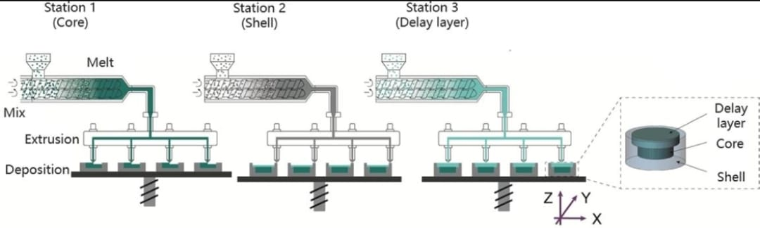

Figure 7. The principle of collaborative preparation of tablets with delayed release shells using multiple print stations through MED technology. Figures were reproduced and modified with permission from [28].

Firstly, raw materials and different products are added to different foods, heated and sheared by the hot melt extrusion system to form a uniform mixture of materials in the molten state, and then transported to the hot melt extrusion module. At last, the printing unit is integrated, and under high accuracy and controlled temperature, different products in molten state are combined with each other and released layer by layer in machine printing to achieve the purpose of 3D printed products. In actual pressure and temperature control, the molten material is combined and placed layer by layer on the printing platform to obtain 3D printing preparation of the target model . Compared to FDM, SSE or other extrusion 3D printing technologies, MED technology does not require prior preparation of filaments or semi-materials and does not require second heating of the record. This machine can complete mixing, melting, conveying and pressing of API and excipients in one step, providing continuous feeding. Compared to FDM, SSE or other extrusion 3D printing technologies, the MED technology process does not require the preparation of filaments or advances. -Semi-material and materials have no second heat. The technology integrates, decodes, distributes and publishes APIs and components in one step, ensuring continuous supply and production. MED technology is now taken into account[28].

***9.1. MED TECHNOLOGY IN PHARMACEUTICS :***

Triastek design 6.2 uses the unique advantages of MED technology. MED technology in pharmaceuticals produces tablets with different release properties by developing pharmaceutical products, multi-drug combinations, using pH-sensitive sustained-release materials, and changing the position of the chemical layer or sustained-release layer as in Yu's paper 2021. This article selects one of the design ideas shown in Figure 8. The white light area is the chemical-free and impermeable coating, while the blue light is the inner layer that contains the chemical[28]. Triastek utilizes the unique advantages of MED technology to create tablets with different release properties by developing pharmaceutical, multi-drug combinations, using pH-sensitive sustained release materials, and developing different output habits. The area of ​​the chemical layer or sustained release layer as described in Yu et al. 2021. This article selects one of the design ideas shown in Figure 8. The white light field is a chemical-free and impermeable layer, while blue light is the inner layer containing chemicals. The amount of drug released per unit time is controlled by changing the number of layers and the inner surface. Control by changing the number of layers and internal space[28].

***10. PRINCIPLE OF SLA TECHNOLOGY AND APPLICATIONS IN THE PHARMACEUTICAL INDUSTRY :***

SLA technology is based on the principle of photopolymerization, which uses laser scanning to harden liquid resin to form 3D printed objects layer by layer. The way it works is shown in Figure 9. Depending on the printer configuration, top-down or bottom-up printing can be done. During printing, the liquid tank is filled with liquid photosensitive resin, and the laser beam is focused on the surface of the resin by the scanning mirror to form a spot. The area swept by the light will heal. Single-layer SLA technology is based on the principle of photopolymerization, which uses laser scanning to process liquid resin into 3D printing objects layer by layer . The way it works is shown in Figure 9. Depending on the printer configuration, top-down or bottom-up printing can be done. During printing, the liquid tank is filled with liquid photosensitive resin, and the laser beam is focused on the surface of the resin by the scanning mirror to form a spot. The area swept by the light will heal. Once a layer of scanning is finished, the printer is lowered one level and the scraper smoothes the resin surface for the next layer of printing, this cycle continues until completed. The product is then removed along with excess material and support . This equipment has high precision and is directly related to the spot diameter. Currently, the minimum spot diameter is 0.011 ~ 0.075 mm and the minimum monolayer thickness is 0.01 ~ 0.02 mm. Another type of medical device . After the scan is finished, the printer lowers one level, the scraper smoothes the resin surface, and the next layer of print is made. The product is then removed along with excess material and support [28]. This equipment has high precision and is directly related to the spot diameter. Currently, the minimum spot diameter is 0.011 ~ 0.075 mm and the minimum monolayer thickness is 0.01 ~ 0.02 mm. Another type of medical device.

During the printing process, photons are released to initiate polymerization, which is the synthesis of polymers through a chain reaction that generally requires at least three elements: light, photopolymerizable monomers/oligomers, and PI. During the polymerization process, PI reacts in the presence of light, producing starting materials (free radicals, anions, cations, etc.). Therefore, the photocuring process can be divided into photoinitiated polymerization and photocrosslinking . The former refers to the connection between complementary lines of monomers, while the latter refers to the process of binding two macromolecules.

In general, SLA products need post-processing after printing. The purpose of finishing is to improve the mechanical properties of the material [114]. It offers a variety of UV light-curable resins for photocentric, SLA and DLP processe . They recommend exposing these resins to UV (36 W) for at least 2 hours to ensure product durability. 3D Center allows for simple support removal, wet grinding, mineral oil treatment, paint (clear UV resistant acrylic), polishing for transparency, etc. Lists various post-processing methods for the SLA process, including: SLA also has some other post-treatment methods, such as surface treatment with sealers, primers, paints, or metal coatings.

***10.1. SLA TECHNOLOGY IN PHARMACEUTICALS :***

SLA technology is more accurate than other 3D printing technologies, with a minimum layer thickness of 0.01-0.02 mm, but research into oral formulations is limited by the lack of photocurable properties that can be used in oral drugs. In 2018, Using SLA technology to produce acetaminophen and 4-aminosalicylic acid sustained-release tablets reduced drug degradation compared to tablets using FDM technology. The way of medicine. In 2018, a research team from University College London used SLA technology to create tablets of different shapes to study factors affecting drug release tablets. The volume ratio is important for the preparation of the same amount of tablets with the same release rate. Additionally, due to the high sensitivity and speed of resin cross-linking during photocuring , no porosity is visible in the SEM images of the tablets, resulting in a very tight internal structure of the tablets and a slow release rate tablets[47,48].

In recent years, SLA technology has been widely used in the microneedle field due to its performance and high efficiency. Microneedles are tiny needles that penetrate biological issues (such as skin) causing minimal disruption, avoiding contact with blood vessels and nerves and therefore not causing pain or bleeding. Microneedles are now considered a powerful drug delivery system with excellent distribution. Figure 10 and Table 3 list the basic information and properties of microneedles prepared with SLA technology in recent years[48,49].

***11. Conclusions:***

This article reviews information on various 3D printing technologies commonly used in the pharmaceutical industry, explains the details and features of each technology, provides information on how well each technology fits and its development trend; Share the work of representative companies or 3D printing drug guidance organizations, development history and achievements to support innovation in drug research and design. As a new technology, 3D printing schemes have special requirements regarding registration and documentation, while laws and regulations such as intellectual property rights and pharmaceutical regulations are still under development. Overall, this review aims to reflect the current developments, market trends and overall development in 3D printing medicine. We hope that this review can provide useful advice to those involved in relevant research. I believe that through continuous efforts, the future of the 3D printing medical industry is promising and will improve the intelligence and individuality of drug preparation.

***12. References:***

1. Bethany, C.G.; Jayda, L.E.; Sarah, Y.L.; Chengpeng, C.; Dana, M.S. Evaluation of 3D Printing and Its Potential Impact on Biotechnology and the Chemical Sciences. Anal. Chem. 2014, 86, 3240–3253. [CrossRef]

2. Belhabib, S.; Guessasma, S. Compression Performance of Hollow Structures: From Topology Optimisation to Design 3D Printing. Int. J. Mech. Sci. 2017, 133, 728–739. [CrossRef]

3. Sachs EM, Haggerty JS, Cima MJ, Williams PA. Three dimensional printing techniques. In: US Patent US 5,204,055 A; 1993.

4. Mostafaei, A.; Elliott, A.M.; Barnes, J.E.; Li, F.; Tan, W.; Cramer, C.L.; Nandwana, P.; Chmielus, M. Binder jet 3D printing—Process parameters, materials, properties, modeling, and challenges. Prog. Mater. Sci. 2021, 119, 100707. [CrossRef]

5. Sen, K.; Mehta, T.; Sansare, S.; Sharifi, L.; Ma, A.W.; Chaudhuri, B. Pharmaceutical applications of powder-based binder jet 3D printing process–a review. Adv. Drug Deliv. Rev. 2021, 177, 113943. [CrossRef]

6. Yu, D.-G.; Shen, X.-X.; Branford-White, C.; Zhu, L.-M.; White, K.; Yang, X.L. Novel oral fast-disintegrating drug delivery devices with predefined inner structure fabricated by three-dimensional printing. J. Pharm. Pharmacol. 2009, 61, 323–329. [CrossRef] [PubMed]

7. Thanawuth, K.; Sutthapitaksakul, L.; Konthong, S.; Suttiruengwong, S.; Huanbutta, K.; Dass, C.R.; Sriamornsak, P. Impact of drug loading method on drug release from 3D-printed tablets made from filaments fabricated by hot-melt extrusion and impregnation processes. Pharmaceutics 2021, 13, 1607. [CrossRef]

8. Algahtani, M.S.; Mohammed, A.A.; Ahmad, J. Extrusion-based 3D printing for pharmaceuticals: Contemporary research and applications. Curr. Pharm. Des. 2018, 24, 4991–5008. [CrossRef]

9. Huanbutta, K.; Sriamornsak, P.; Kittanaphon, T.; Suwanpitak, K.; Klinkesorn, N.; Sangnim, T. Development of a zero-order kinetics drug release floating tablet with anti–flip-up design fabricated by 3D-printing technique. J. Pharm. Investig. 2021, 51, 213–222. [CrossRef]

10. Jivraj, M.; Martini, L.G.; Thomson, C.M. An overview of the different excipients useful for the direct compression of tablets. Pharm. Sci. Technol. Today 2000, 3, 58–63. [CrossRef]

11. Sangnim, T.; Tangpanithanon, A.; Khamtheantong, M.; Charoenwai, J.; Huanbutta, K. Development of personalized colonic drug delivery systems prepared by 3D-printing technology. In Key Engineering Materials; Trans Tech Publications Ltd.: Bäch, Switzerland, 2021; pp. 144–150.

12. Ahlfeld, T.; Akkineni, A.R.; Förster, Y.; Köhler, T.; Knaack, S.; Gelinsky, M.; Lode, A. Design and fabrication of complex scaffolds for bone defect healing: Combined 3D plotting of a calcium phosphate cement and a growth factor-loaded hydrogel. Ann. Biomed. Eng. 2017, 45, 224–236. [CrossRef]

13. Sen, K.; Manchanda, A.; Mehta, T.; Ma, A.W.; Chaudhuri, B. Formulation design for inkjet-based 3D printed tablets. Int. J. Pharm. 2020, 584, 119430. [CrossRef]

14. Islam, R.; Sadhukhan, P. An insight of 3d printing technology in pharmaceutical development and application: An updated review. Curr. Trends Pharm. Res. 2020, 7, 56–80.

15. Huanbutta, K.; Sriamornsak, P.; Singh, I.; Sangnim, T. Manufacture of 2D-printed precision drug-loaded orodispersible film prepared from tamarind seed gum substrate. Appl. Sci. 2021, 11, 5852. [CrossRef]

16. Chia, H.N.; Wu, B.M. Recent advances in 3D printing of biomaterials. J. Biol. Eng. 2015, 9, 4. [CrossRef] [PubMed]

17. Johnson, A.R.; Caudill, C.L.; Tumbleston, J.R.; Bloomquist, C.J.; Moga, K.A.; Ermoshkin, A.; Shirvanyants, D.; Mecham, S.J.; Luft, J.C.; DeSimone, J.M. Single-step fabrication of computationally designed microneedles by continuous liquid interface production. PLoS ONE 2016, 11, e0162518. [CrossRef]

18. Preis, M.; Öblom, H. 3D-Printed Drugs for Children-Are We Ready Yet? AAPS PharmSciTech 2017, 18, 303–308. [CrossRef]

19. Shibata, Y.; Itoh, H.; Matsuo, H.; Nakajima, K. Differences in Pharmaceutical Intervention Triggers for the Optimization of Medication by Patient Age: A University Hospital Study. Biol. Pharm. Bull. 2021, 44, 1060–1066. [CrossRef] [PubMed]

20. Pelkonen, O. Metabolism and Pharmacokinetics in Children and the Elderly. Expert Opin. Drug Metab. Toxicol. 2007, 3, 147–148. [CrossRef]

21. Pratico, A.D.; Longo, L.; Mansueto, S.; Gozzo, L.; Barberi, I.; Tiralongo, V.; Salvo, V.; Falsaperla, R.; Vitaliti, G.; La Rosa, M.; et al. Off-Label Use of Drugs and Adverse Drug Reactions in Pediatric Units: A Prospective, Multicenter Study. Curr. Drug Saf. 2018, 13, 200–207. [CrossRef] [PubMed]

22. Singhvi, G.; Patil, S.; Girdhar, V.; Chellappan, K.; Gupta, G.; Dua, K. 3D-Printing: An Emerging and a Revolutionary Technology in Pharmaceuticals. Panminerva Med. 2018, 60, 622. [CrossRef] [PubMed]

23. Scoutaris, N.; Ross, S.A.; Douroumis, D. 3D Printed “Starmix” Drug Loaded Dosage Forms for Paediatric Applications. Pharm. Res. 2018, 35, 34. [CrossRef]

24. Tabriz, A.G.; Fullbrook, D.H.G.; Vilain, L.; Derrar, Y.; Nandi, U.; Grau, C.; Morales, A.; Hooper, G.; Hiezl, Z.; Douroumis, D. Personalised Tasted Masked Chewable 3D Printed Fruit-Chews for Paediatric Patients. Pharmaceutics 2021, 13, 1301. [CrossRef]

25. Tabriz, A.G.; Nandi, U.; Scoutaris, N.; Sanfo, K.; Alexander, B.; Gong, Y.; Hui, H.-W.; Kumar, S.; Douroumis, D. Personalised Paediatric Chewable Ibuprofen Tablets Fabricated Using 3D Micro-Extrusion Printing Technology. Int. J. Pharm. 2022, 626, 122135. [CrossRef]

26. Roulon, S.; Soulairol, I.; Lavastre, V.; Payre, N.; Cazes, M.; Delbreilh, L.; Alié, J. Production of Reproducible Filament Batches for the Fabrication of 3D Printed Oral Forms. Pharmaceutics 2021, 13, 472. [CrossRef] [PubMed]

27. Li, J.; Wu, M.; Chen, W.; Liu, H.; Tan, D.; Shen, S.; Lei, Y.; Xue, L. 3D Printing of Bioinspired Compartmentalized Capsular Structure for Controlled Drug Release. J. Zhejiang Univ. Sci. B 2021, 22, 1022–1033. [CrossRef] [PubMed]

28. Zheng, Y.; Deng, F.; Wang, B.; Wu, Y.; Luo, Q.; Zuo, X.; Liu, X.; Cao, L.; Li, M.; Lu, H.; et al. Melt Extrusion Deposition (MEDTM) 3D Printing Technology—A Paradigm Shift in Design and Development of Modified Release Drug Products. Int. J. Pharm. 2021, 602, 120639. [CrossRef] [PubMed]

29. Smith, D.M.; Kapoor, Y.; Klinzing, G.R.; Procopio, A.T. Pharmaceutical 3D Printing: Design and Qualification of a Single Step Print and Fill Capsule. Int. J. Pharm. 2018, 544, 21–30. [CrossRef]

30. Seoane-Viaño, I.; Januskaite, P.; Alvarez-Lorenzo, C.; Basit, A.W.; Goyanes, A. Semi-Solid Extrusion 3D Printing in Drug Delivery and Biomedicine: Personalised Solutions for Healthcare Challenges. J. Control. Release Off. J. Control. Release Soc. 2021, 332, 367–389. [CrossRef]

31. Kozakiewicz-Latała, M.; Nartowski, K.P.; Dominik, A.; Malec, K.; Gołkowska, A.M.; ´ ´Złocinska, A.; Rusinska, M.; Szymczyk-Ziółkowska, P.; Ziółkowski, G.; Górniak, A.; et al. Binder Jetting 3D Printing of Challenging Medicines: From Low Dose Tablets to Hydrophobic Molecules. Eur. J. Pharm. Biopharm. 2022, 170, 144–159. [CrossRef]

32. Prasad, L.K.; Smyth, H. 3D Printing Technologies for Drug Delivery: A Review. Drug Dev. Ind. Pharm. 2016, 42, 1019–1031. [CrossRe]

33. Wu, B.M.; Borland, S.W.; Giordano, R.A.; Cima, L.G.; Sachs, E.M.; Cima, M.J. Solid Free-Form Fabrication of Drug Delivery Devices. J. Control. Release 1996, 40, 77–87. [CrossRef]

34. Wang, Y.; Müllertz, A.; Rantanen, J. Additive Manufacturing of Solid Products for Oral Drug Delivery Using Binder Jetting Three-Dimensional Printing. AAPS PharmSciTech 2022, 23, 196. [CrossRef] [PubMed]

35. Sen, K.; Mehta, T.; Sansare, S.; Sharifi, L.; Ma, A.W.K.; Chaudhuri, B. Pharmaceutical Applications of Powder-Based Binder Jet 3D Printing Process—A Review. Adv. Drug Deliv. Rev. 2021, 177, 113943. [CrossRef]

36. Lin, K.-F.; He, S.; Song, Y.; Wang, C.-M.; Gao, Y.; Li, J.-Q.; Tang, P.; Wang, Z.; Bi, L.; Pei, G.-X. Low-Temperature Additive Manufacturing of Biomimic Three-Dimensional Hydroxyapatite/Collagen Scaffolds for Bone Regeneration. ACS Appl. Mater. Interfaces 2016, 8, 6905–6916. [CrossRef]

37. Awad, A.; Gaisford, S.; Basit, A.W. Fused Deposition Modelling: Advances in Engineering and Medicine. In 3D Printing of Pharmaceuticals; Basit, A.W., Gaisford, S., Eds.; AAPS Advances in the Pharmaceutical Sciences Series; Springer International Publishing: Cham, Switzerland, 2018; Volume 31, pp. 107–132. ISBN 978-3-319-90754-3.

38. Goole, J.; Amighi, K. 3D Printing in Pharmaceutics: A New Tool for Designing Customized Drug Delivery Systems. Int. J. Pharm. 2016, 499, 376–394. [CrossRef] [PubMed]

39. Melocchi, A.; Uboldi, M.; Cerea, M.; Foppoli, A.; Maroni, A.; Moutaharrik, S.; Palugan, L.; Zema, L.; Gazzaniga, A. A Graphical Review on the Escalation of Fused Deposition Modeling (FDM) 3D Printing in the Pharmaceutical Field. J. Pharm. Sci. 2020, 109, 2943–2957. [CrossRef]

40. Mania, S.; Ryl, J.; Jinn, J.-R.; Wang, Y.-J.; Michałowska, A.; Tylingo, R. The Production Possibility of the Antimicrobial Filaments by Co-Extrusion of the PLA Pellet with Chitosan Powder for FDM 3D Printing Technology. Polymers 2019, 11, 1893. [CrossRef] [PubMed]

41. Basa, B.; Jakab, G.; Kállai-Szabó, N.; Borbás, B.; Fülöp, V.; Balogh, E.; Antal, I. Evaluation of Biodegradable PVA-Based 3D Printed Carriers during Dissolution. Materials 2021, 14, 1350. [CrossRef] [PubMed]

42. Goyanes, A.; Scarpa, M.; Kamlow, M.; Gaisford, S.; Basit, A.W.; Orlu, M. Patient Acceptability of 3D Printed Medicines. Int. J. Pharm. 2017, 530, 71–78. [CrossRef] [PubMed]

43. Goyanes, A.; Det-Amornrat, U.; Wang, J.; Basit, A.W.; Gaisford, S. 3D Scanning and 3D Printing as Innovative Technologies for Fabricating Personalized Topical Drug Delivery Systems. J. Control. Release 2016, 234, 41–48. [CrossRef] [PubMed]

44. Firth, J.; Basit, A.W.; Gaisford, S. The Role of Semi-Solid Extrusion Printing in Clinical Practice. In 3D Printing of Pharmaceuticals; Springer International Publishing: Cham, Switzerland, 2018; Volume 31, pp. 133–151. ISBN 978-3-319-90754-3.

45. Duty, C.; Ajinjeru, C.; Kishore, V.; Compton, B.; Hmeidat, N.; Chen, X.; Liu, P.; Hassen, A.A.; Lindahl, J.; Kunc, V. What Makes a Material Printable? A Viscoelastic Model for Extrusion-Based 3D Printing of Polymers. J. Manuf. Process. 2018, 35, 526–537. [CrossRef]

46. El Aita, I.; Breitkreutz, J.; Quodbach, J. On-Demand Manufacturing of Immediate Release Levetiracetam Tablets Using Pressure­Assisted Microsyringe Printing. Eur. J. Pharm. Biopharm. Off. J. Arb. Fur Pharm. Verfahr. E.V 2019, 134, 29–36. [CrossRef]

47. Cheng, Y.; Qin, H.; Acevedo, N.C.; Jiang, X.; Shi, X. 3D Printing of Extended-Release Tablets of Theophylline Using Hydroxypropyl Methylcellulose (HPMC) Hydrogels. Int. J. Pharm. 2020, 591, 119983. [CrossRef]

48. Dabbagh, S.R.; Sarabi, M.R.; Rahbarghazi, R.; Sokullu, E.; Yetisen, A.K.; Tasoglu, S. 3D-Printed Microneedles in Biomedical Applications. iScience 2020, 24, 102012. [CrossRef]

49. Martinez, P.R.; Basit, A.W.; Gaisford, S. The History, Developments and Opportunities of Stereolithography. 3D Print. Pharm. 2018, 31, 55–79.