**Gender Influences on Online Purchase Intention in India**

**Abstract:**

Study on various factors influencing customer purchase intention leads to inform business about understanding of consumer behavior and help in creation of consumer-friendly online buying format. Understanding Indian consumer on the basis of various demographic variables will help businesses to design buying platform accordingly.

Indian culture was considered to be very specific about gender roles where women were playing the role of home-maker and men role was bread earner but because of education technology and increasing working women blurred this role difference, lots of product’s categories only cater females

Women is around fifty percent of total population. This is important to understand gender influences in online buying which emerged exponentially. To study gender influences in online buying, their use of technology and behavior is same while purchase online or different for this Unified theory of Acceptance and Use of technology 2 model is tested on 630 online customers.

Results were Habit influencing purchase intention while buying online more in female in comparison with male. This research shows that women can be loyal customers and switch less from one shopping platform to another so online business while targeting female should focus more on acquisition on the contrary male are not loyal customers so focus should be more on retention strategies for male customers.

Key words: Online buying, Gender, Habit, Purchase Intention, Indian Demographic

**Introduction**

The main objective behind carrying out this research is to identify specific factors which influence customer’s purchase intent in online buying. The study has adopted to-the-point approach towards analyzing the consumer purchase behavior in case of online-shopping and analyzed their buying behavior in this regard. It is quite relevant to study this aspect both from consumers’ point of view as well as useful for e-retailers. The study would develop a better understanding of factors which influence customer’s purchase intent in e-retailing.

The research also explains some of the opportunities, which have to be looked for while doing business on the web.

**Changing Demographics of India**

Demographic dividend: India is witnessing great potential to grow online as maximum part of population is young population and as internet and mobile penetration is increasing E-Retailing is accessible for them

Rising standards: Rising standards of living and with high disposable incomes. In India parents provides financial support to children so they enjoy purchasing power and potential customers of e-retailers.

Standard of living: There has been tremendous growth in the living standard of the masses, as a result of which more and more consumers are motivated towards e-retail sites for shopping online. The growth in the per capita income has enabled people to buy goods and services through online medium as per their convenience and choice.

Lifestyle: Todays working youth adopt e-retailing because of their modern lifestyle and usually busy and facing shortage of time for traditional shopping therefore they opt for online shopping; huge traffic jams have also led the masses to opt for online shopping instead of shopping in the market.

* No rent or land costs: Electronic-retailers do not need high-end shopping places in good locations, they transact through their websites or portals. This therefore helps in saving huge store maintenance costs for these firms as compared to physical store retailers.

**Behavioural Factors**

* Availability of much wider product range compared to what is available at brick-and-mortar retailers
* Busy lifestyles, urban traffic congestion and lack of time for offline shopping
* Lower prices compared to brick-and-mortar retail driven by disintermediation and reduced inventory and real estate costs
* There is always a choice for the online buyers to compare the prices of the products and services they wish to purchase with the prices of other companies before they purchase.
* Online portals sell branded products in their sites at a very competitive price. Therefore in a manner this gives an assurance to the customers about the authenticity of the goods.
* Electronic-Retailing also helps in enabling and establishing personalized interaction with consumers.
* There is no doubt about the fact that people have the choice of wider range of products while purchasing online as compared to any traditional retail shop. While purchasing online the consumers have greater access to variety of products and they can explore for greater variety while buying products online and can purchase the products which are not available at the traditional retail shops.
* Free classified have been instrumental in motivating the consumers to buy and sell their used products at a reasonable price while sitting in the luxury of their homes. This has been a revolution in the field of used goods, brought about by these websites, earlier the consumers had to struggle a lot in case of buying/selling used goods.
* The prices of the goods which are available through these websites is usually very competitive as compared to the prices in the traditional shops/super markets.
* To maximize the sales the web portals generally give huge discounts and attractive offers to the consumers.

These factors influence the customer purchase intention but influence of gender in online buying is not studied much so to understand influence of gender is important for the business.

**Conceptual Framework**

As new e-retailing formats like mobile applications and various features like augmented reality etc introduced in Indian market, e-retail can be considered as an innovation and UTAUT2 given by (Venktash et al 2012) model shown improvement in variance explained in behavioural intention

So in context of purchase intention in e –retail, this model is used by researcher

**Behavioral Intention**

Habit

Hedonic motivation

Facilitating Conditions

Price Value

Social Influence

Effort Expectancy

Performance Expectancy

Gender

**Figure 3.6: Proposed Research Model**

**Research Framework:** only Gender moderating effect was studied on all the paths in proposed path model, experience is moderating variable in UTAUT2 model which is dropped in proposed model because data is collected from social media tools with the help of Google form ,respondents are online user and having experience in terms of internet uses

Factors influencing customer purchase intention are incorporated in proposed research framework from UTAUT2 model, here behavioural is purchase intention as purchase intention is kind of behavioural intention (Hausman, A. V et al 2009).

Individual differences—gender is hypothesized to moderate the effects of these constructs on behavioral intention and technology use.

**: Hypothesis Formation**

* H1. PE has positive influence on purchase intention in E-Retailing.
* H2. EE has positive influence on purchase intention in E-Retailing.
* H3. PV has positive influence on purchase intention in E-Retailing
* H4. FC has positive influence on purchase intention in E-Retailing
* H5. HA has positive influence on purchase intention in E-Retailing
* H6. SI has positive influence on purchase intention in E-Retailing.
* H7. HM has positive influence on purchase intention in E-Retailing
* H8. Gender moderates all relationships among constructs in the research model.

**Research Methodology**

Sample of 630 respondents were collected 40 percent were women and 60 percent were male

Proposed research model is tested using partial least square structural equation model .This method is used by many researchers in digital or internet related researches (Chan et al., 2010).

This test is found to be suitable as in complex marketing models , where complete theories and concepts are tested because of this reason authors conducting business research—particularly marketing—have embraced SEM (Henseler,Ringle, and Sinkovics 2009; Steenkamp and Baumgartner 2000). Covariance Based SEM and PLS SEM is used for complex research problem. PLS-SEM is a causal modeling approach aimed at maximizing the explained variance of the dependent latent constructs and if research objective is prediction rather than confirmation of structural relationships, then variance-based PLS‑SEM is the preferred method. In comparison with CB‑SEM results (Hair et al 2011). The difference between Covariance Based‑SEM and PLS‑SEM is that if the research objective is theory testing and confirmation, then the appropriate method is CB‑SEM. In contrast, if the research objective is prediction and theory development, then the appropriate method is PLS‑SEM.

Conceptually and practically, PLS‑SEM is similar to using multiple regression analysis. The primary objective on PLS SEM is to maximize explained variance in the dependent constructs but additionally to evaluate the data quality on the basis of measurement model characteristics. Given PLS‑SEM’s ability to work efficiently with a much wider range of sample sizes and increased model complexity, and its less restrictive assumptions about the data, it can address a broader range of problems than CB‑SEM. Moreover, because the constructs’ measurement properties are less restrictive with PLS‑SEM, constructs with fewer items can be used than those that CB‑SEM requires.

When the emphasis is more on exploration than confirmation, PLS‑SEM is an attractive alternative to CB‑SEM and often more appropriate. It is a non-parametric approach, and it poses fewer restrictions especially on data distribution and sample size (Vinzi et al., 2010).

**Findings and Analysis**

**Significance of moderating effect of Gender on proposed Research Model**

As per Table 5.11, significance for path difference between Gender group 1 (Male) and Gender group 2 (Female) is interpreted on the basis of PLS MGA analysis, where result is significant at 5% probability of error level if the p value is smaller than .05 or larger than .95 for difference of groups.

Hence Habit had shown significant path difference in Gender Group 1 and Gender Group 2

Rest all path difference found to be insignificant.

It can be interpreted on the basis of analysis figure 2 and 3 that in case of female, Habit influencing purchase intention in e-retailing more in comparison with male.

Gender moderate relationship of Habit and customer purchase intention in e retailing

|  |  |  |  |
| --- | --- | --- | --- |
| PLS MGA | **Path Coefficients-diff ( | GROUP_Gender(0.0) - GROUP_Gender(1.0) |)** | **p-Value(GROUP_Gender(0.0) vs GROUP_Gender(1.0))** | **Significance** |
| **Effort Expectancy -> PURCHASE INTENTION** | 0.149 | 0.150 | Not significant |
| **Facilitating Conditions -> PURCHASE INTENTION** | 0.002 | 0.515 | Not significance |
| **Habit -> PURCHASE INTENTION** | **0.180** | **0.957** | **Significant** |
| **Hedonic Motivation -> PURCHASE INTENTION** | 0.116 | 0.163 | Not significant |
| **Performance Expectancy -> PURCHASE INTENTION** | 0.118 | 0.855 | Not significant |
| **Price Value -> PURCHASE INTENTION** | 0.002 | 0.492 | Not significant |
| **Social Influence -> PURCHASE INTENTION** | 0.049 | 0.331 | Not significant |

**Table1:PLS Multi Group Analysis (Gender)**

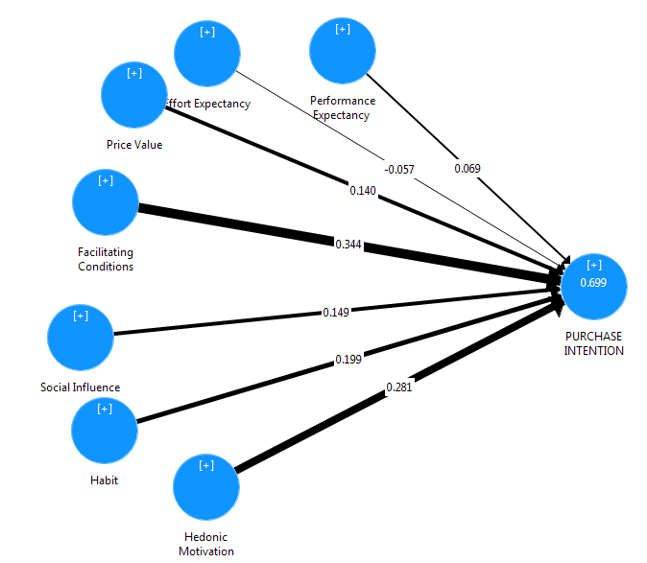

**Figure 2 : Path Model Gender (Male)**

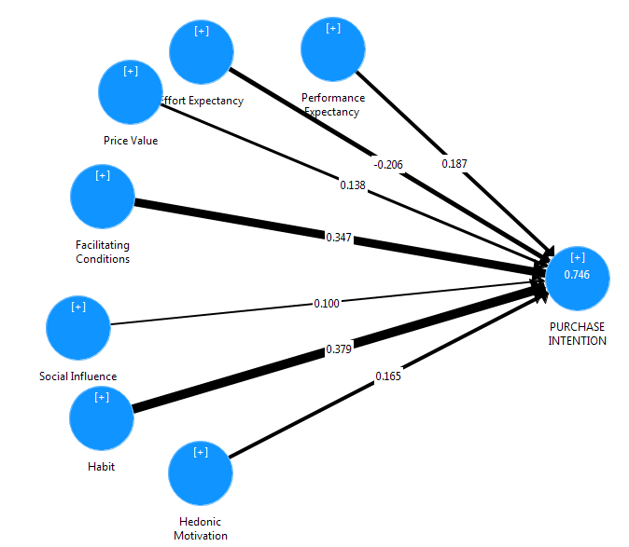

**Figure 3: Path Model Gender (Female)**

**Conclusion**

In case of female Habit influencing purchase intention in e-retailing more in comparison with male. Gender moderate relationship of Habit and customer purchase intention in e retailing

Female respondent had influence more by habit so customer acquisition program is more important where female are customers on the contrary male are tend be more habitual so loyalty program can be run for products and platforms designed for male customers can be run for them .

**References**

* Chan, F.K.Y., Thong, J.Y.L., Venkatesh, V., Brown, S.A., Hu, P.J.H. and Tam, K.Y. (2010),“Modeling citizen satisfaction with mandatory adoption of an e-government technology”, Journal of the Association for Information Systems, Vol. 11 No. 10, pp. 519-549.
* Hair, J. F., Ringle, C. M., & Sarstedt, M. (2011). PLS-SEM: Indeed a silver bullet. Journal of Marketing theory and Practice, 19(2), 139-152.

Hausman, A. V., & Siekpe, J. S. (2009). The effect of web interface features on consumer online purchase intentions. Journal of Business Research, 62(1), 5-13.

* Henseler, J., Ringle, C.M. and Sinkovics, R.R. (2009), “The use of partial least squares path modeling in international marketing”, Advances in International Marketing, Vol. 20 pp. 277-320.
* Steenkamp, Jan-Benedict E.M., and Hans Baumgartner (2000), “On the Use of Structural Equation Models for Marketing Modeling,” International Journal of Research in Marketing, 17 (2–3), 195–202.
* Venkatesh, V., Thong, J.Y.L. and Xu, X. (2012), “Consumer acceptance and use of information technology: extending the unified theory of acceptance and use of technology”, MIS Quarterly, Vol. 36 No. 1, pp. 157-178.
* Vinzi, Vincenzo Esposito; Wynne W. Chin; Joerg Henseler; & Huiwen Wang, eds. (2010). Handbook of partial least squares: Concepts, methods and applications. Series: Springer Handbooks of Computational Statistics. NY: Springer-Verlag.