# “HEART DISEASE PREDICTION WITH MACHINE LEARNING ALGORITHM USING PYTHON”

**Mr.ANIKET NAVALE**

**Student**

**Shree L .R. Tiwari College of Engineering Mr.SIDDHARTH SAPKAL**

**Student**

**Shree L .R. Tiwari College of Engineering**

# Mrs. Swapna Patil

**Department of Electronics and Telecommunication Engineering**

# ABSTRACT

Heart disease is a leading cause of mortality worldwide, emphasizing the need for accurate and timely diagnosis. Machine learning techniques have shown promise in predicting heart disease risk, and this study focuses on the application of the Machine Learning algorithms for heart disease prediction.

We explore a wide range of machine learning techniques, including decision trees, support vector machines, random forests, and K-Nearest Neighbour to assess their performance in heart disease prediction. Our study involves data preprocessing, feature selection, and model evaluation to ensure the robustness and accuracy of the predictions. The results reveal promising outcomes in terms of predictive accuracy, specificity. We compare the performance of these algorithms and discuss their strengths and limitations in the context of heart disease prediction. In this system, to train and test the Machine Learning algorithms, we use a dataset containing clinical and demographic data. Using these algorithms, we divide patients into two categories: those who are at risk of heart disease and those who are not.

## INTRODUCTION

One of the leading causes of morbidity and mortality among the global population is heart disease. One of the most crucial topics in the data analysis area is predicted cardiovascular disease. Since a few years ago, the prevalence of cardiovascular disease has been rising quickly throughout the world. Many studies have been carried out in an effort to identify the most important risk factors for heart disease and to precisely estimate the overall risk. Heart disease is also referred to as a silent killer because it causes a person to pass away without any evident signs. Cardiovascular disease must be detected early. aiding high-risk patients in making decisions regarding lifestyle changes will help to reduce the difficulties.

Making choices and predictions from the vast amounts of data generated by the healthcare sector is made easier with the help of machine learning. By evaluating patient data that uses a machine-learning algorithm to categorise whether a patient has heart disease or not, this study hopes to predict future cases of heart disease. Machine learning methods can be extremely helpful in this situation. There is a common set of basic risk factors that determine whether or not someone will ultimately be at risk for heart disease, despite the fact that heart disease can manifest itself in various ways. By gathering information

from numerous

S

sources, organising it into categories that make sense, and then performing analysis to get out the desired information based on statistics, we may conclude that this technique is quite adaptable.

The main difficulty with heart disease is detecting it. There are tools that can forecast heart disease, but they are either expensive or ineffective at calculating the likelihood of heart disease in a human. The mortality rate and total consequences can be reduced by early identification of heart disorders. Since it takes more intelligence, time, and knowledge, it is not always possible to accurately monitor patients every day, and a doctor cannot consult with a patient for a whole 24 hours. As can use a variety of machine learning methods to search for hidden patterns. The underlying patterns may utilised in medical data for health diagnosis.

## PROBLEM DEFINITION

The major challenge in heart disease is its detection. There are instruments available which can predict heart disease but either they are expensive or are not efficient to calculate chance of heart disease in human. Early detection of cardiac diseases can decrease the mortality rate and overall complications. However, it is not possible to monitor patients every day in all cases

accurately and consultation of a patient for

24 hours by a doctor is not available since it requires more sapience, time and expertise. Since we have a good amount of data in today’s world, we can use Machine Learning Algorithms to analyze and train the data.

## LITERATURE SURVEY

These literature surveys explore various applications of machine learning for heart disease prediction. The studies focus on the significance of leveraging machine learning techniques to address the critical issue of heart disease, a major cause of mortality globally.

* Heart Disease Prediction Using Machine Learning

. The multi-layer perceptron neural network approach is used for dataset training and testing in the study. ”Prediction of Heart Disease using Machine Learning algorithm” that Aditi Gavhane proposed. There will be one input layer , one output layer and perhaps more hidden layers in this algorithm between the two input and output layers.

* Heart Disease Prediction Using Machine Learning

The proposed methodology is also critical in a healthcare organization with experts that have no more knowledge and

skill. It uses different medical attributes such as blood sugar and heart rate, age, sex are some of the attributes are included to identify if the person has heart disease or not. Analyses of the dataset are computed using WEKA software.

* + Heart Disease Prediction Using Machine Learning

Random Forest algorithm is an efficient algorithm which is an ensemble learning method for regression and classification techniques. The algorithm constructs N of Decision trees and outputs the class that is the average of all decision trees output. So accuracy of prediction at early stages is achieved effectively.

* + Heart Disease Prediction Using Machine Learning

To achieve better accuracy and to make ththe more efficient so that it can predict the chances of heart attack.

## SOFTWARE REQUIREMENT

* + **Google colab :**

Google Colaboratory, or Colab, is an as-a- service version of Jupyter Notebook that enables you to write and execute Python code through your browser.

* + **Python Libraries** :
    1. Numpy **:**

A library for the Python programming language called NumPy adds support for big, multi-dimensional arrays and matrices as well as a tonne of high-level mathematical operations that can be performed on these arrays.

* + 1. Matplotlib **:**

For the Python programming language and its NumPy numerical mathematics extension, Matplotlib is a graphing library like Tkinter, wxPython, Qt, or GTK, it offers an object-oriented API

reference to both "Panel Data", and "Python Data Analysis" and was created by Wes McKinney

## FLOWCHART

.

* + 1. Seaborn :-

A matplotlib-based Python data visualisation library is called Seaborn. It offers a sophisticated user interface for creating visually appealing and educational statistical visuals. Python's Seaborn package is mostly used to create statistical visuals.

* + 1. SciPy:-

SciPy includes modules for common tasks in science and engineering like optimisation, linear algebra, integration, interpolation, special functions, FFT, signal and image processing, and ODE solvers.

* + 1. Pandas :

Pandas is a Python library used for working with data sets. It has functions for analyzing, cleaning, exploring, and manipulating data. The name "Pandas" has

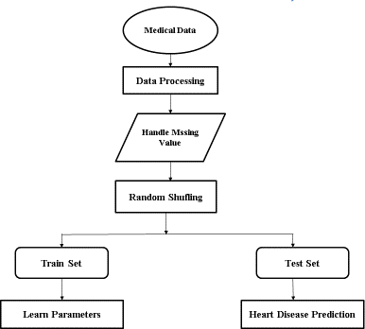**Figure 1:Flowchart of Proposed System**

## DESCRIPTION

Start **:** This is the beginning of the process, indicating that we are about to embark on the journey of creating a heart disease prediction model.

Medical Data **:** Medical data is collected, which can include a wide range of information about patients. This data may consist of attributes such as age, gender, cholesterol levels, blood pressure , family history, lifestyle factors, and more.

Data Preprocessing**:** Data preprocessing involves several tasks to prepare the collected medical data for machine learning. This can include cleaning the data to remove errors and feature extraction, where relevant information is derived from the raw data inconsistencies, normalizing features to bring them to a common scale

Handle Missing Values**:** In real-world datasets, there are often missing values. Handling missing values may involve techniques like imputation, where missing values are filled in based on other data, or in some cases, rows with missing values may be removed.

Random Shuffling**:** To avoid any potential biases in the dataset, the data is randomly shuffled. This step helps ensure that the order of data points doesn't impact the performance of the machine learning model.

Splitting Data into Train and Test Sets**:** The dataset is divided into two subsets: the training set and the test set. The training set is used to train the machine learning model, while the test set is used to evaluate its performance.

For Train Set, It Learns Parameters**:** Using the training set, the machine learning algorithm is applied to learn the parameters that define the model. This process involves adjusting the model's internal settings to make accurate predictions based on the retraining data

Test Set, Heart Disease Prediction: Once

the model has been trained, it is used to

make predictions on the test set. In the context of heart disease prediction, the model uses the information in the test set to predict whether or not a patient is at risk of heart disease.

## RESULTS:

This is the parameters which are use to predict the heart disease.

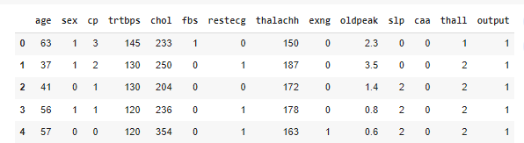

This is the parameters description table. In this, we find the mean, standard deviation , min, max

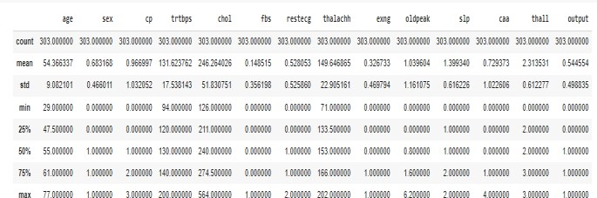

This is a confusion matrix.

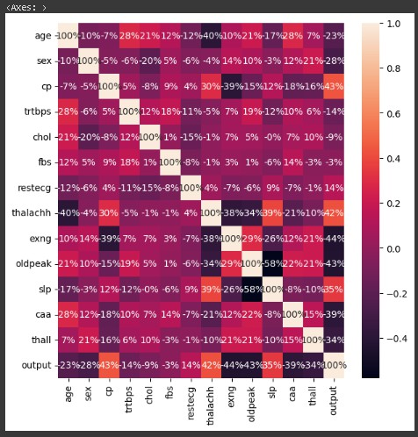

This graph shows the optimal "k" value with the minimum error rate. The minimum error rate with k = 7 is 0.1315.

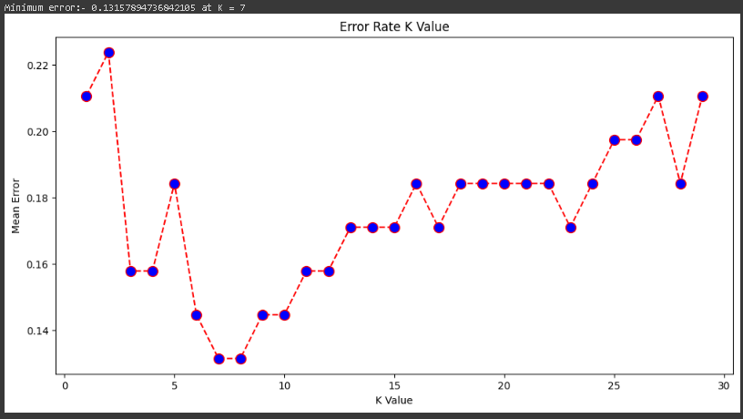

## CONCLUSION

The project on heart disease prediction using the various Machine Learning algorithms has provided valuable insights into the potential of machine learning in healthcare. Through the analysis of a relevant dataset and the implementation of the machine learning algorithms, we have demonstrated that it can be an effective tool for predicting heart diseases with reasonable accuracy

## REFERENCES:

1. Mr. Valle Harsha Vardhan , Mr. Uppala (2023) Rajesh Kumar Heart Disease predictio System using Machine Learning algorithms.
2. Mr. Santhana Krishnan J , Dr.Geeta S Prediction of Heart Disease using KNN algorithm – International Journal of Recent Technology and Engineering (IJRTE)
3. M. Marimuthu Gayatri. R S. Deivarani “Analysis of heart disease prediction using KNN algorithms – Journal of Engineering sciences.
4. Prof. Dr. Sulochana Sonkamble Snehal Dange “Hear Disease Prediction system using SVM algorithm.”- International Journal of Recent Technology and Engineering (IJRTE)
5. M.Senith Raja M.Anurag (2021) Machine learning based Heart Disease prediction system
6. Baban.U. Rindhe, Nikita Ahire, Rupali Patil (2021) Heart Disease Prediction Using Machine Learning.- “International Journal of Recent Technology and Engineering (IJRTE).