Experimental Investigation of Flexural Behaviour and Strengthening Efficiency of CFRP-Wrapped Reinforced Concrete Beams

#### 1Apurva Gaur 2 Abhishek Mishra

1M. Tech Research Scholar, CED Institute of Engineering and Technology, Lucknow,226021, India

2Assistant professor, CED Institute of Engineering and Technology, Lucknow,226021, India

# ABSTARCT-

This study discusses the use of Fiber Reinforced Polymer (FRP) composites to enhance the strength and durability of Reinforced Concrete (RC) beams, particularly those made with M 35 grade concrete. The article highlights the benefits of using FRP composites, such as increased strength and ductility, for repairing damaged or corroded beams and improving the resilience of RC-framed structures. The article also emphasizes the need for further research on the economic benefits and crash behaviour of Carbon Fiber Reinforced Polymer (CFRP) layers in M 35 grade RC frames, building on previous studies conducted with M 30 grade concrete. The article provides methodologies for reinforcing M 35 grade RC beams using CFRP sheets, with a focus on their impact on structural performance when wrapped around pre-cracked beams. The article concludes by discussing the adaptability and effectiveness of FRP composites across different concrete compositions, particularly in M 35 grade contexts.

**Key words- FRP, Composites, CFRP, Strength, Repairing.**

# INTRODUCTION

Reinforced concrete (RC) structures are crucial in the construction industry due to their adaptability, cost- effectiveness, and resilience. However, over time, these structures can deteriorate, leading to a decrease in flexural strength. To address this issue and ensure the ongoing safety and functionality of RC structures, various methods of strengthening have been developed. One notable solution is the use of carbon fiber reinforced polymer (CFRP) sheets. CFRP has gained popularity due to its high strength-to-weight ratio, corrosion resistance, and easy installation. Specifically, applying CFRP sheets to reinforce the flexural capacity of RC beams has shown promise in improving load-bearing capabilities and ductility.

To examine the effect of carbon fiber reinforcement on the strength of damaged beams, B.B. Adhikary et al. carried out an experimental investigation on RC beams. Tests were conducted using carbon fibers loaded at 60% and 90% of ultimate strength on concrete grade beams of the M15, M25, and M35 sizes. According to the results, carbon fiber strengthening increased ultimate beam strength by up to 30%, with an increase that was generally greater than that of control beams. While crack development and ductility remained constant before and after reinforcing, load capacity rose by 35–45%. The study highlights the potential for carbon fibers to significantly increase strength and improve load-bearing capacity.

Grace et al. (2002), 13 rectangular beams were examined using two different setups: one with strengthening material applied only to the bottom face, and another with the material extended to 150mm on the side faces. Out of the 13 beams, four were reinforced with carbon fiber (in the form of sheet, fabric, or plate), while the remaining eight were reinforced with hybrid fabric (either 1.0mm or 1.5mm). The beams reinforced with carbon fiber showed lower yield loads compared to those reinforced with hybrid fabric. However, the hybrid fabric-reinforced beams did not exhibit any significant decrease in ductility.

20 rectangular beams, comprising 2 reference beams and eighteen reinforced with carbon fiber reinforced polymer (CFRP), were examined by Brena et al. in 2003. Unidirectional fibers, woven fabric, and pultruded plates, four CFRP systems, were used in a variety of configurations, including on the soffit, wrapped around the bottom, on the sides, and integrated with transverse straps. Transverse straps delayed the debonding of longitudinal composites by preventing debonding along the shear span. Comparing CFRP to control beams, the flexural capacity increased.

Navya HA et al. (2018) investigated the strength and durability of M25 concrete with varying carbon fiber contents (0%, 0.75%, 1.00%, and 1.25%). 1% carbon fiber infusion, in particular, demonstrated the best improvement in compressive, tensile, and flexural strength. As carbon fiber dosage rose, workability dropped, but slump values remained comparable to 0.75% carbon fiber. Concrete reinforced with carbon fiber showed improved resilience to

exposure to sulfates and acids. In the end, 1% carbon fiber concentration showed the best performance in terms of strength and durability, among other factors.

**2.1 Materials**

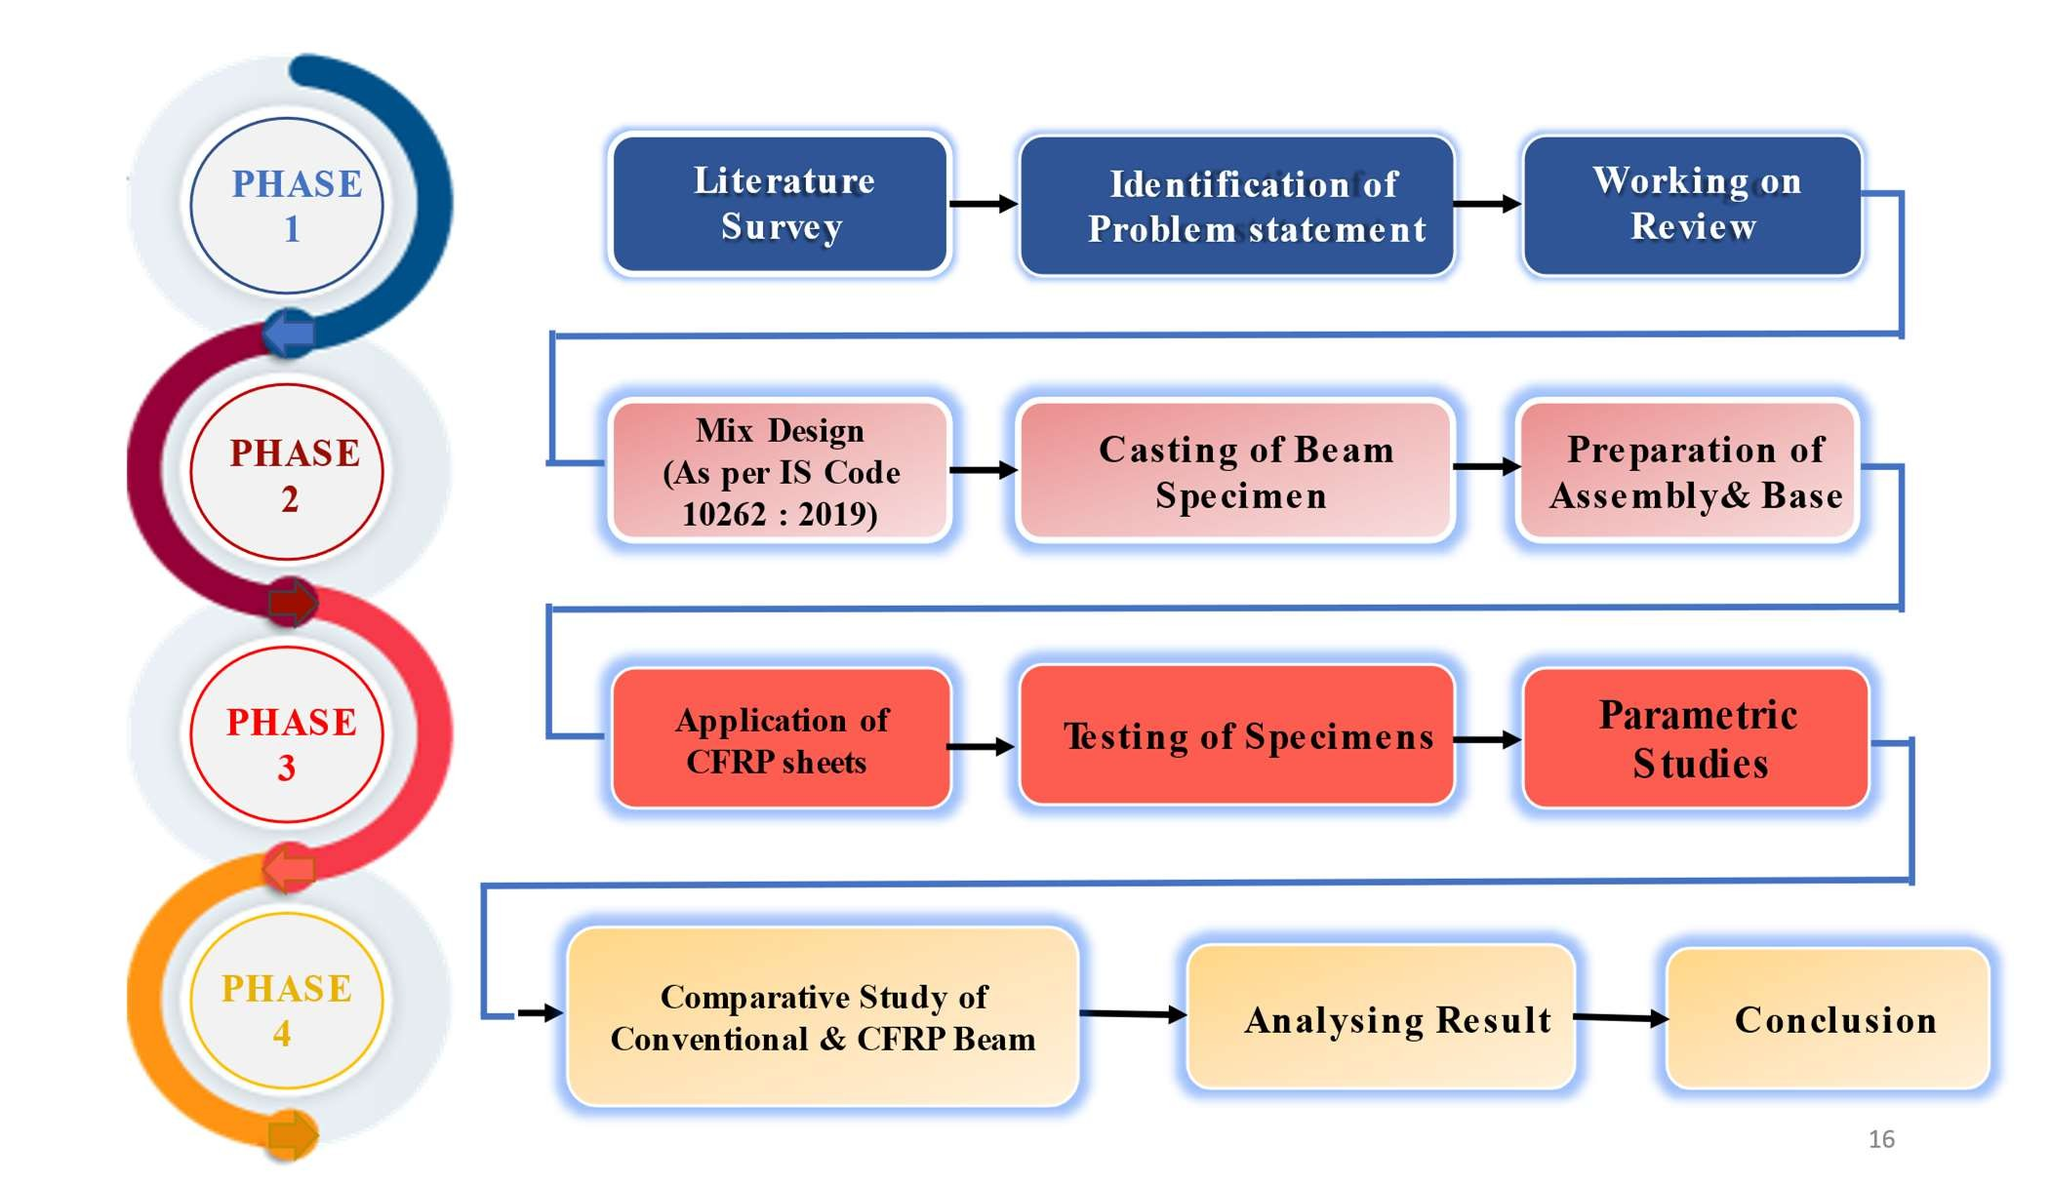

This paper presents an experiment that investigates the use of CFRP sheet wrapping to reinforce RC beams in flexural loading. The main objective is to evaluate the effectiveness and behavior of CFRP-strengthened RC beams. The study involves selecting representative RC beams similar to common structures that require reinforcement. CFRP sheets are carefully attached to the tension surfaces of the beams using appropriate adhesives. Controlled flexural loading is then applied to measure deflection, strain, and failure modes. A comparative analysis is conducted to compare the reinforced beams with control beams and assess the effectiveness of CFRP. This research builds on previous studies and highlights the ability of CFRP to enhance load-bearing capacity, stiffness, and overall structural response in RC beams. By advancing current knowledge and conducting comprehensive experiments, this study contributes to the field of CFRP sheet-based flexural reinforcement in RC beams. The findings have the potential to impact design standards and the practical implementation of CFRP reinforcement in the renovation of existing RC structures. In summary, this paper introduces and validates a laboratory-based investigation of flexural enhancement in RC beams using CFRP sheets. The focus is on evaluating the effectiveness and performance of reinforcement under flexural loading, advancing the field of structural reinforcement, benefiting engineers, and promoting the safe and sustainable use of RC structures.

# METHODOLOGY

An experimental investigation on the flexural strengthening of RC beams wrapped with CFRP sheets typically involves the following steps:

* Beam Selection
* Material Preparation
* Test Setup
* Strengthening Application
* Testing and Data Collection
* Analysis and Evaluation

1. **Cement**- OPC 43 grade cement is used in the experiment as it has a compressive strength of 43 MPa and consists of high-quality raw materials. It offers benefits such as good workability, durability, and resistance to sulfate attacks. It finds applications in general construction works, including plastering, masonry, and non- structural concrete. OPC 43 grade cement is important for achieving strong and durable structures.
2. **Aggregate**-The aggregate used in the experiment typically consists of 10-20 mm sized particles. These aggregates, commonly known as coarse aggregates, provide bulk and strength to the concrete mixture. They contribute to the stability and load-carrying capacity of the beam, ensuring its structural integrity and durability.
3. **Steel**- In RC beams, Fe 415 steel reinforcement is employed with 10 mm diameter bars as main bars and 8 mm diameter bars as distribution bars. The main bars carry the majority of the load and provide tensile strength, while the distribution bars help in distributing the load evenly across the beam's cross-section, enhancing its structural integrity and load-carrying capacity.
4. **Superplasticize**r - Fosroc Conplast SP430 QCDA 820 superplasticizer was used in the construction of RC beams as shown on Fig 2. It is added to the concrete mix to improve workability and reduce water content while maintaining desired slump. This superplasticizer enhances the flow and pumpability of the concrete, resulting in increased strength and durability of the RC beams.
5. **CFRP Sheet** – The Carbon fiber reinforced polymer sheet used in this experimental study is 200 GSM Uni- Directional Woven Carbon Fabric which was bought from Hayel Aerospace India PVT LTD shown in Fig 1.

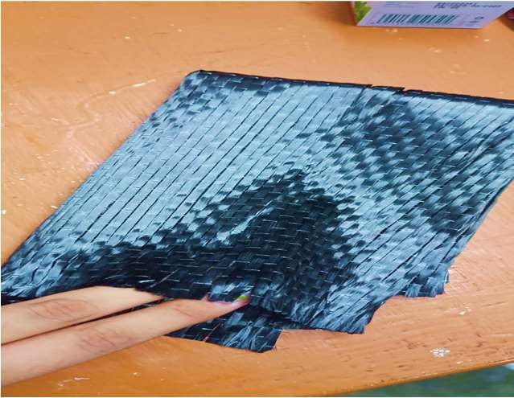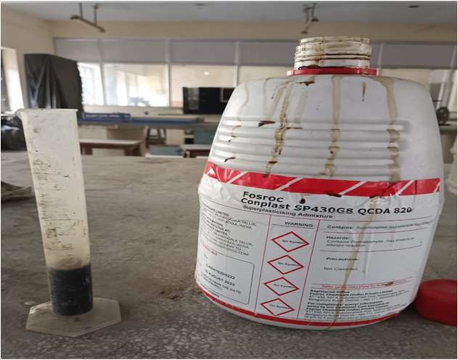

Fig 1. 200 GSM Uni- Directional Woven Carbon Fig 2. SP430 QCDA 820 superplasticizer

Table 1 : Physical properties of fiber

#### Fiber Properties

**Density (g/cm3)** 1.8

#### Filament Diameter (μm) 7

#### Tensile Strength (MPa) 5516

#### Tensile Modulus (GPa) 250

**Elongation (%)** 2.2

**Sizing** Epoxy Compatible

Table 2 : Characteristics of CFRP

**Characteristic Specification Tolerance Test Method Areal Weight (g/m2)** 200 ± 5% ASTM D3776

**Width* (mm)** 500 -0/+10mm ASTM D3774

**Dry Fabric** 0.3 ± 0.03mm ASTM D1777

**Thickness(mm)**

#### Epoxy Resin Hardener-

The Bisphenol-A-based liquid epoxy glue Araldite® LY 556 has a medium viscosity, while the aliphatic polyamine Aradur HY 951 has a low viscosity, and both are generally use as a adhesive element. When combined with Aradur HY 951, Araldite® LY 556 creates a solvent-free, room-temperature curing laminating system with low viscosity. The system's reactivity may be tailored to the processing & curing conditions by changing the hardener Aradur HY 951 concentration from 10 to 12 parts.

The selection of appropriate beams is crucial to ensure that the experimental results accurately represent the behavior and performance of CFRP-strengthened RC beams. By selecting beams with representative dimensions, conditions, and failure modes, the study provided valuable insights into the effectiveness of the strengthening technique and contribute to the development of reliable design guidelines for real-world applications.

Table 4 : Beam specification

**Details of Beam**

|  |  |
| --- | --- |
| **Width (b)** | 150 mm |
| **Overall depth (D)** | 150 mm |
| **Span length (l)** | 700 mm |
| **Concrete Cover** | 30 mm |
| **Effective Depth (d)** | 120 mm |
| **Grade of Concrete** | M35 |
| **Compressive Strength (Fck)** | 35 N/mm2 |

## SPECIMEN PREPARATION

A concrete mix was prepared for the specimens which conforms according to IS 456:2000 and the mix proportion for M35 Garde taking OPC 43 Grade cement (to the requirement of the IS 8112 standards), coarse sand, and crushed stones was calculated and it was taken as 1:2.32:3.26 (Cement: Fine Aggregate: Coarse Aggregate). The ratio of water-cement was maintained at 0.45, and room temperature tap water was used in the mixing process (Using curve for free w/c ratio & Table 3 & Table 5 According to IS 10262:2019), exposure conditions (according to IS 456:200 table 3).

Sand has a fineness modulus of 2.52 and a specific gravity of 2.60. The specimens were prepared using downgraded crushed stones with a maximum size of 20 mm and a specific gravity of 2.64. The designed compressive strength of concrete was 30 MPa and target strength was 43.25 MPa. The current experiment employed miniature beams, with results compared to those of larger-scale research. Beam specimens had dimensions of 150 millimetres by 150 millimetres by 700 millimetres and were reinforced with four mild steel deformed bars.

Deformed bars of 8 mm in diameter were used to construct the stirrups, which were mounted 150 mm from c/c. A concrete covering 30 millimetres thick was used to protect the reinforcements. Steel reinforcements of 10 and 8 mm had yield and ultimate strengths of 600 and 750 MPa, and 465 and 530 MPa, respectively. All the casted beams were cured in tap water at room temperature for 28 days. This allowed for the testing of conventional beams while other beams were strengthened by being covered in carbon fibre reinforced polymer.

The ultimate tensile strength, of the CFRP composite was 5516 MPa. As far as tensile modulus and ultimate elongation are concerned, they are 250 GPa, and 2.2 %, respectively.

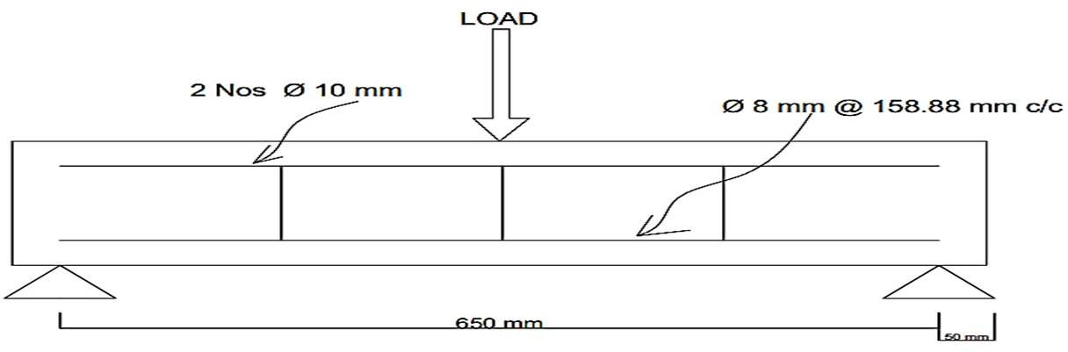

Fig 3- Reinforcement details of Beam

Table : 5 Properties of concrete mix

|  |  |  |  |
| --- | --- | --- | --- |
| **Proportions of Concrete Mix -1:2.32:3.26** | | | |
| **Cement\*** | **Water\*** | **Sand\*** | **Aggregates\*** |
| 350.50 | 147 | 814.73 | 1141.88 |

* Material in Kg use to prepare per cubic meter concrete.

#### SPECIMEN PREPARATION OF CFRP RC BEAM-

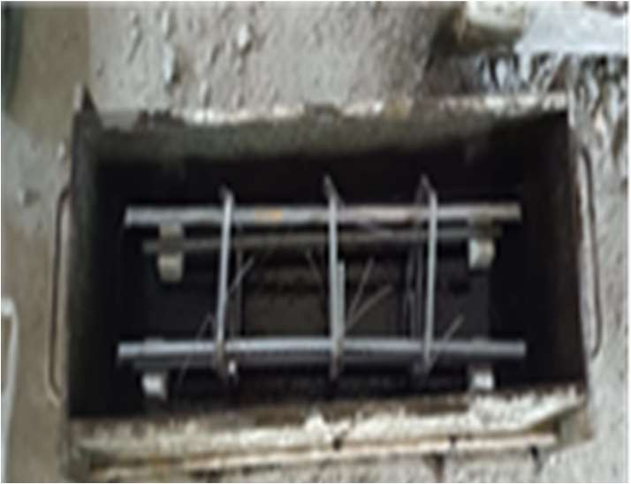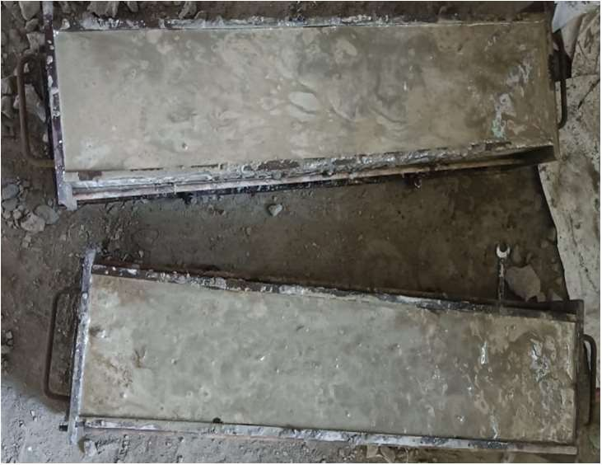The fabrication and preparation of Carbon Fiber Reinforced Polymer (CFRP) wrapped concrete beam specimens were undertaken to investigate their mechanical behaviour under varying configurations. Six concrete beams were meticulously cast to uniform dimensions and furnished with steel reinforcement. Among these, three beams underwent a novel U-shaped CFRP wrapping methodology, while the remaining three were fully enveloped with CFRP sheets. The application of epoxy adhesive served to secure the CFRP sheets to the concrete surface, ensuring reliable adhesion. Following the curing process, each specimen was subjected to comprehensive testing using a universal testing machine (UTM) to evaluate their structural performance. The study embraces a comprehensive approach to exploring the influence of different CFRP wrapping techniques on the load-bearing capacity, deformability, and failure mechanisms of reinforced concrete beams. This research contributes valuable insights into the efficacy of CFRP strengthening strategies for enhancing the structural integrity of concrete elements. The methods employed in the fabrication of these CFRP-wrapped beam specimens adhere to rigorous safety measures and established industry practices, facilitating a robust experimental framework for the investigation of their mechanical behaviour.

Fig 4. Specimen preparation for CFRP Beams Fig 5. Casted specimen for CFRB Beam Table 6 : Beam details

|  |  |  |
| --- | --- | --- |
| **S.no** | **Beam details** | **No. of beams to be casted** |
| 1 | **BEAM - 1 CONTROL BEAM (CB)** | **3** |
| 2 | **BEAM – 2 STRENGTHENED BEAM 1 (SB1)** | **3** |
| 3 | **BEAM – 3 STRENGTHENED BEAM 2 (SB2)** | **3** |

In summary of above specimen preparation, total 9 number of beams have been casted in which 3 beams are control beams which are reinforced by steel bars and are Conventional RC beams (CB) and next 3 beams are wrapped by CFRP sheet in U shaped wrapping along three sides of the Reinforced beam and termed as Strengthened beam 1 (SB- 1) and rest 3 beams are fully wrapped by CFRP sheet in two layers and termed as Strengthened beam 2 (SB-2).

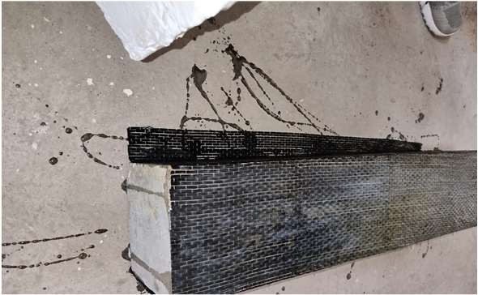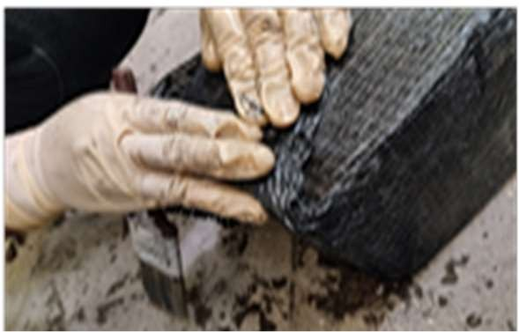

Fig 6. Strengthen Beam 1 Fig 7. Strengthen Beam 2

#### TEST SETUP AND PREPARATION-

In this experimental research, conventional reinforced concrete beam specimens and CFRP wrapped reinforced concrete beam were rigorously tested using a cutting-edge universal testing machine (UTM). The UTM provided a robust platform to assess the beams' load-carrying capacity and behaviour. Careful specimen preparation ensured accurate alignment and secure mounting on the UTM's lower supports. The loading scheme involved incremental load application, with load and displacement recorded at regular intervals to construct load-displacement curves. Visual observations during testing helped monitor cracks, deformations, and failure indicators. The collected UTM data enabled analysis of stiffness, strength, and failure modes of the beams. This experimental setup adhered to safety and testing standards, guaranteeing reliable results. The UTM's role in this study offered profound insights into the mechanical properties and performance of the tested reinforced concrete beams, significantly contributing to structural engineering knowledge.

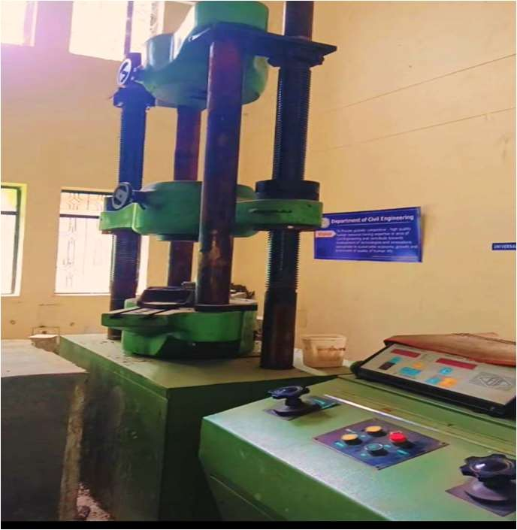

Fig 8. Universal Testing Machine

# TESTING AND DATA COLLECTION

During the flexure strength testing phase, the concrete beams were meticulously mounted onto the universal testing machine (UTM). Incremental load was applied gradually to each beam, inducing bending behaviour. Observations revealed that as the load was exerted, the beams began to exhibit deflection and bending, culminating in failure at specific and varying loads for each type of beam.

The control group, comprising three conventional beams, experienced failure within the load range of 120 kN to 155 kN. This was accompanied by a corresponding deflection range of 7 mm to 9 mm. The response of the control beams under load demonstrated consistent and predictable behaviour.

Remarkably, the beams strengthened using a U-shaped CFRP wrapping technique exhibited enhanced load-bearing capacities. These beams experienced failure at higher loads, ranging from 150 kN to 210 kN. The corresponding deflection ranged between 6 mm and 7 mm, indicating improved performance and increased stiffness due to the CFRP reinforcement. Furthermore, the beams strengthened with a two-layer full wrapping of CFRP exhibited exceptional load-carrying capacities. These beams endured until failure at considerably higher loads, within the range of 190 kN to 265 kN. The deflection was measured between 4 mm and 6 mm, suggesting the significant enhancement of

structural integrity through multi-layer CFRP reinforcement.

#### CONVENTIONAL RC BEAM TESTING

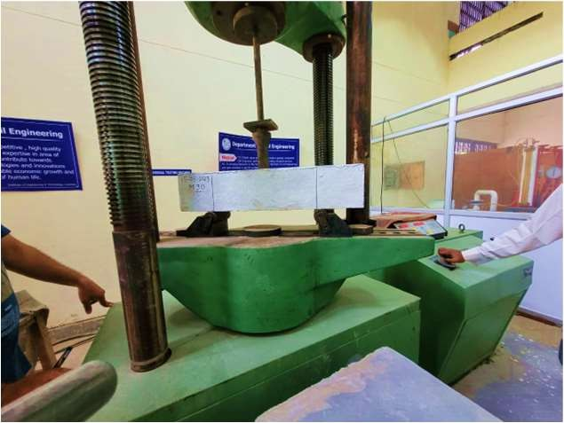

Fig 9. Conventional beam tested under UTM Table : 7 Load and Deflection properties of conventional Beam

**Beam Type Load (kN) Deflection (mm)**

**Conventional Beam (CB)**

CB-1 120 7.6

CB-2 135 8.5

CB-3 155 9.2

Load (kN)

Fig 10. Load vs Displacement graph of conventional beam



200

155

150

120

135

100

50

0

0

1

2

3

4

5

Displacement (mm)

#### U-SHAPED WRAPPED RC BEAM

Table : 8 Load and Deflection properties of U- shaped Beam

|  |  |  |
| --- | --- | --- |
| **Beam Type** | **Load (kN)** | **Deflection (mm)** |
| **U-shaped wrapped** UB-1 | 156 | 6.8 |
| **RC Beam (UB)** UB-2 | 178.2 | 5.9 |
| UB-3 | 210.8 | 7.1 |

|  |  |  |  |
| --- | --- | --- | --- |
|  |  |  | 210.8  178.2  6 |
|  |  | 15 |  |
|  |  |  |  |
|  |  |  |  |
|  |  |  |  |

Fig 11. Load vs Displacement graph of U- shaped wrapped RC beam



250

200

150

100

50

0

0

2

4

Displacement (mm)

6

8

Load(kN)

## FULLY WRAPPED RC BEAM

Table 9 : Load and Deflection properties of fully wrapped RC Beam

### Beam Type Load (kN) Deflection (mm)

**Fully Wrapped RC Beam (FB)**

FB-1 192 4.9

FB-2 218.7 5.83

FB-3 263.5 6.5



300

250

200

150

100

50

0

263.5

218.7

192

0 2

4

Displacement (mm)

6

8

Load (kN)

Fig 12. Load vs Displacement graph of Fully wrapped RC beam

# ANALYSIS AND EVALUATION

## FLEXURE STRENGTH

Table 10 : Flexural strengths of conventional RC beams

#### Beam Type Flexural Strength (MPa)

CB-1 59.74

#### Conventional Beam (CB)

CB-2 67.28

CB-3 77.05

Lowest value indicated less resistance, maybe as a result of weakened reinforcement or concrete. Due to effective materials, the middle number indicated moderate strength. The highest value represented dependable strength, which was linked to optimized components.

Table 11 : Flexural strengths of conventional U-shapped beams

|  |  |
| --- | --- |
| **Beam Type** | **Flexural Strength (MPa)** |
| **U-shaped wrapped RC Beam** UB-1 | 77.70 |
| **(UB)** UB-2 | 88.73 |
| UB-3 | 104.86 |

The three CFRP-wrapped RC beams reported flexural strength values, show a noticeable improvement in load-bearing capacity when compared to their conventional counterparts. Due to the U-shaped wrapping design, this enhancement emphasizes the advantageous effects of CFRP reinforcement. Higher strengths are indicative of better structural integrity and performance.

Table 12 : Flexural strengths of fully wrapped RC beams

#### Beam Type Flexural Strength (MPa)

**Fully Wrapped RC Beam (FB)**

FB-1 95.60

FB-2 108.79

FB-3 131.02

The three totally CFRP-wrapped RC beams' flexural strength measurements, respectively, show a constant climbing trend. Dual- layer wrapping is quite effective, as seen by the considerable improvement in strength compared to both conventional and U-shaped CFRP-wrapped beams. The strength and load-bearing capability of the beams might be greatly improved by multi-layer CFRP reinforcement, according to this finding.



U Wrapped Beam Fully Wrapped in 2 Layers

Beam

Conventional Beam

50

0

77.7 88.73

77.05

59.74 67.28

100

131.02

108.79

95.6

104.86

150

Beam 3

Beam 2

**STRENGTH**

**FLEXURAL**

Beam 1

Fig 13. Flexural Strength graph of beams

## STRESS CALCULATION-

Table 13 : Stress calculation of conventional RC beams

#### Beam Type Stress (N/m2)

CB-1 5.33

#### Conventional Beam (CB)

CB-2 6

CB-3 6.89

The stress analysis of the three conventional RC beams shows a progressive increase in load-bearing capability, This pattern suggests an improvement in the beams' capacity to withstand stress, which is probably due to variations in the quality of the concrete, how the reinforcing is arranged, or the size of the beams. The outcomes highlight how crucial these elements are in determining how well typical RC beams function under stress.

Table 14 : Stress calculation of U-shaped RC beams

|  |  |
| --- | --- |
| **Beam Type** | **Stress (N/m2)** |
| **U-shaped wrapped RC Beam** UB-1 | 6.9 |
| **(UB)** UB-2 | 7.9 |
| UB-3 | 9.33 |

The three U-shaped CFRP-wrapped RC beams' stress analyses, respectively, show a consistent and appreciable improvement in load-bearing capacity. This phase emphasizes the beneficial effects of U-shaped CFRP wrapping on improving strength and stress distribution. The outcomes demonstrate the efficiency of this wrapping technique in enhancing the beams' capacity to carry stress and demonstrating enhanced structural performance.

Table 15 : Stress calculation of fully wrapped RC beams

#### Beam Type Stress (N/m2)

**Fully Wrapped RC Beam (FB)**

FB-1 8.53

FB-2 9.72

FB-3 11.79

The stress analysis of the three totally CFRP-wrapped RC beams shows a steady and incremental strengthening trend, respectively. The dual-layer CFRP wrapping used to accomplish this improvement in stress levels highlights the beams' better load-bearing capability and shows stronger resistance to applied pressures. The results highlight the value of multi-layer CFRP reinforcement in enhancing the beams' structural integrity and stress-bearing capacity.

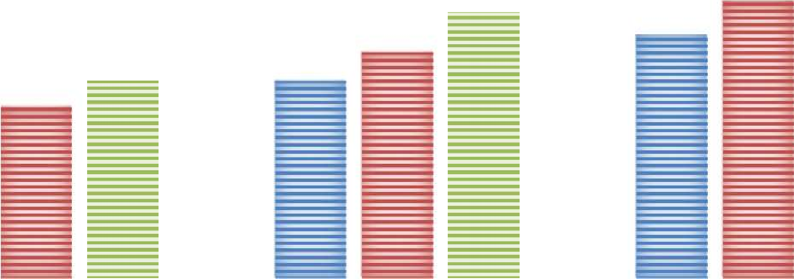

**STRESS ANALYSIS**

Beam 1 Beam 2 Beam 3

14

12

10

8

6

4

2

0

11.79

9.33

9.72

6.89

6.9

7.9

8.53

5.33

6

Conventional Beam U wrapped CFRP Beam Fully wrapped in 2 layers

CFRP Beam

Fig 14. Stress Analysis of beams

# STRAIN CALCULATION

Table 16 : Strain calculation of conventional RC beams

|  |  |  |  |
| --- | --- | --- | --- |
|  | **Beam Type** |  | **Strain** |
|  |  | CB-1 | 0.011 |
| **Conventional Beam (CB)** |  | CB-2 | 0.012 |
|  |  | CB-3 | 0.013 |

The three standard RC beams' measured strains show a steady rising trend in the strain data. This pattern shows the gradual deformation brought on by applied loads. The findings imply that the strain on the beams grows with increasing load, indicating compliance with Hooke's law within the elastic range. The results demonstrate the close connection between load and strain and offer insightful information about how standard RC beams behave structurally under a range of loads.

Table 17 : Strain calculation of fully U-shaped wrapped RC beams

|  |  |
| --- | --- |
| **Beam Type** | **Strain** |
| **U-shaped wrapped RC Beam** UB-1 | 0.0097 |
| **(UB)** UB-2 | 0.0084 |
| UB-3 | 0.0101 |

The three conventional CFRP-wrapped RC beams, each with CFRP wrapping in a U shape, according to the strain analysis. These findings reveal a dependable yet diverse pattern of deformation under load. The CFRP wrapping's reinforcing impact is highlighted by the observed strains, which show greater deformation in comparison to beams that aren't wrapped. The progressive character of the strain values emphasizes how strain depends on the applied load and how important the CFRP reinforcement is for absorbing and redistributing stresses within the structures of the beams.

Table 18 : Strain calculation of fully wrapped RC beams

|  |  |  |  |
| --- | --- | --- | --- |
|  | **Beam Type** |  | **Strain** |
| **Fully Wrapped RC Beam** |  | FB-1 | 0.007 |
| **(FB)** |  | FB-2 | 0.0083 |
|  |  | FB-3 | 0.0092 |

These data indicate a constant deformation pattern under varied loads. The measured stresses show a regulated and relatively reduced amount of beam deformation, demonstrating the significant reinforcing impact of dual-layer CFRP wrapping. This improvement in load-bearing capability is reflected in the limited strain values, confirming the important impact of multi-layer CFRP reinforcement in moderating deformation and improving structural resilience of the beams.



U wrapped CFRP Beam Fully wrapped in 2 layers

CFRP Beam

Conventional Beam

0.005

0

0.0092

0.0070.0083

0.0084

0.01

0.0101

0.0097

0.012 0.013

0.011

0.015

**STRAIN ANALYSIS**

Beam 1 Beam 2 Beam 3

Fig 15. Strain Analysis of beams

# MODULUS OF ELASTICITY

Table 19 : Modulus Of Elasticity calculation of conventional RC beams

|  |  |  |  |
| --- | --- | --- | --- |
|  | **Beam Type** |  | **E (N/m2)** |
|  |  | CB-1 | 484.54 |
| **Conventional Beam (CB)** |  | CB-2 | 500 |
|  |  | CB-3 | 530 |

This data shows a clear climbing trend, indicating greater stiffness and structural integrity. The increase in Modulus of Elasticity values shows that the deformation resistance under applied loads is improving. These variances might be caused by differences in concrete quality, reinforcing configuration, or beam diameters. The findings highlight the significance of these elements in determining the Modulus of Elasticity and, as a result, the load-carrying capacities of typical RC beams.

Table 20 : Modulus Of Elasticity calculation of U-shaped wrapped RC beams

|  |  |
| --- | --- |
| **Beam Type** | **E (N/m2)** |
| **U-shaped wrapped RC Beam** UB-1 | 711.34 |
| **(UB)** UB-2 | 940.47 |
| UB-3 | 923.76 |

When compared to non-wrapped alternatives, these findings show a continuous trend of increased stiffness and structural robustness. Higher Modulus of Elasticity values indicate better deformation resistance under loading situations. The U-shaped CFRP wrapping efficiently increases the stiffness of the beams, increasing their load-bearing capacity and the possibility for better structural performance.

Table 21 : Modulus Of Elasticity calculation of fully wrapped RC beams

|  |  |  |
| --- | --- | --- |
| **Beam Type** |  | **E (N/m2)** |
| **Fully Wrapped RC Beam** | FB-1 | 1218.57 |
| **(FB)** | FB-2 | 1171.08 |
|  | FB-3 | 1281.52 |

These data reveal a significant increase in stiffness when compared to non-wrapped beams. The much higher Modulus of Elasticity values indicate the outstanding reinforcing impact of dual-layer CFRP wrapping, demonstrating a considerable improvement in the resistance of the beams to deformation under varied loads. The findings highlight the ability of multi-layer CFRP reinforcement to significantly improve the structural integrity and load-carrying capacities of the beams.



**MODULUS OF ELASTICITY**

Beam 1 Beam 2 Beam 3

1500

1218.571171.01281.52

8

1000

940.47923.76

711.34

484.54 500

530

500

0

Conventional Beam

U wrapped CFRP Beam Fully wrapped in 2 Layers

CFRP Beam

### 4.5- Crack Propagation

a. Control Beam

Fig 16. Modulus of Elasticity graph of beams

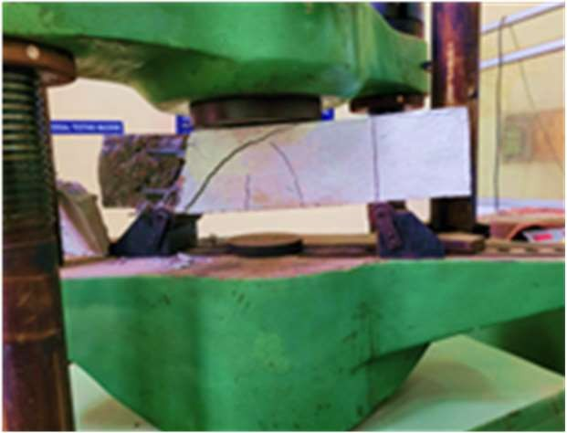

Fig 17. Crack propagation in control beam

The fractures appear in the mid-span of a standard RC beam during testing, a characteristic crack pattern emerges, revealing insight on the structural reaction of the beam. Cracks form in the core owing to high tensile strains and spread radially outward. They can expand and extend as the weight increases, resulting in varied spacing along the length of the beam. Diagonal and shear fractures may form as a result of the combined bending and shear

pressures.

1. U wrapped Strengthened CFRP Beam –

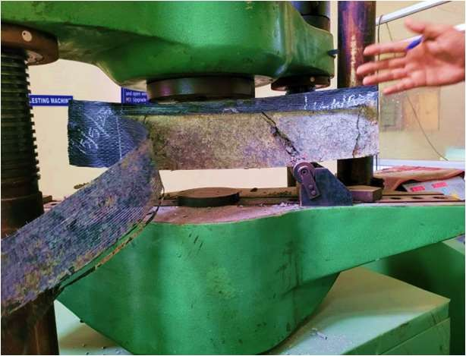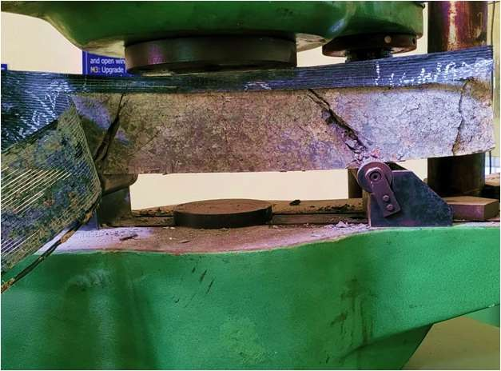

Fig 18. Debonding of CFRP sheet Fig 19. Cracks on U wrapped CFRP Beam

In summary, when a U-shaped CFRP-wrapped RC beam is tested under UTM, crack propagation begins at the ends and develops to the center, frequently accompanied by CFRP sheet debonding. This failure mode emphasizes the interaction of fracture propagation, debonding, and overall structural capability.

Understanding this pattern and failure mechanism contributes to the refinement of CFRP reinforcement schemes and the optimization of the performance of such composite structures.

1. Fully Wrapped in 2 layers CFRP Beam

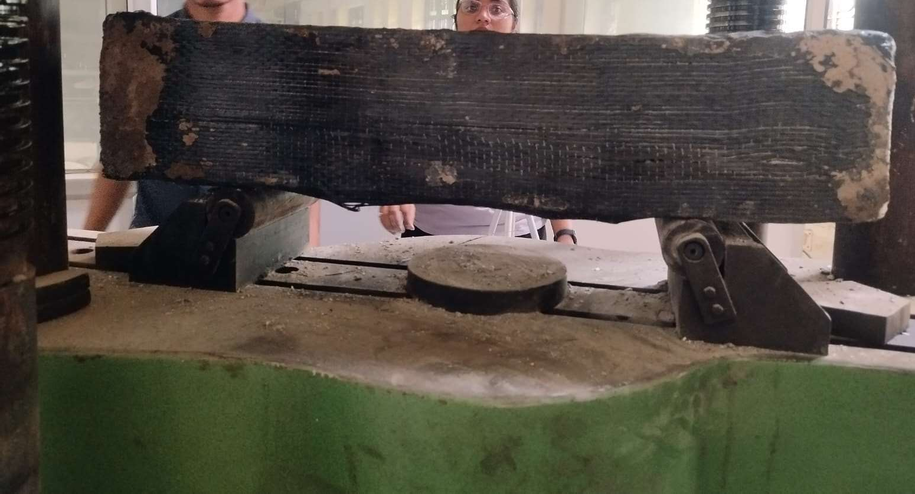

Fig 20. Debonding Failure on Fully Wrapped in 2 layers CFRP Beam

In conclusion, UTM testing of a CFRP-wrapped RC beam entirely enclosed in two layers of CFRP sheet indicates fracture propagation beginning at the end supports and extending to the center. Partial debonding of the CFRP sheet is also possible, reducing load-bearing capability. This complex failure mechanism illustrates the interaction of crack propagation, partial debonding, and beam structural performance. Understanding this behavior is critical for improving CFRP reinforcement tactics and assuring the dependability of such composite structures.

# CONCLUSION

* The comparative analysis highlights the major advantages of CFRP reinforcing techniques in boosting flexural strengths in its overall conclusion. The impressive advancements made by the U-shaped and dual- layer wrapping techniques highlight their potential to enhance structural integrity and performance throughout reinforced concrete beams.
* In conclusion, the comparison research shows that, in terms of stress distribution and load-bearing capacity, completely and U-shaped CFRP-wrapped RC beams are preferable. The findings provide important information for engineering applications by demonstrating the efficiency of CFRP reinforcement techniques in improving the structural performance of reinforced concrete beams.
* This comparison study highlights the distinct strain responses of various beam configurations. Case-specific observations help to provide a more complete knowledge of strain distribution, deformation behavior, and the reinforcing efficiency of CFRP wrapping. These discoveries contribute to a better knowledge of structural performance under various loading circumstances, driving the quest of optimum design and increased load- bearing capabilities.
* In conclusion, the comparative study demonstrates the relationship between Modulus of Elasticity and structural behavior. It emphasizes the enormous gains made possible by CFRP reinforcing methods, both U- shaped and dual-layer, in terms of structural performance and load-bearing capabilities across beam configurations.
* In conclusion, the comparison study highlights the various fracture patterns and failure processes seen across beam configurations. Case 1 illustrates standard RC beams, whereas Cases 2 and 3 investigate CFRP- wrapped beams, each with unique fracture propagation and failure characteristics. These findings highlight the necessity of specialized reinforcing schemes and a thorough understanding of structural behavior in enhancing composite structure performance and dependability.

# REFERENCES

* Alkhawaldeh, A. A., & Al-Rousan, R. Z. (2022). Upgrading cyclic response of heat- damaged RC beam-column joints using CFRP sheets. *Case Studies in Construction Materials*, *17*, e01699.
* Toutanji, H., & Deng, Y. (2007). Comparison between organic and inorganic matrices for RC beams strengthened with carbon fiber sheets. *Journal of Composites for Construction*, *11*(5), 507-513.
* Mashrei, M., Makki, J., & Sultan, A. A. (2019). Flexural strengthening of reinforced concrete beams using carbon fiber reinforced polymer (CFRP) sheets with grooves. *Latin American Journal of Solids and Structures*, *16*.
* Ha, G. J., Cho, C. G., Kang, H. W., & Feo, L. (2013). Seismic improvement of RC beam– column joints using hexagonal CFRP bars combined with CFRP sheets. *Composite Structures*, *95*, 464-470.
* Nawaz, W., Elchalakani, M., Karrech, A., Yehia, S., Yang, B., & Youssf, O. (2022). Flexural behavior of all lightweight reinforced concrete beams externally strengthened with CFRP sheets. *Construction and Building Materials*, *327*, 126966.
* Yun, H. D., Choi, W. C., & Seo, S. Y. (2010). Acoustic emission activities and damage evaluation of reinforced concrete beams strengthened with CFRP sheets. *Ndt & E International*, *43*(7), 615-628.
* Al-Khafaji, A., Salim, H., & El-Sisi, A. (2021, October). Behavior of RC beams strengthened with CFRP sheets under sustained loads. In *Structures* (Vol. 33, pp. 4690- 4700). Elsevier.
* Al-Saidy, A. H., & Al-Jabri, K. S. (2011). Effect of damaged concrete cover on the behavior of corroded concrete beams repaired with CFRP sheets. *Composite Structures*, *93*(7), 1775- 1786.
* Khalifa, A., & Nanni, A. (2002). Rehabilitation of rectangular simply supported RC beams with shear deficiencies using CFRP composites. *Construction and building materials*, *16*(3), 135- 146.
* Al-Rousan, R. Z., Alhassan, M. A., & AlShuqari, E. A. (2018). Behavior of plain concrete beams with DSSF strengthened in flexure with anchored CFRP sheets— Effects of DSSF content on the bonding length of CFRP sheets. *Case Studies in Construction Materials*, *9*, e00195.
* Le-Trung, K., Lee, K., Lee, J., Lee, D. H., & Woo, S. (2010). Experimental study of RC beam–column joints strengthened using CFRP composites. *Composites Part B: Engineering*, *41*(1), 76-85.
* Jafarzadeh, H., & Nematzadeh, M. (2022). Flexural strengthening of fire-damaged GFRP- reinforced concrete beams using CFRP sheet: Experimental and analytical study. *Composite Structures*, *288*, 115378.
* Spadea, G., Bencardino, F., & Swamy, R. N. (1998). Structural behavior of composite RC beams with externally bonded CFRP. *Journal of Composites for Construction*, *2*(3), 132- 137.
* Tiwary, A. K., Singh, S., Kumar, R., Sharma, K., Chohan, J. S., Sharma, S., ... & Deifalla,

A. F. (2022). Comparative Study on the Behavior of Reinforced Concrete Beam Retrofitted with CFRP Strengthening Techniques. *Polymers*, *14*(19), 4024.

* Toutanji, H., & Ortiz, G. (2001). The effect of surface preparation on the bond interface between FRP sheets and concrete members. *Composite structures*, *53*(4), 457-462.
* Belarbi, A., Bae, S. W., & Brancaccio, A. (2012). Behavior of full-scale RC T-beams strengthened in shear with externally bonded FRP sheets. *Construction and Building Materials*, *32*, 27-40.
* Dong, J., Wang, Q., & Guan, Z. (2013). Structural behaviour of RC beams with external flexural and flexural–shear strengthening by FRP sheets. *Composites Part B: Engineering*, *44*(1), 604-612.
* Moradi, E., Naderpour, H., & Kheyroddin, A. (2020). An experimental approach for shear strengthening of RC beams using a proposed technique by embedded through- section FRP sheets. *Composite Structures*, *238*, 111988.