**An Intelligent Waste Classification System for Sustainable Resource Management Using Machine Learning**

**Mrs.Rasika Rewatkar1, Ms.Ragini Thakrel2, Ms. Rachana Madankar3, Mr.Satvik Raut4,**

**Ms. Kumud Bankar5*, Ms.Shailee Goverdhan6***

**\*\***

*Department of Information Technology*

*Kavikulguru Institute of Technology and Science, Nagpur, India*

***Abstract*-** Waste sorting is a major environmental problem. Many have a hard time determining whether waste is organic, meaning food or natural material. Versus recyclable, which are able to be processed and used again. Computer Vision may be used to combat this problem. Our idea is to build and utilize a Convolutional Neural Network (CNN) to classify recyclable and organic waste. We use the Machine Learning Library in our CNN. The model uses a simple CNN model with binary cross entropy to classify through images from our dataset as recyclable (R) or organic (O). The model is about 80-90% successful in its final state. In the majority of cases, it can quickly and successfully determine if an object is recyclable or organic. Waste sorting is a major environmental problem. Many have a hard time determining whether waste is organic, meaning food or natural material. Versus recyclable, which are able to be processed and used again.

***Index Terms***- Computer Vision · Convolutional Neural Networks · Waste Classification. TensorFlow.js · Machine Learning

1. Introduction

The world bank report showed that there are almost 4 billion tons of waste around the world every year and the urban alone contributes a lot to this number, the waste is predicted to increase by 70 percent in the year 2025 [1]. According to [1] in the next 25 years, the less developed countries’ waste accumulation will increase drastically. With the increase in the number of industries in the urban area, the disposal of the solid waste is really becoming a big problem, and the solid waste includes paper, wood, plastic, metal, glass etc. The main method of managing the waste is landfilling, which is inefficient and expensive and polluting natural environment. For example, the landfill site can affect the health of the people who stay around the landfill site. Another common way of managing waste is burning waste and this method can cause air pollution and some hazardous materials from the waste spread into the air which can cause cancer[2]. Hence it is necessary to recycle the waste to protect the environment and human beings’ health, and we need to separate the waste into the different components which can be recycled using different ways.

**Benefits of a Comprehensive Waste Classification Platform:**

Comprehensive waste classification offers several benefits for waste management and environmental protection. It involves categorizing waste into different groups based on its characteristics, source, and potential environmental impact. Here are some of the key benefits of implementing a comprehensive waste classification system**:**

1. Effective Waste Management: A well-defined waste classification system helps in the proper identification and segregation of different types of waste. This, in turn, enables more efficient waste collection, transportation, and disposal methods.
2. Resource Recovery: Comprehensive waste classification allows for the identification of recyclable materials, organic waste, and hazardous substances. This promotes resource recovery and recycling efforts, reducing the need for raw materials and conserving natural resources.
3. Hazard Mitigation: Identifying hazardous waste and classifying it appropriately helps ensure that it is handled, stored, and disposed of safely. This reduces the risk of environmental contamination and harm to human health.
4. Environmental Protection: By categorizing waste according to its potential harm to the environment, regulations and best practices can be developed to minimize negative impacts. This includes controlling the release of pollutants and preventing soil and water contamination.

**Challenges of a Comprehensive Waste Classification:** Implementing a comprehensive waste classification system can be challenging, despite its many benefits. Here are some of the key challenges associated with such a system:

1. Complexity: Waste streams can be highly diverse and complex, making it difficult to create a classification system that accounts for all possible waste types and variations.
2. Continuous Changes: The waste landscape is dynamic, with new materials and products constantly being developed. Keeping a classification system up-to-date and adaptable to emerging waste streams is a challenge.
3. Lack of Standardization: Different regions and countries may have their own waste classification systems and terminology, leading to confusion and inconsistencies in waste management practices, especially in global supply chains.

.

**Opportunities for Society Communities:**

1. Public Awareness and Education: Implementing waste classification systems provides opportunities to educate the public about responsible waste disposal, recycling, and the environmental impact of waste. This can lead to more environmentally conscious behavior.
2. Resource Recovery and Circular Economy: A comprehensive waste classification system can identify valuable materials within the waste stream, promoting resource recovery and recycling. This not only conserves natural resources but also supports the development of a circular economy where materials are reused and recycled.
3. Job Creation: Waste management and recycling industries create jobs in collection, sorting, processing, and recycling activities. As waste management practices become more sophisticated and efficient, there is potential for job growth in these sectors.
4. IDENTIFY, RESEARCH AND COLLECT IDEA

**2.1 Functional Requirements**

Creating an intelligent waste classification system using TensorFlow.js for sustainable resource management involves defining functional requirements to specify what the system should do. Below are some functional requirements for such a system:

1. Image Classification:

The system should accept images of waste items as input.It should accurately classify waste items into predefined categories, such as recyclables, organic waste, and non-recyclables.

1. User Interface:The system should provide a user-friendly web-based interface.

Users should be able to upload waste images for classification.

Optionally, users should have the option to use their webcams or mobile device cameras for real-time waste classification.

1. Feedback and Reporting:Users should have the ability to provide feedback on classification results, such as reporting misclassifications.

There should be a mechanism for users to contact support or request assistance.

1. Accuracy and Confidence Scores:The system should provide accuracy scores or confidence levels for each classification to indicate the system's confidence in its predictions.
2. Model Retraining:The system should support periodic model retraining to improve accuracy over time as new data becomes available.

The process of retraining should be automated and transparent to users.

1. Data Privacy and Security:The system should ensure the privacy and security of user-uploaded images.

It should include mechanisms for data encryption and secure storage.

1. Compatibility and Accessibility:The system should be compatible with popular web browsers and accessible to a wide range of users, including those with disabilities.

Consider responsive design for different screen sizes and devices.

1. Multi-Language Support:The user interface should support multiple languages to accommodate a diverse user base.
2. Scalability:The system should be designed to handle a potentially large number of concurrent users.

Consider load balancing and server scaling mechanisms.

1. Reporting and Analytics:

Implement reporting and analytics capabilities to track system usage, accuracy, and performance.Generate periodic reports on waste classification statistics and trends.

1. Integration with Existing Systems:If applicable, the system should be able to integrate with existing waste management or recycling systems for data exchange and coordination.
2. Error Handling and Recovery:The system should gracefully handle errors and provide clear error messages to users.

It should have mechanisms for recovery in case of system failures.

1. Documentation and Help Resources:Provide user documentation and help resources, including FAQs and tutorials, to assist users in using the system effectively.
2. Support and Maintenance:Offer technical support channels for users to seek assistance or report issues.

Outline a maintenance plan for regular system updates and improvements.

1. Educational Content:Include educational content on waste management and recycling to raise awareness and promote sustainable practices among users.
2. Notification and Alerts:Optionally, the system can provide notifications or alerts to users about waste collection schedules, recycling events, or sustainability initiatives.

These functional requirements are essential for developing a comprehensive intelligent waste classification system using TensorFlow.js that effectively contributes to sustainable resource management. It's crucial to involve stakeholders, including waste management experts, environmentalists, and end-users, in the requirement definition process to ensure the system meets their needs and expectations

1. WRITE DOWN YOUR STUDIES AND FINDINGS

The methodology employed in the Waste Classification using Machine Learning and TensorFlow.js encompasses a systematic approach to achieve accurate and efficient waste detection and classification. This section outlines the key steps and techniques utilized to fulfill the project's objectives.

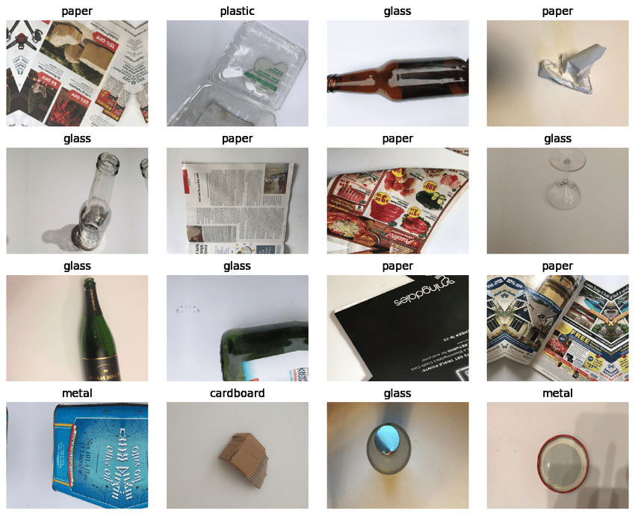

**Fig 1. Images of trash dataset**

Creating an intelligent waste classification system for sustainable resource management using machine learning, specifically with TensorFlow.js, is a complex but rewarding project. Such a system can automatically classify waste items into different categories like recyclables, organic waste, and non-recyclables. Here's an outline of the steps you can follow to build this system:

Data Collection:

* Gather a large dataset of waste images. These images should cover various waste items, including recyclables, organic waste, and non-recyclables.
* Annotate the dataset to label each image with its corresponding waste category.

Data Preprocessing:

* Resize and normalize the images to ensure uniformity in the dataset.
* Split the dataset into training, validation, and testing sets.

Model Selection:

* Choose a suitable pre-trained machine learning model for image classification, such as MobileNet, Inception, or ResNet.
* Fine-tune the selected model for waste classification using TensorFlow.js.

Model Development:

* Create a neural network architecture using TensorFlow.js to fine-tune the pre-trained model for waste classification.
* Define appropriate loss functions and optimization algorithms.
* Train the model using the training dataset.

Model Evaluation:

* Evaluate the model's performance using the validation dataset. Metrics like accuracy, precision, recall, and F1-score can be used.
* Tweak the model architecture and hyperparameters as needed to improve performance.

Model Deployment:

* Convert the trained TensorFlow.js model into a format suitable for web deployment (e.g., TensorFlow.js format or WebAssembly).
* Create a web-based interface (HTML, CSS, JavaScript) for users to interact with the model.

User Interface:

* Design a user-friendly interface where users can upload images of waste items.
* Display the classification results to the user.

Integration with Webcam or Mobile Camera (Optional):

* If desired, enable users to use their webcams or mobile device cameras to capture and classify waste items in real-time.

Testing and Optimization:

* Thoroughly test the system with different waste items to ensure accurate classification.
* Optimize the model and user interface for performance and responsiveness.

Data Security and Privacy:

* Implement measures to ensure data privacy and security, especially if images containing waste are involved.

Deployment and Hosting:

* Host the web-based waste classification system on a server or cloud platform.
* Ensure scalability and reliability of the hosting environment.

Monitoring and Maintenance:

* Regularly monitor the system's performance and accuracy.
* Keep the model up to date by periodically retraining it with new data.
* Address any issues or bugs that may arise in the deployed system.

User Education and Outreach:

* Provide user guides or instructions on how to use the waste classification system.
* Promote the system to the target audience and encourage its use for sustainable resource management.

1. GET PEER REVIEWED

Waste sorting, also known as waste separation or recycling, is the process of separating different types of waste materials to facilitate recycling and reduce the environmental impact of waste disposal. The main objective of waste sorting is to divert as much waste as possible from landfills and incineration facilities and instead redirect it toward recycling, composting, or other sustainable disposal methods. Here's an overview of waste sorting:Source Separation: Waste sorting often begins at the source, which is typically in homes, businesses, or institutions. People separate their waste into different categories based on the type of material. Common categories include:Recyclables: Materials like paper, cardboard, glass, plastic, and metal.Organic Waste: Food scraps, yard waste, and other biodegradable materials.Non-Recyclable Waste: Items that cannot be recycled or composted, like certain plastics, disposable diapers, and some packaging materials. Transport: Collected waste is transported to sorting facilities. At these facilities, further sorting and processing take place.Collection: After source separation, waste is collected in separate bins or containers based on its category. Recycling and compostable materials are collected separately from non-recyclable waste.

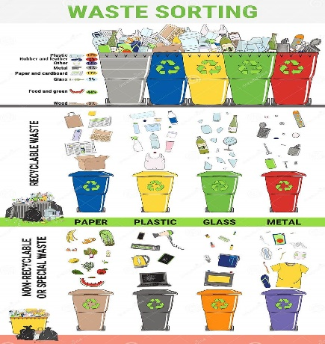

**Fig 2. Waste Sorting**

**SYSTEM ARCHITECTURE**

The system architecture gives an overview of the working of the system.

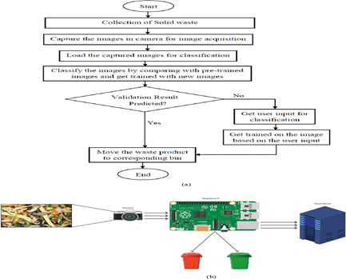

**Fig 3. SYSTEM ARCHITECTURE**

1. Conclusion

The Intelligent Waste Classification project is a web-based platform leveraging TensorFlow.js to classify various types of waste materials in real-time using a webcam. This interactive website features a responsive design, allowing it to adapt seamlessly to different device screen ratios and sizes. Users are greeted with an engaging neon-glow 'Classify' button, which triggers waste classification through the integrated machine learning model. The site also offers educational content with image slideshows that provide information about different waste categories. Powered by TensorFlow.js, this project not only raises awareness about responsible waste management but also demonstrates the potential of real-time machine learning inference in web applications.

References

* [1] K. N. Sami, Z. M. A. Amin, and R. Hassan, ``Waste managementusing machine learning and deep learning algorithms,'' *Int. J. Per-ceptive Cogn. Comput.*, vol. 6, no. 2, pp. 97_106, Dec. 2020, doi:10.31436/ijpcc.v6i2.165
* [2] S. Shahab, M. Anjum, and M. S. Umar, ``Deep learning applicationsin solid waste management: A deep literature review,'' *Int. J.Adv. Comput. Sci. Appl.*, vol. 13, no. 3, pp. 381_395, 2022, doi:10.14569/IJACSA.2022.0130347.
* [3] M. Triassi, R. Alfano, M. Illario, A. Nardone, O. Caporale, andP. Montuori, ``Environmental pollution from illegal waste disposal an effects: A review on the `triangle of death,''' *Int. J. Environ.Res. Public Health*, vol. 12, 2, pp. 1216_1236, Jan. 2015, doi:10.3390/ijerph120201216
* .[4] A. A. Namen, F. da Costa Brasil, J. J. G. Abrunhosa, G. G. S. Abrunhosa,R. M. Tarré, and F. J. G. Marques, ``RFID technology for hazardouswaste management and tracking,'' *Waste Manage. Res., J. Sus-tain. Circular Economy*, vol. 32, no. 9, pp. 59_66, Sep. 2014, doi:10.1177/0734242X14536463.
* [5] S. S. Chandra, M. Kulshreshtha, and P. Randhawa, ``Garbage detectionan robots,'' in *Proc. 9th Int. Conf. Rel.,Infocom Technol. Optim. Trends Future Directions (ICRITO)*, Sep. 2021,pp. 1_4, doi: 10.1109/ICRITO51393.2021.9596382.