**A Review On Polymer Used In Drug Delivery System**

**Authors Name : Tejasvinee Sahebrav Chaudhari 1  Vaibhav Narayan Desale2 Tushar Nana Patil3  Prathmesh kalu Patil4**

**Guide Name: Habiburrehaman Shaikh5 Saeed Ahmad6**

**Dr. Uttamrao Mahajan College Of Pharmacy, Chalisgaon**

**Abstract**

The current review focuses on polymers in the delivery of medical drugs. These materials include tablets, patches, patches, films, semisolids, and powders. Polymers are the basis of drug delivery because they control drug release from the material. The importance of drug delivery has increased in the last few years and significant progress has been made in the development of new technologies. Polymeric drug delivery systems have evolved significantly over the past two decades. Polymer drug delivery is defined as a structure or material that has the capacity to deliver therapeutic drugs into the body. Biodegradable and biodegradable polymers are promising for many new drug delivery systems. Polymers have played an important role in the advancement of drug delivery by enabling long- term controlled release of therapeutic drugs, cyclic drug delivery, and therapeutic release of hydrophilic and hydrophobic drugs. From the early days of using simple materials, the field has grown tremendously, thanks in part to the innovations of chemical engineers..

**Keywords :** Polymers, excipients, synthetic polymer, drug delivery responsive polymers,

**Introduction**

Today, hierarchical advances in drug delivery begin with the use of polymeric materials to facilitate spatiotemporal release of therapeutic agents in delivery systems and implantable devices. Although conventional drugs are effective in treating diseases, the emergence of effective and unique biotherapeutics has spurred the development of smart delivery. Heller and Langer & Peppas pointed out the importance of chemical engineering in the development of new drug delivery systems and stated that control should become the standard of these systems. Over the past few years, research at the molecular biology level has revealed the molecular basis of many diseases. New technologies and important ideas, such as DNA sequencing and gene therapy, provide tools for the development of drugs and techniques specific to these diseases. Chemical uses of polymers include their use as binders in tablets to be used as viscosity and flow control agents in liquids, suspensions, and emulsions. However, the use of these drugs outside the laboratory has been slow, mainly due to the lack of effective drugs. Delivery is a concept that ensures that the drug is released into the body at the right time, without causing a significant impact on the body's vital functions. Polymer drug delivery research has come a long way since the 1980s. The search for new drug delivery methods and new modes of operation is at the forefront of research. These include many research methods that have been successfully applied to achieve significant advances in improving the therapeutic effect and bioavailability of certain drugs. Drug delivery systems combine one or more drug delivery systems with mechanical engineering. The system may specifically target the drug released into the body and/or the rate of release. Polymeric drug delivery systems are defined as formulations or devices that have the ability to deliver drugs into the body. It improves the safety and effectiveness of medications by controlling the amount, time and location of their release in the body. Drug delivery has come a long way in the last two decades, but controlling how drugs enter the body, such as the brain, remains a challenge. Many types of biodegradable polymers are widely used in biomedical applications due to their known biocompatibility and biodegradability. In the biomedical field, polymers are frequently used for implantation with the promise of long-term use. These improvements help improve the quality of treatment and reduce side effects and other factors.

**Polymers are able to**

* Prolong drug availability if medicines are formulated as hydrogels or microparticles.
* Favourably alter bio distribution, if formulated into dense nanoparticles.
* Enable hydrophobic drug administration if formulated as micelles.
* Transport a drug to its usually inaccessible site of action if formulated as gene medicines.
* Make drug available in response to stimuli.

**History**

Theuseofpolymersinthemedicalfieldisnotanovelty‐

naturalpolymershavebeenusedascomponentsof

herbalremediesforcenturies.Whenitcomestosynthetic

polymershoweverthesituationisverydifferent.Because

polymerscienceisarelativelyrecentareaofresearch

syntheticwater‐solublepolymersasmacromolecular

drugsoraspartofdrugdeliverysystemsrelatedto

inoculationcanbeconsideredamodernachievement.

Thefirstpolymer‐drugconjugatesappearedaround1955,

beingmescaline‐N‐vinylpyrolidineconjugateoneofthe

first

Theuseofpolymersinthemedicalfieldisnotanovelty‐

naturalpolymershavebeenusedascomponentsof

herbalremediesforcenturies.Whenitcomestosynthetic

polymershoweverthesituationisverydifferent.Because

polymerscienceisarelativelyrecentareaofresearch

syntheticwater‐solublepolymersasmacromolecular

drugsoraspartofdrugdeliverysystemsrelatedto

inoculationcanbeconsideredamodernachievement.

Thefirstpolymer‐drugconjugatesappearedaround1955,

beingmescaline‐N‐vinylpyrolidineconjugateoneofthe

first

Theuseofpolymersinthemedicalfieldisnotanovelty‐

naturalpolymershavebeenusedascomponentsof

herbalremediesforcenturies.Whenitcomestosynthetic

polymershoweverthesituationisverydifferent.Because

polymerscienceisarelativelyrecentareaofresearch

syntheticwater‐solublepolymersasmacromolecular

drugsoraspartofdrugdeliverysystemsrelatedto

inoculationcanbeconsideredamodernachievement.

Thefirstpolymer‐drugconjugatesappearedaround1955,

beingmescaline‐N‐vinylpyrolidineconjugateoneofthe

first

Theuseofpolymersinthemedicalfieldisnotanovelty‐

naturalpolymershavebeenusedascomponentsof

herbalremediesforcenturies.Whenitcomestosynthetic

polymershoweverthesituationisverydifferent.Because

polymerscienceisarelativelyrecentareaofresearch

syntheticwater‐solublepolymersasmacromolecular

drugsoraspartofdrugdeliverysystemsrelatedto

inoculationcanbeconsideredamodernachievement.

Thefirstpolymer‐drugconjugatesappearedaround1955,

beingmescaline‐N‐vinylpyrolidineconjugateoneofthe

first

The use of polymers in the medical field is not a novelty ‐ natural polymers have been used as components of bal remedies for centuries When it comes to synthetic polymers however the situation is very different. Because polymer science is a relatively recent area of research synthetic water‐soluble polymers as macromolecular drugs or as part of drug delivery systems related to inoculation can be considered a modern achievement. The first polymer‐drug conjugates appeared around 1955, being mescaline‐N‐vinylpyrolidine conjugate one of the first. In 1994, the first synthetic polymer‐drug conjugate (as shown in figure 1b) designed to treat cancer was clinically tested. It consisted on an HPMA (N‐(2‐hydroxypropyl) methacrylamide) copolymer conjugate of doxorubicin.

Theuseofpolymersinthemedicalfieldisnotanovelty‐

naturalpolymershavebeenusedascomponentsof

herbalremediesforcenturies.Whenitcomestosynthetic

polymershoweverthesituationisverydifferent.Because

polymerscienceisarelativelyrecentareaofresearch

syntheticwater‐solublepolymersasmacromolecular

drugsoraspartofdrugdeliverysystemsrelatedto

inoculationcanbeconsideredamodernachievement.

Thefirstpolymer‐drugconjugatesappearedaround1955,

beingmescaline‐N‐vinylpyrolidineconjugateoneofthe

first

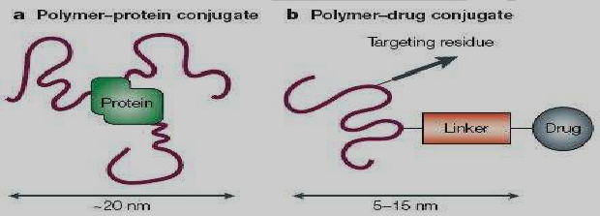

Overthepastdecadesresearchatthelevelofmolecular

biologyhasunveiledthemolecularbasisformany

diseases.Newimportanttechnologiesandconceptssuch

asrecombinantDNAandgenetherapyhaveprovided

toolsforthecreationofpharmaceuticalsandmethods

designedtospecificallyaddresssuchdiseases.However

progresstowardstheapplicationofthesemedicines

outsideofthelaboratoryhasbeenconsiderablyslow

principallyduetothelackofeffectivedrugdelivery

systemsthatismechanismsthatallowthereleaseofthe

drugintotheappropriatebodycompartmentforthe

appropriateamountoftimewithoutseriouslydisrupting

therestoftheorganismfunctionality.Theapplicationof

thepolymericmaterialsformedicalpurposesisgrowing

fast.Polymershavefoundapplicationsindiverse

biomedicalfieldssuchasdrugdeliveringsystems,

developingscaffoldsintissueengineering,implantation

ofmedicaldevicesandartificialorgans,prosthesis,

ophthalmology,dentistry,bonerepair,andmanyother

**Fig No: 1 The families of polymer constructs called polymer therapeutics.**

**Various polymers are used in drug delivery system**

Tremendous use of polymers has been witnessed in the area of polymer therapeutics and Nano medicines[1 nidhi] . Polymers in reservoir based drug delivery systems have shown immense progress in the form of hydrogels and liposomes. Diffusion based drug delivery systems (as shown in Figure 2) and solvent activated drug delivery systems are the other areas being explored for utilizing the polymers . In diffusion based drug delivery systems drug is dissolved in a non-swell able system or a fully swollen matrix which do not decompose during their activation time. Solvent activated systems like hydrogels swell and release the drug when exposed to aqueous environment; this mechanism is depicted in Figure 3. They are hydrophilic in nature . Biocompatible polymers offer a safe passage for drug delivery due to their well engineered molecular architecture according to the transitions in the underlying mechanisms of the biological process. Biodegradable polymers break due to cleavage of covalent bonds between them and bio erodible polymers bring about erosion of the polymer due to dissolution of linking chains without bringing about any change in chemical structure of the molecule . Various drug release mechanisms can be studied comparatively in Figure 4

**PLGA**

In past two decades poly lactic-co-glycolic acid (PLGA) has been among the most attractive polymeric candidates used to fabricate devices for drug delivery and tissue engineering applications. PLGA is biocompatible and biodegradable, exhibits a wide range of erosion times, has tunable mechanical properties.

Polymershavebeenusedformanyyearsasexcipientsin

conventionalimmediate‐releaseoraldosageforms,either

toaidinthemanufacturingprocessortoprotectthedrug

fromdegradationuponstorage.Microcrystallinecellulose

isoftenusedasanalternativetocarbohydratesas

diluentsintabletformulationsofhighlypotentlow‐dose

drugs.Starchandcelluloseareusedasdisintegrantsin

tabletformulations,whichswelloncontactwithwater,

resultinginthetablet“bursting,”increasingtheexposed

surfaceareaofthedrugandimprovingthedissolution

characteristicsofaformulation.Polymersincluding

polyvinyl‐pyrrolidoneandhydroxypropylmethylcellulose

(HPMC)alsoﬁndusesasbindersthataidtheformationof

granulesthatimprovetheﬂowandcompaction

propertiesoftabletformulationspriortotableting.

Occasionally,dosageformsmustbecoatedwitha“non‐

functional”polymericﬁlmcoatinginordertoprotecta

drugfromdegradation,maskthetasteofanunpalatable

drugorexcipients,orimprovethevisualeleganceofthe

Fgffffggfg

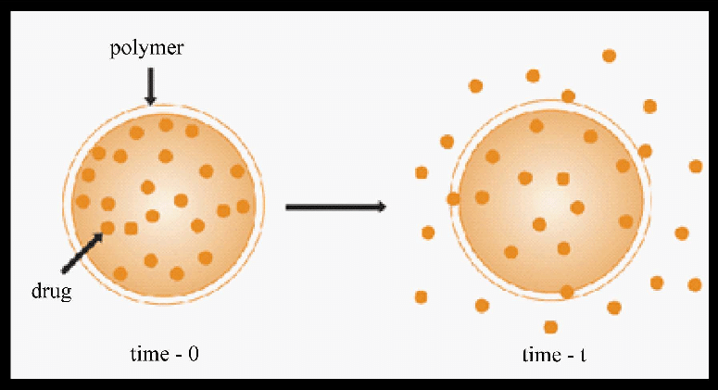

**Fig. No: 2 Diffusion based drug delivery system**

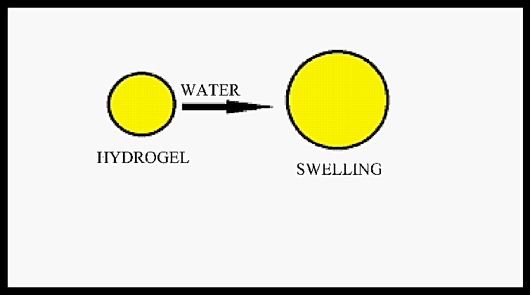

**Fig No: 3 Hydrogen based drug delivery system**

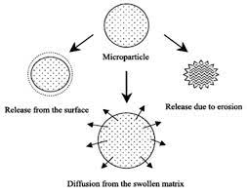

**Fig No: 4 Various drug release machanims**

**PGA(poly glycolic acid)**

Polyglycolic acid (PGA) is a biodegradable, thermoplastic polymer and the simplest linear,aliphatic polyester. It can be prepared starting from glycolic acid by means of poly condensation or ring-opening polymerization. PGA has been known since 1954 as a tough fiber-forming polymer.

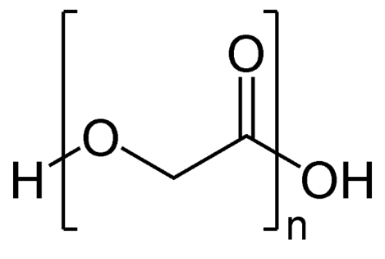

**Poly-l-glutamic acid**

Polyglutamic acid (PGA) is a polymer of the amino acid glutamic acid (GA). Gamma PGA is formed by bacterial fermentation. Gamma PGA has a wide number of potential uses ranging from food and medicine to water treatment. It is widely being used as a drug delivery system in cancer treatment.

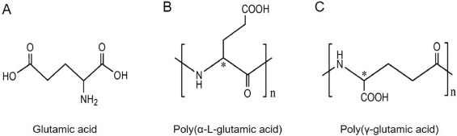

**Polylactic acid**

It is a biodegradable thermoplastic aliphatic polyester derived from renewable resources, such as co r n starch (in the United States and Canada), tapioca roots, chips or starch (mostly in Asia), or sugarcane (in the rest of the world).

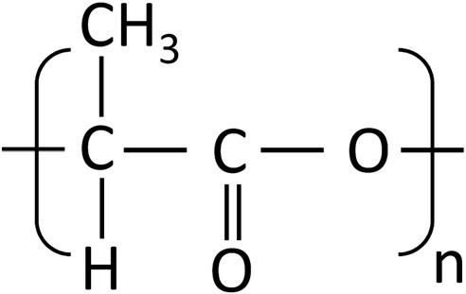

Dextran is can be defined by Leuconostoc mesenteroides (lactic-acid bacteria with the help of

which dextran is synthesized using sucrose) which contains a glucan which is -linked and has side chains that are attached to the backbone of 3-positions of glucose units. The straight chain consists of α-1,6 glycosidic linkages between the molecules of glucose. The branching starts from α-1,3 linkages.

DISCOVERY HISTORY—Allene Jeanes was a scientist at the USA's Northern Regional Research Lab in 1940. One day a company of soft drinks sent them one sample of their product which became thick and sticky. It was found out that this stickiness was due to the presence of a bacterium that converted the sugar present in the soda to dextran. This bacteria was assumed to have come from the dental plaque of one of the workers at the factory. The scientist then discovered that bacterium can be grown in the lab in a sugar solution which will make lots of dextran. This was then purified, dried and sent to korea which helped the soldiers to survive and helped them to heal.

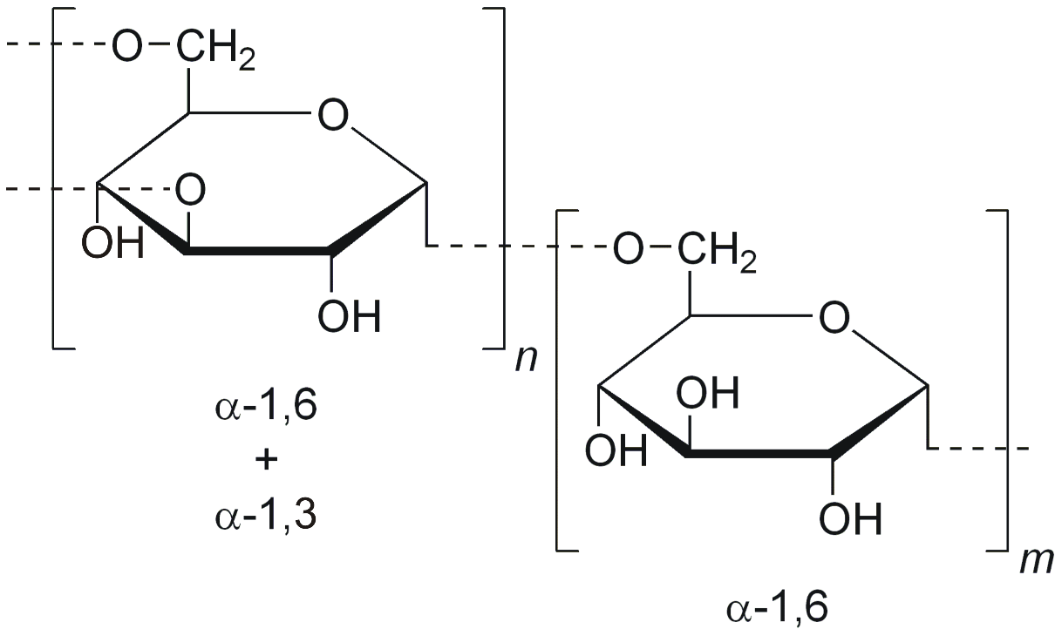

**ROLE OF POLYMERIN DRUG DELIVARY SYSTEM**

**A. Immediate Release Dosage forms Tablets :** Polymers have been used for many years as excipients in conventional immediate‐release oral dosage forms, either to aid in the manufacturing process or to protect the drug from degradation upon storage. Microcrystalline cellulose is often used as an alternative to carbohydrates as diluents in tablet formulations of highly potent low‐ dose drugs.

**B. Capsules:** Capsules are used as an alternative to tablets, for poorly compressible materials, to mask the bitter taste of certain drugs, or sometimes to increase bioavailability. Many of the polymeric excipients used to “bulk out” capsule fills are the same as those used in immediate‐release tablets. Gelatine has been used almost exclusively as a shell material for hard (two‐piece) and soft (one‐piece) capsules.

**C. Modified release Dosage Forms:** It is now generally accepted that for many therapeutic agents drug delivery using immediate release dosage forms results in suboptimal therapy and/or systemic side effect Pharmaceutical scientists have attempted to overcome the limitations of conventional oral dosage forms by developing modified release dosage forms.

**D. Extended Release Dosage Forms**: The therapeutic effect of drugs that have a short biological half‐life may be enhanced by formulating them as extended or sustained release dosage forms. Extended and sustained release dosage forms prolong the time that systemic drug levels are within the therapeutic range and thus reduce the number of doses the patient must take to maintain a therapeutic effect thereby increasing compliance.

**E. Gastroretentive Dosage Forms:** Gastroretentive dosage forms offer an alternative strategy for achieving extended release profile, in which the formulation will remain in the stomach for prolonged periods, releasing the drug in situ, which will then dissolve in the liquid contents and slowly pass into the small intestine.

Water‐SolubleSyntheticPolymers

• Poly(acrylicacid)Cosmetic,pharmaceuticals,

immobilizationofcationicdrugs,baseforCarbopol

polymers.

• Poly(ethyleneoxide)Coagulant,flocculent,veryhigh

molecular‐weightuptoafewmillions,swelling

agent.

• Poly(ethyleneglycol)Mw<10,000;liquid(Mw

<1000)andwax(Mw>1000),plasticizer,basefor

suppositories.

• Poly(vinylpyrrolidone)Usedtomakebetadine

(iodinecomplexofPVP)withlesstoxicitythaniodine,

plasmareplacement,tabletgranulation.

• Poly(vinylalcohol)Water‐solublepackaging,tablet

binder,tabletcoat

**TYPE OF POLYMER DRUG DELIVARY SYSTEM**

**A. Polymers for Drug Delivery in Tissue Engineering:** Several strategies have been developed in order to regenerate functional tissue, the majority of which involve the use of polymer scaffolds specifically designed to direct tissue growth. The cell transplantation method is one of the most commonly used in cartilage and bone formation.20 Polymer matrices both natural and synthetic can play a vital role in the delivery of protein growth factors and cytokines to aid angiogenesis and tissue reconstruction procedure.

**B. Poly (lactic co glycolic acid) Microspheres :** The term microsphere refers to a small sphere with a porous inner matrix and variable surface from smooth and porous to irregular and nonporous. The drug when encapsulated is dispersed throughout the inner matrix. The size range of microspheres is typically 1 to 500 μm in diameter. Poly (lactic‐co‐glycolic acid) microspheres have increasingly become the focus of research efforts in the scientific community and pharmaceutical industry. Their application as drug delivery vehicles has risen in line with the expanding biotechnology sector and the promise of new drugs discovered in the wake of the human genome project and proteomics.

**POLYMER IN PHARMACEUTICAL APPLICATION**

1. Water Soluble Synthetic Polymers

• Poly (acrylic acid) Cosmetic, pharmaceuticals, immobilization of cationic drugs, base for Carbopol polymers.

• Poly (ethylene oxide) Coagulant, flocculent, very high molecular‐weight up to a few millions, swelling agent.

• Poly (vinyl alcohol) Water‐soluble packaging, tablet binder, tablet coating.

1) Cellulose Based Polymers

a) Carboxy methyl cellulose Super disintegrant, emulsion stabilizer.

b) Hydroxy ethyl and hydroxyl propyl celluloses Soluble in water and in alcohol for tablet coating. c) Cellulose acetate phthalate enteric coating.

2) Hydrocolloids

a) Alginic acid Oral and topical pharmaceutical products; thickening and suspending agent in a variety of pastes, creams, and gels, as well as a stabilizing agent for oil‐in‐water emulsions; binder and disintegrants.

b) Carrageenan Modified release, viscosifier.

B. Water Insoluble Biodegradable Polymers (Lactide‐co‐glycolide) polymers Microparticle– nanoparticle for protein delivery.

1) Starch Based Polymers

a) Starch Glidant, a diluent in tablets and capsules, a disintegrant in tablets and capsules, a tablet binder.

b) Sodium starch glycolate super disintegrant for Tablets and capsules in oral delivery.

2) Plastics and Rubbers

a) Polyurethane Transdermal patch backing, blood pump, artificial heart, and vascular grafts, foam in biomedical and industrial products.

b) Polyisobutylene Pressure sensitive adhesives fortransdermal delivery.

**CLASSIFICATION OF POLYMER**

A.Basis on Interaction with Water.

Soluble Polymers:‐ E.g. HPMC, PEG

B.Based on polymerisation method

Addition Polymers:‐ E.g. Alkane Polymers

C. Based on polymerization mechanism

1) Chain Polymerization

2) Step growth Polymerization

D. Based on chemical structure

1) Activated C‐C Polymer

2) Inorganic polymers

3) Natural polymers

E. Based on Bio Stability

1) Bio‐degradable

2) Non Bio‐degradable

**C. Characteristics of an Ideal Polymer**

1) It should be versatile and possess a wide range of mechanical, physical, chemical properties.

2) It should be non‐toxic and have good mechanical strength and should be easily administered.

3) It should be inexpensive and easy to fabricate.

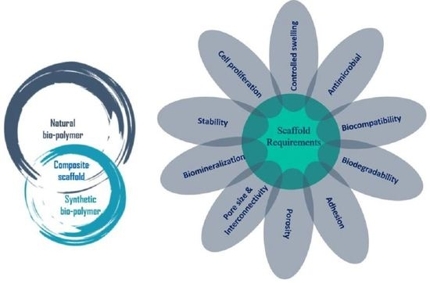

**Fig No: 5**

**POLYMER IN PHARMACEUTICAL DRUG DELIVARY SYSTEM**

A. Rosin Rosin a film‐forming biopolymer and its derivatives have been extensively evaluated pharmaceutically as filmcoating and microenc.

B. Chitin and Chitosan Chitin a naturally abundant muco polysaccharide and consist of 2‐acetamido‐2‐ deoxy‐b‐D‐glucose. Chitin can be degraded by chitinase.

C. Zein Zein an alcohol‐soluble protein contained in the endosperm tissue of Zeamais, occurs as a by‐product of corn processing.

D. Starches It is the principal form of carbohydrate reserve in green plants and especially present in seeds and underground organs.

**MACHANISMS OF MUCOADHESION**

The mucoadhesion must spread over the substrate to initiate close contact and increase surface contact, promoting the diffusion of its chains within the mucus. Attraction and repulsion forces arises and for a mucoadhsion to be successful, the attraction force must do6minate. The mechanism of mucoadhesion is generally divided in to steps the contact stage and the consolidation stage (shown in fig 6)

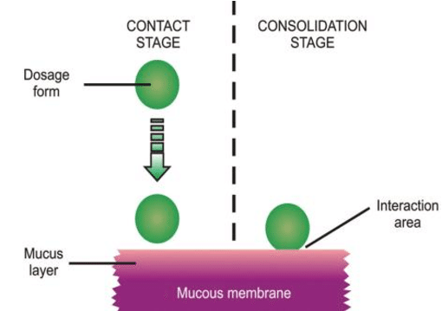

**Fig No: 6**

**FUTURE TRENDS**

Despite the excessive use of synthetic polymers the need for natural biodegradable polymers to deliver drugs continues to be area of active research. Much of the development of novel materials in controlled drug delivery is focusing on the preparation and use of these responsive polymers with specifically designed macroscopic and microscopic structural and chemical features.

A. Such Systems Include

1) Copolymers with desirable hydrophilic/hydrophobic interactions.

2) Complexation networks responding via hydrogen or ionic bonding.

3) Polymers as nanoparticles for immobilization of enzymes, drugs, peptides, or other biological agents.

4) New biodegradable polymers.

5) New blends of hydrocolloids and carbohydrate based polymers.

Design and synthesis of novel combinations of polymers will expand the scope of new drug delivery systems in the futures This will obviously require assimilation of a great deal of emerging information about the chemical nature and physical structure of these new materials. There is an increasing movement of scientists and engineers who are dedicated to minimizing the environmental impact of polymer composite production. Life cycle assessment is of paramount importance at every stage of a product's life, from initial synthesis through to final disposal and a sustainable society needs environmentally safe materials and processing methods.

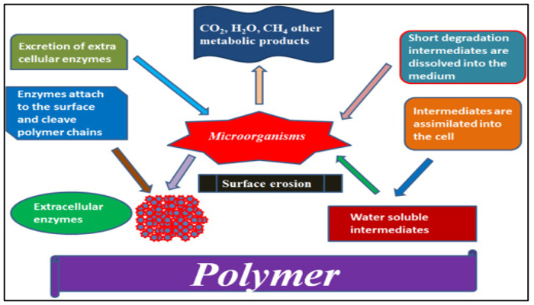

**Fig No: 7**

**Conculsion**

Polymer‐based pharmaceuticals are starting to be seen as key elements to treat many lethal diseases that affect a great number of individuals such as cancer or hepatitis. Polymers are quite advantageous in drug delivery. This leads to enhanced drug delivery with better pharmacokinetics handling all safety parameters. Mechanism and time taken for drug delivery system for a particular tissue or cellular compartment still needs to be studied. Development of therapeutics at nano level with novel improved features utilizing polymeric materials to address unresolved medical needs and to enable the application of personalized medicine is still required. Currently, the main goals in this field are to enable and support further research efforts towards translatable and competitive product development. The micro-processes that are required for the development of such carriers, such as genetic engineering or in vivo treatments to incorporate therapeutic substances, make it difficult to maintain the integrity of natural and synthetic polymers with cells in a body. The gap between synthetic and biological systems has traditionally been very large. The synthetic polymers can be designed or modified as per requirement of the formulation by altering polymer characteristics and on the other hand natural pharmaceutical excipients are biocompatible, non toxic, environment friendly and economical.

**Reference**

[1] Anderson JM, Kim SW. Advances in Drug Delivery Systems (3), Book Review. J Pharm Sci. 1989;78:608–9 [[Google Scholar](https://scholar.google.com/scholar_lookup?journal=AIChE+J&title=Integrated+medical+feedback+systems+for+drug+delivery&author=A+Heller&volume=51&issue=4&publication_year=2005&pages=1054-66&)].

[2] Martinho N, Damgé C, Pinto C. Reis, Recent advances in drug delivery systems. J Biomater Nanobiotechn. 2011;2:510–26 [[Google Scholar](https://scholar.google.com/scholar_lookup?journal=AIChE+J&title=Integrated+medical+feedback+systems+for+drug+delivery&author=A+Heller&volume=51&issue=4&publication_year=2005&pages=1054-66&)].

[3] Schmaljohann, D. (2006) Thermo and pH Responsive Polymers in Drug Delivery. Advanced Drug Delivery Reviews, 58, 1655-1670. <http://dx.doi.org/10.1016/j.addr.2006.09.020>

[4] Liechty, W.B., et al. (2010) Polymers for Drug Delivery Systems. Annual Review of Chemical and Biomolecular Engineering, 1, 149-173. <http://dx.doi.org/10.1146/annurev-chembioeng-073009-100847>.

[5] Pallerlaand, S. and Prabhakar, B. (2013) Review on Polymers in Drug Delivery. American Journal of Pharmtech Research, 3, 901-917.

[6]Biomaterials Tutorial.http://www.sigmaaldrich.com/material science/biomaterials/tutorial.html

[7] Jawahar, N. and Meyyanathan, S.N. (2012) Polymeric Nanoparticles for Drug Delivery and Targeting: A Comprehensive Review. International Journal of Health and Allied Sciences, 1, 217-223. <http://dx.doi.org/10.4103/2278-344X.107832>.

[8] Shaik, M.R., Korsapati, M. and Panati, D. (2012) Polymers in Controlled Drug Delivery Systems. International Journal of Pharma Sciences, 2, 112-116.

[9 Yang, W. and Pierstorff, E. (2012) Reservoir Based Polymer Drug Delivery Systems. Journal of Laboratory Automation, 17, 50-58. http://dx.doi.org/10.1177/2211068211428189.

[10] Srikanth, P., Raju, N., Raja, S.W. and Raj, S.B. (2013) A Review on Oral Controlled Drug Delivery. International Journal of Advanced Pharmaceutics, 3, 51-58.

[11] Vicky V. Mody, Introduction to Polymeric Drug Delivery, Internet Journal of Medical Update, 5(2): 2010 July;1‐2.

[12] Omanathanu Pillai, Ramesh, Polymers in drug delivery, Current Opinion in chemical biology, Vol 5, issue 4, 2001, 447‐451.

[13] Omanathanu Pillai, Ramesh, Polymers in drug delivery, Current Opinion in chemical biology, Vol 5, issue 4, 2001, 447‐451.

[14] Clochard M, Dinand E, Rankin S, Simic S, Brocchini S, New strategies for polymer development in pharmaceutical science‐a short review, J Pharm Pharmacol, 2001, 53(9),1175‐ 1184.

[15] Vyas SP, Khar RK. Controlled Drug Delivery: Concepts and Advances. I st ed. Vallabh prakashan, New Delhi,2002, 156‐189.Kathryn E. Uhrich ,Scott M. Cannizzaro , Robert S. Langer, Polymeric Systems for Controlled Drug Release, Chem. Rev, 99, 1999, 3181‐3198.

[16] Reja M, Quadir MA, Haider SS, Comparative evaluation of plastic, hydrophobic and hydrophilic polymers as matrices 00000for controlledrelease drug delivery, J Pharm Sci 692, 2003, 274‐291.

[17] Taylor and Francis, Polymers in Drug Delivery System, 2006, 1‐236.

[18] Hoffman, A.S., Hydrogels for biomedical applications, Adv. Drug Delivery Rev.54, 2002, 3–12.

[19] Park, J.H., Ye, M.L., and Park, K., Biodegradable polymers for microencapsulation of drugs, Molecules, 10, 146–161, 2005.

[20] Almeida, Biomedical application of polymer based pharmaceuticals, Biomedical Engineering – Group XII,2008. [11] Van Savage, G. and Rhodes, C.T., The sustained release coating of solid dosage forms: a historical review, Drug Dev.

[21] Reja M, Quadir MA, Haider SS. Comparative evaluation of plastic, hydrophobic and hydrophilic polymers as matrices for controlled release drug delivery, J Pharm Sci 692, 2003, 274‐291.

[22] Verhoeven, J, Controlled‐release formulations, a hydrophilic matrix containing furosemide, Int. J. Pharm, 45, 1988, 65‐69.

[23] Ankita Raizada, Polymers In Drug Delivery: A Review, IJPRD, 2(8),2010, 9‐20.

[24] Nokano M, Ogata A, In vitro release characteristics of matrix tablets, Study of Karaya gum and Guar gum as releasemodulators, Ind. J. Pharm. Sc, 68, 6, 2006, 824‐826.

[25] Poddar RK, Rakha P, Singh SK, MishraDN, Bioadhesive Polymers as a Platform for Drug Delivery: Possibilities and Future Trends, Research J on Phamacetical Dosage Form and Technology, 2,1,2010, 40‐54.

tfgherjtfhtfgjhfvjdfvgjhgvhghdfdhgdfhgfghfgh

ttgtgrtfrfff