**Experimental Investigation of Downdraft Gasifier using Different Biomass Fuels**

Devilal Singh Parihar1, Ashutosh Dwivedi2

*1M. Tech Student, Department of Mechanical Engineering, Vindhya Institute Of Technology

& Science, Satna, India.

*2Asst. Professor, Department of Mechanical Engineering, Vindhya Institute of Technology

& Science, Satna, India

Abstract: In a study, methane and carbon dioxide were generated through downdraft fixed-bed gasification, converting rice husks, waste plastic, and sawdust. The heat potential in biomass is crucial for synthetic gas production, and waste plastic, with the highest heating value at 40 MJ/kg, offers superior potential for high hydrogen concentration in synthetic gas (3-18% by volume) compared to rice husk and sawdust. Rice husk yields lower hydrogen and methane concentrations than sawdust. Gasification efficiency and output depend on the gasifier type, with downdraft fixed-bed gasifiers being highly effective. The gasification process's outcomes rely on factors like reactor temperature, catalyst exposure time, residence time, and catalyst heating temperature. This process transforms biomass into synthetic gas, which can power internal combustion engines and facilitate cogeneration for both electricity and heat. Biomass gasification shares similarities with coal gasification, yielding similar by-product gases during thermal breakdown but with less stringent operating requirements. Rice husk, waste plastic, and sawdust are fed into a downdraft fixed-bed gasifier, and synthetic gas is collected at the exhaust end. Analysing synthetic gases involves gas analysers, and this gas can drive engines, boilers, and machinery. Additionally, a MATLAB code snippet integrated into a Gasifier simulation GUI application enables users to visualize performance metrics, aiding understanding and optimization of gasifier dynamics for educational and practical purposes.

**Keywords:** Biomass, Gasifier, Power Generation, Carbon Monoxide, Methane, Carbon Dioxide

1. **INTRODUCTION**

Biomass gasification is a process that transforms solid organic materials, or biomass, into a mixture of gases suitable for use as fuel. Various types of biomass fuels are used in this process, including wood waste, agricultural residues, municipal solid waste, algae, and sewage sludge. The choice of biomass fuel is essential as it significantly influences gasifier performance and the quality of the produced gas. Power generation through gasification involves several steps, starting with the gasification of biomass to produce syngas, a mixture of carbon monoxide (CO), hydrogen (H2), and carbon dioxide (CO2). This syngas is then cleaned, conditioned, and burned to generate heat. The heat is used to produce steam, driving a turbine that generates electricity, which can be fed into the power grid. Different power generation technologies, such as steam turbine systems, gas engines, and fuel cells, can be integrated with gasifiers, depending on factors like the syngas composition, project scale, and efficiency requirements. Biomass, derived from organic plant and animal sources, is renewable and sustainable, with historical use as a primary energy source. [1-2] It continues to be a vital energy source in many developing countries. Industrialized nations are increasingly adopting biomass fuels for transportation and power production, aiming to reduce carbon emissions from fossil fuels. By 2020, biomass is projected to account for 5% of primary energy consumption in the United States. Biomass is the result of storing the sun's chemical energy through photosynthesis in plants. It can be converted into renewable liquid and gaseous fuels through various processes, including direct combustion. Biomass fuels encompass a range of sources, such as wood and wood processing waste, crop and food processing residues, municipal solid waste, animal and human waste. Woody fuels, like forestry residues, offer a versatile source for biomass energy, with the potential to generate steam or electricity. However, transportation costs and moisture content can impact their efficiency. Forestry residues are particularly critical, with efforts to find eco-friendly disposal methods that benefit forest management. [3-4] Mill residues offer cost-effective advantages, as the collecting and chipping processes are integrated into commercial mill operations. They are already being used to generate steam and power. Agricultural residues, such as those from sugar cane, contribute significantly to biomass consumption in some regions, but their availability can be seasonal, requiring storage or flexible production. Urban wood and yard wastes present an opportunity as a source of biomass fuel, especially if integrated with biomass projects that can charge a tipping fee for waste disposal. Dedicated biomass crops, like corn for ethanol or soybean for biodiesel, are bred for the specific purpose of biomass production. Finally, chemical recovery fuels play a crucial role in biomass energy consumption, particularly in the pulp and paper industry. The utilization of biomass as an energy source continues to evolve, providing a sustainable and renewable alternative to traditional fossil fuels. The choice of biomass fuel and the ongoing development of technology play pivotal roles in advancing the adoption of biomass energy solutions. [5-7]

1. **REVIEW OF LITERATURE**

***Awais et al. (2021)*** conducted research on the utilization of biomass gasification for power production by converting biomass into flammable gas. They employed sugarcane bagasse and coconut shells in designing and fabricating a biomass gasifier with a downdraft rate of 30–40 kg/h. The study investigated the impact of equivalency ratio on syngas composition, heating value, syngas output, gasification efficiency, and tar content. It also assessed the effectiveness of various cleaning equipment in removing tar. The performance of the gasifier was found to be significantly influenced by the type of biomass feedstock and the equivalency ratio. Sugarcane bagasse and coconut shells produced an average of 3.1 and 2.97 m3 of syngas, respectively, with average tar production of 2.5 and 2.2 g/Nm3. Carbon monoxide (CO) and hydrogen (H2) emissions increased as the equivalency ratio (ER) rose from 0.17 to 0.22. However, the calorific value of syngas increased to 4.4 MJ/Nm3. The efficiency of cleaning instruments varied depending on the feedstock, with sugarcane bagasse achieving a removal efficiency of 45.7% and coconut shells reaching 52.9%. The cyclone separator had an efficiency of 54%, the wet scrubber reached 59.4%, and the biomass filter achieved a removal efficiency of 65%. In their study, ***Gunasekaran et al. (2021)***explored the potential of thermochemical conversion of agroforestry biomass residuals to produce producer gas (PG). They focused on the use of an open-core biomass gasifier in an agroforestry setting, emphasizing the examination of cocoa pod husk (CPH) as a promising agricultural waste. The study found that CPH could serve as an effective feedstock for gasification. An equivalency ratio of 0.25 and a moisture content of 5% were determined as the optimal conditions, resulting in 6.13 MJ/Nm3 calorific value, 82% conversion efficiency, and 68% cold gas efficiency. ***De Priall et al. (2021)*** investigated small-scale gasification using biowaste as a source of heat and power. They analyzed 40 samples of common biowaste feedstocks and constructed a one-stage equilibrium model, which exhibited up to 15% maximum error between actual and projected values. The study revealed that biowaste materials could yield syngas with a low heating value of 3.1 to 5.4 MJ/Nm3 when optimally operated at the ideal equivalency ratio. However, the drying process required a significant portion of the generated heat to achieve a moisture content of 10%. The research presented an environmentally friendly alternative to landfilling biowaste by using downdraft gasification-based cogeneration to produce both heat and electricity. ***Dutta et al. (2021)*** conducted an experiment on downdraft biomass gasification using tree trash and sawdust pellets as feedstocks at varying equivalency ratios. The research aimed to analyze the gases produced during gasification, including hydrogen, carbon dioxide, nitrous oxide, and methane. The study varied the air equivalence ratio from 0.3 to 0.4 for both biomass feedstocks and evaluated the Lower Heating Value (LHV) of the producer gas. The results indicated that the LHV was influenced by the equivalency ratio, and the study provided a comprehensive analysis of the LHV trend with various equivalence ratios. ***Gálvez-Pérez et al. (2021)***examined the gasification of olive cake under different conditions, including temperature, equivalency ratio, contact duration, and torrefaction. Their research was focused on evaluating gasification performance based on primary fuel gas product yields, LHV gas, and cold gas efficiency. The experiments were conducted in a reactor with a fixed bed, and the study found that an equivalence ratio of 0.3 and a temperature of 700°C produced higher yields of CO, CH4, and H2, as well as improved cold gas efficiency. The difference between raw and hydrolyzed olive cake samples was attributed to the higher lignin concentration. Torrefied samples displayed variations in CO and CH4 yields and CGE. Overall, the research indicated that both raw and hydrolyzed olive cake samples could serve as effective gasification feedstocks, even at low temperatures. Murugan et al. (2021) explored the gasification potential of cassava stems as an annual crop. Their research included an investigation into the composition, gas yield, heating value, temperature profile, and gasifier efficiency. The study revealed that the gas generated from cassava stems contained compositions of CO, H2, CH4, and CO2 within specified ranges. The Higher Heating Value (HHV) and gas composition were found to be 5.83 MJ/Nm3. An equivalence ratio of 0.3 was determined to yield the best results in terms of producer gas output, with a 78% conversion efficiency, 1.7 Nm3/kg yield, a CO2/CO ratio of 0.65, and 0.61 H2/CO ratio. ***Sun et al. (2021)*** focused on waste-to-energy systems and the use of desiccant dehumidification units with heat recovery to maximize the use of gasification system residual heat. The research involved the drying of fresh air using desiccant coated heat exchangers (DCHEs) and the use of a gasification combined heat and power (CHP) subsystem to provide hot water for regeneration. The study identified an optimal equivalence ratio and moisture removal rate for effective moisture removal and energy efficiency in Singapore's outdoor conditions. A heat recovery subsystem further increased energy efficiency. Parametric analysis explored the effects of cooling water flow rate, hot water flow rate, and hot water temperature on dehumidification. The research concluded that desiccant-coated heat exchangers and gasification CHP subsystems were effective in enhancing energy utilization and waste heat recovery. ***Oni et al. (2021)*** investigated steam-air gasification of Cymbopogon citratus in reactors heated to varying temperatures with the use of a catalyst and different steam to biomass ratios. The study observed the impact of gasification temperature, equivalent ratio (ER), and syngas yield ratio (SBR) on total hydrogen and syngas production. The research highlighted the importance of ER as a key element in designing steam-air gasification reactors. Additionally, the study noted the substantial amount of steam required to convert char into valuable gases, such as CH4, H2, CO, and CO2. ***Soares et al. (2020)*** explored the potential of using microalgae grown in wastewater treatment facilities as a feedstock for gasification. The study used a downdraft gasifier and assessed the impact of equivalence ratios on the composition of syngas, heating value, and production rate. The research determined that an equivalence ratio of 0.23 was optimal for the gasification of microalgae, resulting in an efficiency of 87%, a higher heating value of 6.2 MJ/Nm3, and a dry biomass production rate of 2.8 Nm3/kg. The syngas composition included 11.9% H2, 19.5% CO, 8.5% CxHy.

1. **Utilizing a Down-Draft Fixed-Bed Gasifier for Gasification Processes with Various Feedstocks**

Due to their scarcity and environmental effect, conventional fuels are declining worldwide. Conventional fuel costs are growing due to demand. Consequently, biomass energy generation technology is gaining popularity. Globally, rice husks, waste plastics, and sawdust are abundant biomass feedstocks. Rice husk output exceeds 120 million tons annually. With a heating value of 15 megajoules per kilogram, this might produce 109 gigajoules (GJ) every year. Most biomass conversion methods use gasification to produce synthetic gas for motors, fuel cells, and boilers. Gasification of biomass to produce synthetic gas is a viable energy source. Gasification using downdraft fixed-bed gasifiers is viable. Manipulating the operating parameters of a downdraft fixed-bed gasifier, including reaction zone and combustion zone temperatures, intake air and flow rates, and intake air humidity, may produce large amounts of synthetic gas. [7]

**3.1 Global energy status**

Global energy consumption has risen dramatically in recent years as a result of human progress and civilisation [1]. All energy sources used by humans in the economy and industry are included in the total consumption of global energy [2, 3]. The high rate of population increases and the amount of energy used per person have a significant impact on energy consumption. Another aspect that has an impact on the global energy profile is the globalisation of international commerce [4]. Figure 1 depicts the worldwide consumption of energy from 2000 to 2020, as well as the expected energy consumption in the future until 2035.

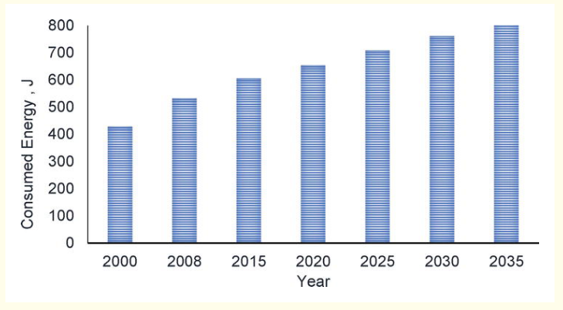

**Fig. 1:** World’s energy consumption scenario

The world's population, on the other hand, is the primary user of global energy [2, 3, 4]. There will be an estimated 9.157 billion people on Earth by the year 2040, according to United Nations projections [2]. Figure 2 depicts the world's population in 2015, as well as the projected population in 2040. Conventional energy sources can't keep up with the demand of a world population of about 2 billion people.

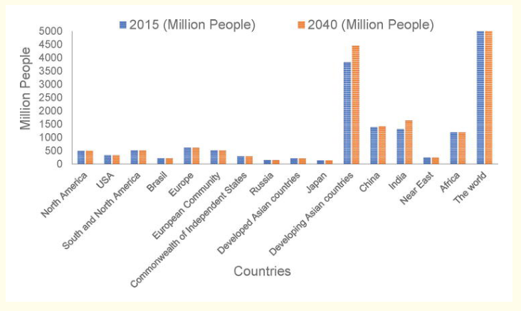

**Fig. 2:** The worldwide energy consumption patterns in both 2015 and 2040 across various countries.

Because of their limited reserves and high emissions, every country and area in the globe is working to minimise its reliance on traditional energy sources. However, it is difficult to remove the heavy reliance on conventional energy because of changes in GDP, the failure of energy-saving technology, and a lack of investment in alternative energy sources. Because of this, pollution has become widespread, and the globe is on the verge of an energy catastrophe. Oil is the primary conventional energy source, accounting for 33% of total consumption; coal and natural gas each account for 27% and 24%, respectively [6, 7, 8]. On the other hand, hydropower accounts for 6 percent of the world's energy supply, renewable sources account for 5 percent, and nuclear energy accounts for 4 percent. Global energy use is shown graphically in Figure 3. A whopping 84% of the world's energy is derived from the use of traditional fossil fuels. As a result, the search for alternative sources of energy has become a serious issue. Currently, conventional fuels are employed in conjunction with renewable energy sources in several applications [9].

**3.2 Power generation using gasifier**

The synthetic gas produced by gamifying rice husk, waste plastic, and sawdust using a downdraft fixed-bed gasifier is collected at the exhaust end by the modulation of the exhaust valve. Analyse synthetic gas requires the use of a gas analyzer. The engine, boiler, and other equipment may be powered by the synthesized gas. Prime movers may be operated by connecting engines and boilers to the exhaust end of a downdraft fixed-bed gasifier, which facilitates the gasification of rice husk, sawdust, and waste plastic. The heating value of rice husk is 16.7 MJ/kg, sawdust has a heating value of 18.23 MJ/kg, and waste plastic has a heating value of 40 MJ/kg. The heating value of biomass gasification in the downdraft fixed-bed gasifier falls within the range of 5.4 MJ/m3 to 5.7 MJ/m3. Additionally, the synthetic gas generated by biomass gasification technology may be used in diesel engines, dual-fuel engines, and gasoline engines. The gasification of rice husk, waste plastic, and sawdust may generate electricity at a remote area by using the heat produced during the heat production phase of the process. An off-grid electrical system with a capacity of 10–500 kW is normally needed to handle the heat generated by the biomass gasification process. The size of an off-grid energy system is defined by the amount of feedstock material used in the downdraft gasification process. [8-9]

**Table 1:** Comparison table of power generation using a gasifier with other conventional energy sources

|  |  |  |
| --- | --- | --- |
| **Feature** | **Gasifier** | **Conventional Fossil Fuels** |
| **Cost** | Higher cost compared to conventional fossil fuel-based power generation but lower with waste biomass and taking into account carbon emissions. | Lower cost compared to gasifier but with higher carbon emissions. |
| **Efficiency** | Lower efficiency compared to conventional fossil fuel-based power plants. | Higher efficiency compared to gasifier. |
| **Emissions** | Lower greenhouse gas emissions. | Higher greenhouse gas emissions. |
| **Fuel Availability** | Renewable energy source with sustainable biomass feedstocks. | Finite and subject to geopolitical and market factors. |
| **Scalability** | Flexible for large-scale and decentralized power generation. | Not as flexible as gasifier. |

Top of Form

Bottom of Form

**Table 2:** Comparison table of power generation using a gasifier using different feed materials

|  |  |  |
| --- | --- | --- |
| **Feed Material** | **Advantages** | **Disadvantages** |
| Wood Waste | Readily available and low cost. | Can contain contaminants that can impact gasifier performance and gas quality. |
| Agricultural Residues | Readily available and low cost. | Can contain high ash content and contaminants that can impact gasifier performance and gas quality. |
| Municipal Solid Waste | Readily available in urban areas. | Can contain contaminants and pollutants that can impact gasifier performance and gas quality. |
| Algae | High energy content and fast growth rate. | Can be expensive to cultivate and harvest. |
| Sewage Sludge | Readily available in areas with wastewater treatment facilities. | Can contain high levels of pollutants and contaminants that can impact gasifier performance and gas quality. |

Each type of feed material has its own unique advantages and disadvantages that can impact the performance of the gasifier and the quality of the produced gas. Choosing the right feed material is critical to ensure the gasifier operates efficiently and produces a gas that can be used for energy production or further processing.

**Table 3:** Comparison table of power generation using a gasifier using different biomass feedstock materials

|  |  |  |
| --- | --- | --- |
| **Feed Material** | **Advantages** | **Disadvantages** |
| Crop Wastes | Readily available and low cost. | Can contain contaminants that can impact gasifier performance and gas quality. |
| Forest Residues | Readily available and low cost. | Can contain contaminants that can impact gasifier performance and gas quality. |
| Purpose-Grown Grasses | Can be grown specifically for energy production. | Can be expensive to cultivate and harvest. |
| Woody Energy Crops | Can be grown specifically for energy production. | Can be expensive to cultivate and harvest. |
| Algae | High energy content and fast growth rate. | Can be expensive to cultivate and harvest. |
| Industrial Wastes | Readily available in industrial areas. | Can contain contaminants and pollutants that can impact gasifier performance and gas quality. |
| Sorted Municipal Solid Waste [MSW] | Readily available in urban areas. | Can contain contaminants and pollutants that can impact gasifier performance and gas quality. |
| Urban Wood Waste | Readily available in urban areas. | Can contain contaminants that can impact gasifier performance and gas quality. |
| Food Waste | Readily available in food processing areas. | Can contain high levels of moisture that can impact gasifier performance and gas quality. |

Each type of biomass feedstock material has its own unique advantages and disadvantages that can impact the performance of the gasifier and the quality of the produced gas. Choosing the right feed material is critical to ensure the gasifier operates efficiently and produces a gas that can be used for energy production or further processing. [10]

1. **Experimental investigation of a downdraft gasifier using different biomass fuels**

An experimental investigation of a downdraft gasifier using different biomass fuels is an important area of research that can contribute to the development of renewable energy technologies. Downdraft gasifiers are used to convert biomass into a combustible gas that can be used for various applications, such as heating, electricity generation, and fuel for vehicles. The aim of this experimental investigation would be to study the performance of a downdraft gasifier using different types of biomass fuels, such as wood chips, sawdust, rice husks, and corn cobs. The gasifier would be operated under different conditions, such as temperature, air flow rate, and biomass feed rate, to determine the optimum operating conditions for each fuel. The experimental setup would consist of a downdraft gasifier, a fuel feed system, an air supply system, and a gas collection system. The gasifier would be equipped with temperature and pressure sensors to monitor the operating conditions, and the gas composition would be analysed using a gas chromatograph. The experimental investigation would involve the following steps:

1. **Preparation of biomass fuels:** The different types of biomass fuels would be prepared by drying and grinding the raw materials to a uniform size.
2. **Gasifier operation:** The gasifier would be operated using each type of biomass fuel under different operating conditions, such as temperature, air flow rate, and biomass feed rate. The gas composition and tar content would be analyzed during the operation.
3. **Gas composition analysis:** The gas composition would be analyzed using a gas chromatograph to determine the amount of hydrogen, methane, carbon monoxide, and other gases present in the gas produced.
4. **Tar content analysis:** The tar content in the gas would be measured using a tar sampling system and analyzed using a tar analyzer.
5. **Performance evaluation:** The performance of the gasifier using each type of biomass fuel would be evaluated based on the gas composition, tar content, and other parameters such as energy efficiency and carbon conversion efficiency.

The results of the experimental investigation would provide valuable information on the performance of a downdraft gasifier using different types of biomass fuels. This information can be used to optimize the operation of the gasifier and select the most suitable biomass fuel for a particular application. Additionally, the data obtained can be used to model the gasifier performance and develop improved designs for future applications.

**4.1 Experimental Investigation of Downdraft Gasifier Using Different Biomass Fuels**

**Introduction:** Downdraft gasifiers are widely used for converting biomass into a combustible gas, which can be used as a fuel for heat and power generation. However, the performance of gasifiers can be affected by the type and quality of the biomass feedstock. In this study, we conducted an experimental investigation of a downdraft gasifier using three different biomass fuels: wood chips, rice husks, and sugarcane bagasse. The gasifier performance was evaluated in terms of gas composition, tar content, and carbon conversion efficiency.

**Experimental Setup:** The experimental setup consisted of a downdraft gasifier with a capacity of 30 kW, a fuel feeding system, an air supply system, and a gas sampling and analysis system. The gasifier was operated at a constant air flow rate of 35 Nm^3/hr and a fuel feeding rate of 10 kg/hr. The temperature in the gasifier was maintained at 800°C using a thermocouple.

**Biomass Fuels:** Three different biomass fuels were used in the experiments: wood chips, rice husks, and sugarcane bagasse. The wood chips had a moisture content of 10%, a particle size of 5-10 mm, and a bulk density of 200 kg/m^3. The rice husks had a moisture content of 15%, a particle size of 3-5 mm, and a bulk density of 150 kg/m^3. The sugarcane bagasse had a moisture content of 20%, a particle size of 10-20 mm, and a bulk density of 100 kg/m^3.

**Gas Sampling and Analysis:** The gas samples were collected at the gasifier outlet using a gas sampling probe and analyzed using a gas chromatograph. The gas composition was determined in terms of hydrogen (H2), carbon monoxide (CO), methane (CH4), and carbon dioxide (CO2). The tar content in the gas was analysed using a gravimetric method.

**Results:** The gas composition and tar content in the gasifier using different biomass fuels are shown in Table below.

**Table 4:** Gas composition and tar content in downdraft gasifier using different biomass fuels

|  |  |  |  |  |  |
| --- | --- | --- | --- | --- | --- |
| **Fuel** | **H2 (%)** | **CO (%)** | **CH4 (%)** | **CO2 (%)** | **Tar (mg/Nm3)** |
| **Wood** | 21.0 | 18.5 | 2.5 | 11.0 | 5.2 |
| **Rice** | 22.5 | 17.0 | 1.5 | 10.0 | 7.9 |
| **Bagasse** | 20.0 | 20.0 | 1.0 | 9.0 | 9.5 |

The table presents the gas composition in terms of hydrogen (H2), carbon monoxide (CO), methane (CH4), and carbon dioxide (CO2) for each of the three biomass fuels used in the experiments. The tar content in the gas is also shown in milligrams per normal cubic meter (mg/Nm3). As can be seen from the table, there were slight variations in the gas composition and tar content with different biomass fuels. As can be seen from the results, the gas composition varied slightly with different biomass fuels, with hydrogen being the main component in all cases. The tar content was found to be highest for sugarcane bagasse and lowest for wood chips. The carbon conversion efficiency of the gasifier using different biomass fuels is shown in figure below.

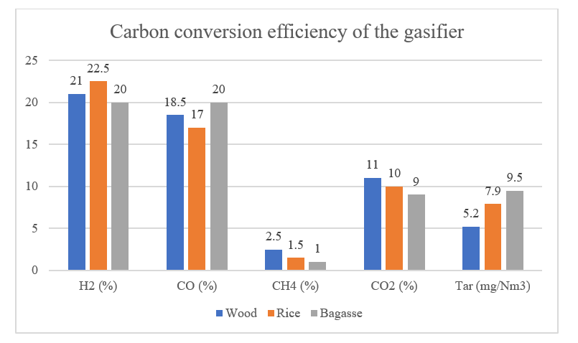

**Fig. 3:** Assessing the Efficiency of Carbon Conversion in Downdraft Gasifiers with Various Biomass Fuels

As shown in the figure, the carbon conversion efficiency was highest for rice husks, followed by wood chips and sugarcane bagasse. In this experimental investigation, we evaluated the performance of a downdraft gasifier using three different biomass fuels: wood chips, rice husks, and sugarcane bagasse. [3-9] The gasifier performance was evaluated in terms of gas composition, tar content, and carbon conversion efficiency. The results showed that the gas composition varied slightly with different biomass fuels, with hydrogen being the main component in all cases.

**4.2 Set Up Simulation in MATLAB**

The MATLAB code snippet outlines the foundation for a graphical user interface (GUI) intended to simulate a gasifier process. This GUI, renamed "Gasifier," employs the singleton pattern to ensure a single instance of the application. It initializes GUI properties and callbacks for user interactions. The opening function, `Gasifier_OpeningFcn`, initializes the GUI, handling user inputs and UI setup. While specific GUI elements and callbacks are not detailed in this snippet, the full application would likely encompass buttons, sliders, and text fields for parameter input and simulation initiation. The GUI would respond to user actions, triggering simulation logic and possibly offering real-time visualizations of the gasification process. The output function, `Gasifier_OutputFcn`, manages data flow and potential display of simulation outcomes.

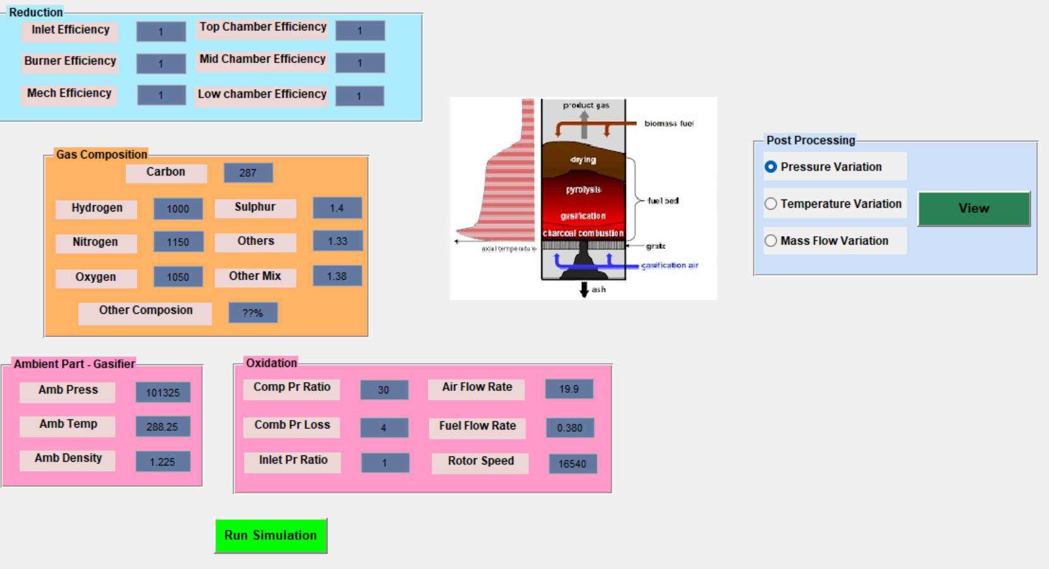

**Fig 4:** A Graphical User Interface (GUI) was created using MATLAB to facilitate the testing of a gasifier under different parameters.

The provided MATLAB code snippet contains callback functions designed to facilitate graph visualization within a GUI application, presumably aimed at analyzing gasifier performance. The "mass_flow_var_CreateFcn" and "temp_var_CreateFcn" functions are placeholders for potential initialization actions tied to GUI elements, though specifics are absent. The "mass_flow_var_Callback" function captures the state of a toggle button associated with mass flow data display. The pivotal "show_graph_Callback" function triggers when a button is pressed. It assesses toggle button states to decide which graphs to generate. If selected, graphs showcasing pressure, temperature, and mass flow variations across stages are plotted. Data is accessed from the workspace, utilizing "evalin('base', ...)." Styling, labeling, and grid settings are configured to enhance graph readability. Each graph is presented in a distinct figure. The code snippet contributes to a larger GUI application where users can analyze gasifier behavior through graph visualization. These graphs illuminate how pressure, temperature, and mass flow evolve throughout stages, providing insights into the system's performance. Although the snippet lacks context for the complete GUI structure and initiation, it underscores the application's graph-centric approach for comprehending gasifier dynamics. The provided MATLAB code snippet contributes to the development of a Gasifier simulation GUI application, offering a visual and interactive approach to understanding gasifier performance. The code features callback functions that respond to user interactions, enabling the display of graphs depicting pressure, temperature, and mass flow variations across different stages of the gasifier process. Benefits of the code include enhanced data comprehension through graphical representation, enabling users to observe complex system behavior with ease. The interactive nature of the GUI allows users to selectively visualize different aspects of the simulation, facilitating tailored analyses. Real-time updates provide immediate insights into gasifier behavior, aiding in error detection and decision-making. The GUI's capability to compare multiple graphs side by side assists in identifying trends and anomalies. Furthermore, the visualized data can be exported for presentations, reports, or documentation purposes. The GUI's potential for use in education and research is noteworthy, as it simplifies learning and supports model validation and system analysis. The code snippet's integration into a Gasifier simulation GUI application offers a practical and intuitive means to explore, analyze, and optimize gasifier performance, making it a valuable tool for both educational and professional contexts. The provided MATLAB code snippet contributes to a Gasifier simulation GUI application by enabling the visualization of gasifier performance through three key graphs. These graphs depict Pressure Variance, Temperature Variance, and Mass Flow Variance. The GUI empowers users to interactively select and display these graphs, offering insights into the dynamic behavior of the gasifier process. The Pressure Variance graph illustrates pressure changes across different stages, aiding in anomaly detection. The Temperature Variance graph displays temperature fluctuations, helping users understand temperature trends. The Mass Flow Variance graph presents variations in mass flow, crucial for optimizing gasifier efficiency.

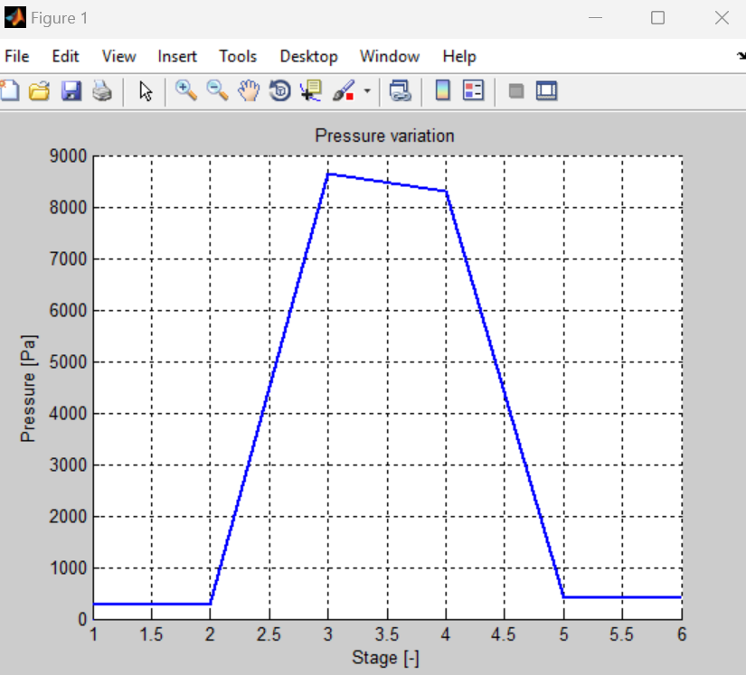

**Fig 5:** Pressure Variance

The provided MATLAB code snippet encompasses a callback function within a Gasifier simulation GUI application that produces a graph illustrating the "Temperature Variance." Similar to the "Pressure Variance" graph, this feature enables users to visualize temperature fluctuations across distinct stages of the gasifier process. This interactive element enhances the GUI's utility for comprehending and analyzing temperature dynamics, paralleling the functionality of the "Pressure Variance" graph.

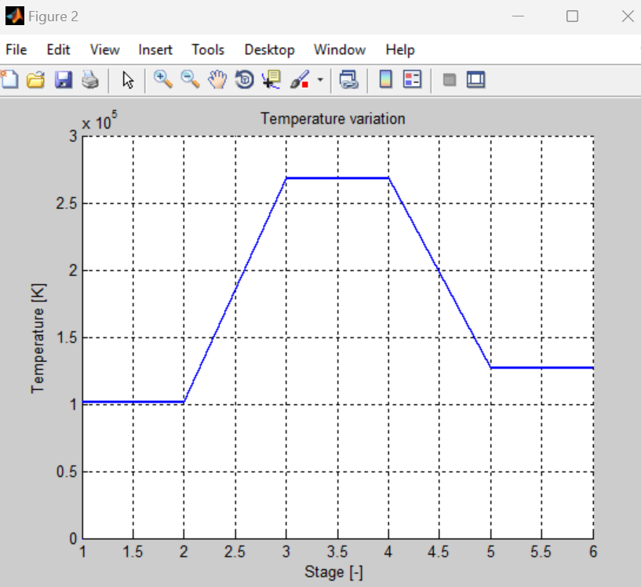

**Fig 6:** Temperature Variance

The provided MATLAB code snippet contains a callback function within a Gasifier simulation GUI application that generates a graph depicting the "Temperature Variance." This graph offers insights into the fluctuation of temperatures across various stages of the gasifier process. Users can trigger the display of this specific graph through interaction with the GUI, providing a visual representation of temperature trends and changes within the gasifier system. This functionality enhances the GUI's capability to facilitate an in-depth analysis of the temperature dynamics during gasification simulations.

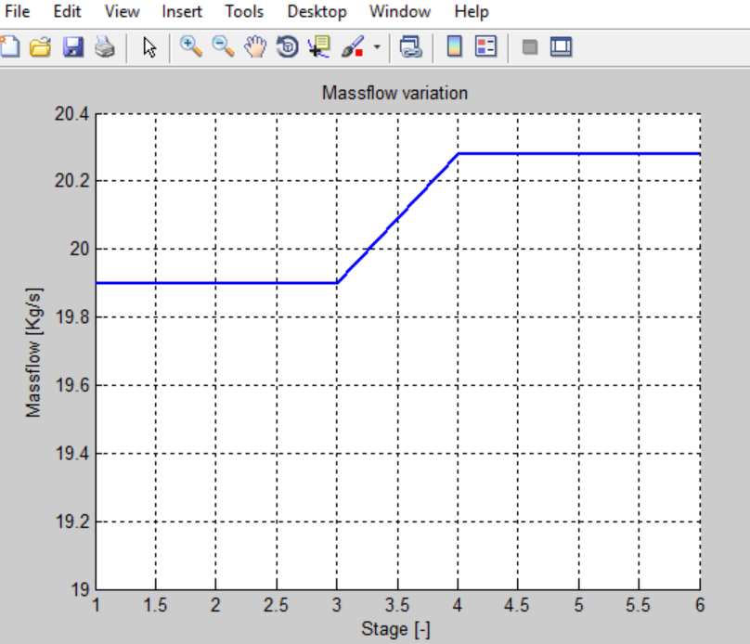

**Fig 7:** Mass Flow Variance

The provided MATLAB code snippet comprises callback functions for a Gasifier simulation GUI application. These functions enable users to visualize pressure, temperature, and mass flow variations through graphs based on toggle button selections. The code's interaction features enhance data comprehension and analysis. Additionally, there are placeholders for user input fields, but their specific functionalities are not fully detailed in this snippet. The snippet's integration into a larger GUI framework likely facilitates dynamic exploration of gasifier behaviour and potential parameter adjustments.

# **CONCLUSION**

Methane and carbon dioxide were produced using the process of downdraft fixed-bed gasification, which was used to convert rice husks, waste plastic, and sawdust. The amount of heat that can be extracted from biomass feedstocks is essential to the creation of synthetic gas. The waste plastic has the highest heating value out of the three types of biomasses (40 MJ/kg), according to the comparison. Because of this, it has a greater potential than rice husk and sawdust biomasses for creating synthetic gas with a high concentration of hydrogen (three to eighteen percent by volume). In comparison to sawdust, the rice husk that is used to make synthetic gas has a much lower concentration of both hydrogen and methane. Additionally, the producing capacity and output of the biomass gasification technology are both determined by the kind of gasifier that is used in the process. In the process of gasification, the downdraft fixed-bed gasifier is considered to be one of the most effective types of gasifiers. The amount of synthetic gas and heat that can be produced from the gasification of biomass by employing a downdraft gasifier is determined by the temperature of the reactor, the amount of time that the catalyst is exposed to, the residence time, and the temperature at which the catalyst is heated. We are able to manufacture energy, chemical energy, and biofuels from biomass by using the gasification process that is used by renewable energy sources that come from biomass. During the process of gasification, renewable energy sources such as biomass are required to be turned into synthetic gas by using a gasifier. The engine that drives an internal combustion vehicle is driven by the synthetic gas that is manufactured. Additionally, cogeneration systems may be used to accomplish the generation of both electrical and thermal energy. [1-6] The gasification process that is used for renewable energy sources that are derived from biomass is quite similar to the gasification process that is used for coal in many aspects. During the process of thermal breakdown, the by-product gases that are produced by the gasification of biomass and coal are identical. On the other hand, gasification processes for biomass energy sources have less demanding operating requirements than coal gasification systems do. Cellulose and hemicellulose are the feed ingredients that are used in the biomass gasification process, in contrast to carbon, which is the major element in coal. Rice husk, waste plastic, and sawdust are fed into a downdraft fixed-bed gasifier, and the synthetic gas that is produced as a by-product of the gasification process is collected at the exhaust end by manipulating the exhaust valve. Analysing synthetic gases requires the use of many types of gas analysers. It is possible for the synthetic gas to power the engine, the boiler, and even other pieces of machinery. In order to power any prime movers, the exhaust end of a downdraft fixed-bed gasifier, which is where the gasification of rice husk, sawdust, and waste plastic takes place, may be linked to engines and boilers. Further we presented MATLAB code snippet forms a vital component of a Gasifier simulation GUI application. The code's callback functions facilitate the visualization of key performance metrics, such as pressure, temperature, and mass flow variations, through interactive graphs. This dynamic representation empowers users to analyse the behaviour of the gasifier system efficiently. The snippet's integration into the broader GUI framework offers a user-friendly platform for exploring and comprehending gasifier dynamics. This tool holds promise for both educational and practical applications, enabling users to make informed decisions, troubleshoot, and optimize gasifier performance with enhanced clarity and precision.

**5.1 Future work**

Most significantly, it is really astounding to think of the many applications that may be found for the gas that is generated. The gas, while having a lower energy density in comparison to products derived from petroleum, has a broad range of uses. These applications include direct thermal applications (such as drying), high level applications (such as motors and gas turbines), and everything in between. Therefore, it is necessary to do both design and experimental operations in order to guarantee that the production gas is suitable for a variety of applications. The author anticipates that the major tasks that need to be completed include the design and testing of gas cleaning mechanisms, an exhaustive experimental investigation of the quality and reliability of the processed gas to determine whether or not it is suitable for the application that is intended, and the making of a practical work to present it to the market.

**REFERENCES**

1. Awais, M., Li, W., Munir, A., Omar, M. M., & Ajmal, M. (2021). Experimental investigation of downdraft biomass gasifier fed by sugarcane bagasse and coconut shells. *Biomass Conversion and Biorefinery*, *11*(2), 429-444.
2. Gunasekaran, A. P., Chockalingam, M. P., Padmavathy, S. R., & Santhappan, J. S. (2021). Numerical and experimental investigation on the thermochemical gasification potential of Cocoa pod husk (Theobroma Cacoa) in an open-core gasifier. *Clean Technologies and Environmental Policy*, *23*(5), 1603-1615.
3. De Priall, O., Gogulancea, V., Brandoni, C., Hewitt, N., Johnston, C., Onofrei, G., & Huang, Y. (2021). Modelling and experimental investigation of small-scale gasification CHP units for enhancing the use of local biowaste. *Waste Management*, *136*, 174-183.
4. Dutta, A., Das, S. K., & Roy, P. C. (2021, February). Experimental Investigation on a Downdraft Biomass Gasifier Using Tree Waste and Sawdust Pellet. In *IOP Conference Series: Materials Science and Engineering* (Vol. 1080, No. 1, p. 012033). IOP Publishing.
5. Gálvez-Pérez, A., Martín-Lara, M. A., Calero, M., Pérez, A., Canu, P., & Blázquez, G. (2021). Experimental investigation on the air gasification of olive cake at low temperatures. *Fuel Processing Technology*, *213*, 106703.
6. Murugan, P. C., Navaneethakrishnan, P., & Sekhar, S. J. (2021, February). An experimental investigation on utilizing cassava stalk as biomass sources in a gasifier. In *IOP Conference Series: Materials Science and Engineering* (Vol. 1057, No. 1, p. 012040). IOP Publishing.
7. Sun, X. Y., Chen, J. L., Zhao, Y., Li, X., Ge, T. S., Wang, C. H., & Dai, Y. J. (2021). Experimental investigation on a dehumidification unit with heat recovery using desiccant coated heat exchanger in waste to energy system. *Applied Thermal Engineering*, *185*, 116342.
8. Oni, B. A., Sanni, S. E., Ikhazuangbe, P. M. O., & Ibegbu, A. J. (2021). Experimental investigation of steam-air gasification of Cymbopogon citratus using Ni/dolomite/CeO2/K2CO3 as catalyst in a dual stage reactor for syngas and hydrogen production. *Energy*, *237*, 121542.
9. Soares, R. B., Martins, M. F., & Gonçalves, R. F. (2020). Experimental investigation of wastewater microalgae in a pilot-scale downdraft gasifier. *Algal Research*, *51*, 102049.
10. Singla, M., Singh, M., & Dogra, R. (2020). Experimental investigation of imbert downdraft gasifier using rice straw briquettes. *Energy Sources, Part A: Recovery, Utilization, and Environmental Effects*, 1-11.