**REVIEW ARTICLE**

**UTILIZATION OF TRACER TECHNIQUE FOR INVESTIGATION OF**

**BIOGENETIC STUDIES**

Dr. Anil Kumar1, Krishanu Samanta2

1Professor, Pharmacy College, Itaura, Chandeshwar, Azamgarh U.P.-India

2Associate Professor, Pharmacy College, Itaura, Chandeshwar, Azamgarh U.P.-India

**Corresponding author**

Dr. Anil Kumar

Email- howruakpatel@gmail.com

**ABSTRACT**

The biological system under investigation is more sensitive to the chemical nature of the elements, but it cannot distinguish between different isotopes of the same element. Therefore tracing of biosynthetic or metabolic pathway by incorporating radioactive isotopes into the precursor or starting material. The location and quantity of the compound can be determined in biological system. Radioactive tracer methods are used both in research and routine analytical methods. So the utilization of tracer techniques is based on the application of stable or unstable radioactive isotopes of an element as markers for the naturally occurring form of the element. The aim of the focus on the radioactive isotopes which are utilized in tracer technique for the investigation of biogenetic pathways.

**Keywords-** Tracer Technique, Radioactive, Isotopes, Biosynthetic pathway

**INTRODUCTION**

There are five techniques used for the investigation of biosynthetic pathway of primary and secondary metabolites such as Tracer technique, Use of isolated organ and tissues, Grafting method. Use of Mutant strains and enzymatic studies. In which Tracer technique method radioactive isotopes are used for the investigation of biogenetic studies.

Tracer techniques utilizes radioactive isotope labelled compound to find out or to trace the different intermediates and various steps in biosynthetic pathways in plants, at a given rate & time. When the labelled compounds are administered to the plants, they become a part of metabolic pool and undergo reaction characteristics. Elements existed with identical chemical properties or same atomic no. but different atomic weights/ mass no. are called isotopes.

**Stable isotopes-** They are stable and do not emit radiation, e.g- 2H, 13C, 15N, 18O

**Radioactive isotopes-** They are unstable and emit radiations. The phenomenon of emitting radiation is called radioactivity and such isotopes are called radioactive isotopes.

**Significance of tracer techniques-**

* + 1. Applicable for living systems. Wide ranges of isotopes are available.
    2. More sensitivity
    3. More effective
    4. Simple administration and isolation.
    5. Shows accurate results when enough metabolic time & technique is used.
    6. Position & Quantity of compound containing tracer isotope 14C marked glucose is used for glucose determination in the biological system.
    7. For different studies, different tracers can be used. For studies on nitrogen and amino acid, Labelled nitrogen gives specific information than carbon.
    8. Biosynthetic pathway can be traced by incorporating radioactive isotopes into the precursor or starting material. e.g- By incorporation of 14C to phenyl alanine, the biosynthesis of cyanogenetic glycosides, prunacin can be traced. Location and quantity can be determined in biological system.

**Different trace elements used for different studies-**

For studies on protein, alkaloids and amino acid, nitrogen atom gives more specific information than carbon. For studies on glycosidic linkage- O, N, S and C atom. For studies on terpenoids- O atom.

**Steps involved in tracer techniques-**

1. Preparation of labelled compound

2. Incorporation of labelled compound

3. Separation and isolation of labelled compound

4. Determination of nature of metabolites in various biochemical fractions.

**1-** **Preparation of labelled compound-**

In biological investigation, the use of bioactive isotopes enables the metabolism of compounds to be followed in living organisms for detection and estimation of soft and easily absorbed radiation from labelled compound.

* 1. Labelled compounds may be prepared by use of radioactive isotopes and stable isotopes e.g- Radioactive isotopes- 14C, 3H, 32P, 131I
  2. Stable isotopes- 2H, 15N, 13C, 18O
  3. Radioactive carbon and hydrogen are mostly used in biological investigation.
  4. Radioactive isotopes having long half-life are used. Criteria for selection of trace elements-Starting concentration of trace element must be sufficient to withstand dilution in the course of metabolism.
  5. Physical and chemical nature of compound must be known.
  6. Half-life should be sufficiently long.
  7. Should not damage the tissue system
  8. Should have low radiation energy.
  9. Instruments used to detect properties of metabolites are Scintillation chamber, GM counter, Autoradiography, NMR and MS- ionization technique.

**2-Incorporation of labelled compound to tissue system**

i) Root feeding ii) Stem feeding iii) direct injection

iv) Infiltration v) Floating method Vi) Spraying technique

**Root feeding-** In case roots are biosynthetic sites e.g- Tobacco. The plants are cultivated hydroponically to avoid microbial contamination.

**Stem feeding-** Labelled compounds are administered through the cut ends of stem immersed in a solution. For latex containing plants this method is not suitable.

**Direct injection-** This method is used in plants with hallow stem. e.g- Umbelliferae and capsule plants (opium poppy). Micro-syringe is used to inject labelled compound solution.

**Infiltration (wick feeding)-** A thread is drawn through the stem which is dipped into radioactive solution or a flap can be cut in stem and this dipped in the solution.

**Floating method-** When a small amount of material is available, this method is used. Leaf disc/chopped leaves are floated on labelled compound solution.

**Spraying technique-** Compounds have been absorbed after being sprayed on leaves. e.g- steroids.

**Separation and isolation of labelled compound-**

1. Different methods are used depending on nature of drug and its source.
2. Soft tissue (Fresh)- Infusion, Maceration
3. Hard tissue- Decoction and hot percolation
4. Unorganized drug- Maceration with solvent
5. Fat and oil- Non-polar solvent
6. Alkaloids, Glycosides, Flavonoids- Slightly polar solvent
7. Plant phenol- Polar solvent

**Detection and assay of radioactivity labelled compound-**

Depending on the nature of isotopes, various instruments are used to determine the chemical nature of intermediate and final product for radioactive isotopes.

**1.** **Geiger-Muller counter-** It is a type of particle detector that measures ionizing radiation, e.g. alpha, beta particles or gamma rays, by ionization produced in low-pressure gas, usually helium, neon or argon with halogens added in the Geiger-Muller tube, which conducts electrical charges briefly when a particle or photon of radiation makes the gas conductive by ionization. This indictment has been detected in form of current pulse.

**2. Scintillation or liquid scintillation counter-** A scintillation detector or scintillation counter is produced when the scintillation detector is coupled to an electronic light sensor such as a photomultiplier tube (PMT) or a photodiode. A scintillator is a material that exhibits scintillation- a luminescence property that is stimulated by ionizing radiation. Samples shall be dissolved or suspended in a "cocktail" containing a solvent (aromatic organics such as benzene or toluene), typically some form of a surfactant, and small amounts of scintillators.

**3. Ionization chamber-** The ionization chamber is the simplest of all gas-filled radiation detectors and is commonly used for ionizing radiation, including x-rays, gamma rays and beta particles. Conventionally, the term "ionization chamber" is used solely to describe those detectors that collect all the charges caused by direct ionization of the gas using an electrical field.

**4. Mass Spectrophotometer-** Mass spectrometry (MS) is an analytical technique used to measure the mass-to-charge ratio of charged particles. It is used to determine the mass of the particles, to determine the elemental composition of the sample or molecule, and to elucidate the chemical structures of the molecules, such as peptides and other chemical compounds.

**5. NMR Spectrophotometer-** NMR spectroscopy is a research technique that exploits the magnetic properties of certain atomic nuclei to determine the physical and chemical properties of the atoms or molecules they contain. It relies on the phenomenon of nuclear magnetic resonance and can provide detailed information on the structure, dynamics, reaction status and chemical environment of the molecules.

**6. Autoradiography-** It is a tool for examining the distribution of radioactive material in a plant object, e.g. histological tissue, chromatography sheet. This method uses a photographic film or emulsion as an ionizing radiation detector. The specimen is in close contact with the emulsion for a period (exposure duration). In this technique, a sample containing a radiolabelled metabolite is placed in direct contact with suitable photosensitive material such as x-ray (photographic) film for a specific period. The pattern of delivery of radioactive substances can be elucidated with the aid of the autograph collected.

**Methods of Tracer Techniques**

**1. Precursor Product sequence-**

The presumed precursor of the constituent under investigation on a labelled form is fed into the plant and after a suitable time the constituent is isolated, purified and radioactivity is determined.

Radioactivity of the isolated compound alone is not sufficient evidence that the particular compound fed is a direct precursor, because the compound may enter the general metabolic pathways and distributed randomly through a whole range of products.

Further evidence can be made by double and triple labelling experiments by using either different isotopes of specific labelling by one isotope at two or more positions in the molecule. Application- Restricted synthesis of hyoscine, distinct from hyoscyamine in *Datura stramonium*. This method is applied to the biogenesis of morphine and ergot alkaloids.

Leete in his experiment used two doubly labelled lysines to determine which nitrogen of the lysine molecule was involved in the formation of the piperidine ring of anabasine in *Nicotiana glauca*

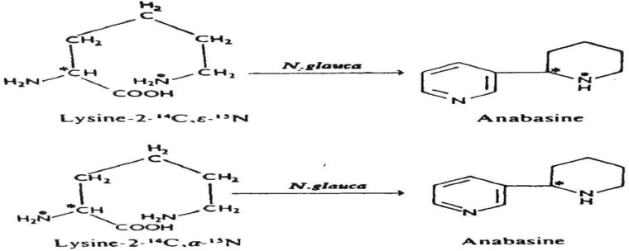

1. **Competitive feeding-**

If incorporation is obtained, it is necessary to consider whether this is the normal route of synthesis in plant not the subsidiary pathway. Competitive feeding can distinguish whether B or B' is the normal intermediate in the formation of C from A (Fig.1.2).

Inactive B and B' are fed with labelled A to separate groups of plants and a control is performed by feeding labelled A only to another group. If the incorporation of activity into C is inhibited in the plants receiving B but is unaffected in the group receiving B' then we may conclude that the pathway from A to C probably proceeds via B.

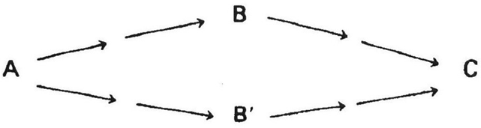

A → C

*A → B → C

*A → B' → C

Tyrosine is the precursor for 3, 4- dihydroxyphenylpyruvic acid and 3, 4- dihydroxyphenylethylamine for the synthesis of Norlaudanosoline which produces morphine through reticuline. 3, 4- dihydroxyphenylethylamine is produced from tyrosine via 3, 4- dihydroxyphenylalanine (DOPA). It was considered that another precursor i.e 3, 4- dihydroxyphenylpyruvic acid would also be synthesized through DOPA but by labelling experiments and competitive feeding it has been confirmed that tyrosine directly gives 3, 4- dihydroxyphenylpyruvic acid without any intermediate. (Fig. 1.3)

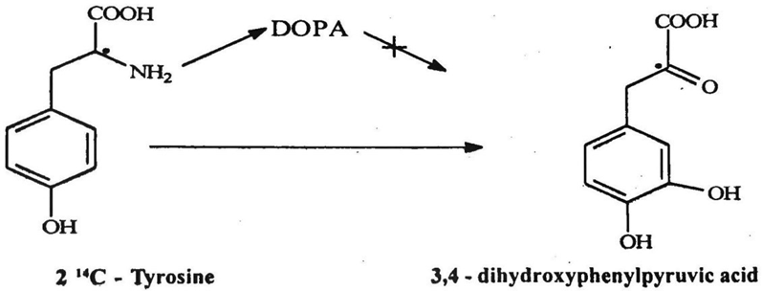

**3. Sequential analysis-**

Principle of this method is to grow a plant in an atmosphere of 14CO2 & then analyse the plant at given time interval to obtain the sequence in which various correlated compound become labelled.

Degradation of isolated radioactive compounds is important, because some units of molecule may become labelled more rapidly than others.

This method is used in the elucidation of path of carbon in photosynthesis.

Application- Exposure period to 14CO2 as short as 5 min. have been used to obtain evidence of biosynthetic sequence as Piperitone → (-)-menthone → (-)-menthol in Mentha piperita.

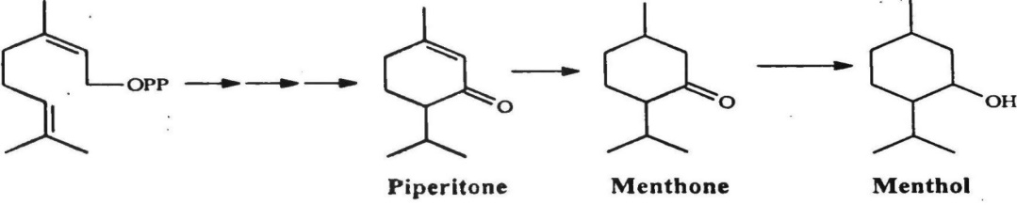

**Fig.1.4** Biosynthetic sequence of Piperitone to Menthone to Menthol

**CONCLUSION**

Trace technique help to identify, observe or follow the behaviour of various physical, chemical or biological processes. The radiation emitted by radiotracers is generally easy to detect and measure with high precision. Therefore tracer technique more useful for utilization of biogenetic studies.

**REFERENCES**

* 1. Khadabadi SS, Deore SL and Baviskar BA. Pharmacognosy and Phytochemistry: A Comprehensive Approach. 1st ed. PharmaMed Press; 2014.
  2. Dandu G, Basu VR, Kamalakar K, Manasa CH, Lavanya B, Pavani J. A Review on Tracer Technique and Its Applications in Synthesis of Secondary Metabolites in Pharmacognosy. Int. J. Adv. Pharm. Biotech (2019) 5(1) 01–05.
  3. Sudha T, Rajeswari R, Ravikkumar VR, Nimbekar TP. Pharmacognosy and Phytochemistry-II. 1st ed. S.Vikas and Company Jalandhar; 2019.
  4. Elving PJ (1986) Treatise on analytical chemistry, part1: theory and practice, vol 14. Section K, Nuclear activation and radioisotopic methods of analysis. Wiley, New York.