**“FORMULATION AND EVALUATION OF HERBAL MOUTHWASH”**

## Project Report Submitted to

***RGPV University***

*In partial fulfillment of the requirement for the Award of degree of*

**BACHELOR OF PHARMACY**

### SUBMITTED BY

**Maya 0142PY201052**

**UNDER THE GUIDANCE OF**

**Ms. Rajeshvari Malik**

***(Professor)***



**NRI Institute of Pharmaceutical Sciences, Bhopal (M.P.)**

**2, Sajjan Singh Nagar, Opp. Patel Nagar, Raisen Road, Bhopal (M.P.)** 462010



**CERTIFICATE**

This is to certify that Project report work entitled ***“FORMULATION AND EVALUATION OF HERBAL MOUTHWASH”*** submitted to Rajiv Gandhi Proudyogiki Vishwavidyalaya, was carried out by **Maya (0142PY201052) in NRI Institute of pharmaceutical Sciences, Bhopal** in partial fulfillment of the requirement for the award of the degree of the Bachelor of Pharmacy. Under the supervision and guidance of **Associate Prof. Rajeshvari Malik,** NRI Institute of Pharmaceutical Sciences, Bhopal

**PRINCIPAL**

**Dr. Jagdish Rathi**

**NRI Institute of Pharmaceutical Sciences, Bhopal**



**C E R T I F I C A T E**

This is to certify that the Project Report Work entitled *“****FORMULATION AND EVALUATION OF HERBAL MOUTHWASH”*** submitted to RGPV University, was carried out by **MAYA (0142PY201052),** in NRI Institute of Pharmaceutical Sciences, Bhopal in partial fulfillment of the requirement for the degree of "Bachelor of Pharmacy" under my supervision and guidance.

This work is original and has not been submitted in part or full for any other degree or diploma of any other university.

**Date:**

**Place: Bhopal SUPERVISOR/GUIDE**

**Prof. Rajeshvari Malik**

***DECLARATION***

The work presented in this report entitled “**FORMULATION AND EVALUATION OF HERBAL MOUTHWASH”** was carried out by me in NRI Institute of Pharmaceutical Sciences., Bhopal, under the direct supervision of **Prof, Rajeshvari Malik**.

This work is original and has not been submitted in part or full for the award of any other degree / diploma or academic award anywhere re before.

### Date: Maya

**Place: Bhopal Enroll No. 0142PY201052**

*Acknowledgement*

I express my profound gratitude to my principal **Prof. (Dr). Jagdish Chandra Rathi** , Principal, NRI Institute of Pharmaceutical Sciences, Bhopal (M.P) Sir, I am highly obliged for your encouragement, foresightedness, valuable suggestions, ever willingness to discuss science, parental affection and the valuable time you have given me from your busy schedule, which provided me with the needed moral and confidence during the work.

I would like to express my sincere gratitude to my project guide **Prof. Rajeshvari Malik**, enabling to complete my Project Work entitled “**FORMULATION AND EVALUATION OF HERBAL MOUTHWASH ”** Your constant quest for knowledge, strive for excellence, dedication and discipline will always remain a source of inspiration to me for the rest of my life. Words will never be enough to express my indebtedness for your teachings and working under your guidance is lifetime achievement for me. I thank my fellow lab mates in for the stimulating discussions, for the sleepless nights we were working together before deadlines, and for the all the fun we have had during project times.

Last but not the least, would like to thank my family, my parents for supporting me spiritually and financially throughout my Project Report Work

*Place: - BHOPAL*

### Date: Maya

**Place: Bhopal 0142PY201052**

# Index

|  |  |  |
| --- | --- | --- |
| **Sr. No.** | **Title** | **Page No.** |
| **1.** | **INTRODUCTION** |  |
| **2.** | **REVIEW OF LITERATURE** |  |
| **3.** | **RESEARCH ENVISAGED & PLAN OF WORK** |  |
| **4.** | **EXPERIMENTAL WORK** |  |
| **5.** | **RESULT AND DISCUSSION** |  |
| **6.** | **SUMMARY AND CONCLUSION** |  |
|  | **REFERENCE** |  |

**Abstract**

The goal of this study is to develop a formula and test its efficacy against bacteria found in the oral cavity. The goal of this study is to develop and test herbal mouthwash, as well as to determine its efficacy against oral microbial load. Water was removed from the plant materials that were collected. the plant components were collected and water-soluble compounds were removed. The antibacterial activity and physicochemical properties of prepared mouthwash were also tested. The present mouthwash possesses a good antibacterial property. The findings of the stability research back up the effectiveness of the preparation. Mouthwash is currently a liquid preparation that usually comprises antibacterial and antiseptic ingredients. These treatments can be used to limit microbial growth in the mouth, but they can also be utilised for other reasons, such as analgesic, anti-inflammatory, or anti-fungal properties. The ingredient contains turmeric, clove oil, honey and *Peppermint* oil were chosen for mouthwash, and the final formulation was tested for antimicrobial activity against *Staphylococcus aureus* and *S. salivarius* cultures, as well as physical properties such as pH, colour, and stability. The presence of mouthwash has a strong antibacterial effect. Mouthwash is a liquid preparation that generally contains antibacterial and antiseptic compounds, and it is stable in a variety of temperatures. This solution can be used to minimise microbial growth in the mouth, as well as for other purposes such as analgesic, anti-inflammatory, or antifungal activities.

### Key Words:.

**CHAPTER -1 INTRODUCTION**

The importance of mouth and teeth cleanliness has been recognized From the dawn of civilisation to the twenty-first century, the importance of keeping one's mouth and teeth clean has been recognised. Patients and dentists are confronted with a plethora of mouthwash products comprising a variety of active and inactive components. Herbal mouthwashes are in high demand since they target oral infections, reduce pain quickly, and have fewer adverse effects. Chemical mouthwashes contain hydrogen peroxide, chlorine dioxide, and cetylpyridinium chloride, which act as an instant whitener, steriliser, and pain reliever for teeth. However, they can discolour teeth and cause side effects, but they are inexpensive. Although several popular herbal products have been shown to help decrease dentalplaque and gingivitis, they have only been taken for a limited period of time and only as needed.Brushing and flossing are examples of other oral hygiene treatments. Dental caries and periodontal diseases are two of the most frequent infectious diseases that many people face. Periodontitis is a serious dental illness that can harm your teeth and gums.

Dental caries is common in children and adolescents in the beginning because they do not practise adequate oral hygiene. Oral infections develop from the contaminated tooth's root through the jawbones and into the crevices between the fascial planes of the surrounding soft tissue. Dental plaque is a complex biofilm that forms on the surface of teeth and contains over 500 bacteria. Initial colonization of bacteria in the salivary film of enamel produces dental plaque, which is followed by subsequent colonization via antibacterial adhesion. The supporting tissues of theteeth are affected by prenominal disorders. Inadequate dental hygiene is the most common cause of gingivitis, the mildest type of prenominal illness. Gingivitis is a condition in which the gums become inflamed and bleed. Plaque that accumulates on the surface of teeth and gums is the main cause of gingivitis. Mechanical plaque control techniques are employed as a mainstay of maintaining dental hygiene.

Herbal mouthwash are made from natural plant extract and essential oil, they contain natural ingredient called phytochemical that have anti-microbial and anti-inflammatory effect, herbal mouthwash are becoming more popular because they don’t contain alcohol, artificial preservative flavor and color herbal mouthwash contain extract from leave, fruit, , flower bark various part of plant.

The main aim of used the herbal mouth wash used can at home as routine to maintain good oral hygiene mouthwash anti-microorganism.

Define mouthwash herbal mouthwash is which is prepared from natural plant extracts. the natural extract present in the herbal mouthwash is obtain from various plant leaves, fruits, seed, bark. why should we prefer herbal mouthwash.

Herbal mouth wash is very high demand. because they act on oral pathogens and relive the s pain instantly and are also less side effect. chemical mouthwash have hydrogen peroxide and chlorhexidine as an immediate whitener, sterilizer and pain reliver of teeth but they tend to produce discoloration of teeth and may produce side effect, meanwhile they are cost effective.

### Uses of herbal mouthwash

* Many conditions within the oral cavity required the uses of a mouthwash
* It can be use in gum disease
* It relives pain and inflammatory
* It freshens breath, most patients use mouth wash for this reason to fresher their breath.

### Herbal mouth wash does not contain:

1. Alcohol
2. Sugar
3. Artificial color
4. Dyes
5. Harse chemical preservative

**CHAPTER-2 REVIEW OF LITERATURE**

**Khobragade et al., 2021** studied that several different varieties of mouthwashes are accessible to us nowadays, including chemical as well as herbal formulations. Appropriatemouthwash can be selected depending on the oral condition, risk, and efficiency of mouthwash. As mentioned in the literature also Mother Nature has provided us abundant medicinal herbs with antibacterial and antimicrobial properties. Though we are having very scarce data onthe medicinal properties of these herbal plants, they are still in use in treating various periodontal diseases and other oral diseases. Knowing scientific expression of the actual effects of the herbal medicine is at most important for the beneficiaries. In the course of this bibliographical revision, papers were collected to validate the ancestral uses of herbs and conclude that the use of plants to treat oral conditions should be based on the experimental studies, verifying their suitability for dental treatments. Oral healthcare professionals would find this review helpful for accurate mouthwash selection while dealing with different conditions of the oral cavity.

**Page RC, Kornman KS. et al., 2020** studied that nowadays, oral diseases are known to be a big issue worldwide.Among numerous oral diseases, periodontal disease is one amongthe significant oral health condition. The quality of life is affected by oral health. Periodontal diseases are known to be chronic inflammatory conditions characterized by loss of connective tissue,alveolar bone resorption, and formation of periodontal pockets asa result of complex interaction between pathogenic bacteria and the host’s immune response. Dental plaque is being one of the primary etiologic factors inperiodontal disease.

**DePaola LG, Overholser CD, Meiller TF, et al. 2000** studied that various plaque control measures are used to prevent or control the progression of periodontal diseases. One among it includes mechanical plaque control measures to maintain proper oral hygiene.

**Dona BL, Gründemann LJ, Steinfort J, et al. et al., 2001** studied that a variety of different chemical plaque control measures are available in the market, which includes mouthwash, dentifrices, chewing gums, and gel. But they have some undesirable side effects, like vomiting, diarrhea, and tooth staining. Mouthwashes may serve as a measure in controlling dental plaque and periodontal disease for mentally or physicallyhandicapped patients who are incapable of brushing their teeth

themselves or other individuals who are lacking dexterity, skill, or motivation for mechanical plaque removal.

**Siddeshappa ST, Bhatnagar S, Yeltiwar RK, et al. et al., 2018** studied that any antimicrobial/antiseptic agents used should be able to modify the oral environment by being specifically effective against the pathogens without altering thenormal flora.

**Najafi MH, et al. et al., 2014** studied that There are a number of mouthwashes available in themarket today worldwide. Many of these mouthwashes have not been tested adequately, and the information is lacking as to when and how to use these agents for maximum benefit.5 Chlorhexidinedigluconate has been the agent of choice as an antiplaque agentwhen compared to others and is considered the gold standard. However, due to its side effects, its acceptance by patients can belimited, especially when a longer period of use is recommended.6

## CHAPTER-3

**RESEARCH ENVISAGED & PLAN OF WORK**

Maintenance of oral hygiene is imperative in preventing the buildup of plaque, a sticky film of bacteria and food that accumulates on teeth. Oral hygiene measures include mechanical aids such as toothbrushes, floss, interdental cleansers and chemotherapeutic agents such as mouthwashes, dentifrices and chewing gums. Mouthwashes (mouth rinses) are solutions or liquids intended to reduce the microbial load in the oral cavity. They provide a safe and effective chemical means of reducing or eliminating plaque accumulation. They also help in removing or destroying bacteria, relieving infection of oral tissues, preventing dental caries, masking bad breath, etc. Most of the mouthwashes available in the market contain alcohol and other chemicals such as chlorhexidine gluconate and triclosan.[1] These chemicals cause various side effects ranging from taste disturbance to allergic contact stomatitis. To overcome such side effects, nontoxic herbal mouthwashes using various herbs and plant extracts have been introduced.[2] Various studies have been conducted to show the effectiveness of herbal mouthwashes. Among these herbal products, the green tea extract has gained much importance. A variety of mouthwashes can be prescribed depending on the oral diseases. Hence, oral healthcare practitioners must have to be cognizant of various etiologic factors and predisposing conditions of the oral cavity. Of course, it goes without saying that chlorhexidine is the gold standard mouthwash. However, when socioeconomic factors, side effects, and/or liking of the population for natural products need consideration, herbal mouthwashes may

## PLAN OF WORK

### Plan of work

The purpose of stability testing is to predict the quality of drug substance or drug product varies with time under the influence of a variety of environmental factors such as temperature, humidity and light, enabling recommended storage condition, re-test periods and shelf-lives. Generally, he observation of the rate at which the product degrades under normal room temperature requires a long time. To avoid this undesirable delay, the principles of accelerated stability studies are adopted. The international Conference on Harmonization (ICH) Guidelines titled ‚stability testing of New Drug substance and products‛ (QIA) describes the stability test requirements. In the present work stability study was carried out for the optimized formulation at 40ºC±2ºC/75%RH±5%RH for one month

## CHAPTER-4 DRUG PROFILE

### Turmeric

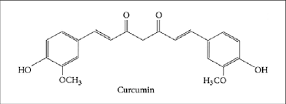

Turmeric :Curcuma longa **Scientific classification** Kingdom: Plantae (unranked): Angiosperms (unranked): Monocots (unranked): Commelinids Order: Zingiberales

Family: Zingiberaceae

Genus: Curcuma

Species: C. longa

Binomial name : ***Curcuma longa Linnaeus[1]***

Turmeric (Curcuma longa) is a rhizomatous herbaceous perennial plant of the ginger family, Zingiberaceae which is native to tropical South Asia. It needs temperatures between 20°C and

30°C, and a considerable amount of annual rainfall to thrive. Plants are gathered annually for their rhizomes, and re-seeded from some of those rhizomes in the following season.

**Biological source**-it is derived rhizome plant.

**Family**-zingiberene

**Chemical constitute**- curcuma longa

**Medicinal uses**-as an anti- oxidant treat arthritis used for cancer treatment improve the liver function.

It is an anti-microbial and acts bacteriostatic and bacteriosidal.it also use the ulceration, and also used the inflammation.

**Formula-** C21H20O6

### Structure -

It is often misspelled (or pronounced) as tumeric. It is also known as kunyit (Indonesian and Malay), Besar (Nepali) or haldi or pasupu in some Asian countries. In Assamese it is called Halodhi. In medieval Europe, turmeric became known as Indian Saffron, since it is widely used as an alternative to far more expensive saffron spice.

Its rhizomes are boiled for several hours and then dried in hot ovens, after which they are ground into a deep orange-yellow powder commonly used as a spice in curries and other South Asian and Middle Eastern cuisine, for dyeing, and to impart color to mustard condiments. Its active ingredient is curcumin and it has an earthy, bitter, peppery flavor and a mustardy smell.

Sangli, a town in the southern part of the Indian state of Maharashtra, is the largest and most important trading centre for turmeric in Asia or perhaps in the entire world.

### Usage : Commercially packaged turmeric powder

In non-Indian recipes, turmeric is sometimes used as a coloring agent. It has found application in canned beverages, baked products, dairy products, ice cream, yogurt, yellow cakes, orange juice, biscuits, popcorn color, sweets, cake icings, cereals, sauces, gelatins, etc. It is a significant ingredient in most commercial curry powders.

Turmeric (coded as E100 when used as a food additive) is used to protect food products from sunlight. The oleoresin is used for oil-containing products. The curcumin/polysorbate solution

or curcumin powder dissolved in alcohol is used for water containing products. Over-coloring, such as in pickles, relishes and mustard, is sometimes used to compensate for fading.

In combination with annatto (E160b), turmeric has been used to color cheeses, yogurt, dry mixes, salad dressings, winter butter and margarine. Turmeric is also used to give a yellow color to some prepared mustards, canned chicken broths and other foods (often as a much cheaper replacement for saffron).

Turmeric is widely used as a spice in South Asian and Middle Eastern cooking. Momos (Nepali meat dumplings), a traditional dish in South Asia, are spiced with turmeric.

### Turmeric rhizome

It is only in recent years that Western scientists have increasingly recognised the medicinal properties of turmeric. According to a 2005 article in the Wall Street Journal titled, "Common Indian Spice Stirs Hope," research activity into curcumin, the active ingredient in turmeric, is exploding. Two hundred and fifty-six curcumin papers were published in the past year according to a search of the U.S. National Library of Medicine. Supplement sales have increased 35% from 2004, and the U.S. National Institutes of Health has four clinical trials underway to study curcumin treatment for pancreatic cancer, multiple myeloma, Alzheimer's, and colorectal cancer.

### Cosmetics

Turmeric is currently used in the formulation of some sunscreens. Turmeric paste is used by some Indian women to keep them free of superfluous hair. Turmeric paste is applied to bride and groom before marriage in some places of India, Bangladesh, and Pakistan, where it is believed turmeric gives glow to skin and keeps some harmful bacteria away from the body.

### Clove oil

**Plant profile – Clove Cloves** are the aromatic flower buds of a tree in the family Myrtaceae, ***Syzygium aromaticum***. They are native to the Maluku Islands (or Moluccas) in Indonesia, and are commonly used as a spice.[2] Cloves are available throughout the year owing to different harvest seasons in different countries.[3]

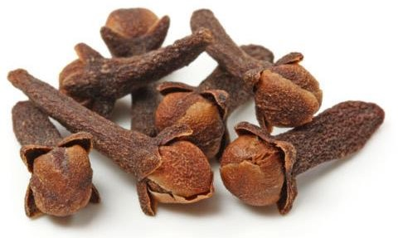

Cloves, a popular cooking spice and important Ayurvedic herb, are the dried flower buds of the Syzygium aromaticum tree, originally native to Indonesia. It is called lavaṃga in Sanskrit.

The very distinctive flavor and aroma of clove buds comes mainly from the compound eugenol, which constitutes up to 90% of the essential oil of clove. Eugenol is also present in and contributes much to the flavor, aroma and medicinal properties of Tulsi, Cinnamon, Nutmeg, and Bay leaf.

As an Ayurvedic herb, Cloves act as a strong kaphahara (herbs which reduce the kapha dosha) and also bring balance to the vata dosha. While being gently warming, increasing the circulation and metabolism and stimulating agni (digestive fire), it does not generally aggravate the pitta dosha unless taken in excess.

### It is an astringent herb with a distinctive pungent taste, classified according to the following properties:

* antiseptic (anti-microbial)
* anaesthetic (pain-relieving)
* carminative (gas-relieving)
* antispasmodic (cramp-relieving)
* antiemetic (nausea-relieving)
* expectorant (congestion-relieving)

Modern medicinal research has focused on investigating the powerful potential of Cloves for pain-relief, including toothaches, reducing oral pathogens and gingivitis and boosting insulin and lowering blood sugar in people with diabetic conditions, among other potential uses.

The beneficial properties of Cloves come in many different forms: it can be used in cooking or as a beverage spice or in tea, as a powder, and as an essential oil, either applied by itself or used in multi-herb formulas in toothpastes, mouthwashes, massage oils or balms and throat lozenges.

### Scientific classification

Kingdom: Plantae *Clade:* Tracheophytes *Clade:* Angiosperms *Clade:* Eudicots *Clade:* Rosids

Order: Myrtales Family: Myrtaceae Genus: *Syzygium* Species: ***S. aromaticum***

**Binomial name : *Syzygium aromaticum*** (L.) Merr. & L.M.Perry

**Biological source**-It is found in a variety of plant including clove bud, cinnamon bark.

**Family**- Allyl- chain -substituted guaiacol.

**Chemical constitute**- Eugenol.

### Medicinal uses-

* Using as a topical antiseptic.
* Using in a dental preparations with zinc oxide for root canal sealing and pain control .
* Promoting hair growth and repairing damaged hair .
* Eugenol is a colorless to pole yellow aromatic oily liquid it acts an antiseptic and antibacterial agent.

**Formula** - C10H12O2

### Structure –

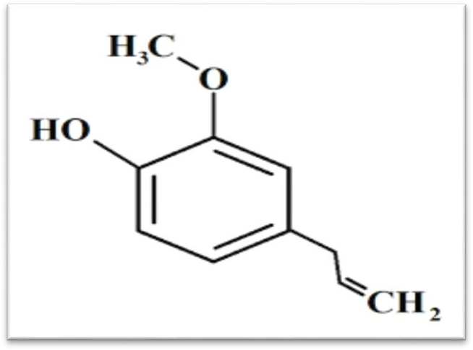

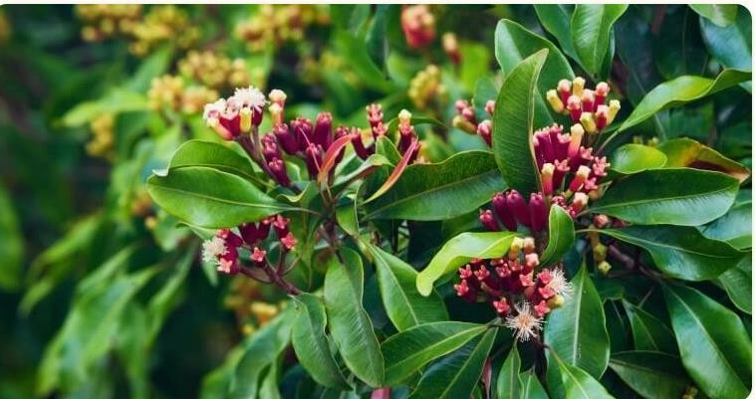

**Potential medicinal uses and adverse effects**

Long-used in traditional medicine, there is evidence that clove oil containing eugenol is effective for toothache pain and other types of pain, and one review reported efficacy of eugenol combined with zinc oxide as an analgesic for alveolar osteitis.] Studies to determine its effectiveness for fever reduction, as a mosquito repellent, and to prevent premature ejaculation have been inconclusiveIt remains unproven whether blood sugar levels are

reduced by cloves or clove oil. Use of clove for any medicinal purpose has not been approved by the US Food and Drug Administration, and its use may cause adverse effects if taken orally by people with liver disease, blood clotting and immune system disorders, or food allergies.

### Traditional medicinal uses:

Cloves are used in traditional medicine as the essential oil, which is used as an anodyne (analgesic) mainly for dental emergencies and other disorders.[11] The essential oil is used in aromatherapy

### Honey –

**Biological source** – Honey is a natural product farmed from nectar of flowers by honeybees.

**Family**- Apidae.

**Chemical constitute** – Glucose, sucrose, fructose, maltose.

**Medicinal uses** – Traditionally honey is used in the treatment of eye diseases bronchial asthma, throat infection tuberculosis, ulcers, and use as a nutritional supplement .

**Formula**- C6H12O6

### Stucture-

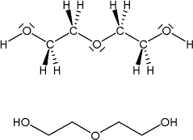

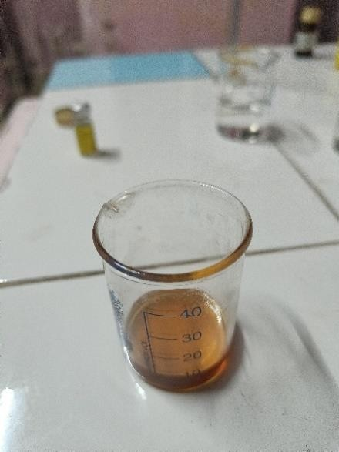

**Peppermint oil** –

**Biological source**- It is extract from the leaves stem and flower.

**Family** – Lamiaceae.

**Chemical constitute**- Menthol.

**Medicinal uses –** Peppermint is promoted of irritable bowel syndrome, the common cold , sinus infections and other conditions peppermint is an aromatic herbs that used for both culinary product medicinal its native to Asia and Europe, and its kill and bad bacteria keeps teeth gums healthy.

**Formula** - C10H20O

### Structure –

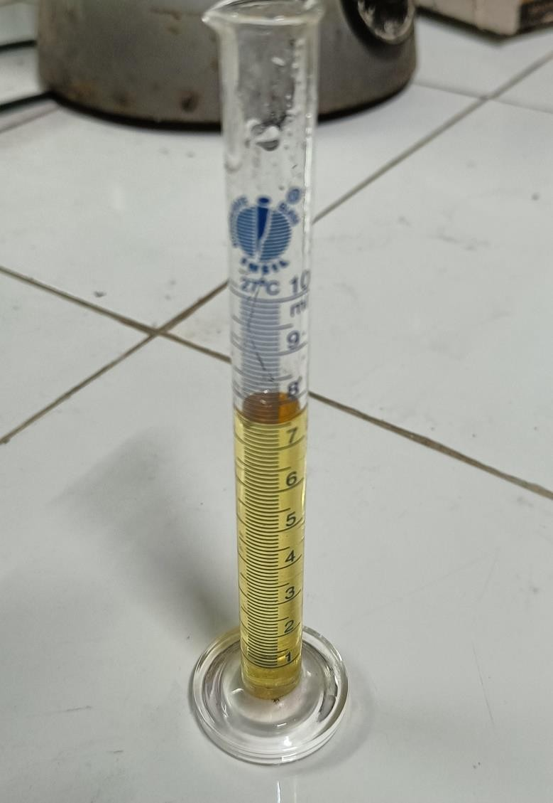

**CHAPTER-5 EXPERIMENTAL WORKS**

**MATERIALS AND METHOD**

**Collection of Plant Sample**

**Ingredient table** –

**List of ingredients** -

|  |  |  |  |
| --- | --- | --- | --- |
| Sr.N. | ingredients | Chemical constitute | uses |
| 1. |  | Curcuma longa | anti-microbial ,bacteriostatic  ,bactericidal. |
| 2. | Clove oil | Eugenol | Dental analgesic ,fight bad breath stimulate circulate. |
| 3. | Honey |  | Anti-inflammatory ,anti-oxidant and anti-bacterial agent. |
| 4. | Peppermint oil | menthol | It gives fragrance ,Anti-viral |
| 5. | Salt |  | Preservative |

|  |  |  |  |
| --- | --- | --- | --- |
| 6. | Distilled water |  | q . s. |

**MATERIALS AND METHODS-**

**Materials –**

**Table:- List of materials:-**

|  |  |
| --- | --- |
| **Sr**.**No**. | **Materials** |
| 1. | Turmeric |
| 2. | Clove |
| 3. | Peppermint |
| 4. | Honey |
| 5. | Salt |
| 6. | Distilled water |

**Table**:- **List of Equipment-**

|  |  |
| --- | --- |
| **Sr.No.** | **Equipment** |
| 1. | Beaker |
| 2. | Measuring cylinder |
| 3. | Heating mental |
| 4. | Weighing machine |
| 5. | Mortar pestle |
| 6. | RB flask |

* **Preparation of herbal mouthwash**

three main extract of the herbal mouthwash turmeric ,clove and peppermint.

And other ingredient use the as a minor ingredient salt and honey ,salt as using the preservative and honey use a sweetening agent improving taste.

For the formulation the mouthwash obtained the powder form

### Soxhlet method

* **Procedure-** turmeric extract curcumin by using Soxhlet method. Take a turmeric 40g accurately wait using weaining machine.

Prepare solution of ethanol and distilled water 100ml

### Working procedure

1. Solid material placed in thimble.
2. Soxhlet extractor is placed flask containing the extraction solvent.
3. The solvent is heated to reflux.
4. The solvent vapour travel up a distillation arm and floods the chamber housing the thimble of solid.
5. Solid material in chamber slowly fills warm solvent.
6. Desired compound dissolves in the warm solvent.
7. When the Soxhlet chamber is almost full, the chamber by the siphon. the solvent running back to the distillation flask.
8. This cycle may be allowed to repeated many times, over hours.
9. During each cycle a portion of the non-volatile compound dissolved in the solvent.
10. After many cycles the desired compound is concentrate in the distillation flask .the advantage of the system is that inlead of many portion of being passed through just care batch of solvent of recycling
11. After extraction the solvent is removed typically by mean of the rotatory evaporate yielding the extraction compound . The non soluble portion of the extraction solid remain in the thimble . And usually discarded.
12. For the formulation the mouth wash herbal ingredient were ground to obtained there powder form.
13. Each ingredient were separately soaked into the distilled water and incubated .
14. After incubation ,the herbal extract were filtered.
15. The extract were then boiled separately and left to cool.
16. Each minor ingredient were added separately into distilled water.
17. After the ingredient extract cool down, and minor and major mixed ingredient were mixed following the formulation table.
18. Finally prepare the formulation of the different different formulation.

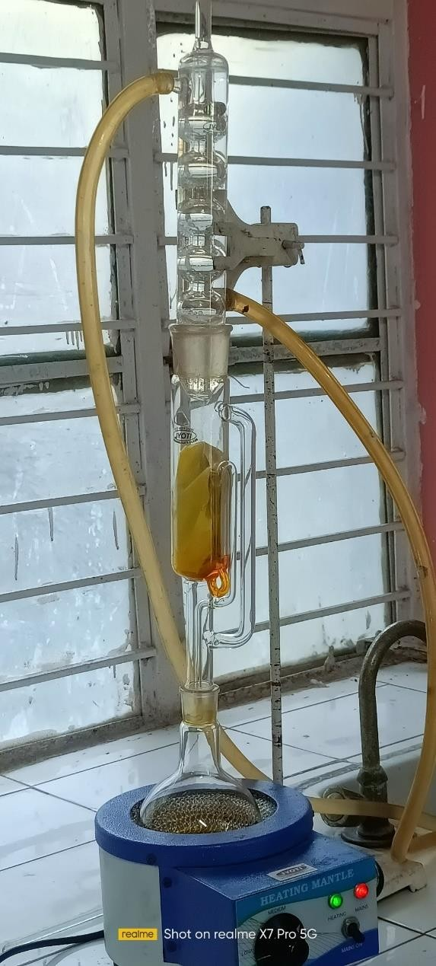

five different formulation of mouthwash

### Formulation table Apparatus:

* + Sterile Petriplates
  + Test tubes
  + Conical flask
  + Whattmann filter paper
  + Incubator
  + Autoclave
  + Laminar air flow
  + Pippetting device
  + Hot air-oven

### Pre-Formulation

**Organoleptic Properties**

The organoleptic quality of a Natural substance refers to its appearance, odour, colour, and taste. The study's first stage is to characterize these features, which assists in the primary identification of the Natural substance as well as estimating the probability of patient acceptability of the raw materials odour, taste, and colour, as well as its probableinclusion in the final dose form. Changes in the colour and odour of the raw material in the formulation might sometimes indicate changes in the formulation's stability (under identical conditions).

### Solubilities

Solubility is defined as the ability of the substance to soluble in a solvent. One gram of the powder is weighed accurately and transferred into a beaker containing 100 ml of water. This was shaken well and warmed to increase the solubility. Then cooled and filter it, the residue obtained is weighed and noted.

|  |  |  |  |  |  |  |
| --- | --- | --- | --- | --- | --- | --- |
| **sr**.**no** | **ingredient** | **F-1**  **ml** | **F-2 ml** | **F-3 ml** | **F-4 ml** | **F-5 ml** |
| 1. | turmeric | 1 | 2 | 4 | 3 | 5 |
| 2. | clove | 1 | 1 | 1.5 | 2 | 2.5 |
| 3. | peppermint | 3.5 | 2.5 | 1.5 | 2 | 1 |
| 4. | honey | 5 | 6 | 7 | 9 | 10 |
| 5. | salt | 0.05 | 0.05 | 0.08 | 0.06 | 0.04 |
| 6. | Distilled water | 30 | 29 | 25 | 23 | 21 |
| 7. | Total volume | 40 | 40 | 40 | 40 | 40 |

### ATR-FTIR Spectra Analysis

The spectrum was captured between the wavelengths of 4000 and 400cm-1. An ATR-FTIR spectrum was obtained using an ATR-FTIR spectrophotometer after a sample was directly put into the cavity of the sample holder.

### Compatibility Studies

**Physical Compatibility Studies**

The physical mixture of drug and excipient was retained in a Petri dish and exposed to storage at normal temperature and high temperature in a stability chamber at 45°C/75 % RH for a weak. Following a weak, the samples are examined for any physical changes such as discoloration, odour, etc.,

### Chemical Compatibility Studies

These compatibility studies are conducted by using an ATR-FTIR spectrophotometer and the spectrum was recorded in the wavenumber region of 4000 to 400cm-1. Natural oils and excipients were mixed well by using the mortar untilcomplete mixing. Then collect the sample from mortar and placed in the cavity of the sample holder and the spectrum was recorded.

### Procedure For Mouthwash

**Procedure**

Weighted quantity of each ingredient will be taken. Extract were taken mixed thoroughly in mortar and pestle properly with small quantity of water. All other remaining ingredient will be gradually added with good mixing. Drop by drop clove oil will be added and mixed properly taking care to avoid lump formation. PEG 40 and Glycerol will then be added drop by drop and mixed well. Finally, water added to make volume and preservative will be added and the product will be packed in an attractive, well closed container. The composition of herbal mouth wash shown in the table no:1

### Evaluation Of Studies for Prepared Formulations

Various physicochemical parameters which are mentioned below were performed to establish quality of the prepared formulations.(12-19)

### Determination of pH test

The pH of all the prepared formulations was determined by using Digital pH Meter. The formulations were dissolved in 100 ml of distilled water and stored for two hours. The measurement pH of formulation was done in previously calibrated pH meter.(12-19)

### Irritancy test:

The irritancy test was performed on the herbal formulation .There is no redness or irritancy in the preparation .The condition was seen for 24 hrs.

### Washabilty

The formulation test was performed on the herbal and the ease with which it could be washed with water was tested.

### Foam ability

For the determination of the herbal for its ability to form foam about 1.0gm of mouthwash was taken and was dissolved in distilled water (about 50ml) in 100ml graduated measuring cyclinder .It the measuring cyclinder was taken shaken for about 10 min .Foam height was measured after 10 minutes. Record the observation for five consecutive experiments and the mean was taken.

### Stability test Introductions

Stability of a drug can be define as the time from the date of manufacture and the packaging of the formulation, untilits chemical or biological activity is not less than a predetermined level of labeled potency and its physical characteristics have not changed appreciably or deleteriously. In any design and evaluation of dosage forms for drugs, the stability of the active component must be a major criterion in determining their acceptance or rejection.

## CHAPTER-6 RESULT AND DISCUSSION

### Determination of Organoleptic Characteristics:

The organoleptic quality of a Natural substance refers to its appearance. odour, colour. and taste. The study's first stage is to characterize these features, which assists in the primary identification of the Natural substance as well as estimating the probability of patient acceptability of the raw materials odour, taste and colour as well as its probable inclusion in the final dose form. Changes in the colour and odour of the raw material in the formulation might sometimes indicate changes in the formulation's stability (ander identical conditions).Therefore a soap containing a combination of surfactant is necessary.

### Solubility

Solubility is defined as the ability of the substance to soluble in a solvent. One gram of the powder is weighed accurately and transferred into a beaker containing 100 ml of water. This was shaken well and warmed to increase the solubility. Then cooled and filter it, the residue obtained is weighed and noted

### ATR -FTIR Sprctra Analysis

The spectrum was captured between the wavelengths of 4000 and 400cm-1. An ATR- FTIR spectrum was obtained using an ATR-FTIR spectrophotometer after a sample was directly put into the cavity of the sample holder. The result shown in the fig no: 1

### Compatability studies Physical compatibility studies

The physical mixture of drag and excipient was retained in a Petri dish and exposed to storage at normal temperature and high temperature in a stability chamber at 45°C/75 % RH for a weak Following a weak. the samples are examined for any physical changes such as discoloration, odour. etc..

### Chemical compatibility studies

These compatibility studies are conducted by using an ATR-FTIR spectrophotometer and the spectrum was recorded in the wavenumber ragion of 4000 to 400cm-1. Natural oils and

excipients were mixed well by using the mortar until complete mixing. Then collect the sample from mortar and placed in the cavity of the sample holder and the spectrum was recorded. The result shown in the fig no: 2

### Determination of pH test :

The pH of all the prepared formulations was determined by using Digital pH Meter. The formulations were dissolved in 100 ml of distilled water and stored for two hours. The measurement pH of formulation was done in previously calibrated ph meter. The result shown in the table no: 2

### Irritancy*:*

The skin irritancy test was performed on the herbal formulation .There is no redness or irritancy in the preparation

.The condition was seen for 24 hrs. The result shown in the table no: 3

### Foam ability:

For the determination of the herbal for its ability to form foam about 1.0gm of mouthwash was taken and wasdissolved in distilled water (about 50ml) in 100ml graduated measuring cyclinder. The result shown in the table no: 4

### Retention time of foaming

Foam retention time refers to the time for which the foam produced by the soap retains. The above procedure was repeated and the foam internal was measured for about 5-10 minutes. The result shown in the table no: 5

### Stability studies

Stability studies were performed in accordance with ICH guidelines for accelerated testing with required modifications. The sample taken formulation was taken and kept at room temperature (30± 2°C) as well as refrigerator (4+2°C) for duration of one month. The samples were tested for their physical appearance, pH, viscosity,% cleaning action. The result shown in the table no: 6

### Tabel.No: 1 Composition of formulation table

|  |  |  |  |  |  |
| --- | --- | --- | --- | --- | --- |
| INGREDIENTS | FORMULATION CODE | | | | |
| F1 | F2 | F3 | F4 | F5 |
| Turmeric | 10gm | 10 gm | 10gm | 10gm | 10gm |
| Clove | 5gm | 5gm | 5gm | 5gm | 5gm |
| Cinnamon | 2 gm | 2gm | 2m | 2gm | 2gm |
| Liquorice | 5gm | 5gm | 5m | 5gm | 5gm |

**Table.no: 2 Determination of pH test**

|  |  |
| --- | --- |
| Formulation.No: | pH Range |
| F1 | 5.1 |
| F2 | 5.3 |
| F3 | 5.5 |
| F4 | 5.4 |
| F5 | 5.6 |

**Table .no: 3 Determination of irritant**

|  |  |
| --- | --- |
| Formulation.No: | Skin irritant |
| F1 | Non-irritant |
| F2 | Non-irritant |
| F3 | Non-irritant |
| F4 | Non-irritant |
| F5 | Non –irritant |

**Table.no : 4 Determination Foam forming ability**

|  |  |
| --- | --- |
| Formulation.No: | Foam index |
| F1 | 25cm |
| F2 | 20cm |
| F3 | 16.5cm |
| F4 | 10cm |
| F5 | 8cm |

**Table.no :5 Determination of Retension time of foam**

|  |  |
| --- | --- |
| Formulation.No: | Retension time |
| F1 | 15 minutes |
| F2 | 13minutes |
| F3 | 10 minutes |
| F4 | 6minutes |
| F5 | 5minutes |

**Table .No: 6 Determination of stability studies**

|  |  |  |
| --- | --- | --- |
| Parameters | Initial | After one month 40/75(0c/RH) |
| Apperaence | Penny brown | Penny brown |
| pH | 5.5 | 5.6 |
| Foam index | 16.5cm | 15cm |
| Foam retension time | 10mins | 8mins |
| irritant | Non irritant | Non irritant |

**CHAPTER-7 SUMMARY & CONCLUSION**

Herbal formulations are also safe to use as a gargle because their systemic availability in trace amounts has no negative consequences. The current liquid herbal mouthwash can go a long way toward assisting folks in overcoming foul breath and a variety of dental ailments. Furthermore, we may rest confident and take comfort in the fact that this meal contains no unhealthy substances. The findings of the physicochemical examination show that the colour and odour of the current herbal formulation are acceptable, with a pleasant odour and better after effects. The zone of inhibition data also revealed that this herbal mouth rinse was proven to be an effective plaque inhibitor, and that the patients favoured it because of its taste, ease of use, and test duration in their mouth after rinsing. As a result, these can be utilised in conjunction with mechanical therapy to cure plaque.The current study has a significantimpact on the development of an effective and low-cost herbal oral health intervention for low- income areas. However, because this was a short-term study, longer trials with larger samples are required. The natural herbs included in this formulation have been shown to help with oral hygiene. These herbs have been proven to work miracles for years and decades, as evidenced by several research findings. This herbal mouthwash can be used to quickly rinse one's mouth and keep one's mouth free of a variety of oral health disorders.

## REFERENCE

1. Jha B., Dodwad V., Herbal Mouthwashes – A Gift of Nature‟ Int. J. Sci, 2012; 3(2): 48- 53.
2. Shubhangi E S, Monali D T,Journal of scientific and innovative research, 2016; 5(4): 149- 151.
3. Sujith S N, Molly M, Sereena K. Int. J.of Pharm. And Clin. Sci, 2012; 1(4): 1362-1368.
4. Bornare Pratiksha S, Deokar Trupti D,Shinde Aishwarya A, Musmade Dipak S. Formulation and evaluation of herbal neem soap. International journal of medicine research,2021;6(1):09-12.
5. Mondal S, Kolhapure SA. Evaluation of the antioidentefficacy and safety of Pure Hands herbal hand sanitizer in hand hygiene and on inanimate objects. The Antiseptic. 2004; 101(2):55-57.
6. Joshi MG, KamatDV, Kamat SD. Evaluation of herbal handwash formulation. Natural Products Radiance. 2008;7(5):413-415.
7. Marjorie MC. Plant products as antioidentagents, Clinical Microbiology Reviews. 1999; 12(4):564-582.
8. Luximon RA, Bahroun T, Soobrattee MA, Aruoma OI. Antioxidant activities of phenolic, proanthocyanidins, and flavonoid components in extracts of Cassia fistula.Journal of Agriculture and Food Chemistry. 2002; 50:5042-5047.
9. Souwalak P, Nongyao P, Vatcharin R, Metta O. Antifungal activity from leaf extracts of Cassia alata L, Cassia fistulaL, and Cassia toraL. Journal of Science and Technology. 2004; 26(5):741-748.
10. Priya S, Zeeshan A, Salma K, Bhuvaneshwari, International Journal of Pharma World Research. 2010; 1(2):1-19.
11. Simin SK, Usmanghani M, Shaiq A, Viqaruddin A. Chemical constituents from the seeds of Pongamiapinnata,.Pakistan Journal of Pharmaceutical Sciences. 1996; 9(1):1120.
12. Arote SR, Dahikar SB, Yeole PG. African Journal of Biotechnology. 2009; 8(22):6393- 6396.
13. G. Sucharita , V. Ganesh ,etal. Formulation and Evaluation of Poly Herbal Anti BacterialSoap.IJESC;2020;10(8);27165-173