**AN EMPIRICAL STUDY ON VIOLENCE AGAINST WOMEN**

**Author**

P.Jerald Matthew

Reg No: 131602051

BBA.LLB (HONS)

Saveetha School Of Law

Saveetha Institute Of Medical And Technical Sciences(SIMATS)

Saveetha University

Chennai-600 077

**Co-Author**

Mrs.K.Niranjana

Assistant Professor

Saveetha School Of Law

Saveetha Institute Of Medical And Technical Sciences(SIMATS)

Saveetha University

Chennai-600 077

**AN EMPIRICAL STUDY ON VIOLENCE AGAINST WOMEN**

P.JERALD MATTHEW[1]

K.NIRANJANA[2]

**ABSTRACT :**

Violence against women has for quite some time been an issue, in the midst of harmony and war. This violenceranges from exceptionally gentle prodding to assault and murder, and happens at home, in the roads, at working environments, prisons, in short all over. Barely any violations against ladies are accounted for, less still prosecuted,and a careless number of charged are really rebuffed. Without even a trace of definite examinations on rate, it is challenging to concoct ideas to diminish in the event that not nullify such viciousness. There Is a critical requirement for additional investigations on this savagery so the brain science of the violators is better perceived. Examples of savagery should be entirely researched, and available resources to decrease their occurrence. There is need for speedy and extreme discipline for the accused,which would go about as an impediment as well. Any general public, wherein a portion of the populace isn't guaranteed ofsafety, requirements to reevaluate its case to being civilised.Key Words: Ladies, brutality, assault, security, violations In concentrating on viciousness, we experience various issues, the first being that we truly don't have any idea what ought to be considered savagery against ladies and what shouldn't. Beginning from basic thankful looks, to the last most savage wrongdoing, we are don't know where to take a stand. What might give off an impression of being straightforward prodding to a gathering of school young men dillydallying close to their bottle might significantly affect the person in question. All things considered, not all young ladies can endure prodding in a similar way.

**Keywords : violence, women security,rape,punishment,crime**

**INTRODUCTION**

The year finishing of 2012 brought back to numerous Indians the distinct truth of wrongdoing against womenin our country. The fierce assault of the 23 year old understudy in Delhi, and the annoyance that shook thecountry brought into concentrate such violations, which had seldom contacted the existences of normal people.For north of about fourteen days, the news took the middle space in the lounges of most families in India,and shook the heart of individuals as never before.The government comprised the Equity Verma Commission, which presented its report in arecord time, giving suggestions on different parts of wrongdoings against ladies (Verma, Sethand Subramanium 2013).The government additionally requested quick track courts to be gotten up positioned attempt thesecases and a portion of the most optimized plan of attack courts have begun working. The effect of these affirmativeactions will ideally prompt a decrease in wrongdoings against ladies, which is yet to be seen.However it is the ideal opportunity for us all to look at different parts of such violations from a scientificperspective to get familiar with them, to help diminish on the off chance that not cancel them completely.Violence against ladies is an infringement of common liberties; it is neither perpetual nor inevitableand could be fundamentally diminished, and ultimately wiped out (Investigation of the Secretary General 2006).There are three parts of this wrongdoing which the general public necessities to deal with, the principal beingprevention of assault. The second significant obligation of the general public is delicate administration ofvictim after the wrongdoing (Azikiwe, Wright, Cheng and D'Angelo 2005), and ultimately discipline ofthe culprit of the wrongdoing. It is many times contended that counteraction of assault requires a change in themindset of the general public and can't be achieved right away; the second and third viewpoints arewell inside quick reach.Specialists in various fields are effectively concentrating on different parts of viciousness against women.One finds an enormous collection of information being distributed every year which assists us with understanding what others have realized through lengthy exploration. While gathering data on brutality against ladies onepoint goes over unequivocally, and that is there isn't sufficient exploration done on the subject.When one goes through the data sets, one is struck by the scarcity of information on viciousness againstwomen, everywhere. Of the 19,708 diaries recorded by SCImago, simply 81 are dedicated to orientation studies, while 114 are given to man-made brainpower and 113 to humanities. Consequently notonly are ladies' issues consigned to a dark spot, very few are keen on considering these,including themselves.In this paper, we have sorted out the different issues connected with savagery against women's.

**OBJECTIVES:**

* To determine the prevalence, characteristics and reasons of domestic violence reported against adult and adolescent females.
* To determine the socio-demographic correlates of domestic violence, if any.
* To find out the perceptions of the females to cope with the act of violence and to overcome the situation.

**REVIEW OF LITERATURE:**

**C Garcia-Moreno(2012)**

Violence against Women defines violence against women as any act of gender-based violence sexual or psychological harm or suffering to women, including threats of such acts.The results indicate that family pressures hinders the success of women entrepreneurs, and lack of education is a barrier to the success of women entrepreneurs.

**Fortunate Mandipaka(2011)**

This research investigates the challenges that are faced by women entrepreneurs in King Williams Town, South Africa, which can be generalised to developing countries as well. Some objectives of the study were to determine whether lack of education is a barrier to the success of women entrepreneurs, also, whether being unexposed to markets hinder the success of women entrepreneurs and women entrepreneurs are discriminated against in a male dominated society .

[**Agholor Ewere Deborah**](https://www.tandfonline.com/author/Deborah%2C+Agholor+Ewere)**(2017)**

The operations of women entrepreneurs are not well understood and have rarely been addressed internationally.[(Nawaz)](https://paperpile.com/c/SU0a49/QIzx)The aim of this paper is to establish a base level of understanding of the operational core values of women entrepreneurs in Nkonkobe Municipality in the Eastern Cape Province. Survey was conducted on 50 women.

[**Swati**  **Panda**](https://www.emerald.com/insight/search?q=Swati%20Panda)**(2018)**

Constraints faced by women entrepreneurs in developing countries arise from gender discrimination, work-family conflict, difficulty in raising capital, lack of infrastructure, unstable business[(Guelich et al.)](https://paperpile.com/c/SU0a49/Pmc0), economic and political (BEP) environments, lack of training and education and personality differences. The study suggests that in addition to financial constraints, unstable BEP environments need to be addressed as top priorities.

**Rathna.C(2016)**

The motivational factors indicate that financial need motivates women to the highest degree to become entrepreneurs compared to other factors like supplementing the family income, improving social status, etc.[(Joison et al.)](https://paperpile.com/c/SU0a49/pLgY) Further, the study has used the Rotated component Matrix to factorise the important motivational factors.

**Kavita Sangolagi(2016)**

Women Entrepreneurship and Women empowerment are considered as an important tool in eradicating poverty and unemployment.Now a day’s Women empowerment has become a buzzword**.**[(Liu et al.)](https://paperpile.com/c/SU0a49/HYE7) Empowerment of women may not be feasible just by creating employment opportunities for them. The need of the hour is to inspire them to set up their own enterprises.

**Anitha D.Pharm(2013)**

Women have been successful in breaking their confinement within the limits of their homes by entering into varied kinds of professionals and services. Women entrepreneurs have proved to be on par with their men counterparts in business acumen and are emerging as smart and dynamic entrepreneurs. [(Anitha and Raynukaa)](https://paperpile.com/c/SU0a49/2Q9x)There are many reasons for women to enter into entrepreneurial ventures in a predominantly society.

**AmanDeep Singh(2013)**

Women are generally perceived as home makers with little to do with economy or commerce. The topic of women in entrepreneurship has been largely neglected both in society in general and in the social sciences. [(Singh and Amandeep)](https://paperpile.com/c/SU0a49/W01D)Not only do women have lower participation rates in entrepreneurship than men but they also generally choose to start and manage firms in different industries than men tend to do. The transition from homemaker to sophisticated business woman is not that easy. But this picture is changing. In Modern India

**Hafiz Ullah(2012)**

Entrepreneurship is about devising and implementing new ideas and practices or improving old ones. It is entrepreneurship that converts an innovation into a sustainable enterprise that generates value. [(Anitha and Raynukaa)](https://paperpile.com/c/SU0a49/2Q9x)An enterprise is ―any entity, new or existing, that provides a new product or service or that develops and uses new methods to produce or deliver existing goods and services at lower cost. Entrepreneurs innovate new ways of manipulating nature, and new ways of assembling and coordinating people.

**Siddiqui.A.B(2014)**

Some of the major problems identified are women's family obligations, Gender inequality, Problem of Finance, Low-level risk taking attitude, and the male - female competition **.**[(Tuteja et al.)](https://paperpile.com/c/SU0a49/SJEQ)The paper concludes that the problems of women entrepreneurs can be eradicated by appropriate training, incentives, encouragement and motivation, social recognition of their entrepreneurial abilities, and family’s moral support.

**Suriyamurthy.S(2009)**

As technology speeds up lives and the new millennium is now upon us, it is useful to take time to reflect on what will surely be one of the driving forces of the global economy of the 21st century. [(Sanchez et al.)](https://paperpile.com/c/SU0a49/6Nk0)Women are an emerging economic force that policymakers cannot afford to ignore. There are however a number of constraints to women owned businesses that need to be addressed. In overcoming these obstacles, there are actions to be taken by government, financial institutions and employers' organisations by working closely with women business associations.

**Fridah Muriungi(2012)**

The study sought to identify the challenges facing small scale women entrepreneurs in Kenya and initiatives put in place to counter the challenges.[(Williams)](https://paperpile.com/c/SU0a49/A5G0)The study employed desktop research. MSEs Baseline survey, recorded 612,848 women in Micro and Small Enterprises (MSEs) in Kenya, accounting for 47.4 per cent of all those in MSEs. The study showed that women tended to operate enterprises associated with traditional women’s roles, such as hairstyling.

**Elizabeth Chinomona(2015)**

Women are stepping up to own and run businesses in numbers that would have been hard to imagine a mere few decades ago. However, women entrepreneurs face a wide variety of challenges both in starting and in growing their business ventures. [(Chinomona and Chinomona)](https://paperpile.com/c/SU0a49/bB1s)The objective of this paper is to investigate the challenges women entrepreneurs face in the Gauteng province of South Africa. Exploring the challenges that women entrepreneurs face in South Africa, is of paramount interest to potential women entrepreneurs, researchers, the government of South Africa and other stakeholders.

[**Daphne Halkias**](https://www.emerald.com/insight/search?q=Daphne%20Halkias)**(2011)**With no or few significant differences shown to exist between male and female business owners or managers once they have already started an enterprise, there is a strong indication that Africa has sizable hidden growth potential in its women. [(Halkias et al.)](https://paperpile.com/c/SU0a49/mFUg)From the results presented, it is evident that female entrepreneurship in Nigeria is driven by micro‐financing as well as family dynamics that work to shape and influence the birth of a business.

**Selvamalar Ayadurai(2019)**

This study examines the “constraints” faced by women entrepreneurs in a war-torn area - the NorthEast of Sri Lanka; “constraints” here refers to factors limiting the growth and development of women entrepreneurship. [(Balmer et al.)](https://paperpile.com/c/SU0a49/aXny)The NorthEast of Sri Lanka is an area which has been ravaged by war for more than three decades now. The women entrepreneurs in the study are the “Tamil” women of Sri Lanka and not the greater majority of “Singhala” women which are more prevalent in the South.

[**Fara Azmat**](https://www.emerald.com/insight/search?q=Fara%20Azmat)**(2013)**

The paper reinforces earlier research that MWEs are not a homogeneous group; the problems they face are multifaceted, and MWEs from developing countries are the most disadvantaged of entrepreneurs. [(Kelly)](https://paperpile.com/c/SU0a49/Fl8l)It identifies multiple factors – human capital, culture, family, institutional factors, gender and social capital – as possible barriers for MWEs. Findings further indicate that among those barriers, culture, family, social capital and gender have the potential to play a dual role for MWEs, by acting either as a barrier or an enabler.

**Alicia Mas-Tur(2012)**

The main purpose of this paper is to examine the relation that exists between the skills possessed by women entrepreneurs and their motivations, barriers and performance. Thus, in the theoretical framework we review literature on some aspects that are related to the skills required of a business owner: level of education, previous occupational experience, and prior business expertise and management skills. The analysis undertaken shows that the lack of education and managerial skills of women business owners are two of the most important variables when it comes to understanding the motivations and the difficulties they have to face.

**Ahmad Nawaz(2018)**

Although there are big numbers of women entrepreneurs in Pakistan, and their percentage in the population is almost half 49.6%. They can play an important role in the economy. In Pakistan, most of the studies were on opportunities for the women in Pakistan.

**Olufemi Aladejebi(2020)**

Women Entrepreneurs play a significant role in the global economy in this 21st Century. The purpose of this study is to examine the specific challenges faced by women entrepreneurs in the southwestern states of Nigeria. Data were collected from businesses owned by women who reside within the six state capitals of Southwestern states of Nigeria. The cities are Lagos, Abeokuta, Ibadan, Oshogbo, Akure, and Ado-Ekiti. Similar big cities within each state were surveyed to increase the number of respondents for state capitals where a small number of questionnaires were retrieved.

[**Sumaira Aslam**](https://papers.ssrn.com/sol3/cf_dev/AbsByAuth.cfm?per_id=1744053)**(2014)**

The study might help the government regulators in addressing the problems of women entrepreneurs in Pakistan to take actions towards developing their performance and in turn to alleviate poverty from Pakistan.

**RESEARCH METHODOLOGY:**

The current study is based on empirical research. It consists of the legal frame of research. It began with the finding of research problems based on the review of literature. The major contribution of the study is to collect the legal facts of a particular area and to test the cause – effect relationship between variables. The research design is descriptive in nature. It explored the problem and provided the solution from the analysis. Convenience sampling method is used (Non probability sampling). The sample size is 200. Data is collected through the primary and secondary sources. Questionnaire is used as the primary data collection and the articles, journals, reports, newsletters are considered as the secondary sources. The analysis is done by using the SPSS 21 version.

**ANALYSIS:**

**FIGURE 1:**

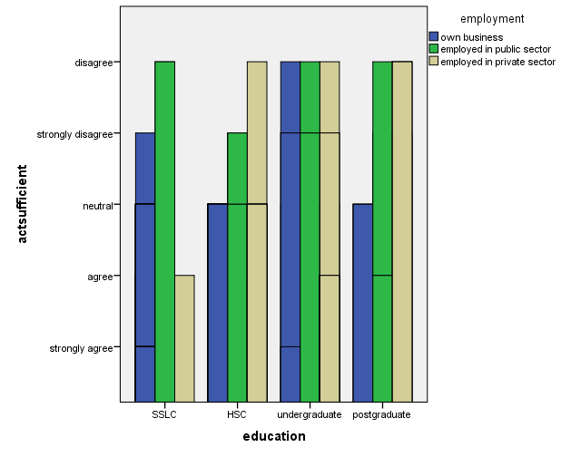

**LEGEND:** From the given graph it shows about the education and employment of the Respondents

**FIGURE 2:**

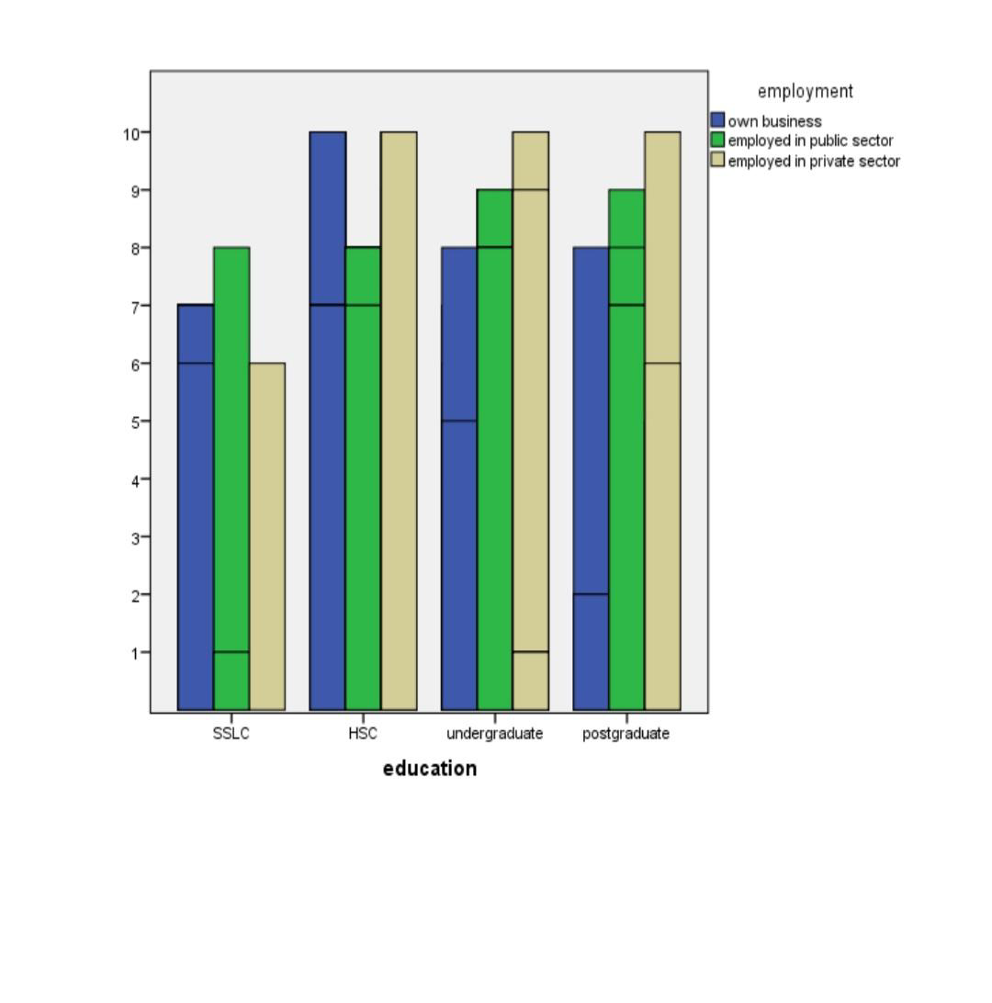

**LEGEND:** From the given graph it shows about the employment and education of the respondents

**FIGURE 3:**

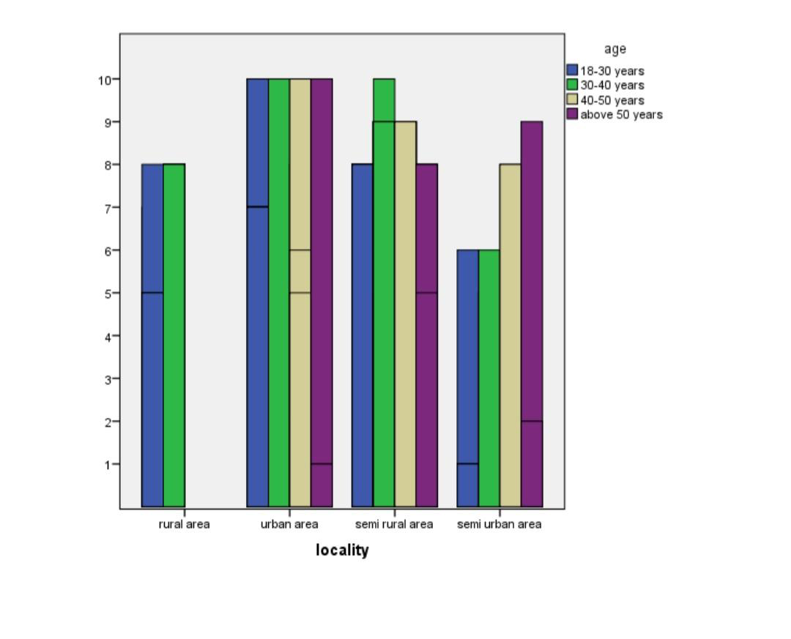

**Legend:** From the given graph it shows about the locality and age of the respondents

**FIGURE 4:**

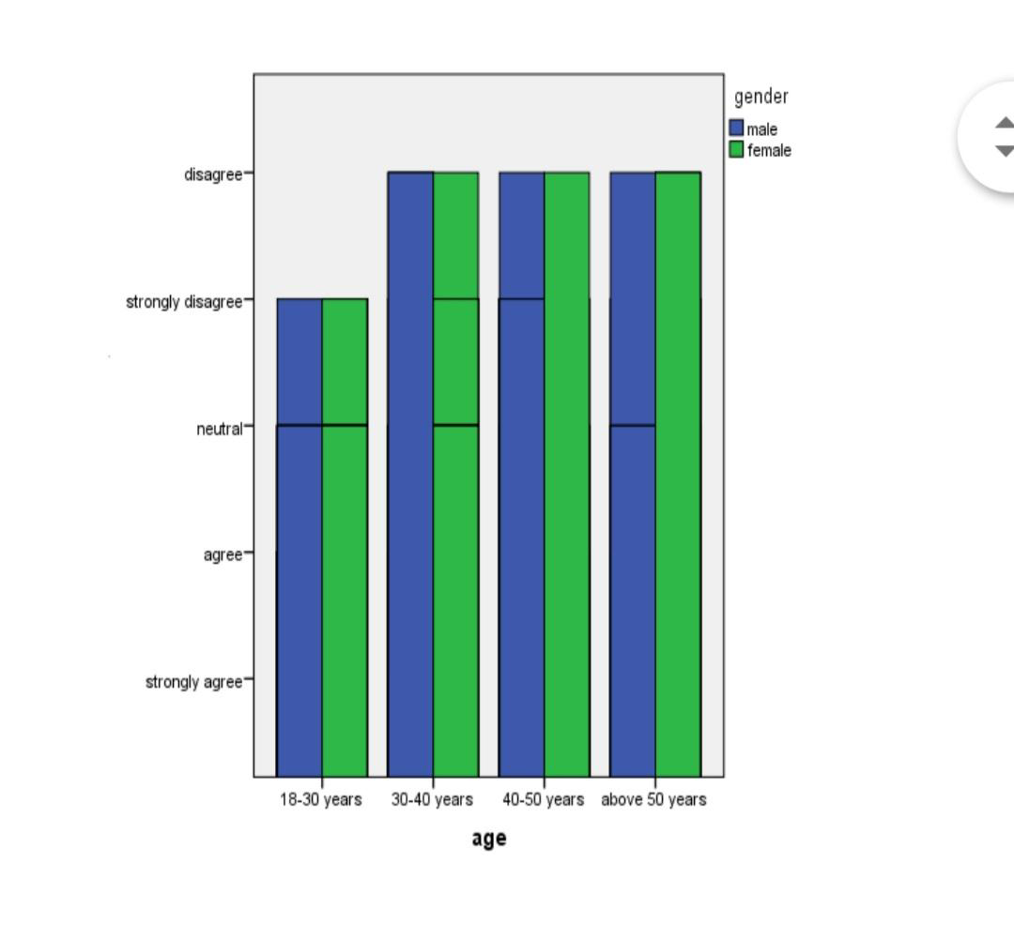

**Legend:** From the given graph it shows about the age and gender of the respondents

**FIGURE 5:**

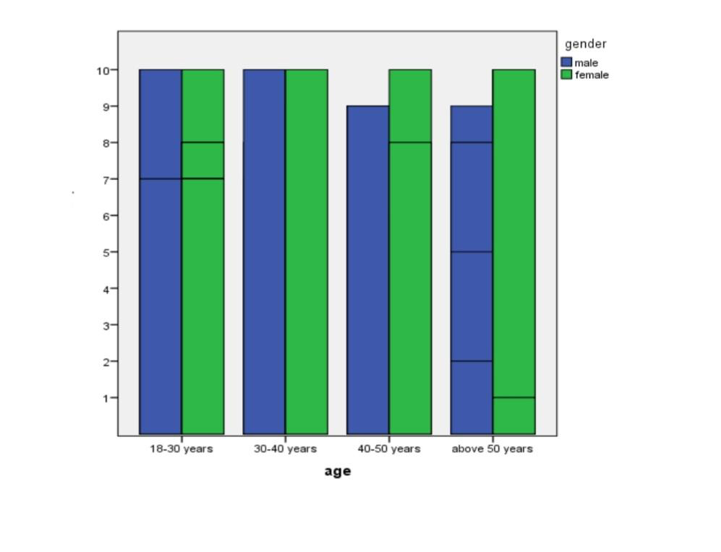

**Legend:** From the given graph it shows about the gender and age of the respondents.

**DISCUSSION:**

**Figure 1:**

From the given graph it is very clear that the UG students under the age group are accepting to that statemenr.Whereas the PG students under the age group of 26-35 had the least acceptance when compared to the other age group. The school students under the age group of 15 have less acceptance to the given statement.

**Figure 2:**

From the given graph it is very clear that the gender category and the occupation agree to that statement.The female respondents Under the UG group have more acceptance to the given statement when compared to Female respondents under the PG Sector Hence it is clear that the majority of the Respondents accepted the given statement.

**Figure 3:**

From the given graph it is very clear that the gender and occupation agree that the violence against women properly responses collected the ug students had the least acceptance when compared to the pg students .The female respondents under the Ug sector has less acceptance to the given statement when compared to the female respondents under the pg sector hence it is clear that the majority of the respondents accepted the given statement.

**Figure 4:**

From the given graph it is very clear that the hsc under the age group are more aware of the women .Whereas the age above 35 are not aware about the women entrepreneurs. The pg students under the age of 35 are aware about the women entrepreneurs and accepted by them in the friends circle.Hence it is clear from the given results that the majority of the respondents are aware of the crime against women.

**Figure 5:**

From the given graph the school students of sslc has been accepted the most of male centric nature forces them and the pg students has been accepted the least. And very few has been accepted the more and hence it is proved that the women in sectors are women friendly.

**SUGGESTION:**

The women are mostly affected due to violence against them in order to reduce the crimes against them the government has initiated many responsibilities towards the women by being safe from the violence. The government has initiated many acts and schemes in order to prevent women from the crime. The suggestion where made in order to protect the womens against the violence.

**CONCLUSION:**

In the current world the Public authority authorized and allowed different honors to the savagery against ladies. The discoveries made sense of that ladies are for the most part impacted by wrongdoings gnificantly more averse to rehash them,than those with past sexual convictions. Moreover guilty parties beyond 50 years old are less inclined to rehash the offense contrasted with more youthful wrongdoers. It was likewise found that the longeroffenders remained without offense locally, the more outlandish they are to re-affront sexually.It is encouraged that exhaustive examinations ought to be embraced at the earliest in India to give abasis to measures taken to battle this issue. It is just through research that one can trust toget understanding into the beginning of this and bear the cost of insurance to ladies. It is fundamental to give ladies a climate, where they are intellectually and genuinely protected. Wellbeing of ladies is one more boundary to be added to the record assessing .

**REFERENCES:**

1. [Adikaram, Arosha S., and Ruwaiha Razik. “Femininity Penalty: Challenges and Barriers Faced by STEM Woman Entrepreneurs in an Emerging Economy.” *Journal of Entrepreneurship in Emerging Economies*, 2022, https://doi.org/](http://paperpile.com/b/SU0a49/KHrM)[10.1108/jeee-07-2021-0278](http://dx.doi.org/10.1108/jeee-07-2021-0278)[.](http://paperpile.com/b/SU0a49/KHrM)
2. [Anitha, Mrs, and M. Veena. “CHALLENGES FACED BY STARTUP ENTREPRENEURS- A REVIEW STUDY.” *EPRA International Journal of Multidisciplinary Research (IJMR)*, 2022, pp. 188–90, https://doi.org/](http://paperpile.com/b/SU0a49/cbJy)[10.36713/epra9946](http://dx.doi.org/10.36713/epra9946)[.](http://paperpile.com/b/SU0a49/cbJy)
3. [Anitha, R., and D. Raynukaa. “EVALUATION OF ANDROGRAPHIS PANICULATA (BURMF) WALL EX NEES, LEAF EXTRACTS AND ANDROGRAPHOLIDE ON GASTROINTESTINAL PATHOGENS.” *International Research Journal of Pharmacy*, vol. 4, no. 5, 2013, pp. 222–25, https://doi.org/](http://paperpile.com/b/SU0a49/2Q9x)[10.7897/2230-8407.04547](http://dx.doi.org/10.7897/2230-8407.04547)[.](http://paperpile.com/b/SU0a49/2Q9x)
4. [Balmer, John M. T., et al. *Advances in Corporate Branding*. Springer, 2016.](http://paperpile.com/b/SU0a49/aXny)
5. [“Challenges Faced by Female Entrepreneurs in Developing Countries.” *Higher Education in the Twenty-First Century II*, 2015, pp. 75–82, https://doi.org/](http://paperpile.com/b/SU0a49/l5fm)[10.1201/b19335-8](http://dx.doi.org/10.1201/b19335-8)

1.
2.