**HOW DOES FISCAL POLICY INFLUENCE INCOME DISTRIBUTION AND POVERTY REDUCTION?**

**1Anish**, **2Dr. D. Sathish Kumar**

1Student

2Assistant Professor, Department of MBA, Sree Chaitanya College of Engineering, Karimnagar, India

**Abstract**

Income inequality among people around the world has been declining in recent decades. This is due to countries like China and India’s incomes catching-up to advanced economies. But the news is not all good. Inequality within countries has increased, particularly in advanced economies. Since the global economic recovery has gained pace and is now widespread, policymakers have a window of opportunity to respond with reforms that tackle inequality. This paper investigates the effect of fiscal policy and institutional capacity on income inequality.

**Keywords :** Income inequality, economics, developing goals, fiscal policy, global.

**Introduction**

There is no doubt that growing income inequality within and among countries is a defining challenge of the United Nations Sustainable Development Goals. Rising income inequality has generated much scholarly and policy attention over recent decades. Though it is a feature of low-income countries, rich countries with high economic growth have witnessed a widening income gap among citizens

Fiscal policy is widely seen as a vital policy instrument to ensure income distribution. Fiscal policy in the form of taxation and social spending influences the welfare of household members through monetary payment by way of taxes and transfers as well as through the provision of in-kind social benefits, including expenditure on free education and health care uptake

Fiscal policy accounts for a large share of differences in inequality across countries. In advanced economies, fiscal policy offsets about a third of income inequality before taxes and transfers—commonly known as market income inequality—with 75 percent coming from transfers. Spending on education and health also affects market income inequality over time by promoting social mobility, including across generations. In developing economies, fiscal redistribution is much weaker, given lower and less progressive taxes and spending.

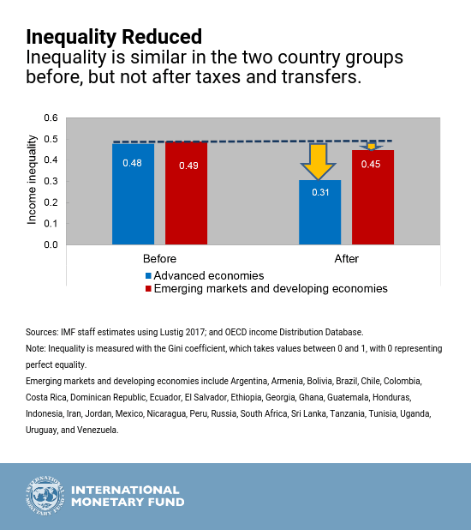

It should be noted that the decidedly mixed results of the nexus between fiscal policy and income inequality could stem from the influence of other factors, including institutional capacity. Yet, the existing publications have paid little or no attention to institutional quality or governance as a possible window for addressing inequalities between the rich and poor. 

The World Inequality Report 2022 reveals that the Middle East and North Africa (MENA) are the unequal regions globally, with the top 10% of the population controlling 58% of the region’s income. In Europe, however, the income shares of the top 10% is 36%. Asia’s 10% income share is 43%, Latin America is 55%, North America is 48%, and Sub-Saharan Africa is 56%.

Nevertheless, since Europe and North American countries (developed) appear to be doing relatively better, it is imperative to examine what is driving the difference based on fiscal policy and institutional quality. This will provide policy implications for other countries, particularly developing countries. Moreso, since most economies, particularly in the developing world, are hard hit by the COVID-19 pandemic, it is expected to devastate the recovery process. The impact of COVID-19 on these countries amplifies the need for fiscal policy not only for post-COVID-19 recovery but also to achieve redistributive outcomes.

A better understanding of how to design tax and social spending policies to achieve the greatest impact on income inequality and poverty within existing constraints is crucial to inform countries’ efforts to build more equitable and sustainable fiscal systems as they recover from the Covid-19 pandemic and tackle the impacts of high energy and food prices.

While inequality is often important from a political or ethical perspective, there is also an increasingly strong economic argument for addressing income inequality. The tension between equality and efficiency (and economic growth, in particular) that has underpinned arguments against progressive tax and spending systems is not supported by the empirical evidence. There is a cost to raising taxes and providing public services and social protection of course, including on incentives to save, invest and work. But it is important to assess the whole system so that the many benefits are considered together with costs to assess their net effects on societies and economies. Not all fiscal instruments have to be progressive, equalising and pro-poor; what matters the most is their combined effect on poverty and income inequality.

**Design of redistribution matters**

There is no one-size-fits-all strategy. Redistribution should reflect a country’s specific circumstances, including underlying fiscal pressures, social preferences, and the government’s administrative and tax capacity. Also, taxes and transfers cannot be considered in isolation. Countries need to finance transfers, and the combination of alternative tax and transfer instruments that countries chose can have very different implications for equity.

While some policies may have conflicting effects on growth and distribution, our empirical evidence shows it is possible to achieve inclusive, sustainable growth with the right mix of policies. Efficiency and equity can and must go hand-in-hand.

**Tackling inequality**

Policymakers have many choices to achieve efficient and equitable results. The *Fiscal Monitor* focuses on three policy debates: progressive taxation, universal basic income (UBI), and public spending on education and health.

* **Progressive income taxes.** Personal income tax progressivity has declined steeply in the 1980s and 1990s, and has remained broadly stable since then. The average top income tax rate for OECD member countries fell from 62 percent in 1981 to 35 percent in 2015. In addition, tax systems are less progressive than indicated by the statutory rates, because wealthy individuals have more access to tax relief. Importantly, we find that some advanced economies can increase progressivity without hampering growth, as long as progressivity is not excessive.
* **Universal basic income (UBI).** A UBI—defined as a cash transfer of an equal amount to *all* individuals in a country—has been widely debated by economists for decades. There is now renewed interest, associated with perceptions of the effects of technology and artificial intelligence on the future of work. The *Fiscal Monitor* does not advocate for or against UBI, but contributes to the policy debate by presenting facts and arguments relevant for evaluating a UBI. A UBI has potential for having a significant impact on inequality and poverty as it covers all individuals at the bottom of the income distribution. But, being universal means it is costly. The *Fiscal Monitor* estimates that it would cost the average advanced economy 6½ percent of GDP to provide a UBI set at 25 percent of median per capita income, and the estimates vary considerably across countries. Thus, the discussion of a UBI cannot be disentangled from a discussion of its financing to make it budget neutral. Key considerations for its introduction are its consistency with other fiscal priorities—to avoid crowding out investments in infrastructure, education and health, for instance—and the method of financing, which needs to be efficient and equitable. A UBI could be an option where it substitutes for inequitable and inefficient social spending.
* **Spending on education and health**. Despite progress, gaps in access to quality education and health care services between different income groups in the population remain in many countries. For example, in advanced economies, males with tertiary education live up to 14 years longer than those with secondary education or less. Better public spending can help, for instance, by reallocating education or health spending from the rich to the poor while keeping total public education or health spending unchanged. The *Fiscal Monitor* finds that closing the inequality gap in basic health coverage could raise life expectancy, on average, by 1.3 years in emerging and developing countries.

The need for fiscal policy is hinged on government’s goals and objectives and its effects may vary along diverse strata of individuals in the economy depending on the direction of its use. For instance, when the authorities decide to lower taxes in the economy, the middle class will benefit more than any other class of individuals, since they constitute the largest economic group in any society. Similarly, if taxes are raised by the government during declining economic activities, then this group (middle class) will equally have to pay more taxes than the rest of the groups.

**Conclusion**

In recent years, income inequality has been rising in developing countries and developed countries despite the ever-increasing level of economic growth across the globe. Extant literature has examined the drivers of income inequality, including fiscal policy. However, the empirical evidence on fiscal policy-income inequality nexus has not only produced decidedly mixed results so far; however, little attention has been paid to the role of institutional quality. The fiscal policy measure employed includes direct tax (income tax), indirect tax (taxes on goods and services), government size, public expenditure on education and health, and public debt. Moreover, government effectiveness and corruption were used to proxy for institutional capacity.

**References**

1. Acemoglu, Daron, Francisco A. Gallego, and James A. Robinson. 2014. Institutions, Human Capital, and Development. *Annual Review of Economics* 6: 875–912.
2. Apergis, Nicholas. 2021. The role of fiscal policy in the link between income inequality and banking crises. *Applied Economic Letters* 28: 1283–87.
3. Brinca, Pedro, Miguel H. Ferreira, Francesco Franco, Hans A. Holter, and Laurence Malafry. 2021. Fiscal consofidation programs and income inequality. *International Economic Review* 61: 405–60.
4. Caminada, Koen, Kees Goudswaard, Chen Wang, and Jinxian Wang. 2019. Income inequality and fiscal redistribution in 31 countries after the crisis. *Comparative Economic Studies* 61: 119–48.
5. Cevik, Mr Serhan, and Carolina Correa-Caro. 2020. Growing (un) equal: Fiscal policy and income inequality in China and BRIC+. *Journal of the Asia Pacific Economy* 25: 634–53.
6. Chancel, L., T. Piketty, E. Saez, and G. Zucman. 2022. World Inequality Report 2022. Available online: [**https://wir2022.wid.world/download/**](https://wir2022.wid.world/download/)
7. Clifton, J., D. Díaz-Fuentes, and J. Revuelta. 2020. Falling inequality in Latin America: The role of fiscal policy. *Journal of Latin Americal Studies* 52: 317–41.
8. Datt, Gaurav, Martin Ravallion, and Rinku Murgai. 2020. Poverty and growth in India over six decades. *American Journal of Agricultural Economics* 102: 4–27.
9. Dotti, Valerio. 2020. Income inequality, size of government, and tax progressivity: A positive theory. *European Economic Review* 121: 103327.
10. Huynh, Cong Minh. 2021. Foreign direct investment and income inequality: Does institutional quality matter? *The Journal of International Trade & Economic Development* 30: 1231–43.
11. Kunawotor, Mark Edem, Godfred Alufar Bokpin, and Charles Barnor. 2020. Drivers of income inequality in Africa: Does institutional quality matter? *African Development Review* 32: 718–29.
12. Law, Chee-Hong, and Siew-Voon Soon. 2020. The impact of inflation on income inequality: The role of institutional quality. *Applied Economics Letters* 27: 1735–38.
13. Nguyen, Van Bon. 2021. The difference in the FDI inflows–Income inequality relationship between developed and developing countries. *The Journal of International Trade & Economic Development* 30: 1123–37.
14. Nolan, Brian, Matteo G. Richiardi, and Luis Valenzuela. 2019. The drivers of income inequality in rich countries. *Journal of Economic Surveys* 33: 1285–324.
15. Ravallion, M., and S. Chen. 2021. Is That Really a Kuznets Curve? Turning Points for Income Inequality in China. (No. W29199; NBER Working Paper Series). Available online: [**http://www.nber.org/papers/w29199.pdf**](http://www.nber.org/papers/w29199.pdf)
16. https://www.imf.org/en/Blogs/Articles/2017/10/11/inequality-fiscal-policy-can-make-the-difference