**DIGITAL STREAMING SERVICES AND THE MUSIC INDUSTRY INTERSECT ECONOMICALLY**

**1Hemakshi, 2Dr. D. Sathish Kumar**

1Student

2Assistant Professor, Department of MBA, Sree Chaitanya College of Engineering, Karimnagar, India

**Abstract**

From going to unrecorded music exhibitions to paying attention to records, tapes, Albums, and advanced documents, individuals' utilization of music has developed. Presently digital music and streaming services rule the market. The ascent of digital music is quite possibly of the main change in the business to date. Computerized music innovation gives shoppers admittance to a huge number of melodies for one low cost and in one area in a manner that was never conceivable. Global revenue for recorded music is forecast to grow 7.5% in 2023 (versus 7.3% in the previous forecast), with a compound annual growth rate of approx...8.6% for 2023 to 2030. Current paper examine the intervention of digital streaming services and music industry economically.

**Keywords :** Digital streaming services, Music industry, economic, technology, performance.

**Introduction**

The market for digital music can't be characterized as customers and makers like most business sectors. Virtually every craftsman is endorsed with a record name, which likewise has income to acquire. Music revenue, meanwhile, as a percentage of what people spend on entertainment is today well below the level in 1998.

**Global recorded music market revenues**

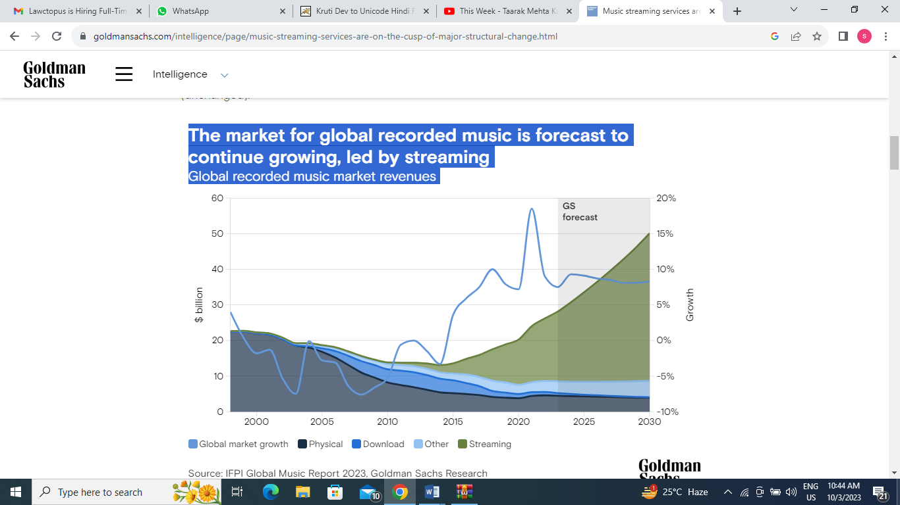

**Free Streaming Services:**

I expect that the free streaming services offer the very heap of music that the paid administrations do yet with limitations. The most widely recognized limit is advertisements played between tunes to intrude on the progression of music. My investigation likewise accepts that the free streaming services have utilitarian contrasts like restricted skips and programmed mix mode (meaning purchasers can't pick which melody to pay attention to). Free administrations additionally don't allow shoppers to download music, and that implies that they can't pay attention to music disconnected.

**Subscription Services:**

This help has a similar music library as a free streaming service however considers all out client independence from interference and has progressed highlights like downloadable music, limitless skips, and customized playlists.

**Music Market:**

Music is a tremendous market that assembles revenue across ages and nations. In 2019, the worldwide music industry produced $20.2 billion as per the Global League of the Phonographic Business' yearly report on the music business. In 2020, music streaming represented 62.1% of the absolute income for the worldwide music industry (IFPI 2020). Actual deals were the following biggest channel of pay at 19.5%.

This worldwide measurement is illustrative of a critical change in the business away from proprietorship. In 2008, Atlantic Records detailed that 66% of income from recorded music came from the offer of Compact discs and 30% came from melodies sold on iTunes (Arango 2008). After twelve years, industry income has changed radically. As per RIAA (2020), 83% of industry income came from spilling in 2020, while 6% came from computerized downloads and 9% came from actual deals in Western countries.

**Income Dislodging in the Music Business:**

Music industry income consistently declined from 2001 to 2010 as advanced music assumed control over the business. Robbery was a huge income removal issue in the beginning of computerized music. Krueger refers to the ascent of Napster, a scandalous unlawful document sharing site, as a significant supporter of the $8 billion/62% reduction in music income from 1999 to 2015, as the market changed in accordance with the ascent of computerized music and unlawful record sharing. The descending pattern in industry income likewise proposes that actual deals can make more income than current computerized music deals models. While streaming became famous and generally embraced somewhere in the range of 2015 and 2017, income began to increment, with a $2 billion lift from streaming income.

**Music Streaming Contrasted with Authentic Method for Utilization:**

Web-based features are remarkable as they supplant normal strong great responsibility for on Cds and open up shoppers to be leaseholders of millions of melodies in computerized music. Before the presentation of streaming, shoppers needed to purchase collections on Compact discs or vinyl, pay attention to music on the radio, or buy collections and individual tracks or collections on the iTunes store. With music streaming, shoppers are not generally bound to the restricted tracks of a collection on a Cd yet have a huge number of collections and tunes readily available. Real time features give heaps of music at a no minor expense for clients since many administrations brag libraries of millions of melodies. Because of this distinction, streaming is a leasing model, which can give a benefit to suppliers and specialists as it kills resale and robbery of music.

With streaming, purchasers additionally get to pick their music and listening request as opposed to having it forced on them through radio or the set playlist of a collection. Streaming considers more opportunity for shoppers as they can blend tunes from various collections, classifications, and specialists to make their own customized listening experience effortlessly.

**Artist Revenues:**

Spotify's model of paying specialists is illustrative of real time features. In 2018, Spotify revealed that 70% of its income is assigned to paying eminences (Assortment 2018). Under this model, 1,000,000 streams on Spotify net a craftsman in the $3,000-$6,000 territory, a normal of 4.5 pennies per stream in 2020 (Olsen 2021). Krueger makes sense of a speculative situation that shows how music streaming suppliers pay artists and names: ...assume a streaming stage has 100 billion tunes spilled in a year, gathers $600 million in income from paying supporters and pays twothirds of its income ($400 million) to rights holders. Assuming that a hit tune represents 100 million transfers on this help (which rises to 0.1 percent of all out streams), the payout to the freedoms holders of that melody will be 0.1 percent X $400 million = $400,000.

This model shows that artists's and names' benefits are decidedly connected with higher measures of streams, and that implies specialists mean to build streams to take up a high level of complete streams and increment income.

Unrecorded music is a basic piece of craftsman income. The top specialists in 2017 procured 80% of their pay from visiting, 15% from recorded music, and 5% from distributing expenses. The offer of tickets and product at live exhibitions can be amazingly rewarding for artists.

**Consumers:**

When the new century rolled over, digitization changed the business and made robbery rise and income to fall. Robbery was wild in the mid 2000s, and streaming never made money until 2006. In 2013 as Spotify and Pandora rose in prominence, music streaming income saw its most memorable spike. It started a vertical pattern to where it is presently, representing the greater part of the income in the music business. Given music's sensational change in benefits starting in the mid 2010s, the development can to a great extent be credited to Age Z, individuals brought into the world from the mid to late 1990s and mid 2000s, growing up with computerized music.

Age Z's effect can't be put into words. As per a review done by Familiar with 2017, 92% of Age Z utilizes a web-based feature, and 84% pay attention to music consistently utilizing these administrations. Age Z likewise has exceptional utilization propensities and pays attention to music behind the scenes during different exercises, making computerized streaming significant because of its movability and convenience. Age Z pays attention to music and utilizations web-based features more than some other age segment, yet just 22% of Age Z buys into a paid web-based feature.

**Benefits of consumers from Streaming:**

The biggest customer of advanced music is youngsters, who are principally cost delicate. Because of their cost responsiveness, youngsters will generally create some distance from purchasing music and really like to utilize a membership model because of the lower cost per tune. It is find out in some studies that membership models are more famous than proprietorship models when membership use cost is lower than the expense of the possession model. This finding proposes that a possession model turns out to be less engaging as buyers' cost awareness increments. Cost responsiveness makes sense of why free web-based features compromise such an enormous portion of utilization in Age Z. Free membership models are a magnificent way for makers of music to acquire audience members and benefit from Age Z purchasers.

General patterns show that Age Z's reception of free web-based features has been changing buyer conduct. Some studies show that music streaming has made recent fads in customer conduct where audience members pay attention to additional artists and for the most part consume more music. Their review shows that the pervasiveness of Spotify has unequivocally expanded how much music that customers pay attention to in the long haul and considers more disclosure.

Changes in purchaser patterns could get more income to the business the long run as buyers keep on paying attention to more music and artists while exploiting the enormous libraries of web-based features. Customers additionally get benefits from gushing through the expanded portability of music, which fits developing shopper conduct. The significance of Age Z and changing purchaser propensities in the streaming business sector upholds the possibility that a free streaming model will help the music business overall since this huge piece of the market will utilize the free administrations.

**Free Streaming and Proprietorship as Substitute Merchandise:**

Despite the fact that free web-based features can build the quantity of music shoppers, there is proof that these administrations can remove benefits from the business by diminishing proprietorship deals. Music on free promotion based stages removes deals from collections, recommending that free promotion based administrations and possession models are substitute merchandise. The utilization of free web-based features diminished spending in different region of the music market by 11%, and paid administrations decreased spending by 24%. From these information, they finish up web-based features are a substitute to possession and that shoppers might purchase less music over the long haul in the wake of turning out to be more familiar with the real time features. At the nation level, development in streaming lessens deals of collections and that thousand extra streams push down deals income by $1.76.

While studies propose that streaming and music proprietorship are substitute merchandise, they are flawed substitutes. Despite the fact that purchasers who take on a paid web-based feature are bound to stop purchasing music than somebody who utilizes a free help, numerous shoppers actually purchase music. This proposes that individuals who utilize web-based features will in any case purchase music from the customary possession markets. While it might diminish proprietorship deals, streaming doesn't annihilate this benefit weighty piece of the market.

Despite the fact that computerized music at first discouraged industry benefit, income from streaming has risen as of late. While streaming income has not yet had the option to make up for the underlying degree of collection and proprietorship deals relocation in the mid 2000s, this reality shows guarantee that streaming incomes will increment income more than they have dislodged it as streaming advances. These sources all suggest that the market is moving away from proprietorship, however streaming is starting to make up for a portion of the underlying misfortunes brought about by its presentation. While streaming is unquestionably a substitute really great for music proprietorship, shoppers are as yet captivating in purchasing physical and computerized music for possession.

**Advantages to All Specialists from Streaming:**

There is proof that spilling overall could carry buyers to the unrecorded music market. The accessibility of streaming carries customers to the unrecorded music market. The exchange to the unrecorded music market would address an increase for the business and all specialists since the unrecorded music market is an extensive income source. The expansion in income to the unrecorded music market could make up for any of the likely misfortunes in the market because of its general size of income contrasted with streaming and give advantages to artists, all things considered.

The consideration of a noticeable craftsman on a real time feature can likewise give gains to different specialists. Despite the fact that suppliers might have to pay higher eminences to whiz artists to draw in them to their administrations, assuming the assistance actually draws in an adequate number of specialists to make variety, it can offer more memberships at greater costs because of the great benefit of having both enormous name artists and a broad library with numerous more modest artists. A different music library that energizes disclosure can give more streams to specialists, everything being equal.

**Advantages to Enormous Artists from Streaming:**

Music industry geniuses, like Taylor Quick, have more to lose from the accessibility of free web-based features. The negative relationship between's the accessibility of free music and collection deals to be more grounded for enormous artists. Hiller's discoveries recommend that when music is free of charge, more individuals will utilize free music to pay attention to unmistakable specialists than purchasing their collections.

Notwithstanding, specialists can in any case acquire from being on free web-based features, contingent upon their music mark. Bigger names have really dealing power with the web-based feature suppliers and can campaign for higher payouts to their artists. The effect of a name could counter the likely misfortunes for greater artists. While large artists have the most to lose, they are likewise most often in the best situations to get a decent arrangement while haggling with a streaming supplier. This is apparent on account of Taylor Quick, particularly taking into account she haggled for more cash for herself as well as for different artists with the Apple Music stage in 2015.

**Advantages to Little Specialists from Streaming:**

While more modest artists might not have as much influence with suppliers as large specialists endorsed to huge names, they can in any case track down outstanding advantages from having their music on web-based features. Little specialists are for the most part not worried about social event income from a lot of streams and are bound to lean toward free administrations since they give a more prominent chance to grow their crowd and fan base. Not reliant upon a craftsman's insight, specialists who gain the majority of their pay from shows favor the free streaming administrations as each stream furnishes them with another potential worthwhile show pass deal. There is proof that individuals pay attention to a more extensive assortment of music when they stream their music. More utilization expands the likelihood for a fresher craftsman to be found, which can mean deals in the live show market.

**Conclusion**

Through the spread of streaming, purchasers approach a more extensive assortment of music than any time in recent memory, which they reliably use to track down new music and extend their preferences. Music streaming has decisively changed shopper conduct, and free administrations take into consideration expanded revelation and more utilization from the undeniably significant Age Z populace of buyers.

Expanded shopper reception of streaming has prompted direct advantages to suppliers, names, and specialists. Specialists, particularly new and more modest craftsmen, gain from the disclosure that web-based feature's huge libraries give to the market. Specialists are proceeding to adjust to this new model, which has permitted them to make really streaming benefit and move buyers to the unrecorded music industry to expand their income. Streaming has additionally permitted little craftsmen to make more progress through utilizing free web-based features to make new fans and sell show passes.

Where purchasers and specialists get gains, so does the business all in all. As specialists can expand their streams and sell more show passes, the entire business will acquire. Streaming additionally still boosts purchasers to possess music, which gives critical benefit to the business. While there is less industry benefit from possession than there was before the presentation of streaming, the business is starting to get back to its unique degrees of benefit, particularly as the model has hindered music piracy.

**References :**

1. Aly‐Tovar, Ramadan, Maya Bacache‐Beauvallet, Marc Bourreau, and Francois Moreau. 2019. “Why Would Artists Favor Free Streaming?” Journal of Cultural Economics, 44: 255–280. <https://doi.org/10.1007/s10824-019-09358-z>
2. Beer, Chris. 2018. “Music Streaming Yet to Prove Premium Worth.” Global Web Index. <https://blog.globalwebindex.com/chart-of-the-day/music-streaming-premium/>.
3. Bender, Mark, Esther Gal-Or and Tansev Geylani. 2021. Attracting Artists to Music Streaming Platforms.” European Journal of Operational Research 290, no. 3: 1083-1097. <https://doi.org/10.1016/j.ejor.2020.08.049>.
4. Hiller, Scott R. 2016. “Sales Displacement and Streaming Music: Evidence from YouTube.” Information Economics and Policy, 34: 16-34. https://doi.org/10.1016 /j.Infoecopol.2015.12.002.
5. Ingham, Tim. 2020. “Global Recorded Music Industry Revenues Topped $20BN Last Year – ButStreaming Growth Slowed.” <https://www.musicbusinessworldwide.com/the-global-recorded-musicindustry-generate-over-20bn-last-year-but-streaming-growth-slowed/>
6. Lozic, Josko. 2020. “The Revenue Recovery of the Music Industry as a Result of Revenue Growth from Streaming.” 63rd International Scientific Conference on Economic and Social Development, Zagreb: 203-214. https://www.researchgate.net/Publication/347512692_The_revenue_recovery_ of_the_music_industry_as_a_result_of_revenue_growth_from_streaming
7. Variety, pub. 2018. “With 70 Million Subscribers and a Risky IPO Strategy, Is Spotify Too Big to Fail?” NASDAQ. [https://www.nasdaq.com/articles/70- million-subscribers-and-risky-ipo-strategy-spotify-too-big-fail-2018-01-24](https://www.nasdaq.com/articles/70-%20million-subscribers-and-risky-ipo-strategy-spotify-too-big-fail-2018-01-24).
8. <https://onlabor.org/streaming-services-are-the-future-of-the-music-industry-but-theyre-leaving-musicians-behind/>
9. <https://www.goldmansachs.com/intelligence/page/music-streaming-services-are-on-the-cusp-of-major-structural-change.html>