DR. UTTAMRAO MAHAJAN COLLEGE OF B.PHARMACY CHALISGAON

**FORMULATION, DEVELOPMENT, AND EVALUATION OF HERBAL ANTI-ULCER TONIC.**

**AUTHORS NAME: Prathamesh Gorakh Patil1, Rohit Rajendra Dhangar2 Pratik Jagdish Gadhe3**

**GUIDE: Prakash Sapkale, DR.Swapnil Deo**

* **ABSTRACT:**

Peptic ulcer is the most common stomach disease and is often caused by a mismatch between defense and aggression in the stomach. Diseases occur frequently in industrialized, civilized and developing countries due to the pressures of life. Factors such as smoking, alcohol consumption, stress, use of non-steroidal anti-inflammatory drugs and poor nutrition can cause peptic ulcer disease. Symptoms of peptic ulcer are pain and abdominal pain. Duodenal ulcers have a pain-food relief pattern, and stomach ulcers have food pain. According to popular belief, ulcers are not caused by spicy foods, but are most often caused by infection or long-term medication use. Standard treatment is a combination of antibiotics and medications such as proton pump inhibitors. Data show that many synthetic drugs are used to treat peptic ulcers but may cause some side effects.

Ayurveda plants therefore stand out for their ethno, ethno botanical and ethno medical uses. Peptic ulcers occur due to the presence of acid in the juice, which causes damage to the mucosal barrier of the digestive tract. Two main factors can cause mucosal damage: Non-steroidal Anti-inflammatory drugs (NSAIDs), such as aspirin and Helicobacter pylori infection. Many natural products have been evaluated as treatments for a variety of conditions, including peptic ulcers. Extensive pharmacological studies have been conducted on the antiulcer activity of some compounds.

* **KEYWORDS:**

Antiulcer activity, peptic ulcer, medicinal plant, phytoconstituents, flavonoids, tannins.

* **INTRODUCTION:**

Today, 75-80% of the world's population still uses herbal medicine only in developing countries and is rarely used due to better culture and social relations of body sex Side effects. Histological studies have shown that this medicinal plant has no acute toxicity. Preliminary photochemical analysis of this medicinal plant has shown the presence of important metabolites such as flavonoids and tannins, which are active substances in disease prevention. Peptic ulcer disease (PUD), including stomach and duodenal ulcers, is the most common gastrointestinal problem and requires treatment strategies. The most common place for bacteria is the first few centimeters of the stomach and duodenum. Peptic ulcers, due to some drugs such as non-steroidal anti-inflammatory drugs (NSAIDS), stomach acid and pepsin, cause obstruction in the continuation of the stomach or duodenal mucosa and ultimately cause pain.[1-2]

Basically, the word “peptic” is derived from the Greek word “pepticos” meaning something related to digestion. Many reports show that older people are more susceptible to stomach infections. The risk of developing duodenal ulcer is higher in young people . The pathogenesis of peptic ulcer disease indicates a complex imbalance of gastric attack factors such as acid, pepsin secretion, Helicobacter pylori (H. pylori), bile salts, ethanol, some drugs such as non-steroidal anti-inflammatory drugs and plasma peroxidation of lipids. , Zollinger-Ellison syndrome and protective mucosal factors such as prostaglandins, nitric oxide, gastric mucus, cell regeneration, blood circulation, mucosal cell loss, glycoproteins, mucin secretion, hyperplasia of antioxidant enzymes such as catalase, superoxide dismutase and glutathione [3,4,5,6,7]

The pathophysiology of peptic ulcer disease is similar with the disagreement between critical problems and protective factors. Peptic ulcers were once thought to be caused by tasteless foods and stress. These conditions have been found to be improved by an infection (H. pylori) or resistance to various medications, especially nonsteroidal anti-inflammatory drugs (NSAIDS). Depression, alcohol and smoking are the main causes associated with peptic ulcer. It is suggested that the Gram-negative bacterium Helicobacter pylori remains between the mucosal layer and the gastric epithelium and lives in the stomach environment. Initially, H. pylori is found in the antrum, but over time it migrates to the proximal part of the stomach [8,9,10,11]

* **Peptic ulcer are of two types:**

1. **Gastric ulcer:** when the ulcer occurs in stomach they are called gastric ulcer
2. **Duodenal ulcer:** when the ulcer occurs in the duodenum it is called as duodenal ulcer

The duodenal ulcer is the commonest of peptic ulcer with the ratio of 4:1 in duodenum and stomach respectively. Peptic ulcer can lead to several complications such as obstruction, hemorrhage and perforation.

* **Signs and symptoms of peptic ulcer:**

Abdominal pain and nausea, bulking and abdominal pulpness, Water brash, vomit, Melena, Rarely acute peritonitis, Dark or black stools, Dry tongue, delicate or weak pulse, reduce of breath.

* **The potential medicinal plants used in ulcer:**

Although it is one of the famous plants used in the treatment of many diseases in Indian medicine, there is a lack of research on the pharmacological properties of some medicinal plants. We examined the antiulcer activity and toxicity of some medicinal plants. Our study shows that the studied medicinal plants can prevent diseases in mice at dosage. Histological studies have shown that this medicinal plant has no acute toxicity. Preliminary analysis of this medicinal plant detected the presence of important metabolites such as flavonoids and tannins [12,13]

* **Emergence of herbal drug to treat ulcer:-**

Different classes of synthetic drugs are used to treat peptic diseases, but most of them have serious side effects such as cardiac arrhythmias, gynecomastia, impotence, arthralgia, hyper gastrinemia and hematopoietic changes. One option these days is to study medicine from Ayurveda or traditional medicine. It has been shown that the use of herbal ingredients in the treatment of serious diseases is more effective and less toxic than existing drugs, while at the same time reducing their offensive properties and trying to prevent digestion. Sexual intercourse. In this season, most of the people in the world use herbal medicines in basic treatment, primarily in developing countries, due to their recognition, compliance and low side effects. Plants or medicines contained in plants are considered to have a good relationship with the human body, as they are part of the physiological functions of living things. This review highlights the properties of some medicinal plants with antiulcer activity.

|  |  |  |
| --- | --- | --- |
| **Sr.no.** | **Name of plants** | **Phytoconstituents** |
| 1. | Bacopa moniera | Bascoside A |
| 2. | Moringa oleifera | Beta setosterol, quercetin |
| 3. | Aloevera | Barbaloin, saponins |
| 4. | Ocimum sanctum | Fixed oil eugenol |
| 5. | Allium sativum | Alliin, allicin |
| 6. | Psidium guajava | Quercetin, flavonoids |
| 7. | Annona squamosal | Tannic acid |
| 8. | Sesbania grandiflora | Tannis, saponins |
| 9. | Magnifera indica | Mangiferin |
| 10. | Carica papaya | Chymopapain papain |
| 11. | Mimosa pudica | Alkaloid mimosine |
| 12. | Shorea robusta | Ursolic acid, amyrin |
| 13. | Azadirachta indica | Nimbidin |
| 14. | Terminalia chebula | Tannins, gallic acid |
| 15. | Fiscus religiosa | Flavonoids-Naringenin |
| 16. | Aegel marmelos | Luvangetin |

* **Mechanism based study of some herbal antiulcer drug :-**

**1. Bacopa Monniera:**

**Family:** Scrophulariaceae

**Synonyms:** Indian Pennywort

**Biological Source:** Found in warm wetlands, and native to Australia and india

**Uses:** Ayurvedic medicine are memory improvement insomnia

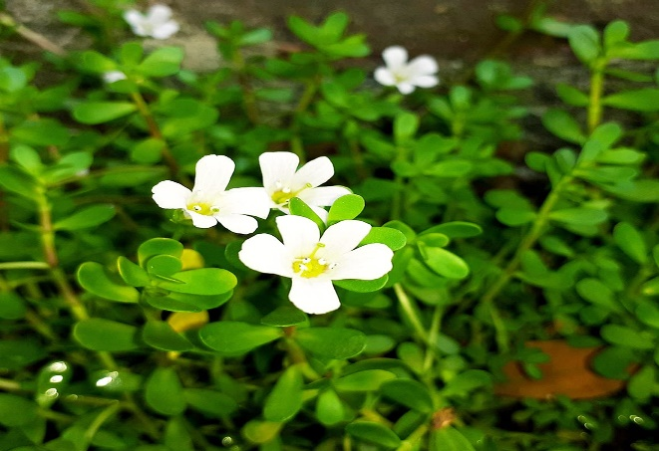

**Fig no: 1 Bacopa Monniera**

It is often as saraswati and belongs to the figwort family. It is effective in the treatment of various stomach ulcer diseases. The main ingredient used to treat the disease is bacoside A. It has anti-ulcer and ulcer healing activities. Several potential mechanisms for baccoside A have been proposed. The first treatment for the disease is anti-H. H. pylori was found to be active at a dose of 1000 mg/ml and prostaglandins (PGE and PGI2) were increased at a dose of 10 mg/ml. Other possible mechanisms are mucosal aggressive pepsin secretion and protective factors such as mucin secretion, mucosal cell shedding, cell proliferation and antioxidant activity in mice.[14,15,16]

**2.Moringa oleifera**

**Family:** Moringaceae

**Synonyms:** Horseradish tree

**Biological source**: Moringa oleferia is native to northwestern india and widely cultivated topical and subtropical areas

**Uses:** Oxidation and Toxicity

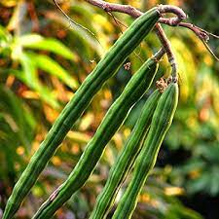

**Fig no: 2 Moringa oleifera**

Antimicrobial activity. Moringa's leaves, roots, bark and seeds contain antibacterial properties against bacteria and fungi. In vitro activity of the plant against bacteria, yeast, dermatophytes and helminths was found by disk diffusion method.

1. **Aloevera**

**Family:** Asphodelaceae

**Synonyms:** Aloe Indica Royle

**Biological source:** The biological source of aloe is dried latex of leaves.

**Use:** Aloe is topically orally.

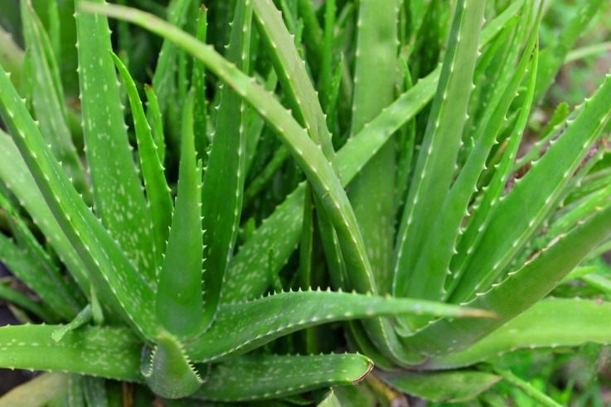

**Fig no: 3 Aloevera**

Mechanism. Therapeutic Properties: Glucomannan (a mannose-rich polysaccharide) and gibberellin (a growth hormone) interact with the growth receptors of fibroblasts, thereby promoting their activity and growth, enabling local and oral aloe vera to increase collagen synthesis**.**

1. **Ocimum Sanctum**

**Family:** Labiatae

**Snynonyms:** Ocimum tenuiflorum

**Biological source:** It is propagated by seeds

**Used:** Anticancer, Antidibetic

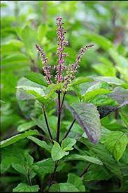

**Fig no: 4 Ocimum Sanctum**

Ocimum sanctum has also been shown to be anti-anxiety by normalizing blood sugar, blood pressure, and blood lipid levels, its positive effects on memory and cognitive functions, and to combat mental stress thanks to its anxiolytic and antidepressant properties. Tulsi's broad-spectrum antibacterial activity, including activity against a wide range of human and animal diseases, suggests its potential as a hand sanitizer, mouthwash, and water purifier, as well as feed for animals, wound healing, food, medicinal herbs, and a product for travelers health.

1. **Allium Sativum**

**Family:** Amaryllidaceae

**Snynonyms:** Allium Controversum

**Biological source**: Garlic is originally from Asia. But It is cultivated china, north Africa

**Uses:** Abdominal pain, low blood pressure

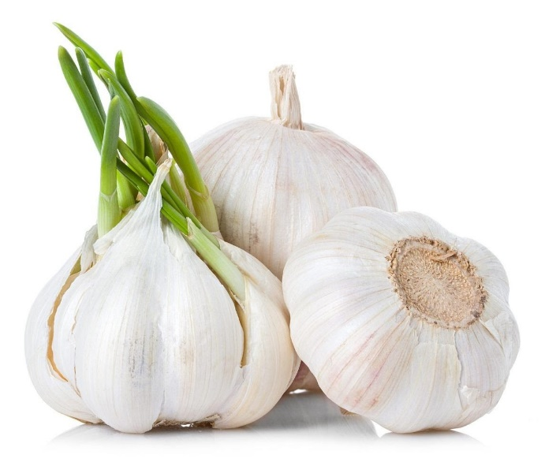

**Fig no: 5 Allium Sativum**

The hypotensive mechanism of action of garlic extract is that garlic contains many active sulfur molecules, which have been shown to increase endothelial contraction and relaxation, thereby lowering blood pressure.

1. **Psidium Guajava**

**Family:** Myrtaceae

**Synonyms:** Guajava pyrifera

**Biological Source**: Guava is belived to have originated from an area extending from southern mexico into or through central America

**Uses**: Stomach Aches, and Indigestion

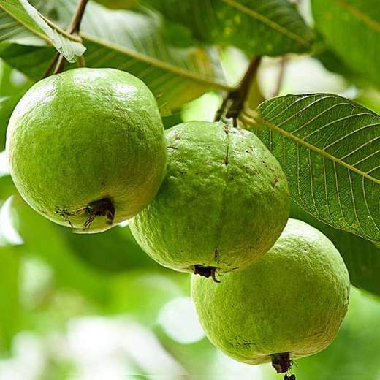

**Fig no: 6 psidium Guajava**

Morphine-like antispasmodic effects (irreversible with naloxone; include inhibition of acetylcholine release) and effects on the transport of electrolytes (Na + and K + ) and water have been reported as part of the anti-inflammatory properties of the leaf's guava polar potential. Subtract**.**

1. **Carica Papaya**

**Family:** Caricaceae

**Synonyms:** Carica bourgeaui solms

**Biological Source:** The papaya may represent the fusion of two or more species of carica native to mexico and central America

**Uses:** It is used in inflammation, diabetics

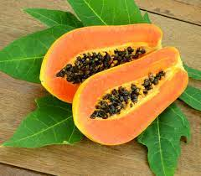

**Fig no: 7 carica Papaya**

The methanolic extract of the plant showed gastroprotective and ulcer-healing effects in rats at doses of 125, 250 and 500 mg/kg. reduces stomach pain by inhibiting it by 56%, 76% and 82% respectively. The cytoprotective effects of papaya are responsible for its anti-inflammatory activity. Enzymes found in papaya P1G10 have anti-inflammatory properties.[17,18,19]

1. **Fiscus Religiosa**

**Family**: Moraceae

**Synonyms:** Bodhi tree

**Biological source:** Ficus religiosa is native to most of the indian subcontinent Bangladesh, Bhutan, Nepal.

**Uses:** Antiulcer, Antibacterial, Antidibetic

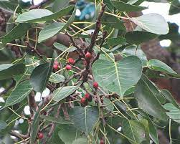

**Fig no: 8 Fiscus Religiosa**

It is commonly known as the "Bodhi Tree". It property of the mulberry family. Alcoholic extract of Buddha at doses of 250 mg\kg and 560 mg has been reported to be effective against pyloric ligation-induced ulcers, ethanol-induced ulcers, and aspirin-induced ulcers. . . Antibiotic resistance\kg Swiss albino mice. Root bark ethanolic extract has anti-inflammatory properties due to endogenous prostaglandins that stimulate mucus secretion.together ensure that these plants have the ability to protect against diseases.[20,21]

**9.Mimosa Pudica**

**Family:** Fabaceae

**Synonyms:** Shame plant and humble plant

**Biological Source**: Diffuse prick undershrub belonging to family

Mimosaceae

**Uses**: The herb has been used traditionally for ages in the treatment

of urogenital disorder, piles.

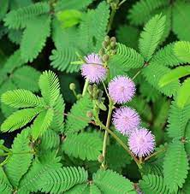

**Fig no: 9 Mimosa Pudica**

inducement of mimosa sensitiva causes K+ secretion from the cytosol the apoplast. 20 Mechanical stimulation causes a decrease in K+ ions in the extensor muscles. 8,21 Contraction of the extensor muscles and swelling of the flexor muscles cause the occipital colliculus to bend. 22 The degree of petiole curvature is related to actin tyrosine phosphorylation within the petiole. 11 Although the actin cytoskeleton, rather than microtubules, is involved in regulating movement, the breaking of actin filaments and microtubules occurs during bending.

1. **Shorea Rubosta**

**Family:** Dipterocarpaceae

**Synonyms:** Sal tree, shala

**Biological Source:** The plant belongs to the dipterocarpaceae botanical family

**Uses:** Manufacturing of papers, wood varnishes and lacquers, and paints.

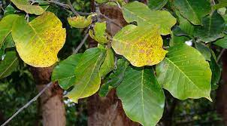

**Fig no: 10 Shorea Rubosta**

In both the hot plate test and the tail kick method, shorewood resin extract significantly increased the mean reaction time over the entire study period (P < 0.001). Considering the need for new, safe and effective treatments and the side effects associated with currently used drugs, Wangshan resin represents an important and promising herbal medicine for the healing of pain for which there is no effective treatment, such as chronic pain. From this, we conclude that Robusta leaf resin extract has significant analgesic activity and wound healing potential. Debprasad et al also reported that Lagaonia exercise works by inhibiting TNF and INOS expression. Acetate-induced writhing and tail wagging tests were performed to determine activation.

* **Some potential plant with antiulcer activity:**

|  |  |  |  |  |
| --- | --- | --- | --- | --- |
|  |  |  |  |  |

|  |  |  |  |  |
| --- | --- | --- | --- | --- |
| Botanical name and family | Common name | parts used | Active constituents | medicinal used |
| Aloe vera  Fam: liliaceae | Gritkumari | Leaves | Barbaloin, saponins. | Laxative, ulcer |
| Capsium  Fam: solanaceae | Chilli or Paprika | Fruit | Triterpenoids, saponins | Flatulent dyspepsia, Antiulcer |
| Basellla rubra  Fam: Apocynaceae | Ceylon spinach, india spinach | Leaf | Saponin, protin | Antiulcer |
| Nigella sativa linn  Fam:ranunuculaceae | Kalonji | Seed | Alkaloids nigellicin, tannin | Diuretic, hypoglycemic,antiulcer |
| Curcuma longa  Fam: zingiberaceae | Haldi | Rhizome | Phenolic, tannins | Antiulcer, wound healings |
| Vetiveria ziziinoides  Fam: graminae | Benachar | Root | Phenolic compound, flavonoids | Hyperdipsia, buerning, ulcer |

* **Conclusion:**

The research of natural products is mainly driven by health knowledge, and its contribution to the use of new medicine is enormous by providing new drug models and methods of action. Folk medicine uses many medicinal plants to treat various diseases. Synthetic drugs used in its treatment have side effects, and some synthetic drugs have been shown to have harmful effects. In this case, the safe and balanced one, such as herbal medicine and synthetic medicine, is the obvious other. This article presents various botanical sources based on traditional knowledge and reports of different scientists. Additionally, only by understanding the mechanisms by which wounds form can we find new ways to treat diseases.

Peptic ulcer is a type of gastrointestinal disease caused by repeated and various complications. Moreover, the allopathic medicine used in its treatment can also be harmful and worsen people's health. For this reason, researchers have focused on medicinal plants with therapeutic effects. This plant contains alkaloids, tannins, flavonoids, phenols, saponins, etc. It is rich in many phytochemicals such as; Isolating and using these substances may provide health benefits. Therefore, medicinal plants that are both safe and cheap and have the ability to prevent diseases are discussed here.

**Referance:**

1. R. Kumar, “A review on medicinal plants for peptic ulcer. Scholar Research Library,” Der Pharmacia Lettre, vol. 3, no. 3, pp. 414–420, 2011.
2. G Patel and S. Jain, “Antiulcer activity of Neriutn indicum in rats,” Research Journal of Pharmacology, vol. 4, no. 3, pp. 66–68, 2010.
3. Verma M, A Review on Peptic ulcer: A global threat, Journal of Pharmacy Research, 2010, 3(9), 2088-2091.
4. Richardson CT, Role of Aggressive Factors in the pathogenesis of Peptic Ulcer Disease, Scandinavian Journal of Gastroenterology, 1990 25(1), 37-43.
5. Lunevicius R, Morkevicius M, Management strategies early results, benefits and risk factors of laparoscopic repair of perforated peptic ulcer, World Journal of surgery, 2005, 29, 1299-1310.
6. Pahwa R, Neeta, Vipin K, Kohli K, Clinical manifestations, causes and management strategies of Peptic Ulcer Disease, International Journal of pharma sciences and drug research, 2010, 2(2), 99-110.
7. Marietta JOEB, John FL, Perforated peptic ulcer disease: A review of history and treatment, Digestive Surgery, 2010, 27, 161-169.
8. W. A. Hoogerwerf and P. J. Pasricha, Agents Used for Control of Gastric Acidity and Treatment of Peptic Ulcers and Gastro Esophageal Reflux Diseaseedition, pp. 1005–19, McGraw-Hill, New York, NY, USA, 10th edition, 2001
9. B. J. Marshall and J. R. Warren, “Unidentified curved bacilli in the stomach of patients with gastritis and peptic ulceration,”The Lancet, vol. 1, no. 8390, pp. 1311–1315, 1984.
10. P. Malfertheiner, F. K. Chan, and K. E. McColl, “Peptic ulcer disease,” The Lancet, vol. 374, no. 9699, pp. 1449–1461, 2009
11. D. L. Kasper, E. Braunwald, S. L. Hauser, J. L. Jameson, A. S. Fauci, and D. L. Lengo, Principles of Internal Medicine, pp. 221- 222, McGraw-Hill Medical Publishing Division, New York, NY, USA, 16th edition, 2005.
12. Kokate CK, Purohit AP, Gokhale SB. Pharmacognosy. 13th ed. Pune: Nirali Prakashan Publisher; 2007. p. 35.
13. Parmar NS, Parmar S. Anti-ulcer potential of flavonoids. Indian J Physiol Pharmacol 1998;42:343-51.
14. Dorababu M , Prabha T, Priyambada S, Agrawal VK, Aryya NC, Goel RK, Effect of Bacopa monniera and Azadirachta indica on gastric ulceration and healing in experimental NIDDM rats, Indian Journal of Experimental Biology, 2004,42(4),389-397
15. Goel RK , Sairam K, Babu MD, Tavares IA, Raman A, In vitro evaluation of Bacopa monniera on anti-Helicobacter pylori activity and accumulation of prostaglandins, Phytomedicine, 2003,10(6-7),523-527.
16. Sairam K , Rao CV, Babu MD, Goel RK, Prophylactic and curative effects of Bacopa monniera in gastric ulcer models, Phytomedicine, 2001, 8(6),423-430.
17. Pinto LA , Cordeiro KW, Carrasco V, Carollo CA, Cardoso CA, Argadoña EJ, Freitas Kde C, Antiulcerogenic activity of Carica papaya seed in rats, Naunyn Schmiedeberg’s Archives of Pharmacology, 2015, 388(3),305-317
18. Ezike AC , Akah PA, Okoli CO, Ezeuchenne NA, Ezeugwu S, Carica papaya (Paw-Paw) unripe fruit may be beneficial in ulcer, Journal of Medicinal Food, 2009, 12(6),1268-1273
19. Gomes FS , Spínola Cde V, Ribeiro HA, Lopes MT, Cassali GD, Salas CE, Wound healing activity of a proteolytic fraction from Carica candamarcensis on experimentally induced burn, Burns, 2010, 36(2),277-283.
20. Saha S, Goswami G, Study of anti ulcer activity of Ficus religiosa L. on experimentally induced gastric ulcers in rats, Asian Pacific Journal of Tropical Medicine. 2010; 791-793.
21. Khan MSA, Hussain SA, Jais AM, Zakaria ZA, Khan M, Anti-ulcer activity of Ficus religiosa stem bark ethanolic extract in rats, Journal of Medicinal Plant Research, 2011,5(3),354-359
22. Rao CV, Ojha SK, Radhakrishnan K, Govindarajan R, Rastogi S, Mehrotra S, Pushpangadan P, Antiulcer activity of Utleria salicifolia rhizome extract, Journal of Ethnopharmacology, 2004, 91, 243–249.
23. Shenoy AM, Shastry SC, Anti Ulcer Activity Of Heliotrpium indicumLeavesExtract, International Journal of Parmaceutical Sciences and Research, 2011, 2(10), 2651-2654
24. Vasudeva N, Sethi P, Sharma SK, Kumar S, Sharma S, Antiulcer Potential of the Ethanolic Extract of Aerva Persica Merrill Root in Rats, Journal of Acupuncture and Meridian Studies, 2012, 5(2),80-86.
25. K. M. Nadkarni’s, Indian Materia Medica, Volume 1, pp. 38-39, Popular Prakashan, Mumbai, India, 1976.
26. R. K. Goel, R. N. Maiti, M. Manickam, and A. B. Ray, “Antiulcer activity of naturally occurring pyrano-coumarin and iso-coumarins and their effect on prostanoid synthesis using human colonic mucosa,” Indian Journal of Experimental Biology, vol. 35, no. 10, pp. 1080–1083, 1997.
27. Z. P. Lima, J. A. Severi, C. H. Pellizzon et al., “Can the aqueous decoction of mango flowers be used as an antiulcer agent?” Journal of Ethnopharmacology, vol. 106, no. 1, pp. 29–37, 2006.
28. Hornick CA, Sanders LI, Lin YC. Effect of carpaine, a papaya alkaloid, on the circulatory function in the rat. Res Commun Chem Pathol Pharmacol 1978;22:277-89.
29. Santos AF, Santana AE. Mollusicaidal properties of some of some species of annona. Phytomedicine 2001;8:115-20.
30. Goel RK, Sairam K. Anti-ulcer drugs from indigenous sources with emphasis on Musa sapientum, Asparagus racemosus and Zingiber officinale. Indian J Pharmacol 2002;34:100-10.