DR.UTTAMRAO MAHAJAN COLLEGE OF B PHARMACY,CHALISGAON

***The Role of Vitamin B12 in Management of Dengue Fever***

Author Name:- Tejas Ishwar Wagh, Snehal Dilip Mahajan, Swati Vijay Mahajan, Jagruti Sunil Patil.

***ABSTRACT***

Dengue is an infectious febrile disorder characterised by thrombocytopenia( Deficiency of platelet in blood) and platelet dysfunction leading to bleeding manifestations. Vitamin B12 is essential for platelet production in the bone  marrow. This Study was to know the clinical profile of dengue fever patients and to correspond serum vitamin B12 level with severity of thrombocytopenia, platelet transfusion and duration of hospital stay. This monitoring study was done on dengue patients . This monitoring study was done on dengue patients for period of 3 months. Confirmed cases of dengue fever with IgM positive & NS1 Ag antibody positive were included in the study. Patient with underlying malignancy, autoimmune disorder,sepsis , hematological disorder, drugs causing thrombocytopenia were excluded from the study. Appropriate statistical methods. Dengue fever patients with vitamin B 12 deficiency had average to severe thrombocytopenia and more bleeding manifestations. Those patients need more platelet transfusion and increased extent of hospital stay .

***KEY WORDS:-*** Dengue , Vitamin B12, Thrombocytopenia

***INTRODUCTION:-***

Dengue is a mosquito-borne viral disease that has quickly spread in all area of WHO in recent years.

1. The incidence of dengue has grown intensely around the world in recent decades. A extensive majority of cases are asymptomatic or mild and self-managed, and hence the actual numbers of dengue cases are under-reported. Many cases are also overdiagnosed as other fevered illnesses.

2. The virus is transmitted to humans through the bites of infected female mosquitoes, primarily the (Aedes aegypti , Aedes albopictus) mosquito. It is caused by a virus of the Flaviviridae family and there are four distinct serotypes of the virus that cause dengue (DENV-1, DENV-2, DENV-3 and DENV-4).

3. It causes a wide spectrum of disease. This can range from sub clinical disease to severe flu-like symptoms in those infected. Although less common, some people develop severe dengue, which can be associated with severe bleeding, organ damage and plasma leakage.

4.Severe dengue has a higher risk of death when not managed adequately. Dengue fever is a severe flu-like infection that involves separates of all age groups (children, adults ,adolescents and infants).

5. Transmission among human beings occurs by the mosquito Aedes aegypti and chiefly occurs and spread during the rainy season.

6. The proposed etiologies for dengue virus infection are Viral replication, primarily in macrophages, direct skin infection by the virus, immunological and chemical-mediated mechanism induced by host–viral interaction.

Nutritional deficiencies are the most common cause of anemia in the humid countries. Deficiencies of vitamin B12 and folate can cause severe anemia and cytopenias due to inadequate hematopoiesis and can sometimes mirror hemolytic anemia. Also megaloblastic anemia, presenting only as pyrexia, can be found in only a small proportion of cases and is poorly described. This diagnosis can often be missed and delay the diagnosis if not actively looked for in cases pyrexia of unknown origin (PUO).

***DENGUE IMMUNOPATHOGENESIS:-***

The onset of severe dengue often occurs during the reduction stage after peak viremia suggesting that the host immune responses are involve in viral consent, inferring that life-threatening dengue involves a complex interchange between virus and the host . Natural infection with one of the serotypes consults long-lasting immunity to later infection with the same serotype. However, subgroup infection with heterotypic serotypes often results in severe immunopathological symptoms, start early during the course of disease. This at least in part, could be assign to a phenomenon known as original antigenic sin that bring about sterile B and T cell responses and possibly harmful symptoms, particularly during secondary infection. The complex interchange between these factors may after some time lead to both antibody-dependent enhancement (ADE), antibody-dependent cellular cytotoxicity (ADCC), cytokine storm (hypercytokinemia), abnormal activation of the complement system (CS), as well as endothelial dysfunction, ultimate in severe clinical dengue.

***ORIGINAL ANTIGENIC SIN AND ANTIBODY DEPENDENT ENHANCEMENT:-***

Although both T and B cell responses play a most important role in fight DENV infection, they could be pathological during secondary infection due to original antigenic sin. Because the four DENV serotypes share ~80% parallel in amino acid sequences, cross-reactivity is common. Hence, during a heterotypic infection, the preexistant memory T and B cells rapidly become activated and increase rapidely to enter into the effector phase. As protective adaptive immunity is more efficient against homotypic than heterotypic reinfection, seeing that cross-reactive responses may have negligible avidity and affinity towards the antigenic determinnt of the secondary-infecting virus. These cross-reactive T cells often exhibit lower cytostatic yet secreting higher profusion of several pro-inflammatory cytokines, generate viral control ineffective as well as overstated release of pro-inflammatory cytokines leading to cytokine attack and endothelial dysfunction.

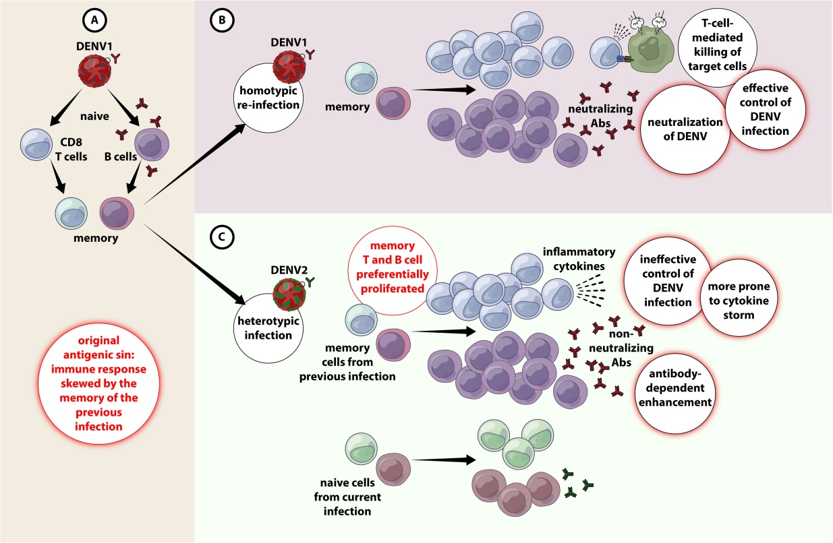***INTERACTION OF THE COMPLEMENT SYSTEM WITH DENV:-***

The complement system composed of ~50 plasma proteins is essential to first-line immune observation and are found in inactive forms in the circulation. The proteins can be activated via three pathways, i.e. lectin (binding by ribose binding lectins (MBLs) , the classical ( binding of c1g with antigen – antibody ex).

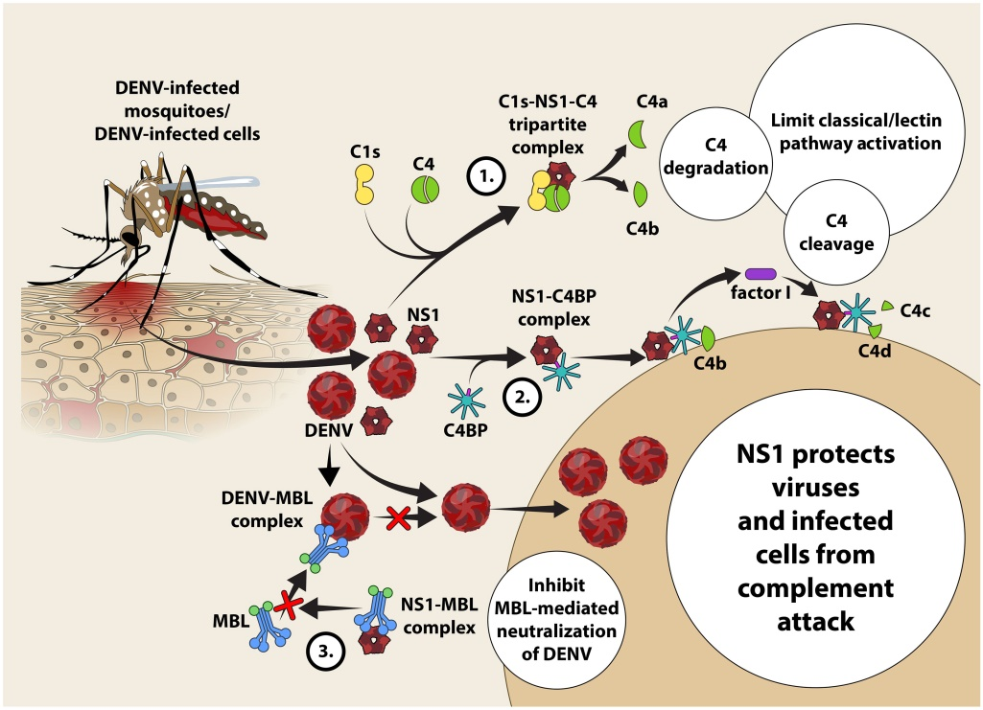

***MATERIALS AND METHODS:-***

We conducted observational study on dengue patients of sample size 50 admitted in general medicine ward for period of 4 months Feburarey 2020 to april 2020, ESI PGIMSR Rajajinagar, Bangalore. Demographic data, history, clinical examination was recorded in the official study. A thorough clinical evaluation was carried out and recorded in the agreement. Applicable laboratory investigations was sent and results are systemize. Approval was obtained from the Institutional Ethics Committee prior to the starting of the study.

***CONCLUSIONS:-***

Vitamin B12 deficiency is an important and easily solvable cause of PUO. All patients presenting with pyrexia and cytopenia with hemolytic picture should be carefully evalu- ated for possible vitamin B12 and folate defi- ciency in order to prevent the unnecessary load of investigations and treatments. More studies evaluating the possible roles of cytokine signaling and bone marrow epihelium microenvironment might help in understand- ing the pathophysiological mechanism of pyrexia in megaloblastic anemia. Presence of hyperhomocysteinemia and hypovitaminosis D-induced hypophosphatemia in vitamin B12 deficiency are additional risk factor for severe hematolysis in megaloblastic anemias.

***REFERENCES:-***

1. World Health Organization. Dengue and severe dengue. 2020 June 23.
2. Jesse J, Lionel G, Maria J, Gabriela B, Yolanda T, James S, et al. Viremia and Clinical Presentation in Nicaraguan Patients Infected With Zika Virus, Chikungunya Virus, and Dengue Virus. Clinical Infectious Diseases, 2016. 63(12): p. 1584-1590.
3. Halstead SB. Pathogenesis of dengue: Challenges to molecular biology science.1988;239:476-481.
4. Kurane I. Dengue hemorrhagic fever with special emphasis on immunopathogenesis. Comp Immunol Microbiol Infect Dis. 2007; 30:329-340.
5. Thomas EA, John M and Bhatia A. Muco-Cutaneous manifestations of dengue viral infection in Punjab. Int J Dermatol. 2007; 46:715-719.
6. Messina JP, Brady OJ, Scott TW, Zou C, Pigott DM, Duda KA, et al. Global Spread of Dengue Virus Types: Mapping the 70 Year History. Trends Microbiol (2014) 22(3):138–46. doi: 10.1016/j.tim.2013.12.011
7. WHO. Dengue and Severe Dengue, Fact Sheets, World Health Organization (2020).
8. Bhatt S, Gething PW, Brady OJ, Messina JP, Farlow AW, Moyes CL, et al. The Global Distribution and Burden of Dengue. Nature (2013) 496(7446):504–7. doi: 10.1038/nature12060