Mathematical Model The Heat Pump Dryer Variables Equations & Approach

Amr Abbass
Mississippi State University

Abstract :

To develop a Model for the performance of the basic components of the Vapor compression wet sheet dryers ( compressor , condenser, evaporator , expansion device and the wet sheet Dryer ) could be done to optimize the design of the finned-tube heat exchangers ( evaporator or the condenser) in this kind of application.

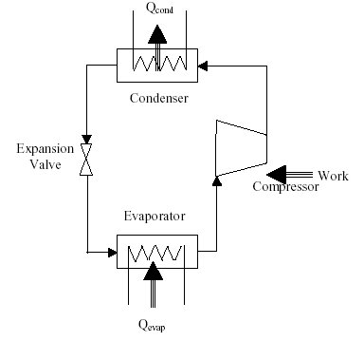
Introduction
Heat pump drying is the technology that invokes to efficiently use the energy. Heat pump, by its name, is a device implicitly supplying heat mainly in space heating application and heat recovery. Heat pump application in drying has continuously received attention since it possesses two-fold beneficial characteristic. Through the evaporator, the heat pump recuperates sensible and latent heat from the dryer exhaust, hence the energy is recovered. Condensation occurring at the evaporator reduces the humidity of the working air, thus increases the driving force for product drying. It is, therefore, anticipated that the heat pump dryer (HPD) can accelerate the drying process and use energy efficiently. Furthermore, heat pump dryer is suitable for temperature-sensitive products because effective drying can occur at low temperature (because of low humidity).

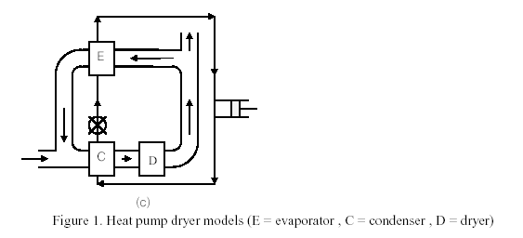

The superheat, saturated, and subcool portions of the heat exchanger will be modeled separately and in detail using appropriate pressure drop and heat transfer fundamental equations for both the air-side and refrigerant-side of the heat exchangers. The study will use accurate refrigerants and air properties and can be modified from a refrigerant to other as a characteristic of the EES software .

The compressor model uses the physical indicative volumetric efficiency equation and the
constant polytropic exponent and a catalog data fitted Clearance volume ratio , a suction pressure drop and a adiabatic efficiency mode .

The Cycle cooling output and electrical input to evaporator and condenser fans Will be also calculated for various ambient temperature conditions. The condenser fan, and evaporator components of the cycle are also modeled but in a more global manner using thermal science laws.

The cycle coefficient of performance will be the optimization objective function

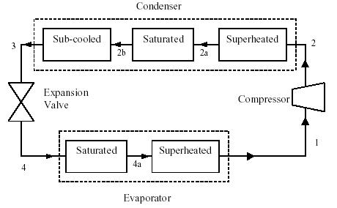
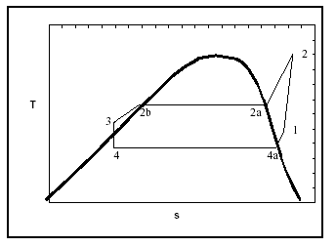

The Methodology
The compressor Model :

The model used in this study will be based on the volumetric efficiency which is defined as the mass of vapor that is actually pumped divided by the mass of vapor that the compressor could pump if it could handle the total piston displacement at the suction state ( Ref to the bellow indicator diagram ) .

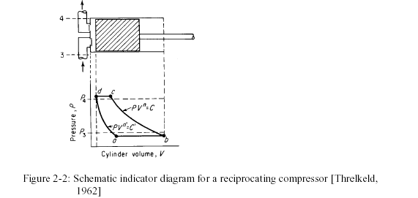

From the above indicator diagram shows the refrigerant states that are being
used in the following derivation. The volumetric efficiency can be represented by:
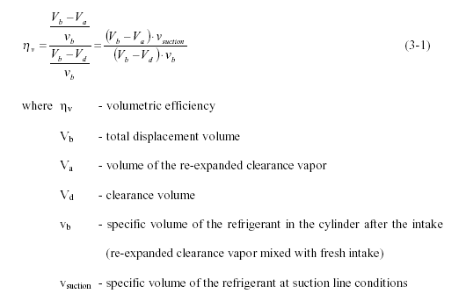
The compression and expansion process are described as polytropic processes. It
is assumed that they have the same polytropic exponent n.

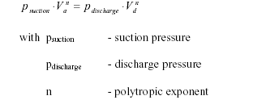

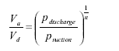
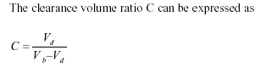

and accordingly

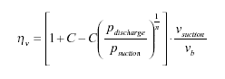
and as
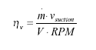
Finally we get this equation for the refrigerant mass flow rate
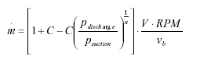

we are going to fit the compressor catalog data using above volumetric efficiency equation with a constant polytropic exponent. And with two parameters Clearance volume ratio C and suction pressure drop Δpsuction such that :

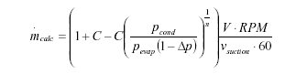
The Power Model will be as follows

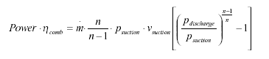
In order to account for motor and other inefficiencies. The model uses an inverse proportional relationship between the combined efficiency and the evaporating pressure.

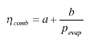
The Values of C, Δpsuc , a & b will be determined through the objective function for the least squares curve fit for mass flow rate and Power consumed to that of catalog by :
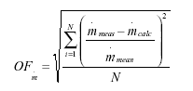
OF - objective function determined error

N - number of data points
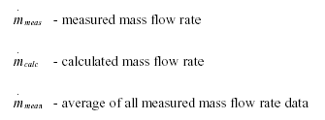

The following is a sample of catalog data
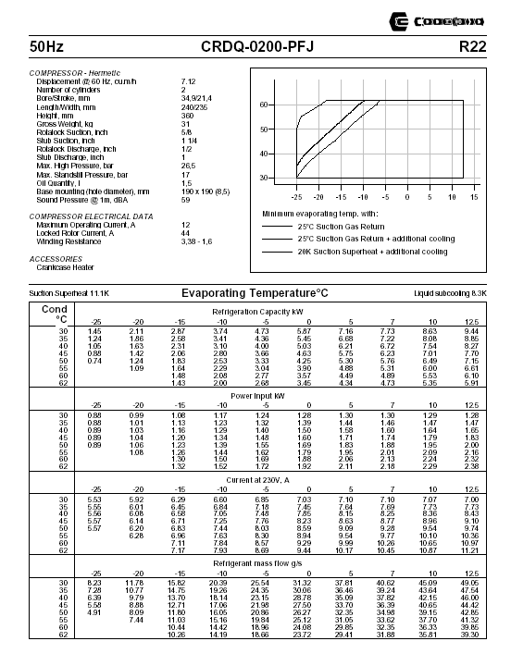

The Evaporator and the condenser Models

The following Figures represent the Geometric composition of both of the Condenser and the evaporator :
- The term “tubes per circuit” is the number of parallel passages the refrigerant mass flow rate is divided among.
- The number of parallel circuits is used to determine the number of tubes in each row. If the number of parallel circuits is set to 12, and the number of tubes per circuit is 2, then there will be a total of 24 tubes in each row.
- The number of rows refers to the number of tube rows in the direction normal to air flow.

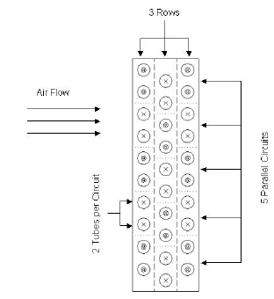

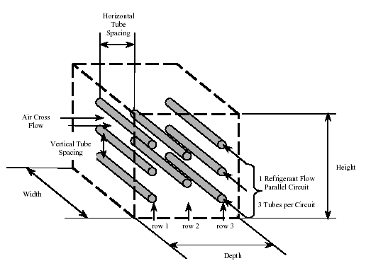

NTU-Effectiveness Relations

For the heat exchanger, the total heat rejected from the hot fluid, in this case, refrigerant, to the cold fluid, air, is dependent on the heat exchanger effectiveness and the heat capacity of each fluid.:
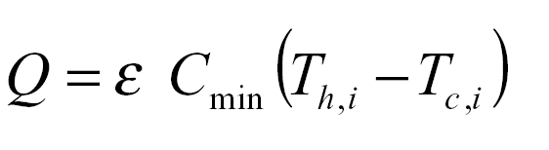
As in both of the conceder and the evaporator there is more than a refrigerant state then the following applies for each portion
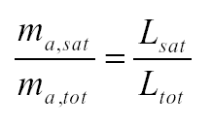
The equations used to determine the effectiveness depend on the temperature
distribution within each fluid and on the paths of the fluids as heat transfer takes place, ie. parallel-flow, counter-flow or cross-flow. In typical condensers and evaporators, the refrigerant mass flow is separated into a number of tubes and does not mix. As the air flows through the fins, the plates prevent mixing and air at one end of the heat exchanger will not necessarily be the same temperature as air at the other end. For a cross-flow heat exchanger with both fluids unmixed, the effectiveness can be related to the number of transfer units (NTU) with the following equation:
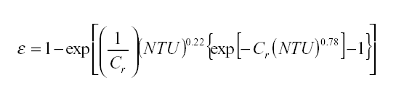
Cr = heat capacity ratio
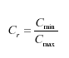
In the saturated portion of the condenser, the heat capacity on the refrigerant side
approaches infinity and the heat capacity ratio goes to zero. When Cr =0, the
effectiveness is calculated with the following equation :
Where 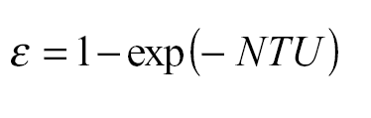
And 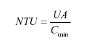
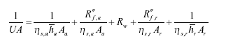

The surface Efficiency
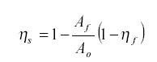
where:
ηs = surface efficiency
Af = total fin surface area
Ao = total air side surface area, tube and fins
ηf = fin efficiency
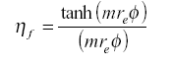
For a plate fin heat exchanger with multiple rows of staggered tubes, the plates can be evenly divided into hexagonal shaped fins as shown in Figure

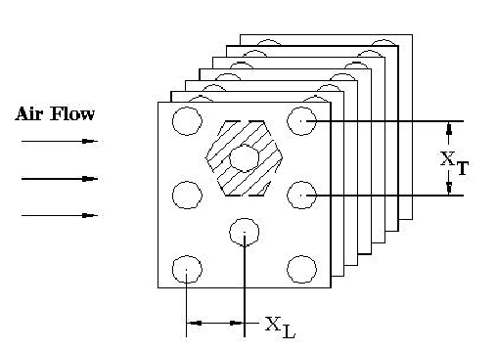

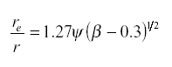
where:
re=equivalent radius of fins
r = outside tube radius
The coefficients ψ and β are defined as:
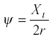
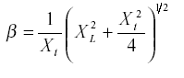
Once the equivalent radius has been determined, the equations for standard circular fins can be used. For the fins in this study, the length is much greater than the
thickness, so a parameter m can be expressed as:
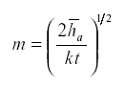
where: ha = air side heat transfer coefficient
k = conductivity of fin material
t = thickness of fins

And
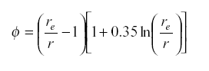

The Heat transfer for the air side of the condenser ( without condensation)

The model is developed for dry coils. The heat transfer coefficient is based on the Colburn j-factor, which is defined as:

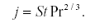
Substituting the appropriate values for the Stanton number, St, gives the following
relationship for the air-side convective heat transfer coefficient, .ha,
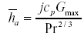
where
cp is the specific heat,
Gmax is the mass flux of air through the minimum flow area which is expressed as:
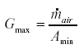
McQuiston use a 4-row finned tube heat exchanger as the baseline model, and define the Colburn j-factor for a 4-row finned-tube heat exchanger as:
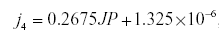
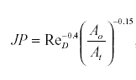
Ao is the total air side heat transfer surface area (fin area plus tube area), and At is
the tube outside surface area. The Reynolds number, ReD in the above expression is
based on the outside diameter of the tubes, Do, and the maximum mass flux, Gmax. The area ratio can be expressed as:
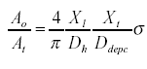
Ddepc is the depth of the condenser in the direction of the air flow, Dh is the hydraulic
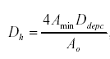
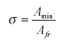
The j-factor for heat exchangers with four or fewer rows can be found using the following correlation, where z is No. of rows, and Rers is based on the row spacing, Xrs,
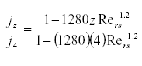
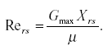

Refrigerant Side Models

Single Phase Heat Transfer Coefficient

To find the single phase heat transfer coefficient, the standard heat transfer equations and the experimental work of Kays and London were considered. Kays and London
have established equations in the transition region. The heat transfer coefficient was
related to the Stanton number, St. The Stanton number is defined by the following:

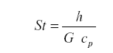
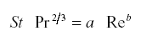
where: cp= specific heat
The coefficients a and b are based on the flow regime.
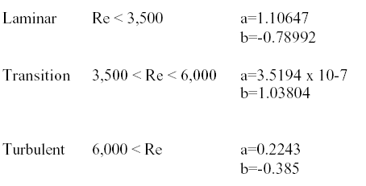

The heat transfer Coefficient For complete condensation,
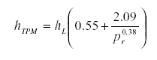

Evaporative heat transfer Coefficient
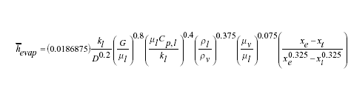

Pressure drop

Single phase pressure drop equations are, Straight tube pressure drop,

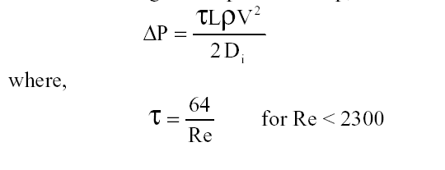
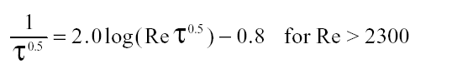
pressure drop in bending and friction coefficient was defined as
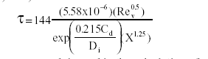

Two phase pressure drop equations in Straight tube pressure drop,

For horizontal tube, the components of the total pressure gradient are related to wall
friction and acceleration gradient as follows:
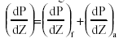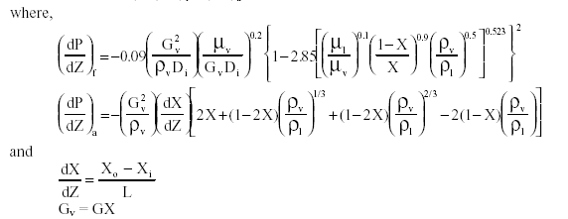

Expansion Device

For TXV the Evaporator load is calculated from Maps as follows

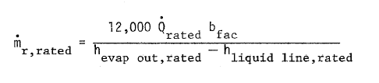

Where Q rated is function in degree of sub cool and TXV type and evaporation temperature as follows

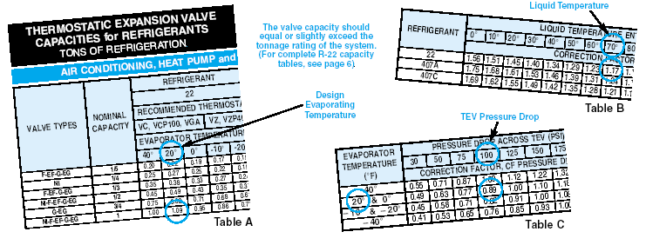

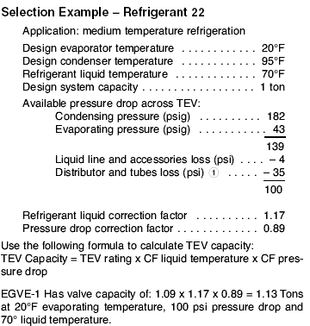

Conclusion

The collection of the Equations required to Model the Heat Pump Dryer is a challenge and the Equations were collected and indicated as per the paper details this forms the first part in creating a numerical Model to implement the design parameters and study their effect on the cycle

- Yang, Z.; Zhu, Z.; Zhao, F. Simultaneous control of drying temperature and superheat for a closed-loop heat pump dryer. Appl. Therm. Eng. 2016, 93, 571–579. [Google Scholar] [CrossRef]
- Singh, A.; Sarkar, J.; Sahoo, R.R. Energetic and exergetic performance simulation of open-type heat pump dryer with next-generation refrigerants. Dry. Technol. 2019, 1–13. [Google Scholar] [CrossRef]
- Liu, Y.; Zhao, K.; Jiu, M.; Zhang, Y. Design and drying technology research of heat pump Lentinula edodes drying room. Procedia Eng. 2017, 205, 983–988. [Google Scholar] [CrossRef]
- dryer. Food Chem. 2018, 260, 152–159. [Google Scholar] [CrossRef] [PubMed]
- TeGrotenhuis, W.; Butterfield, A.; Caldwell, D.; Crook, A.; Winkelman, A. Modeling and design of a high efficiency hybrid heat pump clothes dryer. Appl. Therm. Eng. 2017, 124, 170–177. [Google Scholar] [CrossRef]

- Fundamentals of the Finite Element Method for Heat and Mass Transfer Second Edition P. Nithiarasu, R. W. Lewis, and K. N. Seetharamu
- HEAT AND MASS TRANSFER DURING AIR DRYING OF FRUITS Manal H. AL-Hafidh Shaimaa Mohammed Ameen Ass. Prof. /University of Baghdad Mechanical Engineer
- Anderson, Dale A., John C., Tannehill, Richard H. and Pletcher (1984), Computational Fluid Mechanics and Heat Transfer,
- Engineering Equation solver EES , https://fchartsoftware.com/ees/
- Chemkhi S., Zagroba F. and Bellagi A. (2005), Modeling and Simulation of Drying Phenomena with Rheological Behavior, Brazilian journal of chemical engineering, vol. 22, no.02, pp153-163, April- June
- Desrosier N.W. (1985), The Technology of Food Preservation”, pp219-257, 4. ed., Westport, USA.
- Frank P. Incropera and David P. Dewitt (1996), Fundamentals of Heat and Mass Transfer, Wiley, New York.
- Prarin Chupawa, Wanwisa Suksamran, Donludee Jaisut,4 Frederik Ronsse, and Wasan Duangkhamchan Combined Heat and Mass Transfer Associated with Kinetics Models for Analyzing Convective Stepwise Drying of Carrot Cubes
- Kumar C., Karim M.A., Joardder M.U.H. Intermittent Drying of Food Products: A Critical Review. J. Food Eng. 2014;121:48–57. doi: 10.1016/j.jfoodeng.2013.08.014
- Castro A.M., Mayorga E.Y., Moreno F.L. Mathematical Modelling of Convective Drying of Fruits: A Review. J. Food Eng. 2018;223:152–167. doi: 10.1016/j.jfoodeng.2017.12.012.
- Mahapatra A., Tripathy P.P. Modeling and Simulation of Moisture Transfer during Solar Drying of Carrot Slices. J. Food Process. Eng. 2018;41:e12909. doi: 10.1111/jfpe.12909
- Ibrahim Dinçer, Calin Zamfirescu Drying Phenomena Theory and Applications
- Odilio Alves-FilhoHeat Pump DryersTheory, Design and Industrial Applications

