Review Article

Dr. Uttamrao Mahajan Collage of B Pharmacy Chalisgaon

**A Comprehensive Review of Conjunctivitis: Types, Causes, Symptoms, Therapies and their Treatments.**

**Yashwant Sanjay Ahire 1 Rutuja Gajanan Chaudhari 2**

**Mohammad Awais3, Momin Sanaurrehman4, Dr. Swapnil Deo5.**

**Abstract:**

Eye flu is the popular disease, which affect millions of individuals each year throughout the world. It is also referred to as viral conjunctivitis and is a viral infection that causes redness and itching of the eyes. Bacterial conjunctivitis is rare and the second most common cause of conjunctivitis. Eye flu was first described in print by S.T.Quellmaz in 1881. Human adenovirus is the (HAdV) is the most common cause of viral conjunctivitis accounting for 65 % to 90 % of cases. Long-term usage of eye drops with preservatives in a patient with conjunctival irritation and discharge point to the toxic conjunctivitis as the underlying etiology. In this review, we discuss how it is treated, diagnosed, managed, and challenged.

**Keywords:**

Conjunctivitis, Viral, Bacterial, Adenovirus, Treatment, Management, Challenges.

**INTRODUCTION**

Every year, millions of people around the world are affected by a disease called eye flu. Also known as viral conjunctivitis, this condition is an infection caused by various viruses that causes the eyes to become red, itchy, and itchy. Conjunctivitis, commonly known as pink eye, is inflammation of the conjunctiva, the membrane that covers the outer layer of the eye and the inner part of the eyelid.

The most common form of conjunctivitis is viral conjunctivitis, which is usually caused by adenoviral infection of the eye. British rock Quellmaz first published a description of conjunctivitis in 1881. Bacteria, viruses, allergens and irritants are the main causes of conjunctivitis, a disease of the conjunctiva. The cause of conjunctivitis may or may not be infectious. Viral conjunctivitis followed by viral infections is the most common cause of infection, while allergies and toxins that cause infection are the most common causes of infection.

From the perspective of chronic disease, conjunctivitis can be divided into acute conjunctivitis lasting more than 4 weeks, subacute conjunctivitis and acute conjunctivitis lasting more than 4 weeks. Additionally, conjunctivitis may be labeled as severe if the patient has severe symptoms and mucopurulent discharge. It has been reported that blepharoconjunctivitis and keratoconjunctivitis may be associated with tissue involvement such as eyelids and calluses. It also treats diseases in the body, including conjunctivitis and the immune system.

**History:**

Conjunctivitis of the newborn (ophthalmia neonatorum) was first described by S.T. in 1750. Quellmaz. In 1883, Koch discovered two types of bacillary conjunctivitis or ophthalmia egyptian. In 1886, Weeks discovered that the same organism caused pink eye.

In 1963, supramarginal keratoconjunctivitis was first described by Thygeson and Kimura as a chronic, localized, filamentous conjunctivitis, and was later named "superior limbic keratoconjunctivitis" by Theodore. Hemorrhagic conjunctivitis was first described in Ghana in 1969.Four outbreaks of hemorrhagic conjunctivitis occurred in the Western Hemisphere between 1981 and 2003. In 2006, hemorrhagic conjunctivitis (in more than 200,000 people) was reported in Brazil.

**Types of Conjunctivitis:**

**1. Viral Conjunctivitis -**

As the name suggests, viral conjunctivitis is caused by a virus that is transmitted through the air or direct contact. Viruses that cause colds, respiratory problems, or diseases such as measles or herpes are often the cause of viral infections. Up to 80% of severe conjunctivitis cases are caused by infection, and many of these cases are misdiagnosed as infectious.65% to 90% of viral conjunctivitis (VC) is caused by adenoviruses, which give us the most common features associated with VC;Follicular conjunctivitis, pharyngeal conjunctivitis, fever and destructive keratoconjunctivitis. **­**

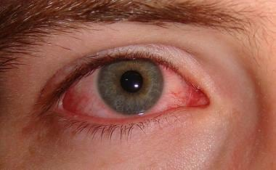

**Fig.1 Viral Conjunctivitis**

Viral conjunctivitis is a self-limiting disease that does not require antibiotics unless there is a secondary infection. Cold compresses can help relieve discomfort, but most patients should let the disease run its course. Antiviral drugs such as acyclovir are not indicated

**2. Bacterial Conjunctivitis -**

Bacteria such as Staphylococcus, Streptococcus and Haemophilus are responsible for this conjunctivitis, which is highly contagious and spreads easily, especially in children. All broad-spectrum ophthalmic antibiotics are effective in treating conjunctivitis, and there does not appear to be a difference between antibiotics in treatment success. Factors influencing antibiotic choice include local availability, patient allergies, resistance patterns, and cost.

Many studies on conjunctivitis have shown that approximately 90% of affected individuals may experience symptoms of sticky and itchy eyelids; These findings are followed by lesser signs and symptoms, such as purulent discharge and burning eyes. Haemophilus influenzae conjunctivitis may be associated with otitis media and upper respiratory tract infections.More than 60% of patients feel the same for a week or two, and serious complications are rare. Conjunctival diseases, especially in conditions associated with corneal epithelial defects such as dry eye, place patients at higher risk for corneal inflammation Although antibiotics can prolong the duration of the disease, neither outcome is different from treatment.

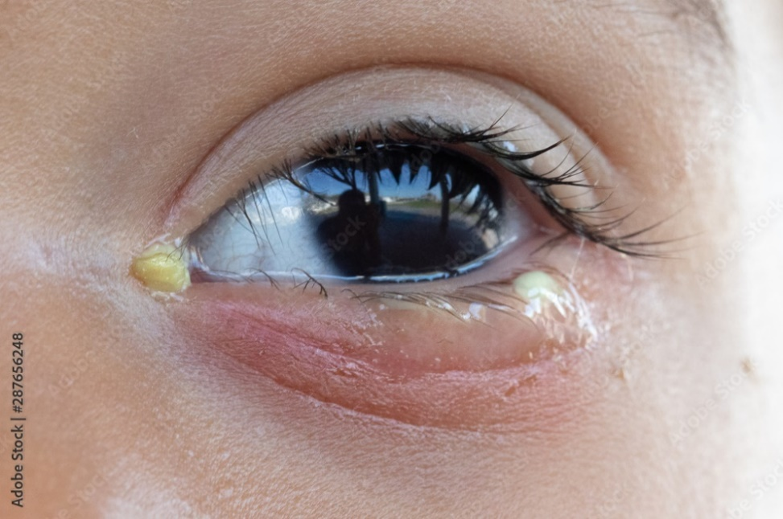

**Fig. 2 Bacterial conjunctivitis**

**3. Allergic Conjunctivitis -**

It mostly occurs in people with allergies, and many personalized medications can cause allergic diseases. This type of conjunctivitis is usually seasonal and is seen more in spring and seasonal transitions. Other allergies are usually dust, pollen, cosmetics, perfumes, or medications, and red eye symptoms usually affect both eyes, with severe itching and swelling being common. Eye irritation is common. The number of allergic diseases is increasing over the years, and this increase is thought to be caused by many factors such as genetics, city air, contact with animals and children. 28-30 Allergic conjunctivitis is a cap to seasonal allergies.

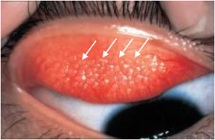

**Fig.3 Allergic Conjunctivitis**

**Symptoms:**

* **Viral Conjunctivitis symptoms:**

Among these, conjunctivitis is usually caused by adenovirus in 65% to 90% of conjunctivitis. Viral conjunctivitis is often associated with an upper respiratory tract infection, cold, or sore throat. Symptoms include tearing and itching. The infection usually starts in one eye but can easily spread to the other. Conjunctivitis causes redness of the eyes, swelling, clear, mucoid or mucopurulent discharge, tightness of the eyelids (especially when you first wake up), and swelling of the papillae of the upper eyelid.

* **Bacterial Conjunctivitis symptoms:**

Eyes with conjunctivitis may be red, dull, and sticky. Symptoms usually appear first in one eye but spread to the other eye within 2-5 days. Sometimes pain or itching is felt in many places, in which case the patient can understand that there is a foreign body in the eye. Infections are caused by Staphylococcus, Streptococcus, and Haemophilus less frequently than Chlamydia.

* **Allergic Conjunctivitis symptoms:**

Conjunctival edema develops in eyes with allergic conjunctivitis. Allergic conjunctivitis is inflammation of the conjunctiva due to allergy. Certain allergies may vary from patient to patient. Symptoms result from the release of histamine and other reactive substances from mast cells and include redness (due to dilation of small peripheral blood vessels), conjunctival swelling, itching, and discharge. There is no perfect treatment and some medications used cause problems. Cold packs may help relieve minor symptoms. Astringent drops such as zinc sulfate will not solve the problem but may reduce the symptoms.

**Diagnosis:**

Diagnosis of pink eyes is usually based on symptoms, medical archives, and physical examination. Your doctor may use a special light to look at the back of your eye and check for abnormalities or signs of disease. They may also take a sample of the secretion and send it to the laboratory for testing; however, this is more likely if pink eye reoccurs or if the cause is unknown.

Doctors will pay attention to the type of discharge and other factors that can help them determine the type of conjunctivitis you have. Your doctor can rule out infection if you have other symptoms of the disease, such as fever or sore throat. Thick, sticky, yellow-green discharge usually indicates an infection, while thin, watery discharge usually indicates an allergy or infection. Your doctor may also check your eyes for other underlying conditions that may cause red eyes, including dry eyes, allergies, or excessive contact lens use.

Conjunctival incisional operation is irregularly finished when granulomatous diseases (e.g., sarcoidosis) or dysplasia are suspected (Mark, 1996). The cellular response in conjunctivitis varies according to the cause, as follows:

* Bacterial infections: Neutrophils predominate
* Viral infections: Lymphocytes predominate
* Allergic reactions: Eosinophils predominate

**Different therapies used in conjunctivitis:**

* **Allopathic Therapy:**

Allopathic medicine is an expression commonly used by homeopaths and proponents of other forms of alternative medicine to refer to mainstream medical use of pharmacologically active agents to treat or suppress symptoms or pathophysiologic processes of diseases or conditions.

* **Homeopathy Therapy:**

Homeopathy (also spelled homoeopathy) from the Greek hómoios páthos "like- and "suffering") is a system of alternative medicine produced in 1796 by Samuel Hahnemann, based on his principle of like cures like, according to which a substance that causes the symptoms of a disease in healthy people will cure similar symptoms in sick people. Homeopathy is a pseudoscience and its remedies have been found to be no more effective than placebo.

* **Ayurveda Therapy:**

Ayurvedic medicine is a system of Hindu traditional medicine native to the Indian subcontinent and a form of alternative medicine. The oldest known ayurvedic texts are the Suśrutha Samhitā and the Charaka Samhitā. In classical Sanskrit literature, Ayurveda was called "the science of eight components", a classification that became canonical for Ayurveda (Tripathi, 2000).

1. General medicine – Kāya-chikitsā: "cure of diseases affecting the body”

2. Pediatrics – Kaumāra-bhrtya: "treatment of children”

3. Surgery– Śhalya-chikitsā: "removal of any substance which has entered the body (as extraction of darts, of splinters, etc.)"

4. Ophthalmology / ENT/Dentistry – Śālākya-tantra: "cure of diseases of the teeth, eye, nose or ear etc. by sharp instruments"

5. Demonology / exorcism / psychiatry – Bhoot (ghost)-vidyā: "treatment of mental diseases"

6. Toxicology – Agada-tantra: Gada means Poison. "doctrine of antidotes”

7. Anti Agings – Rasayana-tantra: "doctrine of Rasayana”

**Fig. 4 Different therapies used in conjunctivitis**

**Treatment:**

1. Regular eye examinations are also recommended for general eye health, as they can help detect hidden problems. Also, if you wear contact lenses or glasses, follow good hygiene when handling them.

2. Do not self-medicate or take eye drops. Please consult an ophthalmologist for correct and treatment.

3. Although most cases of conjunctivitis are infectious and self-limiting, antibiotic eye drops are used to treat additional infections.

4. Antihistamines: Over-the-counter antihistamines may temporarily relieve symptoms by reducing itching and reducing allergic reactions associated with eye infections.

5. Nonsteroidal anti-inflammatory drug may also help decrease pain, and eye redness.

6. Over-the-counter pain relievers (such as acetaminophen or ibuprofen) can help relieve headaches or discomfort such as eye pain. Do not use contact lenses.

7. Consume foods in rich vitamin C: Consume foods rich in vitamin C to strengthen your immune system and aid the healing process. Citrus fruits (including oranges, grapefruits and lemons), strawberries, kiwis, guavas and peppers red peppers are an excellent source of vitamin C.

8. Eat foods rich in beta-carotene: "Beta-carotene is converted to vitamin A in the body, which is important for maintaining health and boosting immunity. Add foods like carrots, sweet potatoes, pumpkin, squash, mangoes, apricots, and more spinach and kale to your diet."

9. Include omega-3 fatty acids: Omega-3 Fatty acids have anti-inflammatory properties that help reduce eye inflammation and improve overall eye health. Include fatty fish (such as salmon, mackerel, sardines and trout) and plant sources containing omega-3s (such as flaxseeds, chia seeds, walnuts and hemp seeds) in your diet.

**Drug and their Brand names:**

|  |  |  |
| --- | --- | --- |
| Sr. No. | Composition | Brand Name |
| 1. | Ciprofloxacin | Ciproxin, Cipwell, Ciloxan  Cprokap, Ciplox. |
| 2. | Tobramycin and fluorometholone | Flutob-SP, Tobum-F, Flurokick-T  Ucitob-F, Tovib-FM. |
| 3. | Moxifloxacin | Milflox, Moxylen, Moxicip  Mahaflox, Vigamox. |
| 4. | Moxifloxacin and Dexamethasone | Mahaflox-D, Cantomox-D, Moxitik-D,  Polytis-D, Moxisure-D. |
| 5. | Levofloxacin | Levox, Levokap, Levoris,  Levoflox, Loxaprime. |
| 6. | Chloramphenicol | Renicol, Divicol, Iracol,  Livchlor, Simercetin. |

**Conclusion:**

Most occurrences of conjunctivitis in children are caused by bacteria and manifest themselves clinically as purulent discharge and mattering of the eyes. As with other upper respiratory symptoms, viral conjunctivitis causes a gritty feeling and watery discharge. In most cases, both eyes are affected by allergic conjunctivitis, and symptoms tend to flare up when pollen counts rise. People who wear contact lenses, live in particularly polluted areas, and those whose symptoms extend beyond conjunctivitis are more likely to be affected by these and other less common causes of the condition. Antibiotics may be indicated for some cases of bacterial conjunctivitis, however this will vary according to the severity of the infection, the patient's and family's preferences, and the clinician's therapeutic philosophy. If a case doesn't improve after a reasonable amount of time, it should be sent to someone who specializes in eyes.

1) Allopathy has captured nearly the whole market. Other therapies are left with only the small space to thrive in.

2) Every therapy has its own benefits and limitations: Allopathy in rapid in action but has various side-effects. Homeopathy is relatively slow in action but very safe. Ayurveda is also relatively quick and safe but nowadays it is drug have been adultered.

3) Each therapy treat conjunctivitis in its own unusual way.

**References:**

1. Shekhawat NS, Shtein RM, Blachley TS, Stein JD. Antibiotic prescription fills for acute conjunctivitis among enrollees in a large United States managed care network.Ophthalmology 2017; 124:1099-1107.
2. Smith AF, Waycaster C. Estimate of the direct and indirect annual cost of bacterial conjunctivitis in the United States. BMC Ophthalmol 2009;9:13.
3. Publishing LLC; 2020.
4. Buckner, Frederick S., Anne C. Moore and MSC. Chagas Disease. Travel Trop Med Man E-b 68.2016; 68:2016.
5. Ryder EC, Benson S. Conjunctivitis. In: StatPearls. Treasure Island (FL): StatPearls Moudgil T, Kaur B, Singh G. Preferred practice patterns of ophthalmologists in management of viral conjunctivitis. Indian J Clin Exp Ophthalmol.2019:5(3):390-4.
6. Gupta AK, Sarin GS. Serum complement component depression during acute adenovirus conjunctivitis. Br J Ophthalmol. 1984; 68(5):350-2.
7. Baj, J., Forma, A., Teresinska, B., Tyczyńska, M., Zembala, J., Januszewski, J., & Teresinski, G. (2022). How Does SARS-CoV-2 Affect Our Eyes- What Have We Learnt So Far about the Ophthalmic Manifestations of COVID-19? Journal of clinical medicine, 11(12), 3379.
8. & Vanderveen, D. K. (2021). Retinopathy of prematurity screening and risk mitigation during the COVID-19 pandemic. Journal of American Association for Pediatric Mantagos, I. S., Wu, C., Griffith, J. F., Jastrzembski, B. G., Gonzalez, E., Goldstein, S., ... Ophthalmology and Strabismus, 25(2), 91-el.
9. Alnahdi, M. A., & Alkharashi, M. (2023). Ocular manifestations of COVID-19 in the pediatric age group. European Journal of Ophthalmology, 33(1), 21-28.
10. 1-1011 Mallika P, Asok T, Faisal H, Aziz S, Tan A Intan G (2008) "Neonatal conjunctivitis a review Malays Fam Physician 22021 Reports from the obstetrical clinic in Leipzig Prevention of eye inflammation in the newborn. Am J Dis Child 121
11. Mallika P, Asok T, Faisal H, Aziz S, Tan A, Intan G (2008). "Neonatal conjunctivitis - a review" Malays Fam Physician. 3 (2): 77–81. PMC 4170304. PMID 25606121.
12. Smith K. 2012. Homeopathy is Unscientific and Unethical. Bioethics 26(9):508–512.
13. Tripathi KD. 2000. Essentials of Medical Pharmacology, Fourth edition; Jaypee Brothers Medical Publishers Ltd, New Delhi.
14. Tuomela R. 1987. Chapter 4- Science, Protoscience, and Pseudoscience; In Pitt JC, Marcello P, Rational Changes in Science: Essays on Scientific Reasoning, Boston Studies in the Philosophy of Science (Springer), pp. 83–101.
15. Varsney RL. 2000. Marketing Management, 2nd edition; Dr. S.L. Gupta Sultan Chand and Sons, New Delhi Wells JC. 2009. Longman Pronunciation Dictionary, London: Pearson Longman. Bio-social Issues in Health pp 129 by Anil Kishore Sinha.
16. Ryder EC, Benson S. Conjunctivitis. In: StatPearls. Treasure Island (FL): StatPearls Publishing LLC; 2020.
17. de Laet C, Dionisi-Vici C, Leonard JV, McKiernan P, Mitchell G, Monti L, et al.Recommendations for the management of tyrosinaemia type 1. Orphanet J Rare Dis 2013;8:8–8. [PMC free article] [PubMed]
18. Sati A, Sangwan VS, Basu S. Porphyria: varied ocular manifestations and management. BMJ Case Rep 2013;2013:bcr2013009496. [PMC free article] [PubMed]
19. Narayana S, McGee S. Bedside diagnosis of the ‘Red Eye’: a systematic review. Am J Med 2015;128:1220–1224.e1221. [PubMed]
20. Everitt H, Little P. How do GPs diagnose and manage acute infective conjunctivitis? A GP survey. Fam Pract 2002;19:658–660. [PubMed]
21. La Rosa M, Lionetti E, Reibaldi M, et al. Allergic conjunctivitis: a comprehensive review of the literature. Ital J Pediatr 2013;39:18. [PMC free article] [PubMed]
22. Chopra, AS. 2003. Ayurveda, In Selin Helaine, Medicine across Cultures: History and Practice of Medicine in Non Western cultures, Kluwer Academic Publishers, pp 80.
23. Goodman and Gillman. 2011. The Pharmacological Basis of Therapeutics, Fifth edition, Mc Graw-Hill Medical Publishing Division, New York.
24. Mannis MJ, Macsai MS, Huntley AC. 1996, Eye and skin disease, Lippincott-Raven, Retrieved, 2014-04-23.
25. Sandford Smith J. Eye Diseases in Hot Climates.Second Edition, Butterworths, 1990
26. Caldwell DR, Verin Hartwick-Young R, MeyerSM, Drake MW. Efficacy and safety of Lodoxamide 0.1% vs. Cromolyn Sodium 4% in patients with vernal keratoconjunctivitis. Amer J Ophthalmol 1992: 113: 632–37