IOT EMPOWERED SMART STICK ASSISTANCE FOR VISUALLY IMPAIRED

Raghul kumar S1, Nishar Ahamed T2, Magesh Kannan N3, Ganesh Kumar S4, Saravana Selvan A5,

1Bachelor of Engineering, Department of ECE, National Engineering College, Kovilpatti, India. 2 Bachelor of Engineering, Department of ECE, National Engineering College, Kovilpatti, India. 3Bachelor of Engineering, Department of ECE, National Engineering College, Kovilpatti, India.

4Bachelor of Engineering, Department of ECE, National Engineering College, Kovilpatti, India.

5Assistant Professor, Department of ECE, National Engineering College, Kovilpatti, India.

[119110](mailto:119110)[97@nec.edu.in,](mailto:1911043@nec.edu.in)  [219110](mailto:219110)[93@nec.edu.in,](mailto:1911027@nec.edu.in) [31911080@nec.edu.in](mailto:1911008@nec.edu.in), 41911064[@nec.edu.in](mailto:1911008@nec.edu.in),

5saravanaselvan@nec.edu.in

*Abstract -* **The smart walking stick for people with visual impairments is shown in this work and is based on ultrasonic sensors, water sensors, Arduino, and voice processors. The World Health Organization estimates that there are about 37 million blind persons in the world. Individuals with visual impairments frequently require outside help, which may come in the form of trained dogs, people, or specialized technological gadgets that act as decision-support systems. We were thus inspired to create a clever white cane to get around these restrictions. We were able to achieve this by adding ultrasonic sensors to the cane in certain locations that detect items on the left, right, and front sides and reflect the discovered objects to the user under voice processor control. We put forth a low-cost, lightweight device that uses sensors and an Arduino to interpret signals and warn the blind person of any obstacles, bodies of water, or gloomy areas. Thealarm system then warns the user to take immediate action. The system is made up of obstacle and water detection sensors for signal reception, processing, and transmission. The system was created, developed in C language, and validated by a person who is visually challenged. The sensor can detect up to 100cm.**

INTRODUCTION:

The WHO estimates that 285 million people worldwide are visually impaired, of which 39 million are blind and 246 have poor vision. Our area of focus is the issue of reading, one of the many issues that blind people encounter. Science and technology are developing, yet the methods utilized by the blind are archaic despite these advancements. For the most part, Braille is used in reading materials for the blind. A person must learn Braille solely for reading, and if he or she is unable to do so, reading will be impossible for them. The fact that incorrect data will be read as a result of an understanding error is another drawback. The last drawback is that in order for the blind to read books, documents, etc., they must be transformed into elevated dots. The number of Braille-formatted books and papers available for the blind is fairly little in compared to the huge number of books that are printed every day. Thus, a reading aid for the blind is a requirement.

This page describes how to utilize a raspberry pi as the primary unit, which includes an integrated camera used to scan any written document and turn the image into digital text using optical character recognition (OCR). The digitized text is then translated into a synthesized voice using a text to audio technology. We are utilizing a raspberry pi, a single-board computer about the size of a credit card. It is an entire computer unto itself, replete witha functional operating system. Depending on how the device is used, the operating system may change.We used an Atmega328 in our article and wrote thecode in the language of Python. The World Health Organization estimates that 285 million individuals around the world are visually impaired. There are an estimated 50 million blind persons worldwide who need independent mobility to work, go outside, integrate into society, and perform all other everyday tasks. According to figures from the 2011 census, India has the highest number of blind persons in the world at 12 million. The previously employed white cane has significant drawbacks since the subject must be close to the obstacle in order to feel the location of the barrier with the whitecane's tip. He might run into other barriers while perceiving the white can's impediment. The nearby impediment is not disclosed by the white can. The specially created smart walking stick is fitted with numerous sensors that warn the user of potential hazards as he walks. This walking can has health monitoring capabilities. With the use of such healthmonitoring tools, users can check their pulse rate and body temperature. Sticks come with GPS and GSM components that can be used to track the user'swhereabouts and alert others. The voice alert systemis yet another crucial aspect of this walking stick. The user will receive voice alerts when there is an obstacle, pit, wet surface, or health concern. The blind person's mobility will be made easier because he will become more alert after hearing voice alerts.This smart stick also has significant inbuilt functionsfor item, pit, and water detection. These characteristics of smart walking sticks aid the mobility and accident prevention of elderly and

blind users. With the use of this clever walking stick, the user can move around freely and without assistance in an unfamiliar environment. This technology offers a solution for smart electronic assistance for blind persons in both public and private settings. The ultrasonic sensor, water sensor, speech playback board, raspberry pi, and speaker are all parts of the proposed system. With the aid of a camera, the suggested method locates obstacles that are visible both indoors and outdoors. Using an ultrasonic sensor, the Stick calculates the separation between the items and its smart walking stick. The headphone announces the name of the obstacle that is in front of the stick when any items or obstacles come within range of an ultrasonic sensor.

1. HARDWARE DESCRIPTION
2. ARDUINO UNO

An integrated circuit (IC) known as a microprocessor contains the essential components of a computer's central processing unit (CPU). It is a clock-driven, register-based, programmable multipurpose silicon device that accepts binary data as input and processes it in accordance with instructions stored in memory. Microprocessors and microcontrollers have significant differences. The silicon chip that makes up a microprocessor has an ALU, register circuits, and control circuitry. Microcontrollers are silicon chips with a microprocessor, memory, and I/O all in one unit. The Arduino board's ATMEGA 328 microcontroller serves as its processor. There are almost 28 pins in it. By sending and receiving inputs to the external device from these 28 pins, the inputs can be controlled. Furthermore, pulse width modulation is included (PWM). These PWM are used to pulse- modulatory convey the whole signal. It uses input power supplies like Vcc and Gnd. These integrated circuits mostly have analogue and digital inputs. Many applications employ these analogue and digital inputs to carry out their processes.

1. ULTRASONIC SENSOR

By sending out a brief ultrasonic burst and then "listening" for the echo, the PING sensor locates objects. The sensor sends off a brief 40 kHz (ultrasonic) burst under the direction of a host microcontroller (trigger pulse). This burst moves through the air at a speed of around 1130 feet per second before hitting something and returning to the sensor. The PING))) sensor sends an output pulse to the host, and since this pulse will end when an echo is detected, its breadth reflects the target's distance. When an object in the air causes the ultrasonic wave being transmitted by the ultrasonic transmitter to be

reflected back towards the sensor, the ultrasonic receiver module can view this reflected wave.

1. LIQUID CRYSTAL DISPLAY (LCD)

The LPG, propane, methane, hydrogen, alcohol, smoke, and carbon monoxide content in the air is determined by a sensor known as the MQ2 gassensor using electronics.. As a chemo- resistor, the MQ2 gas sensor is also known. In response to contact with the gas, the sensing component's resistance alters. Gas can be detected using thisvariation in resistance value. Metal oxide semiconductors are the sort of gas sensors used in MQ2. The gas concentrations in the gas are determined using the voltage divider network of thesensor. 5V DC electricity is required for the sensor to function. Between 200 and 10,000 ppm of gas canbe detected by it.A liquid crystal is a substance that will flow like a liquid but whose molecular structure has some features often associated with solids (usually organic for LCDs). A low power gadget is the liquid crystal display (LCD).

1. VOICE PROCESSOR

To play MP3 files stored on a micro SD card or USB memory, use the Non-Destructive MP3 Decoding Board with Self-Powered TF Card U Disk Decoded Player module. The ideal tool for playing warning signals, messages on platforms, etc. superior audio caliber. The speaker (recommended 4 3W speakers) is connected to the onboard 2W mono amplifier (5V power of up to 3W), and the 3.5mm gold-plated headphone connection can be used to connect headphones or external music. containing a Micro USB port.

through a USB 5V power supply, 3.7V lithium battery, or transportable power supply. support for the TF Card (memory card for mobile phones) and U disc play modes. Speaker terminals don't require soldering for simple wiring. The modification will be made by the module.

1. EXISTING SYSTEM

Those with serious conditions are unable of moving on their own. These people typically live in poverty in today's fast-paced society. Several techniques have been employed to assist them and give them some degree of movement comfort. The traditional approaches of using trained dogs or a cane to provide information about potential obstacles are not sufficient. Also, controlling and teaching dogs is a difficult undertaking. There are some guidance systems that employ RFID. Nevertheless, using this technology in a public outdoor space is not possible. This paper suggests a straightforward electronic

guidance system to assist blind and visually impaired people's mobility both indoors and outdoors. an effective and customizable embedded vision system.

III PROPOSED WORK

This system comprises of two units, such as the head unit and the blind stick. We employ four ultrasonic sensors in the blind stick. For blind persons, it is used to identify obstacles at a specific distance. Conductivity sensor is used to measure the water level of the blind walking area. We use an Arduino controller in this unit. The controller receives sensor data and communicates with blind individuals verbally. Microcontroller is another headset component we employ. Information will be announced by the controller using a voice processor and speaker.

1. BLOCK DIAGRAM

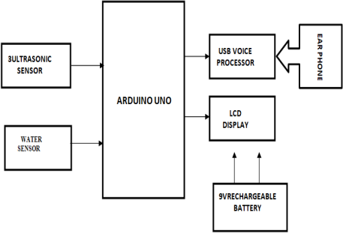

**Fig1. Block Diagram**

1. CIRCUIT DIAGRAM

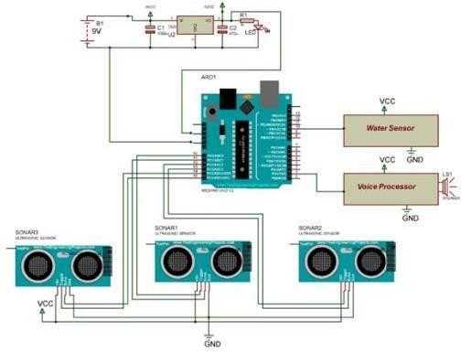

**Fig2. Circuit Diagram**

VI.OUTPUT

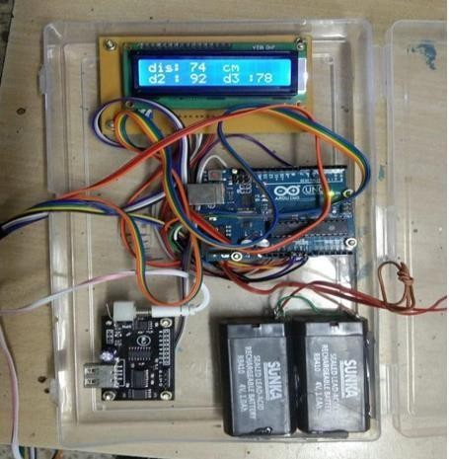

**Fig3. Obstacle Detected**

VII. WORKING

This system has two units: a transmitter and a receiver. Each device has its own power source, such as a battery. It is utilized to supply power to every component. Arduino serves as our controller. 28 pins are on it. We have four ultrasonic sensors and are like a blind stick. For blind persons, it is used to identify obstacles at a specific distance. The area where blind people walk has its water levelmeasured using a conductivity sensor. They are connected to the ultrasonic sensor's controller ports A0 through A5.Connected to controller port 10 is theconductivity sensor. Every sensor sends data to the controller, which can then raise the threshold value to alert the blind persons via voice output. Thecontrollers 2 and 3 are connected to the voice processor unit. The information is announced by speakers using it.

* 1. CONCLUSION

The Smart Walking Stick for the Blind is an embedded technology that will be used to lessen the difficulties faced by blind individuals. The blind will be able to go from one location to another using this technology without assistance. It will serve as a foundation for the development of additional visually impaired assistive technology, and it will be a huge help to the blind. The created system performs well at spotting obstructions in front of the user. The sensor is a crucial component of this system since it allows the blind to move freely by detecting objects in front of them.These attributes make it the ideal walking aid for blind and visually impaired people on the road. So, the system can address the issues that the blind encounter on a regular basis. Also, the system employs safeguards to protect them. In the modern world, living with a disability of any kind, including blindness, can be challenging for anyone. Typically, blind individuals are treated unfairly. Giving a blind person vision is

quite challenging. This project provides a straightforward, efficient, and electronic guided embedded vision system. The technology supports blind and visually impaired people's mobility whether they are indoors or outside, enabling them to be very independent.

* 1. REFERENCES

1. T. Ahonen, A. Hadid, and M. Pietikainen, "Face description with local binary patterns: Application to face recognition," IEEE transactions on pattern analysis and machine intelligence, vol. 28, no. 12, pages 2037–2041, 2006.
2. "Learning compact binary face descriptor for face recognition," IEEE transactions on pattern analysis and machine intelligence, vol. 37, no. 10, pp. 2041–2056 (2015). J. Lu, V. E. Liong, X. Zhou, and J. Zhou.
3. "Half-face dictionary integration for representation-based categorization," IEEE Transactions on Cybernetics, vol. 47, no. 1, pp. 142- 152, 2017. X. Song, Z.-H. Feng, G. Hu, and X.-J.

Wu

1. "Gaussian mixture 3d morphable face model," Pattern Recognition, vol. 74, pp. 617-628, 2018. P. Koppen, Z.-H. Feng, J. Kittler, M. Awais, W. Christmas, X.-J. Wu, and H.-F. Yin.
2. X. Song, Z.-H. Feng, G. Hu, J. Kittler, and X.-J. Wu, "Dictionary integration for pose-invariant collaborative representation-based categorization using 3d morphable face models," IEEE Transactions on Information Forensics and Security, vol. 13, no. 11, pp. 2734-2745, 2018.
3. "Deepface: Bridging the Gap to Human-Level Performance in Face Verification," Proceedings of the IEEE Conference on Computer Vision and Pattern Recognition, 2014, pp. 1701–1708. Y. Taigman, M. Yang, M. Ranzato, and L. Wolf.
4. "Cosface: Wide margin cosine loss for deep face identification," Proceedings of the IEEE Conference on Computer Vision and Pattern Recognition, 2018, pp. 5265–5274. H. Wang, Y. Wang, Z. Zhou, X. Ji,

D. Gong, J. Zhou, Z. Li, and W. Liu.

1. "Arcface: Additive angular margin loss for deep face identification," Proceedings of the IEEE Conference on Computer Vision and Pattern Recognition, 2019, pp. 4690–4699. J. Deng, J. Guo,

N. Xue, and S. Zafeiriou.

1. P.Tejaswitha and G. Prasanthi Transactions on Engineering and Sciences, " Sensor Assisted Stick for the Blind People ".
2. "Obstacle Detection and Position Finding For Blind Persons," by A.Sangami, M.Kavithra, K.Rubina, and S.Sivaprakasam.
3. Ankita R.Pawar, M.M.Mahajan "Multitasking Stickfor Indicating Safe Way to Visually Impaired Persons".
4. Shruti Dambhare, Professor A. Sakhare, "Smart Stick for Blind: Obstacle Detection, Artificial vision, and Real-time help via GPS"

"The thirdeye for the blind utilising Arduino and ultrasonic sensor," by M. Narendran, Sarmistha Padhi, and Aashita Tiwari

1. "Smart walking stick for blindperson" by Sathya, S. Nithyaroopa, P. Betty, G. Santoshni, S. Sabharinath, and M. J. Ahana.
2. Jayakumar, S.Magesh, K. Prasanth, P. Umaheswari, and R. Senthilkumar, "Smart Walking Stick for Visually Impaired People".
3. Adekunle, Dada Emmanuel, Gbenga, Arhyel, Ibrahim Shani, and Dada Emmanuel. "Smart walking stick with Arduino and ultrasonic sensor for those with vision impairment"

[17]D. Sekar, S. Shivakumar, P. Thiyagarajan, R. Premkumar, and Vivekkumar, "Ultrasonic and voice-based smart stick".