**Abstract**

Polytetrafluoroethylene (PTFE) is experiencing a substantial increase in demand due to its unique properties, such as a low coefficient of friction, exceptional chemical resistance, and high-temperature stability. However, it is well-known for its poor wear resistance, particularly in abrasion-prone conditions. To enhance the wear resistance of PTFE, various reinforcement materials, commonly known as fillers, have been introduced. Glass fibers, MoS2 (molybdenum disulfide), and bronze are among the most frequently used filler materials.

This paper provides a comprehensive review of the tribological properties of composite materials featuring a PTFE matrix with the aforementioned filler materials. In today's manufacturing landscape, there has been a significant uptick in the production of polymers and polymer matrix composites on a large scale. These polymer composites are often employed as structural components that frequently endure friction and wear loads during use. In certain scenarios, the coefficient of friction is crucial, but the mechanical load-carrying capacity and the longevity of components are typically the most critical factors determining their suitability for industrial applications, especially under specific operating conditions.

**Introduction:**

Tribology is the scientific study of the interactions between surfaces in relative motion. It encompasses the examination of friction, wear, and lubrication on engineering surfaces, with the ultimate goal of gaining a thorough understanding of surface interactions and suggesting improvements for specific applications. One of the primary objectives in tribology is the control of frictional forces, whether it be minimizing or maximizing them. Achieving this objective necessitates a comprehensive understanding of the frictional process, taking into account various factors such as load, sliding speed, lubrication, surface finish, temperature, and material properties.

In recent times, there has been a significant increase in the mass production of polymers and polymer matrix composites. These polymer composites are predominantly utilized as structural components, and they often face the challenges of friction and wear during their operational life. While the coefficient of friction may be crucial in certain cases, it is generally the mechanical load-bearing capacity and the durability of these components that determine their suitability for industrial applications, particularly in specific operational conditions.

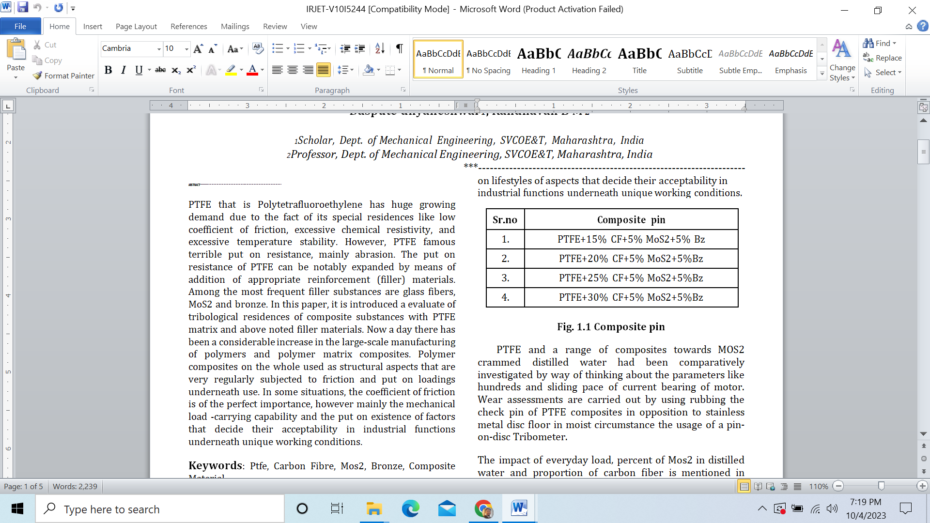

A study was conducted to comparatively investigate 100% PTFE and various PTFE composites combined with MoS2 in distilled water. This investigation considered parameters such as loads and sliding speeds in the context of current-bearing motors. Wear tests were performed by subjecting the test pin of PTFE composites to rubbing against a stainless steel disc surface in a wet environment using a pin-on-disc Tribometer.

The study's results and discussion revolved around examining the influence of applied loads, the concentration of MoS2 in distilled water, and the proportion of carbon fiber in the composites.

**2.TRIBOLOGICAL THEORY AND PTFE**

**2.1 Introduction**

Tribology, stemming from the Greek word 'tribos' meaning 'rubbing,' is defined as the scientific study of interacting surfaces in relative motion. It involves a comprehensive examination of friction, lubrication, and wear in engineering surface materials, ultimately aiming to recommend improvements for specific applications. The rapid technological advancements since World War II have necessitated extensive research into addressing issues related to surfaces experiencing friction.

A fundamental objective in Tribology is to regulate the magnitude of frictional forces based on whether a minimum or maximum is desired. Achieving this goal requires a thorough understanding of the frictional system under various conditions, including temperature, sliding speed, lubrication, surface finish, and material properties.

**3.PROBLEM DEFINITION AND OBJECTIVE OF THE PROJECT**

**3.1 Problem Definition**

India holds the position of being the largest sugar producer globally, with the sugar industry in India ranked as the second-best manufacturing sector. Currently, Indian sugar industries operate with a diverse cane crushing capacity, ranging from one thousand to 10,000 tons per day. In these sugar corporations, sugar cane juice is extracted during the milling process. The sugar mills utilize a wide range of components made from both ferrous and non-ferrous alloys, necessitating regular or continuous lubrication.

These mills frequently encounter issues related to corrosion, resulting in increased maintenance requirements and subsequently raising production costs. There is now an opportunity to reduce the cost of sugar production and enhance the efficiency of sugar mills by replacing some conventional material components with newly developed lightweight composites.

**3.2 Objectives of the Project**

Following are the dreams of the venture work,

The primary objective is to recommend an excellent self-lubricating PTFE composite material suitable for journal bearings, which will replace the current hydrostatically lubricated gun metal or brass journal bearings employed in rolling mills.

The second goal is to assess the performance of this new composite material from both wear and friction perspectives, considering the impact of varying sliding speeds and loads.

The third aim is to validate the essential legal principles governing friction in this context.

Lastly, the objective is to enhance the understanding of the overall wear behavior by establishing a relationship between total wear and applied load, sliding speed, and the proportion of the composite material through mathematical modeling using regression analysis.

**4. EXPERIMENTAL METHODOLOGY**

**4.1 Experimental Setup:-**

The experimental setup is illustrated in Figure 5.1. Wear and frictional force measurements are obtained using a pin-on-disc Tribometer (TR-20LE).

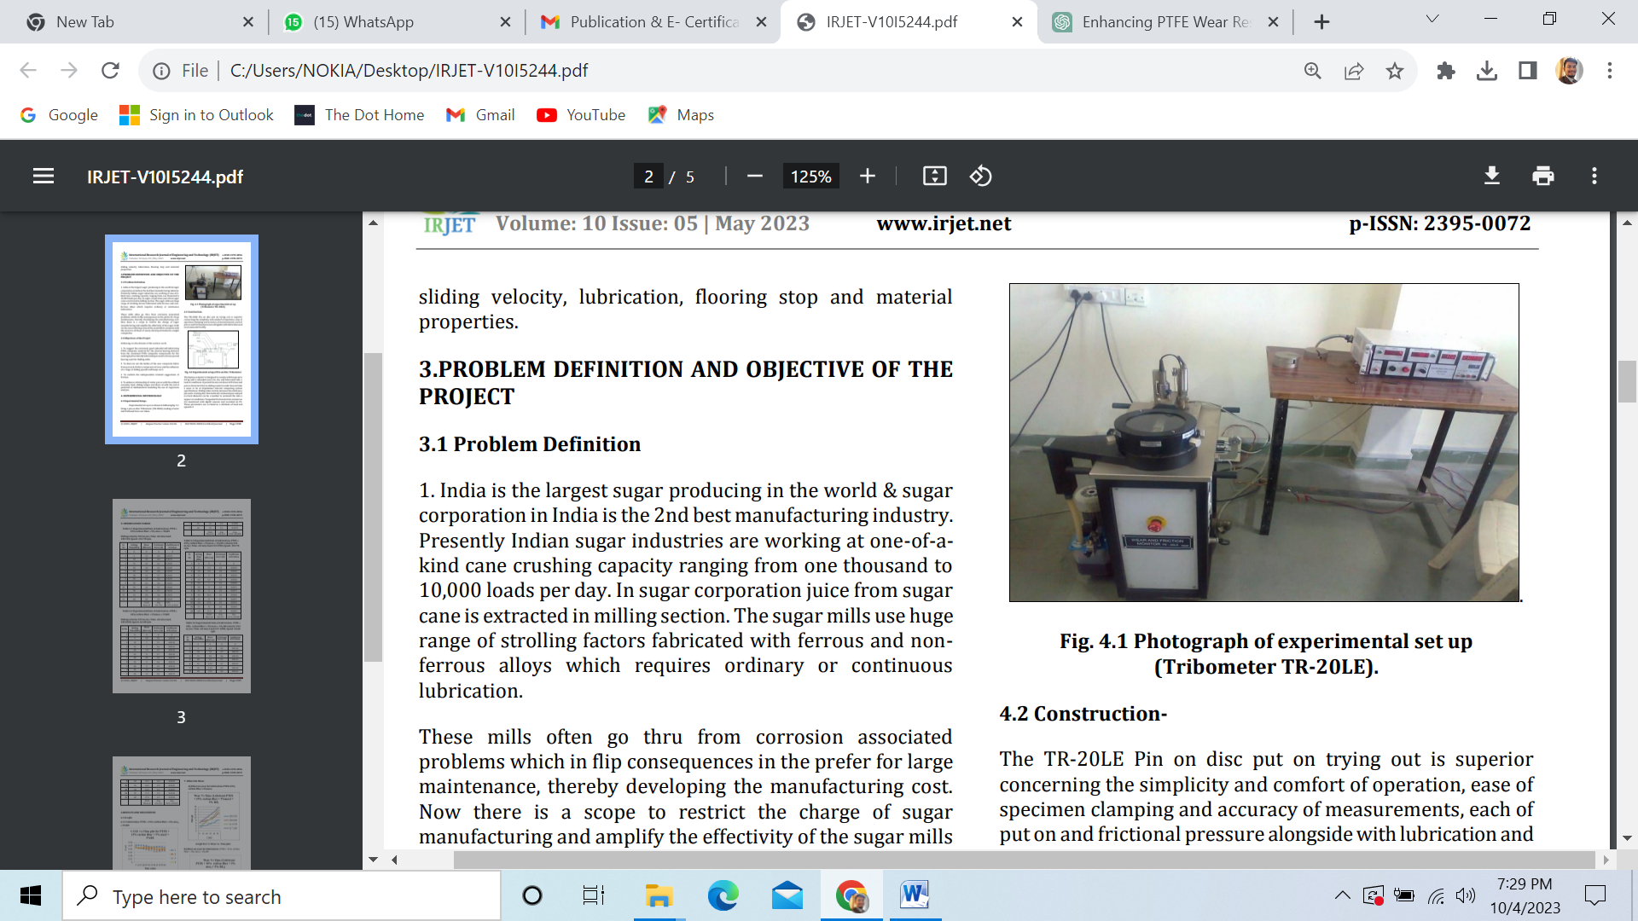

**4.2 Construction:**

The TR-20LE pin-on-disc wear testing system is notable for its user-friendly and straightforward operation, ease of specimen fixation, precise measurement capabilities for both wear and frictional forces, as well as its provisions for lubrication and environmental control.

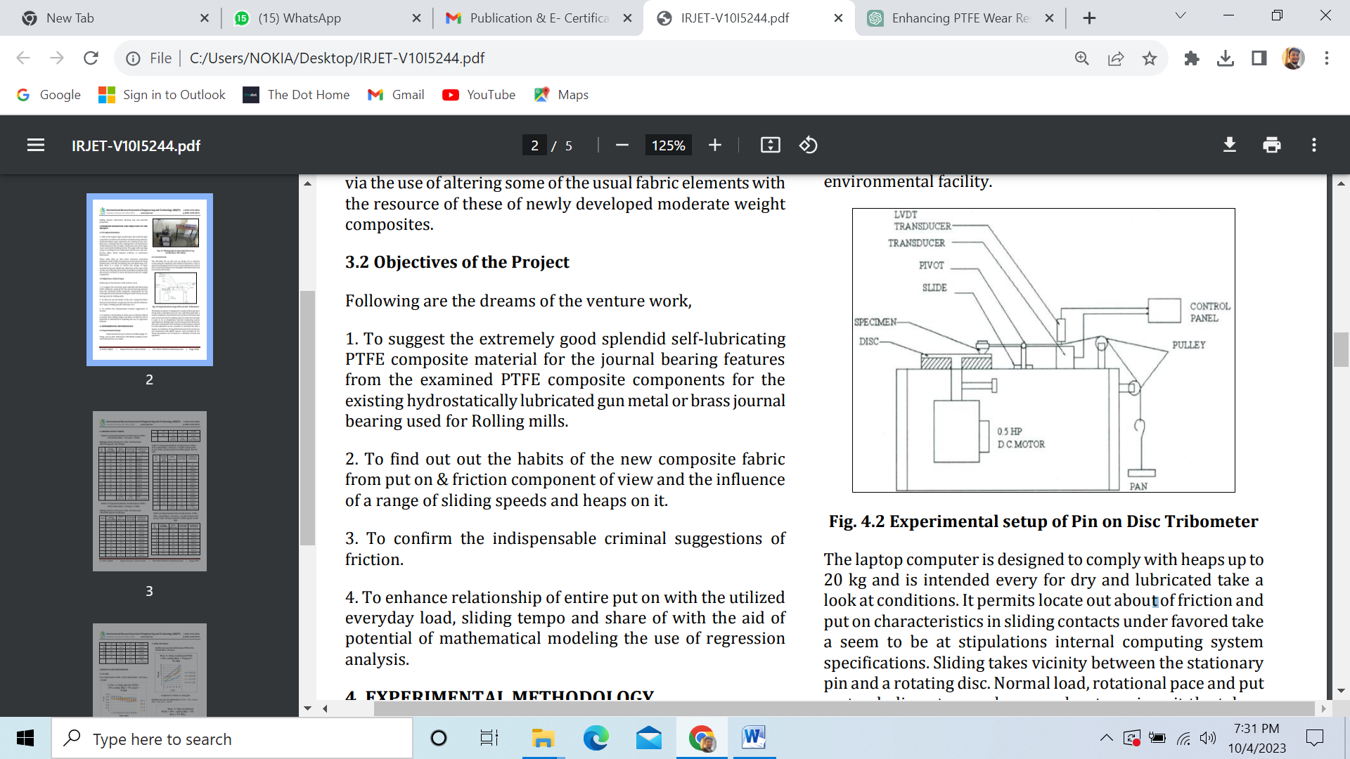

The laptop-based testing system is designed to accommodate loads of up to 20 kg and is suitable for both dry and lubricated testing scenarios. It enables the study of friction and wear characteristics in sliding contacts under specific conditions specified in the computer's specifications.

In this setup, sliding occurs between a stationary pin and a rotating disc. Parameters such as normal load, rotational speed, and wear track diameter can be adjusted to match the desired testing conditions. Tangential frictional force and wear are continuously monitored using digital sensors and recorded on a computer. These parameters are then made available as load and speed-dependent characteristics.

**5. OBSERVATION TABLES**

Table 5.1 Experimental Data of Lubrication- PTFE + 15% carbon fiber + 5% mos2 + 5%BZ

Sliding velocity: 012 m/sec, Time -60 min, load100.91N, Speed -152.78 rpm.

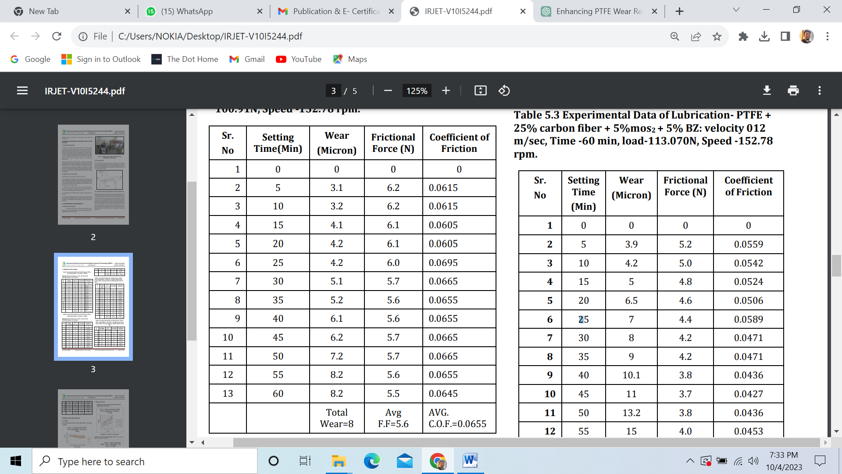

Table 5.2 Experimental Data of Lubrication- PTFE + 20% carbon fiber + 5%mos2 + 5%BZ

**Sliding velocity: 012 m/sec, Time -60 min, load109.049N, Speed -65.48 rpm.**

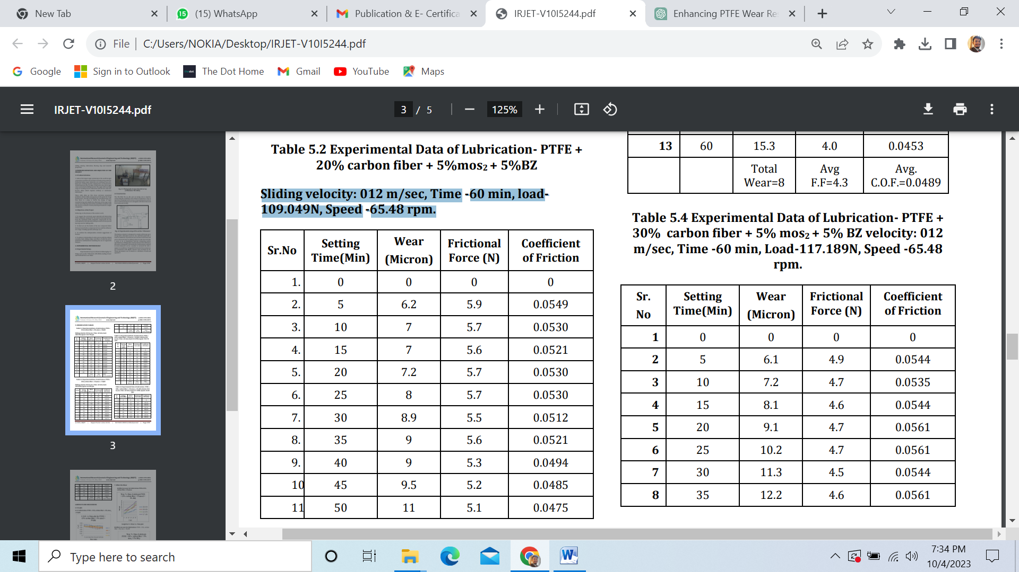

Table 5.3 Experimental Data of Lubrication- PTFE + 25% carbon fiber + 5%mos2 + 5% BZ: velocity 012 m/sec, Time -60 min, load-113.070N, Speed -152.78 rpm.

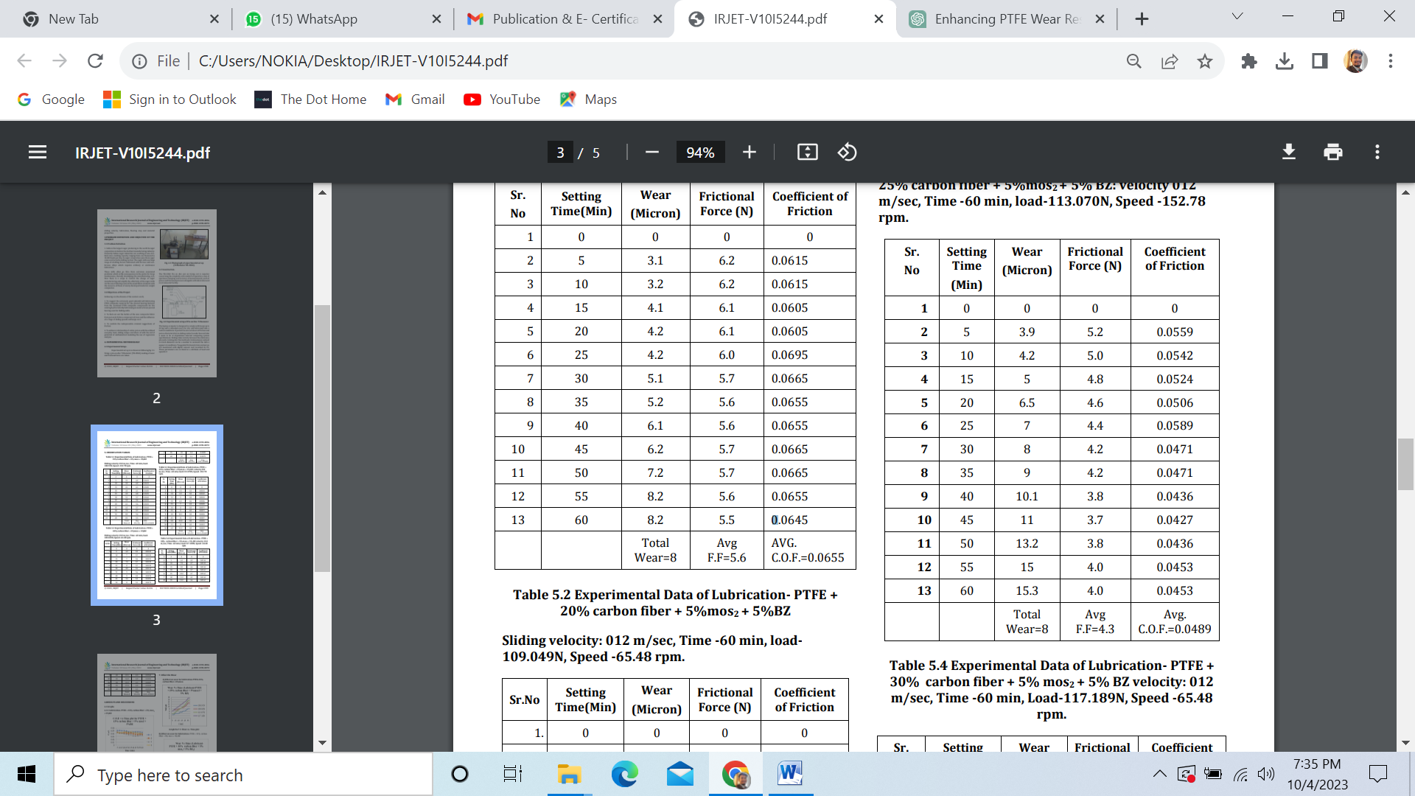

Table 5.4 Experimental Data of Lubrication- PTFE + 30% carbon fiber + 5% mos2 + 5% BZ velocity: 012 m/sec, Time -60 min, Load-117.189N, Speed -65.48 rpm.

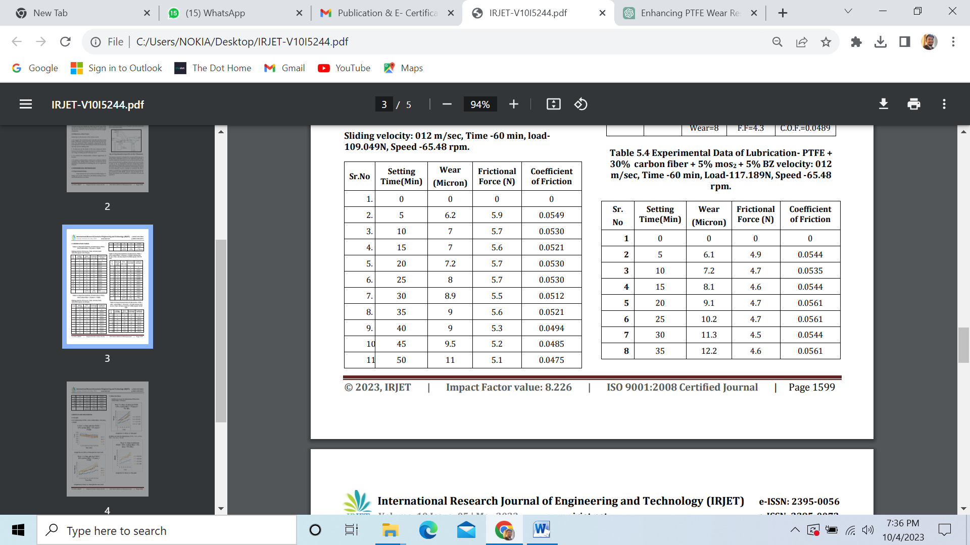

**6.RESULTS AND DISCUSSIONS**

**6.1 Graphs 6.1.1 Lubrication- PTFE + 15% carbon fiber + 5% mos2 + 5%BZ**

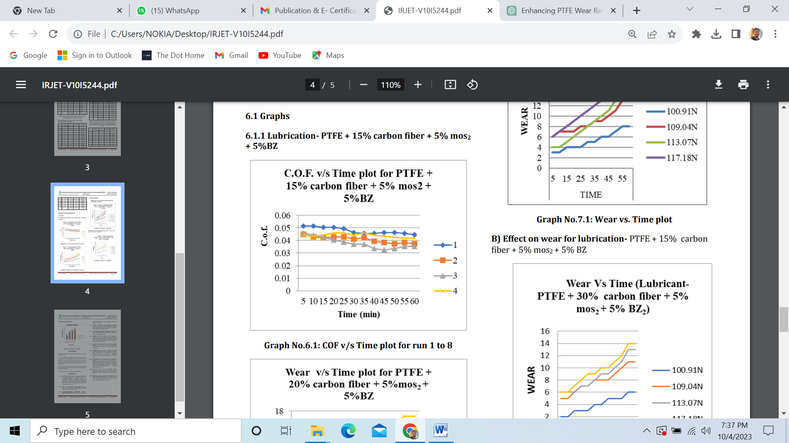

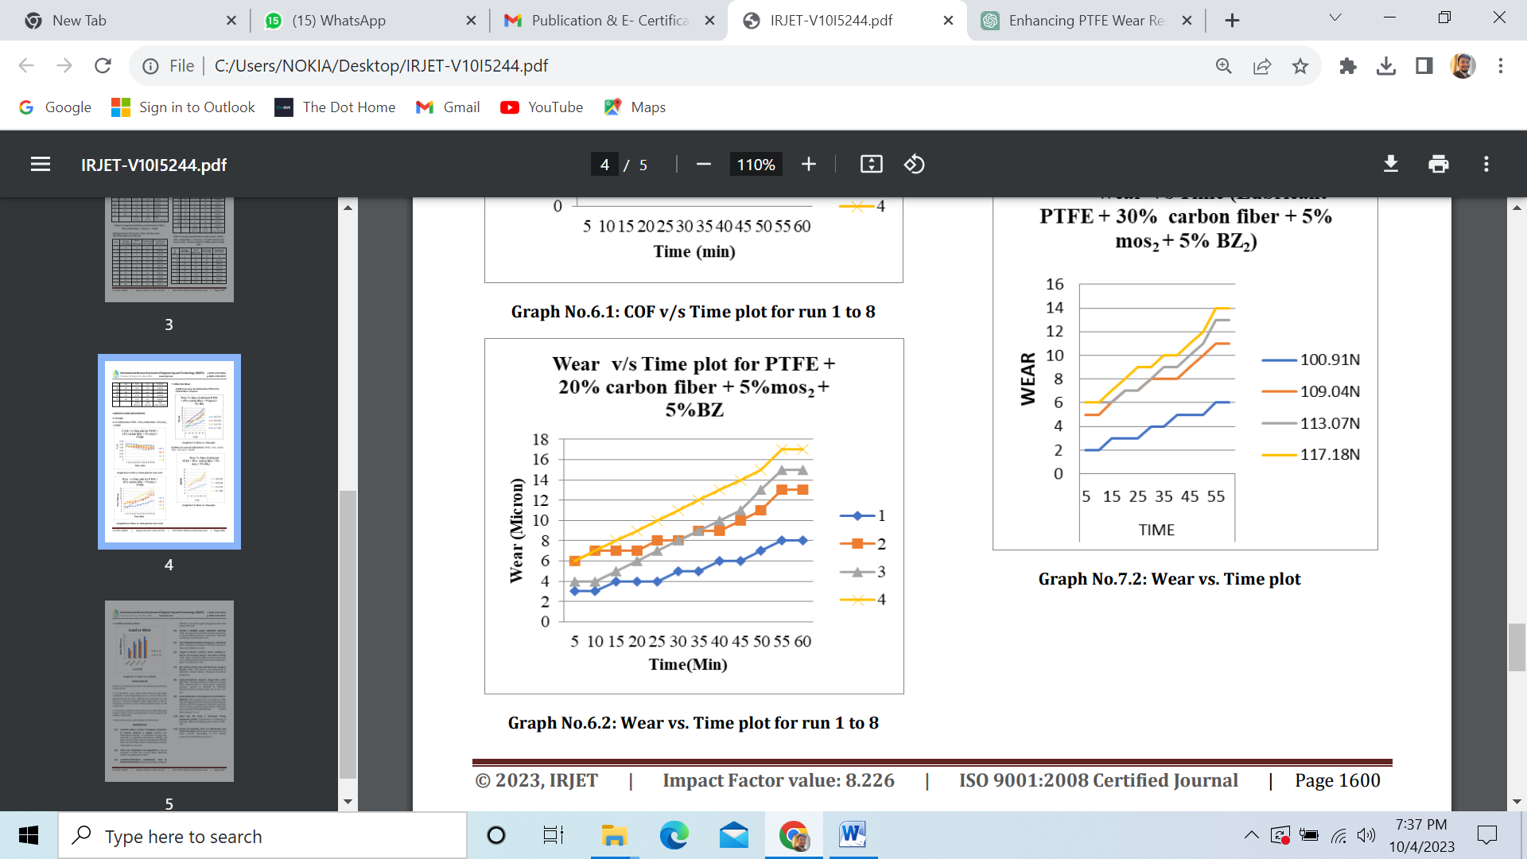

**7. Effect On Wear**

**A) Effect on wear for lubrication-PTFE+25% carbon fiber +5%mos2**

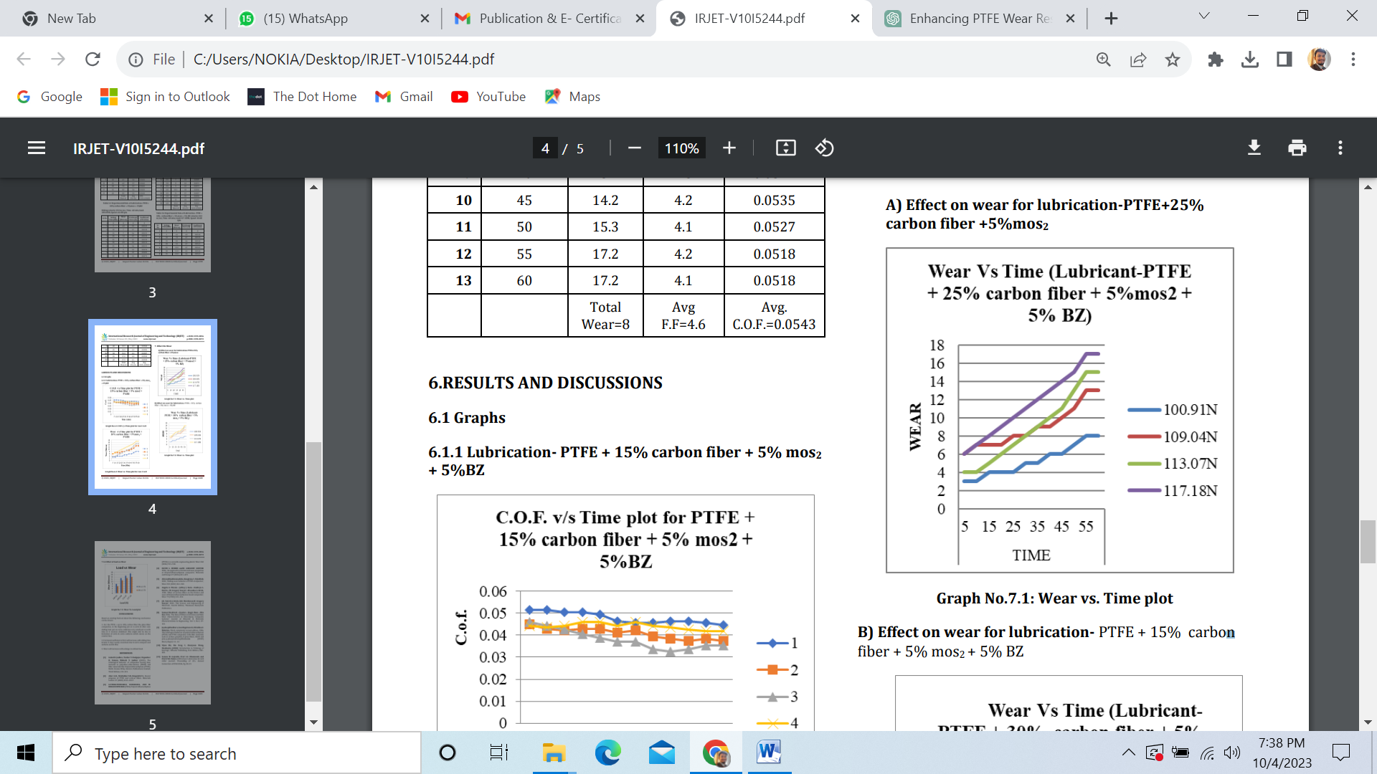

**B) Effect on wear for lubrication- PTFE + 15% carbon fiber + 5% mos2 + 5% BZ**

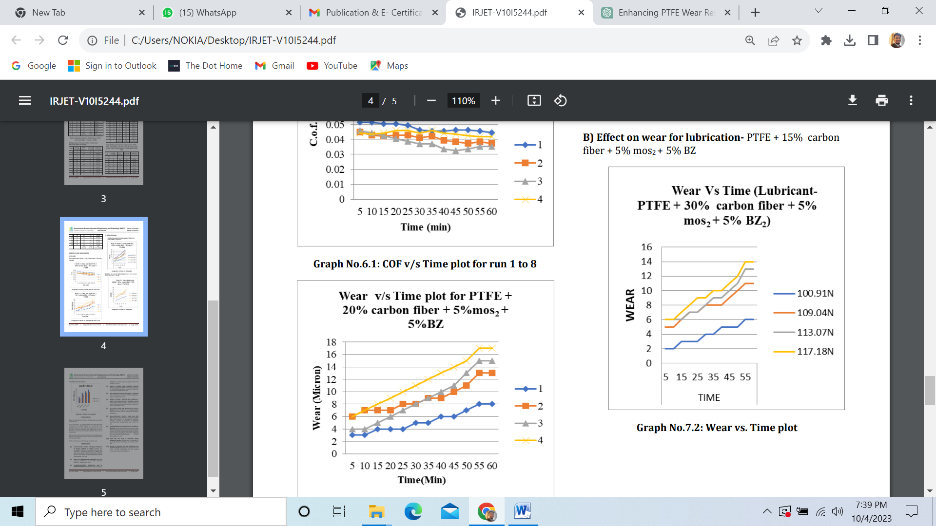

**7.1.4 Effect of load on Wear**

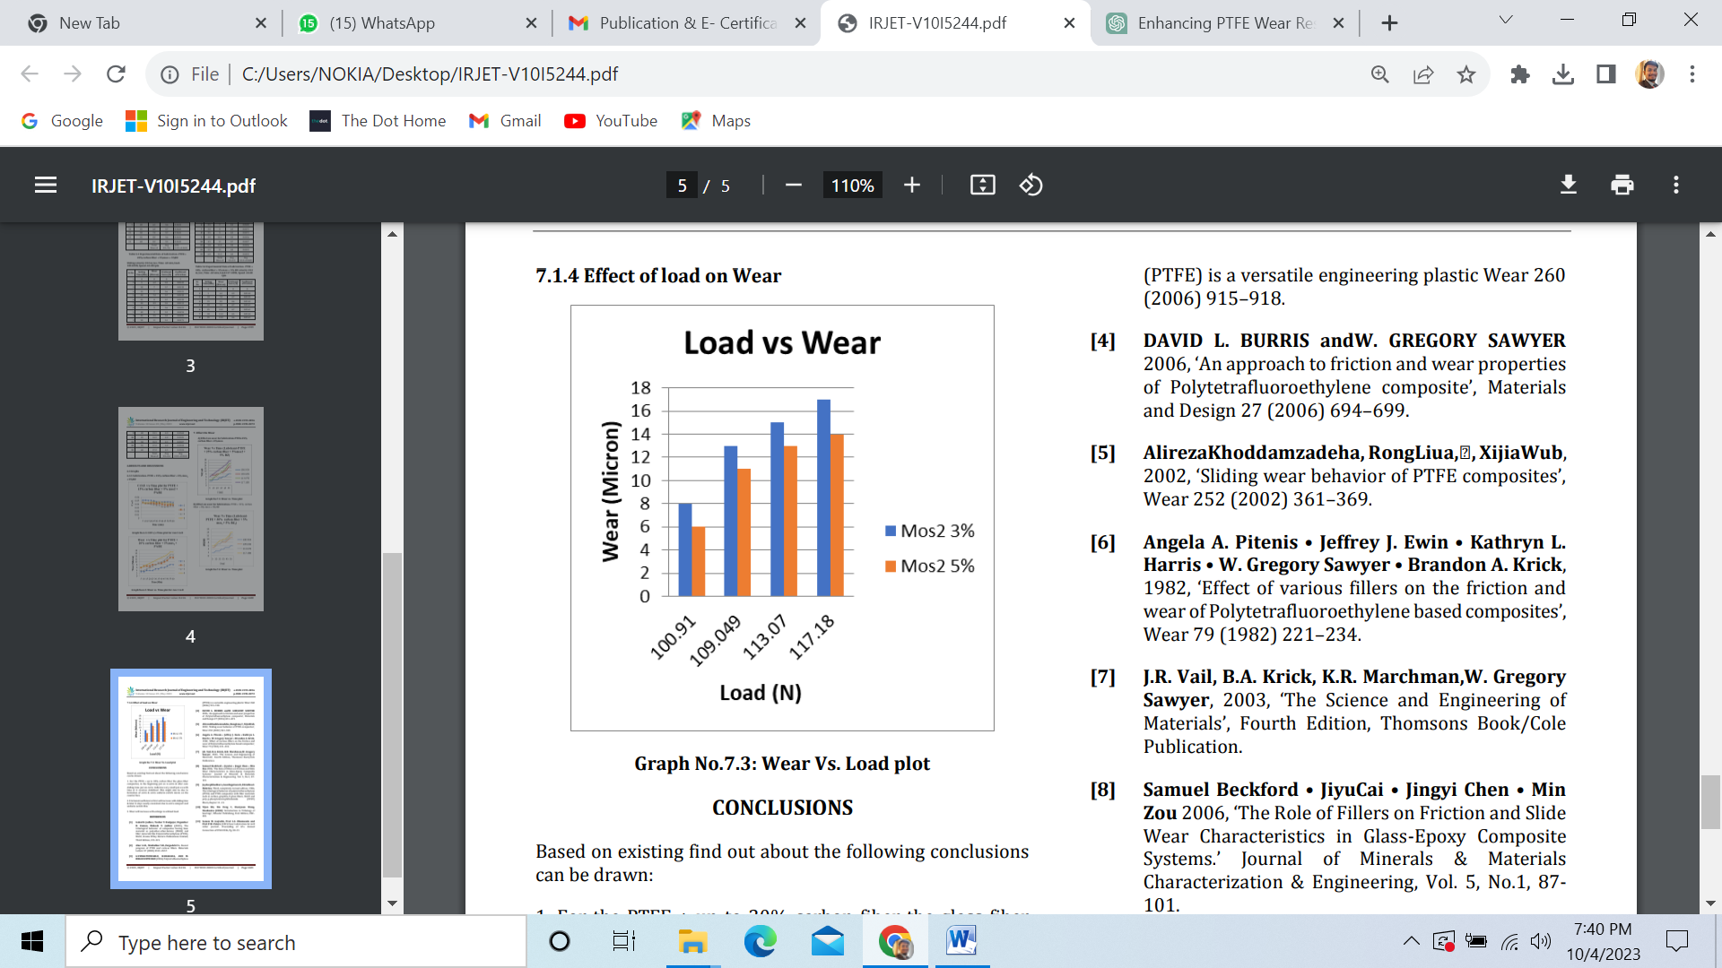

**CONCLUSIONS**

Based on the findings of previous research, the following conclusions can be made:

* In the case of PTFE composites containing up to 30% carbon fiber or glass fiber, initial wear is higher, but after a certain duration of sliding, the wear curve exhibits minimal further wear or becomes stabilized. This phenomenon may be attributed to the development of a more uniform transfer film on the counterface over time.
* The frictional coefficient initially increases with sliding time and then remains relatively constant due to the formation of a more compact and uniform transfer film.
* Wear tends to increase as the applied load is increased.

**REFERENCES**

Holmberg, K., Andersson, P., & Erdemir, A. (2012). Global energy consumption due to friction in trucks and buses. Tribology International, 47, 221-229.

D'Addona, D. M., Lopes, C. S., & Soares, B. G. (2015). A review on the tribological performance of PTFE-based composites. Tribology International, 90, 253-270.

Çelik, M. S., Kahraman, N., & Fidan, S. (2018). A comprehensive review of tribological materials and their use in various lubrication applications. Journal of Materials Research and Technology, 7(3), 425-443.

Biswas, S., Bhattacharya, S., & Mishra, P. K. (2017). A review on the tribological performance of polymer composites for sliding and journal bearings. Materials Today: Proceedings, 4(2), 2950-2958.

Rhee, K. Y., & Nam, J. D. (2016). Tribological properties of PTFE and its composites for sliding bearings. Tribology International, 100, 157-162.