ECO FRIENDLY PAPAYA STEM SANITARY NAPKINS ,FOR ALTERNATIVE USING OF CHEMICAL PADS .
Abstract :
Basically pads are made by petroleum gel and chemicals in present life . But in previous days at all they are using cotton clothes or other fiber content materials . The naturally available fibers that is suitable for absorb liquid such as cotton , banana fiber , jute , bamboo etc . these are basically biodegradable in nature and also having carbon footprint which not only makes it eco friendly and also reduce cost of pads . Organic pads are made by 100% organic material . The other pads are mixture of plastic and cotton and many other elements . These are made organic pad and which are free from irritation , and free from harmful effects also these are hygienic and comfort to use in previous . Today many natural sanitary pads are available but not in high process to sale . The chemical pads are major use of now a days and these are made cancer and skin irritation and many other harmful problems to health , so alternative of this we can made papaya tree stem sanitary pads . This is healthy and also bio degradable eco friendly too.
Key words : problems of using chemical sanitary pads , eco friendly sanitary pads , manufacturing process of papaya tree pads , benefit of papaya pads
1.Introduction :
In our daily life our peoples are not care about health the major example is health problem created by using non approval medicine and now days we are hearing about problem created by using sanitary napkins . which is contain inorganic substance and dangerous chemical substance . which cause cervical cancer and vagina cancer . That is a big issue but many of them don’t care about health . So after I entering into the deep research about sanitary pads and what are the ways to reduce it . I got idea to prepare pads from natural resource so I choose the papaya tree which has naturally contains fiber and also edible to absorb water and store .and also we know that papaya has many medical benefits and it give gloving to skin. the tree was grow 16 to 32 feet tall and spirally arranged leaves . it is water contain plant .papaya contain high level of antioxidants, vitamin a, vitamin c ,vitamin e. it used for heart diseases , diabetes ,cancer ,improving blood glucose level, lowering blood pressure and improving wound healing. But the steam parts are basically used for making rope . why not we can alternatively used for making pads . I make a research how its work . my out was success . finally the organic pad was made which give good comfort and reusable pad will sure that it does not create any hazardous to health . The obvious disadvantage of using a sanitary pads is irritation caused by wearing them for a long time . In papaya pad there is no cause of itching and discomfort because it is fully made up of organic natural material Not changing the pad often may also cause rashes on the skin In this pad there is no option to rashes and it is safety to our body skin also . It has a heavy particles to hold the fluid . so might not be flow outer .
2.Cellulose core :
Organic pads are contain absorbing components called cellulose . it is hold the menstrual liquid and keep it dry . like this bamboo pulp from bamboo tree also we can use for making pads . which prevents moisture from escaping .

Fibre | Cellulose (%) | Hemicellulose (%) | Lignin (%) | Wax (%) | Ash (%)
C. Papaya | 58.71 | 11.8 | 14.26 | 0.81 | 4.7
Coir | 43 | 1.7 | 45 | – | –
Bamboo | 26 | 31 | 30 | – | –
Jute | 72 | 13 | 13 | 0.5 | 0.5-2
Flax | 81 | 14 | 3 | 1.7 | –
Ramie | 76 | 15 | 1 | – | –
Hemp | 74 | 18 | 4 | 2.3 | 1480
Kenaf | 53.14 | 14.33 | 8.18 | 0.8 | 2-5
Sisal | 60-78 | 10-14.2 | 8-14 | 2.0 | –
Cotton | 82.7 | 5.7 | – | – | –

Table :1,Cellulose core in papaya .[1]
The papaya fibres and obtained tensile modulus and strength of up to 10 GPa and 100 MPa. these values are comparatively lower than these natural fibres in general [4,5] , the density of the papaya fibre is one of the lowest in the plant kingdom (approximately 0.86 ± 0.07 g/cm³) [2,6] and this make the special properties of the fibre attractive to produce sustainable composite materials. Lautenschläger et al. [3] were probably the first to fabricate and evaluate the mechanical properties of composites reinforced with papaya fibres. Short papaya fibres (~ 10 mm) in polypropylene composites with a fibre volume fraction of 30% were investigated. The fibres were obtained from the maceration of the parenchymal tissue of the plant stem and subsequently cut. These authors observed an increase in tensile modulus of up to 162% (26.4%) relative to the pure resin.
4.Separation of fiber :
step one is to separate fiber from papaya tree stem . for this purpose we should use old method without machining process .which is by using knife peal it and remove a fiber particles from bark or outer layer of the tree . after this process dry it for two days with moderate room temperature These layers are soak into water and dried in the shade for a week . The process is eco-friendly, and no chemical or physical treatments are performed on the extracted fibres. we know that all plants are made up of cells and plant cell have cell wall it protect swelling made up of soak into water . step two was the fiber pour into a container and will with sufficient water and add baking soda ( for 100 g of fiber add one teaspoon of baking soda ) and add common detergent which was we used for washing clothes .which is also equal to baking soda . now the three thing are pour into same container and soak for 10 hours.(shown in fig :1)
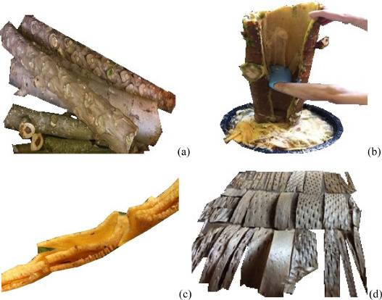
Fig. 1. (a) papaya cut stems; (b) removal of the parenchymal xylem; (c) inner, intermediate and external fibre layers; (d) dried extracted layers

5.Heating and Pulp form :
After the process we need to cook the fiber with high temperature . using the normal water which we soak into the fiber . boil and cook it nearly one hour with high temperature .In middle of time stir it often . cook it well and it turn into soft and may convert to pulp. Nearly (temperature=150 degree ) after the process is completed rest it in cool for some time. after it cooled ready for next steps. After the cooking was completed need to grind the fiber particles into fine elements . By using mixer grinder which was we used in normal domestic purpose . fill the mixer jar with fibers and grind into soft pulp or finite fiber particles in middle add little amount of water to turn soft . up to it will turn soft .And grind the all fiber into pulp .(shown in fig :2)
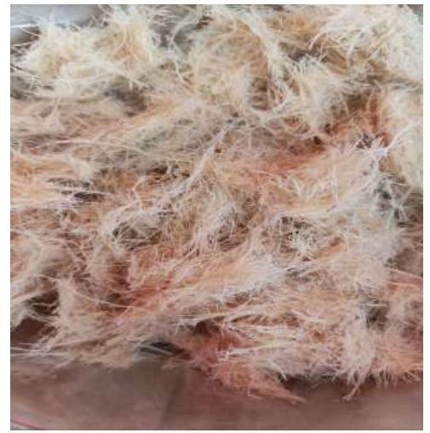fig :2, papaya fiber pulp
6.Machining process:
In term of price , papaya fiber composite represent a worth of alternative fiber . polylatic acid is well known biopolymer it also investigate higher tensile strength of plantation for green house fiber. The mechanical test are listed below (table :2) . here observed that pp is represent the papaya which has a higher elongation compared to other the tensile strength also medium in range and young modulus is lower in range from that we concluded that pp is best of making papaya sanitary pads .

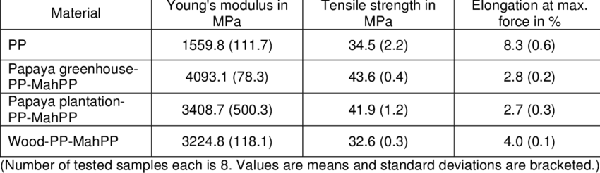
Table :2
In (Fig. 3a and b). The resin and hardener were mixed with the proportion of 5:1 (wt/wt), according to the manufacturer's recommendations. A plastic film was used inside the mould to provide a better surface finishing. A lid closes the mould and a pressure of 654 kPa is applied for 24 h, after which the material is de moulded and post-cured at 50 °C for 24 h following the manufacturer's recommendations. Finally, the samples are cut on a band saw in dimensions 165 × 19 × 3 mm³ [17] and 114 × 15 × 3 mm³ [18] for tensile and three-point bending . Now the final step to make pad was . first take cotton cloths and measure a required length and width . or measuring by using common sanitary pads and draw a trace line like common pad . now cut the cotton piece and repel the shape four times .now we have four parts of cloth .after by using two piece of cloth stitch and in between fill the particles we prepared nothing but fiber particles . after filling it cover the hole . And stitch another two cloths also with in it over .(shown in fig :4)
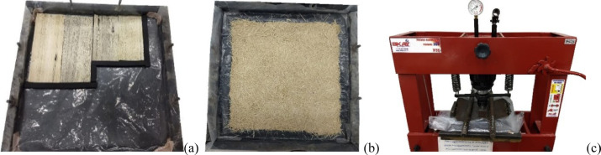 Fig. 3. Fabrication of the composites: papaya fiber layers (a) or randomly oriented short fibres (b) placed onto the metallic mould; (c) cold pressing.

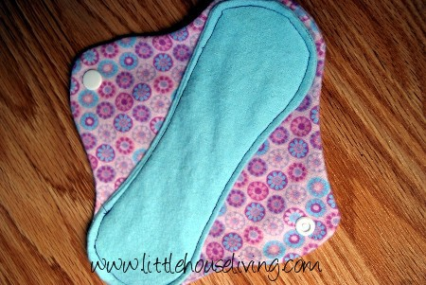fig:4. Final finishing of pad
7.Problems happened using chemical pads :
Skin Irritation Many commercial sanitary pads contain synthetic materials and chemicals like dioxins, fragrances, and dyes. These can cause skin irritation, redness, itching, and discomfort, especially for individuals with sensitive skin. Allergic Reactions Some people may be allergic to the chemicals and fragrances used in sanitary pads, leading to more severe skin reactions, such as rashes and hives. Toxic Chemical Exposure Chlorine bleaching is often used in the production of sanitary pads, which can produce dioxins, a group of highly toxic chemicals. Prolonged exposure to dioxins may be linked to health issues such as hormone disruption, immune system suppression, and an increased risk of cancer .Vaginal Discomfort Chemicals and fragrances in pads can disrupt the natural pH balance of the vaginal area, potentially leading to infections or discomfort. Environmental Impact The production and disposal of disposable chemical sanitary pads contribute to environmental pollution and waste. These pads take hundreds of years to decompose in landfills.
8.Conclusion :
Papaya tree fiber layers are highly anisotropic. The mechanical reinforcement test of layers to longitudinal loads, that is, along the longest axis of the honeycomb-like cells, is much superior relative to the transverse direction .The tensile and flexural properties of epoxy composites reinforced by longitudinal papaya stem fiber layers with alternating holes are compared to those of different materials, leading to the conclusion that papaya stem fiber layers are a promising reinforcement for polymeric composites. I conclude that the best product which is eco friendly to environmental and helpful to women . it will works effectively and protect from cancer and other reproductive diseases . it will definite create a great demand in future. it will helpful for periods time and avoid harmful causes by using this organic pad .

Reference :

[1].Tensile and flexural properties of epoxy laminates with natural papaya bast fibre cellular layers,https://doi.org/10.1016/j.jcomc.2020.100017
[2].E.A. Evans, F.H. Ballen, An Overview of Global Papaya Production, Trade, and Consumption, FE913University of Florida (2012)

[3] .A. Kempe, T. Lautenschläger, A. Lange, C. Neinhuis How to become a tree without wood- Biomechanical analysis of the stem of Carica papaya L Plant Biol., 16 (1) (2014), pp. 264-271,https://doi.org/10.1111/plb.12035

[4]. L.G. Thygesen, M. Eder, I. Burgert ,Dislocations in single hemp fibres – investigations into the relationship of structural distortions and tensile properties at the cell wall level J. Mater. Sci., 42 (2007), pp. 558-564, https://doi.org/10.1007/s10853-006-1113-5

[5].T. Gurunathan, S. Mohanty, S.K. Nayak A review of the recent developments in biocomposites based on natural fibres and their application perspectives Composites, 77 (2015), pp. 1-25 ,https://doi.org/10.1016/j.compositesa.2015.06.007

[6] .A.K. Bledzki, W. Zhang, A. Chate Natural-fibre-reinforced polyurethane microfoams
Compos. Sci. Technol., 61 (16) (2001), pp. 2405-2411, https://doi.org/10.1016/S0266-3538(01)00129-4

[7]. Lautenschläger, Thea & Kempe, Andreas & Neinhuis,Christoph&Wagenführ,André&Siwek, Sebastian. (2016). Not Only Delicious: Papaya Bast Fibres in Biocomposites. BioResources. 11.10.15376/biores.11.3.6582-6589.

