Antimicrobial Activity of Syzygium aromaticum
Farha Khan and Swapanil Yadav
Department of Biotechnology, G.F. College, Shahjahanpur, U.P.- 242001
swapanilgfc@gmail.com
Abstract
Due to its extensive spectrum of pharmacological effects that have been accumulated over centuries of traditional use and have been documented in literature, clove is a significant medicinal plant. In the present study, Staphylococcus aureus, Escherichia coli, and Pseudomonas aeruginosa were tested for Clove's antibacterial properties. When methanol extract was used to treat both Escherichia coli and Pseudomonas aeruginosa, the highest zone of inhibition (25mm) was seen against both bacteria at a dosage of 100 g/ml. Pseudomonas aeruginosa was then treated with a concentration of 50µg/ml of methanol extract (21mm). At a dose of 25µg/ml, the smallest zone of inhibition against Escherichia coli (15mm) was noted.
Key Words: Antimicrobial activity, Agar well diffusion assay, Clove, Escherichia coli, Syzygium aromaticum.
Introduction
Antimicrobial compounds are widely available in medicinal plants. Since many medicinal plant extracts have potential antibacterial activity, they are utilised to treat a variety of infections. Many herbal companies screen and trade some of these bioactive compounds as raw materials (Renisheya et al., 2011). After noticing that manufactured medications had more negative side effects than positive ones, experts refocused their attention on using medicinal plants to their advantage (Bushra et al., 2012). Out of the 422128 plant species that have been recognised as being in the world, it is believed that between 35,000 and 70,000 species are employed as medical plants (Bibi et al., 2011).The term "antimicrobial activity" describes the method of eradicating or restraining disease-causing bacteria. For this, a variety of antimicrobial agents are employed. Antibacterial, antifungal, or antiviral are all examples of antimicrobial. Each of them uses a distinct method of action to combat the virus. In our study of articles published in PubMed between 1966 and 1994 that discussed the antibacterial properties of medicinal plants, we discovered 115; however, between 1995 and 2004, this number more than doubled to 307.Between 1971 and 2005, 187 references in PubMed focused on the antibacterial action of essential oils; however, the number of references for essential oils was substantially higher in a search processed by the ISI web of knowledge (323 between 1986 and 2005). These numbers show the growing interest in this kind of research within the scientific community's subset that focuses on the study of plants' therapeutic capabilities.One can find a wide variety of criteria in the studies themselves. Numerous studies concentrate on figuring out the antimicrobial activity of plant extracts used in traditional medicine (Ngwendson et al., 2003), essential oils (Alma et al., 2003), or isolated substances like alkaloids (Klausmeyer et al., 2004), flavonoids (Sohn et al., 2004), sesquiterpene lactones (Lin et al., 2003), diterpenes (El- Seedi et al., 2002), triterpenes (Katerere et al., 2003) or naphtoquinones (Machado et al., 2003), among others.Some of these substances were separated or acquired by bio-guided isolation after the plant's antibacterial action was first discovered.The fragrant dried flower buds known as cloves come from a tree in the Myrtaceae family. Cloves have been used as medicine in Ayurveda, Chinese, Unani, and western herbalism for centuries to treat a variety of illnesses, including dental problems and oral ailments.Clove essential oil is used in conventional medicine. The bark, flowers, and leaves all have an odour. The clove is the unopened bloom bud. The tree grows to a height of 8 to 15 metres and can live for more than 100 years (26–50 ft). The Molucca Islands' native clove tree is also referred to as a tropical myrtle. Essential oils from aromatic plants are used in foods as dietary antioxidants, which are thought to protect against a range of diseases caused by free radicals, in addition to adding smell and flavour.
Materials and Methods
Collection of Sample
Plant material of Syzygium aromaticum or Clove buds is used in this study was collected from the local market of Shahjahanpur, Uttar Pradesh (India) and identified by the Head, Department of Biotechnology and were preserved for future use.
Bacterial Cultures
Staphylococcus aureus (NCIM-2079), Escherechia coli (NCIM2064), Pseudomonas aeruginosa (NCIM-5210).
Solvents and Media
Methanol for extraction, Nutrient Agar Nutrient.
Extraction
The dried buds of Syzygium aromaticum were homogenised to a fine powdered and stored in a airtight bottle. 6 g of Clove was ground finely and used for solvent extraction via Soxhlet apparatus following standard protocol. After the complete process, the collected extracts were for evaporation at room temperature. The dried extracts were stored at 4°C for future analysis.
Agar Well Diffusion method
Extracts were tested for the anti-bacterial potential by Agar well diffusion method. Initially, autoclaved nutrient media were poured in the Petri plates under laminar air flow and after solidification of media the bacterial suspension (24 hrs old) swab over the media. The wells were prepared using cork borer. Test sample was dissolved in DMSO in different concentrations such as 25, 50, 100µg/ml and 40µl dissolved test sample from each concentration was loaded to the wells and incubated for 24 hrs at 37°C. DMSO (Di Methyl Sulfoxide) used as a negative control whereas antibiotic amoxicillin disc having amoxicillin 10µg concentration used as positive control.
Results and Discussion
In present study antimicrobial activity of Clove was carried out. Table- 1 shown the antimicrobial activity of spice extracted in methanol solvents against Staphylococcus aureus, Escherichia coliand Pseudomonas aeruginosa. The maximum zone of inhibition was observed against Escherichia coli (25mm) and Pseudomonas aeruginosa (25mm) at 100µg/ml concentration by methanol extract in both the bacteria followed by 50µg/ml concentration by methanol extract against Pseudomonas aeruginosa (21mm). The minimum zone of inhibition was observed against Escherichia coli (15mm) at 25µg/ml concentration. In the present study of clove antimicrobial activity against Pseudomonas aeruginosa and Escherichia coli was found significantly maximum by methanol extract. Staphylococcus aureus showed minimum activity against methanol extracts. The results suggest that clove produced significant antimicrobial activity. Antimicrobial activity of extracts increases as the concentration increases. The clove extract, showed a diameter of inhibition zone ranging from 25 to 15 mm, when used a higher concentration of the methanol extract, for the tested bacteria after 24 hours of incubation. The antimicrobial effect of the medicinal plants is well documented (Valero and Salmeron, 2003). In this study, using the disk diffusion method it was observed that extracts of clove produce antimicrobial activity against both gram positive and gram negative pathogens. Results of this study confirmed the observation of earlier studies (Yuste and Fung, 2004; Fang and Chen, 2001).The data supports the hypothesis that clove has an inhibitory effect on the growth of certain pathogens and may be used effectively against various microbial infections.
Table 1: Effect of Clove extract on growth of bacteria in vitro.
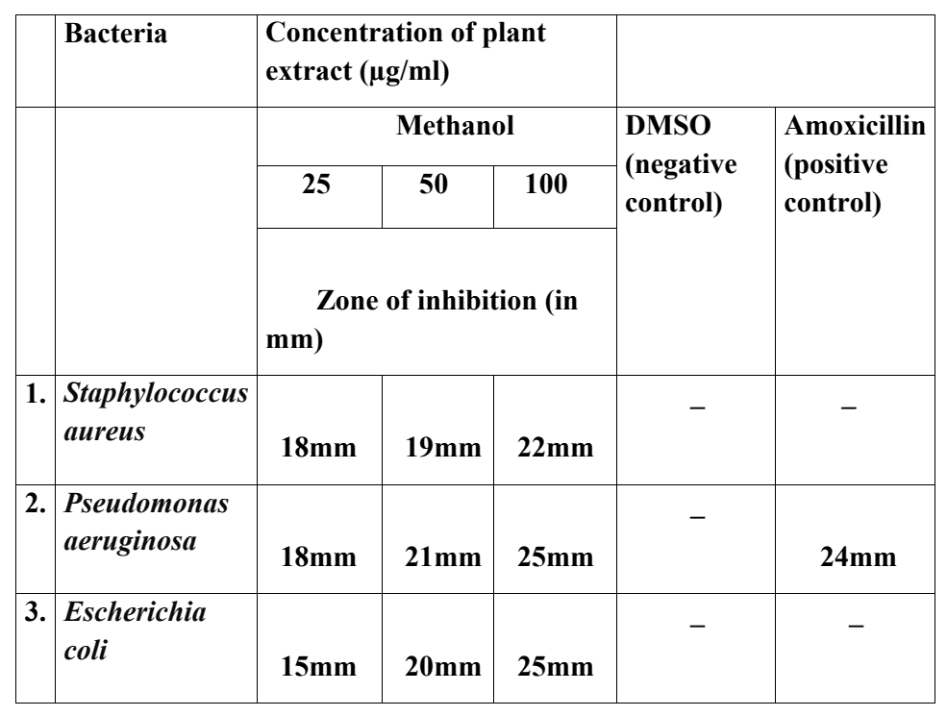
References
Alma, M.H., Mavi, A., Yildirim, A., Digrak, M., Hirata, T. 2003. Screening chemical composition and in vitro antioxidant and antimicrobial activities of the essential oils from Origanum syriacum L. growing in Turkey. Biological and Pharmaceutical Bulletin 26, 1725–1729.
Bibi, Y., Nisa, S., Chaudhary, F. and Zia, M. 2011. Antibacterial activity of some selected medicianal plants of pakistan. BMC Complem Altern Med. 11: 892-897.
Bushra, I. Fozia, Abdul, W., Ali, R., Ullah. Hussain, Iqbal. Hamid, Almas, M. and Ahmad, A. 2012. Antimicrobial activity of Malva neglecta and Nasturtium microphyllum. Int J Res Ayurveda Pharm., 3: 808-810.
Fan M, and J. Chen. 2001. Studies on antimicrobial activity of extracts from thyme. Wei Sheng Wu Xue Bao. 41:499-504.
Klausmeyer, P., Chmurny, G.N., McCloud, T.G., Tucker, K.D., Shoemaker, R.H., 2004. A novel antimicrobial indolizinium alkaloidfrom Anibapanurensis. Journal of Natural Products 67, 1732– 1735.
Ngwendson, J.N., Bedir, E., Efange, S.M., Okunji, C.O., Iwu, M.M., Schuster, B.G., Khan, I.A. 2003. Constituents of Peucedanumzenkeri seeds and their antimicrobial effects. Pharmazie 58, 587–589.
Renisheya, J. J., Malar, T., Johnson, M., Mary, U. M. and Arthy, A. (2011). Antibacterial activities of ethanolic extracts of selected medicianal plants against human pathogens. Asian Pac J Trop Biomed., S76-S78.
Sohn, H.Y., Son, K.H., Kwon, C.S., Kwon, G.S., Kang, S.S., 2004. Antimicrobial and cytotoxic activity of 18 prenylated flavonoids isolated from medicinal plants: Morus alba L., Morus mongolica Schneider, Broussnetiapapyrifera (L.) Vent, Sophora flavescens Ait and Echinosophorakoreensis Nakai. Phytomedicine 11, 666– 672.
Valero M, Salmeron M C. Antibacterial activity of 11 essential oils against Bacillus cereus in tyndallized carrot broth. Int J Food Microbiol. 2003;85:73–81.
Yuste, J., and D. Y. Fung. 2004. Inactivation of Salmonella typhimurium and Escherichia coli O157:H7 in apple juice by a combination of nisin and cinnamon. J. Food Prot. 67:371-317.
Lin, F., Hasegawa, M., Kodama, O. 2003. Purification and identification of antimicrobial sesquiterpene lactones from yacon (Smallanthussonchifolius) leaves. Bioscience, Biotechnology and Biochemistry 67, 2154–2159.
El-Seedi, H.R., Sata, N., Torssell, K.B., Nishiyama, S.2002. New labdene diterpenes from Eupatorium glutinosum. Journal of Natural Products 65, 728–729.
Katerere, D.R., Gray, A.I., Nash, R.J., Waigh, R.D. 2003. Antimicrobial activity of pentacyclic triterpenes isolated from African Combretaceae. Phytochemistry 63, 81–88.
Machado, T.B., Pinto, A.V., Pinto, M.C., Leal, I.C., Silva, M.G., Amaral, A.C., Kuster, R.M., Netto-dos Santos, K.R. 2003. In vitro activity of Brazilian medicinal plants, naturally occurring naphthoquinones and their analogues, against methicillin-resistant Staphylococcus aureus. International Journal of Antimicrobial Agents 21, 279–284.

