**Using software to conduct a comparative analysis of floating columns in multistory buildings**

**Suresh Kumar Savlay1, Dr. Arafat Rehman2**

1M.Tech Scholar, Dept. Of Civil Engineering, RKDF Institute & Science Technology, Bhopal

2Associate Professor and Head of the Department, Dept. Of Civil Engineering, RKDF Institute & Science Technology, Bhopal

**ABSTRACT**

Modern multi-story buildings in Indian cities often use floating columns, which are very unwelcome in structures erected in seismically active regions. In this study, a multi-story structure with and without floating columns is subjected to static analysis. By shifting the placement of the floating columns floor by floor, several construction situations are explored. Investigated is how the building models respond structurally to base shear and storey displacements. The analysis is done using the sap2000v17 Software.

**Keywords*:* Floating column, linear static analysis, sap2000v17, Multi-story buildings, 3D Analysis**

# 1. INTRODUCTION

Due to population growth, space constraints, and other factors, multi-story structures in metropolitan areas are now required to include column-free space for aesthetic and practical reasons. Buildings are equipped with floating columns at one or more stories for this purpose. In a structure constructed in a seismically active location, these floating columns constitute a significant drawback. The shortest route must be used to carry the seismic forces that are generated at various floor levels in a structure down to the ground. The building performs poorly if this load transfer route deviates from it or becomes interrupted. In addition to how the earthquake forces are transmitted to the ground, a building's general design, scale, and geometry have a significant impact on how it responds to earthquakes. During the 2001 Bhuj earthquake, several buildings in Gujarat with an open ground floor designed for parking fell or sustained significant damage. [1]

* 1. **Floating Column:** A floating column is an unsupported vertical element that rests on a beam. By acting as a point load on the beam, the floating column distributes the weight to the columns below it. [4]

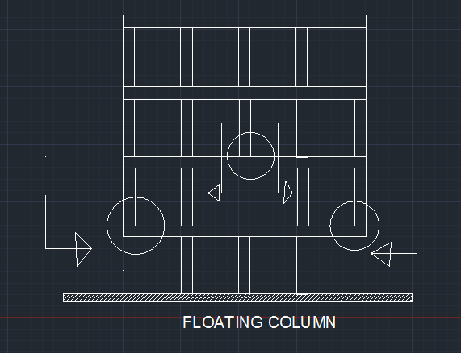

Fig.1: Floating column in building**.**

**2. LITRATURE REVIEW**

**Shrikanth M.K*1,Yogendra.R.Holebagilu2**In this paper study is all about to compare the behavior of a building having only floating column and having floating column with complexities. High rise building is analyzed for earthquake force. For that purpose created four models and analyzed for lower and higher seismic zones for medium soil condition. Analysis was carried out by using extended 3 dimensional analysis of building system ETAB version 9.7.4 software. Results are presented in terms of Displacement, storey drift for these four models and tabulated on basis of linear seismic analysis. [2]

**T.raja sekhar*,Mr.P.V.Prasad1**The behavior of building frame with and without floating column is studied under static load, free vibration and forced vibration condition. The results are plotted for both the frames with and without floating column by comparing each other time history of floor displacement, base shear. The equivalent static analysis is carried out on the entire project mathematical 3D model using the software STAAD Pro V8i and the comparison of these models are been presented. This will help us to find the various analytical properties of the structure and we may also have a very systematic and economical design for the structure. [3] static analysis of these model are done by using STAAD Pro V8i .Different parameters such as a xia l load ,moment distribution, importance of line of action of force and seismic factors are studied for models. This will help them to find the various analytical properties of the structure and also have a very systematic and economical design for the structure. [4]

**3. OBJECTIVES OF STUDY**

The main objectives of the proposed work are:

1. Static linear analysis of different building having floating column at different floors.
2. To compare the Base shear, Storey displacement.

# 4. METHODOLOGY

## 4.1 Using Sap2000 v17

When we pick new for a new model, we are presented with a dialogue box like the one in Figure 2 below, asking

Us to choose a new template. Avail Just the Grid Option.

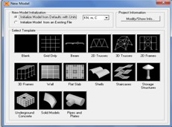

Fig 2: New model formation

The following graphic shows after choosing "Grid alone," asking for the number of grid lines in each direction as well as the grid spacing in each direction. Give the grid line values according to your design, then click OK. Recall that grid lines are those that cut through the middle of each column in both directions. Gridlines in a plan's X direction are horizontal, Y direction are vertical, and Z direction are vertical in elevation. The programme builds the model for the supplied values after receiving the grid line values as shown in the image. The model is simultaneously visible in 3D and in plan. [14].

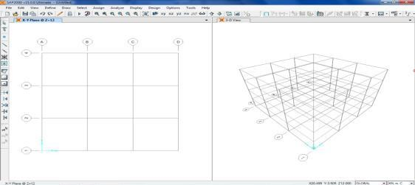

Fig 3: Grid line formation

**4.2 Material Property & Model's load Patterns**

Choose Define, Section Properties, Slab Sections, and Add New Property from the drop-down menu. [14]

* Write "new load pattern, EQX" in the text box.
* Pick the kind load QUAKE from the drop-down menu. Make sure the self-weight multiplier is set to 0, then click the button to add a new load pattern to the list to add an EQX load. Do the same thing for EQY load?

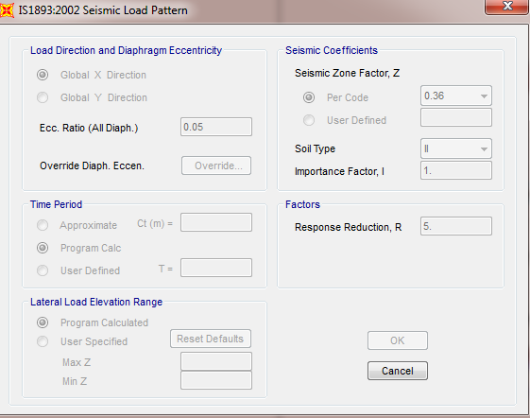

Fig 4: Seismic load pattern

Repeat the process for various load patterns give load patterns as dead, live, superimposed. Note: for dead load, the self-weight multiplier is 1 and for the rest all is considered as 0. For superimposed load, the type is super dead. [14]

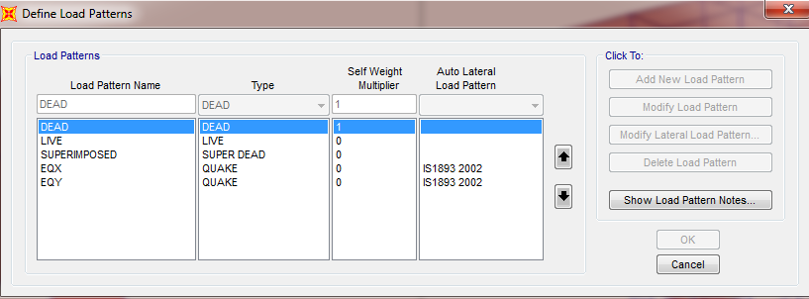

# Fig.5: Define load patterns formation

# 

A five storied building with floating column at 1st floor and building with floating column at 2nd floor and building without floating column located in zone v of India as per code IS 1893(Part1):2002 were taken for the investigation. Linear static analysis of buildings were done under gravity loads and seismic loads. Then compare base shear and storey displacement of each building. Modeling and analysis was carried out in sap 2000v17.modeling consists of following step: Building detail

**Building dimensions: 16.70m×7.55m**

1. Height of floor: 3.1m

2. Column sizes: 230mm×450mm, 230mm×380mm.

3. Beam sizes: 230mm×450mm.

4. Slab thickness: 125mm.

5. Grade of concrete: M20

6. Grade of steel: Fe500

7. Density of masonry: 18 KN/ m3

8. Density of concrete: 25 KN/ m3

9. Seismic zone: V

10. Importance factor: 1

11. Building frame: Special RC moment resisting frame (SMRF)

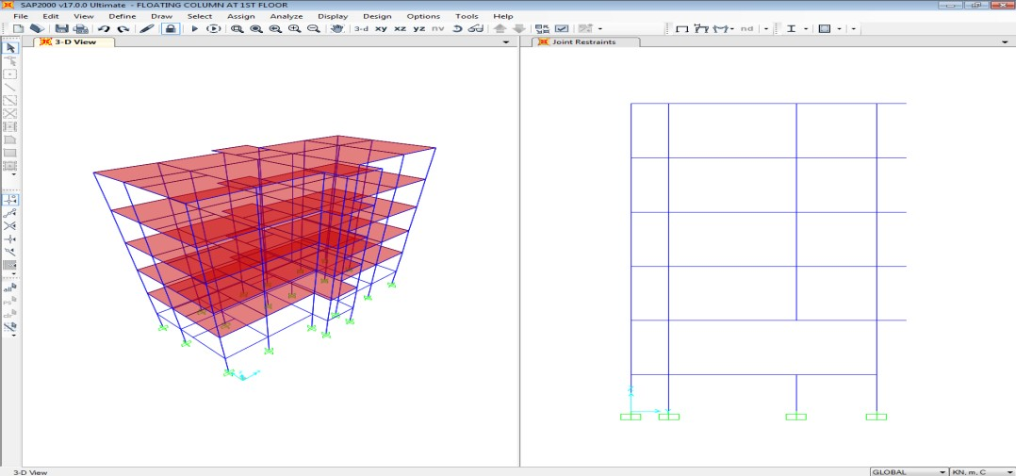

Fig.6: Model 1

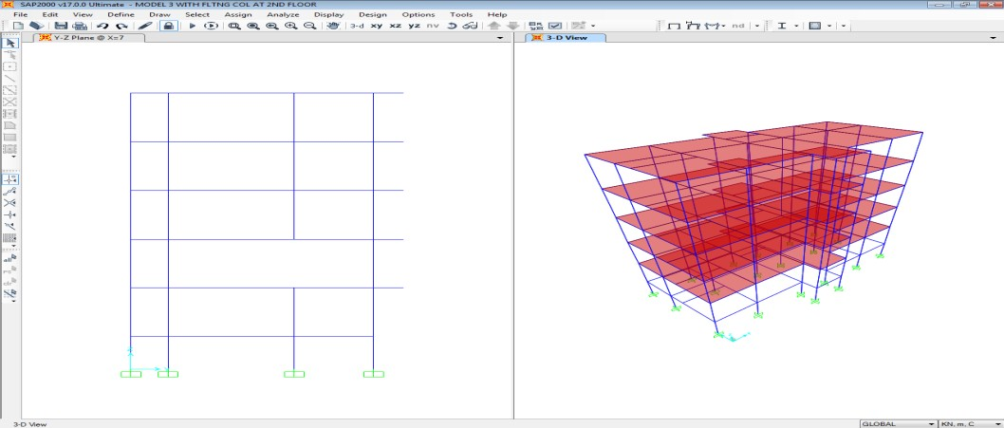

Fig.7: Model 2

# 5. RESULT

## Base shear

Base shear is the horizontal reaction at the base against horizontal earthquake load. This Base shear is acting at the base or supports of the structure or wherever structure is fixed.

|  |  |
| --- | --- |
| **Model** | **Base shear in x direction in KN** |
| WITHOUT F/ C | 379.336 |
| F/C AT 1ST FLOOR | 371.176 |
| F/C AT 2ND FLOOR | 372.597 |

Table 1: Base shear in x direction

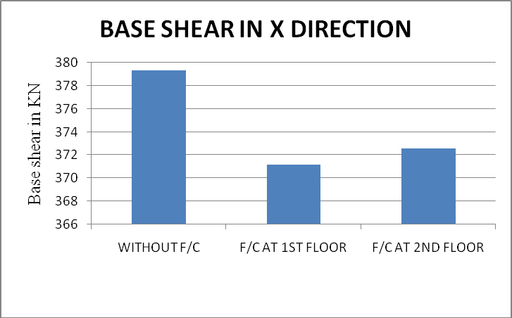

Fig.8: Base shear in KN

**5.2 Storey Displacement**

Storey displacement is the lateral movement of the structure caused by lateral force.

|  |  |  |  |
| --- | --- | --- | --- |
| **HEIGHT** | **DISPLACEMENT** | | |
|  | **Model 1** | **Model 2** | **Model 3** |
| 17 | 0 | 0 | 0 |
| 14 | 0.00082 | 0.000904 | 0.000845 |
| 11 | 0.003526 | 0.003844 | 0.003572 |
| 8 | 0.006583 | 0.006606 | 0.006365 |
| 5 | 0.009119 | 0.009113 | 0.008919 |
| 2 | 0.011143 | 0.011128 | 0.010972 |
| 0 | 0.012409 | 0.012388 | 0.012254 |

Table 2: Storey displacement

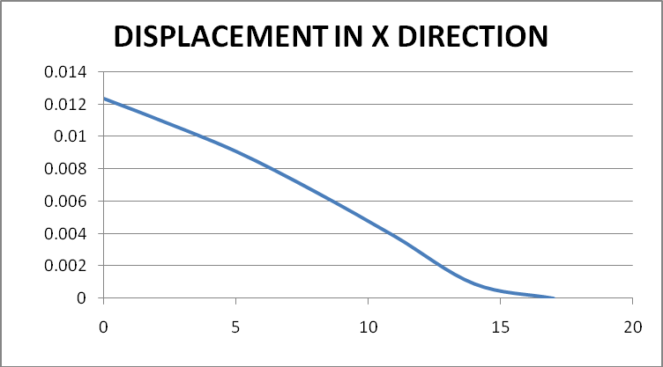

Fig. 9: Comparison of storey displacement for model 1

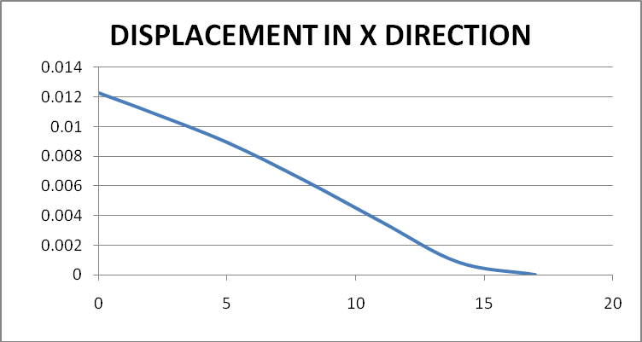

Fig. 10: Comparison of storey displacement for model 2

**6. CONCLUSION**

Some of the findings that were reached as a result of this investigation are listed below. Building foundation shear was shown to diminish when floating columns were added to the first level compared to buildings without floating columns. In addition, it was shown that base shear rises from the first story. It was found that floating column buildings cause greater displacement between each story than non-floating column buildings do.

**REFERENCES**

[1]. Hardik Bhensdadia(2015)- Pushover analysis of Rc structure with floating column and soft storey in different earthquake zones , frame International Journal of Research.

[2]. Shrikanth .M.K (2014) –Seismic response of complex building with floating column and without floating column, International journal of Engineering Research-Online. A Peer Reviewed International Journal .Vo l. 2. Issue.4, 2014 .ISSN: 2321-7758

[3]. T.Raja. Sekhar (2014) – Study of behavior of seismic analysis of multistory building with and without floating column. T. Raja Sekhar et al, Carib .j. SciTech, 2014, VO l2, 697-710.

[4]. A. P. Mundada (2014) – Comparative seismic analysis of multi storey building with and without floating column , International Journal of Current Engineering and Technology, Vol.4, No.5 (Oct 2014)

[5]. Sukumar Behera (may2012)-Seismic analysis of multistory building with floating column , Department of Civil Engineering, National Institute of Technology Rourkela- 769008 MAY 2012.