**STUDY & ANALYSIS OF FLOATING COLUMN WITH LATERAL LOAD RESISTING SYSTEM BY USING STAAD PRO SOFTWARE**

**Suresh Kumar Savlay1, Dr. Arafat Rehman2**

1M.Tech Scholar, Dept. Of Civil Engineering, RKDF Institute & Science Technology, Bhopal

2Associate Professor and Head of the Department, Dept. Of Civil Engineering, RKDF Institute & Science Technology, Bhopal

**Abstract**-In India nowadays, open first level is a common and inescapable element of urban multistory structures. The main reason for adopting this is to provide room for parking or reception lobbies in the first storey. In contrast to the seismic force distribution, which depends on the distribution of stiffness and mass along the height, the total seismic base shear that a structure experiences during an earthquake is influenced by the earthquake's natural period. A vertical member that terminates at its lower level and rests on a beam, which is a horizontal member, is referred to as a floating column. The beams then shift the weight to a different column below it. Buildings with floating columns are a common design element in India's new multistory construction at the moment. In the current paper, an attempt has been made to choose the ideal location for the floating column. Buildings of the G+4, G+10, and G+20 types were examined, and it was discovered that the building with the floating column in the centre behaved properly.

**Keywords: Multistorey, seismic, floating column, Self-weight Loading, 3D Analysis Software Staad Pro**

**1. Introduction**

A column is means to be a vertical part that carries the weight from the foundation level to the ground. The phrase "floating column" refers to a vertical element that at its lower level (termination level) rests on a beam, which is a horizontal part, because of the architectural design or site circumstance. The weight is then transferred from the beams to the columns underneath them. Floating columns are often used in construction projects, particularly above the bottom level when transfer girders are used to provide more open space on the ground floor. These open areas could be necessary for a parking lot or an assembly hall. Particularly in earthquake zones, the transfer girders must be adequately specified and planned. The beam that supports the column is under a concentrated load from the column. The column is often considered to be pinned at the base during analysis, in which case it is treated as a point load on the transfer beam. This sort of structure may be analysed using STAAD Pro.

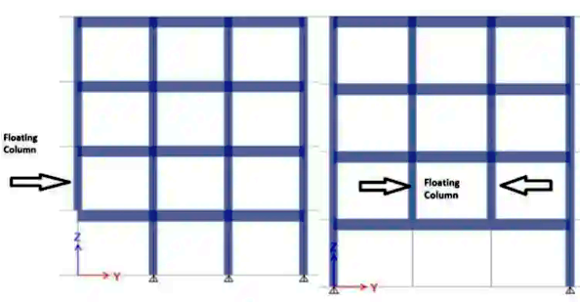

Fig.1: Floating Column in Building

**2. Objective of Study**

The current work's goal is to investigate how multistory structures with floating columns respond to both normal loads and seismic excitations. The following are the goals of the current work:

* To investigate the behaviour of a multi-story structure with a floating column under typical loading conditions.
* Studying how a multi-story skyscraper with a floating column responds to seismic excitation
* Research potential collapse patterns for floating column multistory buildings.
* Propose strategies for bracing a floating column and analyse their effects.
* Compare and discover the most efficient way to reinforce floating columns.

**3. Problem Identification**

In the current work, reaction spectrum analysis was used to examine the seismic response of conventional multi-story structures with and without floating columns. Using STAAD Pro V8i, storey frame models with G+4, G+10, and G+20 floors have been examined. The crucial point of the floating column has been determined after varying its position. To assess the impact of floating columns on the seismic response of RC-framed structures, a variety of input parameters were employed. Table 1 provides thorough information on the input parameters.

**4. Materials and Methodology**

|  |  |  |  |  |  |  |  |  |
| --- | --- | --- | --- | --- | --- | --- | --- | --- |
| **Sr.**  **No.** | **I** | **II** | **III** | **IV** | | | | **V** |
| 1 | Structure | Beam | Slab | | Column | | | Wall |
| 2 | Storey | --- | --- | | G+4 | G+10 | G+20 | --- |
| 3 | Size | 350x730mm2 | 150mm | | 350x350mm2 | 500x500mm2 | 660x660mm2 | 300mm |
| 4 | Material | M20 | M25 | | M25 | M30 | M35 | Brick |

Table 1: Material and Structural Information

|  |  |  |
| --- | --- | --- |
| **Sr. No.** | **I** | **II** |
| 1 | No. of stories | G+4, G+10, G+20 |
| 2 | Floor Height | 3m |
| 2 | Dimension of plan | 25m x 22.5 m |

Table 2: Building Information

|  |  |  |
| --- | --- | --- |
| **Sr. No.** | **I** | **II** |
| 1 | Seismic zone | III |
| 2 | Importance factor(I) | 1 |
| 3 | Response reduction factor(R) | 3 |
| 4 | Zone factor | 0.16 |

Table 3: Earthquake Data

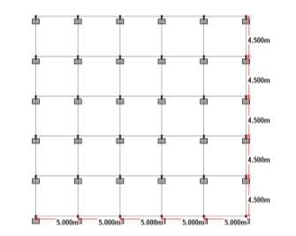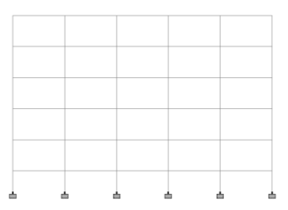

Fig 2: Models have been created in STAAD Pro V8i using the given information

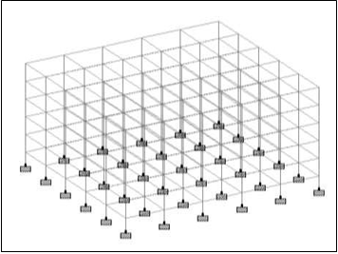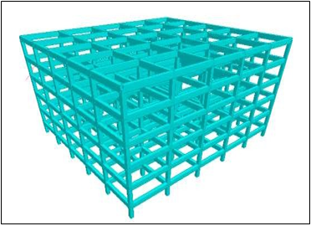

Fig.3: 3D perspective of G+4 Building and 3D perspective of G+4 Building (Rendering view)

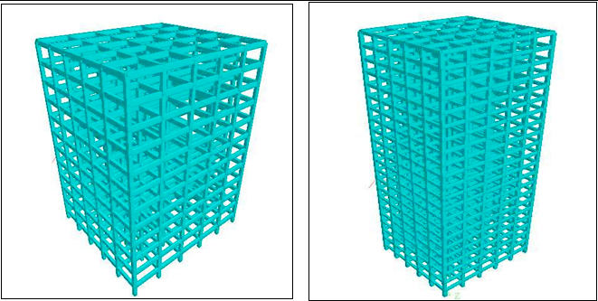

Fig. 4: 3D image of the G+20 Building and 3D picture of the G+10 Building (Rendering view)

|  |  |  |
| --- | --- | --- |
| **Type Load** | **Particulars** | **Calculations** |
| **Dead Load** | Weight of slab | = 25 *D  = 25*0.15  = 3.75 KN/m2 |
| Weight of partition wall | = 20*t*h  = 20 *0.3*(3.0- 0.73)  =13.62 KN/m |
| Weight of parapet wall | = 20*t*h  =20*0.3*0.9  =5.4 KN/m |
| Floor Finish | = 1 KN/m2 |
| **Live Load** | Live load | = 3.00 KN/m2 (As per IS 875 part II) |

Table 4: Static Analysis Loading Calculations

**5. RESULT**

At first, G+4. In order to determine the most effective place for the floating column, static and dynamic analyses of the G+10 and G+20 structures were performed. Column displacement is used as a baseline for comparison of the findings.

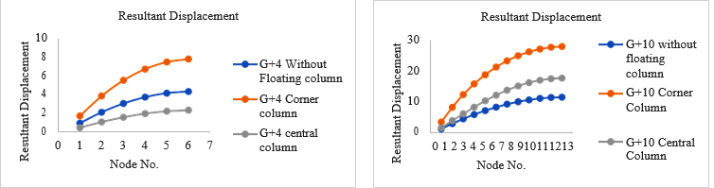

Fig.5: Resultant displacement for G+4 Building (Static) and displacement for G+10 Building (Static)

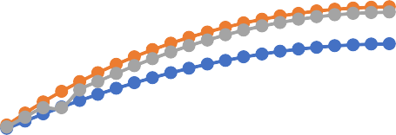

Resultant Displacement

50

40

30

20

10

0

G+20 without floating

Column

G+20 corner column

0 1 2 3 4 5 6 7 8 9101112131415161718192021222324

Node No.

G+20 central column

Fig 6: Resultant displacement for G+20 Building (Static)

In order to examine structures for the combinations of dead load and live load, graphs were produced between nodes based on the heights and displacements of the loads. The data collected shows that the displacements in the constructions without floating columns are at their lowest. When a floating column is added to a structure, the displacements grow, reaching their peak when the floating column is positioned at a corner.

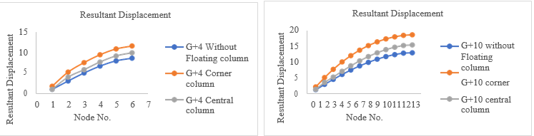

Fig.7: Resultant displacement for G+4 Building (Static) and displacement for G+10 Building (Dynamic)



Resultant Displacement

50

40

30

20

10

0

G+20 without floating

Column

G+20 corner column

0 1 2 3 4 5 6 7 8 9101112131415161718192021222324

Node No.

G+20 central column

Fig 8: Resultant displacement for G+20 Building (Dynamic)

**6. CONCLUSIONS**

* Building height grows along with the displacement it causes.
* When a floating column is added to a symmetrically loaded structure, its displacements under static loading rise.
* Floating columns placed in the centre of a structure react better for static analysis than floating columns placed in the corners.
* According to a dynamic study, a building with a central floating column acts better than one with a corner floating column.
* Base shear values calculated manually and using STAAD Pro V8i are quite similar.
* The building's geometric centre is directly above where the centre of mass is positioned.
* Depending on the kind of bracing system used, the building's displacement reduces.
* The G+4 structure has the least displacement when using the inverted V system.
* For the G+10 and G+20 structure, K-type bracing techniques seem to be effective.
* Further research is also conducted for the structures from (G+5) to (G+9), and it is discovered that the Inverted V system is effective up to (G+4), after which the K system is effective.
* Implementing a bracing system enhances how the structure responds to lateral loads.

**REFERENCES**

1. Ankit kumar and Durgesh nandan verma.2018. Effect of Floating Column On Irregular Buildings Subjected To Lateral Loads. International Journal of Creative Research Thoughts.657:661
2. Badgire Udhav S., Shaikh A.N., Maske Ravi G.2015. Analysis of Multistorey Building with Floating Column. International Journal of Engineering Research. Volume No.4, Issue No.9: 475-478
3. Mo Farhan.2019. Behaviour of a Floating Column in a Building. International Journal for Scientific Research & Development, Vol.7, Issue 04, ISSN: 2321-0613. PP: 895-899.
4. Sreadha A R, C.Pany. 2020. Seismic Study of Multistorey Building using Floating Column. International Journal of Emerging Science and Engineering (IJESE) ISSN: 2319–6378, Volume-6 Issue-9, April 2020. PP:6-11
5. Dr.H.M. Somasekharaiah, Mr. Madhu Sudhana Y. B, Mr. Md Muddasar Basha S. 2016. A Comparative Study on Lateral Force Resisting System for Seismic Loads. International Research Journal of Engineering and Technology (IRJET) e-ISSN: 2395 -0056 Volume: 03 Issue: 08, August -2016, www.irjet.net p-ISSN: 2395-0072. PP: 1138-1144.
6. Hemavathi S, Ramya K.2017. The Structural Behaviour of Lateral Load Resisting System induced in Tall Buildings - A Comparitive Study. Journal of Chemical and Pharmaceutical Sciences ISSN: 0974-2115, JCHPS Special Issue 3: February 2017 www.jchps.com, PP: 83-87.
7. Dhruba jyoti Borthakur1, Dr. Nayanmoni Chetia.2016. A Study on the Effectiveness of Bracing System for Lateral loading. International Journal of Advanced Engineering Research and Science (IJAERS) [Vol-3, Issue-4, Apr- 2016] ISSN: 2349-6495. PP: 79-84